Support Information
Controlled Synthesis of Hybrid Carbon Allotropes with Tunable Size and Photoluminescent Properties
A. La Torre^{1,2*}
1 Institut de Physique et Chimie des Matériaux de Strasbourg, UMR 7504 CNRS, Université de Strasbourg, 23 rue du Loess, Strasbourg, 67034, France
2 University of Nottingham, School of Chemistry, University Park, Nottingham, NG7 2RD, UK.
This Supporting Information provides complementary experimental evidence supporting the structural, chemical, optical and electronic characterisation of the carbon matrices described in the main text. It includes additional TEM and HRTEM imaging, EELS, Raman and photoluminescence measurements, XPS and EDX analyses, electrical measurements of an individual carbon chain.
Supporting Figures
Figure S1: Characterisation of the pristine few-layer hexagonal boron nitride (FLBN) substrate. (a) Bright-field TEM image of an FLBN flake. Scale bar: 5 nm. (b) Raman spectrum of the FLBN flake.
Figure S2: TEM images of partially filled (a–b) and filled (c–d) carbon matrices. Scale bars: 5 nm. The measured d-spacings of the carbon matrices are approximately 4–16% larger than those of graphite.
Figure S3: Size distribution of carbon matrices. Histograms showing the diameter distributions of (a) FLBN@CNC1 (8.7 ± 1.0 nm) and (b) FLBN@CNC2 (12.4 ± 1.3 nm). The solid lines represent Gaussian fits. N denotes the number of particles analysed and SD the standard deviation.
Figure S4: Carbon matrices grown on carbon nanofibres (CNF@CNC). TEM images of carbon matrices synthesised on PD50 carbon nanofibres (CNFs) using the same experimental procedure described in the Methods section. Carbon nanofibres were used as the supporting substrate in place of few-layer hexagonal boron nitride (FLBN).
Figure S5: Aberration-corrected electron microscopy images of individual carbon matrices. (a) AC-HRTEM image of an individual carbon matrix viewed in side view. (b) AC-STEM image of an individual carbon matrix viewed in top view. (c–d) AC-HRTEM images of carbon matrices showing the hemispherical morphology and the layered structure of the sidewall. The sidewalls consist of three to four carbon layers. Scale bars: 5 nm in (a–d).
Figure S6: Correlative dark-field STEM imaging and low-loss EELS analysis of an individual carbon matrix.
Figure S7: High-loss and low-loss EELS spectra acquired from carbon matrices grown on carbon nanofibres (CNF@CNC). Spectra 1–6 were collected from individual carbon matrices, whereas Spectrum 7 was acquired from the supporting carbon nanofibre (CNF).
Figure S8: Raman characterisation of carbon matrices grown on FLBN.
Figure S9: Comparison of the EELS spectra of the carbon matrices with those of well-established carbon allotropes. The reference EELS spectra of the carbon allotropes were reproduced from Reference 15.
Figure S10: Raman spectrum of FLBN@CNC1 in the 100–320 cm⁻¹ spectral region, showing features that may be associated with sp¹-hybridised carbon.
Figure S11: Comparison of the normalized carbon K-edge EELS spectra acquired from carbon matrices synthesised on carbon and few-layer hexagonal boron nitride (FLBN) substrates.
Figure S12: (a) X-ray photoelectron spectroscopy (XPS) survey spectrum of the carbon matrices. (b) High-resolution S 2p XPS spectrum.
Figure S13: Electrical characterisation of an individual carbon chain. The upper electrode consists of carbon, whereas the lower electrode is gold. (a) TEM image of a carbon chain unravelled using a gold electrode. (b) Current–voltage (I–V) characteristics of the carbon chain, exhibiting asymmetric electrical behaviour. Scale bar: 5 nm.
Figure S14: X-ray photoelectron spectroscopy (XPS) of carbon matrices grown on few layers boron nitride sheets (FLBN). (a) High-resolution C 1s spectrum showing carbon atoms in different chemical environments. (b) High-resolution N 1s spectrum showing a nitrogen chemical environment consistent with C-N bonding.
Figure S15: Photoluminescence characterisation of the FLBN@CNC1 carbon matrix.
Figure S16: Photoluminescence characterisation of the FLBN@CNC1 carbon matrix.
Figure S17: Photoluminescence and Raman characterisation of the FLBN@CNC1 carbon matrix.
Figure S18: Photoluminescence (PL) and Raman characterisation of the FLBN@CNC1 and FLBN@CNC2 carbon matrices.
Figure S19: Representative high-energy EELS spectrum acquired from Area 9.3.
Figure S20: Representative high-energy EELS spectrum acquired from Area 9.4.
Figure S21: Representative high-energy EELS spectrum acquired from Area 9.5.
Figure S22: Representative high-energy EELS spectrum acquired from Area 10.4.
Figure S23: Representative high-energy EELS spectrum acquired from Area 11.4.
Figure S24: Representative high-energy EELS spectrum acquired from Area 11.5.
Figures S25-28: Representative low-loss EELS analysis acquired from the carbon matrices.
Figures S29-33: Representative low-loss EELS analysis acquired from the carbon matrices after heating to 360 °C.

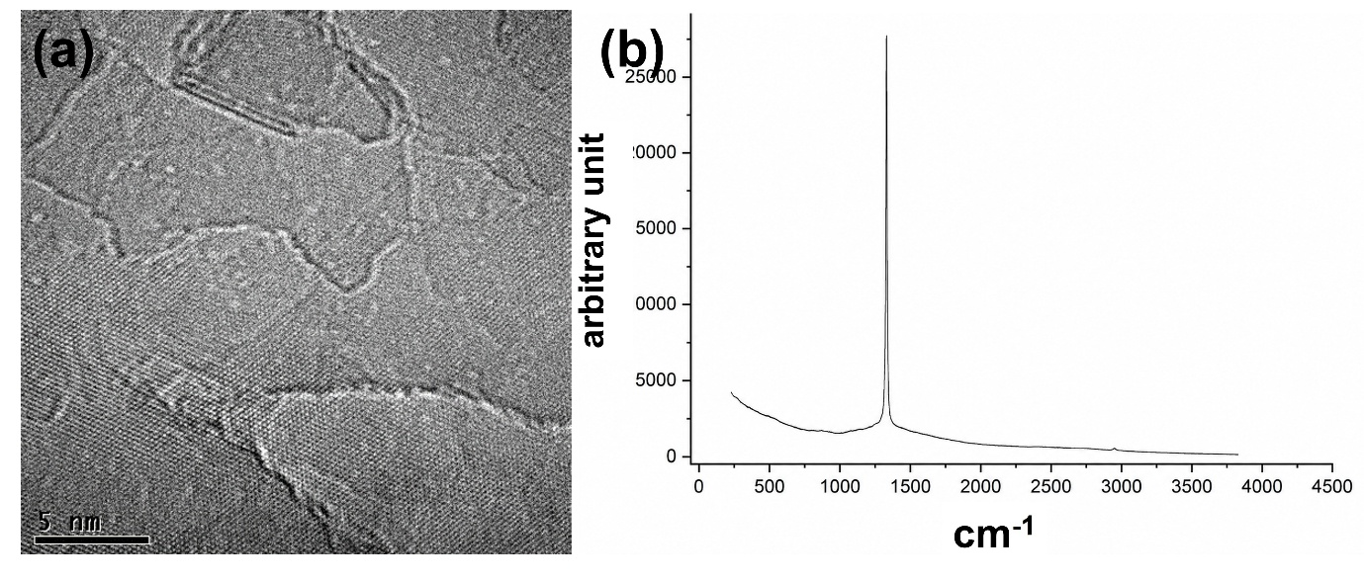
Figure S1: Characterisation of the pristine few-layer hexagonal boron nitride (FLBN) substrate. (a) Bright-field TEM image of an FLBN flake. Scale bar: 5 nm. (b) Raman spectrum of the FLBN flake.
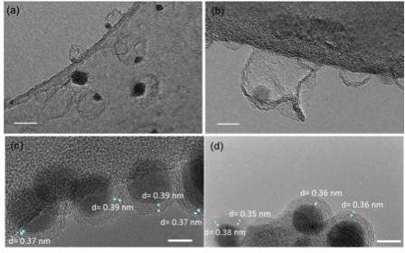
Figure S2: TEM images of partially filled (a–b) and filled (c–d) carbon matrices. Scale bars: 5 nm. The measured d-spacings of the carbon matrices are approximately 4–16% larger than that of graphite.
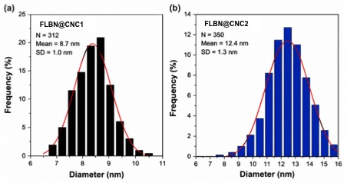
Figure S3: Size distribution of carbon matrices. Histograms showing the diameter distributions of (a) FLBN@CNC1 (8.7 ± 1.0 nm) and (b) FLBN@CNC2 (12.4 ± 1.3 nm). Gaussian fits are shown as solid lines. N, number of particles analysed; SD: standard deviation
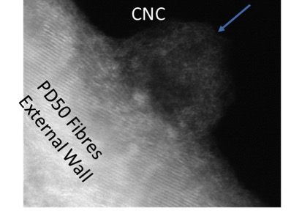
Figure S4: Carbon matrices grown on carbon nanofibres (CNF@CNC). TEM images of carbon matrices synthesised on PD50 carbon nanofibres (CNFs) using the same experimental procedure described in the Methods section. Carbon nanofibres were used as the supporting substrate in place of few-layer hexagonal boron nitride (FLBN).
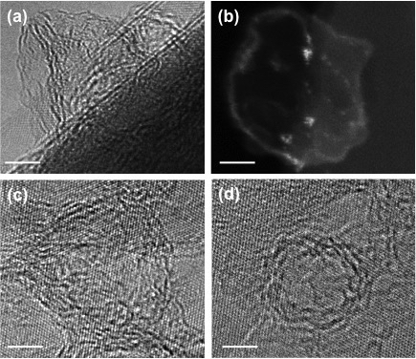
Figure S5: Aberration-corrected electron microscopy images of individual carbon matrices. (a) AC-HRTEM image of an individual carbon matrix viewed in side view. (b) AC-STEM image of an individual carbon matrix viewed in top view. (c–d) AC-HRTEM images of carbon matrices showing the hemispherical morphology and the layered structure of the sidewall. The sidewalls consist of three to four carbon layers. Scale bars: 5 nm in (a–d).
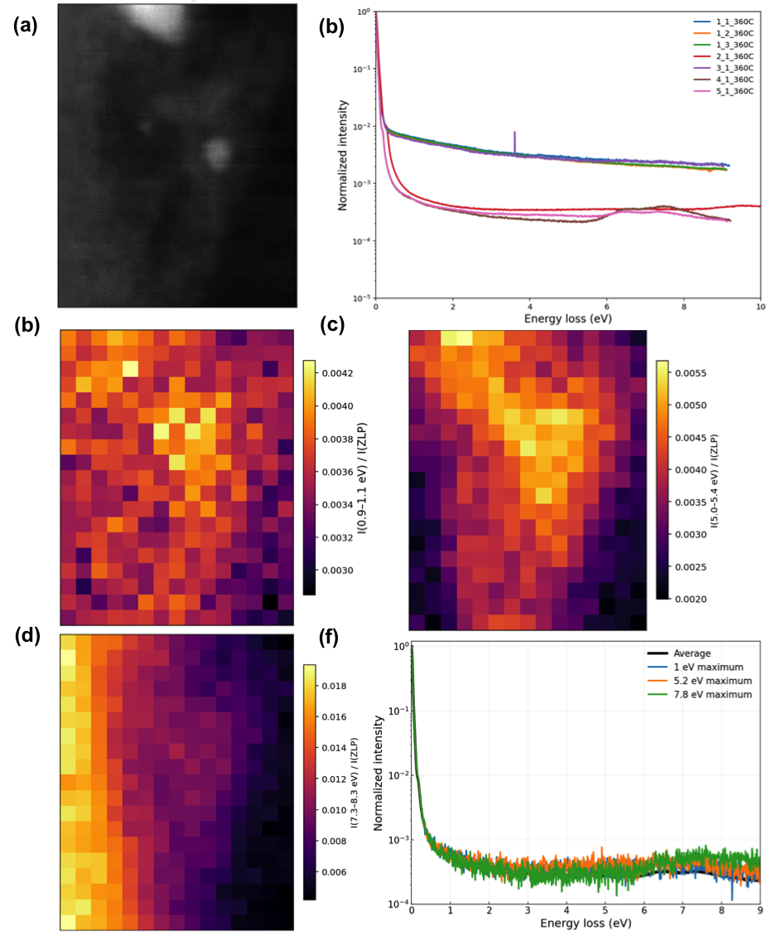
Figure S6: Correlative dark-field STEM imaging and low-loss EELS analysis of an individual carbon matrix. (a) Dark-field STEM image of a representative carbon matrix supported on few-layer hexagonal boron nitride (FLBN). (b) Normalized low-loss EELS spectra acquired from several regions of the carbon matrix, showing good spectral reproducibility. (c–e) Spatial maps of the integrated EELS intensity corresponding to the 7.3–8.3 eV, 5.0–5.4 eV, and 0.9–1.1 eV energy-loss windows, respectively, illustrating the distribution of the principal low-loss electronic excitations across the carbon matrix. The intensity maps were generated by integrating the EELS signal over the indicated energy ranges and normalizing to the integrated zero-loss peak (IZLP). (f) Representative normalized low-loss EELS spectra extracted from regions exhibiting the strongest electronic excitations near 1.0 eV, 5.2 eV, and 7.8 eV, together with the average spectrum for comparison. The low-loss EELS maps were obtained after background subtraction and identical processing parameters were applied to all datasets.
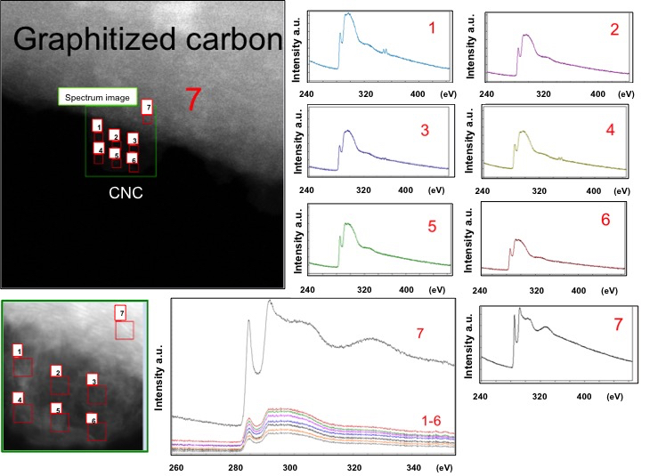
Figure S7: High-loss and low-loss EELS spectra acquired from carbon matrices grown on carbon nanofibres (CNF@CNC). Spectra 1–6 were collected from individual carbon matrices, showing the reproducibility of the weak nitrogen-related feature across independent matrices, whereas Spectrum 7 was acquired from the supporting carbon nanofibre (CNF, graphitized carbon containing residual nitrogen).
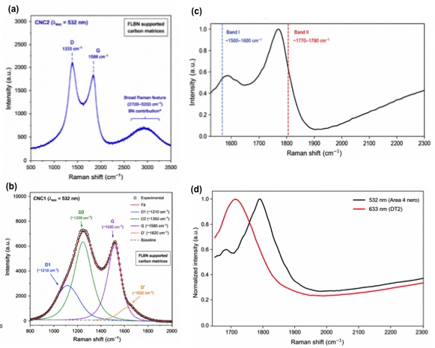
Figure S8: Raman characterisation of the hybrid carbon allotrope (FLBN@CNC1 and FLBN@CNC2). (c) Representative normalized Raman spectrum acquired from the carbon matrices on FLBN substrate (FLBN@CNC1). The spectrum exhibits two broad vibrational features centered in the ~1500–1600 cm⁻¹ (Band I) and ~ 1770–1780 cm⁻¹ (Band II) regions, highlighted by the dashed guidelines. (d) Comparison of normalized Raman spectra acquired using 532 nm (black) and 633 nm (red) electronic excitation wavelengths, demonstrating the reproducibility of the characteristic spectral profile and the excitation-dependent relative intensity of the Raman bands (FLBN@CNC1).
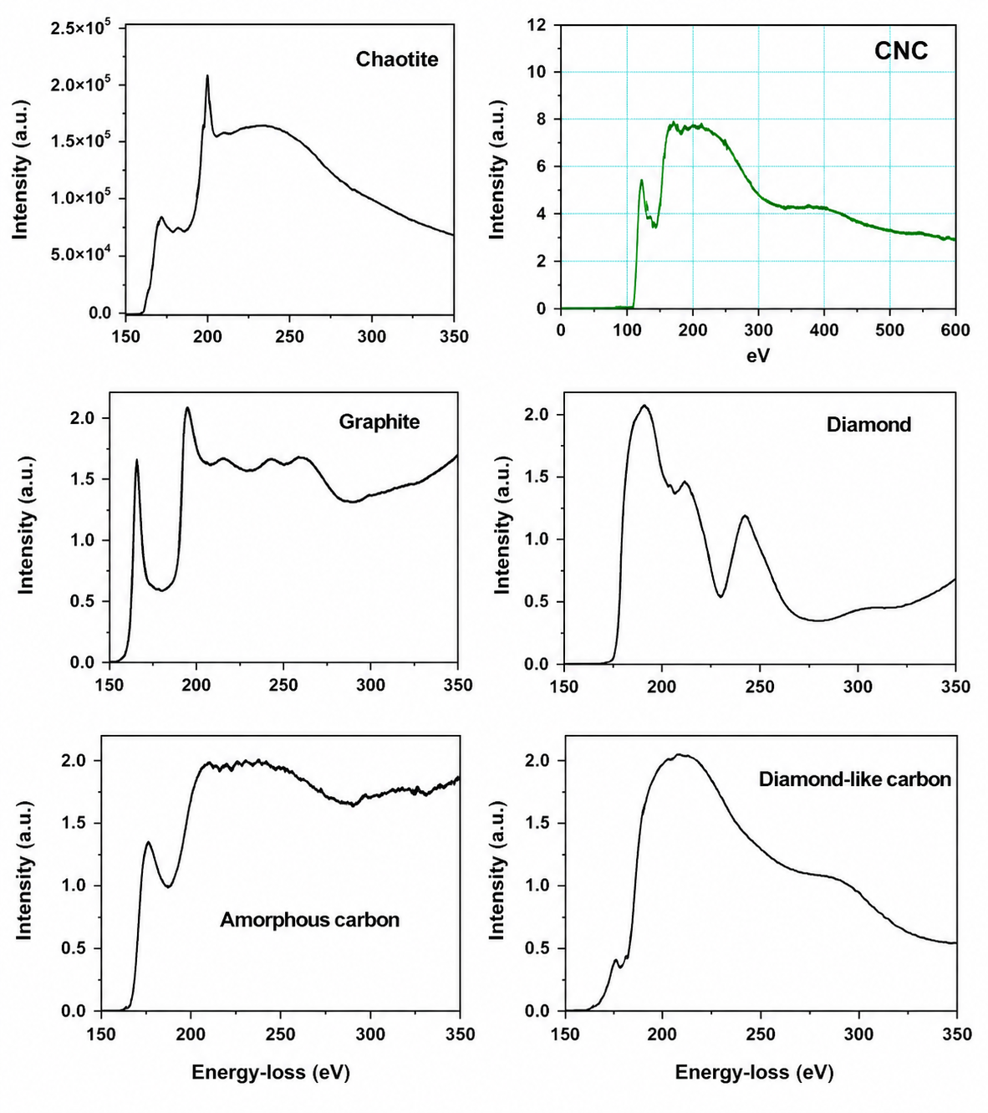
Figure S9: Comparison of the EELS spectra of the carbon matrices with those of well-established carbon allotropes. The reference EELS spectra of the carbon allotropes were reproduced from reference 15.

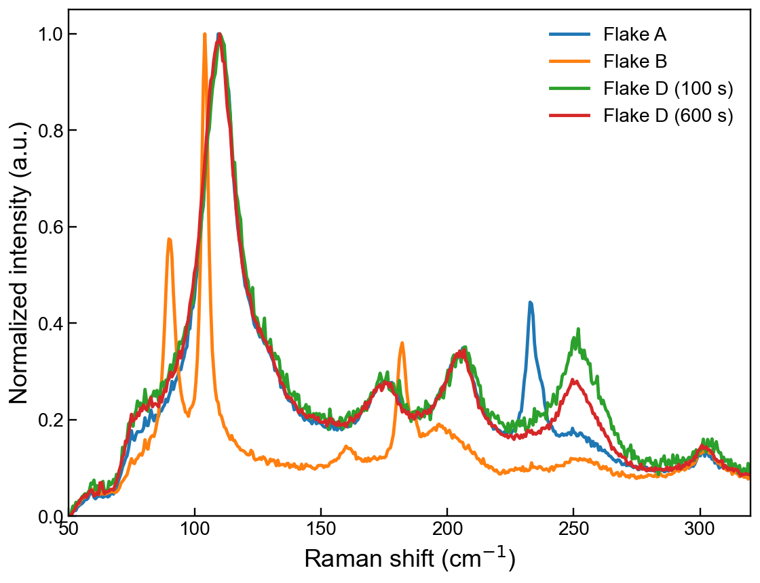Figure S10: Normalized low-frequency Raman spectra acquired from different carbon matrices using a 633 nm excitation laser. All measurements were performed using the same excitation wavelength, allowing a direct comparison of the low-frequency vibrational response between different flakes. The spectra reveal reproducible broad vibrational features in the 50–320 cm⁻¹ spectral region, while the relative intensities vary between measurement locations.

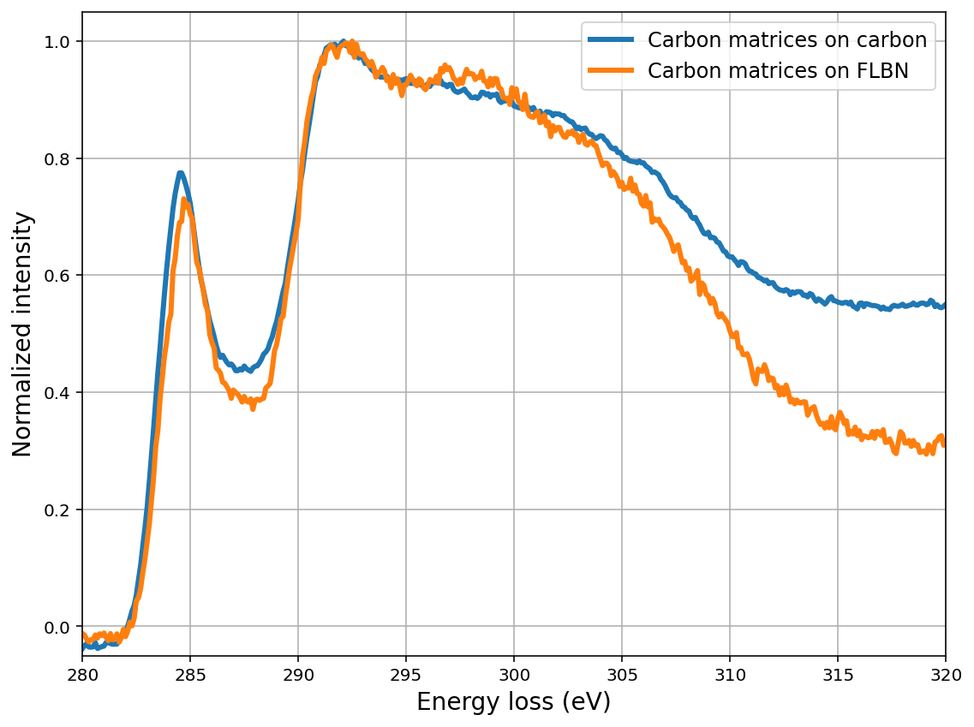

Figure S11: Comparison of the normalized carbon K-edge EELS spectra acquired from carbon matrices synthesised on carbon and few-layer hexagonal boron nitride (FLBN) substrates. The spectra were normalized to the intensity of the π* peak to facilitate comparison of the fine structure. Both samples exhibit the characteristic carbon K-edge features, including the π* transition at approximately 285 eV and the broad σ* band centered at higher energy losses. While the overall spectral profiles are similar, noticeable differences are observed in the extended σ* region above approximately 305 eV, where the carbon matrices grown on FLBN display a more rapid decrease in intensity than those synthesised on the carbon substrate. These variations indicate differences in the local electronic structure and bonding environment associated with the supporting substrate. The spectra were background-subtracted, deconvolved, and normalized to the π peak intensity prior to comparison.
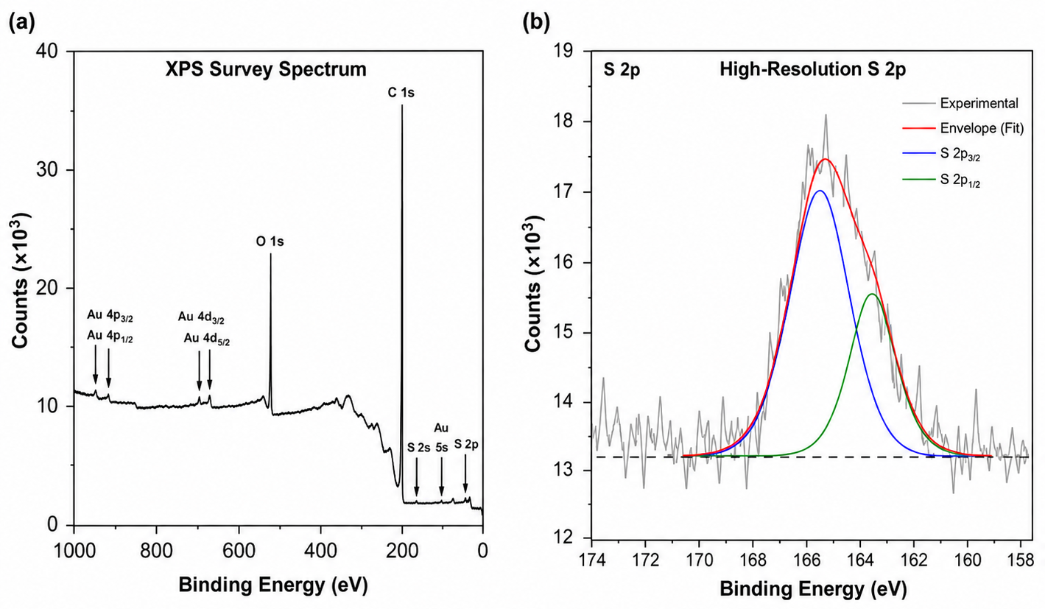
Figure S12: (a) X-ray photoemission spectroscopy (XPS) survey spectrum of the carbon matrices on gold grid sample after the heating experiment. The main photoemission lines of C 1s and O 1s are observed. Sulfur is detected as a weak S 2p (and S 2s) signal, indicating a low sulfur content after thermal treatment. The low-binding-energy peaks arise from the gold TEM support grid (Au 4p, Au 4d and Au 5 s core levels) (b) High-resolution S 2p XPS spectrum. The experimental data (grey) are fitted with two spin-orbit components corresponding to S 2p_{3/2} (blue) and S 2p_{1/2} (green). The fitted envelope (red) confirms the presence of only a small amount of sulfur in the sample. The oxygen signal observed by XPS is attributed to the supporting grid, as neither EELS nor EDX detected oxygen in the carbon matrices.

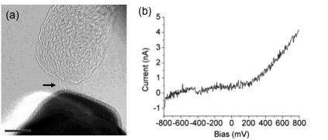
Figure S13: Electrical characterisation of an individual carbon chain. (a) TEM image of an individual carbon chain unravelled using a gold electrode. The upper electrode consists of carbon, whereas the lower electrode is gold. (b) Current–voltage (I–V) characteristic measured for the individual carbon chain, showing asymmetric electrical behaviour. The scale bar is 5 nm.

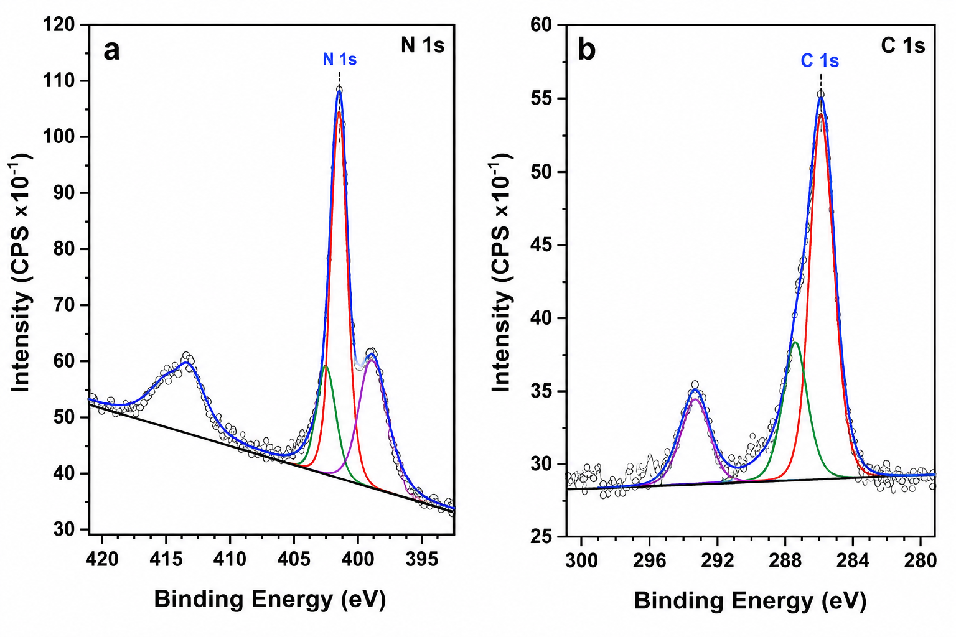
Figure S14: X-ray photoemission spectroscopy (XPS) of carbon matrices grown on few layers boron nitride (FLBN). (a) High-resolution C 1s spectrum showing carbon atoms in different chemical environments. (b) High-resolution N 1s spectrum showing a nitrogen chemical environment consistent with C-N bonding.
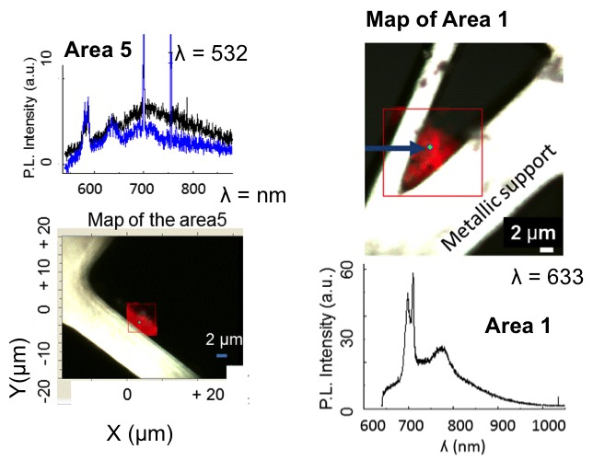
Figure S15: Photoluminescence characterisation of the FLBN@CNC1 carbon matrix. The PL spectrum acquired from Area 1 using 633 nm excitation exhibits a broad emission band centred at approximately 774 nm. The corresponding spatial map identifies the analysed region within the FLBN-supported carbon matrix.

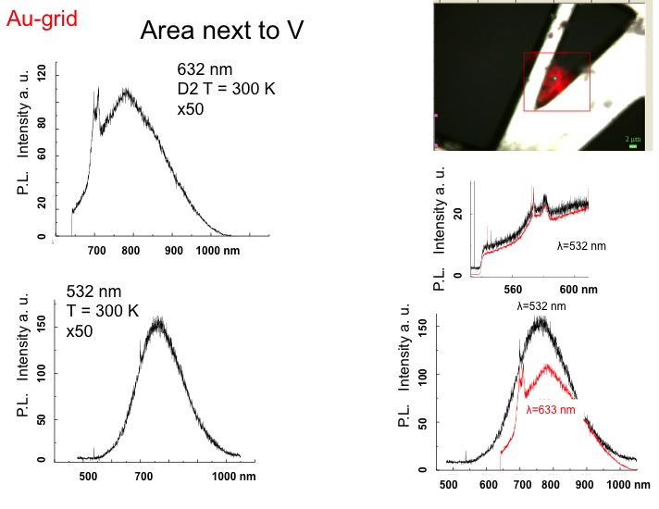
Figure S16: Photoluminescence (PL) spectra acquired from the FLBN@CNC1 carbon matrix at the same selected position using different excitation wavelengths, showing the persistence of the emission response under different excitation conditions.
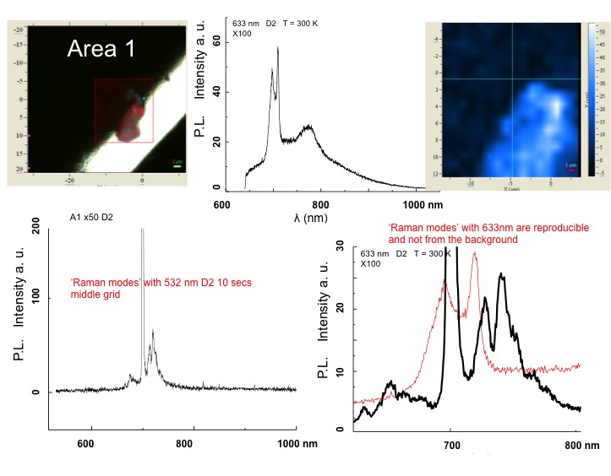
Figure S17: Photoluminescence (PL) and Raman characterisation of the FLBN@CNC1 carbon matrix. Optical micrograph identifying the analysed carbon matrix region (Area 1). PL spectrum acquired from the selected region, showing the characteristic broad emission response. PL intensity map of the analysed region, showing the spatial distribution of the emission. Raman spectrum acquired from the carbon matrix, showing the characteristic Raman features. Raman spectrum acquired from the same region under the corresponding excitation conditions, highlighting the reproducible vibrational response of the carbon matrix.

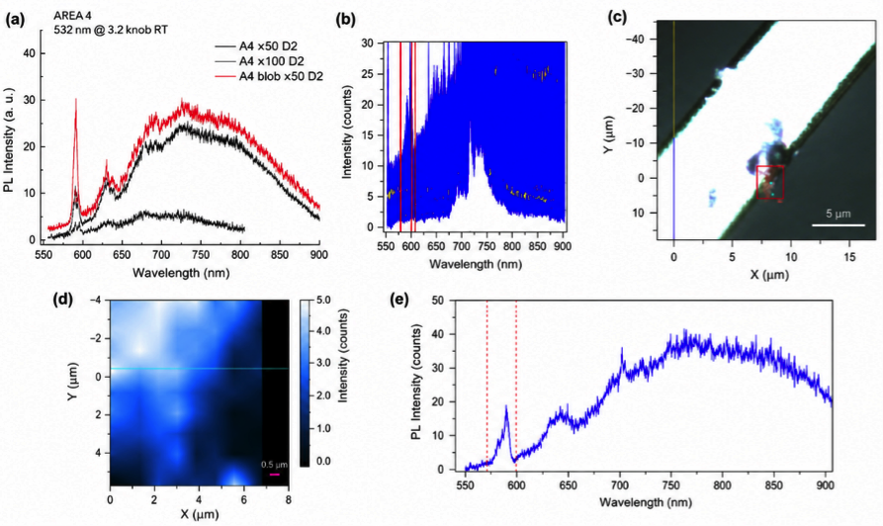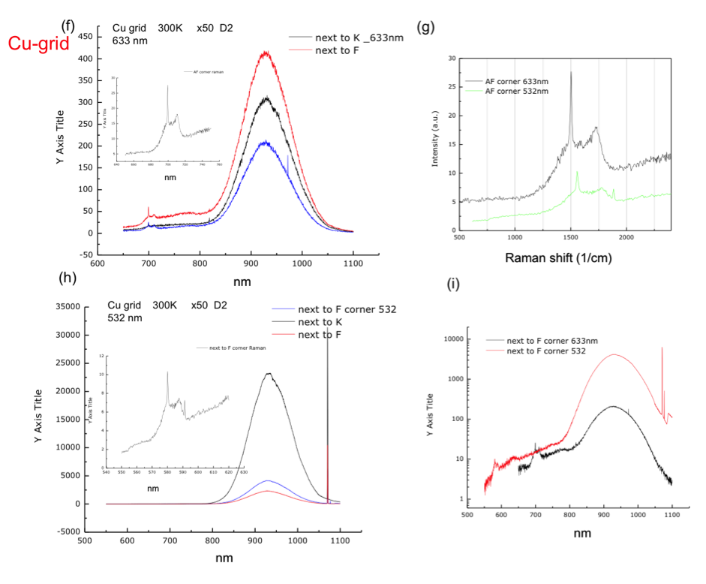
Figure S18: Photoluminescence (PL) and Raman characterisation of the FLBN@CNC1 and FLBN@CNC2 carbon matrices. (a) PL spectra acquired from different positions of the carbon matrix under 532 nm excitation at room temperature, showing the reproducibility of the broad emission band. (b) Spectral window selected for PL intensity mapping. (c) Optical micrograph of the analysed region; the red square indicates the mapped area and the cyan marker indicates the position from which the representative spectrum in (e) was extracted. (d) Integrated PL intensity map obtained over the spectral window selected in (b). (e) PL spectrum extracted from the selected emitting region, showing the broad visible emission together with additional spectral features. (f) PL spectra acquired from different positions of the FLBN@CNC2 carbon matrix under 633 nm excitation, demonstrating the reproducibility of the emission response. (g) Raman spectra extracted from the same positions analysed in (f), converted to Raman shift (cm⁻¹). (h) PL spectra acquired from the FLBN@CNC2 carbon matrix at the same positions under 532 nm excitation, confirming the persistence of the emission under different excitation wavelengths. (i) Comparison of PL spectra obtained from equivalent regions of the CNC2 sample under 532 and 633 nm excitation, highlighting the excitation-dependent spectral response.

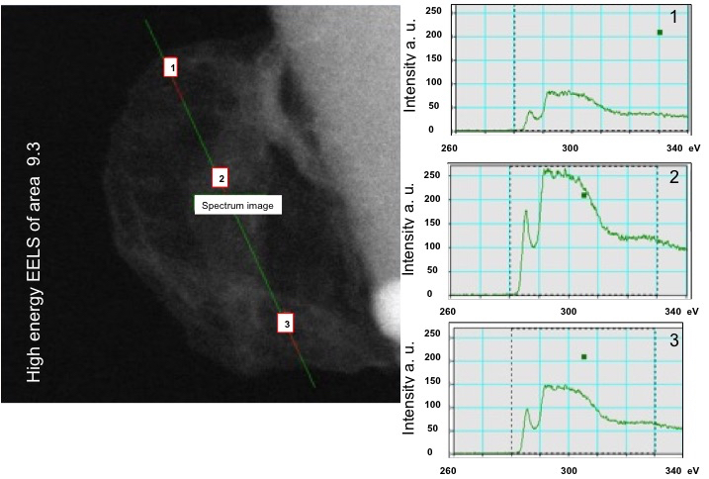
Figure S19: Representative high-energy EELS spectrum acquired from Area 9.3.
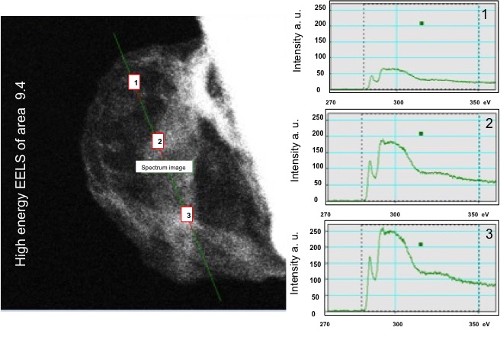
Figure S20: Representative high-energy EELS spectrum acquired from Area 9.4.
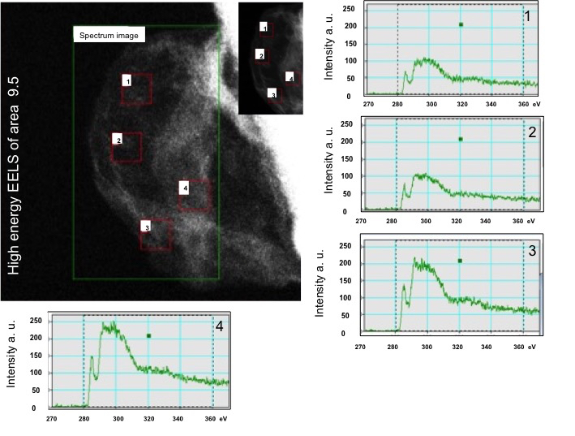
Figure S21: Representative high-energy EELS spectrum acquired from Area 9.5.
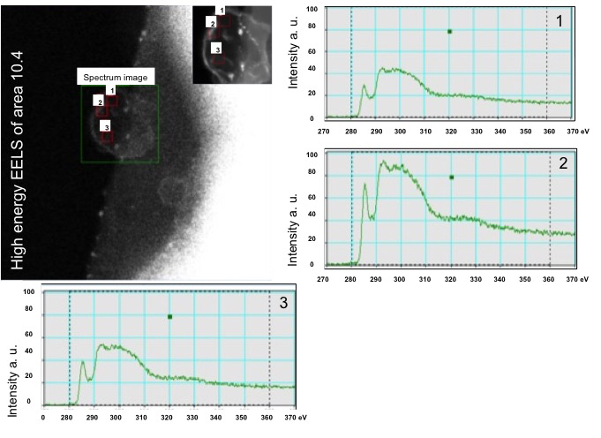
Figure S22: Representative high-energy EELS spectrum acquired from Area 10.4.
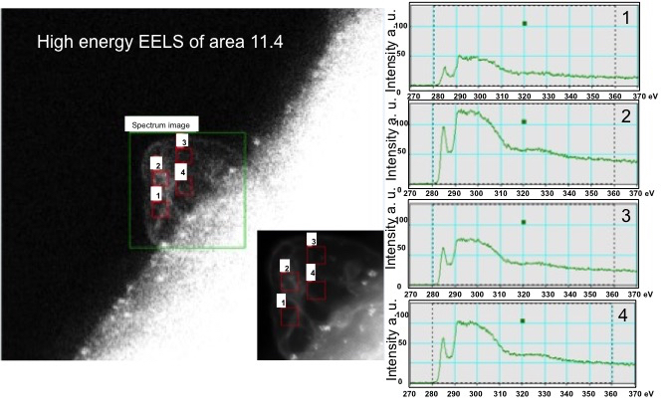
Figure S23: Representative high-energy EELS spectrum acquired from Area 11.4.
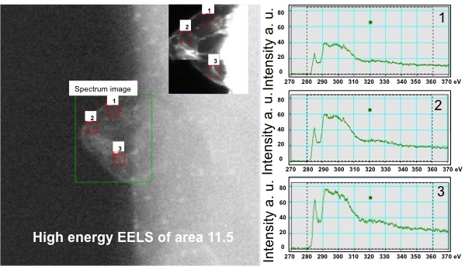
Figure S24: Representative high-energy EELS spectrum acquired from Area 11.5.

Figure S25: Representative low-loss EELS analysis acquired from the carbon matrices. The upper panels show the survey image indicating the analysed region, the corresponding EELS spectrum image, and the dark-field image used to identify the selected sampling positions. The lower panels present the low-loss EELS spectra extracted from the individual regions of interest. All spectra were energy calibrated with respect to the zero-loss peak (ZLP) and normalised using the integrated zero-loss peak (iZLP) intensity. The spectra reveal reproducible low-energy electronic excitations at approximately 0.9-1.1 eV, demonstrating the spatial consistency of the electronic structure across different sampling positions. Measurements were performed at room temperature (RT).

Figure S26: Representative low-loss EELS analysis acquired from the carbon matrices. The upper panels show the survey image indicating the analysed region, the corresponding EELS spectrum image, and the dark-field image used to identify the selected sampling positions. The lower panels present the low-loss EELS spectra extracted from the individual regions of interest. All spectra were energy calibrated with respect to the zero-loss peak (ZLP) and normalised using the integrated zero-loss peak (iZLP) intensity. One sampling position exhibits a pronounced low-energy electronic excitation centred at approximately 1 eV, whereas the second spectrum is largely featureless within the same energy range, highlighting the local variation in the intensity of the low-energy excitation while remaining consistent with the overall electronic structure of the carbon matrices. Measurements were performed at room temperature (RT).

Figure S27: Representative low-loss EELS analysis acquired from the carbon matrices. The upper panels show the survey image indicating the analysed region, the corresponding EELS spectrum image, and the dark-field image used to identify the selected sampling positions. The lower panels present the low-loss EELS spectra extracted from the individual regions of interest. All spectra were energy calibrated with respect to the zero-loss peak (ZLP) and normalised using the integrated zero-loss peak (iZLP) intensity. The extracted spectra exhibit reproducible low-energy electronic excitations in the ~0.9–1.1 eV energy range, although the intensity varies between different sampling positions. These observations demonstrate the spatial reproducibility of the low-energy electronic response within the carbon matrices. Measurements were performed at room temperature (RT).

Figure S28: Representative low-loss EELS analysis acquired from the carbon matrices. The upper panels show the survey image indicating the analysed region, the corresponding EELS spectrum image, and the dark-field image used to identify the selected sampling positions. The lower panels present the low-loss EELS spectra extracted from the individual regions of interest. All spectra were energy calibrated with respect to the zero-loss peak (ZLP) and normalised using the integrated zero-loss peak (iZLP) intensity. The extracted spectra exhibit reproducible low-energy electronic excitations centred at approximately 0.9–1.1 eV, with moderate variations in intensity between the selected sampling positions. The consistency of the spectral features confirms the reproducibility of the low-energy electronic response across different regions of the carbon matrices. Measurements were performed at room temperature (RT).

Figure S29: Representative low-loss EELS analysis acquired from the carbon matrices after heating to 360 °C. The upper panels show the survey image indicating the analysed region, the corresponding EELS spectrum image, and the dark-field image used to identify the selected sampling positions. The lower panels present the low-loss EELS spectra extracted from the individual regions of interest. All spectra were energy calibrated with respect to the zero-loss peak (ZLP) and normalised using the integrated zero-loss peak (iZLP) intensity. The spectra exhibit reproducible low-energy electronic excitations at multiple independent locations, confirming the spatial uniformity of the electronic response after thermal treatment.

Figure S30: Representative low-loss EELS analysis acquired from the carbon matrices after heating to 360 °C. The upper panels show the survey image indicating the analysed region, the corresponding EELS spectrum image, and the dark-field image used to identify the selected sampling positions. The lower panels present the low-loss EELS spectra extracted from the individual regions of interest. All spectra were energy calibrated with respect to the zero-loss peak (ZLP) and normalised using the integrated zero-loss peak (iZLP) intensity. The extracted spectra exhibit a broad low-loss feature centred at approximately 5–7 eV, which is consistently observed at multiple independent sampling positions following thermal treatment. The reproducibility of this feature demonstrates the spatial consistency of the low-energy electronic response within the carbon matrices after heating.
Figure S31: Representative low-loss EELS analysis acquired from the carbon matrices after heating to 360 °C. The upper panels show the survey image indicating the analysed region, the corresponding EELS spectrum image, and the dark-field image used to identify the selected sampling positions. The lower panels present the low-loss EELS spectra extracted from the individual regions of interest. All spectra were energy calibrated with respect to the zero-loss peak (ZLP) and normalised using the integrated zero-loss peak (iZLP) intensity. The extracted spectra exhibit a broad low-loss electronic excitation extending over approximately 5–10 eV, with the intensity and position of the maximum varying moderately between different sampling positions. The reproducibility of this feature across multiple independent regions demonstrates the spatial consistency of the low-energy electronic response following thermal treatment.

Figure S32: Representative low-loss EELS analysis acquired from the carbon matrices after heating to 360 °C. The upper panels show the survey image indicating the analysed region, the corresponding EELS spectrum image, and the dark-field image used to identify the selected sampling positions. The lower panels present the low-loss EELS spectra extracted from the individual regions of interest. All spectra were energy calibrated with respect to the zero-loss peak (ZLP) and normalised using the integrated zero-loss peak (iZLP) intensity. The spectra exhibit reproducible low-energy electronic excitations at multiple independent locations, confirming the spatial uniformity of the electronic response after thermal treatment.
Figure S33: Representative low-loss EELS analysis acquired from the carbon matrices after heating to 360 °C. The upper panels show the survey image indicating the analysed region, the corresponding EELS spectrum image, and the dark-field image used to identify the selected sampling positions. The lower panels present the low-loss EELS spectra extracted from the individual regions of interest. All spectra were energy calibrated with respect to the zero-loss peak (ZLP) and normalised using the integrated zero-loss peak (iZLP) intensity. The extracted spectra exhibit a broad low-loss electronic excitation extending over approximately 5–10 eV, with moderate variations in intensity between different sampling positions. The reproducibility of this feature across multiple independent regions demonstrates the spatial consistency of the electronic response of the carbon matrices following thermal treatment at 360 °C.

