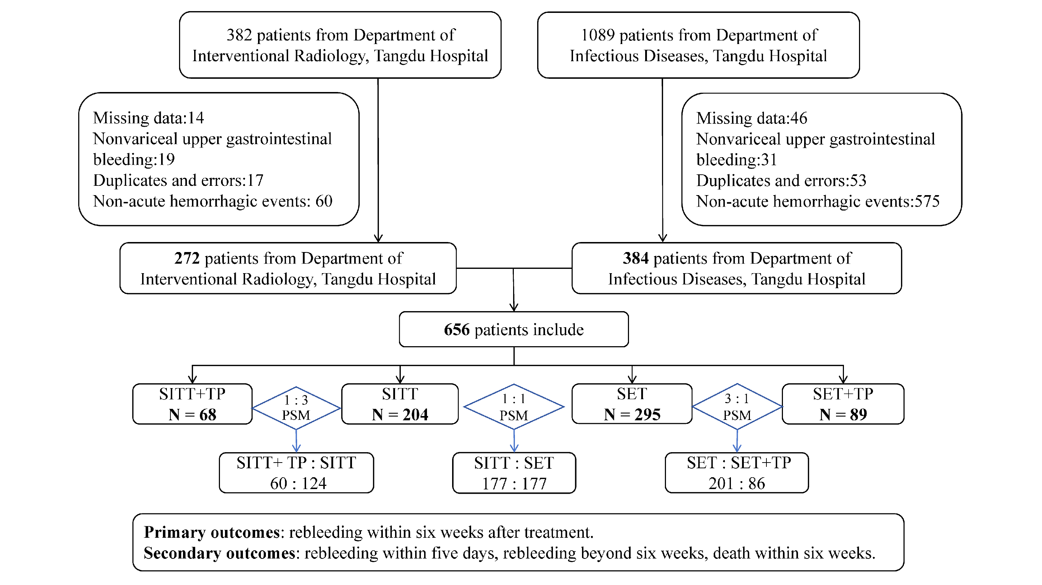
Figure S1 Patient flow diagram. SET, standard endoscopic therapy (octreotide-assisted endoscopic sclerotherapy/tissue adhesive injection); SITT, standard interventional therapy (octreotide combined with TIPS and gastric coronary vein embolization); SET+TP, SET plus terlipressin; SITT+TP, SITT plus terlipressin; PSM, propensity score matching.

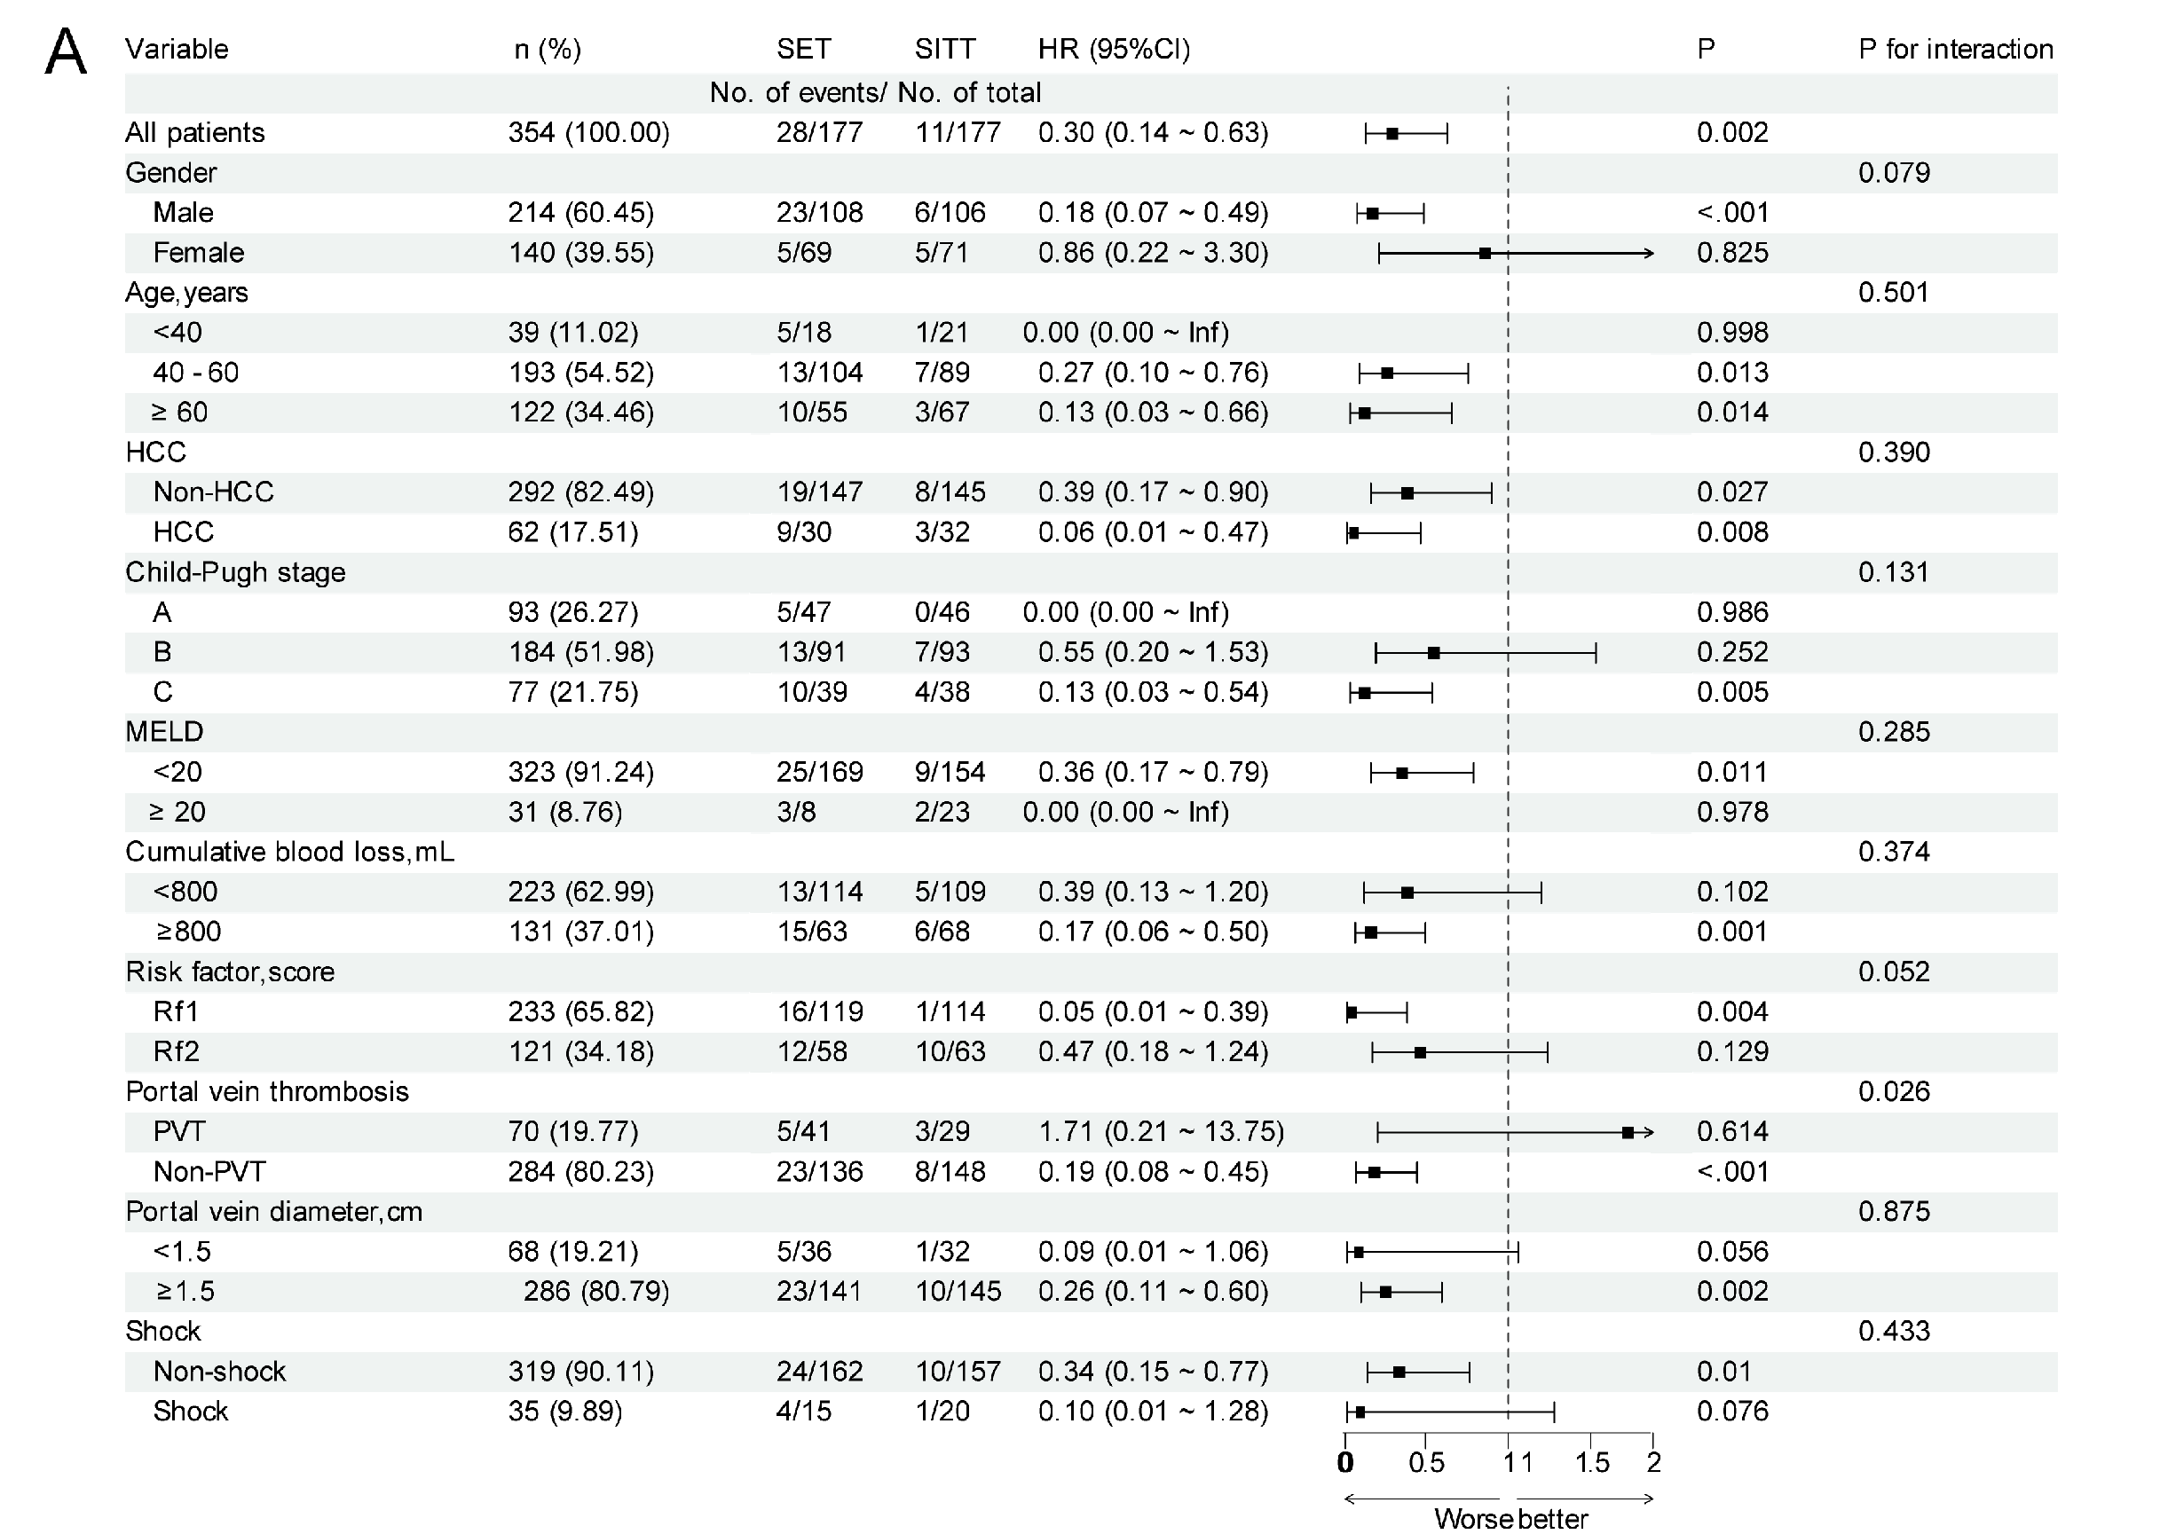
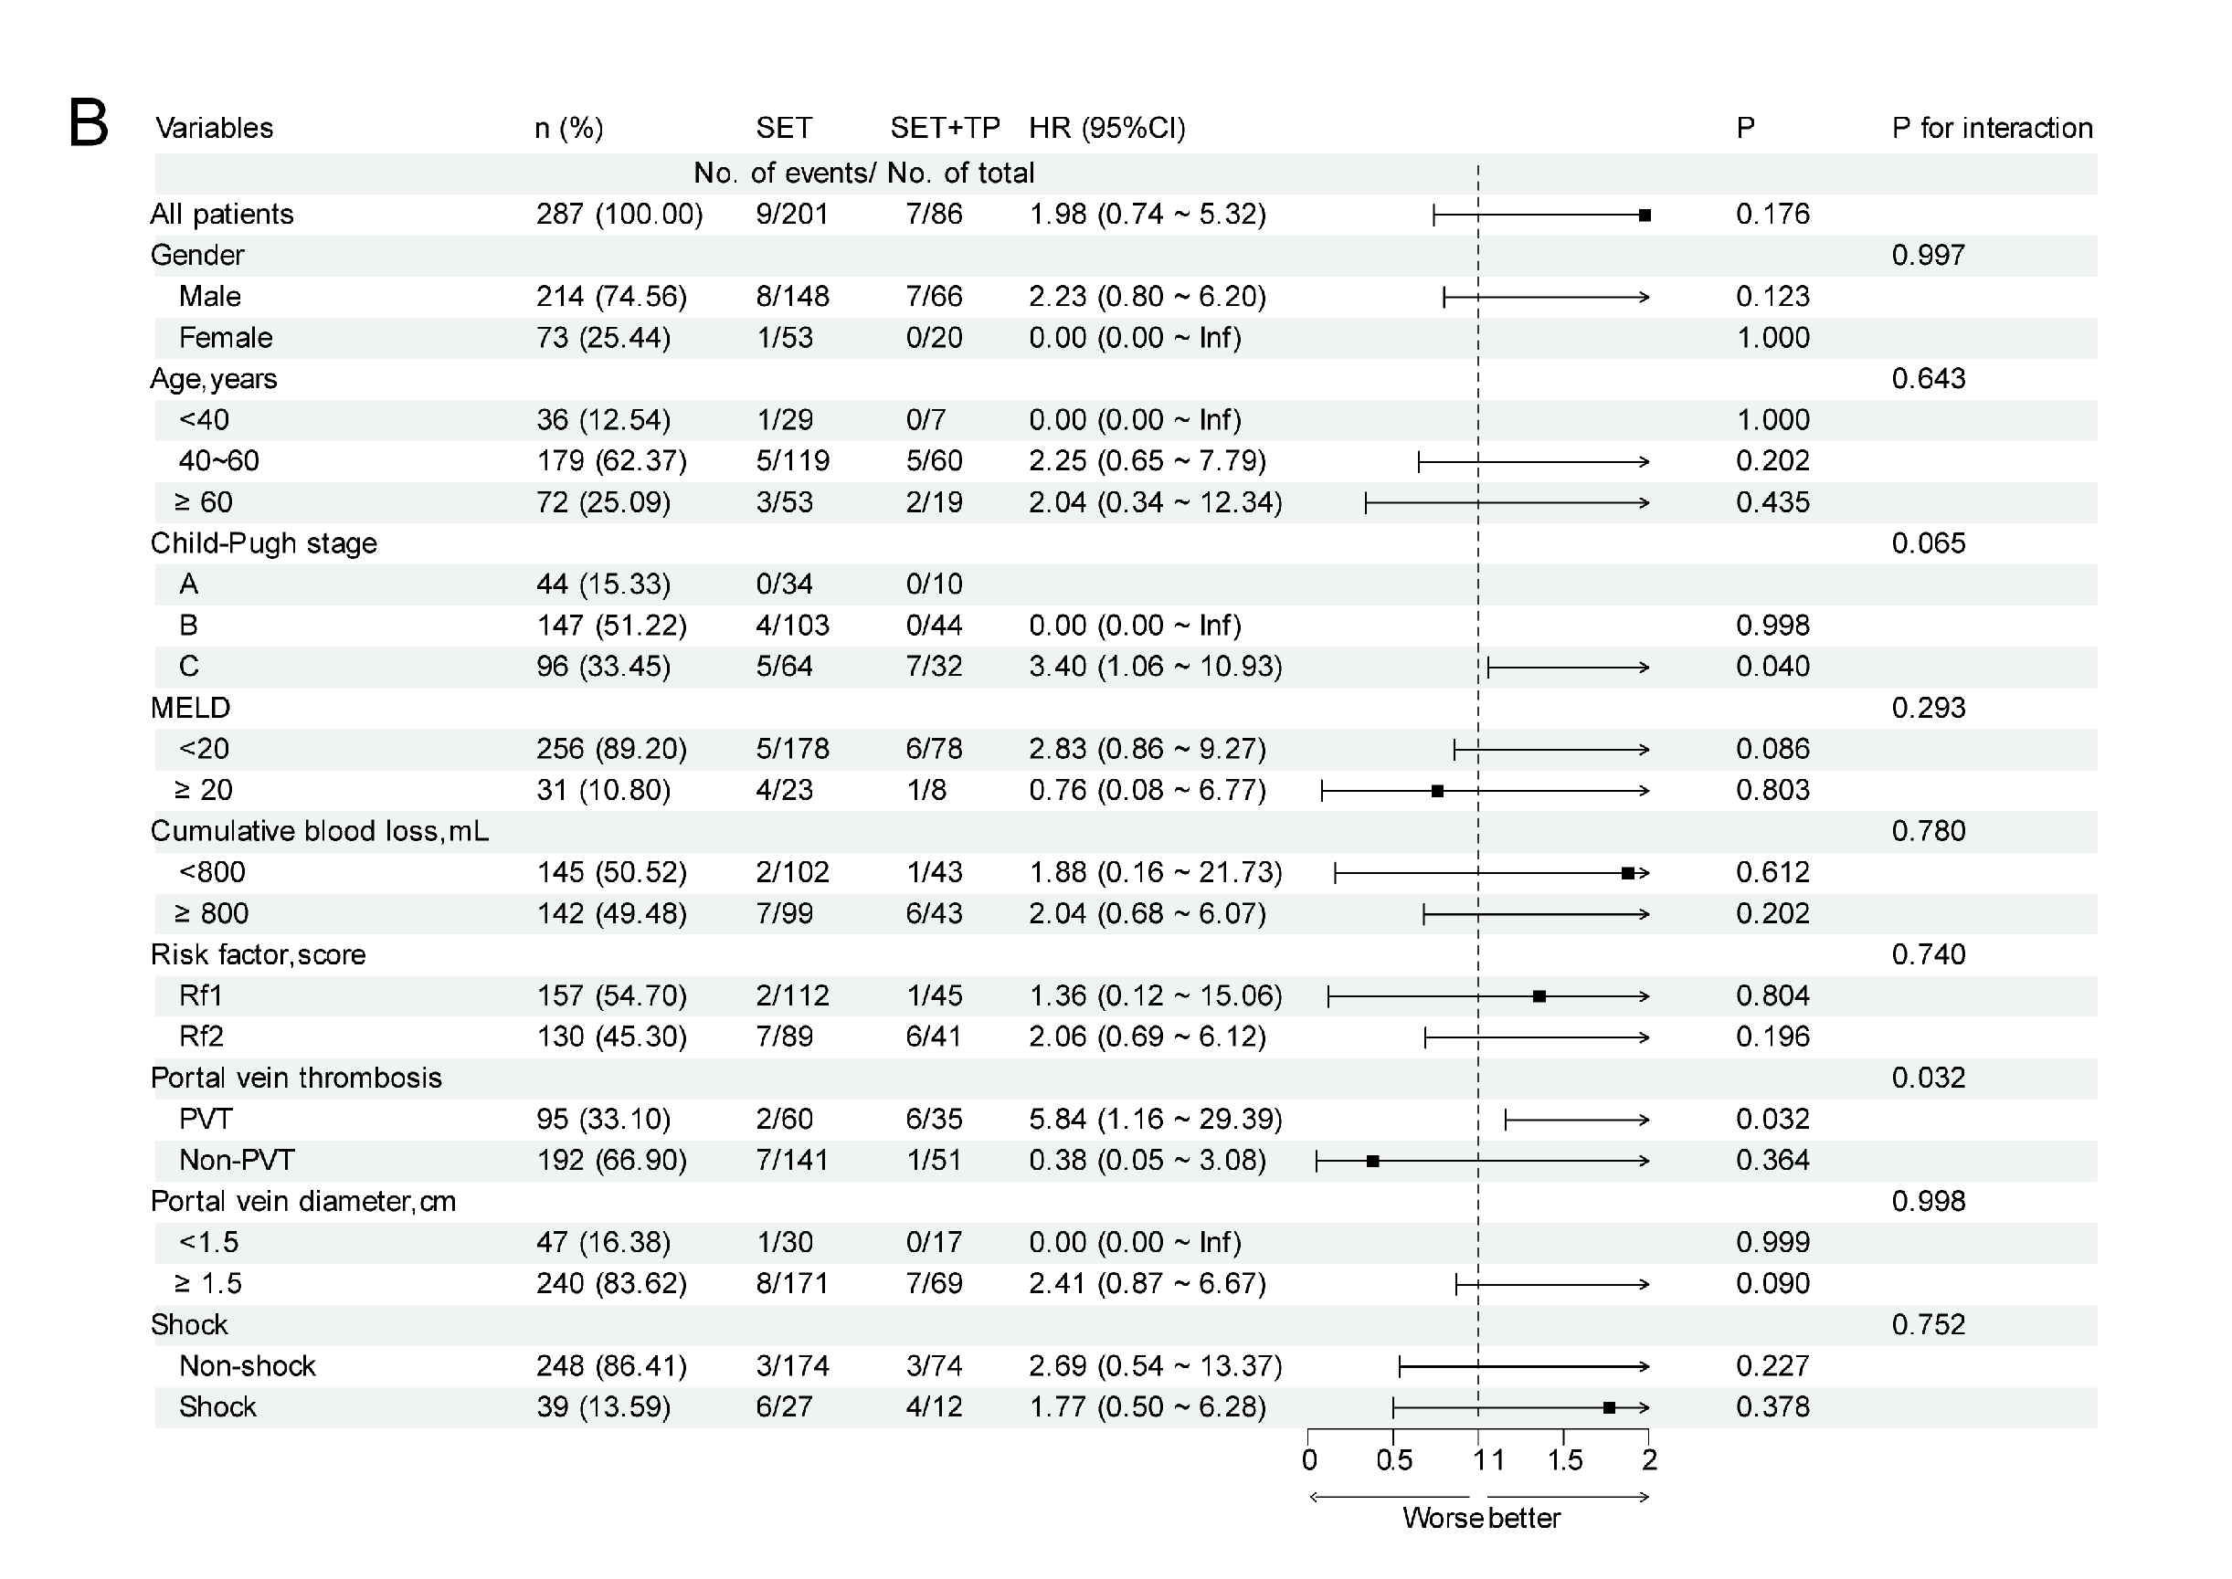
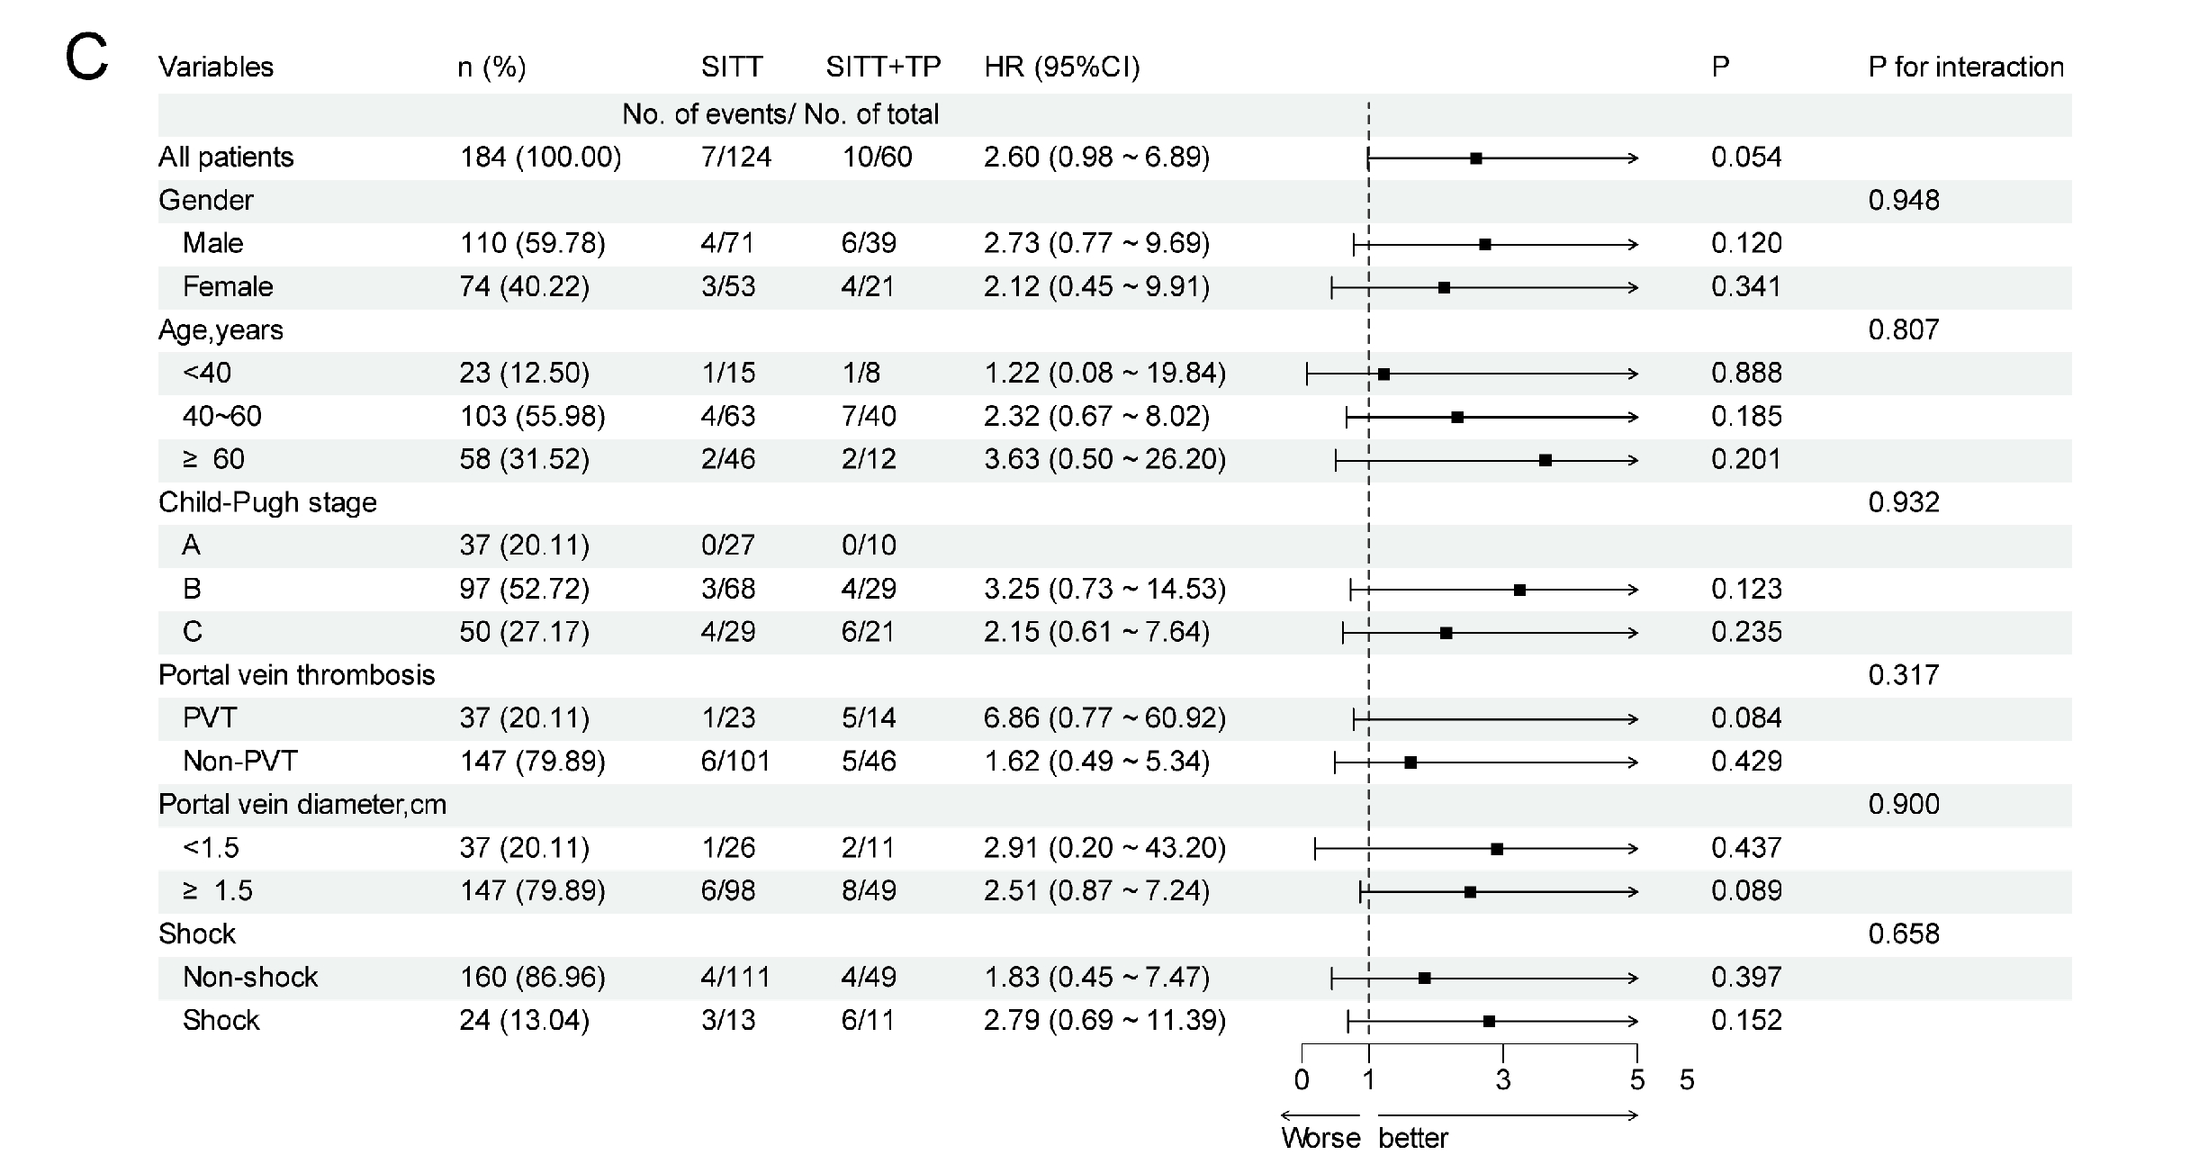
Figure S2 Forest plots of subgroup analyses. A: subgroup analysis comparing the risk of rebleeding within six weeks between SITT and SET; B: subgroup analysis comparing the risk of death within six weeks between SET+TP and SET; C: subgroup analysis comparing the risk of adverse events (rebleeding or death) within six weeks between SITT+TP and SITT; Abbreviations: SET, standard endoscopic therapy (octreotide-assisted endoscopic sclerotherapy/tissue adhesive injection); SITT, standard interventional therapy (octreotide combined with TIPS and gastric coronary vein embolization); SET+TP, SET plus terlipressin; SITT+TP, SITT plus terlipressin; Rf1: presence of red wale marks on varices under endoscopy; Rf2: presence of erosion, thrombotic head, or active bleeding under endoscopy.
Figure S3 The kernel density plots of the propensity scores before and after matching.

Table S1 Clinical characteristics of the patients on admission
Variable | Total  (n = 656) | EIS Total  (n = 384) | TIPS Total  (n = 272) | Statistic | P
Age (years) | 53.27 ± 11.42 | 52.39 ± 11.30 | 54.52 ± 11.50 | t=-2.36 | 0.019
Sex, n (%) |  |  |  | χ²=11.88 | <0.001
Male | 440 (67.07) | 278 (72.40) | 162 (59.56)
Female | 216 (32.93) | 106 (27.60) | 110 (40.44)
Etiology of cirrhosis, n (%) |  |  |  | χ²=15.82 | 0.007
Hepatitis B | 455 (69.36) | 284 (73.96) | 171(62.86)
Hepatitis C | 78 (11.89) | 42 (10.94) | 36 (13.24)
Alcoholic | 14 (2.13) | 5 (1.30) | 9 (3.31)
Autoimmune | 42 (6.40) | 20 (5.21) | 22 (8.09)
Other | 67 (10.21) | 33 (8.59) | 34 (12.50)
Residential area, n (%) |  |  |  | χ²=10.34 | 0.001
Rural | 480 (73.17) | 263 (68.49) | 217 (79.78)
Urban | 176 (26.83) | 121 (31.51) | 55 (20.22)
Precipitating factor (hard food), n (%) |  |  |  | χ²=3.15 | 0.076
Yes | 148 (22.56) | 96 (25.00) | 52 (19.12)
No | 508 (77.44) | 288 (75.00) | 220 (80.88)
Total blood loss (mL) | 790.70 ± 360.30 | 822.14 ± 389.30 | 746.32 ± 310.14 | t=2.77 | 0.006
MELD-Na score | 14.01 ± 4.51 | 13.70 ± 4.43 | 14.46 ± 4.60 | t=-2.14 | 0.033
Child‒Pugh class, n (%) |  |  |  | χ²=3.91 | 0.142
A | 138 (21.04) | 72 (18.75) | 66 (24.26)
B | 331 (50.46) | 194 (50.52) | 137 (50.37)
C | 187 (28.51) | 118 (30.73) | 69 (25.37)
Risk factor, n (%) |  |  |  | χ²=5.10 | 0.024
Rf1 | 413 (62.96) | 228 (59.38) | 185 (68.01)
Rf2 | 243 (37.04) | 156 (40.62) | 87 (31.99)
GOV classification, n (%) |  |  |  | χ²=23.05 | <0.001
GOV1 | 517 (78.81) | 285 (74.22) | 232 (85.29)
GOV2 | 84 (12.80) | 69 (17.97) | 15 (5.51)
EV | 43 (6.55) | 22 (5.73) | 21 (7.72)
IGV | 12 (1.83) | 8 (2.08) | 4 (1.47)
Variceal diameter (cm) | 1.05 ± 0.41 | 1.03 ± 0.45 | 1.09 ± 0.34 | t=-1.99 | 0.047
Main portal vein diameter (cm) | 1.65 ± 0.68 | 1.65 ± 0.86 | 1.64 ± 0.26 | t=0.26 | 0.792
Spleen thickness (cm) | 5.51 ± 0.81 | 5.58 ± 0.84 | 5.42 ± 0.75 | t=2.58 | 0.010
Albumin (g/dL) | 31.23 ± 4.56 | 30.88 ± 4.42 | 31.72 ± 4.72 | t=-2.31 | 0.021
INR | 1.43 ± 0.33 | 1.37 ± 0.25 | 1.51 ± 0.40 | t=-4.80 | <0.001
Creatinine (mg/dL) | 60.89 ± 22.92 | 61.29 ± 20.85 | 60.34 ± 25.59 | t=0.50 | 0.616
Hb (g/dL) | 87.52 ± 22.09 | 85.23 ± 21.48 | 90.76 ± 22.56 | t=-3.18 | 0.002
PLT (×10⁹/L) | 78.30 ± 53.19 | 74.97 ± 46.48 | 83.01 ± 61.22 | t=-1.91 | 0.056
TBil (mg/dL) | 51.79 ± 69.72 | 51.43 ± 71.75 | 52.30 ± 66.88 | t=-0.16 | 0.875
Na⁺ (mmol/L) | 139.13 ± 4.63 | 138.30 ± 4.34 | 140.31 ± 4.79 | t=-5.52 | <0.001
Adjunctive use of terlipressin, n (%) |  |  |  | χ²=0.29 | 0.590
Yes | 157 (23.93) | 89 (23.18) | 68 (25.00)
No | 499 (76.07) | 295 (76.82) | 204 (75.00)
Hepatocellular carcinoma, n (%) |  |  |  | χ²=5.43 | 0.020
Yes | 153 (23.32) | 102 (26.56) | 51 (18.75)
No | 503 (76.68) | 282 (73.44) | 221 (81.25)
Portal vein thrombosis, n (%) |  |  |  | χ²=4.38 | 0.036
Yes | 160 (24.39) | 105 (27.34) | 55 (20.22)
No | 496 (75.61) | 279 (72.66) | 217 (79.78)
Ascites, n (%) |  |  |  | χ²=30.15 | <0.001
None | 98 (14.94) | 56 (14.58) | 42 (15.44)
Mild | 379 (57.77) | 193 (50.26) | 186 (68.38)
Moderate to severe | 179 (27.29) | 135 (35.16) | 44 (16.18)
Pleural effusion, n (%) |  |  |  | χ²=4.08 | 0.043
Yes | 167 (25.50) | 109 (28.39) | 58 (21.40)
No | 488 (74.50) | 275 (71.61) | 213 (78.60)
Table S1 Clinical characteristics of the patients on admission. Abbreviations: EIS Total, all patients treated with endoscopic therapy (including those who received additional terlipressin); TIPS Total, all patients treated with TIPS (including those who received additional terlipressin); INR, international normalized ratio; Hb, hemoglobin; PLT, platelet count; TBil, total bilirubin; Rf1: presence of red wale marks on varices under endoscopy; Rf2: presence of erosion, thrombotic head, or active bleeding under endoscopy. GOV, gastroesophageal varices; EV, esophageal varices; IGV, isolated gastric varices.
Table S2 Baseline characteristics of patients before and after PSM
Variable | Before PSM |  |  |  | After PSM
Variable | SET (n = 295) | SITT (n = 204) | P | SMD |  | SET (n = 177) | SITT (n = 177) | P | SMD
Age(years) | 52.38 ± 11.53 | 55.13 ± 11.85 | 0.010 | 0.232 |  | 54.11 ± 11.29 | 54.93 ± 12.28 | 0.514 | 0.067
Na⁺ (mmol/L) | 138.33 ± 4.30 | 140.41 ± 4.66 | <.001 | 0.445 |  | 139.58 ± 3.68 | 139.72 ± 4.30 | 0.732 | 0.034
Hb (g/dL) | 86.41 ± 21.35 | 91.99 ± 22.75 | 0.005 | 0.245 |  | 88.84 ± 20.24 | 89.61 ± 20.89 | 0.724 | 0.037
PLT（×10⁹/L） | 73.91 ± 46.50 | 88.62 ± 67.25 | 0.004 | 0.219 |  | 81.08 ± 51.27 | 83.07 ± 63.15 | 0.746 | 0.031
Child-pugh score | 8.28 ± 2.11 | 7.98 ± 2.02 | 0.112 | -0.149 |  | 7.93 ± 2.09 | 7.99 ± 2.02 | 0.776 | 0.031
Total blood loss（mL） | 796.10 ± 378.79 | 713.48 ± 290.49 | 0.006 | -0.284 |  | 739.55 ± 338.01 | 731.36 ± 294.39 | 0.808 | -0.028
Variceal diameter(cm) | 1.03 ± 0.45 | 1.06 ± 0.33 | 0.371 | 0.094 |  | 1.07 ± 0.49 | 1.06 ± 0.34 | 0.832 | -0.028
Spleen thickness(cm) | 5.53 ± 0.90 | 5.37 ± 0.74 | 0.030 | -0.218 |  | 5.45 ± 0.92 | 5.40 ± 0.75 | 0.631 | -0.057
Gender, n (%) |  |  | 0.004 |  |  |  |  | 0.828
Male | 209 (70.85) | 119 (58.33) |  | -0.254 |  | 108 (61.02) | 106 (59.89) |  | -0.023
Female | 86 (29.15) | 85 (41.67) |  | 0.254 |  | 69 (38.98) | 71 (40.11) |  | 0.023
HCC, n (%) |  |  | 0.017 |  |  |  |  | 0.780
Non-HCC | 221 (74.92) | 171 (83.82) |  | 0.242 |  | 147 (83.05) | 145 (81.92) |  | -0.029
HCC | 74 (25.08) | 33 (16.18) |  | -0.242 |  | 30 (16.95) | 32 (18.08) |  | 0.029
Risk factor, n (%) |  |  | 0.471 |  |  |  |  | 0.575
Rf1 | 183 (62.03) | 133 (65.20) |  | 0.066 |  | 119 (67.23) | 114 (64.41) |  | -0.059
Rf2 | 112 (37.97) | 71 (34.80) |  | -0.066 |  | 58 (32.77) | 63 (35.59) |  | 0.059
Table S2 Baseline characteristics of patients before and after PSM. Abbreviations: SET, Standard Endoscopic Therapy; SITT, Standard Interventional Therapy.

Table S3 Baseline characteristics of patients before and after PSM
Variable | Before PSM |  |  |  |  | After PSM
Variable | SET (n = 295) | SET+TP (n = 89) | P | SMD |  | SET (n = 201) | SET+TP (n = 86) | P | SMD
Age(years) | 52.38 ± 11.53 | 52.43 ± 10.55 | 0.972 | 0.004 |  | 52.57 ± 11.73 | 52.71 ± 10.15 | 0.925 | 0.014
Hb(g/dL) | 86.41 ± 21.35 | 81.31 ± 21.59 | 0.050 | -0.236 |  | 84.15 ± 20.54 | 82.02 ± 21.56 | 0.428 | -0.099
PLT（×10⁹/L） | 73.91 ± 46.50 | 78.47 ± 46.53 | 0.418 | 0.098 |  | 73.15 ± 48.21 | 77.79 ± 47.01 | 0.453 | 0.099
Child-pugh score | 8.28 ± 2.11 | 8.79 ± 1.76 | 0.041 | 0.287 |  | 8.50 ± 2.08 | 8.73 ± 1.77 | 0.360 | 0.133
Total blood loss (mL) | 796.10 ± 378.79 | 908.43 ± 412.88 | 0.017 | 0.272 |  | 854.23 ± 402.02 | 884.88 ± 393.71 | 0.552 | 0.078
Variceal diameter(cm) | 1.03 ± 0.45 | 1.02 ± 0.44 | 0.828 | -0.027 |  | 1.00 ± 0.34 | 1.02 ± 0.45 | 0.744 | 0.035
Spleen thickness(cm) | 5.53 ± 0.90 | 5.73 ± 0.74 | 0.054 | 0.274 |  | 5.62 ± 0.85 | 5.74 ± 0.74 | 0.268 | 0.159
Risk factor, n (%) |  |  | 0.053 |  |  |  |  | 0.597
Rf1 | 183 (62.03) | 45 (50.56) |  | -0.229 |  | 112 (55.72) | 45 (52.33) |  | -0.068
Rf2 | 112 (37.97) | 44 (49.44) |  | 0.229 |  | 89 (44.28) | 41 (47.67) |  | 0.068
Portal vein thrombosis, n (%) |  |  | <.001 |  |  |  |  | 0.074
Yes | 67 (22.71) | 38 (42.70) |  | 0.404 |  | 60 (29.85) | 35 (40.70) |  | 0.221
No | 228 (77.29) | 51 (57.30) |  | -0.404 |  | 141 (70.15) | 51 (59.30) |  | -0.221
Table S3 Baseline characteristics of patients before and after PSM. Abbreviations: SET, Standard Endoscopic Therapy (octreotide-assisted endoscopic sclerotherapy/tissue adhesive injection); SET+TP, SET plus terlipressin.

Table S4 Baseline characteristics of patients before and after PSM
Variable | Before PSM |  |  |  |  | After PSM
Variable | SITT  (n = 204) | SITT+TP  (n = 68) | P | SMD |  | SITT  (n = 124) | SITT+TP  (n = 60) | P | SMD
PLT（×10⁹/L） | 88.62 ± 67.25 | 66.21 ± 32.71 | <.001 | -0.685 |  | 71.60 ± 45.48 | 66.83 ± 33.41 | 0.470 | -0.143
Child-pugh score | 7.98 ± 2.02 | 8.40 ± 2.10 | 0.146 | 0.199 |  | 8.23 ± 1.99 | 8.42 ± 2.17 | 0.554 | 0.088
Total blood loss (mL) | 713.48 ± 290.49 | 844.85 ± 346.75 | 0.002 | 0.379 |  | 742.74 ± 287.81 | 812.50 ± 332.25 | 0.145 | 0.210
Variceal diameter (cm) | 1.06 ± 0.33 | 1.18 ± 0.35 | 0.012 | 0.340 |  | 1.11 ± 0.38 | 1.17 ± 0.36 | 0.290 | 0.174
Risk factor, n (%) |  |  | 0.084 |  |  |  |  | 0.906
Rf1 | 133 (65.20) | 52 (76.47) |  | 0.266 |  | 92 (74.19) | 45 (75.00) |  | 0.019
Rf2 | 71 (34.80) | 16 (23.53) |  | -0.266 |  | 32 (25.81) | 15 (25.00) |  | -0.019
Portal vein thrombosis, n (%) |  |  | 0.029 |  |  |  |  | 0.448
Yes | 35 (17.16) | 20 (29.41) |  | 0.269 |  | 23 (18.55) | 14 (23.33) |  | 0.113
No | 169 (82.84) | 48 (70.59) |  | -0.269 |  | 101 (81.45) | 46 (76.67) |  | -0.113
Table S4 Baseline characteristics of patients before and after PSM. Abbreviations: SITT, Standard Interventional Therapy (octreotide combined with TIPS and gastric coronary vein embolization); SITT+TP, SITT plus terlipressin.

Table S5 Multivariate analysis: comparison of the risk of rebleeding within six weeks between the SITT group and the SET group
Variables | Univariate Logistic analysis |  | Multivariate Logistic analysis
Variables | P | HR (95%CI) |  | P | HR (95%CI)
Treatment
SET |  | 1.00 (Reference) |  |  | 1.00 (Reference)
SITT | 0.006 | 0.37 (0.19 ~ 0.75) |  | 0.002 | 0.31 (0.15 ~ 0.65)
Hepatocellular carcinoma (HCC)
Non-HCC |  | 1.00 (Reference) |  |  | 1.00 (Reference)
HCC | 0.021 | 2.23 (1.13 ~ 4.41) |  | 0.038 | 2.13 (1.04 ~ 4.34)
Risk factor
Rf1 |  | 1.00 (Reference) |  |  | 1.00 (Reference)
Rf2 | 0.002 | 2.69 (1.43 ~ 5.06) |  | 0.014 | 2.32 (1.19 ~ 4.54)
Portal vein thrombosis (PVT)
PVT |  | 1.00 (Reference)
Non-PVT | 0.905 | 0.95 (0.44 ~ 2.08)
Shock
No |  | 1.00 (Reference)
Yes | 0.526 | 1.35 (0.53 ~ 3.46)
Age | 0.541 | 0.99 (0.97 ~ 1.02)
PLT | 0.848 | 1.00 (1.00 ~ 1.01)
Child-pugh score | 0.018 | 1.18 (1.03 ~ 1.36) |  | 0.146 | 1.11 (0.96 ~ 1.28)
Variceal diameter | <.001 | 2.72 (1.70 ~ 4.37) |  | 0.001 | 2.38 (1.40 ~ 4.05)
Portal vein diameter | 0.013 | 3.78 (1.32 ~ 10.79) |  | 0.009 | 5.35 (1.53 ~ 18.75)
Table S5 Multivariate analysis: comparison of the risk of rebleeding within six weeks between the SITT group and the SET group. Abbreviations: SET, Standard Endoscopic Therapy; SITT, Standard Interventional Therapy.

Table S6 Multivariate analysis: comparison of the risk of rebleeding or death within six weeks between the SITT group and the SET group
Variables | Univariate Logistic analysis |  | Multivariate Logistic analysis
Variables | P | HR (95%CI) |  | P | HR (95%CI)
Treatment
SET |  | 1.00 (Reference) |  |  | 1.00 (Reference)
SITT | 0.047 | 0.54 (0.29 ~ 0.99) |  | 0.022 | 0.47 (0.25 ~ 0.90)
Hepatocellular carcinoma (HCC)
Non-HCC |  | 1.00 (Reference) |  |  | 1.00 (Reference)
HCC | 0.003 | 2.58 (1.39 ~ 4.79) |  | 0.005 | 2.54 (1.32 ~ 4.90)
Risk factor
Rf1 |  | 1.00 (Reference) |  |  | 1.00 (Reference)
Rf2 | 0.001 | 2.61 (1.45 ~ 4.70) |  | 0.023 | 2.05 (1.10 ~ 3.81)
Portal vein thrombosis (PVT)
PVT |  | 1.00 (Reference)
Non-PVT | 0.703 | 1.16 (0.54 ~ 2.49)
Shock
No |  | 1.00 (Reference) |  |  | 1.00 (Reference)
Yes | 0.002 | 2.97 (1.47 ~ 5.99) |  | 0.037 | 2.16 (1.05 ~ 4.44)
Age | 0.752 | 1.00 (0.98 ~ 1.03)
PLT | 0.452 | 1.00 (1.00 ~ 1.01)
Child-pugh score | <.001 | 1.28 (1.13 ~ 1.46) |  | 0.009 | 1.18 (1.04 ~ 1.34)
Variceal diameter | <.001 | 2.72 (1.78 ~ 4.17) |  | <.001 | 2.46 (1.52 ~ 4.00)
Portal vein diameter | 0.042 | 2.92 (1.04 ~ 8.19) |  | 0.153 | 2.44 (0.72 ~ 8.27)
Table S6 Multivariate analysis: comparison of the risk of rebleeding or death within six weeks between the SITT group and the SET group. Abbreviations: SET, Standard Endoscopic Therapy; SITT, Standard Interventional Therapy.
Table S7 Multivariate analysis: comparison of the risk of rebleeding beyond six weeks between the SITT group and the SET group
Variables | Univariate Logistic analysis |  | Multivariate Logistic analysis
Variables | P | HR (95%CI) |  | P | HR (95%CI)
Treatment
SET |  | 1.00 (Reference) |  |  | 1.00 (Reference)
SITT | <.001 | 0.24 (0.15 ~ 0.39) |  | <.001 | 0.23 (0.14 ~ 0.38)
Hepatocellular carcinoma (HCC)
Non-HCC |  | 1.00 (Reference)
HCC | 0.052 | 1.60 (1.00 ~ 2.57)
Risk factor
Rf1 |  | 1.00 (Reference) |  |  | 1.00 (Reference)
Rf2 | 0.021 | 1.59 (1.07 ~ 2.35) |  | 0.184 | 1.33 (0.87 ~ 2.02)
Portal vein thrombosis (PVT)
PVT |  | 1.00 (Reference) |  |  | 1.00 (Reference)
Non-PVT | 0.013 | 0.58 (0.38 ~ 0.89) |  | 0.452 | 0.84 (0.54 ~ 1.31)
Shock
No |  | 1.00 (Reference)
Yes | 0.395 | 1.33 (0.69 ~ 2.55)
Age | 0.758 | 1.00 (0.98 ~ 1.01)
PLT | 0.504 | 1.00 (1.00 ~ 1.00)
Child-pugh score | 0.027 | 1.11 (1.01 ~ 1.21) |  | 0.388 | 1.04 (0.95 ~ 1.14)
Variceal diameter | <.001 | 2.41 (1.67 ~ 3.47) |  | 0.001 | 2.00 (1.32 ~ 3.03)
Portal vein diameter | 0.034 | 2.27 (1.06 ~ 4.85) |  | 0.006 | 3.46 (1.42 ~ 8.45)
Table S7 Multivariate analysis: comparison of the risk of rebleeding beyond six weeks between the SITT group and the SET group. Abbreviations: SET, Standard Endoscopic Therapy; SITT, Standard Interventional Therapy
Table S8 Analysis of efficacy and safety between the SET group and the SITT group
Variables | Total (n = 354) | SET (n = 177) | SITT(n = 177) | Statistic | P
Rebleeding within 5 days |  |  |  | χ²=0.71 | 0.397
Rebleeding | 15(4.24) | 8(4.52) | 5(2.82)
Non-rebleeding | 341(95.76) | 169(95.48) | 172(97.18)
Rebleeding within 6 weeks |  |  |  | χ²=8.33 | 0.004
Rebleeding | 39 (11.02) | 28 (15.82) | 11 (6.21)
Non-rebleeding | 315 (88.98) | 149 (84.18) | 166 (93.79)
Death within 6 weeks |  |  |  | χ²=0.08 | 0.778
Death | 13 (3.67) | 7 (3.95) | 6(3.39)
Non-death | 341 (96.33) | 170 (96.05) | 171 (96.61)
Rebleeding beyond 6 weeks (within 1 years) |  |  |  | χ²=27.53 | <0.001
Rebleeding | 84 (23.73) | 63 (35.59) | 21 (11.86)
Non-rebleeding | 270 (76.27) | 114 (64.41) | 156 (88.14)
Rebleeding beyond 6 weeks (within 2 years) |  |  |  | χ²=25.62 | <0.001
Rebleeding | 101 (28.53) | 72 (40.68) | 29 (16.38)
Non-rebleeding | 253 (71.47) | 105 (59.32) | 148 (83.62)
Upper gastrointestinal discomfort | - | 21 (11.86) | -
Transient fever | - | 29 (16.38) | -
Hepatic encephalopathy | - | - | 34 (19.21)
Stent stenosis or occlusion | - | - | 13 (7.34)
Table S8 Analysis of efficacy and safety between the SET group and the SITT group. Abbreviations: SET, Standard Endoscopic Therapy; SITT, Standard Interventional Therapy
Table S9 Analysis of efficacy and safety between the SET group and the SET+TP group
Variables | Total  (n = 287) | SET  (n = 201) | SET+TP  (n = 86) | Statistic | P
Rebleeding within 5 days |  |  |  | χ²=0.46 | 0.49
Rebleeding | 22(7.67) | 14(6.97) | 8(9.30)
Non-rebleeding | 265(92.33) | 187(93.03) | 78(90.70)
Rebleeding within 6 weeks |  |  |  | χ²=0.002 | 0.967
Rebleeding | 53 (18.47) | 37 (18.41) | 16 (18.60)
Non-rebleeding | 234 (81.53) | 164 (81.59) | 70 (81.40)
Death within 6 weeks |  |  |  | χ²=1.53 | 0.216
Death | 16 (5.57) | 9 (4.48) | 7(8.14)
Non-death | 271 (94.43) | 192 (95.52) | 79 (91.86)
Rebleeding or death within 6 weeks |  |  |  | χ²=0.03 | 0.865
Rebleeding or death | 55 (19.16) | 38 (18.91) | 17 (19.77)
Non-rebleeding or death | 232 (80.84) | 163 (81.09) | 69 (80.23)
Abdominal discomfort, abdominal pain, or diarrhea | - | - | 17 (19.77)
Transient blood pressure elevation | - | - | 8 (9.30)
Table S9 Analysis of efficacy and safety between the SET group and the SET+TP group. Abbreviations: SET, Standard Endoscopic Therapy (octreotide-assisted endoscopic sclerotherapy/tissue adhesive injection); SET+TP, SET plus terlipressin.
Table S10 Comparison of efficacy between the SITT group and the SITT+TP group
Variables | Total  (n = 184) | SITT  (n = 124) | SITT+TP  (n = 60) | Statistic | P
Rebleeding within 5 days |  |  |  | χ²=0.35 | 0.555
Rebleeding | 7(3.80) | 4(3.23) | 3(5.00)
Non-rebleeding | 177(96.20) | 120(96.77) | 57(95.00)
Rebleeding within 6 weeks |  |  |  | χ²=2.27 | 0.132
Rebleeding | 9 (4.89) | 4 (3.23) | 5 (8.33)
Non-rebleeding | 175 (95.11) | 120 (96.77) | 55 (91.67)
Death within 6 weeks |  |  |  | χ²=3.40 | 0.065
Death | 8 (4.35) | 3 (2.42) | 5 (8.33)
Non-death | 176 (95.65) | 121 (97.58) | 55 (91.67)
Rebleeding or death within 6 weeks |  |  |  | χ²=2.27 | 0.015
Rebleeding or death | 17 (9.24) | 7 (5.65) | 10 (16.67)
Non-rebleeding or death | 175 (90.76) | 117 (94.35) | 50 (83.33)
Table S10 Comparison of efficacy between the SITT group and the SITT+TP group. Abbreviations: SITT, Standard Interventional Therapy (octreotide combined with TIPS and gastric coronary vein embolization); SITT+TP, SITT plus terlipressin

Table S11 Analysis of healthcare resource utilization and medical costs
Variables | SET (n = 201) | SET+TP (n = 86) | Statistic | P
The length of hospital stay, (days)  M (Q₁, Q₃) | 10.25 (8.00, 13.68) | 12.02 (8.93, 14.85) | Z=-2.25 | 0.024
Total hospitalization costs, ($)  M (Q₁, Q₃) | 5973.1  (4042.2–7806.1) | 7952.2  (5830.6–10495.6) | Z=-4.57 | <.001
Transfusion requirement, n(%) |  |  | χ²=0.16 | 0.689
Yes | 100 (49.75) | 45 (52.33)
No | 101 (50.25) | 41 (47.67)
ICU requirement, n(%) |  |  | χ²=0.31 | 0.575
Yes | 19 (9.45) | 10 (11.63)
No | 182 (90.55) | 76 (88.37)
Table S11 Analysis of healthcare resource utilization and medical costs. Abbreviations: Abbreviations: SET, Standard Endoscopic Therapy (octreotide-assisted endoscopic sclerotherapy/tissue adhesive injection); SET+TP: SET plus terlipressin.

Table S12 Analysis of risk factors for six-week rebleeding or death
Variables | Univariate Logistic analysis |  |  |  | Multivariate Logistic analysis
Variables | β | t | P | OR (95%CI) |  | β | t | P | OR (95%CI)
HCC
Non-HCC |  |  |  | 1.00 (Reference) |  |  |  |  | 1.00 (Reference)
HCC | 1.02 | 2.57 | 0.010 | 2.78 (1.28 - 6.04) |  | 1.66 | 2.76 | 0.006 | 5.24 (1.61 - 17.02)
Cumulative blood loss
< 800 mL |  |  |  | 1.00 (Reference) |  |  |  |  | 1.00 (Reference)
> 800 mL | 1.20 | 2.93 | 0.003 | 3.32 (1.49 - 7.42) |  | 1.33 | 2.61 | 0.009 | 3.79 (1.39 - 10.30)
Timing of endoscopy
<6 h |  |  |  | 1.00 (Reference) |  |  |  |  | 1.00 (Reference)
6~24 h | -1.39 | -2.01 | 0.044 | 0.25 (0.06 - 0.97) |  | -2.42 | -2.53 | 0.011 | 0.09 (0.01 - 0.58)
> 24 h | -1.21 | -2.72 | 0.006 | 0.30 (0.12 - 0.71) |  | -0.80 | -1.34 | 0.181 | 0.45 (0.14 - 1.45)
Risk factor
Rf1 |  |  |  | 1.00 (Reference) |  |  |  |  | 1.00 (Reference)
Rf2 | 0.85 | 2.11 | 0.035 | 2.35 (1.06 - 5.18) |  | 0.30 | 0.50 | 0.618 | 1.35 (0.42 - 4.34)
Shock
No |  |  |  | 1.00 (Reference) |  |  |  |  | 1.00 (Reference)
Yes | 1.75 | 3.62 | <.001 | 5.74 (2.23 - 14.79) |  | 1.12 | 1.93 | 0.054 | 3.06 (0.98 - 9.56)
Ascites
Mild |  |  |  | 1.00 (Reference) |  |  |  |  | 1.00 (Reference)
Moderate to severe | 0.77 | 2.10 | 0.036 | 2.17 (1.05 - 4.45) |  | 0.16 | 0.34 | 0.732 | 1.17 (0.48 - 2.87)
Table S12 Analysis of risk factors for six-week rebleeding or death. Abbreviations: Analysis of risk factors for six-week rebleeding or death after octreotide combined with endoscopic therapy for AEVB. Abbreviation: HCC, hepatocellular carcinoma.

