Npj Climate and Atmospheric Science
Supporting Information for
Climate and weather drivers increase landfalling typhoons during the Maunder (Solar) Minimum

Mu-Ting Chien^{1,*}, Kuan-Hui Lin², Wan-Ling Tseng^{3*}, Wenchang Yang⁴, Eric D. Maloney⁵, Elizabeth A. Barnes^{1,5,6}

1 Faculty of Data and Computer Sciences, Boston University, USA
2 Graduate Institute of Sustainability & Environmental Education, National Taiwan Normal University, Taiwan
3 College of Sustainability, National Tsing Hua University, Taiwan
4 Department of Geoscience, Princeton University, USA
5 Department of Atmospheric Science, Colorado State University, USA
6 Department of Earth and Environmental Science, Boston University, USA
*Corresponding author: mchien@bu.edu, wltseng@mx.nthu.edu.tw

Contents of this file

Figures S1 to S8

Introduction
The supporting information contains eight figures that are supplementary to the main results.

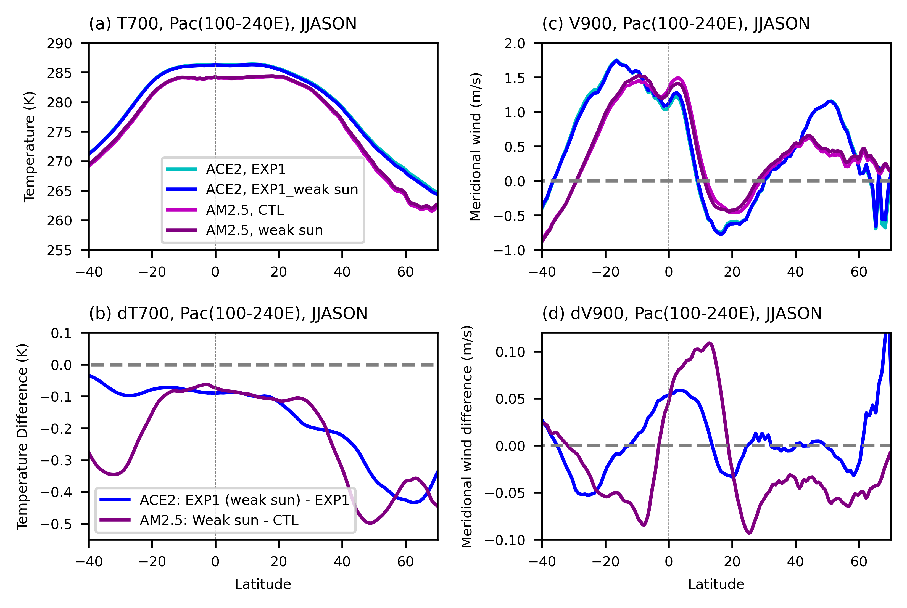
Figure S1. The zonal mean Pacific climatology of (a) temperature at 700 hPa and (c) meridional wind at 900 hPa. The zonal mean is averaged between 100-240 E from June to November. The difference between solar dimming and no dimming is shown for (b) temperature at 700 hPa and (d) meridional wind at 900 hPa. Green lines represent the Ai2 Climate Emulator (ACE2) paleo simulation, and blue lines represent the physical model AM2.5 simulation of the current climate.

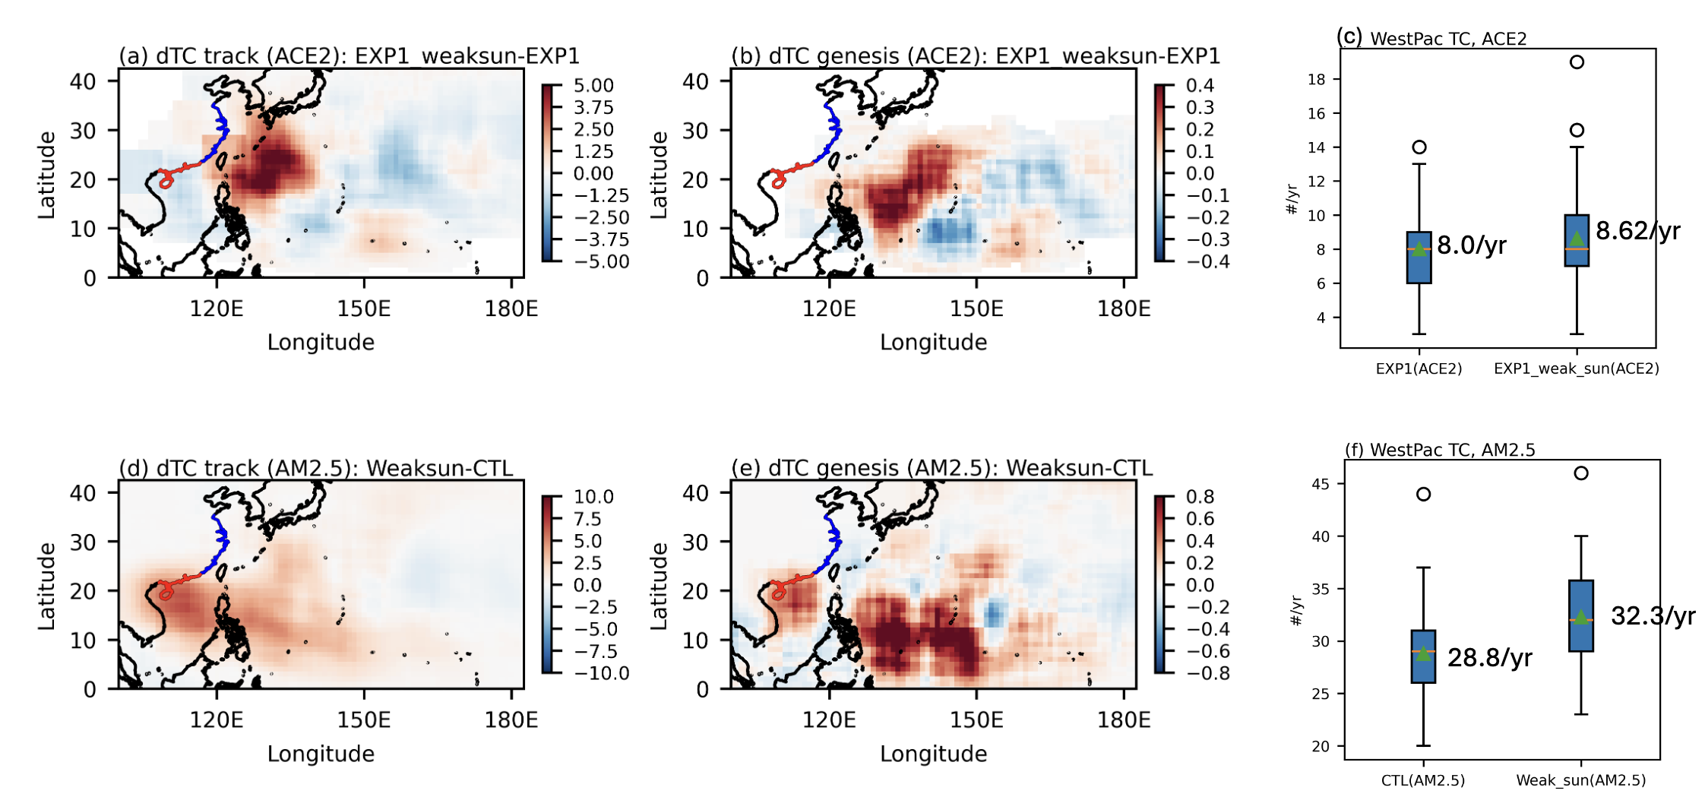
Figure S2. TC track and genesis density change due to solar dimming. (a) TC track density change from the Ai2 Climate Emulator (ACE2) in the 17th century, based on EXP1 and EXP1_weak_sun, (b) TC genesis density change in the ACE2 in the 17th century, based on EXP1 and EXP1_weak_sun, (c) Western Pacific total TC number from ACE2, (d) TC track density change in the dynamical climate model AM2.5, based on the current climate and the weak sun experiment, and (e) TC genesis density change in the dynamical climate model AM2.5, based on the current climate and the weak sun experiment, and (f) Western Pacific total TC number from ACE2.

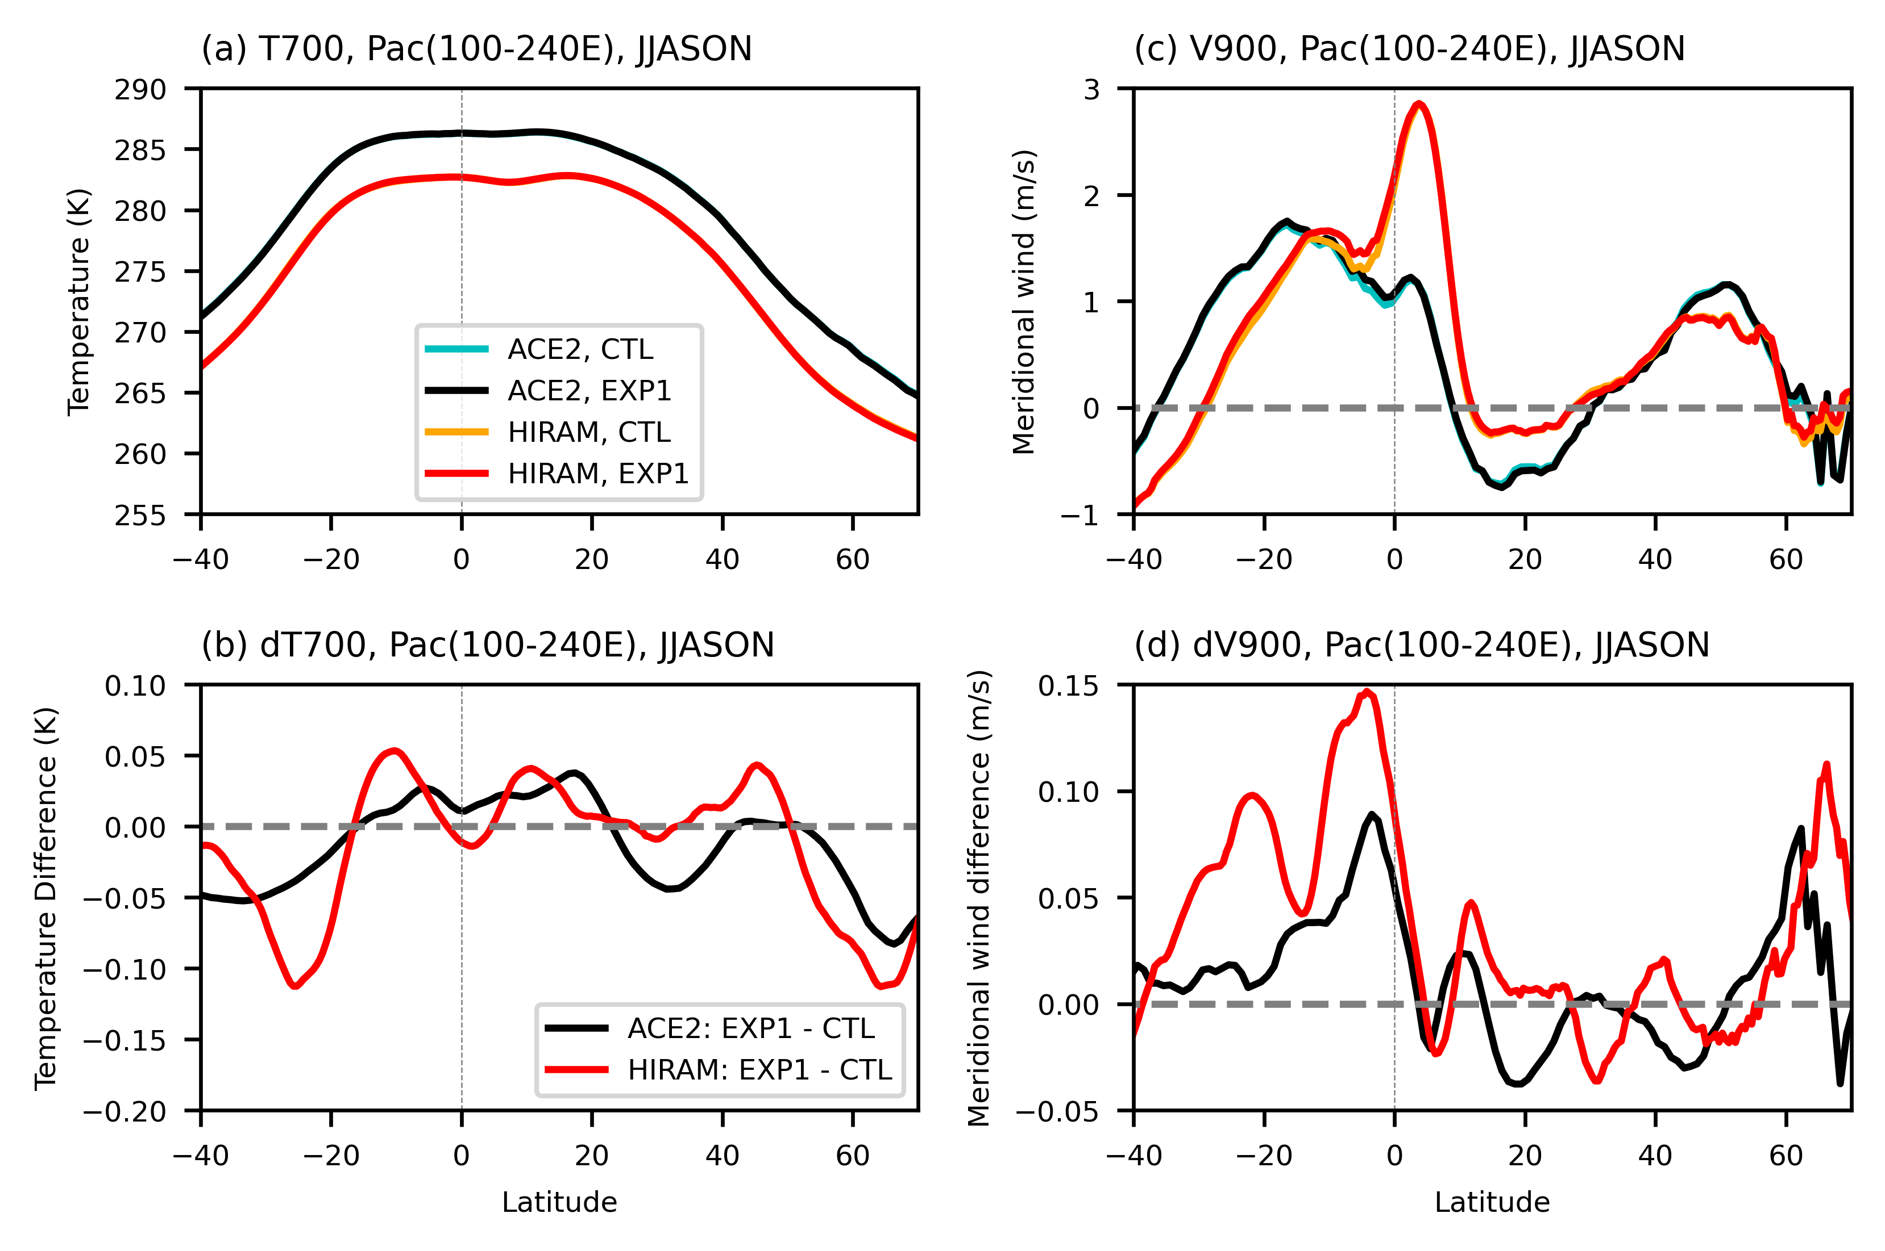Figure S3. Zonal mean temperature and meridional wind over the Pacific in boreal summer from the Low and High landfall periods in HiRAM and ACE2 in the 17th century.
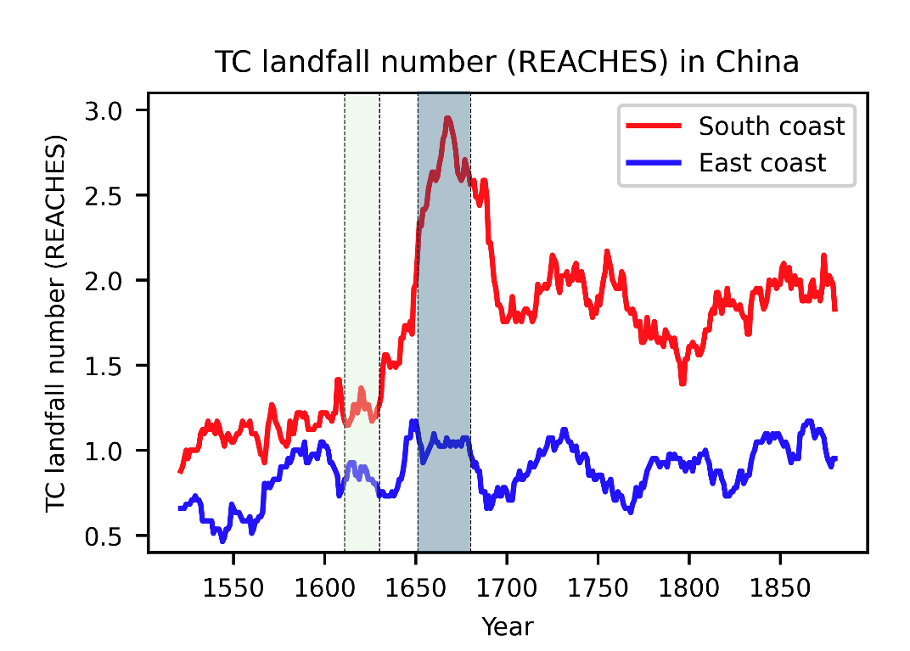
Figure S4. Time series of landfall TC number along the South coast and East coast of China from the historical Chinese written record (REACHES).

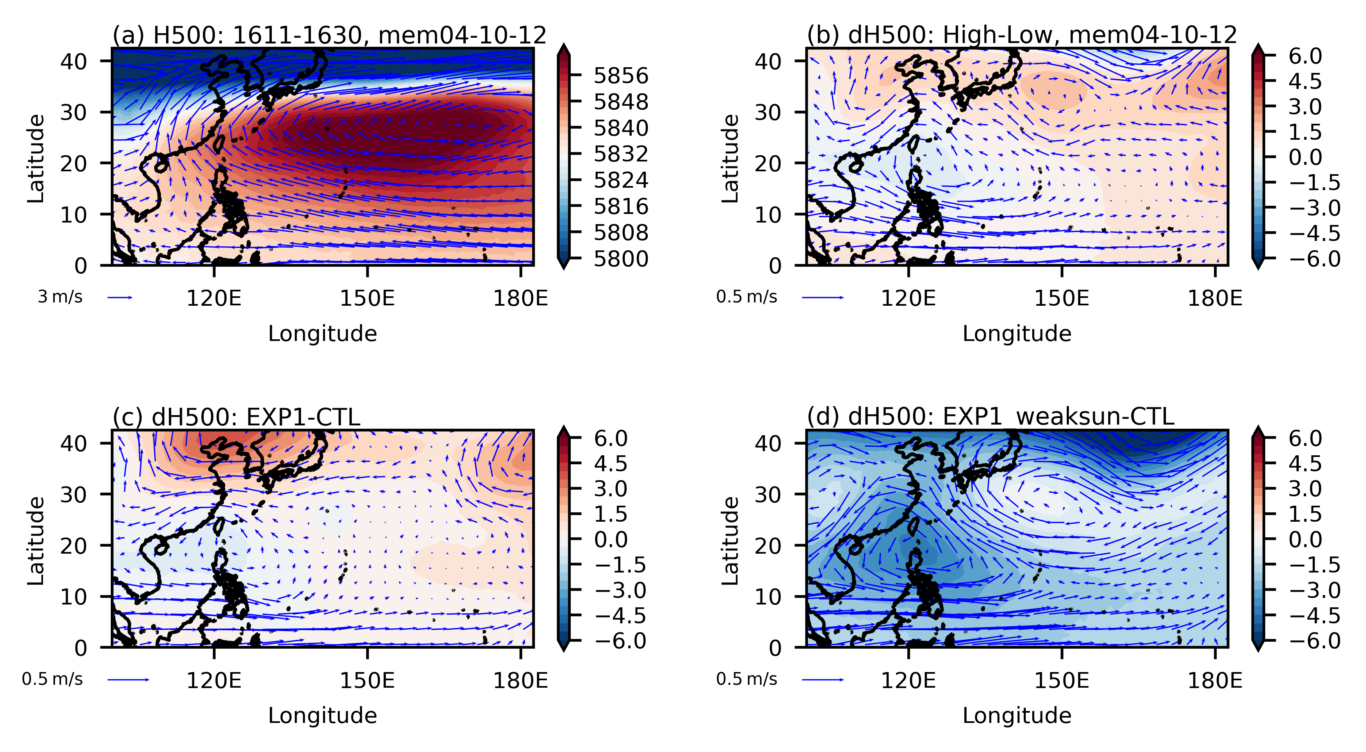

Figure S5. (a) Geopotential height and steering flow from the low landfall period (1611-1630AD), (b) the difference in geopotential height and steering flow from the Low landfall period to the High landfall period, averaged across the 3 members similar to REACHES, (c) the difference in geopotential height and steering flow from the ensemble mean of the CTL and EXP1, and (d) the difference in geopotential height and steering flow from the ensemble mean of CTL and EXP1_weaksun.

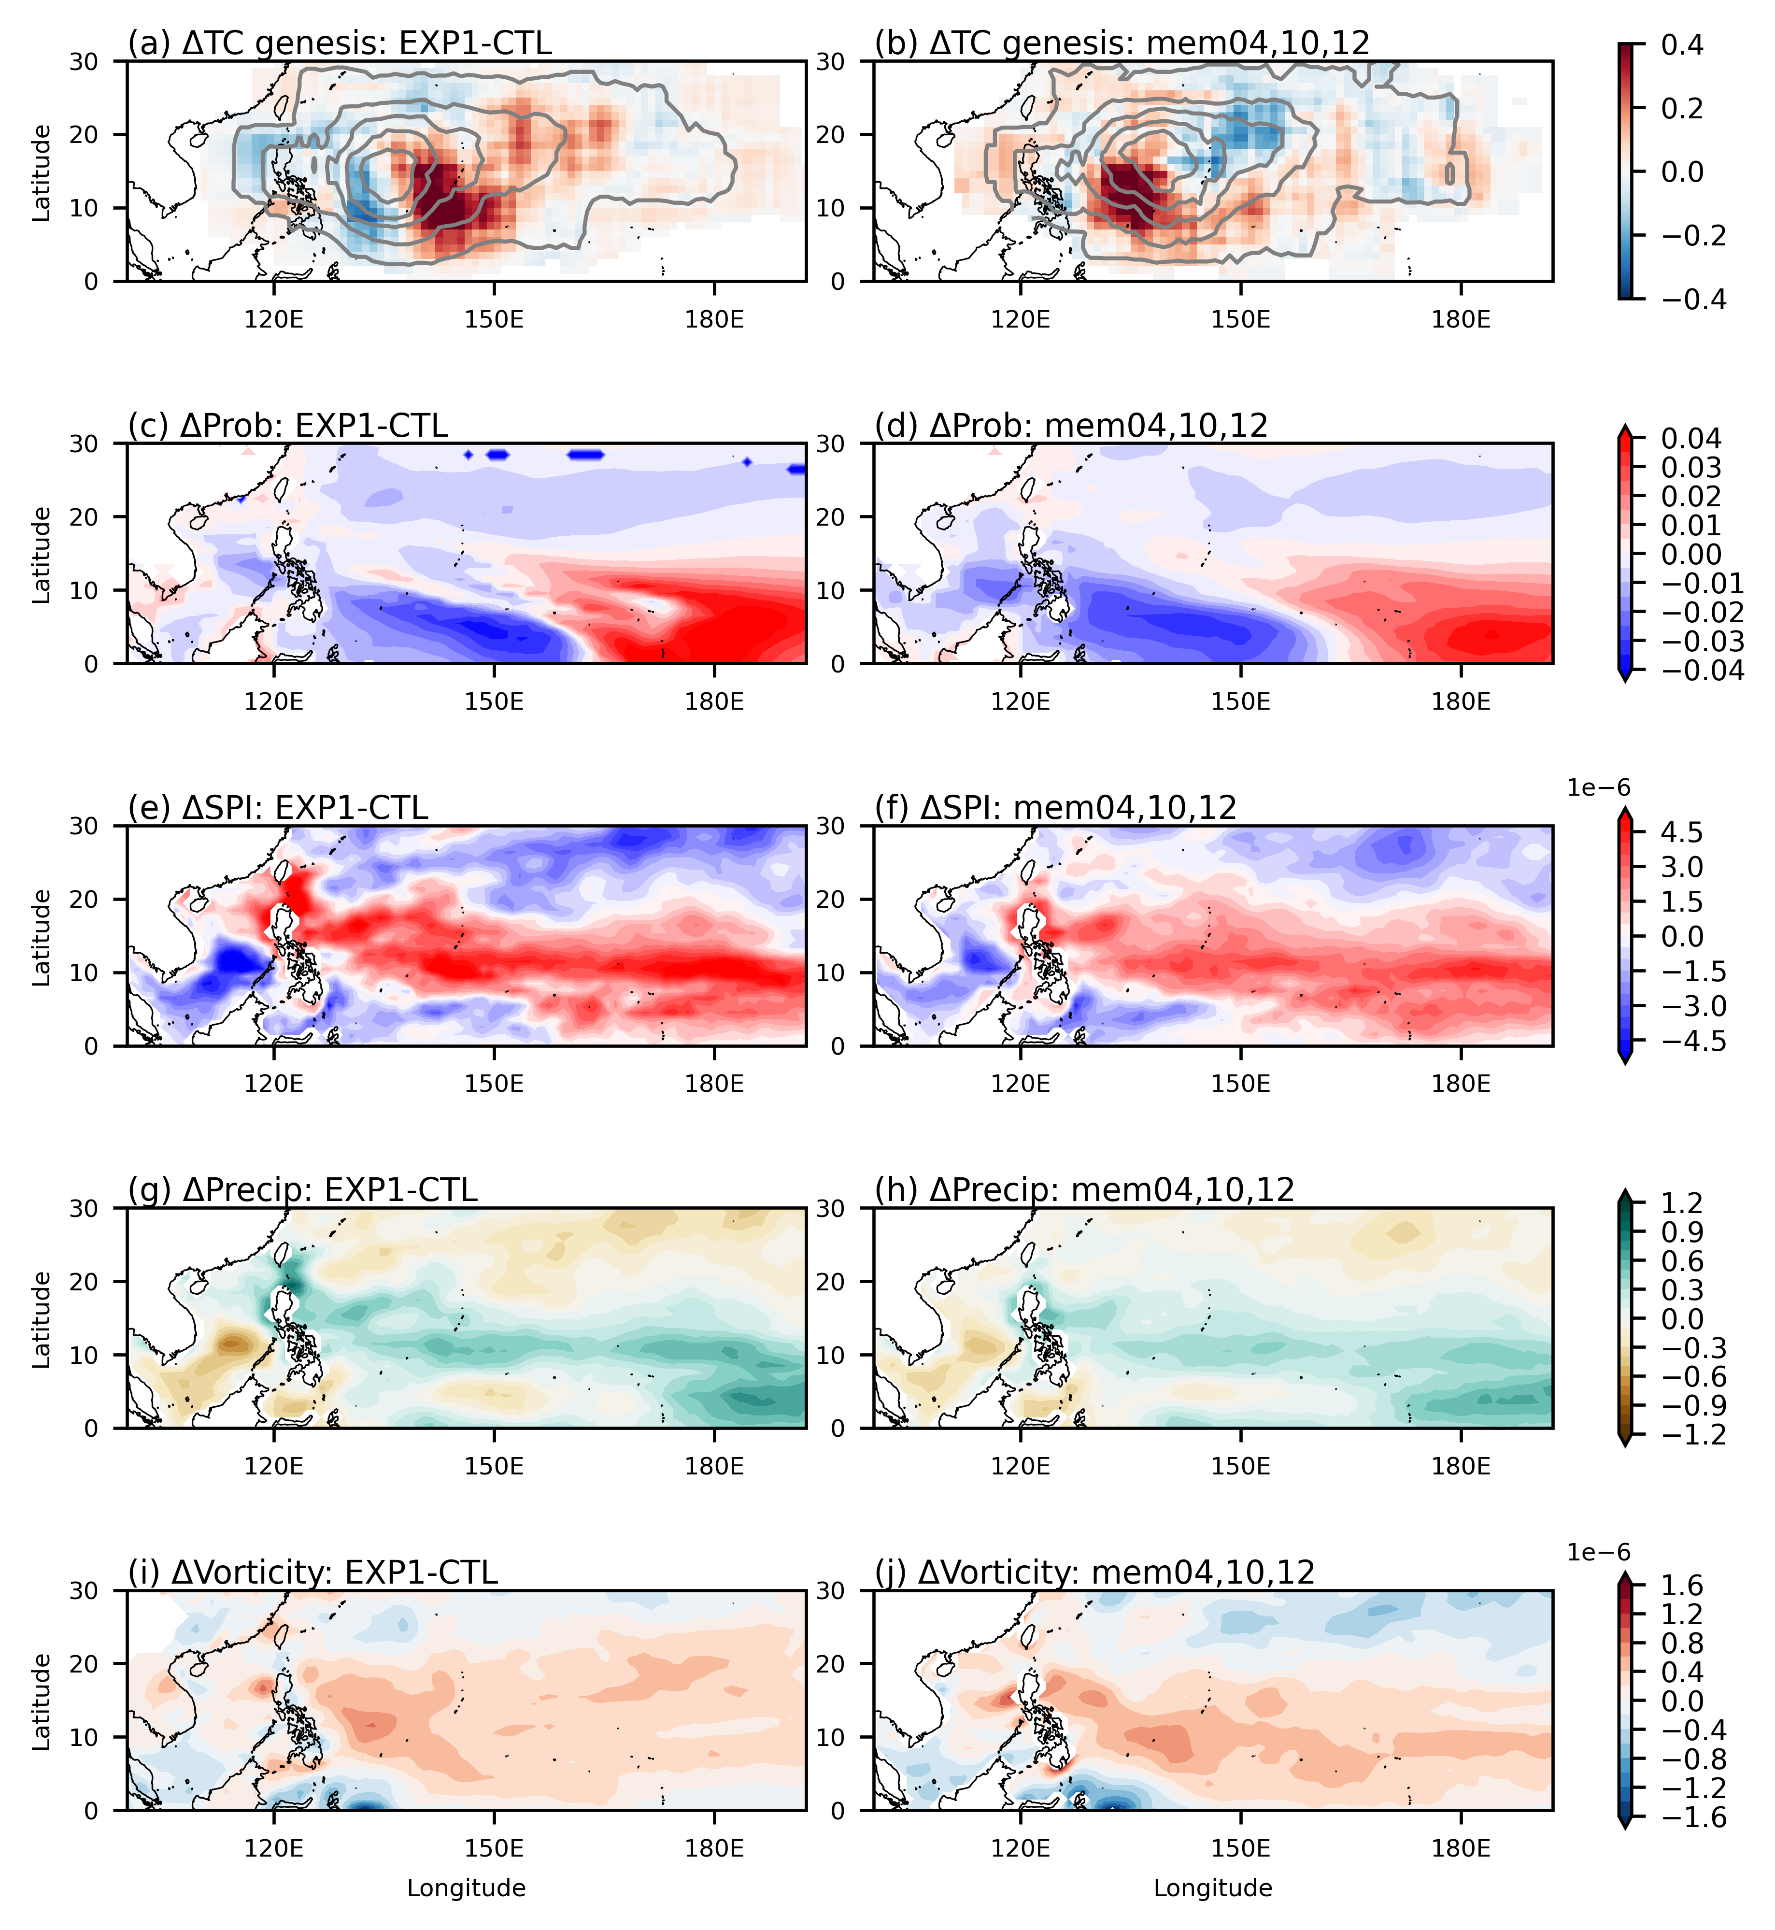
Figure S6. (a-b) Shading shows the difference in genesis density between the earlier and latter periods, while contours represent the climatological genesis density of the earlier period: (c-d) transition probability, (e-f) seed propensity index, (g-h) precipitation, and (i-j) vorticity at 850 hPa. The left column represents the 100-member ensemble mean of the time-slice experiments, and the right column represents the 3 members of the time-evolving simulations that perform similarly to REACHES.

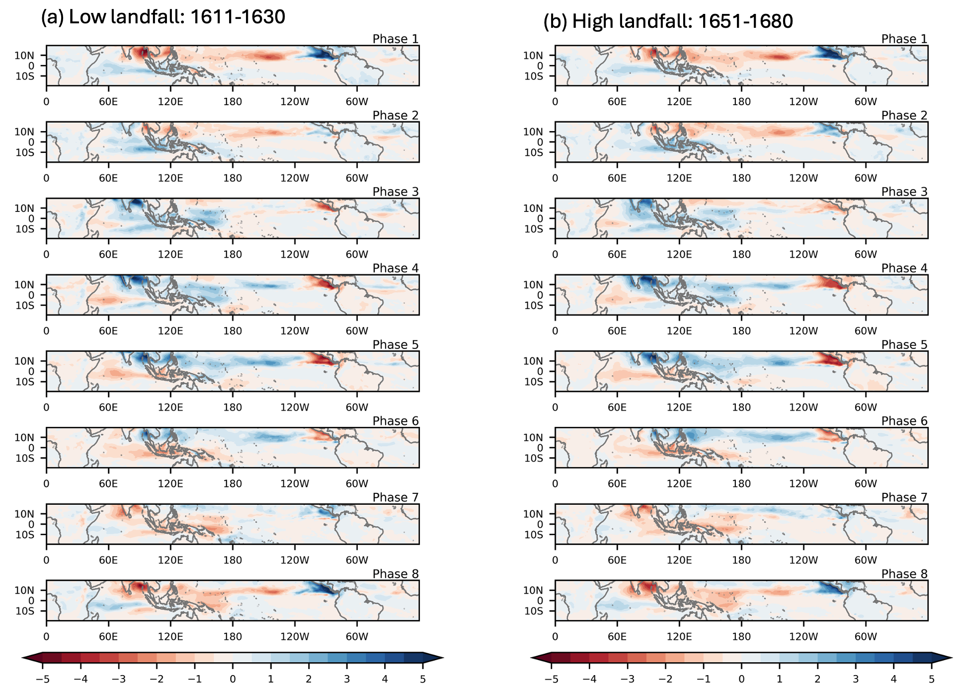
Figure S7. The 8-phase composite of the Madden Julian Oscillation precipitation anomalies (mm/day) in boreal summer (June-Nov) (a) the low TC landfall period (1611-1630 AD) and (b) the high landfall TC period (1651-1680). The composite is obtained from the 3 ACE2 members similar to REACHES.

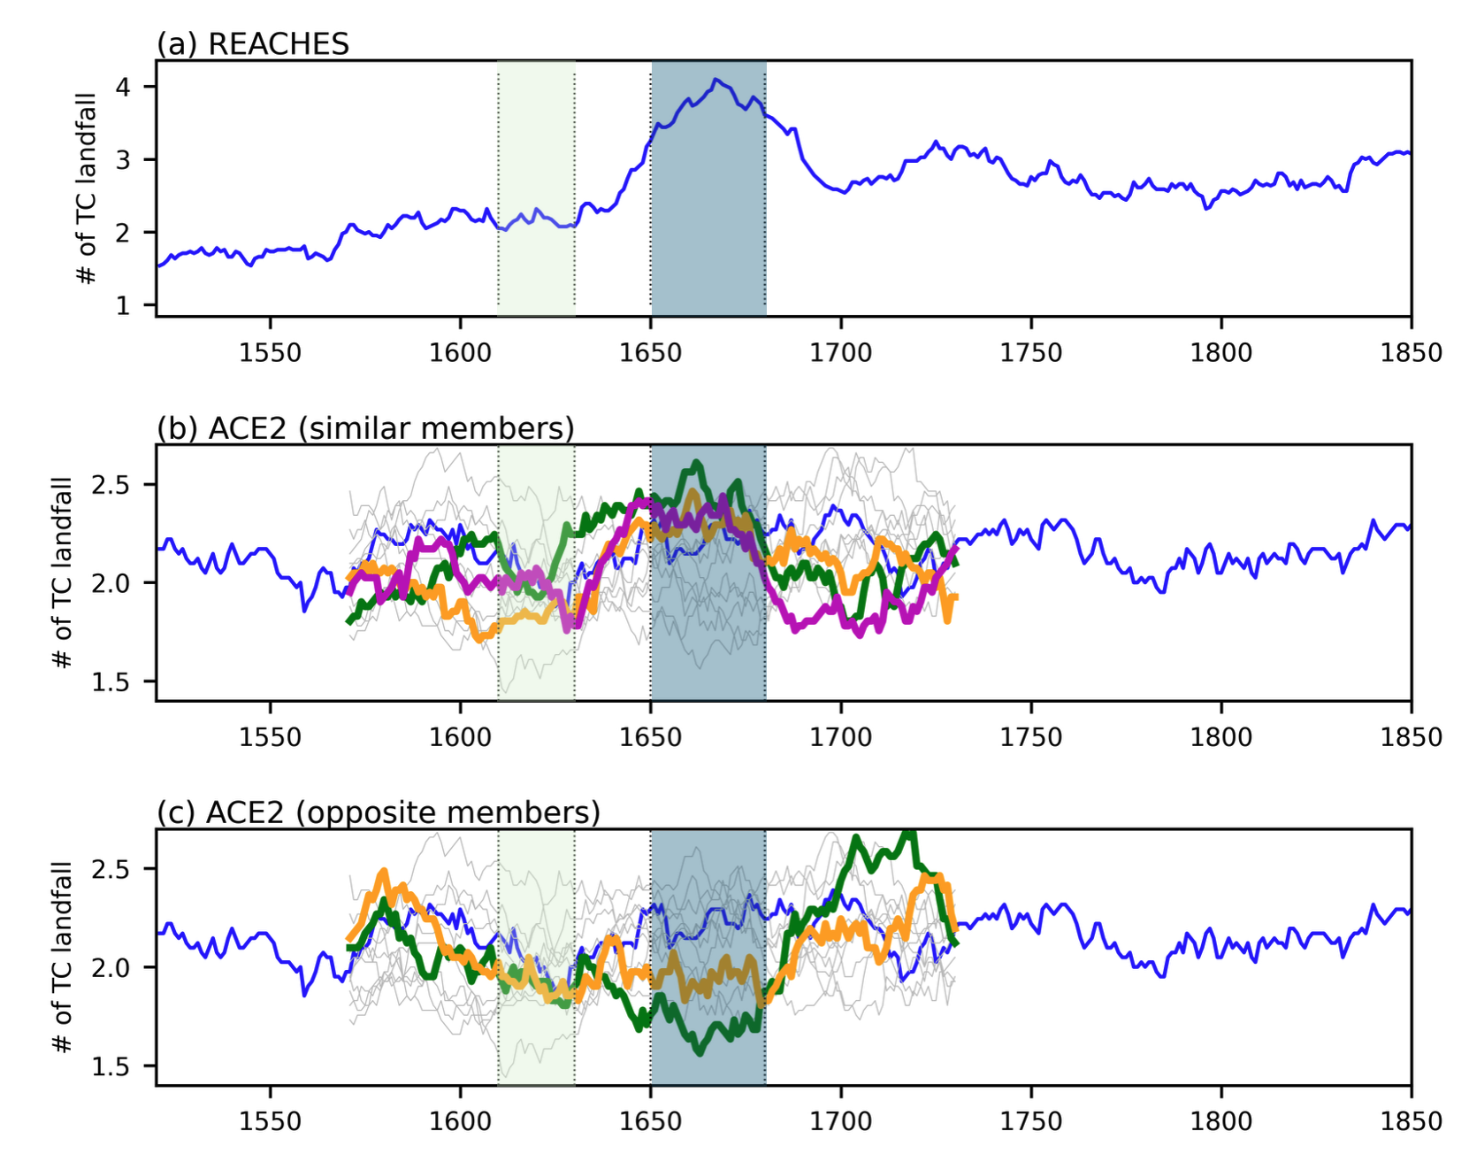
Figure S8. Time series of landfall TCs from (a) REACHES, (b) ACE2, highlighting members showing similar peaks to REACHES, (c) ACE2, highlighting members showing opposite peaks to REACHES. All other members are shown as thin grey lines. The green shading represents the low landfall period (1611-1630 AD), and the blue shading represents the high landfall period (1651-1680 AD).

