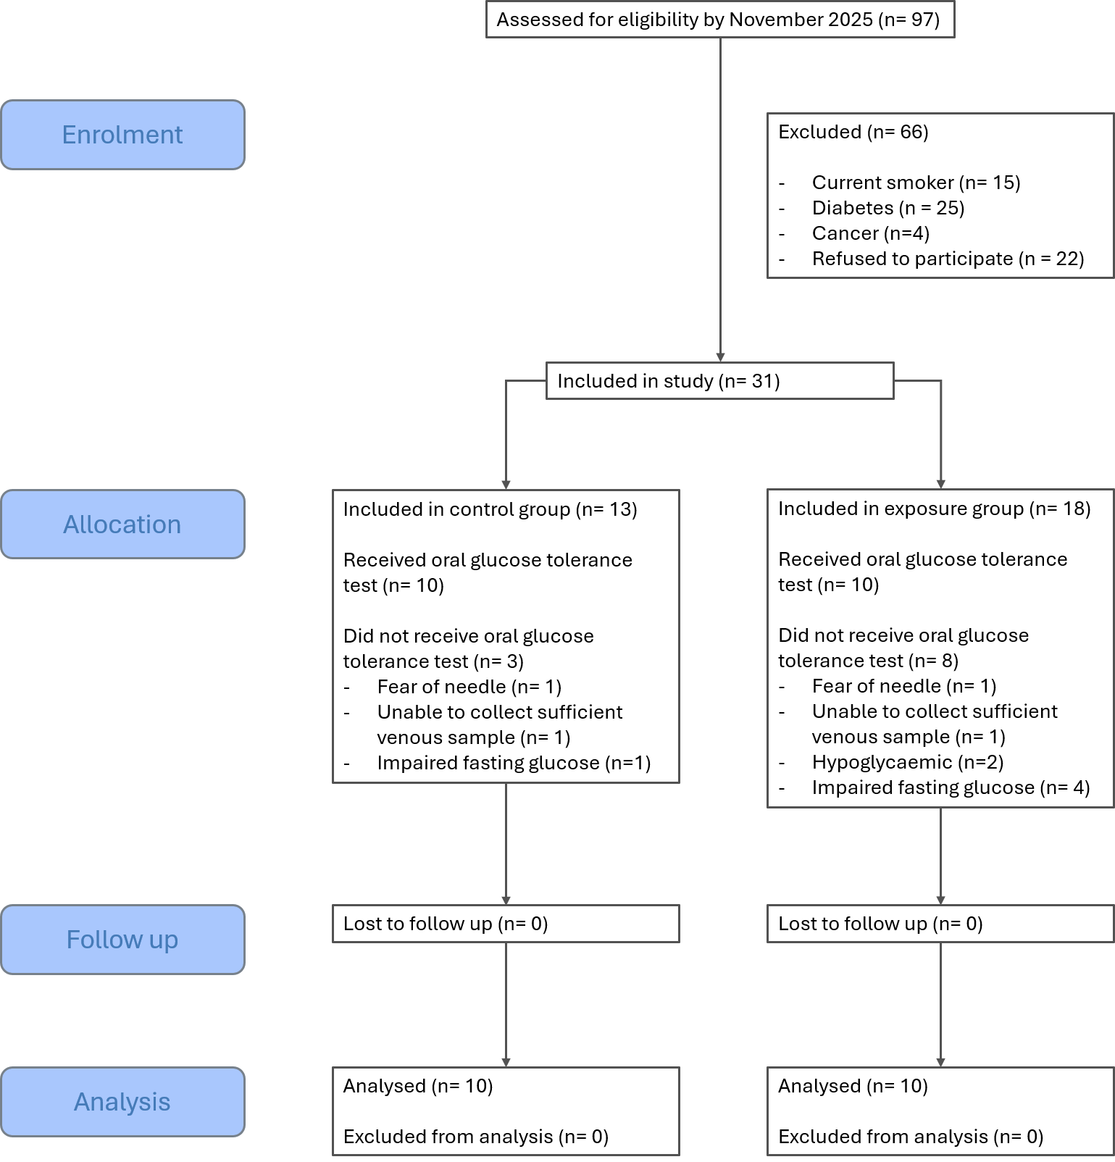
Appendix 1: Flow diagram of participant enrolment, allocation, follow-up and analysis.

