Supplementary video link
https://drive.google.com/file/d/1vXEVpVSi_x_8P8bva58qL_Wqh7u5bRRB/view?usp=sharing

Supplementary Fig 1: Pay-it-forward model overview

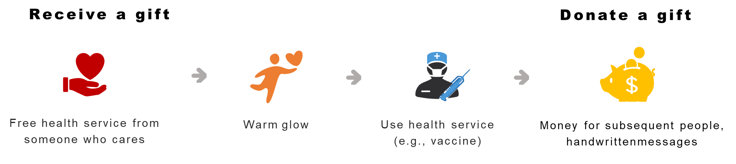

Supplementary Fig 2 postcard example
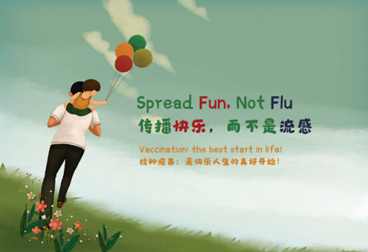

Supplementary Fig 3: translated hand-written postcard messages
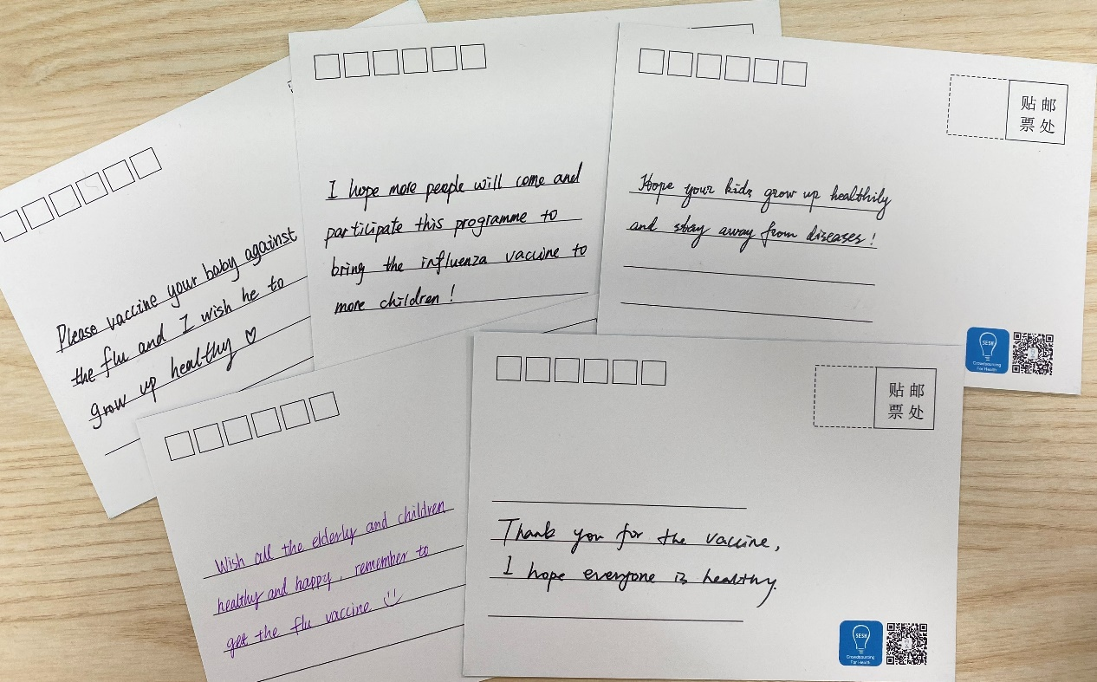

Supplementary Fig 4 Time-based recruitment for the three study arms at three study sites¹

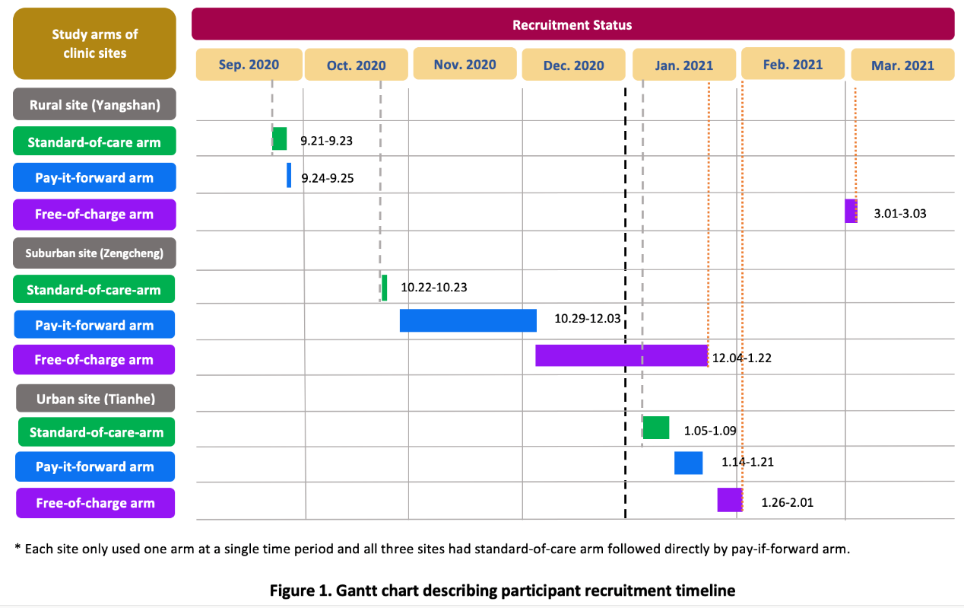
Footnote: The recruitment in Yangshan was spaced out because of occasional stock outs. The lengths of time for the three arms at the study sites varied due to variations in patient volume and recruitment pace. There was a gap between 26 September and 21 October because of heavier COVID-19 related preventive service tasks at all three study sites. The gap between 1 Feb 2021 and 1 Mar 2021 was due to the Chinese New Year holiday.

Supplementary Fig 5: Introduction to influenza (English translation).
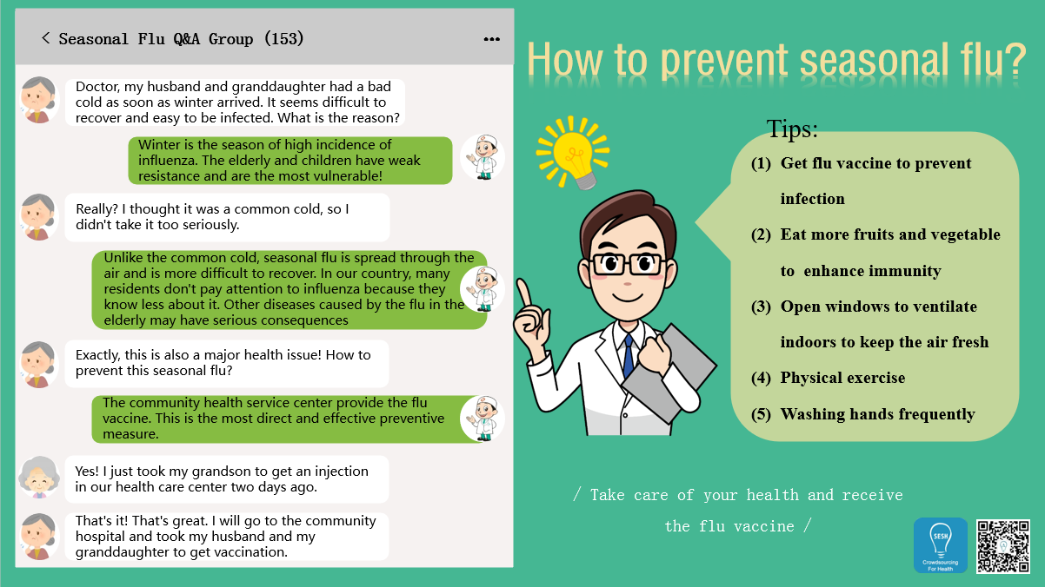

Supplementary Fig 6: pay-it-forward pamphlet (English translation).
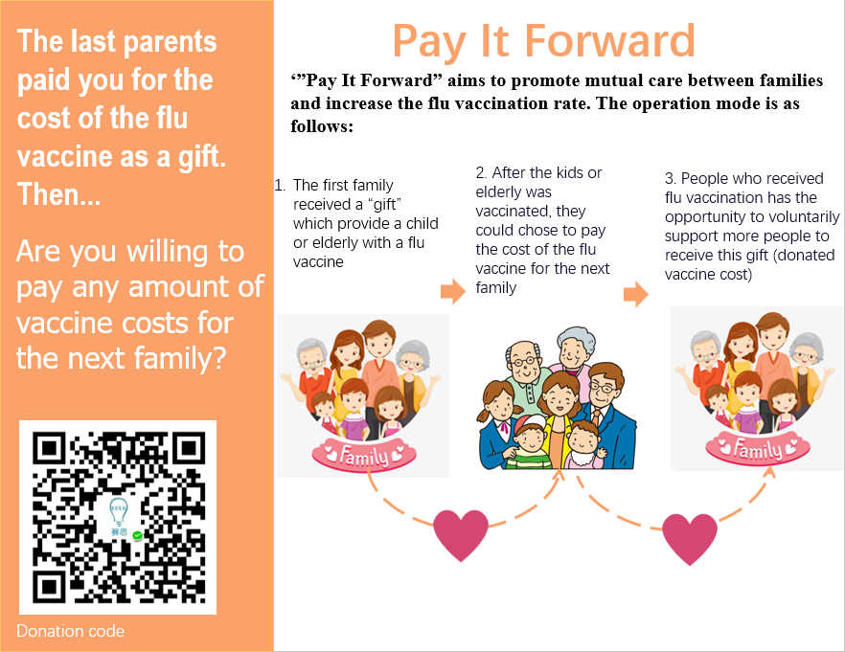

Supplementary Fig 7: Distribution of donation amounts by study site (n=107)
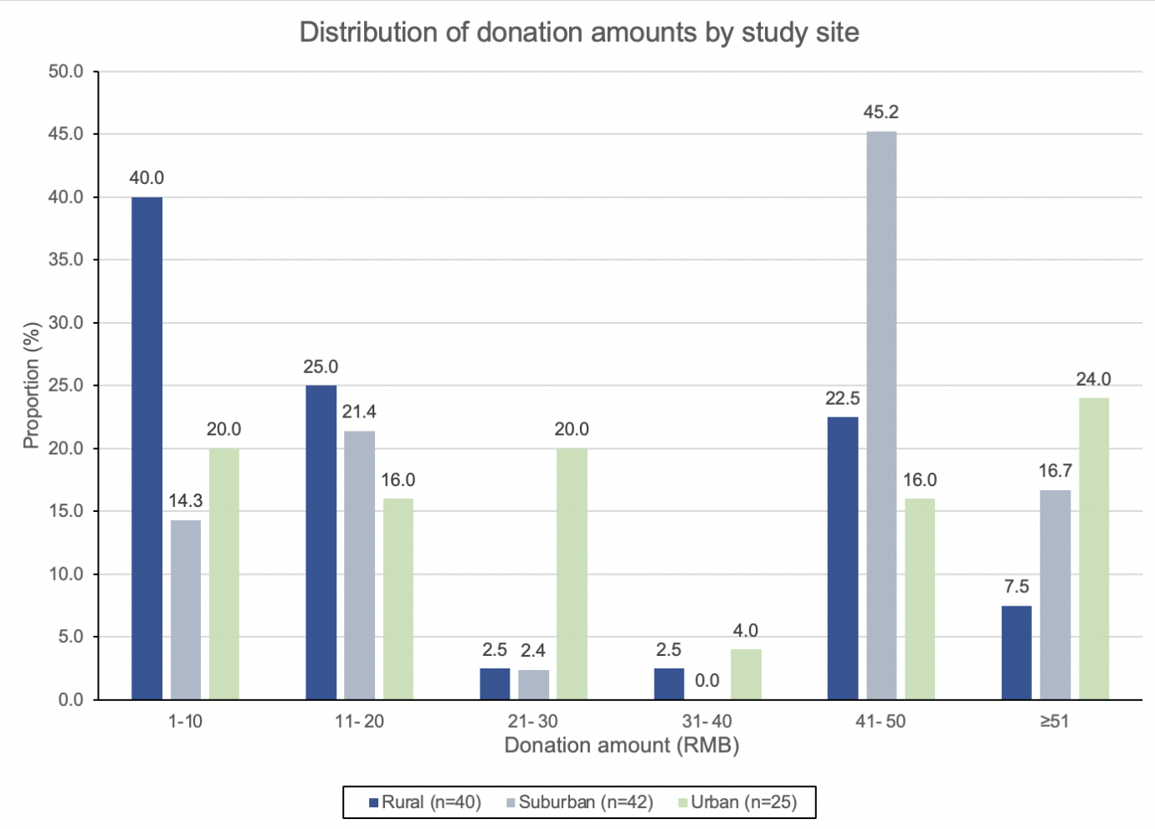
Note: 1 US$=6.59 RMB

Supplementary table 1 Proportion differences in influenza vaccination rates between the three study arms by age groups in Guangdong Province, China, 2020-2021 (N=450)
 | Children  N=225 |  | Older adults  N=225
Uptake (n,%) |  | P value |  | P value
 |  | <0.0001 |  | <0.0001
Standard of care | 40 (53.3) |  | 15 (20)
Pay-it-forward | 66 (88) |  | 45 (60)
Free vaccine | 64 (85.3) |  | 50 (66.7)
Study arms | Crude proportion difference (95%CI) | P value | Crude proportion difference (95%CI) | P value
Pay-it-forward vs Standard of care | 34.7 (21.2, 48.1) | <0.0001 | 40.0 (25.7, 54.3) | <0.0001
Free vaccine vs Standard of care | 32.0 (18.2, 45.8) | <0.0001 | 46.7 (32.7, 60.7) | <0.0001
Pay-it-forward vs Free vaccine | 2.7 (-8.2, 13.5) | 0.81 | -6.7 (-22.1, 8.7) | 0.50
Adjusting study site | Adjusted proportion difference (95%CI) | P value | Adjusted proportion difference (95%CI) | P value
Pay-it-forward vs Standard of care | 34.7 (21.4, 47.9) | <0.0001 | 40.0 (26.3, 53.7) | <0.0001
Free vaccine vs Standard of care | 32.0 (18.4, 45.6) | <0.0001 | 46.7 (33.0, 60.3) | <0.0001
Pay-it-forward vs Free vaccine | 2.7 (-7.7, 13.0) | 0.80 | -6.7 (-21.3, 8.0) | 0.476
Adjusting education level
Pay-it-forward vs Standard of care | 36.3 (22.1, 50.5) | <0.0001 | 41.1 (27.1, 55.1) | <0.0001
Free vaccine vs Standard of care | 36.3 (22.9, 50.0) | <0.0001 | 45.8 (31.9, 59.7) | <0.0001
Pay-it-forward vs Free vaccine | 3.3 (-7.9, 14.5) | 0.81 | -5.6 (-20.6, 9.3) | 0.486

Supplementary table 2: Distribution of donation status and participants with a donation of 50 RMB or above by study site
Characteristic | Rural  (n=50) | Suburban  (n=50) | Urban  (n=50) | p-value*
Donation status (n=150)  - Donated  - Did not donate | 80.0 (40)  20.0 (10) | 84.0 (42)  16.0 (8) | 50.0 (25)  50.0 (25) | <0.001
Characteristic | Rural  (n=40) | Suburban  (n=42) | Urban  (n=25) | p-value*
Donation amount  (n=107)  - <50 RMB  - >=50 RMB | 70.0 (28)  30.0 (12) | 38.1 (16)  61.9 (26) | 60.0 (15)  40.0 (10) | 0.013
Note: US$ 1 = RMB 6.59

Supplementary costs file

Title: Pay-it-forward to improve influenza vaccine uptake and public engagement among children and older adults in China: A quasi-experimental pragmatic study

Costs file Table 1: Unit costs (in 2020 USD) and frequency of vaccine use
Intervention | Cost item | Unit cost | Resource use | Source
Pay-it-forward |  | Staff wage per hour (USD/hour)*
- Start-up costs
 | Time designing postcards to be written on by participants in the PIF programme† | 7.47 | 1 x 5 hr | Personal communication with research staff
 | Time of research fellow participating in preparatory workshop† | 12.7 | 1 x 5 hr | Personal communication with research staff
 | Time of research assistant participating in preparatory workshop† | 7.47 | 1 x 5 hr | Personal communication with research staff
 | Time of nurses participating in preparatory workshop | 4.81 | 3 x 1 hr | Personal communication with research staff  China Social Welfare Foundation (12)
 | Time of clinic coordinators participating in preparatory workshop | 4.81 | 3 x 1 hr | Personal communication with research staff China Social Welfare Foundation(12)
- Fixed costs
 | Vaccinators (doctors) for the three clinics | 11.07 | 3 x 70 hr | China Social Welfare Foundation (12)
- Recurrent costs
 | Time of nurses in recruiting patients to join the PIF programme†† | 4.81 | 3 x 25 hr | Personal communication with research staff  China Social Welfare Foundation (12)
 | Time of clinic coordinators in performing administrative work for the PIF programme†† | 4.81 | 3 x 25 hr | Personal communication with research staff  China Social Welfare Foundation (12)
 |  | Cost per vaccine (USD)
 | Cost of adult vaccines in Yangshan# | 22.9 | 41 | Health clinic reimbursement invoices
 | Cost of adult vaccine in Zengcheng | 22.9 | 17 | Health clinic reimbursement invoices
 | Cost of child vaccine in Zengcheng | 8.38 | 25 | Health clinic reimbursement invoices
 | Cost of adult vaccine in Tianhe# | 12.2 | 28 | Health clinic reimbursement invoices
 |  | Cost per item / batch (USD)
 | Introductory pamphlets for the PIF programme (batch cost) | 29.0 | 1 | Project research staff invoices
 | Ballpoint pens (for writing messages on PIF postcards) (batch cost) | 2.25 | 1 | Project research staff invoices
 | Cost of printing postcards (batch cost) | 7.41 | 1 | Project research staff invoices
 | Surgical gloves | 0.075 | 222 | Personal communication with research staff

Intervention | Cost item | Unit cost | Resource use | Source
Standard-of-care |  | Staff wage per hour (USD/hour)*
- Start-up costs | Time of nurses participating in preparatory workshop | 4.81 | 3 x 1 hr | China Social Welfare Foundation (12)
 | Time of clinic coordinators participating in preparatory workshop | 4.81 | 3 x 1 hr | China Social Welfare Foundation (12)
- Fixed costs
 | Vaccinators for the three clinics | 11.07 | 3 x 70 hr | China Social Welfare Foundation (12)
- Recurrent costs
 | Time of nurses in recruiting patients to receive seasonal influenza vaccination†† | 4.81 | 3 x 12.5 hr | Personal communication with research staff  China Social Welfare Foundation (12)
 | Time of clinic coordinators in performing administrative work for influenza vaccination†† | 4.81 | 3 x 12.5 hr | Personal communication with research staff  China Social Welfare Foundation (12)
 |  | Cost per vaccine (USD)
 | Cost of adult vaccines in Yangshan# | 22.9 | 15 | Health clinic reimbursement invoices
 | Cost of adult vaccine in Zengcheng | 22.9 | 5 | Health clinic reimbursement invoices
 | Cost of child vaccine in Zengcheng | 8.38 | 14 | Health clinic reimbursement invoices
 | Cost of adult vaccine in Tianhe# | 12.2 | 21 | Health clinic reimbursement invoices
 |  | Cost per item (USD)
 | Surgical gloves | 0.075 | 110 | Personal communication with research staff
Intervention | Cost item | Unit cost | Resource use | Source
Free vaccination
- Start-up costs |  | Staff wage per hour (USD/hour)*
 | Time of nurses participating in preparatory workshop | 4.81 | 3 x 1 hr | Personal communication with research staff  China Social Welfare Foundation (12)
 | Time of clinic coordinators participating in preparatory workshop | 4.81 | 3 x 1 hr | Personal communication with research staff  China Social Welfare Foundation (12)
- Fixed costs
 | Vaccinators for the three clinics | 11.07 | 3 x 70 hr | China Social Welfare Foundation (12)
- Recurrent costs
 | Time of nurses in recruiting patients to join the PIF programme†† | 4.81 | 3 x 12.5 hr | Personal communication with research staff  China Social Welfare Foundation (12)
 | Time of clinic coordinators in performing administrative work for the PIF programme†† | 4.81 | 3 x 12.5 hr | Personal communication with research staff  China Social Welfare Foundation (12)
 |  | Cost per vaccine (USD)
 | Cost of adult vaccines in Yangshan# | 22.9 | 42 | Health clinic reimbursement invoices
 | Cost of adult vaccine in Zengcheng | 22.9 | 13 | Health clinic reimbursement invoices
 | Cost of child vaccine in Zengcheng | 8.38 | 18 | Health clinic reimbursement invoices
 | Cost of adult vaccine in Tianhe# | 12.2 | 41 | Health clinic reimbursement invoices
 |  | Cost per item / batch (USD)
 | Surgical gloves | 0.075 | 228 | Personal communication with research staff
 | Information pamphlet for free vaccination arm | 20.4 | 1 | Project research staff invoices
PIF - pay-it-forward, USD – United States dollars
*Hourly wages were calculated from monthly or yearly wages based on an assumption of 250 working days per year and 10 working hours per day.
†These costs were annualised over a three-year period at a discount rate of 3% as they were part of the preparatory workshop for the conception of PIF programme specifically. The training, supplies and expertise gained through these sessions are expected to be useful in future years to inform further iterations of the programme and were therefore annualised over three years.
†† It was assumed that each nurse spent 10 minutes per patient to recruit and persuade participants to be vaccinated in the pay-it-forward programme, while they spent 5 minutes per patient for the standard-of-care group, and 5 minutes per patient in the free vaccination arm.
#Only adult influenza vaccine was used in Yangshan and Tianhe, i.e. children were inoculated with the same influenza vaccine as the adults in those study sites.

Addendum: Breakdown for obtaining the total economic cost and the total financial cost of each intervention arm
Total economic cost of an intervention
= Start-up costs + Fixed costs + Recurrent costs

Total financial cost of an intervention
= Start-up costs + Fixed costs + Recurrent costs – (Payment / Donation contributions)

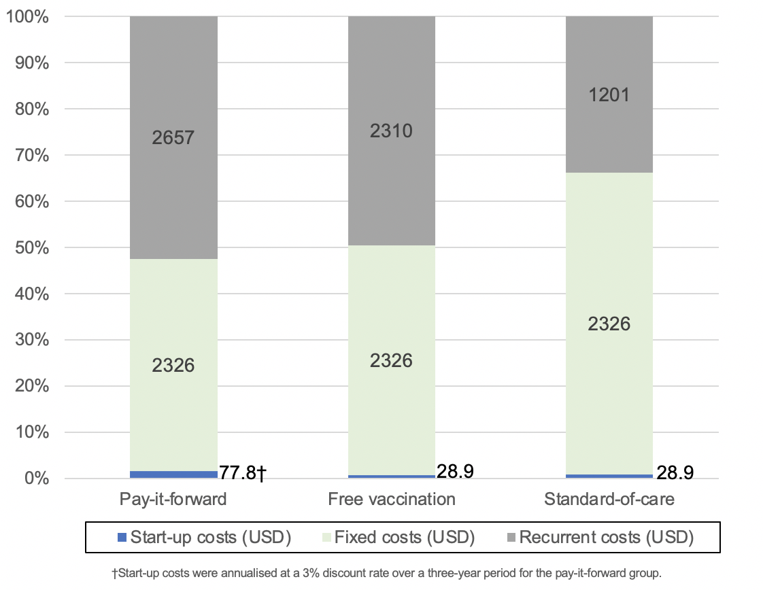
Costs file Figure 1: Breakdown of economic costs by category in the three intervention arms

Costs file Table 2: Total economic costs and total financial costs by intervention arm
Intervention arm | Total economic cost (USD) | Total financial cost (USD)
Pay-it-forward | 5062 | 4477
Free vaccination | 4665 | 4665
Standard-of-care | 3557 | 2725
Note: See Table 1 for detailed breakdown of the economic and financial costs
Sensitivity analysis
One-way deterministic sensitivity analysis
The results of the one-way deterministic sensitivity analysis are shown below in the tornado diagram (Figure 2-5). Overall, they indicate the study is most sensitive to the effectiveness of each intervention in increasing vaccine uptake, which was indicated by the variable of ‘vaccine uptake’. The difference in proportions of vaccinated people between different intervention groups greatly affect the ICER by vastly increasing or decreasing the denominator for the ICER (i.e. the incremental number of vaccinations).
Other important factors that affected the ICER of the two interventions included the combined cost of all types of vaccines in all three study sites, the cost of adult vaccines in Yangshan, Zengcheng, and Tianhe respectively. For the ICER obtained using financial costs, the amount of pay-it-forward donations received was also able to shift the ICER by more than 10% above and below the original ICER estimate.
Figure 8 shows the ICER comparing pay-it-forward against standard-of-care calculated using financial costs and Figure 9 shows the ICER comparing the same two groups calculated using economic costs.
The most important factor that affected the outcome of the ICER was that of the difference in vaccine uptake between the pay-it-forward and standard-of-care groups, which shifted the upper limit of the ICER to 77.19 USD per person vaccinated, which is 2.46 times that of the original estimate of 31.29 USD. The lower limit value of the effect size of the pay-it-forward intervention compared to standard-of-care also resulted in significant improvement of the ICER to 16.56 USD per person vaccinated, halving the original estimate. This shows that the current intervention is only effective if the difference in vaccine uptake of pay-it-forward and standard-of-care groups remain substantial in future iterations of the programme and has the potential to be even more cost-effective if a higher vaccine uptake rate could be achieved in pay-it-forward.
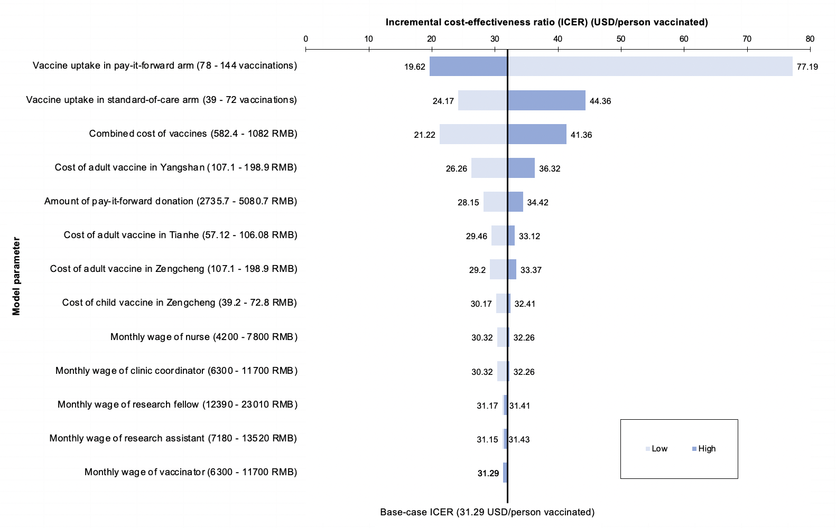

Supplementary Figure 2: Tornado diagram showing the effect of varying different input parameters on the ICER comparing pay-it-forward against standard-of-care calculated using financial costs

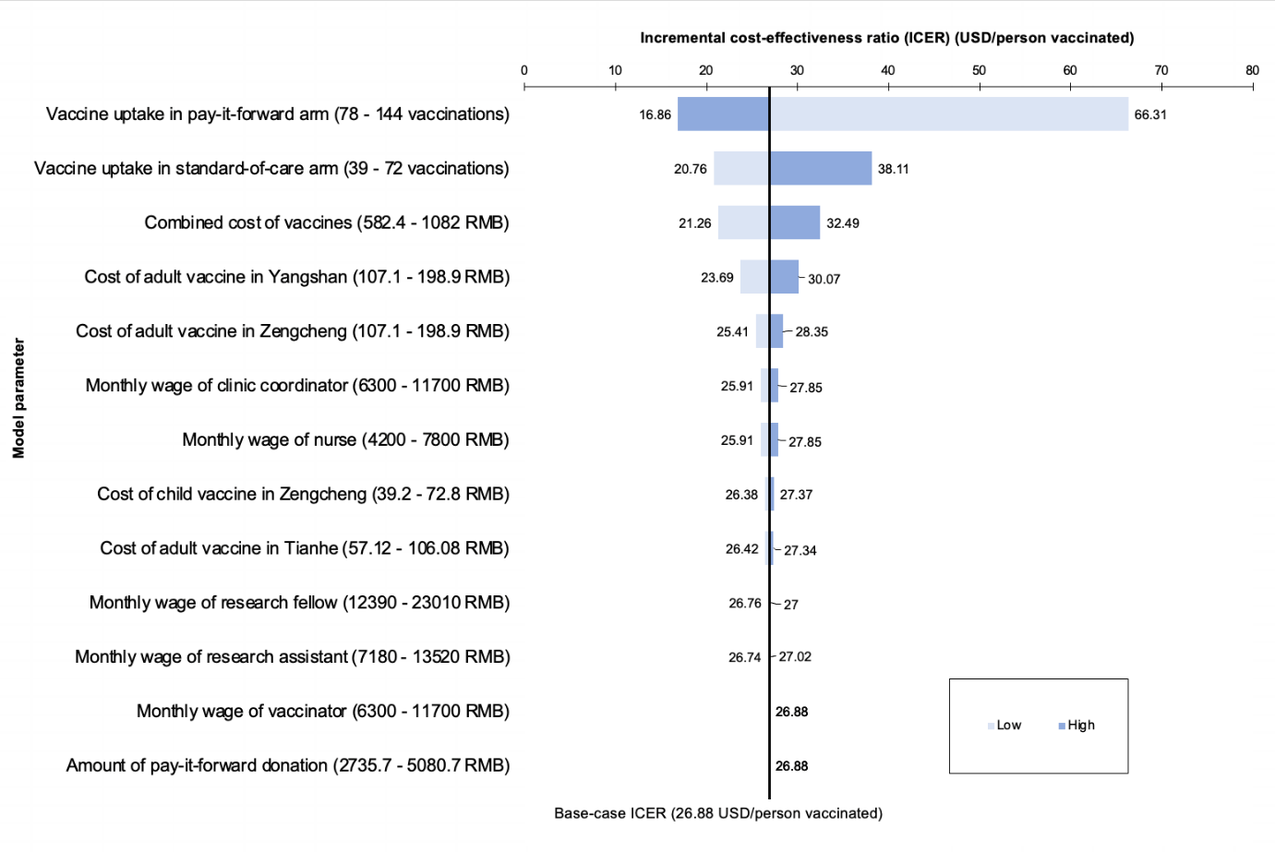
Supplementary Figure 3: Tornado diagram showing the effect of varying different input parameters on the ICER comparing pay-it-forward against standard-of-care calculated using economic costs

Below figures show the ICER comparing pay-it-forward against free vaccination calculated using financial costs and the ICER comparing the same two groups calculated using economic costs.
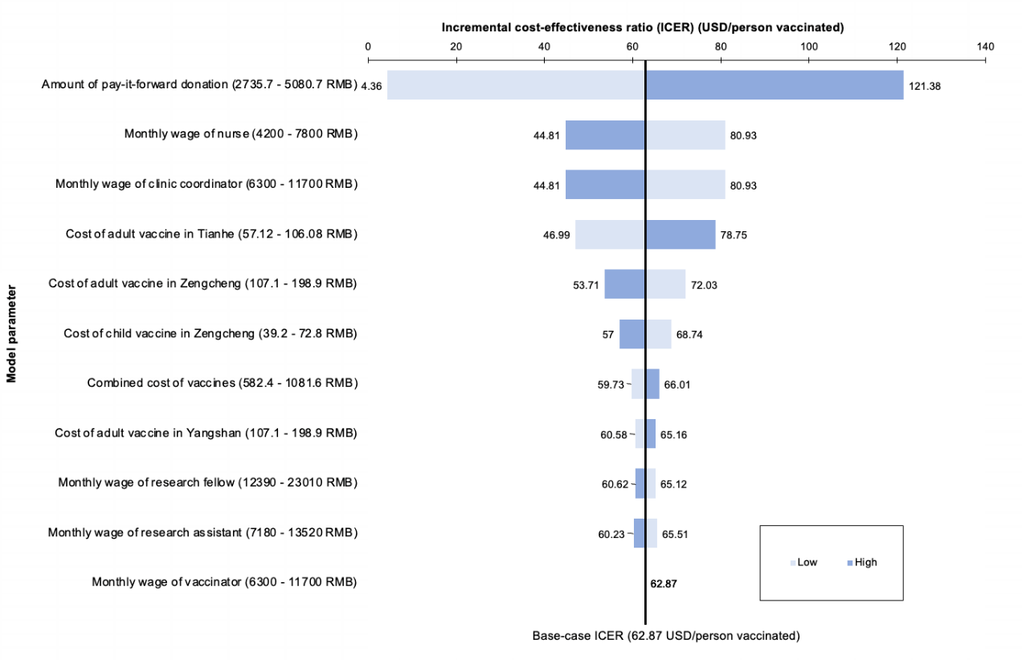
Supplementary Figure 4: Tornado diagram showing the effect of varying different parameters on the ICER comparing pay-it-forward against free vaccination calculated using financial costs
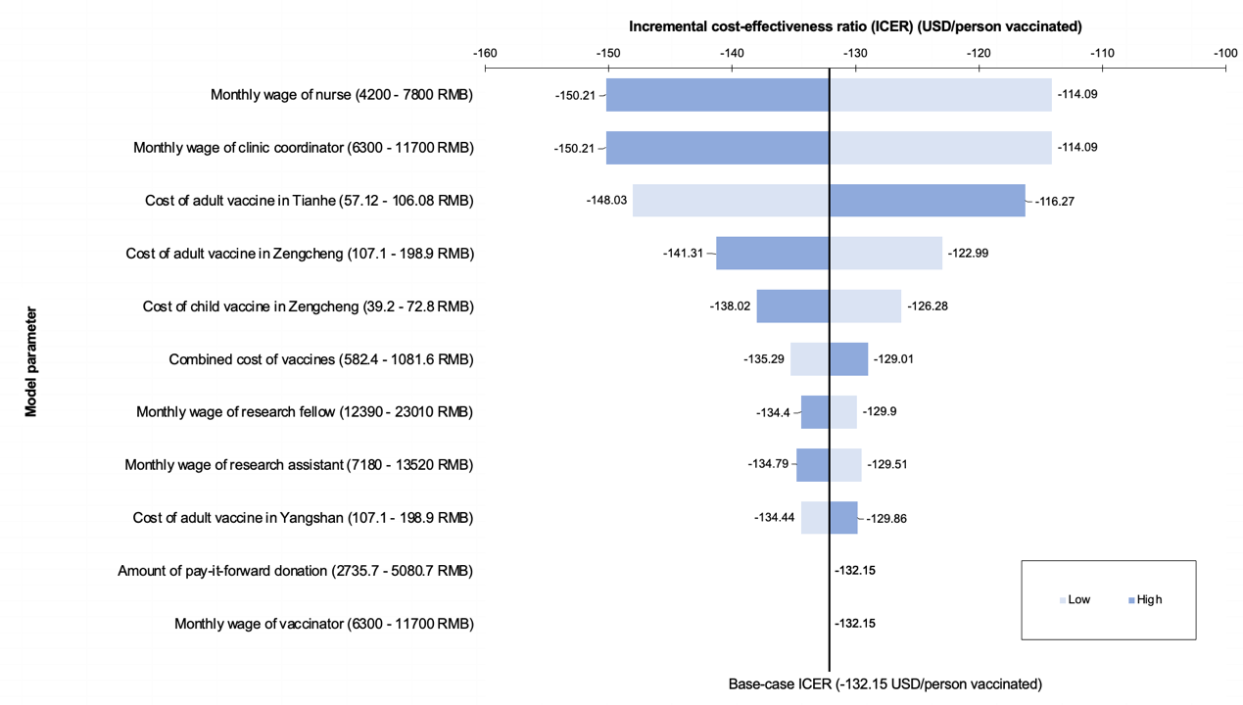
Supplementary Figure 5: Tornado diagram showing the effect of varying different parameters on the ICER comparing pay-it-forward against free vaccination calculated using economic costs
The variables of vaccine uptake in the pay-it-forward and free vaccination groups were omitted from the tornado graphs (Figure 6-7) in the one-way DSA comparing these two groups. This was because he difference in their effect sizes (i.e. the denominator for the ICER) approached zero, and produced ICERs which were not interpretable.

Questionnaire survey
Influenza vaccination for children and elderly people
About this study:
You are invited to participate in this influenza vaccination study. The results of this study can provide evidence for the government to develop better intervention strategies to promote influenza vaccination in China and prevent seasonal influenza among at-risk populations.
Details of this study:
You will need to fill out a questionnaire. This questionnaire will ask about your socio-demographic information and opinions towards influenza vaccine. To protect your privacy, all your answers will be transformed into digital formats and password encrypted. If you are eligible to participate in this program, out project personnel will provide you with more detailed information. To confirm whether you are qualified to participate in this program, we will first ask you a few screening questions. If you are not eligible for this program, we will not keep your survey information.
Note: If the participant is a child, the guardian will need to consent on the child’s behalf and fill in the questionnaire. For the purpose of equality, only one quota is provided for each participating family, either for a child or an elderly individual.

Screening questions (all groups)
i.Which category do you belong to____
○Caregivers of a 3-8 year-old children
○Elderly people (>=60)

ii. Your age (fill in a number) ____
iii. Your gender（male-1, female-2）___
iv. Have you been vaccinated against influenza in the past year?
○Yes (Please skip to the end of the questionnaire and submit the answer sheet)
○No
A. Basic information (all groups)
1. Ethnicity
○Han
○Other, please specify： ____________

2. Your highest education level:
○Primary school
○Junior middle school
○High school
○Undergraduate or college
○Postgraduate or above

3. Your occupation is:
○Student
○Civil servant
○Farmer
○Ordinary workers (blue collar)
○Company staff (white collar)
○Technical personnel
○Unemployed or retired
○Other：___________________*
4. Your personal monthly income:
○0-1000 RMB/Month
○1000-5000 RMB/Month
○5000-10,000 RMB/Month
○10,000 RMB/Month or above

5. Your current legal marriage status is:
○Unmarried
○Engaged or married
○Separated or divorced
○Widowed (skip questions 6-9)

6. Age of your partner：____

7. The highest education level of your partner:
○Primary school
○Junior middle school
○High school
○Undergraduate or college
○Postgraduate

8. The occupation of your partner is:
○Student
○Civil servant
○Farmer
○Ordinary workers (blue collar)
○Company staff (white collar)
○Technical personnel
○Unemployed or retired
○Other：___________________*

9. Your partner’s personal monthly income
○0-1000 RMB/Month
○1000-5000 RMB/Month
○5000-10,000 RMB/Month
○10,000 RMB/Month or above

10 Do you have children in your family?
○Yes
○No (skip question16)

11. How many children are there in your family? (fill in your children's age and sex in chronological order, for example, Child 1, 2 years old, male-1 or female-2)
○Child 1
Age_____
Sex_____
○Child 2
Age_____
Sex_____
○Child 3
Age_____
Sex______
○Child 2
Age_____
Sex_____
○Child 2
Age_____
Sex_____

12. Do you have elderly people in your family?
○Yes
○No

13. How many elderly people (>=60 years) are there in your family? Age and gender?
○Elderly individual 1
Age:
Sex:
○Elderly individual 2
Age:
Sex:
B-0. “Standard of care” group
1. Main purpose of coming to the clinic？
○See a doctor for myself
○Take my child(ren) to see a doctor
○Take my child(ren) to vaccinate
○Accompany elderly family members to see a doctor
○ Body examination
○Other： ____________________ *

2. The researcher has introduced the influenza vaccine. Would you like to participate in the program to vaccinate your child (or yourself if older than 60 years) today?
○Yes
○No（Please skip to the question 22）

3. Who would you like to vaccinate today?
○My Child
○Elderly family member

4.The information of the vaccination recipient?
○Sex___
○Age___

5. Has anyone in your family got seasonal flu in the past year?
○Yes
○No（Skip to the Question 24）

6.If yes, who got seasonal flu in your family?
○Children
○Elderly people
○Children’s parents

7. If you want your family to vaccinate, what is the main reason?
○Children in my family are easy to get seasonable flu
○Elderly people in my family are easy to get seasonable flu
○Both my children and the old people in my family are easy to get seasonable flu
○I’m easy to get seasonable flu
○Recommended by my friends/family member
○Recommendation by HCP the clinic
○Other, please note： ______________ *
8. If you don't want to vaccinate your child or an elderly individual in your family today, why not? [multiple choices] * (if you answered "yes" to question 2, skip this item)
□I don't know enough about seasonal influenza
□I'm not sure about the effect of the influenza vaccine
□My family don't need vaccinations
□It’s too cumbersome
□I'm worried about the side effects
□ I think it is too expensive
□Other, please specify: _______________*

B-1. “Pay it forward” group
1. Main purpose of coming to the clinic？
○See a doctor for myself
○Take my child(ren) to see a doctor
○Take my child(ren) to vaccinate
○Accompany elderly family members to see a doctor
○Other： ____________________ *

2. The researcher has introduced the influenza vaccine and ‘Pay it forward’ program to you. Would you like to participate in the program to vaccinate your child (or yourself if older than 60 years) today?
○Yes
○No（Please skip to the question 27）

3. Who would you like to vaccinate today?
○My Child
○Elderly family member

4.The information of the vaccination recipient?
○Sex___
○Age___

5. Are you willing to donate some money to the next family to get the same influenza vaccination?
○Yes
○No（Skip to the Question 25）

6. How much would you like to donate to the next family?
○200 RMB (support one family to get vaccination (1elderly+1children))
○150 RMB (support 1 elderly or 3 children get vaccination)
○100 RMB (support 2 children get vaccination)
○50 RMB (support 1 children to get vaccination)
○Other amount_____

7. If you want your family to vaccinate, what is the main reason?
○Children in my family are easy to get seasonable flu
○Elderly people in my family are easy to get seasonable flu
○Both my children and the old people in my family are easy to get seasonable flu
○I’m easy to get seasonable flu
○Recommended by my friends/family member
○Recommendation by medical personnel at the clinic (irrelevant to ‘Pay it forward’ program)
○The ‘Pay it forward’ program
○Other, please note： ______________ *

8. What do you think are the benefits of the ‘Pay it forward’ program?
[Multiple choice]
□Other families’ donation can lower my financial burden
□I learn about influenza vaccines that can prevent flus
□Can promote more families to be vaccinated against influenza
□Can reduce the spread of influenza
□Spread love and warmth within the community
□Other： _______________________ *

9. If you don't want to vaccinate your child or an elderly individual in your family today, why not? [multiple choices] * (if you answered "yes" to question 2, skip this item)
□I don't know enough about seasonal influenza
□I'm not sure about the effect of the influenza vaccine
□My family don't need vaccinations
□It’s too cumbersome
□I'm worried about the side effects
□Other, please specify: _______________*

B-2. “Free vaccination” group
1. Main purpose of coming to the clinic？
○See a doctor for myself
○Take my child(ren) to see a doctor
○Take my child(ren) to vaccinate
○Accompany elderly family members to see a doctor
○ Body examination
○ elderly get vaccination
○Other： ____________________ *

2. The researcher has introduced the influenza vaccine and free vaccination programme. Would you like to participate in the program to vaccinate your child (or yourself if older than 60 years) today?
○Yes
○No（Please skip to the question 27）

3. Who would you like to vaccinate today?
○My Child
○Elderly family member

4.The information of the vaccination recipient?
○Sex___
○Age___

5. Has anyone in your family got seasonal flu in the past year?
○Yes
○No（Skip to the Question 25）

6.If yes, who got seasonal flu in your family?
○Children
○Elderly people
○Children’s parents

7. If you want your family to vaccinate, what is the main reason?
○Children in my family are easy to get seasonable flu
○Elderly people in my family are easy to get seasonable flu
○Both my children and the old people in my family are easy to get seasonable flu
○I’m easy to get seasonable flu
○Recommended by my friends/family member
○Recommendation by HCP at the clinic
○Because the free vaccination programme
○Other, please note： ______________ *
8. If you don't want to vaccinate your child or an elderly individual in your family today, why not? [multiple choices] * (if you answered "yes" to question 2, skip this item)
□I don't know enough about seasonal influenza
□I'm not sure about the effect of the influenza vaccine
□My family don't need vaccinations
□It’s too cumbersome
□I'm worried about the side effects
□Other, please specify: _______________*

C. Vaccine related information (all groups)

1. Have you heard about the flu vaccine before this program?
○Yes ○No
2. In general, I think influenza vaccine is important. [Single choice] *
○Strong disagree | ○Disagree | ○Agree | ○Strongly agree
3. In general, I think the influenza vaccine is safe. [Single choice] *
○Strong disagree | ○Disagree | ○Agree | ○Strongly agree
4. In general, I think the influenza vaccine is effective. [Single choice] *
○Strong disagree | ○Disagree | ○Agree | ○Strongly agree
5. Has your child ever been vaccinated against influenza?
(if there is no child in your family, please skip this question) [Single choice] *
○Yes ○No
6. Have elderly people in your family ever been vaccinated against influenza
(if there are no elderly individuals in your family, please skip this question) [Single choice] *
○Yes ○No
7. Have you ever been hesitant about having your child or elderly family members to get the flu vaccine (except for allergies)? [Single choice] *
○Yes ○No
8. Have you ever postponed your child or elderly family members to get the flu vaccine (except for allergies)? [Single choice] *
○Yes ○No
9. Have you ever been refused to have your child or elderly family members to get the flu vaccine (except for allergies)? [Single choice] *
○Yes ○No
10. Have you ever heard about negative information about influenza vaccine?
○Yes ○No
11. Do any of your friends or relatives object to the influenza vaccination?
○Yes ○No
12. Have you or people around you had adverse reactions to influenza vaccination?
○Yes ○No
13. Do you trust the advice provided by the medical personnel in the clinic on influenza vaccine?
○Yes ○No
14. Is price of the vaccine a barrier for your child and/or elderly individuals in your family to get the influenza vaccine?
○Yes ○No
Supplementary Study Protocol Version 3, February 9, 2021
Title: Pay-it-forward to improve influenza vaccine uptake among children and older adults in China: A three-arm quasi-experimental study
Study team: Dan Wu, Weiming Tang, Chenqi Jin, Zaisheng Wang, Yewei Xie, Huipeng Liao, Yafei Si, Jason Ong, Mark Jit, Tracey Chandler, Heidi Larson, Fiona Sun, Kaiyi Han, Weibin Cheng, Nina Ren, Zhangjun Tian, Joseph Tucker, and SESH Global Team.
Trial Sponsor
Name: London School of Hygiene & Tropical Medicine
Address: London School of Hygiene & Tropical Medicine, Keppel Street, London WC1E 7HT
Tel: +44 207 927 2626
China Clinical Trials Number: ChiCTR2000040048

Project Summary
Despite a high burden of influenza-related mortality, China has low rates of influenza vaccination among key groups including children and older people. Ten people die of influenza each hour in China. However, only 2% of Chinese are vaccinated and most people in China have limited understanding of influenza vaccines. Influenza vaccines cost 9-16 GBP and are not covered by the government or employers. We propose a pay-it-forward intervention to increase influenza vaccination uptake among children and older people in China. Pay-it-forward has one person receive a gift (e.g., a free influenza vaccination) and then asks them if they would like to pay-it-forward for other individuals to receive a free vaccine. Participants will also be able to create handwritten postcards encouraging people in the local community to pay-it-forward to the next individual and donate to the rolling finance pool. We will evaluate the intervention using a quasi-experimental study including three arms (i.e., pay-it-forward, free of charge, and pay out-of-pocket) at three sites in Guangdong province. A total of 450 participants will be recruited, including 225 parents/guardians of children and 225 older adults, with 75 per site per age group (25 per arm). The primary outcome is influenza vaccination rate as assessed by administrative records. The main comparison is influenza vaccination rates in the pay-it-forward, standard of care, and free arms.
Background
Influenza is a viral respiratory infectious disease of global importance. Seasonal influenza cause 3 to 5 million severe cases and 290,000 to 650,000 deaths in the world each year.¹ Pregnant women, infants and children, older people, and patients with chronic diseases are at high risks of serious illness and death when infected. In China, about 10 people die from influenza-related illnesses each hour. ² People older than 60 years old are 26 times more likely to die from influenza than younger individuals.² Influenza vaccination is considered the most effective way to prevent influenza-related diseases. For example, globally, over 40% of countries have policies to provide free flu vaccine to key populations.
Chinese Center for Diseases Control and Prevention (China CDC) has released a high-level guideline for influenza vaccination services provision to at-risk populations in 2018. The guideline defines several at-risk populations including pregnant women, children, family members and caregivers of infants less than 6 months of age, and people aged over 60 years old. However, the most recent pooled evidence by 2016 revealed that only 11.9% of children (aged 6 months to 17 years old) and 21.7% of older people (aged >=60 years) were vaccinated in China.³
There are several reasons for low influenza vaccination rates in the country. First, influenza vaccines are not subsidized by government funding in most places and people need to pay around 16 pounds out-of-pocket for getting the vaccination. Second, the lack of trust in vaccines due to a massive vaccine scandal in China is also considered to decrease demand for influenza vaccine in China.⁴ In addition, pregnancy is widely considered a contraindication for influenza vaccination, and pregnant women in many places are rejected by health workers for vaccination.⁵ Even in places where influenza vaccines are free, public awareness and vaccination rates are suboptimal compared to other countries.⁶ The widespread hesitancy in safety and effectiveness of influenza vaccine would be the main reason for this phenomenon.⁷ Innovative strategies are needed to reduce financial burden, build up public trust and collect evidence on effective interventions to improve vaccine uptake.
Pay-it-forward is an innovative, participatory behavioral intervention. Pay-it-forward has one individual receive a free influenza vaccine who will be informed by using hand-written postcard messages co-created by participants that someone else paid for them, then ask if they would like to support a future vaccination. Figure 1 illustrates how the model works. Our previous pay-it-forward studies focused on diagnostic services uptake among marginalized populations have proven effective in increasing chlamydia and gonorrhea tests uptake by three folds, compared to the control group.⁸ In addition,89% of participants donated to the rolling finance pool and the community generosity built up trust in health services.⁸ Evidence also showed simple acts of kindness are contagious ⁹ and hold potential to be leveraged to enhance public health services delivery.
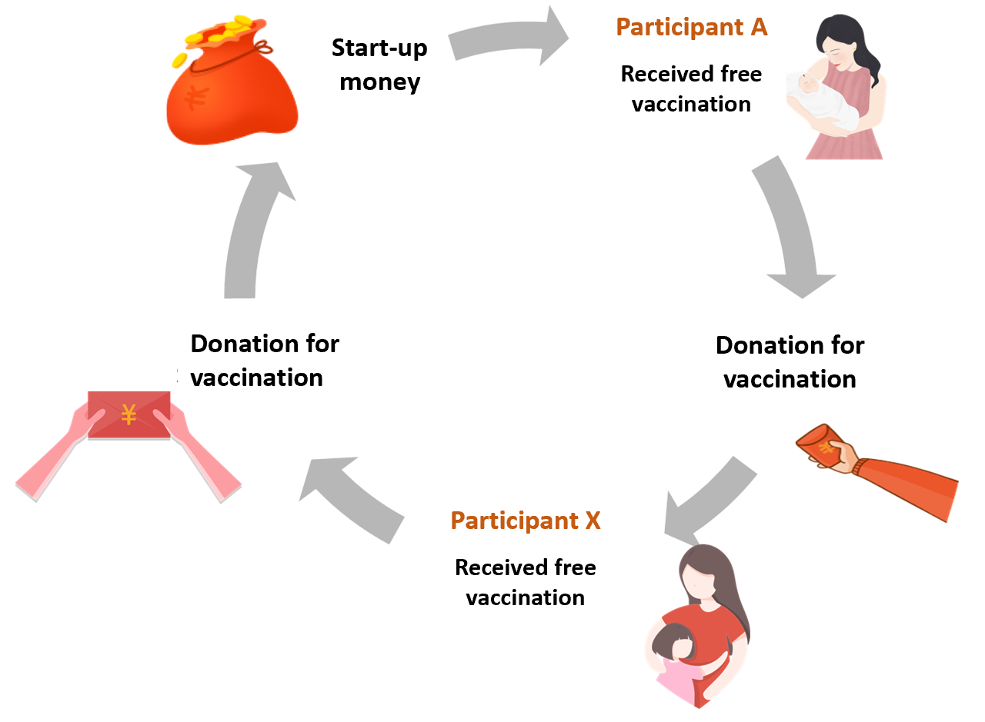
Figure 1: “Pay-it-forward” Model
In this quasi-experimental study, we propose a pay-it-forward approach, aiming to improve influenza vaccine uptake among two key sub-groups, namely children aged between 6 months and 8 years old and older adults aged 60 or above in Guangdong province of China. We determined these two sub-groups based on the disease burden, the national definition of at-risk populations and local clinical practice guidelines. Specific objectives include 1) to examine the effectiveness of pay-it-forward approach on influenza vaccine uptake among Chinese people in comparison to standard-of-care and free vaccination; 2) to conduct an economic evaluation of pay-it-forward on vaccine uptake in comparison to free vaccination and standard-of-care; and 3) to examine factors associated with vaccine uptake, confidence/hesitancy, and other secondary outcomes.
Hypotheses
Our main hypotheses include the following:
- Pay-it-forward can significantly improve the influenza vaccination rate among at-risk populations compared to the standard-of-care arm
- Pay-it-forward is more cost-effective than standard-of-care in terms of cost per person vaccinated.
- Many participants will donate money to support subsequent people to receive a free vaccine.
- Influenza vaccine uptake in the pay-it-forward arm will be similar to that of the free vaccine arm (exploratory).

Methods
Study setting
Guangdong is a subtropical southern province in China with a population over 100 million. In southern China, influenza is prevalent throughout the year with a clear peak in the summer and a less pronounced peak in the winter.¹⁰ In response to the national guideline to provide influenza vaccine to at-risk populations, Guangdong Province has released relevant provincial level policies to promote influenza vaccine. Stockouts of influenza vaccines have been reported in different regions due to tighter quality control of pharmaceutical products after the national vaccine scandal in 2018.¹¹ We also liaised with Sanofi China office and Guangdong Second Provincial General Hospital to help identify study sites that have sufficient influenza vaccines.

Intervention development
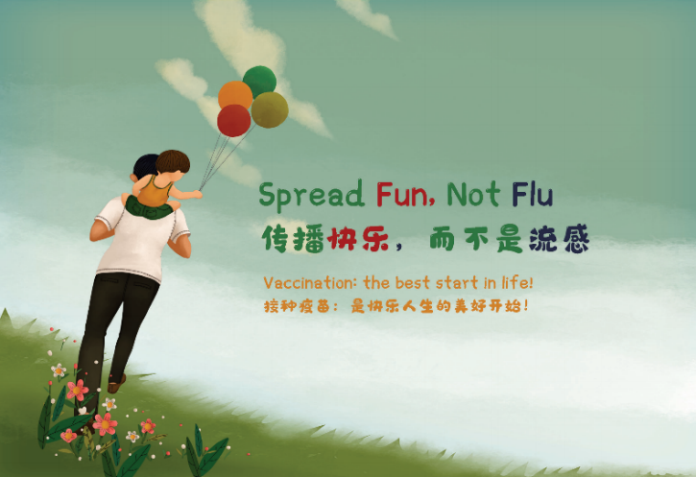
Our team co-created messages as part of a participatory hackathon in Tanzania and a nationwide crowdsourcing open call in China. First, our team worked with diverse individuals as part of a three-day hackathon organized by the Bill and Melinda Gates Foundation and the World Food Program in Tanzania. We identified engagement strategies, including 1) inviting participants to co-create postcard messages for the pre-test (see Fig 2 for an example); 2) organizing a nationwide crowdsourcing open call to engage public in generating health messages focused on influenza and vaccines; 3) engaging local community staff in implementing the pay-it-forward pragmatic trial.
Fig 2: Postcard example
Then, our partner SESH (Social Entrepreneurship to Spur Health) led a nationwide crowdsourcing open contest to solicit messages promoting influenza vaccination. The crowdsourcing open call had five steps – organizing a steering committee to oversee the process, promoting the open call via digital and in-person methods, evaluating submissions (texts, images, videos), celebrating exceptional submissions, and sharing and implementing exceptional ideas. Due to COVID-19, the open call was transitioned to a mostly digital format. The open call website was viewed 7151 times according to analytics. We received a total of 305 submissions, including 204 texts, 90 images, and three videos. All eligible submissions were evaluated by a crowd judge panel and an expert judge panel based on pre-defined criteria (novelty, relevance, feasibility, and elaboration). Crowd judges were invited via social media platforms on a voluntary basis and each submission was judged by at least three independent crowd judges. Experts in public health research, health communication, vaccines, and infectious diseases were invited to the expert panel. Submissions were scored on a 1 to 10 scale and those ranked in the top 15% were deemed exceptional. Some of these messages were integrated into the recruitment pamphlet for the study.
Study population and inclusion criteria
The study will focus on children and older adults. The inclusion criteria of this study are divided into two age groups:
- Parents or guardians of children between six months and eight years old. Each child needed to meet the following eligibility criteria: i) no acute moderate or severe illnesses, ii) eligible to receive an influenza vaccine based on clinical evaluation from a physician; iii) has a legal guardian (e.g. a parent or grandparent) who lives in China and consents to participate in the study; and iv) has not received an influenza vaccine in the past year.
- Older people: i) ≥ sixty years old; ii) no acute moderate or severe illness; iii) eligible to receive an influenza vaccine based on clinical evaluation from a physician; iv) capable of making informed decisions and consenting to participate in the study; and v) have not received an influenza vaccine in the past year.
Study design
In this study, three sites –one in rural Yangshan county, one in the suburban Zengcheng district, and one in urban Guangzhou city will be selected in Guangdong Province for recruitment, to represent the three different economic conditions in Guangdong province. The selected community health centers or vaccination clinics should have established infrastructure to provide influenza vaccination services, e.g. have sufficient influenza vaccine stock, relevant medical personnel including designated physicians and nurses for providing vaccine services. The research design is shown in Figure 3.
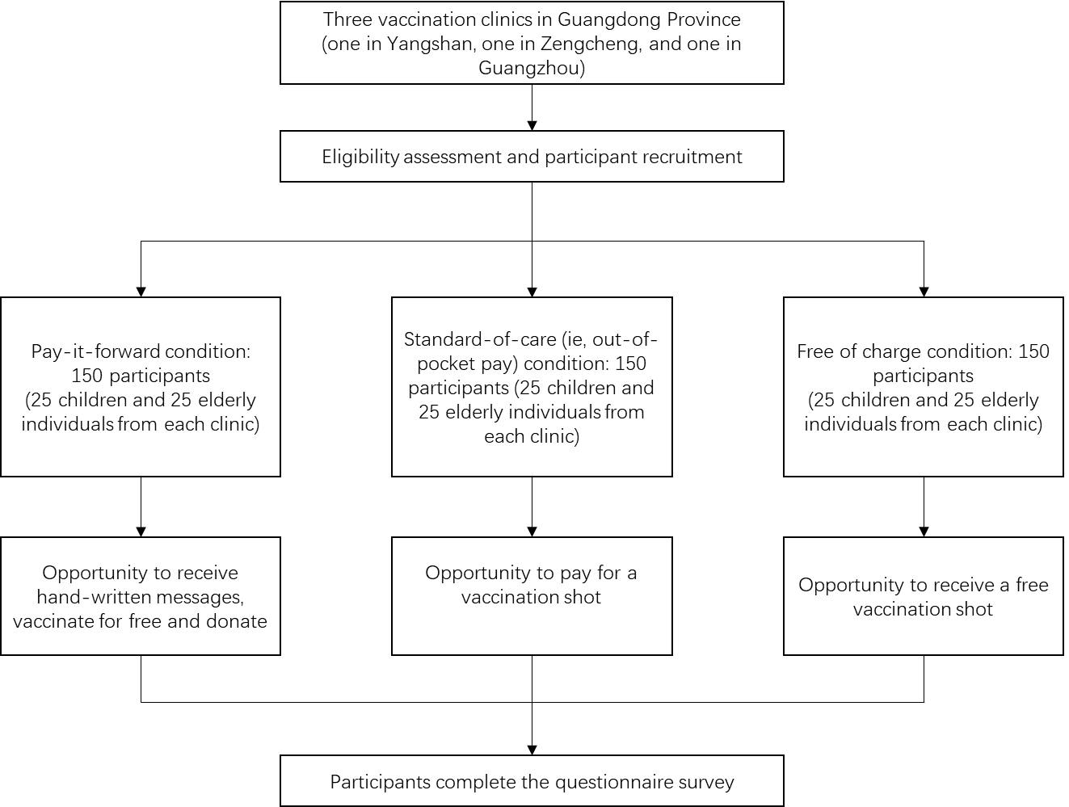
Figure 3: Flowchart of the quasi-experimental study
Sample size
Based on our previous pay-it-forward research and pre-test data, we calculated the sample sizes for both children and older groups. The conservative estimated proportion of vaccine uptake in the standard-of-care group is 0.40. The proportion in the pay-it-forward group is assumed to be 0.5 under the null hypothesis and 0.8 under the alternative hypothesis. To achieve a 90% power to detect a difference between the pay-it-forward and standard-of-care arms among children, 50 children are needed in the pay-it-forward group and 45 children are needed in the standard-of-care group (Figure 4). The test statistic used is the one-sided unpooled Z test. The significance level of the test is 0.025. To allow sub-analysis by age group, we will recruit 25 more children and older individuals respectively for each arm as a boost sample of each age group. In addition, given free vaccination is likely the future of influenza vaccine programs in China, we add a free vaccination arm with an equal number of participants by age group. In summary, 150 participants (75 children and 75 older adults) will be recruited for each arm, totaling 450 participants for the study.

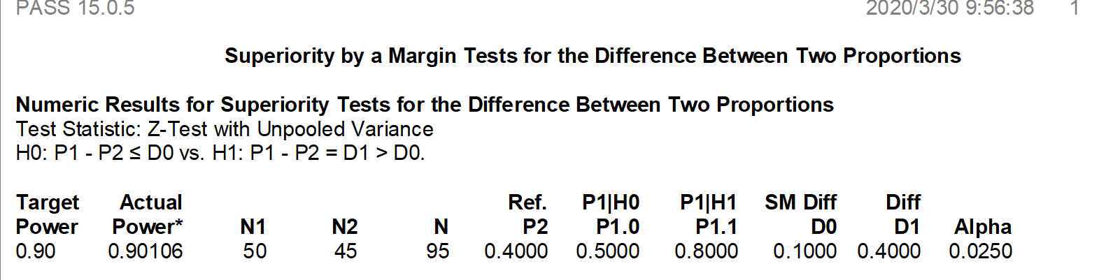
Figure 4: Sample size calculation using PASS 15.0.5.

Sampling and recruitment
The study participants will be recruited in selected vaccination clinics or community health centers. Project staff will assess eligibility based on inclusion criteria as aforementioned and provide educational information about seasonal influenza to all potential participants, ie, guardians of children and older people. Participants will be recruited into three arms, namely standard-of-care (out-of-pocket payment) arm, pay-it-forward arm, and free-of-charge arm at all three sites on a time-based recruitment manner. In order to decrease the effect of temporal trends, we will minimize the time between participants receiving the standard-of-care treatment and participants receiving the pay-it-forward treatment.
Standard-of-care: Participants recruited in the standard care arm will be asked to pay out of pocket in the event of being willing to receive the influenza vaccination shot. Expected sample sizes for both children and older adults in standard-of-care arm are 75 respectively (25 children and 25 older adults from each clinic) (Figure 3).
Pay-it-forward Intervention: Participants recruited during the period of pay-it-forward arm will be informed about the pay-it-forward vaccination program with handwritten warm messages co-created by participating families to enhance public trust and community cohesion (Supplementary files 1 and 2). After introducing the ‘pay-it-forward’ program, the project staff will provide eligible participants with the opportunity to take part, which means one eligible child or older individual can receive an influenza vaccine. The guardian or participant will then be asked whether they are willing to donate any amount of money into the pay-it-forward seed fund to support more future users to receive the same vaccination service. A donation collection box will be provided on site for those who prefer to donate cash and a WeChat QR code (a multifunctional social mobile app embedded with monetary transaction functions) will be provided to those who prefer online donation to the program. Neither the willingness to donate nor the amount of donation will affect them receiving the influenza vaccination services for free. The microdonations will be used to support future users and usage will be publicized periodically. Expected sample sizes for both children and older adults in pay-it-forward arm are 75 respectively (25 children and 25 older individuals from each clinic) (Figure 3).
Free-of-charge: Participants will be invited and provided a free influenza vaccine but they will not receive any community created messages about the pay-it-forward program. Expected sample sizes for both children and older adults in free-of-charge arm are 75 respectively (25 children and 25 older individuals from each clinic) (Figure 3).
Participation in each arm is fully voluntary and anonymous. Access to other vaccination and medical services in the clinic will not be affected in any way due to the project. All participants will complete a short questionnaire survey to collect information about demographic backgrounds, prior influenza vaccine history, information about participating pay-it-forward program (pay-it-forward arm only), and confidence and hesitancy in influenza vaccines.
Data collection
Written consent form will be obtained from all participants. This study will collect the following information: data recorded by the project staff using standard information tracking sheet including the number of invited and participating individuals, the number of participants who receive a vaccine, the number of individuals who donate and donation amount in the pay-it-forward arm, as well as survey data through the self-administered online questionnaire. Those who have difficulty in reading the questionnaire survey will be assisted by the project staff on-site. A small gratitude gift worth of around 1 GBP will be given to each participant after completing the questionnaire survey.
Outcomes
The primary outcome of the study will be influenza vaccine uptake in each arm after the intervention. This will be assessed by administrative records. Secondary outcomes include costs outcomes, vaccine confidence, vaccine hesitancy, and adverse events by administrative records. The main comparison will be between the three arms – standard of care, pay-it-forward, and free vaccine. Outcomes will also be stratified by age group (children and older people) and study sites.
Data analysis
Descriptive analyses of demographic and behavioral characteristics, participation rate, vaccination rate in each arm will be conducted. We will compare the vaccination rate between standard of care, pay-it-forward, and free-of-charge arms using chi-squared test and logistic regression, reported as crude odds ratios (cOR) and adjusted odds ratios (aOR), by adjusting for education, employment status, and study sites. We choose these covariates because they are potential confounders. We will use descriptive statistics to report the participants’ awareness, prior influenza vaccination history, confidence and hesitancy in influenza vaccines, contributions to future participants in the pay-it-forward arm, and the fraction of the total cost of vaccination covered by pay-it-forward.
Secondary analyses
In addition to the pre-specified comparisons above, a decision-tree model will be built to analyze the within-trial costs outcomes of pay-it-forward in comparison to standard-of-care and free vaccination. We will use a healthcare provider perspective and the time horizon of the trial. A micro-costing approach will be used for the cost collection, including the start-up costs related to the pay-it-forward arm. We will examine factors associated with vaccine uptake in the standard-of-care arm and intervention arms. We will also determine factors associated with vaccine confidence and vaccine hesitancy in the standard-of-care group and overall.
Risk assessment and management
According to the World Health Organization reports, influenza vaccines are well tolerated, and side effects are mild and transient in general. Common adverse events include soreness, redness, and/or swelling at the vaccination site, fever, muscle pain, headache, nausea which do not require medical attention.¹² Severe threatening allergic reaction after vaccination, such as difficulty breathing, hoarseness or wheezing, swelling around the eyes or lips, hives, paleness, weakness, or a fast heart beat or dizziness, are rare. These signs most likely happen within a few minutes to a few hours after the vaccine is given. Participants who receive a vaccine will be required to stay at least half an hour in the vaccination clinic to be closely monitored by a designated nurse. They will be informed to self-monitor signs mentioned above for a few more hours after they leave the clinic. The contact number to a designated physician from the selected clinic will be provided to participants as emergency contact in the event of any severe adverse effects within 24 hours after the vaccination.
Withdrawal of participants
Participants can withdraw from the study at any time without giving any explanations. Withdrawal from the study would not affect the participant’s medical care or other preventive services at the clinic in any way.
Reporting of adverse events
The local CDCs and vaccination clinics have established a strong surveillance system to monitor any adverse events associated with vaccinating patients. Each patient who receives an influenza vaccine is recorded in the clinical health information system and uploaded to the local CDCs’ surveillance system. Patients with any adverse events will be dealt with by local health staff on a timely manner. The research team will leverage their existing platform for reporting any adverse events and keep a tracking record of adverse events. The research team will periodically meet with the designated health workers to make sure adverse events are properly treated.
Data management
Data will be managed according to the principles in accordance with good research practice specified by LSHTM Research Data Management Policy.¹³ All data will be kept confidential and accessible only to trained study staff. All consent forms, administrative and survey data will be transformed into digital format and data in non-digital formats will be stored in a securely locked cabinet at local institutes (Guangdong Second Provincial General Hospital in Guangzhou). Paper questionnaires will be filed and stored for at least 10 years after project completion as per LSHTM’s Records Retention and Disposal Schedule. Study databases will be managed by a dedicated data manager (DM). All data will be checked and cleaned before being updated to the main database. The databases will be regularly backed up on the local server where back-ups are maintained in the disaster recovery room. Copies of the databases will be transferred to LSHTM using the fully encrypted (SSL) server.
The main risks to data security relate to loss of electronic data and breach of participant confidentiality. With the acquisition of a dedicated office, all data on computers will be stored in this office which will be locked overnight. Only data entry personnel and study personnel will have access to any of the electronic data. After all checks have been completed, data will be entered into databases using desktops. The data manager will upload double entered data at the end of each day onto their computer. The Data Manager will create weekly back-ups on an external password protected hard drive. When necessary or required, and copies of this data will be securely transferred to LSHTM using encrypted files. The risks for confidential breaching are minimal since most data will use anonymized IDs unique to each participant. We will ensure that all copies of the quantitative data files are password protected, with access to the password restricted to staff who need to work with the data. Also, we will report study results only at the aggregate level. To further minimize the risk of breaching confidentiality, all study staff will be trained and certified as part of MENISCUS-1 using the NIH online training course in Protecting Human Subject Research Participants and will be required to sign a staff confidentiality agreement form.
Audits and inspections
The study may be subject to audit by the London School of Hygiene & Tropical Medicine under their remit as sponsor, the Study Coordination Centre and other regulatory bodies to ensure adherence to GCP.
Insurance provision
Trial insurance is covered by the trial sponsor.
DSMB
Given the low risks associated with a quasi-experimental study to improve existing public health service uptake, we believe having the project team as well as designate a data manager to meet periodically and monitor the data safety would suffice. DSMB will not be assembled in this particular project.
Trial registration
This study was initially registered on Chinese clinical trials in September 2020. The proposal was last updated on 9 February 2021.
Ethics
We have obtained ethical approvals from Zhuhai CDC and the LSHTM ethics committee.
Publication
As per the funder’s requirement, we will publish articles from this study on an open access basis.
Confidentiality
Each participant will be assigned a unique ID and personal identifiable information will not be collected. Participant survey data will only be used for research purpose of this particular project. Participant survey data will be transformed into digital format and copies of the quantitative data files will be password protected. Only designated project staff will have access to this encrypted information. We will report study results only at the aggregate level which will be difficult for others to identify individual participants. Without participant permission, project team researchers will not share the information to a third party.
Project timeline
This will be an 18-month project. The proposed activities and time periods are as below.
 | Proposed activities and time periods
 | Year 1 |  |  | Year 2
Quarter | Q1 | Q2 | Q3 | Q4 | Q1 | Q2
Develop subcontracts and obtain ethical approval
Recruit participants for standard care arm
Recruit participants for pay-it-forward arm
Recruit participants for free-of-charge arm
Data entry and cleaning
Data analysis
Writing the report and disseminate findings

Summary of Protocol Changes
- Version 2, April 14, 2020. We added a free vaccination arm and revised the total estimated number of participants from 200 to 300. We increased the sample size by 50% to allow for secondary analyses, resulting in a sample size of 75 for each age group in each arm with a total sample size of 450.
- Version 3, February 9, 2021. Shenzhen study site was removed because of logistic difficulties. Instead, we confirmed availability of influenza vaccine at an alternative urban site in Guangzhou City. We added a section on intervention development. We clarified the secondary outcomes (factors associated with vaccine uptake, vaccine confidence and hesitancy, and economic evaluation). We added the China clinical trial number.

Reference
1. China CDC. Technical guideline for influenza vaccination in China 2018. http://www.chinacdc.cn/jkzt/crb/bl/lxxgm/jszl_2251/201809/t20180921_194050.html (accessed 19 Nov 2019).
2. Li L, Liu Y, Wu P, et al. Influenza-associated excess respiratory mortality in China, 2010–15: a population-based study. The Lancet Public Health 2019; 4(9): e473-e81.
3. Yang J, Atkins KE, Feng L, et al. Seasonal influenza vaccination in China: Landscape of diverse regional reimbursement policy, and budget impact analysis. Vaccine 2016; 34(47): 5724-35.
4. Hospital BJCs. Vaccination fraud alarmed the central government! In addition to anger, you should also understand these. CN-Healthcare. 2018.
5. Kala W. Pregnant women are facing dilemma: both priority and contraindication for influenza vaccine. 2019 (accessed 22 Jan 2020).
6. Wu S, Su J, Yang P, et al. Factors associated with the uptake of seasonal influenza vaccination in older and younger adults: a large, population-based survey in Beijing, China. BMJ open 2017; 7(9): e017459-e.
7. Song Y, Zhang T, Chen L, et al. Increasing seasonal influenza vaccination among high risk groups in China: Do community healthcare workers have a role to play? Vaccine 2017; 35(33): 4060-3.
8. Li KT TW, Wu D, et al. . Pay it forward gonorrhea and chlamydia testing among men who have sex with men in China. Presented at: Yale Institute for Network Science. New Haven; 2018.
9. Ciocarlan A, Masthoff J, Oren N. Kindness is contagious: Study into exploring engagement and adapting persuasive games for wellbeing. Proceedings of the 26th Conference on User Modeling, Adaptation and Personalization; 2018: ACM; 2018. p. 311-9.
10. Shu Y-L, Fang L-Q, de Vlas SJ, Gao Y, Richardus JH, Cao W-C. Dual seasonal patterns for influenza, China. Emerging infectious diseases 2010; 16(4): 725-6.
11. Xueqiao W, Tom H. China pharma crackdown leads to flu vaccine shortage. 2018. https://www.ft.com/content/6829cd0e-f07b-11e8-ae55-df4bf40f9d0d (accessed 19 Jan 2020).
12. WHO. Information sheet: Observed rate of vaccine reactions - Influenza vaccine. . 2012. https://www.who.int/vaccine_safety/initiative/tools/Influenza_Vaccine_rates_information_sheet.pdf (accessed 19 Jan 2020).
13. LSHTM. Research data management policy. 2019. https://www.lshtm.ac.uk/sites/default/files/research_data_management_policy.pdf (accessed 19 Jan 2020).

Supplementary file 1: Pay-it-forward leaflet
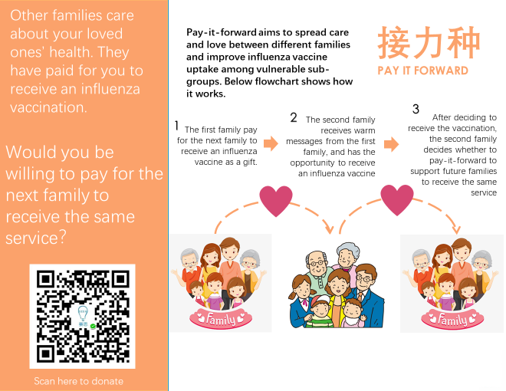

Supplementary file 2: Examples of hand-written messages
