Supplementary Figures
Point Prevalence of the 10 Most Common Mental Health Conditions in Nigeria: A Systematic Review and Meta-analysis
These plots provide the study-level detail supporting the pooled estimates in the main manuscript. Estimates should be interpreted within their stated condition, case definition, population and recall window.
Supplementary Figure S1
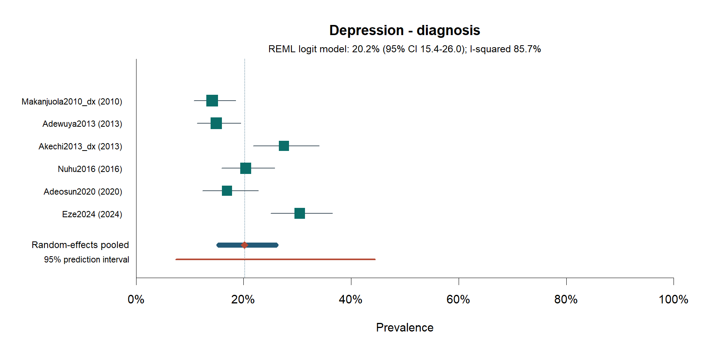
Figure S1. Forest plot: current depression—diagnostic definition.

Supplementary Figure S2
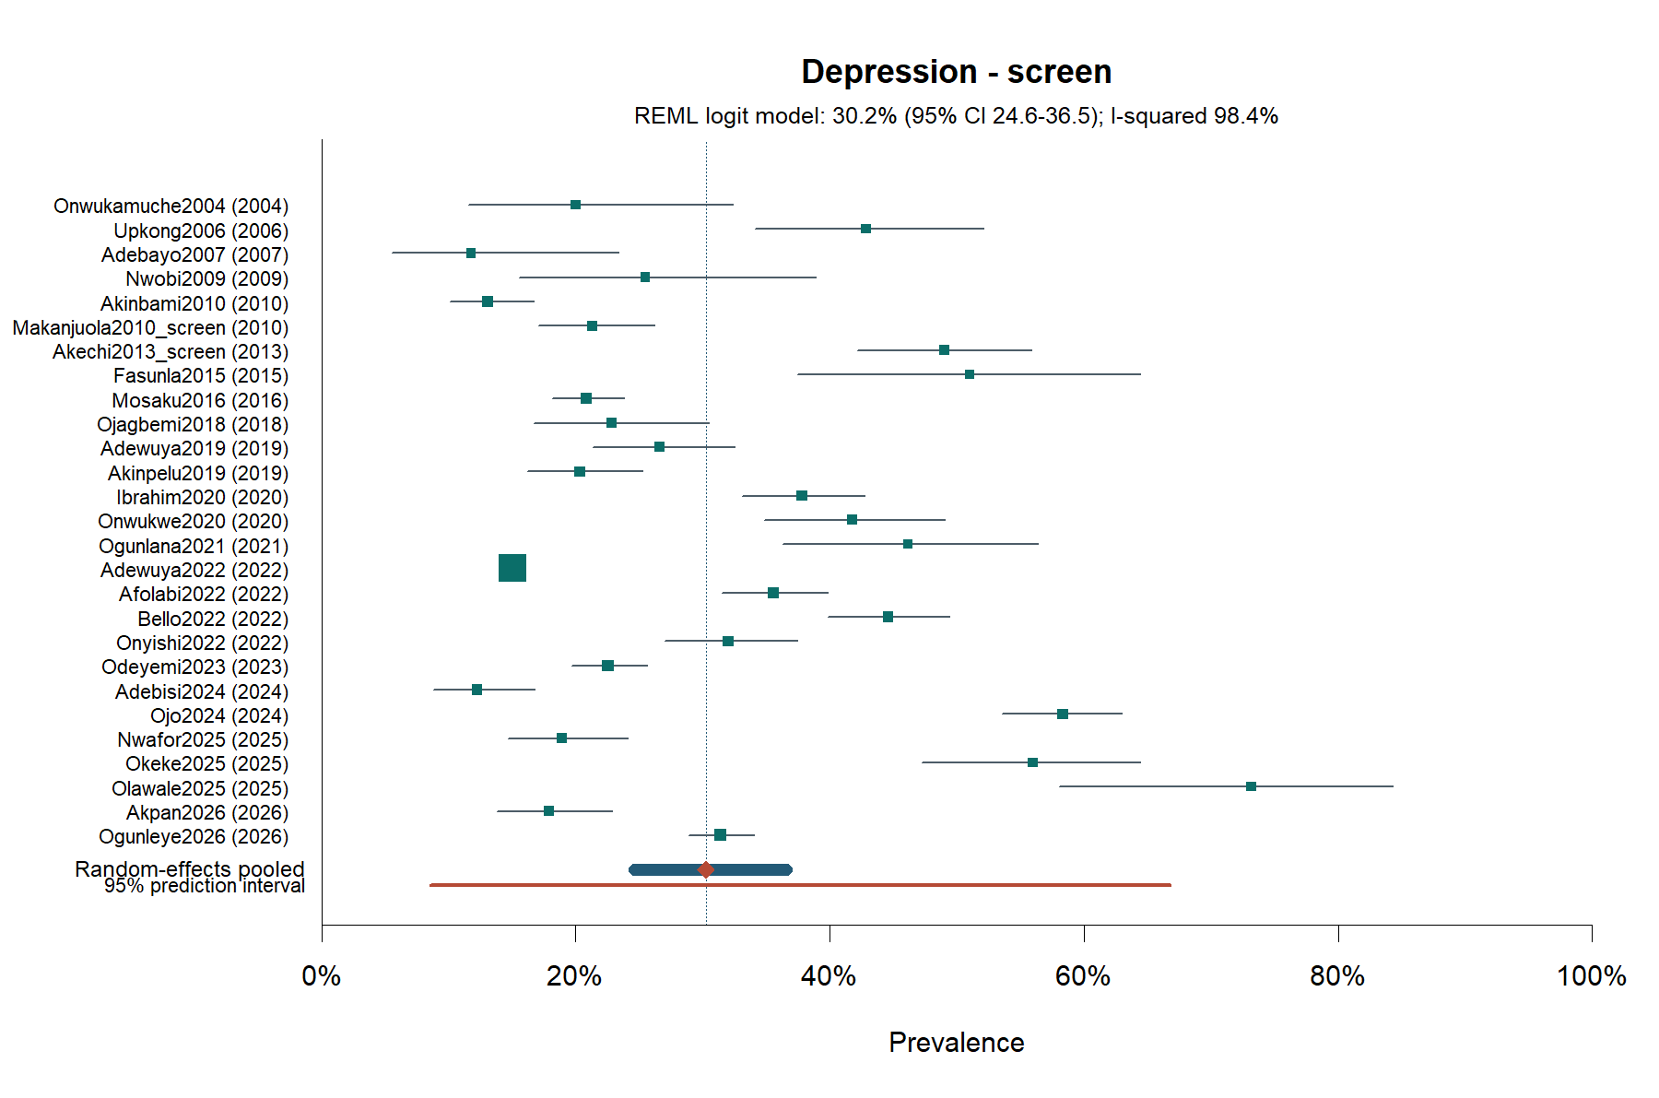
Figure S2. Forest plot: current depression—screening threshold.

Supplementary Figure S3
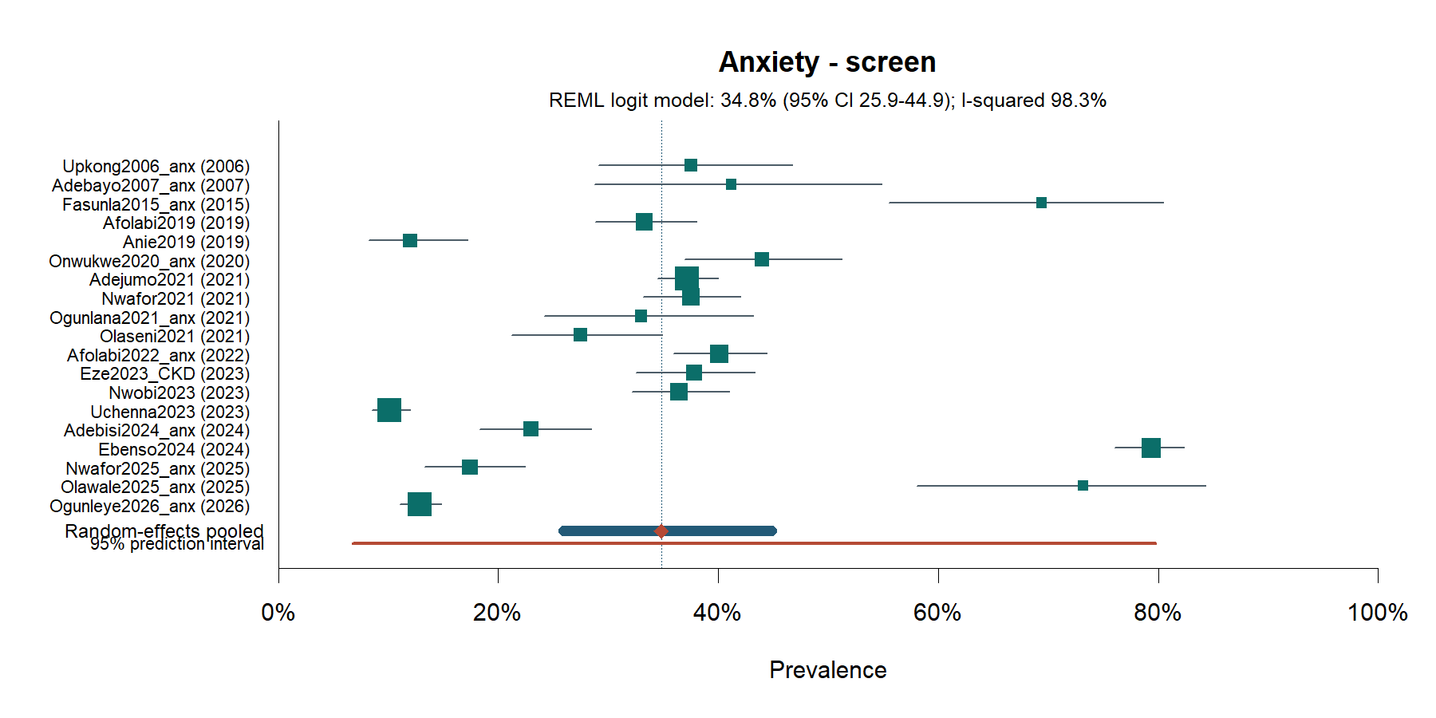
Figure S3. Forest plot: current anxiety—screening threshold.

Supplementary Figure S4
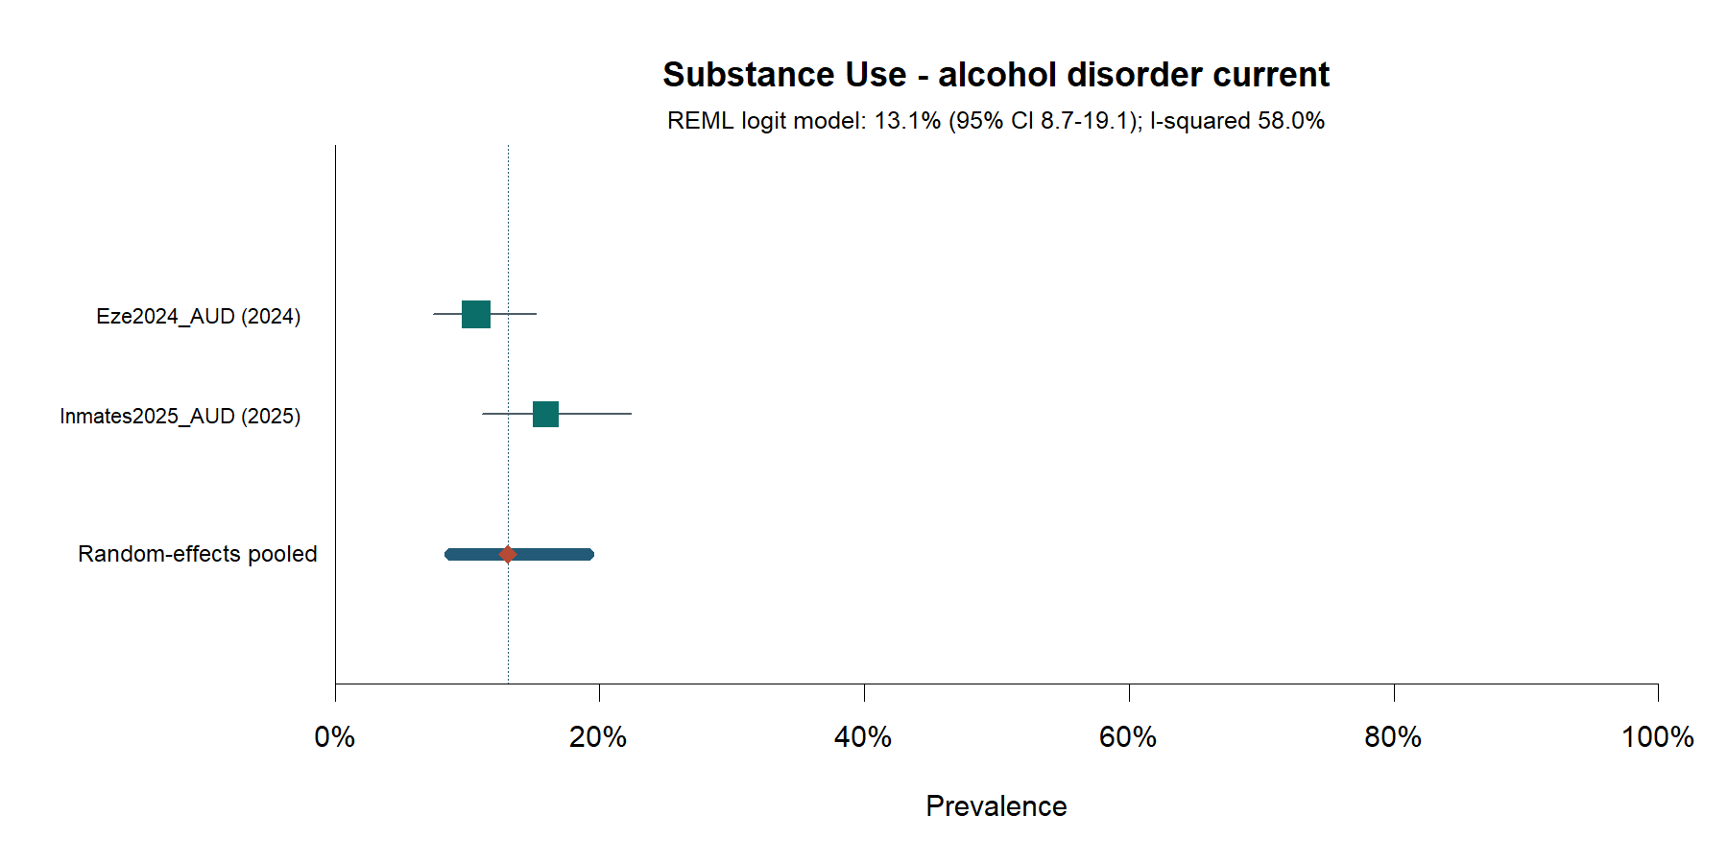
Figure S4. Forest plot: current alcohol-use disorder.

Supplementary Figure S5
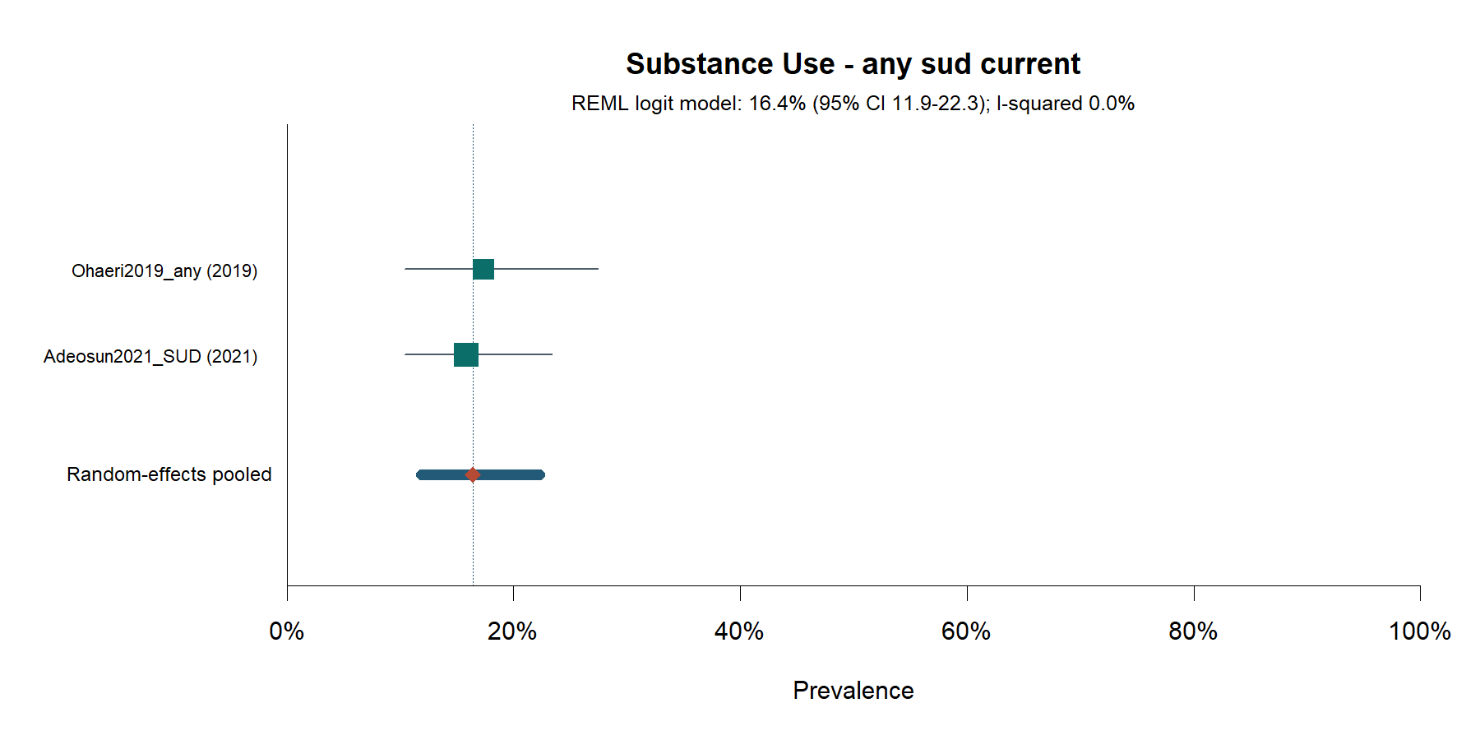
Figure S5. Forest plot: current substance-use disorder, any substance.

Supplementary Figure S6
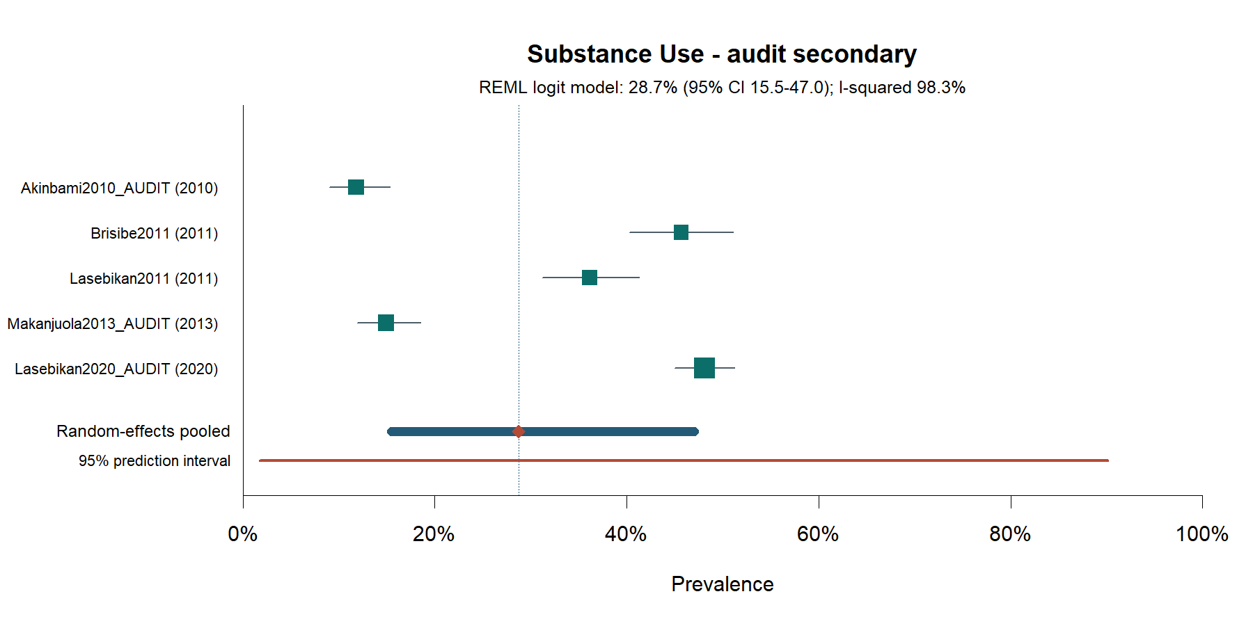
Figure S6. Forest plot: secondary AUDIT-defined harmful or hazardous alcohol use.

Supplementary Figure S7
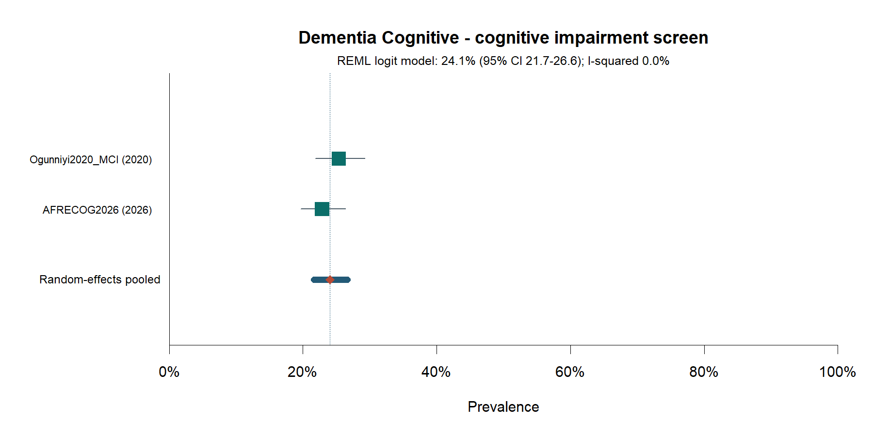
Figure S7. Forest plot: current cognitive impairment—screening threshold.

Supplementary Figure S8
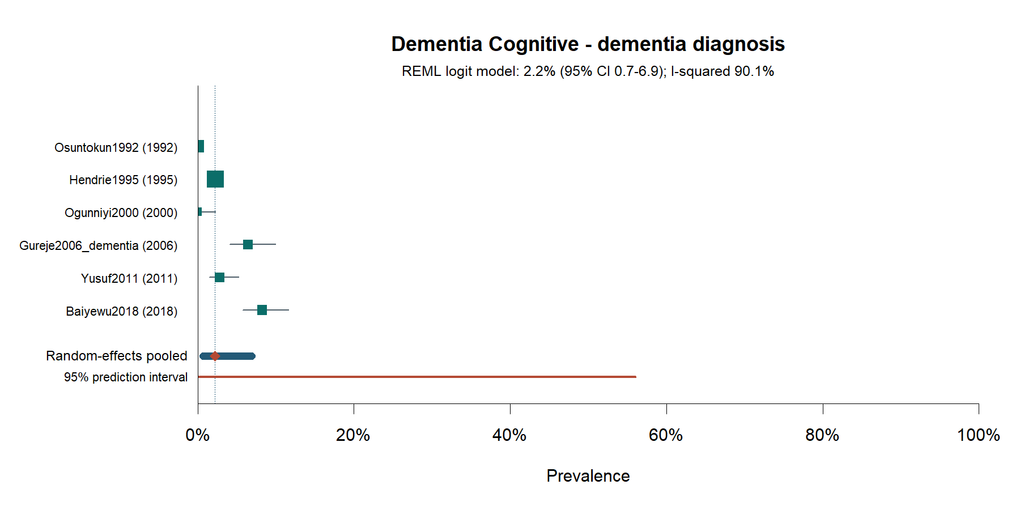
Figure S8. Forest plot: current dementia—diagnostic definition.

Supplementary Figure S9
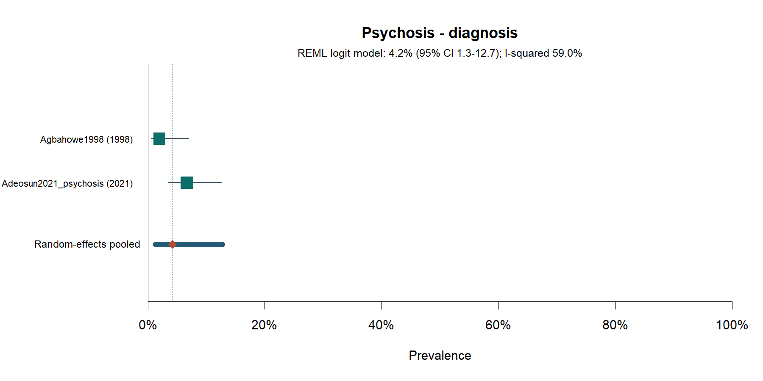
Figure S9. Forest plot: current psychosis—diagnostic definition.

Supplementary Figure S10
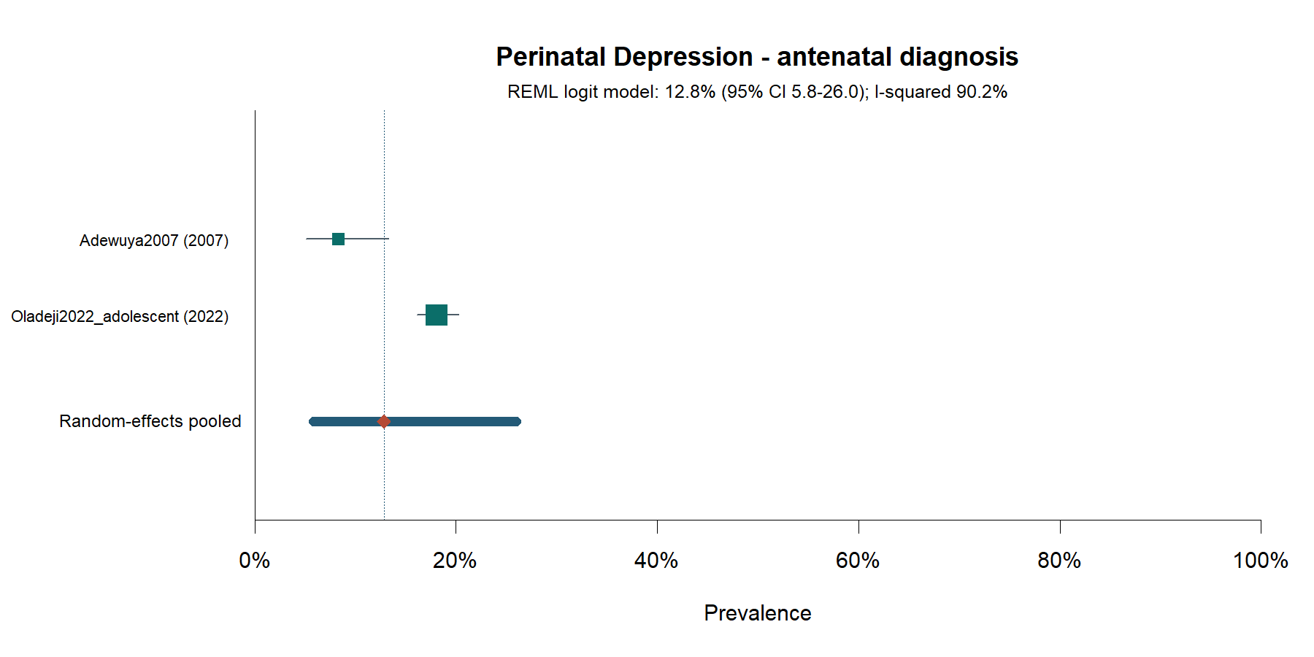
Figure S10. Forest plot: antenatal depression—diagnostic definition.

Supplementary Figure S11
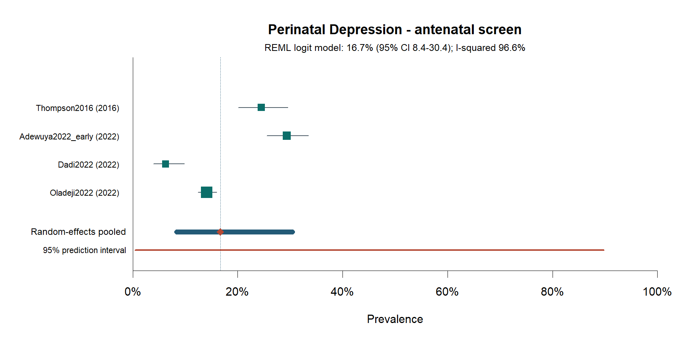
Figure S11. Forest plot: antenatal depression—screening threshold.

Supplementary Figure S12
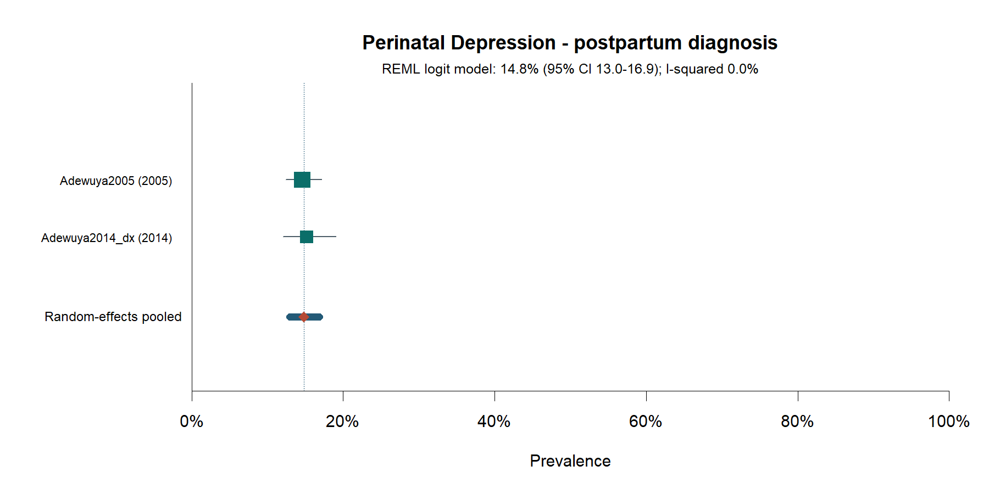
Figure S12. Forest plot: postpartum depression—diagnostic definition.

Supplementary Figure S13
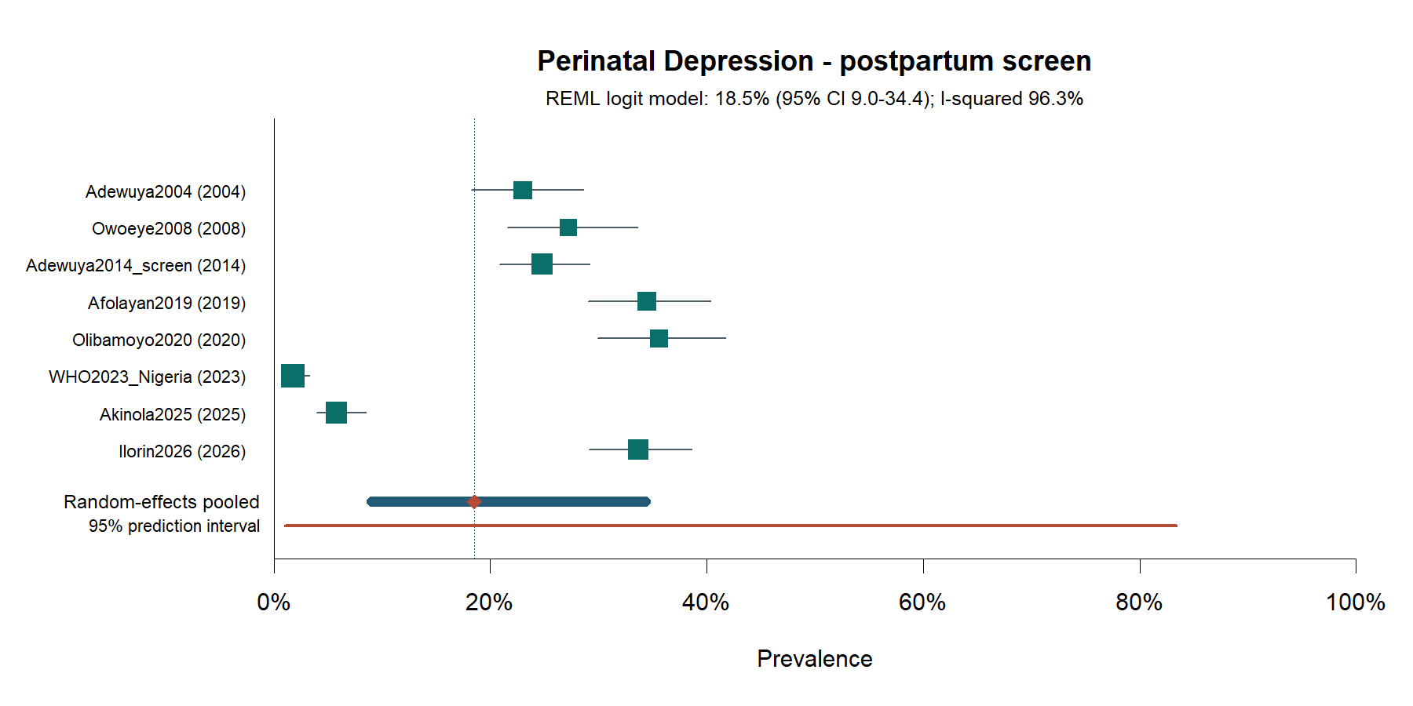
Figure S13. Forest plot: postpartum depression—screening threshold.

Supplementary Figure S14
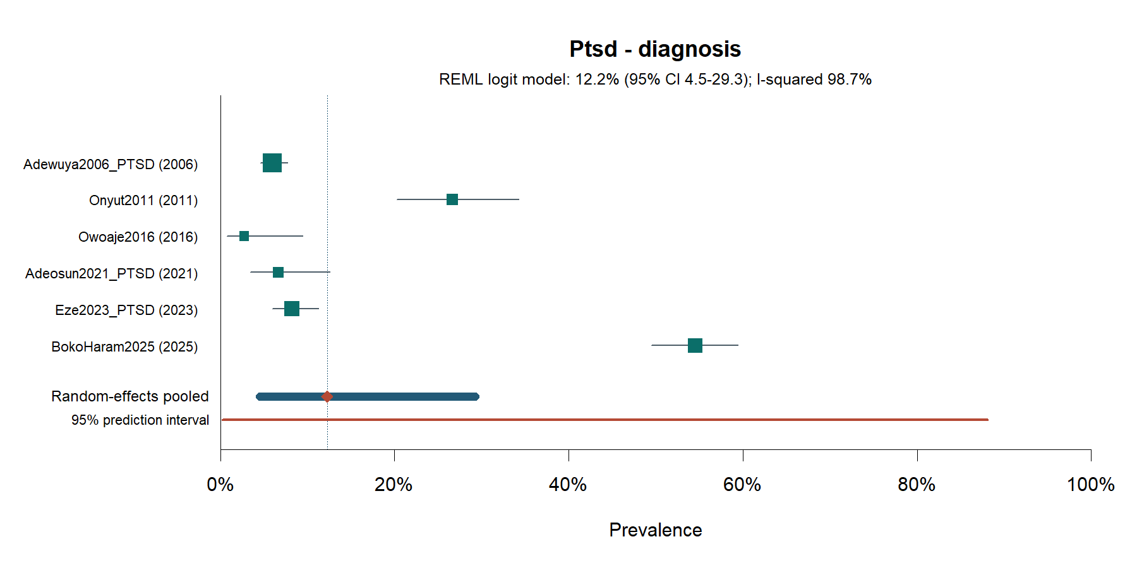
Figure S14. Forest plot: current post-traumatic stress disorder—diagnostic definition.

Supplementary Figure S15
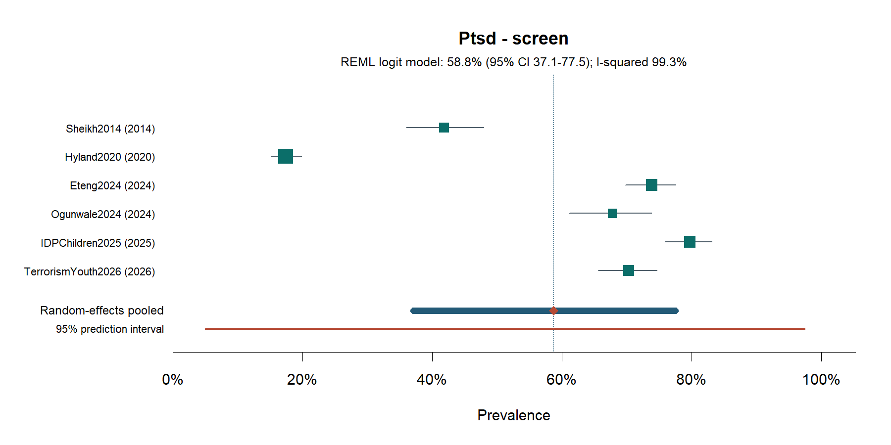
Figure S15. Forest plot: current post-traumatic stress disorder—screening threshold.

Supplementary Figure S16
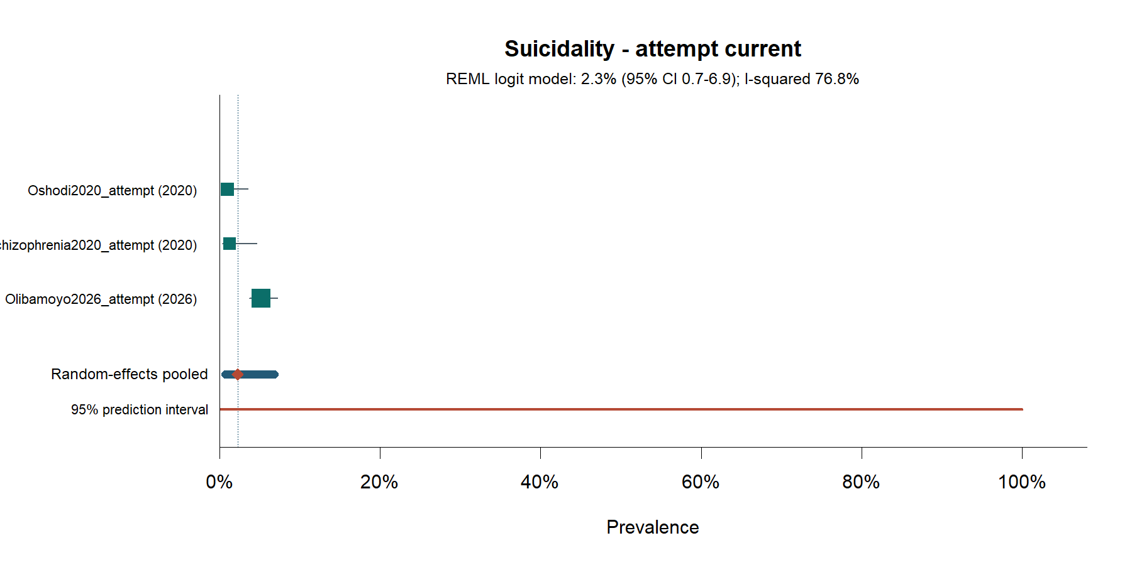
Figure S16. Forest plot: current suicide attempt.

Supplementary Figure S17
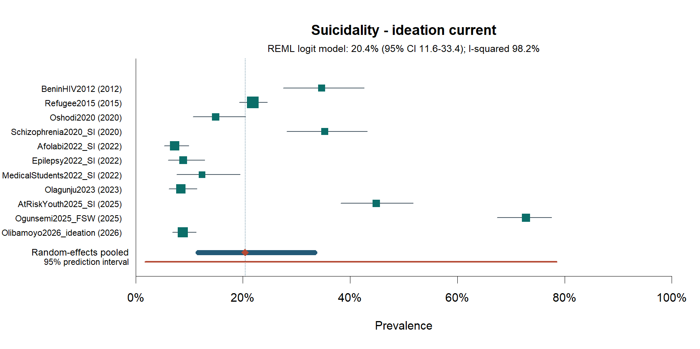
Figure S17. Forest plot: current suicidal ideation.

Supplementary Figure S18
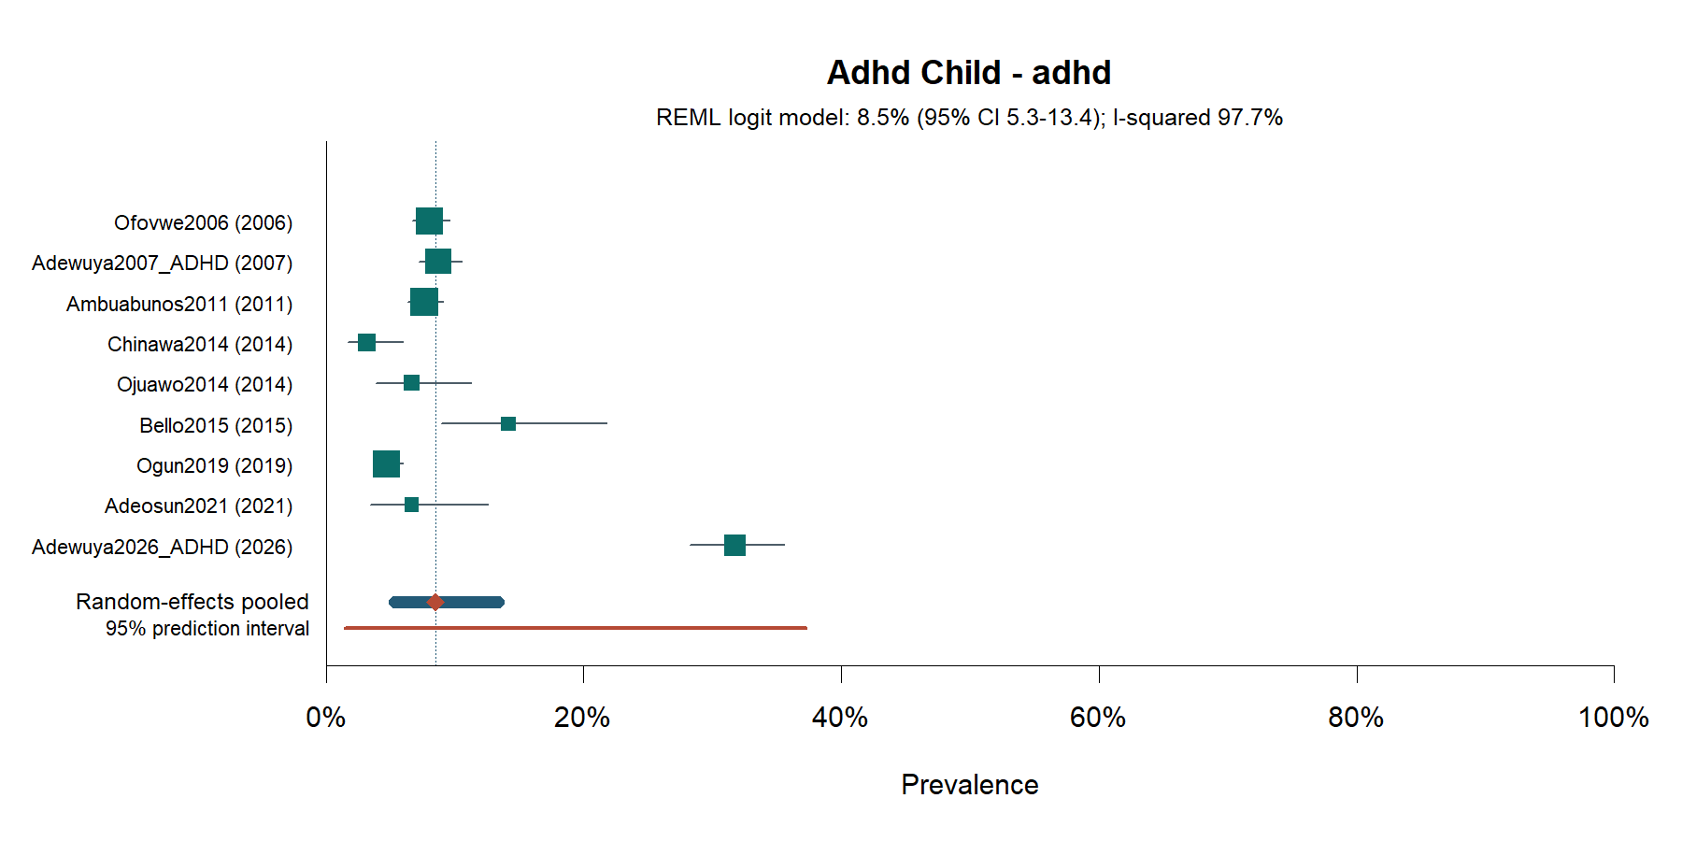
Figure S18. Forest plot: current attention-deficit/hyperactivity disorder in children and adolescents.

Supplementary Figure S19
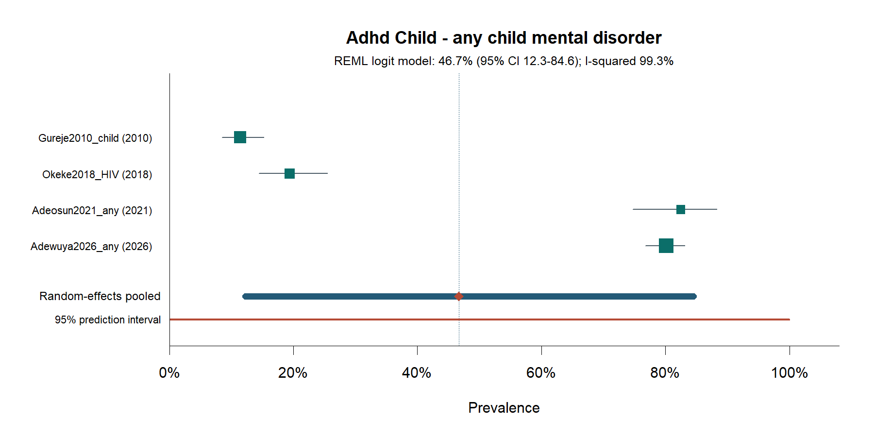
Figure S19. Forest plot: current mental disorder, any definition, in children and adolescents.

Supplementary Figure S20
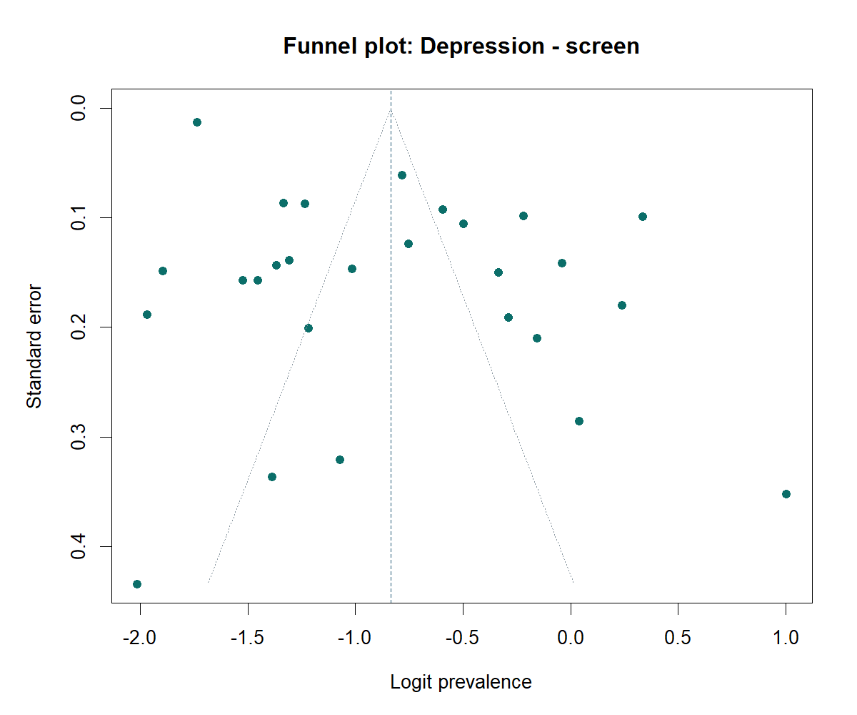
Figure S20. Funnel plot: current depression—screening threshold.

Supplementary Figure S21
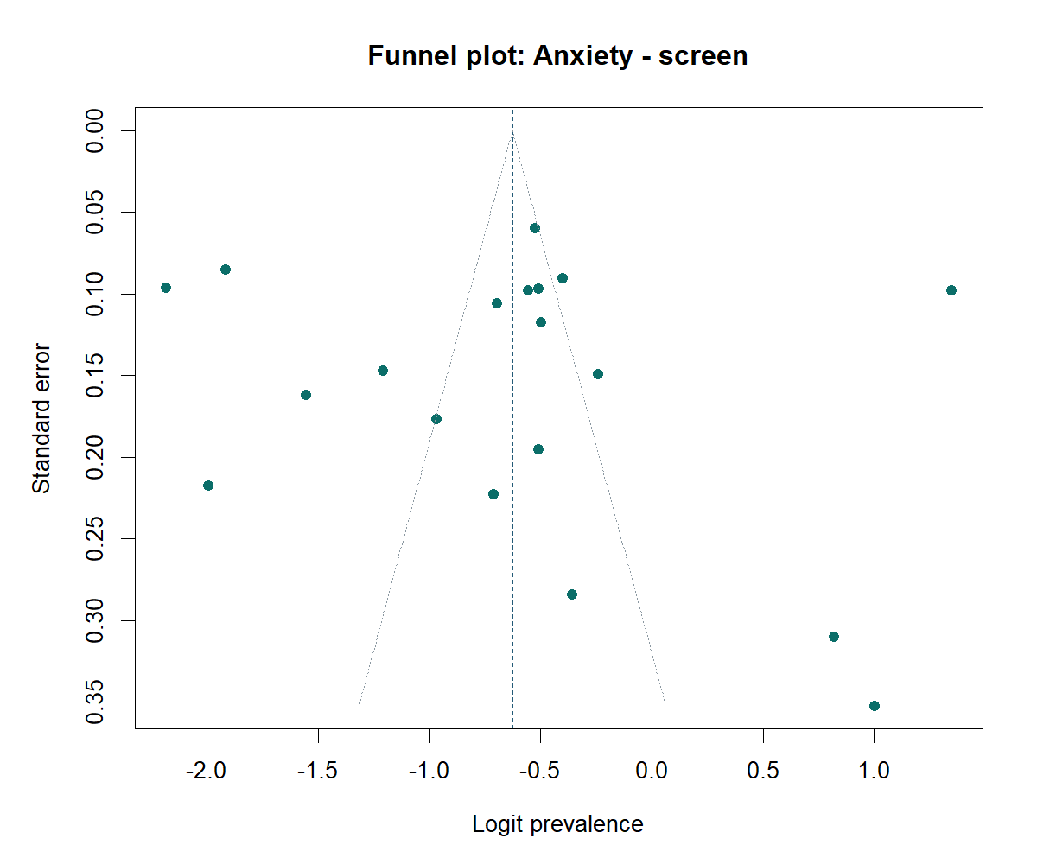
Figure S21. Funnel plot: current anxiety—screening threshold.

Supplementary Figure S22
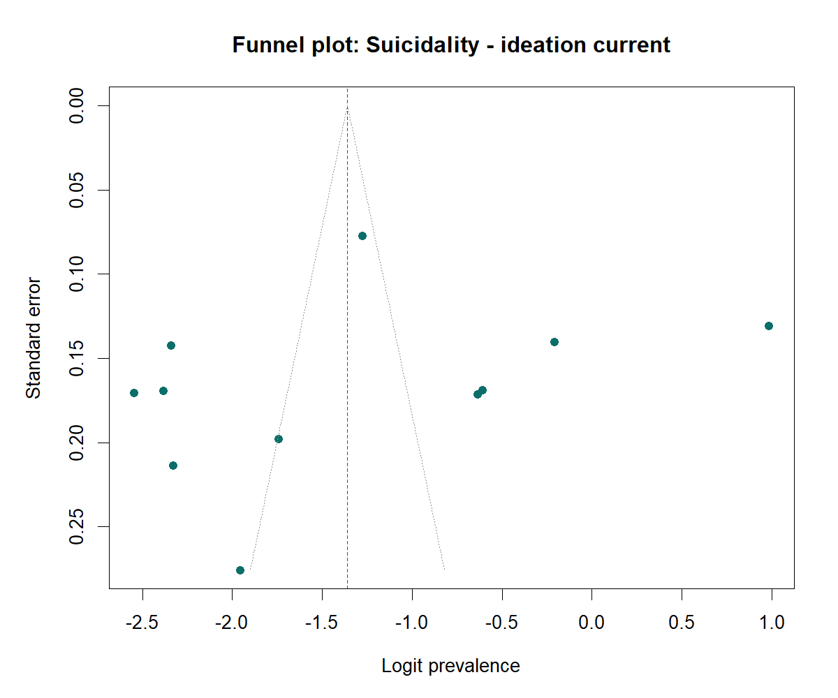
Figure S22. Funnel plot: current suicidal ideation.

