Supporting Information

This Supporting Information provides additional experimental data and characterization results supporting the structural evolution and generality discussed in the main text.
Supplementary figures include morphological comparisons across different monomer systems, additional structural characterization, and thermal and chemical stability analyses. These data further support the diffusion–reaction-controlled mechanism and the decoupling between apparent morphology and internal packing density.

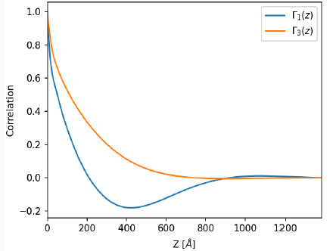
Figure S1 | Correlation-function analysis of the SAXS profile of TTPA–IL.
Correlation-function analysis performed on the SAXS profile of TTPA–IL. The analysis yields a characteristic hard-domain size of approximately 31 nm and a long-period correlation of approximately 108 nm. These values suggest structural correlations extending beyond the characteristic ~12 nm periodicity identified from the SAXS reflections.

Figure S2 | Comparison of morphology in TPA-based systems.
Polarized optical microscopy (POM) images of polymer structures derived from TPA–DBT, TPA–IL, and TTPE–IL systems. Samples were treated by sonication in isopropanol for 10 minutes prior to observation. Differences in morphology reflect the influence of solvent environment and reaction conditions on structure formation.

Figure S3 | X-ray diffraction analysis of different polymer systems.
Powder X-ray diffraction (PXRD) patterns of representative systems, including TPA–DBT, TPA–IL, and TTPE–IL. Characteristic interlayer spacings are observed in the range of ~3.9–4.1 Å, indicating that local packing is preserved despite differences in morphology, consistent with the conclusions in Figure 6. Minor additional peaks are attributed to residual or confined BMIM–PF₆ species associated with the polymer structures under ionic liquid conditions.

Figure S4 | SEM comparison across different systems.
Scanning electron microscopy (SEM) images of polymer structures obtained from TPA–IL, TPA–DBT, and TTPE–IL systems. Variations in morphology demonstrate the effect of reaction environment and monomer reactivity on structural evolution.

Figure S5 | Internal structural heterogeneity across different systems.
STEM–SEM images of representative polymer systems, including TPA–IL, TPA–DBT, and TTPE–IL. Contrast differences within particles indicate spatially heterogeneous internal organization under non-equilibrium conditions. The relative contributions of molecular orientation, mesoscale order and local composition cannot be distinguished from these data alone. These observations complement the cross-sectional FIB–SEM analysis (Figure 4), which confirms the solid nature of the particles.
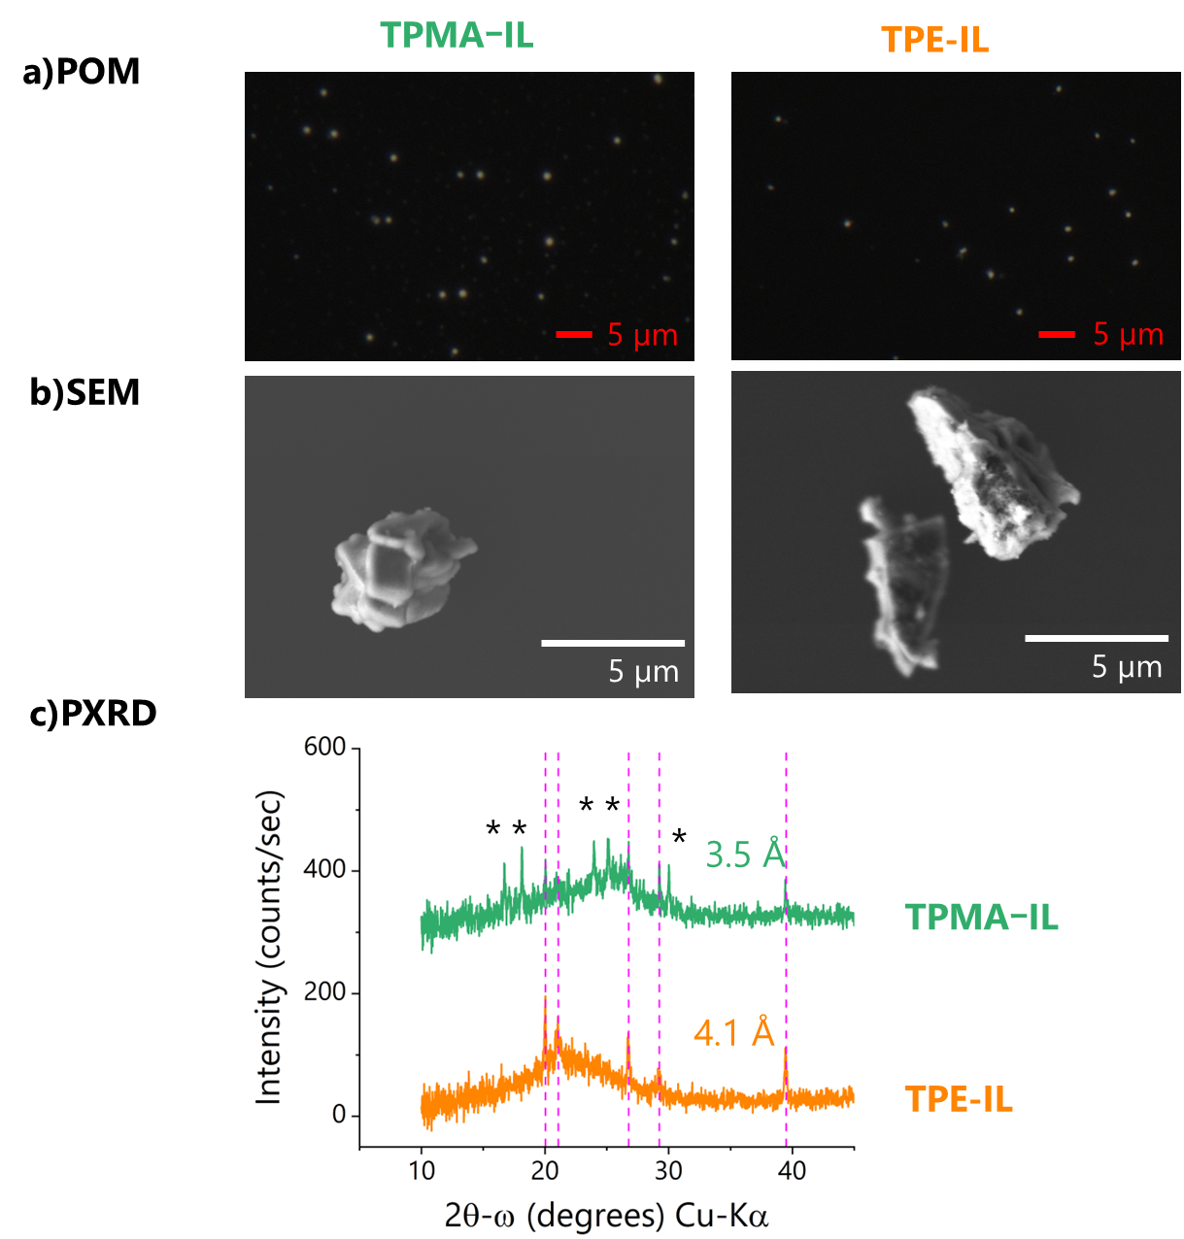

Figure S6 | Structural characterization of low-reactivity systems.
POM, SEM, and PXRD data for TPMA–IL and TPE–IL systems. These systems exhibit planar lamellar morphologies and characteristic interlayer spacings, consistent with diffusion-dominated growth under low effective-Damköhler-number conditions. Additional peaks (marked with asterisks) observed in the PXRD patterns are attributed to confined BMIM–PF₆ species, which remain associated with the polymer structures under ionic liquid conditions, particularly in lower-reactivity systems where polymer network formation is less dense.

Figure S7 | Correlation between density and molecular packing across different polymer systems.
True density values measured by helium pycnometry are compared with interlayer spacings obtained from PXRD. A dashed line is added as a guide to the eye to highlight the inverse correlation between interlayer distance and density. When the ester systems (TPE-IL and TTPE-IL) are considered separately, the data show an approximately linear trend, suggesting a possible difference in intercept between ester and amide systems. These results indicate that density is primarily governed by local molecular packing rather than macroscopic morphology.

Figure S8 | Chemical stability under acidic conditions.
Optical microscopy images of polymer particles after exposure to concentrated sulfuric acid under crossed and parallel polarizers. The preservation of morphology indicates high chemical stability of the formed covalent networks.

Figure S9 | Thermal stability of polymer particles.
Thermogravimetric analysis (TGA) curves measured under inert (Ar) and oxidative (Ar/O₂) atmospheres for representative systems. The materials exhibit high thermal stability characteristic of aromatic polymer structures.

Supplementary Note | Effective reaction–transport parameter
In the present study, the Damköhler number is used as an effective, qualitative descriptor of the competition between bond-formation kinetics and mass transport during phase-transition polymerization. A rigorous determination of $Da$ would require independently measured reaction-rate constants, diffusion coefficients in the evolving reaction medium, and a physically defined characteristic transport length scale. These quantities are not directly accessible under the present heterogeneous polymerization conditions. Accordingly, no absolute $Da$ values are assigned. Instead, increasing temperature and monomer reactivity are considered to increase the effective reaction-to-transport ratio, shifting the system from a diffusion-dominated regime that favours lamellar growth towards a reaction-dominated regime associated with three-dimensional particle formation.

