Supplementary data
Table S1. Confusion matrix for the 2024 LULC classification
Reference Class | Forest | Water | Built-up | Bare Land | Grassland | Agriculture | Total | PA (%)
Forest | 9845 | 0 | 0 | 6 | 40 | 163 | 10054 | 97.92
Water | 0 | 7326 | 0 | 3 | 0 | 0 | 7329 | 99.96
Built-up | 0 | 0 | 1181 | 4 | 0 | 60 | 1245 | 94.86
Bare Land | 30 | 0 | 10 | 252 | 5 | 232 | 529 | 47.64
Grassland | 6 | 0 | 0 | 11 | 244 | 217 | 478 | 51.05
Agriculture | 0 | 1 | 1 | 75 | 64 | 2105 | 2246 | 93.72
Column Total | 9881 | 7327 | 1192 | 351 | 353 | 2777 | 21881
UA (%) | 99.64 | 99.99 | 99.08 | 71.79 | 69.12 | 75.80

Table S2. Confusion Matrix for 2014 LULC Classification
Reference Class | Forest | Water | Built-up | Bare Land | Grassland | Agriculture | Total | PA (%)
Forest | 4832 | 0 | 0 | 0 | 31 | 3 | 4866 | 99.30
Water | 0 | 8862 | 0 | 5 | 2 | 140 | 9009 | 98.37
Built-up | 0 | 0 | 432 | 21 | 32 | 250 | 735 | 58.78
Bare Land | 0 | 0 | 21 | 4680 | 75 | 19 | 4795 | 97.60
Grassland | 136 | 17 | 19 | 388 | 1260 | 217 | 2037 | 61.86
Agriculture | 0 | 75 | 20 | 138 | 30 | 2549 | 2812 | 90.65
Column Total | 4968 | 8954 | 492 | 5232 | 1430 | 3178 | 24254
UA (%) | 97.26 | 98.97 | 87.80 | 89.44 | 88.11 | 80.21

Table S1. Confusion Matrix for the 2004 LULC Classification
Reference Class | Forest | Water | Built-up | Bare Land | Grassland | Agriculture | Total | PA (%)
Forest | 25260 | 0 | 6 | 11 | 2 | 72 | 25351 | 99.64
Water | 0 | 13277 | 6 | 0 | 0 | 0 | 13283 | 99.95
Built-up | 3 | 22 | 344 | 93 | 13 | 17 | 492 | 69.92
Bare Land | 24 | 1 | 95 | 5126 | 553 | 2092 | 7891 | 64.96
Grassland | 10 | 4 | 0 | 477 | 4098 | 764 | 5353 | 76.55
Agriculture | 34 | 33 | 10 | 1235 | 1048 | 4602 | 6962 | 66.10
Column Total | 25331 | 13337 | 461 | 6942 | 5714 | 7547 | 59332
UA (%) | 99.72 | 99.55 | 74.62 | 73.84 | 71.72 | 60.98
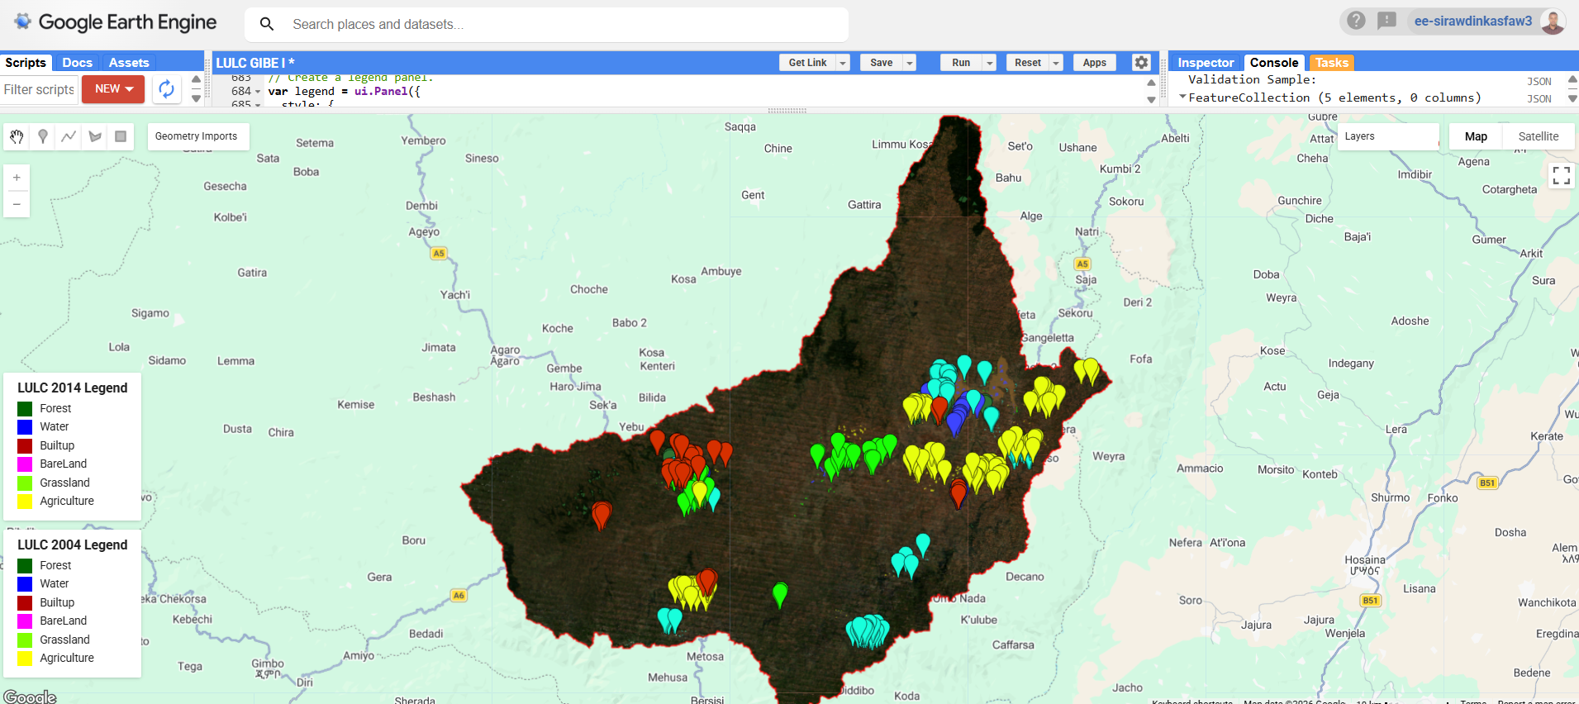
Figure S1: Training sample distribution for 2004 LULC classification
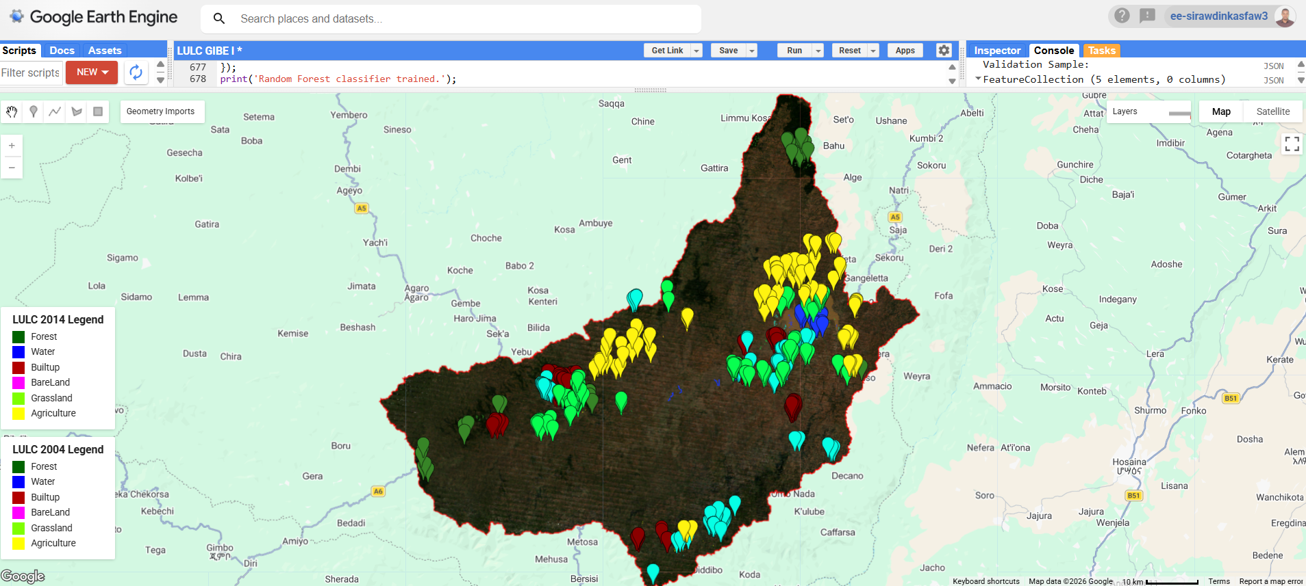
Figure S2: Training sample distribution for 2014 LULC classification
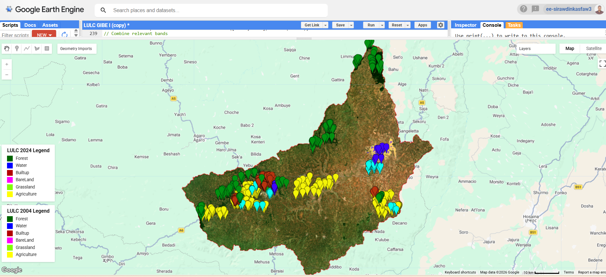
Figure S3: Training sample distribution for 2024 LULC classification
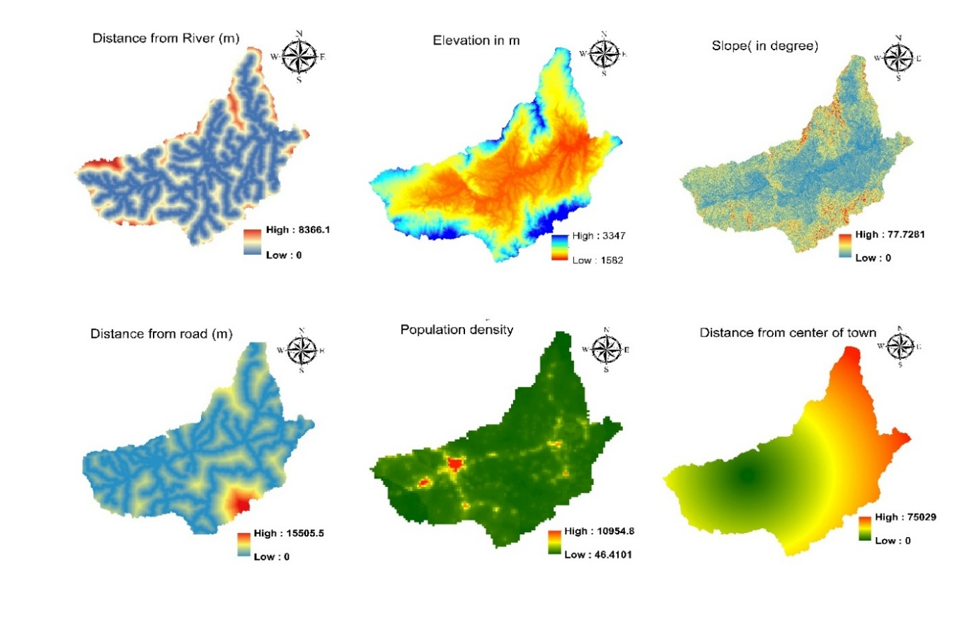
Figure S4: Spatial thematic layers of LULC change deriving factors

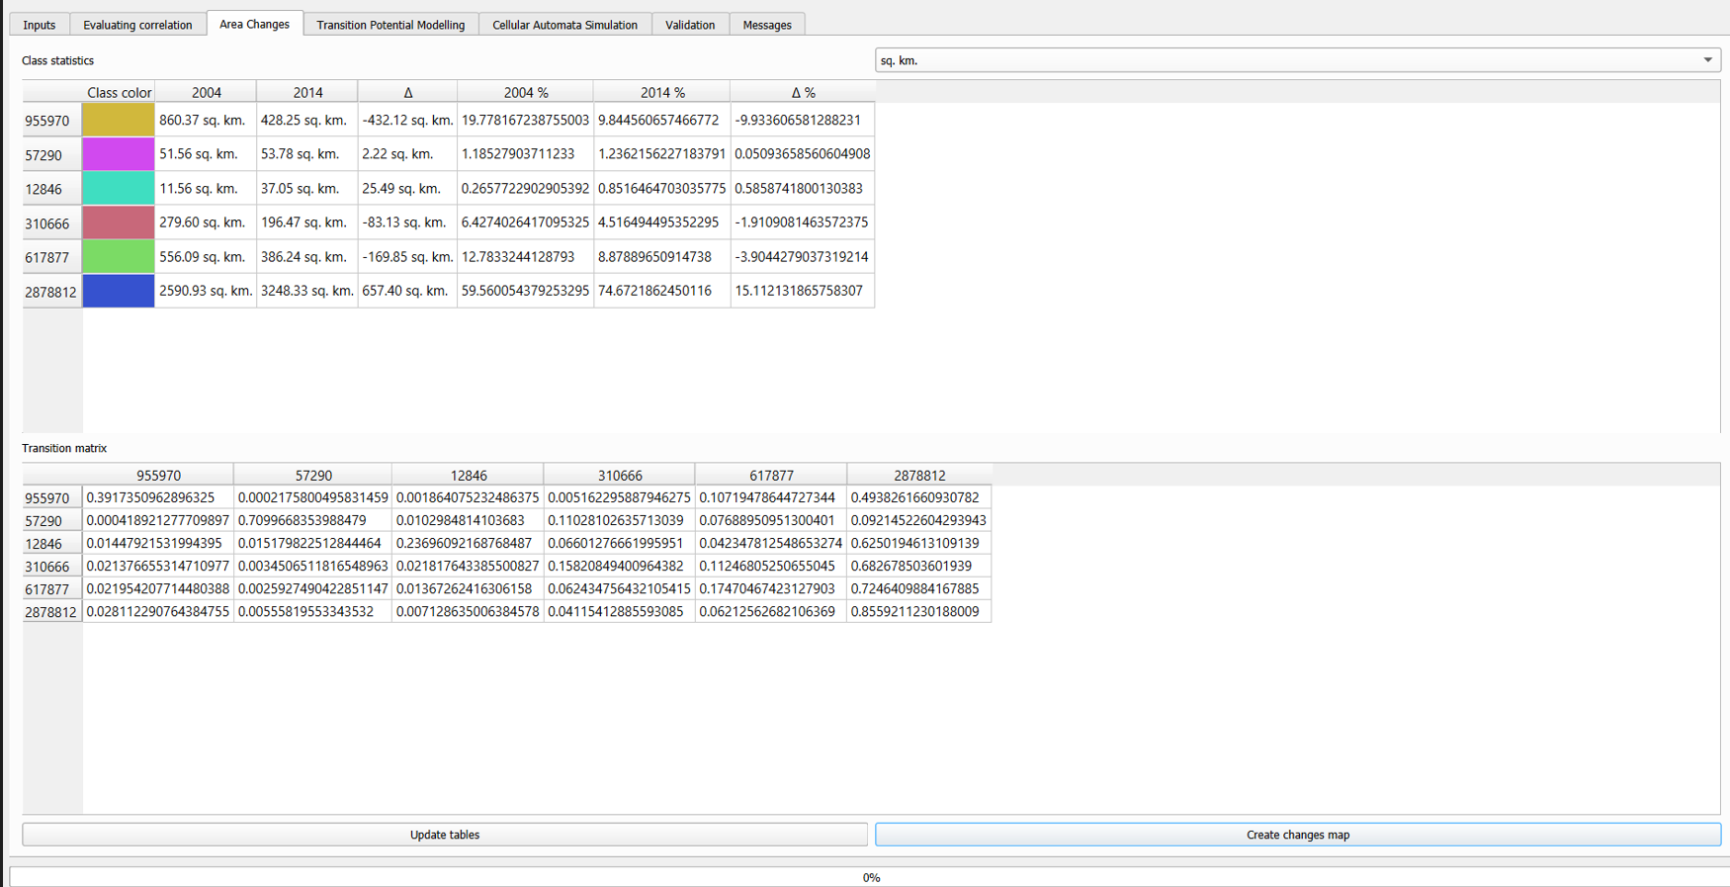
Figure S5: Historic LULC area change and transition matrix report of MOLUSCE tool

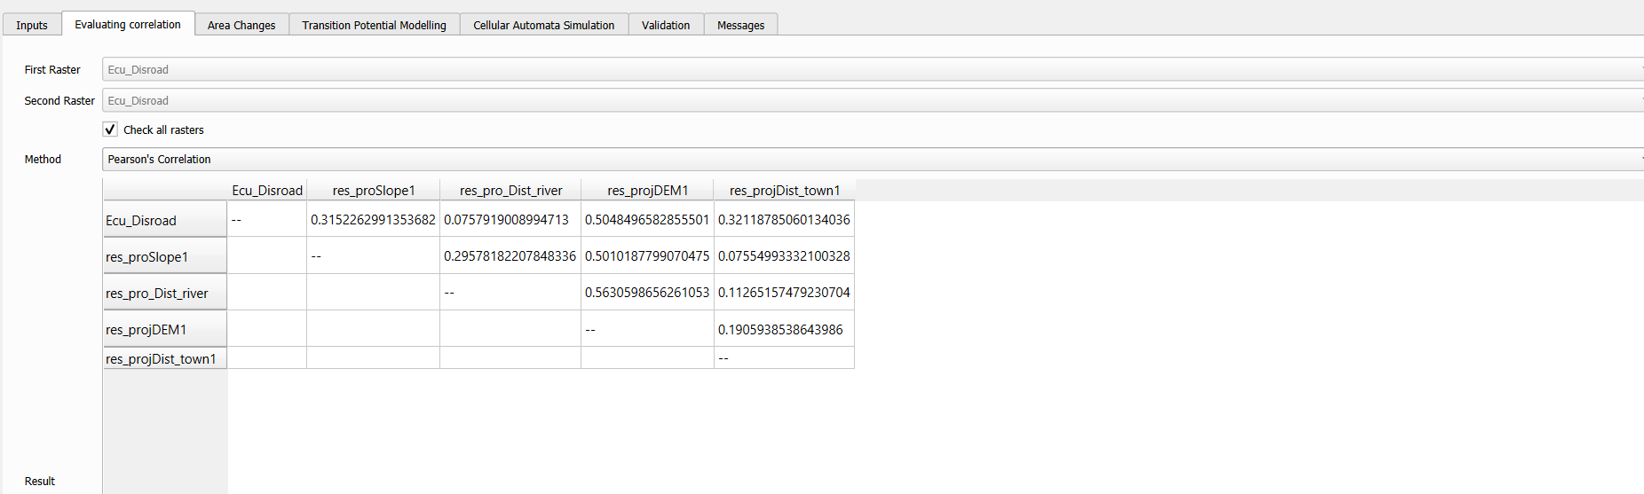
Figure S6: Pearson correlation between predictor variables

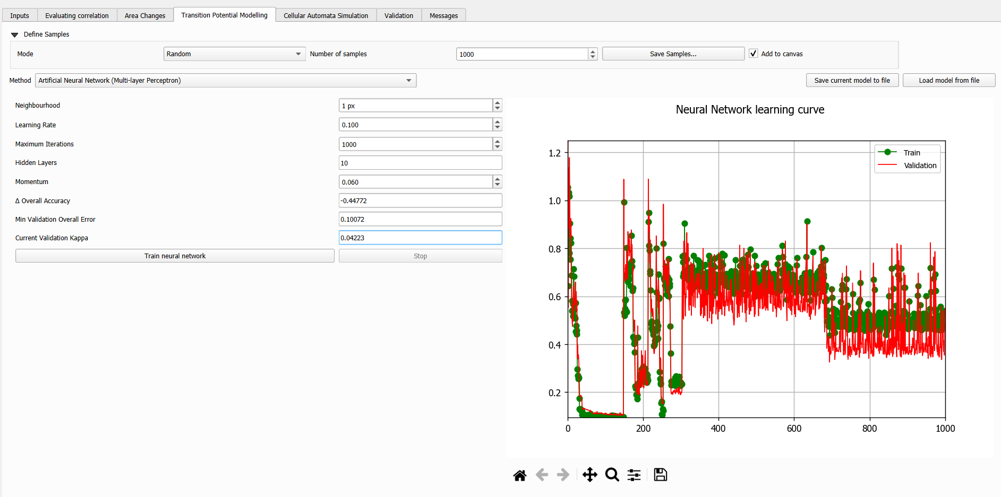

Figure S7: Transition potential modeling and ANN learning curve

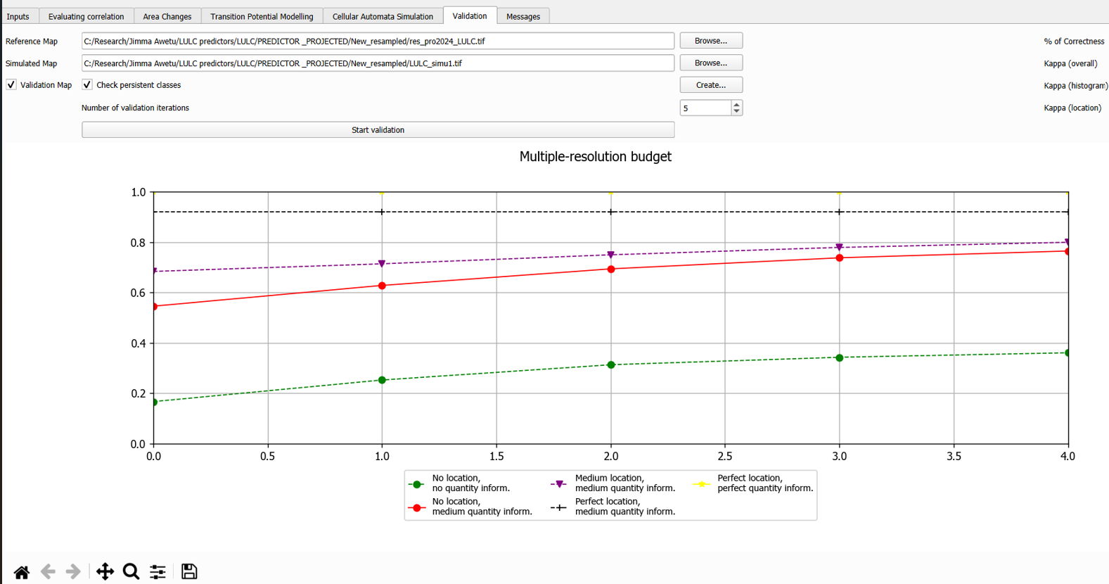
Figure S7: CA-ANN model validation plot

