Coping with a Planet in Crisis: Psychological Distress and Climate-Policy-Related Conspiracy Beliefs in Youth

– Supplementary Information –
Table of Contents
Appendix A 2
Supplementary Tables 2
Table A.1 2
Table A.2 4
Table A.3 5
Table A.4 6
Table A.5 7
Table A.6 8
Table A.7 9
Table A.8 10
Table A.9 11
Supplementary Figures 12
Figure A.1 12
Figure A.2 13
Appendix B 14
B.1 Detailed Description of the Adopted Theoretical Model 14
B.2 Detailed Results of the Statistical Prerequisites 18
References 20

Appendix A

Supplementary Tables

Table A.1
Participants’ Sociodemographic Characteristics
Demographic Variables | n | %
Age
15 | 7 | 1.69
16 | 32 | 7.75
17 | 35 | 8.47
18 | 41 | 9.93
19 | 70 | 16.95
20 | 52 | 12.59
21 | 36 | 8.72
22 | 36 | 8.72
23 | 32 | 7.75
24 | 35 | 8.47
25 | 37 | 8.96
Gender
Female | 309 | 74.82
Male | 88 | 21.31
Diverse | 11 | 2.66
Other | 1 | 0.97
Prefer not to say | 4 | 0.24
Educational level
High school diploma (Abitur) | 235 | 56.90
German Fachabitur | 22 | 5.33
German Realschule diploma | 50 | 12.11
German middle school diploma* | 10 | 2.42
Bachelor | 53 | 12.83
Master | 8 | 1.94
Magister | 0 | 0
No school degree (yet) | 30 | 7.26
Other | 5 | 1.21
Current work status
School student | 77 | 19.06
University student | 223 | 55.20
Laborer | 37 | 9.16
Volunteering | 62 | 15.01
Other | 5 | 1.21
Current financial situation
Very good | 59 | 14.68
Adequate | 262 | 65.17
Tight | 69 | 17.16
Inadequate | 12 | 2.99
Table A.1 (continued)
Demographic Variables | n | %
Small village: up to 1,000 inhabitants | 27 | 6.60
Large village: 1,000 to 5,000 inhabitants | 31 | 7.58
Small town: 5,000 to 20,000 inhabitants | 55 | 13.45
Medium-sized town: 20,000 to 100,000 inhabitants | 104 | 25.43
Large city: 100,000 to 1,000,000 inhabitants | 144 | 35.21
Metropolis: More than 1,000,000 inhabitants | 48 | 11.74
News consumption
Several times a day | 140 | 33.90
Once a day | 91 | 22.03
A few times a week | 107 | 25.91
Once a week | 39 | 9.44
Less than once a week | 36 | 8.72
Frequency of Engagement in Climate Action
Very often | 23 | 5.65
Often | 132 | 32.43
Sometimes | 162 | 39.80
Rarely | 59 | 14.50
Never | 31 | 7.62
Discussions frequency about climate change with others
Very often | 20 | 4.89
often | 100 | 24.45
Sometimes | 177 | 43.28
Rarely | 95 | 23.23
Never | 17 | 4.16
Note. N = 413. *: German middle school = “Mittelschule” (Grade 5-9). Race and ethnicity were not assessed, as German ethics committees limit their measurement when they are not primary variables of interest.

.

Table A.2
Means, Standard Deviations, and Correlations with 95% Confidence Intervals
Variable | M (SD) | 1 | 2 | 3 | 4 | 5 | 6 | 7 | 8 | 9 | 10
1. Affective Symptoms | 0.72 (0.63) | -
2. Rumination | 0.58 (0.63) | .65**  [.59, .70] | -
3. Behavioral Symptoms | 0.43 (0.60) | .48**  [.40, .55] | .33**  [.24, .42] | -
4. Anxiety about Personal Impact | 1.11 (0.81) | .56**  [.49, .63] | .54**  [.46, .60] | .31**  [.22, .39] | -
5. Depression | 6.40 (5.15) | .43**  [.35, .51] | .24**  [.15, .33] | .37**  [.28, .45] | .27**  [.17, .35] | -
6. Anxiety | 5.15 (4.74) | .49**  [.41, .56] | .34**  [.25, .42] | .41**  [.33, .49] | .29**  [.20, .38] | .67**  [.62, .72] | -
7. Stress | 7.58 (5.01) | .42**  [.34, .50] | .25**  [.16, .34] | .34**  [.26, .43] | .27**  [.18, .36] | .71**  [.66, .76] | .72**  [.67, .76] | -
8. Meaning- and Problem-Focused Coping | 2.45 (0.57) | .24**  [.15, .33] | .29**  [.20, .38] | .13**  [.04, .23] | .36**  [.27, .44] | -.02  [-.12, .08] | .02  [-.08, .11] | -.01  [-.10, .09]
9. Climate-Policy-Related Conspiracy Beliefs | 318.84 (97.36) | .28**  [.18, .36] | .25**  [.16, .34] | .13**  [.04, .23] | .24**  [.15, .33] | .13**  [.03, .22] | .15**  [.06, .25] | .15**  [.05, .24] | .17**  [.07, .26]
10. Conspiracy Mentality | 225.08 (97.41) | .11*  [.02, .21] | .23**  [.13, .32] | .17**  [.08, .26] | -.03  [-.13, .06] | .14**  [.04, .23] | .20**  [.10, .29] | .16**  [.06, .25] | .06  [-.04, .15] | .49**  [.41, .56]
11. Belief in Science | 614.21 (198.60) | -.00  [-.10, .09] | -.00  [-.10, .09] | -.04  [-.13, .06] | -.06  [-.15, .04] | -.05  [-.15, .05] | -.04  [-.13, .06] | -.07  [-.17, .02] | .02  [-.08, .11] | .12*  [.02, .21] | -.10*  [-.20, -.00]
Note. N = 413. Estimated correlations based on bivariate Pearson correlation coefficients; *p < .05. **p < .01. Bold: Bonferroni-corrected significance level p < .001. Values in square brackets indicate the 95% confidence interval for each correlation.

Table A.3
Hierarchical Regression Results for Anxiety, Conspiracy Mentality, and Belief in Science Predicting Climate-Policy-Related Conspiracy Beliefs
Variable | B | 95% CI | SE | t | R² | ΔR²
Step 1 |  |  |  |  | .27
Constant | 157.44 | [123.41, 191.48] | 17.31 | 9.09***
Anxiety | 1.30 | [-0.44, 3.04] | 0.89 | 1.47
Conspiracy Mentality | 0.49 | [0.41, 0.58] | 0.04 | 11.32***
Belief in Science | 0.08 | [0.04, 0.12] | 0.02 | 3.98***
Step 2 |  |  |  |  | .27 | 0
Constant | 158.97 | [124.57, 193.37] | 17.50 | 9.09**
Anxiety | 1.81 | [-0.56, 4.18] | 1.50 | 0.13
Anxiety (quadratic) | -0.10 | [-0.42, 0.22] | 0.16 | -0.63
Conspiracy Mentality | 0.49 | [0.41, 0.58] | 0.04 | 11.32**
Belief in Science | 0.08 | [0.04, 0.13] | 0.02 | 4.02**
Note. N = 413. CI = 95% confidence interval of B. In model 1, anxiety, conspiracy mentality, and belief in science were entered to examine their relationship to climate-policy-related conspiracy beliefs. In model 2, the quadratic term of anxiety was added.
*p < .05. **p < .01. ***p < .001.

Table A.4
Hierarchical Regression Results for Affective Symptoms, Conspiracy Mentality, and Belief in Science Predicting Climate-Policy-Related Conspiracy Beliefs
Variable | B | 95% CI | SE | t | R² | ΔR²
Step 1 |  |  |  |  | .31
Constant | 161.18 | [128.28, 194.07] | 16.73 | 9.63***
Affective Symptoms | 34.33 | [21.82, 46.84] | 6.36 | 5.39***
Conspiracy Mentality | 0.48 | [0.40, 0.56] | 0.04 | 11.54***
Belief in Science | 0.08 | [0.04, 0.12] | 0.02 | 4.04***
Step 2 |  |  |  |  | .32 | .01*
Constant | 163.53 | [130.80, 196.25] | 16.65 | 9.82***
Affective Symptoms | 47.53 | [31.53, 63.54] | 8.14 | 5.84***
Affective Symptoms (quadratic) | -19.54 | [-34.47, -4.61] | 7.59 | -2.57*
Conspiracy Mentality | 0.49 | [0.41, 0.57] | 0.04 | 11.86***
Belief in Science | 0.08 | [0.05, 0.12] | 0.02 | 4.23***
Note. N = 413. CI = 95% confidence interval of B. In model 1, affective symptoms, conspiracy mentality, and belief in science were entered to examine their relationship to climate-policy-related conspiracy beliefs. In model 2, the quadratic term of affective symptoms was added.
*p < .05. **p < .01. ***p < .001.

Table A.5
Hierarchical Regression Results for Rumination, Conspiracy Mentality, and Belief in Science Predicting Climate-Policy-Related Conspiracy Beliefs
Variable | B | 95% CI | SE | t | R² | ΔR²
Step 1 |  |  |  |  | .285
Constant | 163.45 | [129.62, 197.28] | 17.21 | 9.50***
Rumination | 22.69 | [9.74, 35.64] | 6.59 | 3.45***
Conspiracy Mentality | 0.47 | [0.38, 0.55] | 0.04 | 10.89***
Belief in Science | 0.08 | [0.04, 0.12] | 0.02 | 3.93***
Step 2 |  |  |  |  | .29 | .005*
Constant | 166.41 | [132.58, 200.25] | 17.21 | 9.67***
Rumination | 33.85 | [16.87, 50.83] | 8.64 | 3.92***
Rumination (quadratic) | -15.92 | [-31.67, -0.17] | 8.01 | -1.99*
Conspiracy Mentality | 0.47 | [0.39, 0.56] | 0.04 | 10.99***
Belief in Science | 0.09 | [0.04, 0.13] | 0.02 | 4.13***
Note. N = 413. CI = 95% confidence interval of B. In model 1, rumination, conspiracy mentality, and belief in science were entered to examine their relationship to climate-policy-related conspiracy beliefs. In model 2, the quadratic term of rumination was added.
*p < .05. **p < .01. ***p < .001.

Table A.6
Hierarchical Regression Results for Behavioral Symptoms, Conspiracy Mentality, and Belief in Science Predicting Climate-Policy-Related Conspiracy Beliefs
Variable | B | 95% CI | SE | t | R² | ΔR²
Step 1 |  |  |  |  | .27
Constant | 156.77 | [122.77, 190.77] | 17.30 | 9.06***
Behavioral Symptoms | 9.07 | [-4.52, 22.66] | 6.91 | 1.31
Conspiracy Mentality | 0.49 | [0.41, 0.58] | 0.04 | 11.45***
Belief in Science | 0.08 | [0.04, 0.12] | 0.02 | 3.98***
Step 2 |  |  |  |  | .27 | 0
Constant | 160.44 | [126.12, 194.75] | 17.46 | 9.19***
Behavioral Symptoms | 20.34 | [-0.08, 40.76] | 10.39 | 1.96
Behavioral Symptoms (quadratic) | -10.70 | [-25.19, 3.78] | 7.37 | -1.45
Conspiracy Mentality | 0.50 | [0.41, 0.58] | 0.04 | 11.52***
Belief in Science | 0.08 | [0.04, 0.12] | 0.02 | 3.95***
Note. N = 413. CI = 95% confidence interval of B. In model 1, behavioral symptoms, conspiracy mentality, and belief in science were entered to examine their relationship to climate-policy-related conspiracy beliefs. In model 2, the quadratic term of behavioral symptoms was added.
*p < .05. **p < .01. ***p < .001.

Table A.7
Hierarchical Regression Results for Anxiety about Personal Impact, Conspiracy Mentality, and Belief in Science Predicting Climate-Policy-Related Conspiracy Beliefs
Variable | B | 95% CI | SE | t | R² | ΔR²
Step 1 |  |  |  |  | .34
Constant | 147.61 | [115.27, 179.95] | 16.45 | 8.97***
Anxiety about Personal Impact | 32.41 | [22.83, 41.98] | 4.87 | 6.65***
Conspiracy Mentality | 0.51 | [0.43, 0.59] | 0.04 | 12.69***
Belief in Science | 0.09 | [0.05, 0.13] | 0.02 | 4.55***
Step 2 |  |  |  |  | .34 | 0
Constant | 147.92 | [115.24, 180.60] | 16.62 | 8.90***
Anxiety about Personal Impact | 32.69 | [22.31, 42.07] | 5.28 | 6.19***
Anxiety about Personal Impact (quadratic) | -0.71 | [-10.67, 9.26] | 5.07 | -0.14
Conspiracy Mentality | 0.51 | [0.43, 0.59] | 0.04 | 12.62***
Belief in Science | 0.09 | [0.05, 0.13] | 0.02 | 4.54***
Note. N = 413. CI = 95% confidence interval of B. In model 1, anxiety about personal impact, conspiracy mentality, and belief in science were entered to examine their relationship to climate-policy-related conspiracy beliefs. In model 2, the quadratic term of anxiety about personal impact was added.
*p < .05. **p < .01. ***p < .001.

Table A.8
Hierarchical Regression Results for Depression, Conspiracy Mentality, and Belief in Science Predicting Climate-Policy-Related Conspiracy Beliefs
Variable | B | 95% CI | SE | t | R² | ΔR²
Step 1 |  |  |  |  | .27
Constant | 156.29 | [122.38; 190.20] | 17.25 | 9.06***
Depression | 1.24 | [-0.34, 2.83] | 0.81 | 1.54
Conspiracy Mentality | 0.49 | [0.41, 0.58] | 0.04 | 11.52***
Belief in Science | 0.08 | [0.04, 0.12] | 0.02 | 4.01***
Step 2 |  |  |  |  | .27 | 0
Constant | 156.44 | [122.20, 190.68] | 17.42 | 8.98***
Depression | 1.29 | [-0.77, 3.34] | 1,05 | 1.23
Depression (quadratic) | -0.01 | [-0.29, 0.27] | 0.14 | -0.07
Conspiracy Mentality | 0.49 | [0.41, 0.58] | 0.04 | 11.48***
Belief in Science | 0.08 | [0.04, 0.12] | 0.02 | 4.00***
Note. N = 413. CI = 95% confidence interval of B. In model 1, depression, conspiracy mentality, and belief in science were entered to examine their relationship to climate-policy-related conspiracy beliefs. In model 2, the quadratic term of depression was added.
*p < .05. **p < .01. ***p < .001.

Table A.9
Hierarchical Regression Results for Stress, Conspiracy Mentality, and Belief in Science Predicting Climate-Policy-Related Conspiracy Beliefs
Variable | B | 95% CI | SE | t | R² | ΔR²
Step 1 |  |  |  |  | .27
Constant | 156.36 | [122.52; 190.19] | 17.21 | 9.08***
Stress | 1.62 | [-0.01, 3.26] | 0.83 | 1.96
Conspiracy Mentality | 0.49 | [0.41, 0.57] | 0.04 | 11.43***
Belief in Science | 0.08 | [0.04, 0.13] | 0.02 | 4.07***
Step 2 |  |  |  |  | .27 | 0
Constant | 156.41 | [122.24, 190.57] | 17.38 | 9.00***
Stress | 1.63 | [-0.15, 3.41] | 0.91 | 1.80
Stress (quadratic) | -0.01 | [-0.29, 0.28] | 0.15 | -0.02
Conspiracy Mentality | 0.49 | [0.41, 0.58] | 0.04 | 11.39***
Belief in Science | 0.08 | [0.04, 0.13] | 0.02 | 4.06***
Note. N = 413. CI = 95% confidence interval of B. In model 1, stress, conspiracy mentality, and beliefs in science were entered to examine their relationship to climate-policy-related conspiracy beliefs. In model 2, the quadratic term of stress was added.
*p < .05. **p < .01. ***p < .001.

Supplementary Figures

Figure A.1
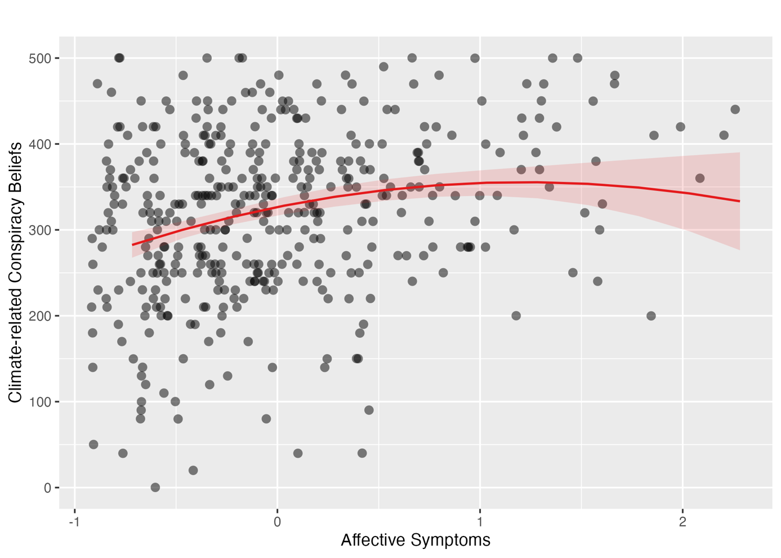
Quadratic Association between Affective Symptoms and Climate-Policy-Related Conspiracy Beliefs
Note. N = 413. The red line is the quadratic regression curve with 95% confidence intervals (shaded area). Data points reflect observed values (jittered). The predictor is mean-centered.

Figure A.2
Quadratic Association between Rumination and Climate-Policy-Related Conspiracy Beliefs
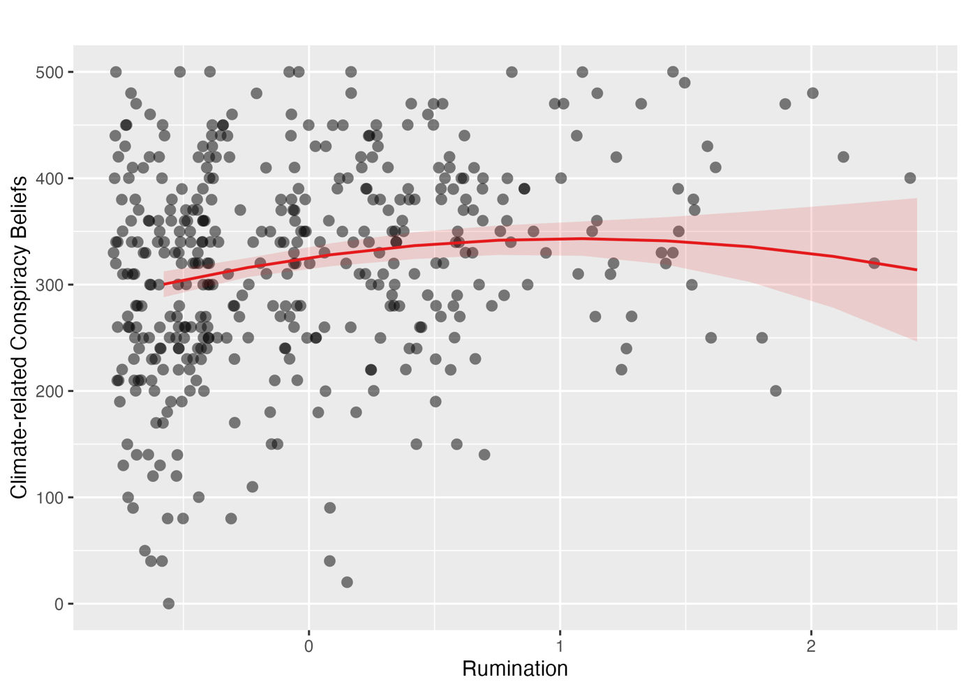
Note. N = 413. The red line is the quadratic regression curve with 95% confidence intervals (shaded area). Data points reflect observed values (jittered). The predictor is mean-centered.

Appendix B

B.1 Detailed Description of the Adopted Theoretical Model
The overall research question of this study is based on an adapted theoretical model that bridges social-psychological and clinical perspectives on conspiracy belief formation (see Figure 1). The adaptation derives mainly from the Existential Threat Model (1) and the Intolerance of Uncertainty Model (2).
Existential Threat Model (1)
The Existential Threat Model proposes that conspiracy beliefs arise from an interplay of three core factors: existential threat, sense-making processes, and an antagonistic outgroup. Existential threat, which the author defines as feelings of anxiety and uncertainty triggered by distressing events (e.g., crises, disasters, rapid societal change), activates epistemic sense-making processes, meaning people’s drive to identify meaningful, causal patterns in their environment. The mediating role of sense-making processes can only translate into conspiracy beliefs when a salient antagonistic outgroup is present. The perceived conspirators may occupy positions of high power, such as political figures or corporate leaders, or may instead belong to marginalized groups with little societal influence. Without a perceived outgroup, the same anxiety may instead fuel religiosity, political extremism, or support for the status quo.
Intolerance of Uncertainty Model (2)
While the Existential Threat Model explains how situational threat can culminate in conspiracy beliefs at the group or population level, it does not account for why, under the same situational conditions, some individuals are substantially more susceptible than others. This underlines a theoretical gap that the present study aims to address. To fill this gap, the Intolerance of Uncertainty Model (2) is introduced as a clinical complement. The model proposes that intolerance of uncertainty (IU), defined as the tendency to perceive ambiguous situations as threatening and to respond with maladaptive cognitive, emotional, and behavioral reactions, is the central mechanism driving pathological worry and anxiety. These processes are further maintained by dysfunctional beliefs about the utility of worrying, a negatively biased problem orientation, and cognitive avoidance strategies, all of which limit effective engagement with uncertainty. The model conceptualizes these processes as transdiagnostic, i.e., they operate across different forms of psychological distress rather than being tied to a single situational trigger. This perspective allows for a shift from external, event-based conceptualizations of threat toward internal, person-level vulnerability factors. Linked to the Existential Threat Model, the IU model highlights that individuals who are less able to tolerate uncertainty may be particularly motivated to adopt simplified explanations for complex and ambiguous phenomena, thereby increasing susceptibility to rigid or unfalsifiable belief systems. While research on conspiracy beliefs has predominantly focused on situational and societal sources of uncertainty, clinical models emphasize stable individual differences in the perception and regulation of uncertainty. The intersection of these two models, that is, how person-level vulnerability factors and coping responses shape the translation of situational uncertainty into conspiracy beliefs, has received little theoretical and empirical attention. The present study addresses this gap by proposing an adapted model in which clinical and social-psychological mechanisms are explicitly integrated. The adapted version of the Existential Threat Model, linked with the IU model, is presented in Figure 2.
Adapted Theoretical Framework of Climate-Policy-Related Conspiracy Beliefs Formation
In the adapted model, the focus shifts from situational existential threat per se to individual differences in the processing of uncertainty. As van Prooijen (1) defines existential threat as “feeling of anxiety or uncertainty often because of distressing events that call one’s values, one’s way of life, or even one’s existence into question” (p. 16), it can be operationalized as psychological distress (3). Specifically, situational uncertainty (e.g., planetary crises) is conceptualized as a distal trigger. In contrast, person-level vulnerability factors constitute the intermediate pathways through which such uncertainty may be translated into belief formation.
Based on the IU model, uncertainty gives rise to feelings of anxiety and psychological distress, which represent emotional responses to existential threat. Intolerance of uncertainty is conceptualized as a key vulnerability factor that amplifies these emotional responses and shapes how individuals cope with uncertain situations. In line with the IU model, it can be assumed that individuals who experience higher intolerance of uncertainty can experience complex situations as more threatening and are more likely to engage in maladaptive cognitive strategies aimed at reducing uncertainty. Drawn from the Existential Threat Model, meaning-focused coping is conceptualized as the sense-making process through which uncertainty is interpreted and managed. Built on van Prooijen (1), this coping strategy involves both the reinterpretation of events through individual appraisals and the search for broader, global meanings. While such processes can be adaptive, they may also promote a preference for simplified explanations when individuals are confronted with high levels of uncertainty, particularly as conspiracy beliefs can help deal with subjective uncertainty (4). When individuals struggle to make sense of threatening situations, the appeal of such explanations increases (1), and conspiracy beliefs may serve this function precisely by providing a seemingly coherent framework that reduces uncertainty. In contrast to van Prooijen’s (1) original conceptualization of sense-making as a mediating process, meaning- and problem-focused coping is here treated as a moderator, reflecting the assumption that individuals differ in the extent to which they draw on such strategies when confronted with uncertainty, and that these differences shape susceptibility to conspiracy beliefs. Specifically, it can be theorized that individuals who show more adaptive meaning- and problem-focused coping are better equipped to tolerate uncertainty without resorting to simplified explanatory frameworks and, thus, reducing the likelihood of endorsing conspiracy beliefs. Furthermore, climate-policy-related conspiracy beliefs contain assumptions about powerful actors and institutions in the adopted model. These beliefs are characterized by suspicions that powerful actors intentionally conceal, manipulate, or distort information for their own purposes. Therefore, the antagonistic outgroup component is treated as embedded in the outcome construct rather than modelled as a separate process. Consequently, the adopted model assumes that individual differences shape the extent to which uncertainty can be translated into conspiracy beliefs.

B.2 Detailed Results of the Statistical Prerequisites
Modell Specification
The correct specification of the functional form was examined for each of the seven hierarchical regression models (Block 2) using residual plots generated with the residualPlot-function from the car-package (5). Across all models, the smoothed trend line of the Pearson residuals remained close to zero across the range of fitted values, with no systematic curvature or trend. Minor fluctuations at the extremes of the fitted-value range were observed but were attributable to lower data density in these regions rather than misspecification. These results indicate that the assumption of a correctly specified linear model was met for all seven models.
Normal Distribution for Residuals
The assumption of normally distributed residuals was assessed visually using quantile-quantile (Q-Q) plots generated with the qqPlot-function from the car-package (5), complemented by density curves produced with the plot_model function (type = "diag") from the sjPlot-package (6). Across all seven models, residuals followed the expected normal distribution closely in the central range of the quantiles. However, minor deviations were observed in the tails, particularly in the lower quantiles, indicating a slightly heavier left tail than expected under normality.
To test the normality assumption, Shapiro-Wilk tests were conducted using the shapiro.test-function for each model’s residuals. All seven tests were significant, p < .05. Given the sample size (N = 413), the Shapiro-Wilk test is sensitive to minor deviations from normality that may be of limited practical relevance (7). In addition to the visual inspection, which showed only modest deviations concentrated in the tails, and given the robustness of ordinary least squares estimation to violations of normality at this sample size (8), the assumption was considered adequately met for hypothesis testing.
Heteroscedasticity
Homoscedasticity was inspected visually using scatter plots of residuals against fitted values, generated with the base plot-function, and tested using the Breusch-Pagan test via the ncvTest-function from the car-package (5). Visual inspection across all seven models suggested a mild funnel-shaped pattern, with somewhat greater residual variance at lower fitted values compared to higher fitted values. The Breusch-Pagan test was significant, p < .05, for four of the seven models, specifically those predicting climate-policy-related conspiracy beliefs from affective symptoms, rumination, anxiety about personal impact, and depression; the models for anxiety, behavioral symptoms, and stress showed no significant heteroscedasticity.
For the four affected models, heteroscedasticity-robust standard errors (HC3) were computed as a robustness check, using the coeftest and vcovHC-functions from the lmtest-package (9) and the sandwich-package (10). Across these models, regression coefficients and their significance patterns remained largely consistent with the original estimates. One exception emerged in the rumination model, where the main effect of coping was significant under conventional standard errors (b = 17.26, SE = 8.66, p = .047) but narrowly missed significance under robust standard errors (b = 17.26, SE = 8.97, p = .055).
Multicollinearity
Multicollinearity was assessed by calculating variance inflation factors (VIF) and tolerance values for each of the seven models using the vif function from the car-package (5). Across all models, VIF values ranged from 1.00 to 1.20, well below the commonly applied threshold of concern (VIF > 5) and far below the threshold indicating severe multicollinearity (VIF > 10). Correspondingly, tolerance values (1/VIF) ranged from .84 to 1.00, above the conventional cutoff of .10.

References
1. Van Prooijen JW. An Existential Threat Model of Conspiracy Theories. European Psychologist. 2020 Jan;25(1):16–25. doi:10.1027/1016-9040/a000381
2. Dugas MJ, Gagnon F, Ladouceur R, Freeston MH. Generalized anxiety disorder: a preliminary test of a conceptual model. Behaviour Research and Therapy. 1998 Feb;36(2):215–26. doi:10.1016/S0005-7967(97)00070-3
3. Fox N, Williams MN, Hill SR. Do stress, depression, and anxiety lead to beliefs in conspiracy theories? [Internet]. PsyArXiv; 2025 [cited 2026 Apr 6]. Available from: https://osf.io/zr5se_v1 doi:10.31234/osf.io/zr5se_v1
4. Douglas KM, Sutton RM, Cichocka A. The Psychology of Conspiracy Theories. Curr Dir Psychol Sci. 2017 Dec;26(6):538–42. doi:10.1177/0963721417718261
5. Fox, John, Weisberg, Sanford. An R Companion to Applied Regression, Third edition. Sage, Thousand Oaks CA. [R package]. 2023. Available from: https://r-forge.r-project.org/projects/car/
6. Lüdecke D. sjPlot: Data Visualization for Statistics in Social Science [Internet]. 2025. Available from: https://CRAN.R-project.org/package=sjPlot
7. Razali NM, Wah YB, others. Power comparisons of shapiro-wilk, kolmogorov-smirnov, lilliefors and anderson-darling tests. Journal of statistical modeling and analytics. 2011;2(1):21–33.
8. Lumley T, Diehr P, Emerson S, Chen L. The Importance of the Normality Assumption in Large Public Health Data Sets. Annu Rev Public Health. 2002 May;23(1):151–69. doi:10.1146/annurev.publhealth.23.100901.140546
9. Hothorn T, Zeileis A, Farebrother RW, Cummins C. lmtest: Testing Linear Regression Models [Internet]. 2022 [cited 2026 Jun 21]. p. 0.9-40. Available from: https://CRAN.R-project.org/package=lmtest doi:10.32614/CRAN.package.lmtest
10. Zeileis A, Lumley T. sandwich: Robust Covariance Matrix Estimators [Internet]. 2024 [cited 2026 Jun 21]. p. 3.1-1. Available from: https://CRAN.R-project.org/package=sandwich doi:10.32614/CRAN.package.sandwich

