Supporting Information
Pyrolysis temperature-driven radical-to-nonradical pathway transition in Fe⁰/biochar activated peroxymonosulfate: Structural evolution and mechanistic insights
Zi-En Xu¹, Yu-Xuan Wang^{1,2}, Li Wu¹, Jin-Rong Xiang¹, Zi-Mu Qiu¹, Yang-Kai Ren¹, Ming-Hui Li¹, Chao-Fei Guo^{1,2}, Xue-Juan Yang^{1,2}, Xi-Ping Luo^{1,2}
¹College of Chemistry and Materials Engineering, Zhejiang A&F University, Hangzhou, China
²Zhejiang Provincial Key Laboratory of Chemical Utilization of Forestry Biomass, Zhejiang A&F University, Hangzhou 311300, China
* Yu-Xuan Wang, wangyuxuan@zafu.edu.cn
Supplementary Material
1. Chemicals
Potassium peroxymonosulfate (KHSO₅, 42–48%, referred to as PMS), L-histidine (C₆H₉N₃O₂, 99%), sodium dihydrogen phosphate (NaH₂PO₄, 99%), Potassium thiocyanate (KSCN, 98.5%), p-benzoquinone (C₆H₄O₂, 97%), Heavy water (D₂O, 99.9%) tert-butyl alcohol (C₄H₁₀O, 97%), and iron (III) chloride hexahydrate (FeCl₃·6H₂O, 99 atom%) were purchased from Macklin (Shanghai, China). Reagents of analytical grade, including sodium sulfate, sodium chloride, methanol, and sodium hydroxide, were also obtained from Macklin (Shanghai, China). Congo red (C₃₂H₂₂N₆Na₂O₆S₂) was purchased from Sinopharm Chemical Reagent Co., Ltd. (Shanghai, China). Sodium thiosulfate (Na₂S₂O₃, 98%) was obtained from Zhonglian Chemical Reagent Co., Ltd.
2. Characterization methods
The functional groups of the biochar were characterized using a Fourier transform infrared spectrometer (FTIR, Thermo Fisher Scientific Nicolet iS20, USA). The morphology of the biochar was examined by field emission scanning electron microscopy (SEM, ZEISS Sigma 360, Germany). The phase composition of the biochar was analyzed via X-ray diffraction (XRD, DX-2700 BH, China). The chemical composition and elemental states of the biochar were characterized by X-ray photoelectron spectroscopy (XPS, Thermo Scientific K Alpha, USA). The magnetic properties of the biochar were evaluated through vibrating sample magnetometer (VSM, LakeShore 8604, USA) measurements. Electron paramagnetic resonance (EPR) spectroscopy (Bruker EMXplus 6/1, Germany) was employed to detect the characteristic signals of singlet oxygen (¹O₂) using TEMP as a trapping agent.
3. Supplementary Methods
The catalytic degradation performance of the material was evaluated by calculating the removal capacity (q_{t}) and removal efficiency (R) according to methods described in previous studies. Taking the moment of PMS addition as the starting point (t = 0), the ratio C_{t}/C30 (where C_{t} is the concentration at time t and C₃₀ is the concentration at the moment of PMS addition) was plotted against time t, and the reaction rate constant k was obtained through nonlinear fitting. The above calculation formulas are shown in Equations (1)–(3):
$$\begin{aligned}q_{t}=\frac{V×\left(C_{0}-C_{t}\right)}{m}\#\left(1\right)\end{aligned}$$
$$\begin{aligned}R=\frac{\left(C_{0}-C_{t}\right)}{C_{0}}×100\%\#\left(2\right)\end{aligned}$$
$$\begin{aligned}\frac{C_{t}}{C_{30}}=e^{-kt}\#\left(3\right)\end{aligned}$$
where V is the volume of the reaction solution (L), C₀、C_{t} and C₃₀ are the initial concentration, concentration at time t, and concentration at adsorption equilibrium (mg/L) of CR, respectively, m is the mass of the catalyst (g), and k is the apparent reaction rate constant (min⁻¹).
4. Arrhenius equation
The relationship between the reaction rate constant and temperature was fitted using the Arrhenius equation (Equation. 4):
$$\begin{aligned}\ln{k}=-\frac{E_{a}}{R}⋅\frac{1}{T}+\ln{A}\#\left(4\right)\end{aligned}$$
where k is the reaction rate constant (min-1), T is the temperature (K), R is the gas constant (8.314 × 10⁻³ kJ·mol⁻¹·K⁻¹), and Eₐ is the apparent activation energy (kJ/mol).
5. Relevant chemical formulas
$$\begin{aligned}\begin{matrix} & {\text{Fe}}^{0}+{\text{HSO}}_{5}^{-}→{\text{Fe}}^{2+}+{\text{SO}}_{4}^{2-} & & \end{matrix}\#\left(5\right)\end{aligned}$$
$$\begin{aligned}\begin{matrix} & {\text{Fe}}^{2+}+{\text{HSO}}_{5}^{-}→{\text{Fe}}^{3+}+{\text{SO}}_{4}^{\text{•}-}+{\text{OH}}^{-} & & \end{matrix}\#\left(6\right)\end{aligned}$$
$$\begin{aligned}\begin{matrix} & {\text{SO}}_{4}^{\text{•}-}+{\text{H}}_{2}\text{O}→\text{•OH}+{\text{SO}}_{4}^{2-}+{\text{H}}^{+} & & \end{matrix}\#\left(7\right)\end{aligned}$$
$$\begin{aligned}\begin{matrix} & {\text{HSO}}_{5}^{-}+{\text{O}}_{2}\overset{{Fe}^{o}}{→}{\text{SO}}_{4}^{2-}+{\text{¹O}}_{2}+{\text{H}}^{+} & & \end{matrix}\#\left(8\right)\end{aligned}$$
$$\begin{aligned}\begin{matrix} & {\text{Fe}}^{2+}+{\text{HSO}}_{5}^{-}→{\text{Fe}}^{3+}+{\text{SO}}_{5}^{2-}+{\text{H}}^{+} & & \end{matrix}\#\left(9\right)\end{aligned}$$
$$\begin{aligned}\begin{matrix} & {\text{Fe}}^{2+}+{\text{SO}}_{5}^{2-}→{\text{Fe}}^{3+}+{\text{SO}}_{4}^{2-}+{\text{O}}_{2}^{\text{•}-} & & \end{matrix}\#\left(10\right)\end{aligned}$$
$$\begin{aligned}\begin{matrix} & {\text{O}}_{2}+e^{-}→{\text{O}}_{2}^{\text{•}-} & & \end{matrix}\#\left(11\right)\end{aligned}$$
$$\begin{aligned}\begin{matrix} & 2{\text{O}}_{2}^{\text{•}-}+2{\text{H}}^{+}→{\text{¹O}}_{2}+{\text{H}}_{2}{\text{O}}_{2} & & \end{matrix}\#\left(12\right)\end{aligned}$$
$$\begin{aligned}\begin{matrix} & {\text{O}}_{2}^{\text{•}-}+\text{•OH}→{\text{¹O}}_{2}+{\text{OH}}^{-} & & \end{matrix}\#\left(13\right)\end{aligned}$$
$$\begin{aligned}\begin{matrix} & {\text{SO}}_{5}^{2-}+{\text{H}}_{2}\text{O}→{\text{SO}}_{4}^{2-}+{\text{H}}_{2}{\text{O}}_{2}→{\text{SO}}_{4}^{2-}+{\text{¹O}}_{2}+{\text{H}}_{2}\text{O} & & \end{matrix}\#\left(14\right)\end{aligned}$$
Supplementary Tables
Table S1 Iron content in the material as shown by SEM mapping.
 | C | N | O | Fe
BC-400 | 70.39% | 0.11% | 29.5% | 0.00%
BC-800 | 81.84% | 1.86% | 16.3% | 0.00%
Fe/C-0.2-800 | 91.22% | 0.00% | 6.18% | 2.60%
Fe/C-0.5-800 | 90.38% | 0.00% | 5.52% | 4.10%
Fe/C-1-800 | 81.76% | 0.45% | 9.68% | 8.72%

Supplementary Figures
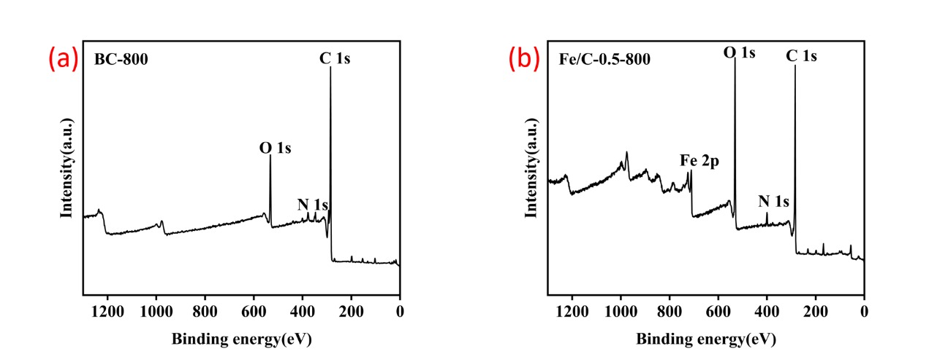
Fig. S1 Survey XPS spectrum of (a) BC-800, (b) Fe/C-0.5-800.
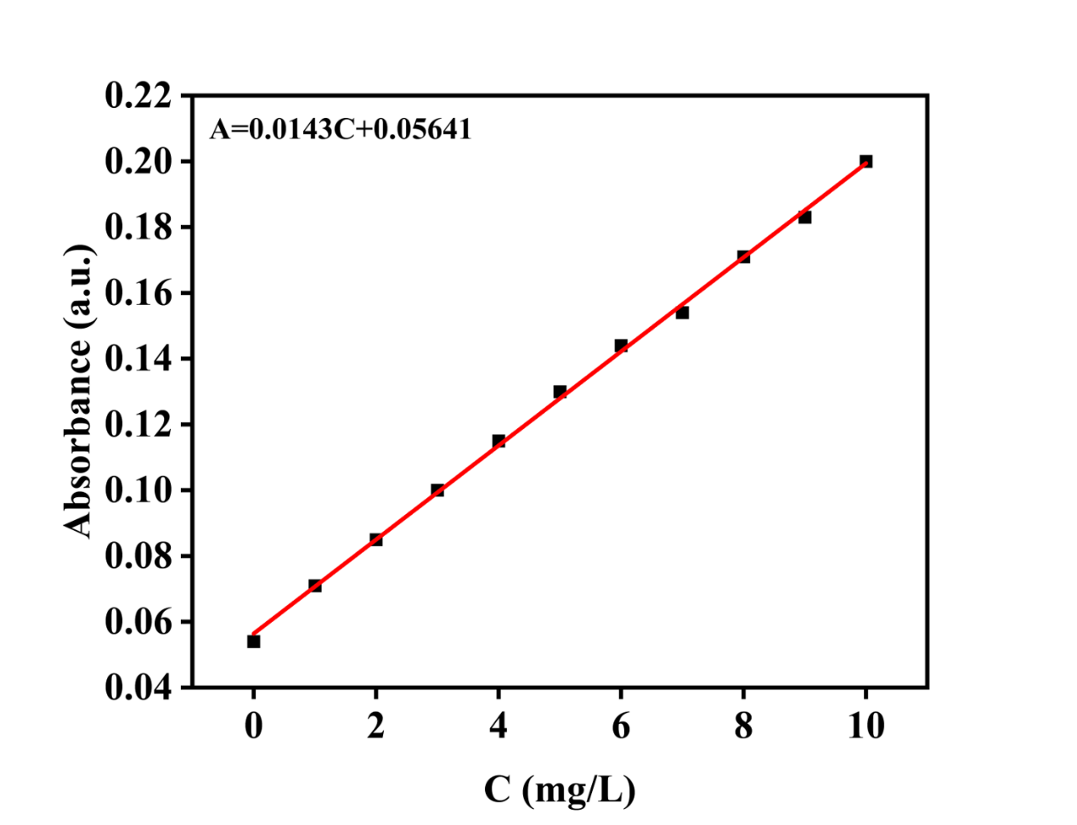
Fig. S2 Standard curve of CR at 497 nm.
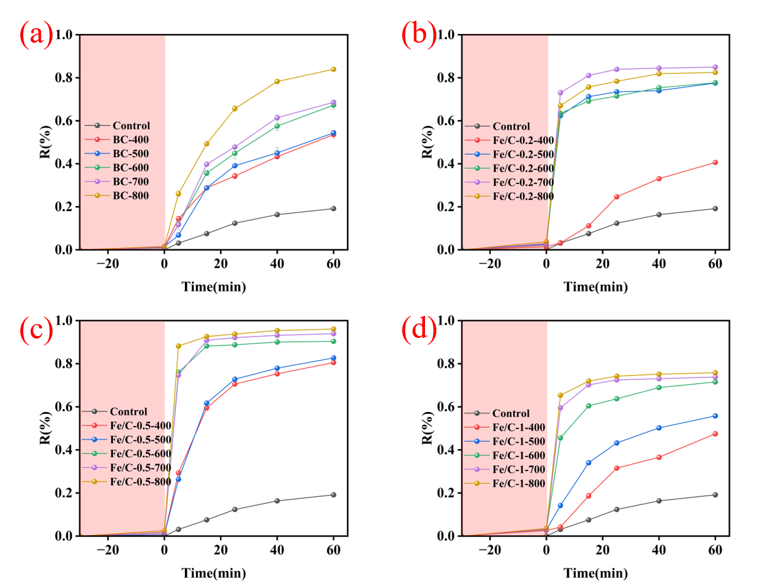
Fig. S3 (a) Removal efficiency of CR by BC at different pyrolysis temperatures (b) Removal efficiency of CR by Fe/C-0.2 at different pyrolysis temperatures, (c) Removal efficiency of CR by Fe/C-0.5 at different pyrolysis temperatures, (d) Removal efficiency of CR by Fe/C-1 at different pyrolysis temperatures. (Conditions: [C] = 0.1 g/L [CR]₀ = 60 mg/L, [PMS] : [CR] = 10 : 1, reaction time = 60 min, T = 25 °C, dark.).
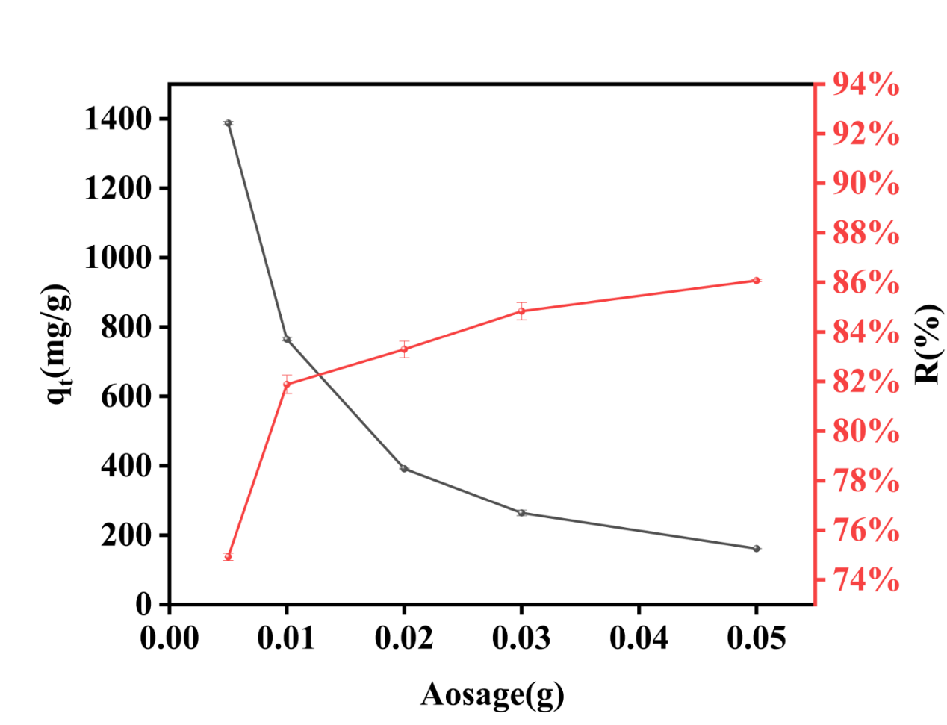
Fig. S4 Effect of Fe/C-0.5-800 dosage on the removal capacity (q_{t}, mg/g) and removal efficiency (R, %) of CR. (Conditions: [CR]₀ = 60 mg/L, [PMS] : [CR] = 10 : 1, reaction time = 60 min, T = 25 °C, dark.).
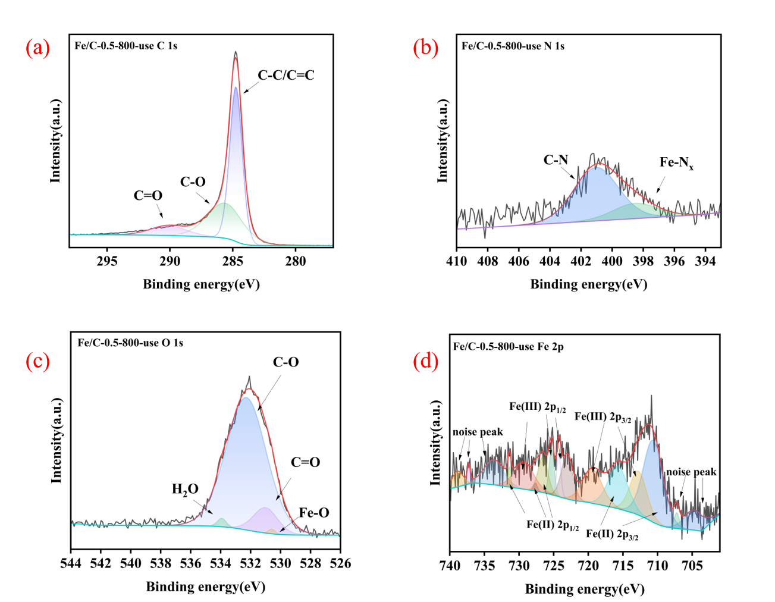
Fig. S5 XPS spectra of Fe/C-0.5-800-use (d) C 1s, (f) O 1s, (h) N 1s and (i) Fe 2p.
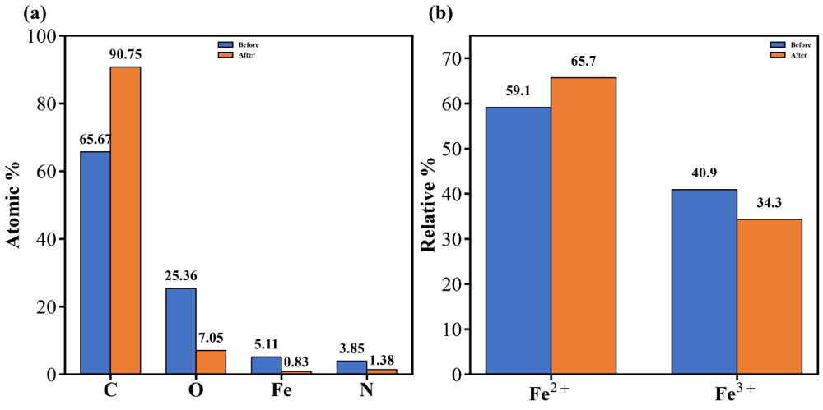
Fig. S6 XPS analysis of Fe/C-0.5-800 before and after PMS activation: (a) surface elemental composition and (b) relative proportions of Fe²⁺ and Fe³⁺ species.

