Supplementary
Supplementary Figure 1
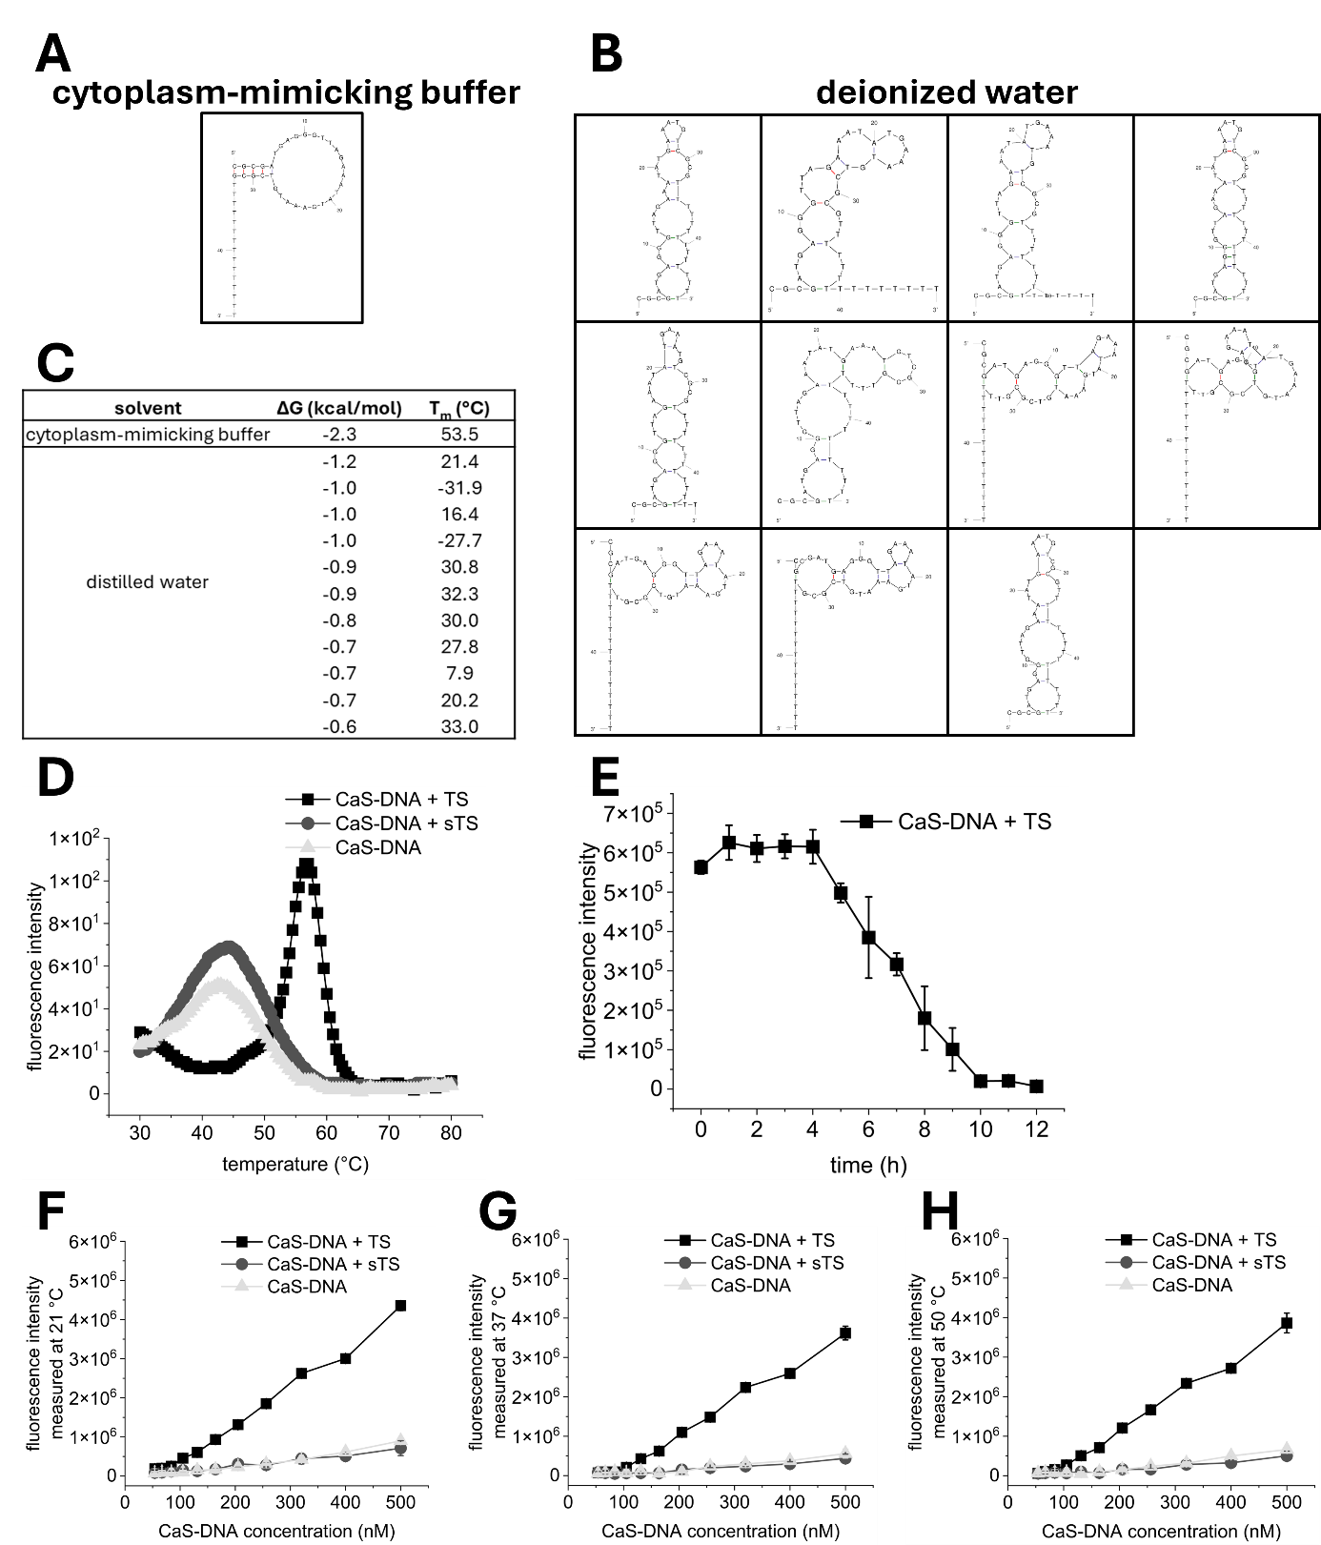

Supplementary Fig. 1│ Physico-chemical characterization of CaS-DNA. (A/B) Predicted secondary structures of CaS-DNA (mFold) showing stem-loop formation in cytoplasm-mimicking buffer (A) and structural variability in deionized water (B). (C) Thermodynamic parameters such as Gibbs free energy (ΔG) and melting temperature (Tm) are summarized for the predicted structures shown in (A) and (B). (D) Temperature-dependent melting profiles in the absence of target sequence (CaS-DNA, light grey rectangles) and in the presence of scrambled target sequence (CaSDNA + sTS; grey circles) or target sequence (CaS-DNA + TS, black squares) are shown. (E) Time-dependent fluorescence intensity following CaS-DNA:TS hybridization was monitored. (F-H) Fluorescence intensities are shown for the same samples as in (D), across increasing CaS-DNA concentrations measured at different temperatures (21-51 °C, F to H). Data represents three independent measurements.
Supplementary Figure 2

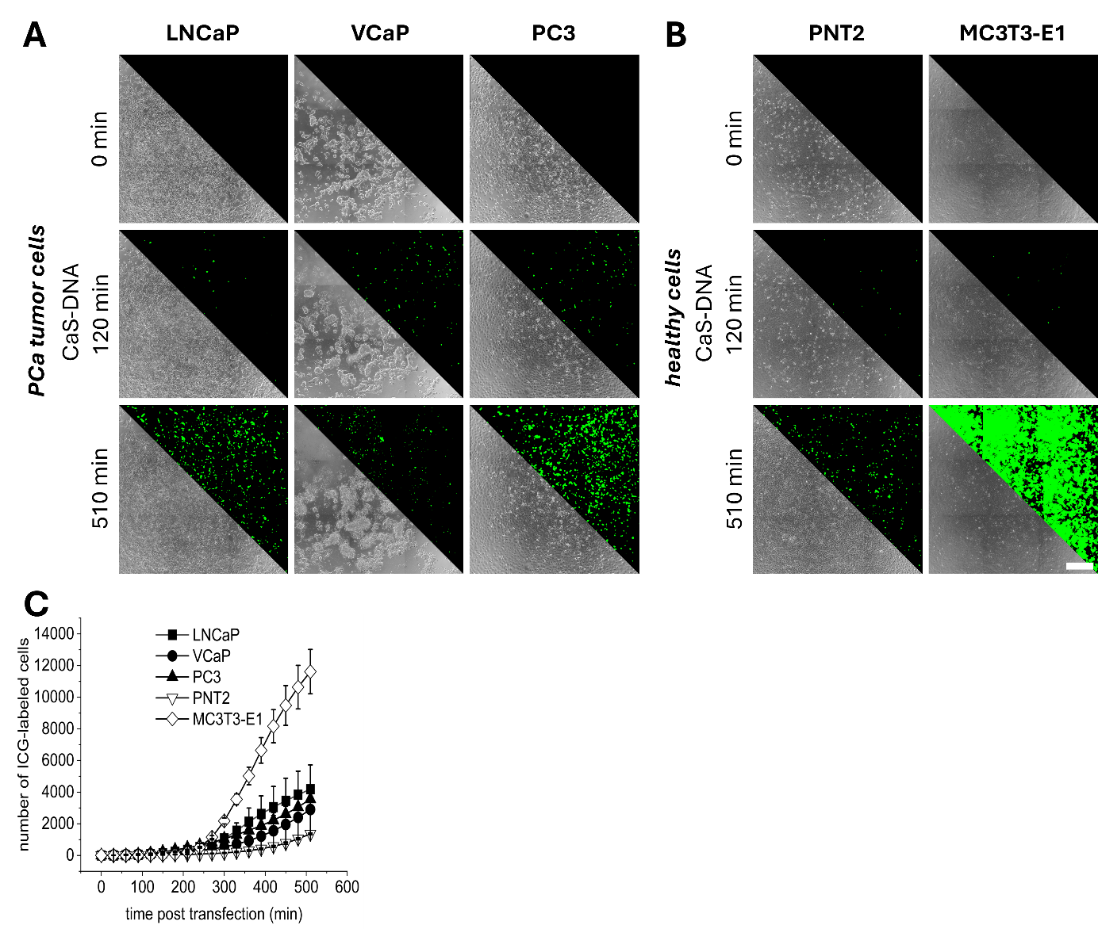

Supplementary Fig. 2│In vitro characterization of CaS-DNA in mono-cultures.
(A/B) Representative images of CaS-DNA fluorescence activation over time in prostate cancer (PCa) cell lines (LNCaP, VCaP, PC3) (A) and healthy control cells (PNT2 and MC3T3-E1) (B). Images include phase contrast, nuclei staining (blue), and CaS-DNA signals (green). Scale bar: 100 µm.
(C) CaS-DNA fluorescence activation (number ICG-labeled cells) was quantified and is shown in PCa tumor (filled symbols) and healthy control cells (unfilled symbols) over 500 min. Data represents three independent experiments.

Supplementary Figure 3
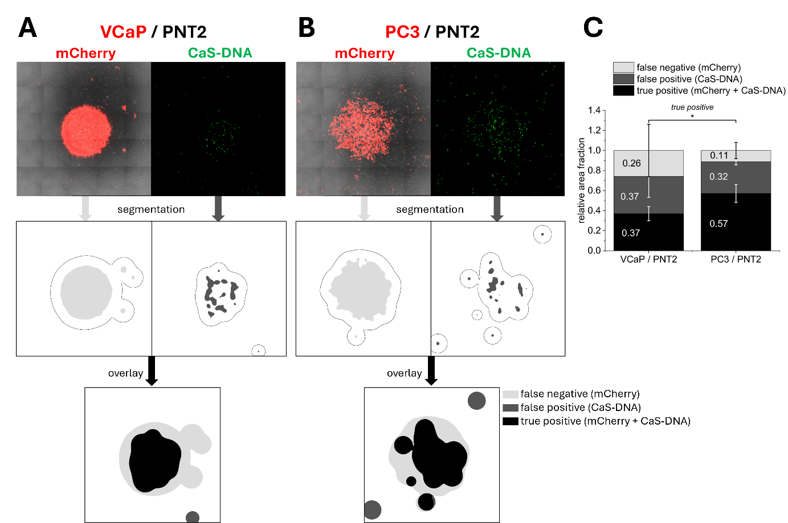

Supplementary Fig. 3│In vitro characterization of CaS-DNA in co-cultures. (A-B) Representative images 2 h post-transfection include merged phase-contrast and mCherry-labeled tumor cell lesions (red) alongside the CaS-DNA signal distribution (green) for VCaP and PC3 in co-culture model with PNT2. Scale bar 500 µm. Image-based segmentation identified tumor cells (mCherry, light gray), CaS-DNA fluorescence (CaS-DNA, gray) and overlapping regions (mCherry + CaS-DNA, black). Tumor cells without CaS-DNA were defined as false negatives (mCherry only, light gray), non-tumor areas with signal as false positives (CaS-DNA, gray), and overlapping regions as true positives (mCherry + CaS-DNA, black). (C) Quantification of relative area fractions is shown indicating tumor-specific labeling efficiency for both VCaP and PC3 / PNT2 co-culture models. Data represents three independent experiments.

Supplementary Figure 4
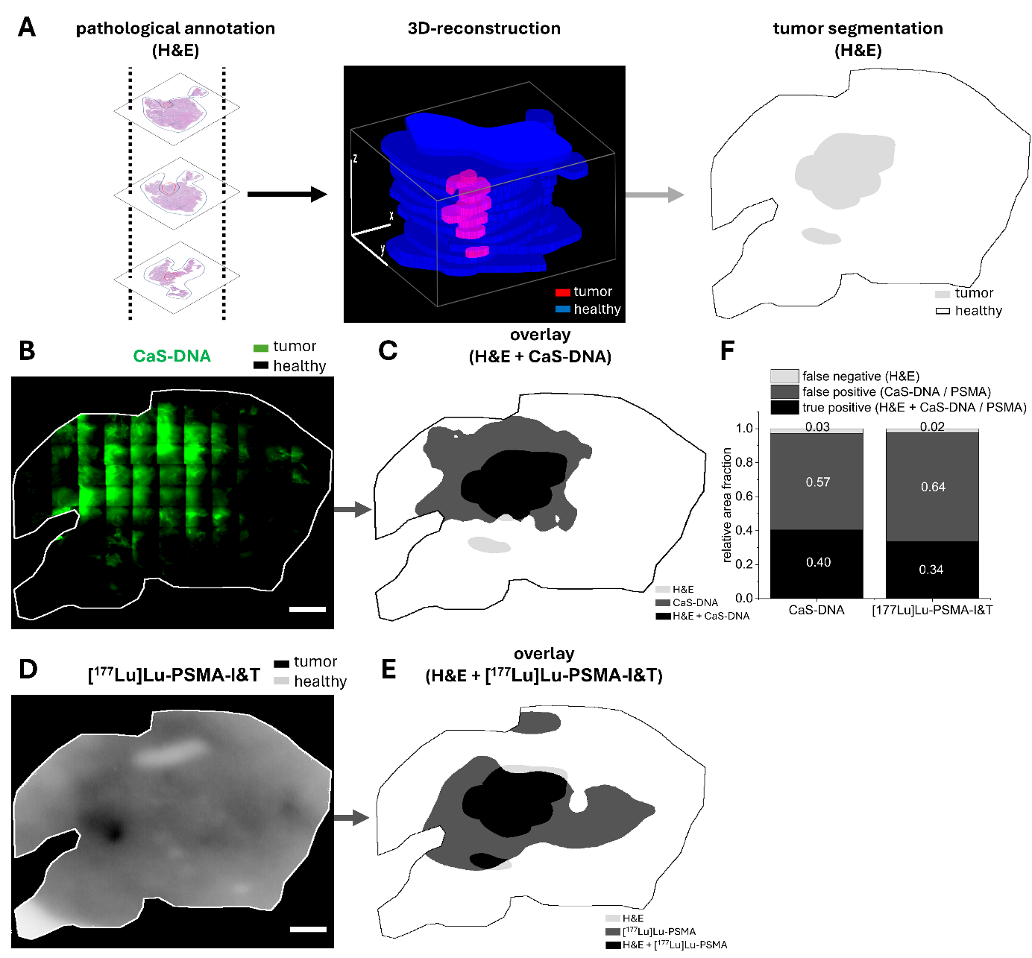

Supplementary Fig. 4│ Comparison of CaS-DNA and [¹⁷⁷Lu]Lu-PSMA-I&T autoradiography for tumor labeling in patient-derived prostate cancer tissues. (A) Prostate cancer tissue slice (~300 µm) was treated with CaS-DNA. Afterwards, tumor (red) and healthy (blue) regions were annotated by an experienced uropathologist based on H&E staining. Serial sections were 3D-reconstructed to generate tumor heatmap (from left to right). (B) CaS-DNA signal distribution is shown across the respective tissue slice (green). Scale bar 2 mm. (C) Fluorescence signals were segmented and overlaid with H&E-based tumor heatmap. (D) [¹⁷⁷Lu]Lu-PSMA-I&T autoradiography is shown on an CaS-DNA-treated adjacent tissue slice (tumor, black). (E) Tracer signals were converted into heatmaps and overlaid with H&E tumor annotation as in (C). (C/E) Tumor regions lacking CaS-DNA or tracer signals were classified as false negatives (H&E only, light gray), non-tumor regions with signals as false positives (CaS-DNA or [¹⁷⁷Lu]Lu-PSMA only, gray), and overlapping regions as true positives (H&E + CaSDNA or H&E + [¹⁷⁷Lu]Lu-PSMA, black). (F) Quantification of relative area fractions based on H&E annotation and CaSDNA or tracer signal tumor segmentation. Data represents one additional and independent tissue slice obtained from Gleason 7a from Fig. 5.

Supplementary Figure 5
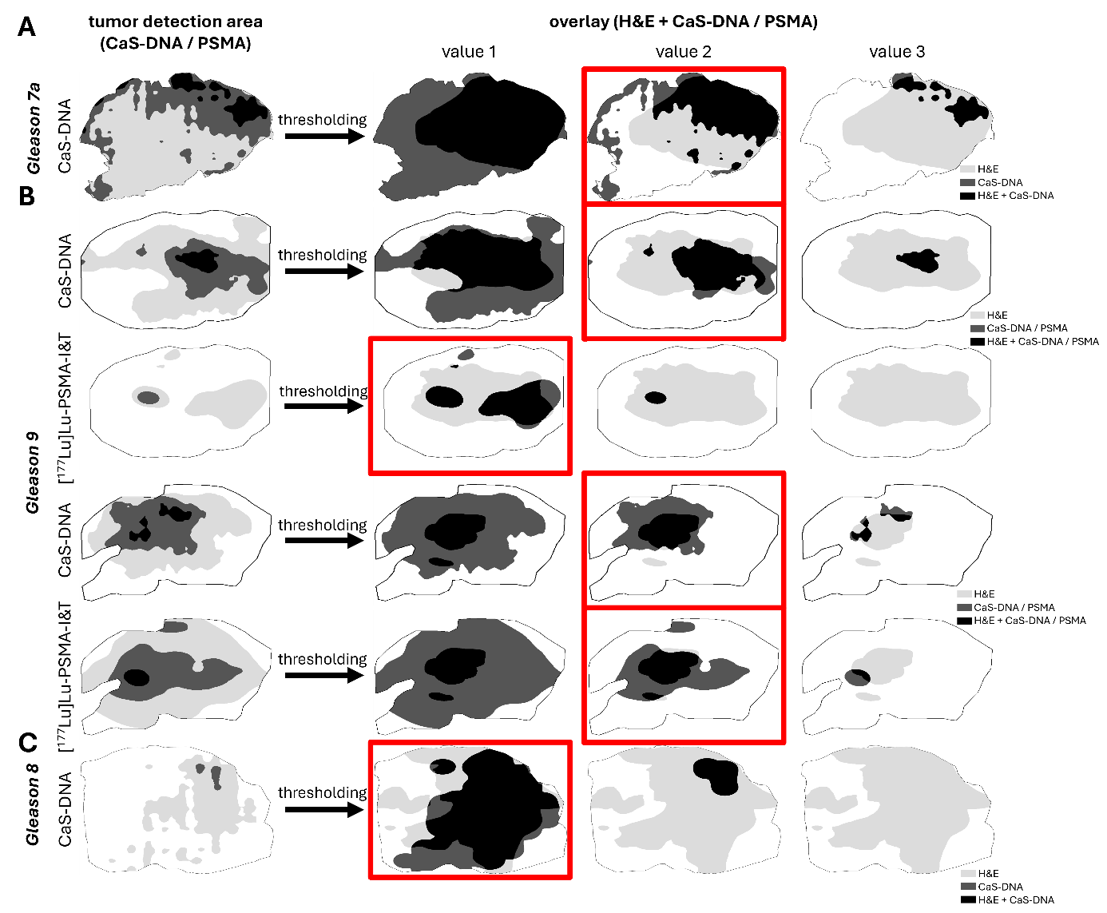

Supplementary Fig. 5 │ Determination of optimal threshold parameters. The figure represents all individually analyzed tissue slices obtained from Gleason 7a (CasDNA; A), Gleason 9 (CasDNA and [¹⁷⁷Lu]Lu-PSMA-I&T; B), and Gleason 8 (CasDNA; C). For each tissue section, different threshold values
(1–3) were tested to achieve optimal tumor area detection. Tumor regions annotated by H&E are shown in light grey, regions detected by CaS-DNA or [¹⁷⁷Lu]Lu-PSMA in grey and overlapping regions in black. The threshold values highlighted in red were subsequently selected for the quantification of relative area fractions for each analysis individually.

