Table S1. Grid box center coordinates and dimensions used for molecular docking analysis of hub target proteins
Protein | PDB ID | Grid Center (x,y,z) | Grid Size (x,y,z)
AKT1 | 3O96 | X= 3.51  Y= -8.991  Z= 19.285 | X= 68.075  Y= 73.479  Z= 77.970
IL6 | 4NI9 | X= -2.755  Y= 20.380  Z= 11.673 | X= 48.399  Y= 47.567  Z= 58.100
HSP90AA1 | 3O0I | X= -0.270  Y= -14.208  Z= -29.109 | X= 48.399  Y= 50.212  Z= 55.466
CASP3 | 1RHJ | X= -103.773  Y= 34.459  Z= 58.229 | X= 48.398  Y= 64.8454  Z= 59.291
SRC | 6E6E | X= 29.617  Y= -4.143  Z= 13.810 | X= 56.398  Y= 62.8454  Z= 69.291

Table S2 Physiochemical, pharmacokinetics and drug-likeness-associated properties of GC-MS-identified compounds from Pleurotus membranaceus (P.M.)
S.No. | Compounds | Physiochemical properties |  |  |  |  |  | Lipinski’s Violations | Bioavailability | Pharmacokinetics
S.No. | Compounds | MW | H-bond acceptors | H-bond donors | MLOGP | TPSA | Rotatable bonds | Lipinski’s Violations | Bioavailability
S.No. | Compounds | <500 | <10 | <5 | ≤4.15 | <140 | <10 | <1 | >0.1 | BBB | CYP2D6 | CYP3A4
1 | Butyrolactone | 86.09 | 2 | 0 | 0.09 | 26.3 | 0 | 0 | 0.55 | No | No | No
2 | Dimethyl sulfone | 94.13 | 2 | 0 | -0.59 | 42.52 | 0 | 0 | 0.55 | Yes | No | No
3 | 2-Cyclopenten-1-one, 2-hydroxy- | 98.1 | 2 | 1 | -0.42 | 37.3 | 0 | 0 | 0.55 | Yes | No | No
4 | 1-Methyl-1-(3-methylbutyl)oxy-1-silacyclobutane | 172.34 | 1 | 0 | 2.15 | 9.23 | 4 | 0 | 0.55 | Yes | No | No
5 | Isosorbide | 146.14 | 4 | 2 | -1.52 | 58.92 | 0 | 0 | 0.55 | No | No | No
6 | 5-Methyl-1R,3-trans-cyclohexanediol | 130.18 | 2 | 2 | 0.57 | 40.46 | 0 | 0 | 0.55 | Yes | No | No
7 | beta.-Methyl xyloside | 164.16 | 5 | 3 | -1.94 | 79.15 | 2 | 0 | 0.55 | No | No | No
8 | DL-Proline, 5-oxo-, methyl ester | 143.14 | 3 | 1 | -0.55 | 55.4 | 2 | 0 | 0.55 | No | No | No
9 | n-Octadecyl-N'-6-[N-aziridyl]hexylthiourea | 453.81 | 1 | 2 | 4.94 | 59.16 | 26 | 1 | 0.55 | No | No | No
10 | .alpha.-D-Galactopyranoside, methyl | 194.18 | 6 | 4 | -2.4 | 99.38 | 2 | 0 | 0.55 | No | No | No
11 | Hexadecanoic acid, methyl ester | 270.45 | 2 | 0 | 4.44 | 26.3 | 15 | 1 | 0.55 | Yes | No | No
12 | Docosanoic acid, ethyl ester | 368.64 | 2 | 0 | 6 | 26.3 | 22 | 1 | 0.55 | No | No | No
13 | 9,12-Octadecadienoic acid, methyl ester | 294.47 | 2 | 0 | 4.7 | 26.3 | 15 | 1 | 0.55 | No | No | No
14 | 10-Octadecenoic acid, methyl ester | 296.49 | 2 | 0 | 4.8 | 26.3 | 16 | 1 | 0.55 | No | No | No
15 | Tetradecanoic acid, 12-methyl-, methyl ester | 256.42 | 2 | 0 | 4.19 | 26.3 | 13 | 1 | 0.55 | Yes | No | No
16 | Linoleic acid ethyl ester | 308.5 | 2 | 0 | 4.93 | 26.3 | 16 | 1 | 0.55 | No | No | No
17 | (Z)-Ethyl heptadec-9-enoate | 296.49 | 2 | 0 | 4.8 | 26.3 | 16 | 1 | 0.55 | No | No | No
18 | Hexanedioic acid, dioctyl ester | 370.57 | 4 | 0 | 4.55 | 52.6 | 21 | 1 | 0.55 | No | No | Yes
19 | 2-(Dimethylamino)ethyl vaccenoate | 353.58 | 2 | 2 | 4.18 | 49.33 | 20 | 1 | 0.55 | No | No | No
20 | Hexadecanoic acid, 2-hydroxy-1-(hydroxymethyl)ethyl ester | 330.5 | 4 | 2 | 3.18 | 66.76 | 18 | 0 | 0.55 | Yes | Yes | No
21 | 9,12-Octadecadienoic acid (Z,Z)-, 2,3-dihydroxypropyl ester | 354.52 | 4 | 2 | 3.42 | 66.76 | 18 | 0 | 0.55 | Yes | Yes | Yes
22 | 13-Docosenamide, (Z)- | 337.58 | 1 | 1 | 5.06 | 43.09 | 19 | 1 | 0.55 | No | No | No
23 | Ergosterol | 396.65 | 1 | 1 | 6.33 | 20.23 | 4 | 1 | 0.55 | No | No | No
Keys: MW, molecular weight; HD, the number of hydrogen bond donors; HA, the number of hydrogen bond acceptors; MolLogP, lipophilicity; TPSA, total polar surface area; BBB, blood brain barrier; CYP2D6, cytochrome P450 2D6 and CYP3A4, cytochrome P450 3A4.

Table S3 separated from this document its upload separately because is huge size and contain excel sheet data

Table S4. The DC, BC and CC values of the top 20 hub genes.
Gene | Degree | Betweenness | Closeness
AKT1 | 59 | 0.165730845 | 0.509138381
HSP90AA1 | 48 | 0.115479084 | 0.479115479
IL6 | 48 | 0.125989271 | 0.466507177
STAT3 | 42 | 0.06814406 | 0.451388889
SRC | 41 | 0.055665394 | 0.453488372
CASP3 | 36 | 0.065295713 | 0.453488372
NFKB1 | 34 | 0.040924239 | 0.45034642
STAT1 | 31 | 0.04511652 | 0.427631579
MAPK1 | 29 | 0.022156145 | 0.426695842
MMP9 | 29 | 0.092395662 | 0.435267857
HIF1A | 29 | 0.0477883 | 0.438202247
KRAS | 27 | 0.051777395 | 0.422993492
PIK3R1 | 27 | 0.016350384 | 0.405405405
JAK2 | 24 | 0.008113615 | 0.413135593
TGFB1 | 22 | 0.019993537 | 0.415778252
RHOA | 21 | 0.058689413 | 0.409663866
CDC42 | 20 | 0.018053628 | 0.402892562
CYCS | 20 | 0.039421875 | 0.419354839
XIAP | 19 | 0.018634092 | 0.384615385
RAF1 | 19 | 0.011939781 | 0.402892562
Keys: DC, BC, and CC represent Degree Centrality, Betweenness Centrality, and Closeness Centrality, respectively

Table S5. Types of intermolecular interactions and key amino acid residues involved in the binding of isosorbide with AKT1, HSP90AA1, SRC, IL6, and CASP3 proteins.
Protein–Ligand Complex | Interaction Type | Interacting Residues | No. of Interactions
AKT1–Isosorbide | Conventional hydrogen bond | ASN54, ARG273, TYR272, CYS296 | 4
 | π-Sulfur interaction | CYS296 | 1
 | π-Alkyl interaction | VAL270 | 1
HSP90AA1–Isosorbide | Conventional hydrogen bond | SER52, TYR139, GLY108, ASN105 | 4
SRC–Isosorbide | Carbon hydrogen bond | GLY347, ASP351, GLY279 | 3
 | Conventional hydrogen bond | LYS298, CYS280, SER348, LYS346 | 4
 | π-Alkyl interaction | VAL284, ALA406, LEU396 | 3
 | π-Cation interaction | LYS298 | 1
IL6–Isosorbide | π-Sigma interaction | ARG40 | 1
 | Carbon hydrogen bond | THR43, HIS164, ARG168 | 3
 | Conventional hydrogen bond | SER107, GLU106, LYS171, ARG168 | 4
 | π-Cation interaction | ARG168 | 1
 | π–π T-shaped interaction | HIS164 | 1
CASP3–Isosorbide | Conventional hydrogen bond | ASN263, ARG269 | 2
 | Carbon hydrogen bond | LYS260 | 1
 | π–π T-shaped interaction | PHE264 | 1
 | π-Alkyl interaction | ARG271, CYS270, LYS260 | 3
 | Donor hydrogen bond | SER272 | 1

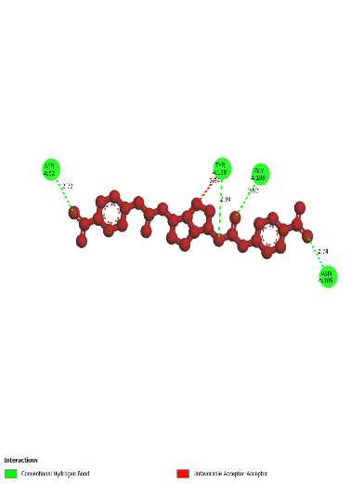
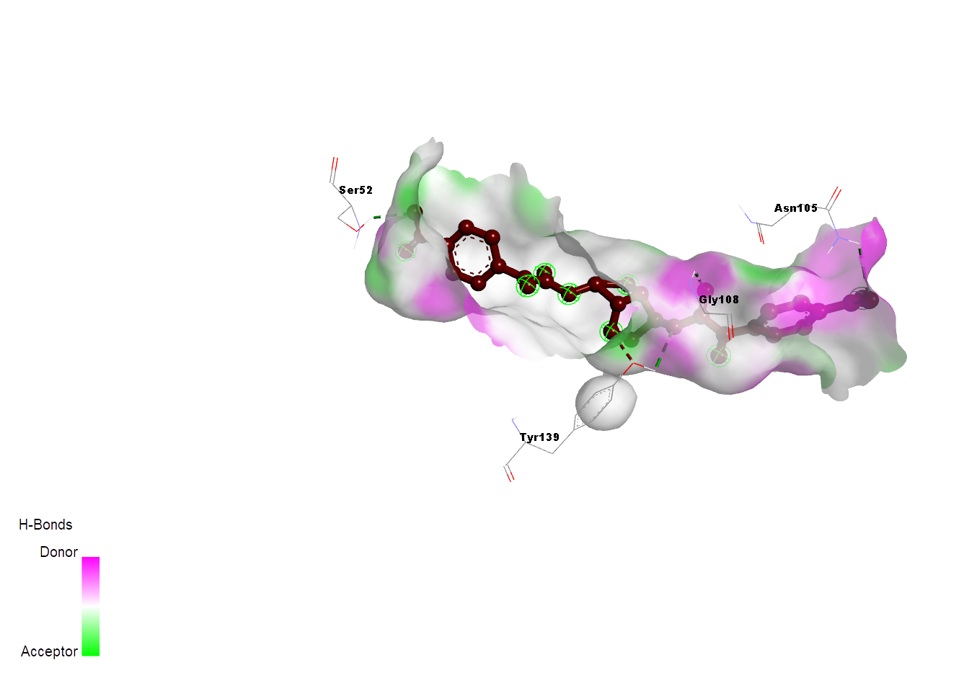
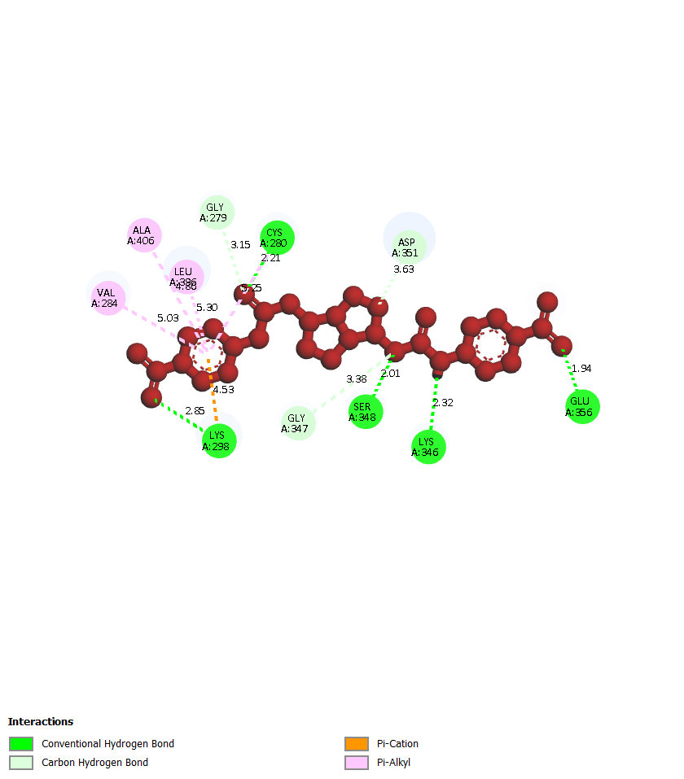
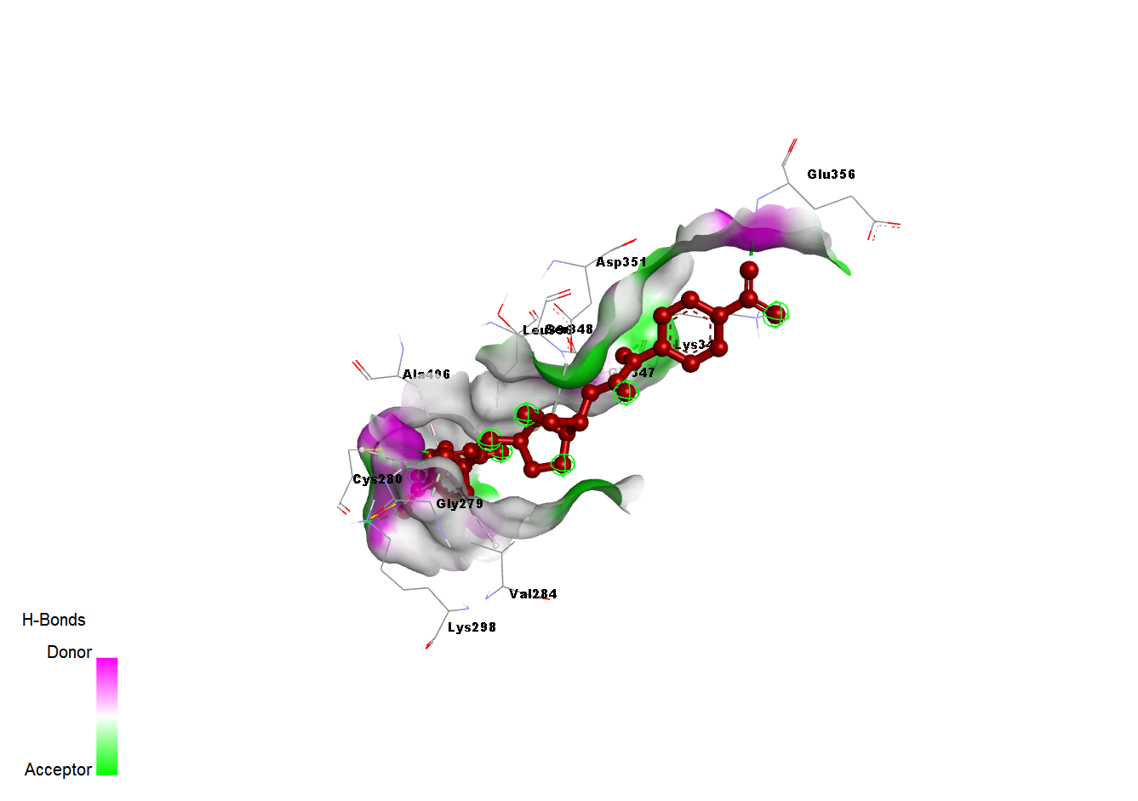
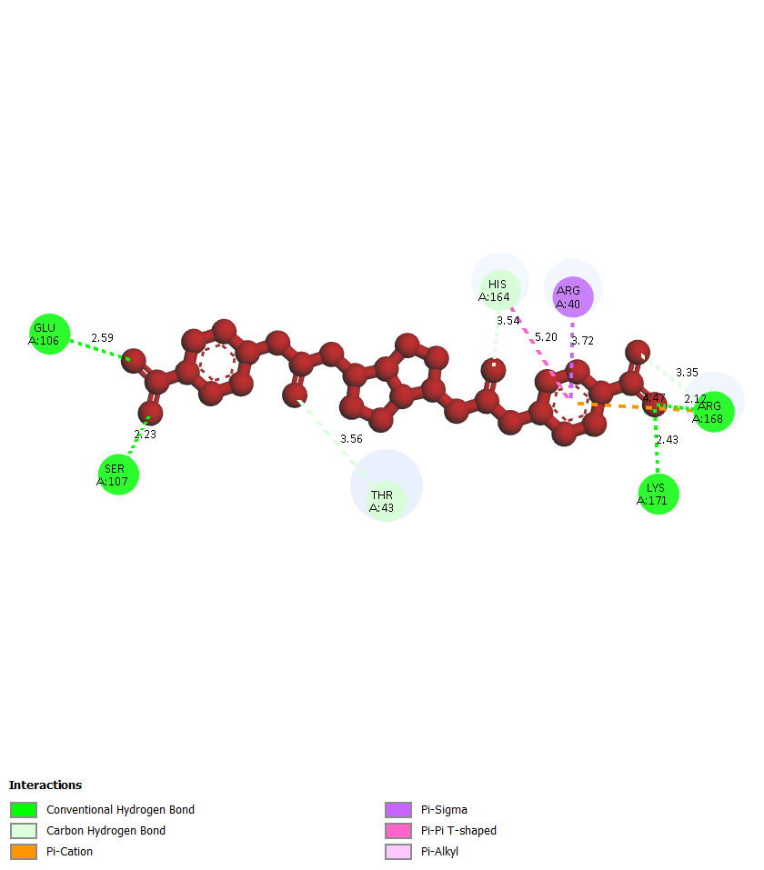
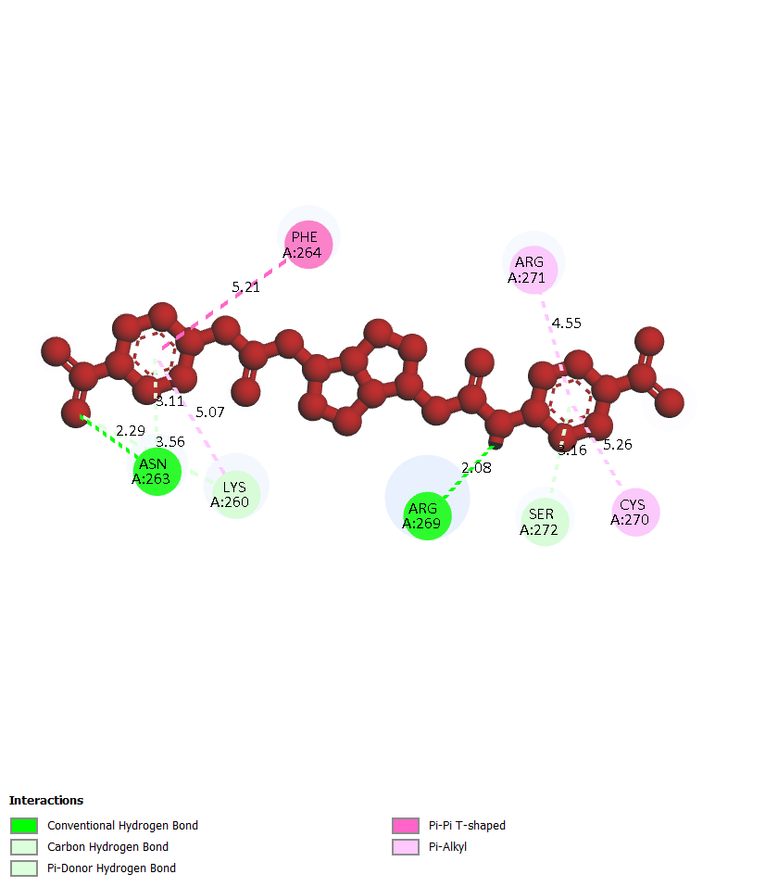
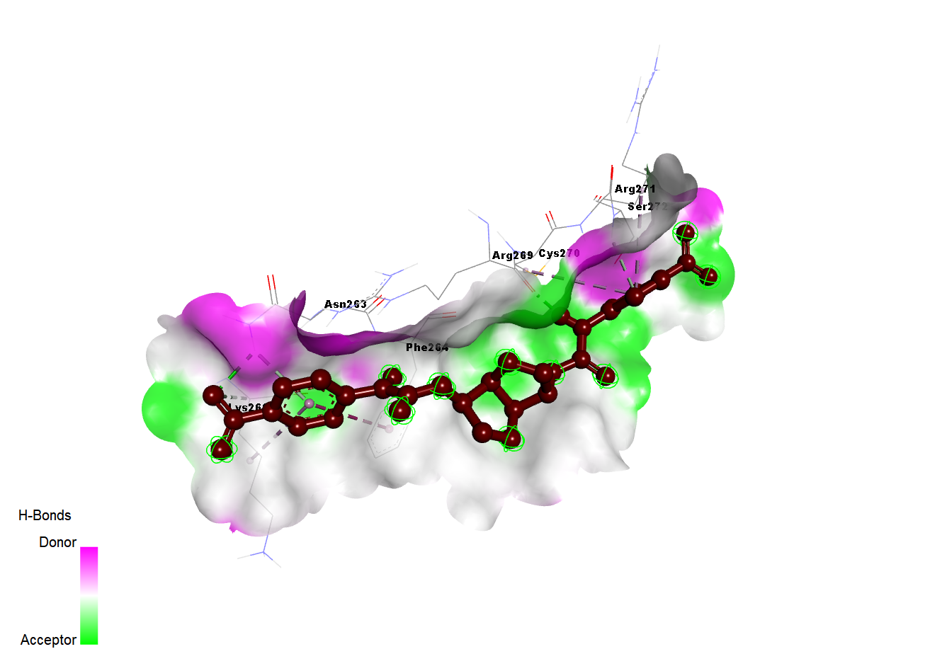
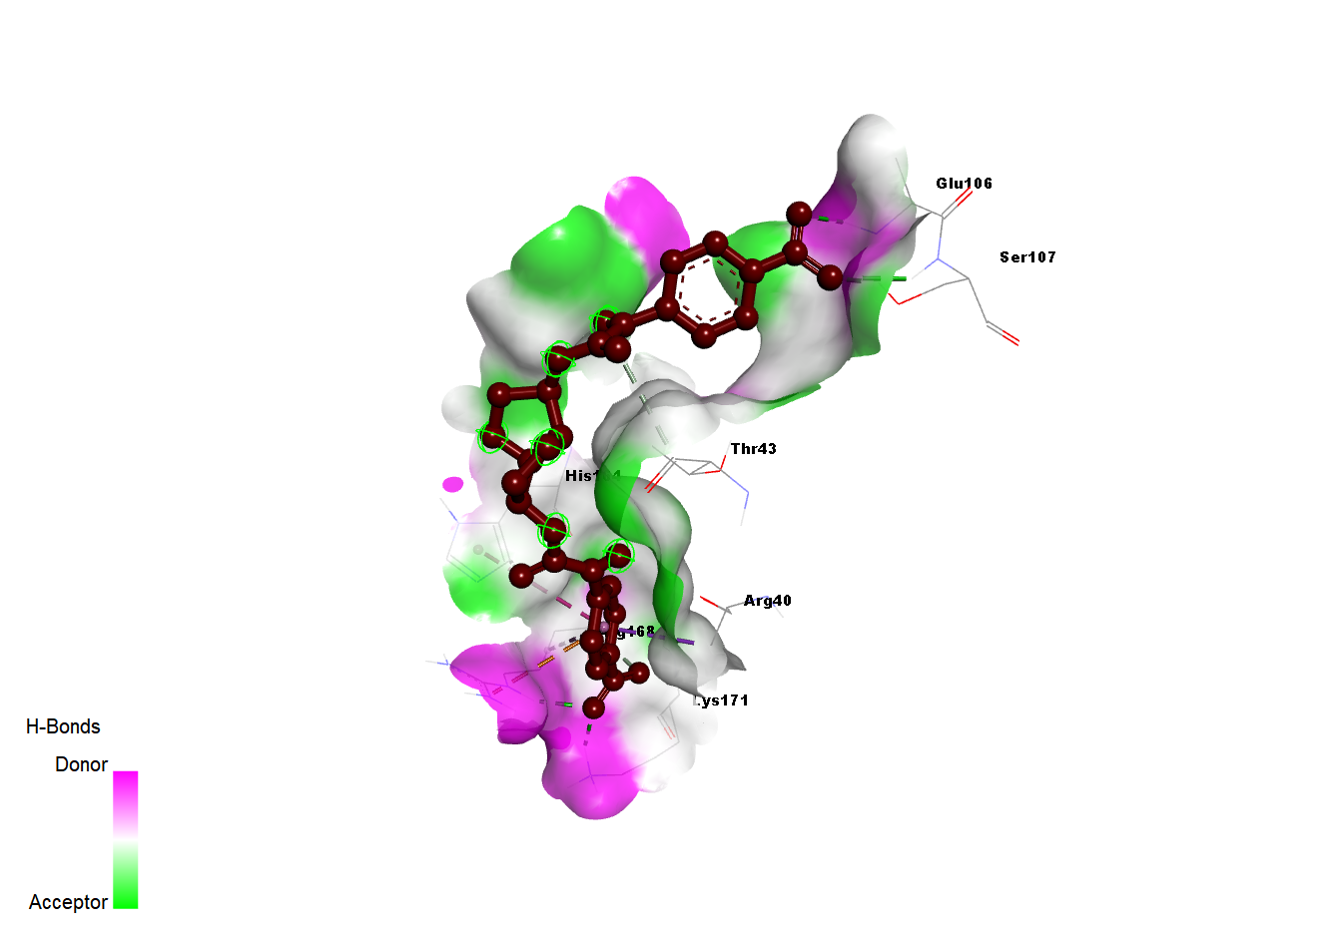
(B)
(C)
(D)
(E)

Fig. S1 Molecular docking interaction patterns of isosorbide with the top five hub target proteins showing 3D and 2D binding interactions (B) HSP90AA1–Isosorbide (3O0I), (C) SRC–Isosorbide (6E6E), (D) IL6–Isosorbide (4NI9) and (E) CASP3–Isosorbide (1RHJ)

