Laser-Induced Surface Structuring of Silicon for Enhanced Antibacterial Performance of Silver Thin Films
Lynda Lounis¹, Barthélemy Aspe*¹, Pierre Birnal¹, Hervé Rabat¹, Loïc Gimenez¹, Arnaud Stolz¹, Fabienne Brulé-Morabito², Anne-Lise Thomann¹, Eric Millon¹, Nadjib Semmar¹
1 Université d’Orléans, CNRS, GREMI UMR7344, 14 rue d’Issoudun, F-45067 Orléans, France
2 Université d'Orléans – INSERM, InTheRNA UMR1364, CHU Orléans, 14 avenue de l'Hôpital, 45100 Orléans La Source, France

*Corresponding author: barthelemy.aspe@univ-orleans.fr
ORCID Barthélemy Aspe: 0000-0001-8927-4013

Apprendix
Estimation of the surface enhancement by LIPSS
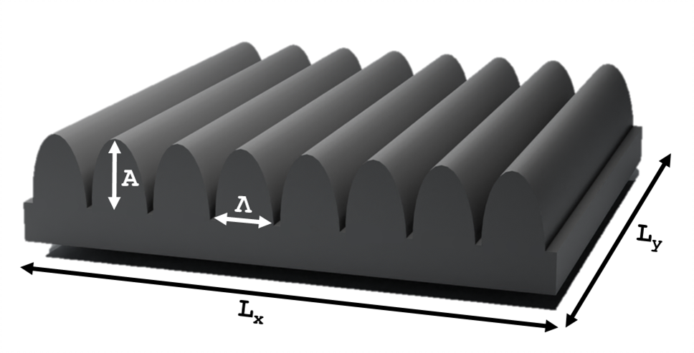Fig. S1: Schematic of LIPSS structures approximated as elliptical half-cylinders (EHC).
The specific surface area of the surface after LIPSS formation was calculated using the method described by Karim et al. [1]. Initially, the flat, unstructured surface (S₀) was considered to be rectangular, its surface area being defined by:
$$S_{0}=L_{x}×L_{y} (1 SEQ Eq \backslash * ARABIC )$$
After laser structuring, the shape of the D‑LIPSS is assumed to be approximated by elliptical half-cylinders (EHC), as shown in Fig. S1. The surface area of an EHC is given by:
$$S_{EHC}=\frac{P×L_{y}}{2}$$
Where P is the perimeter of the EHC and L_{y} likely refers to the length of the EHC along the y-direction. If N_{x} elliptical half-cylinders (N_{x} protrusions) are considered, the total surface area is given by:
$$S_{EHC}^{tot}=\frac{P×N_{x}×L_{y}}{2}$$
The number of nano-structures N_{x} is calculated as:
$$N_{x}=\frac{L_{x}}{Λ}$$
Where Λ denotes the spatial period of the LIPSS equal to 850 ± 20 nm. The specific surface area is then expressed as:

$$S_{EC}^{tot}=\frac{P×L_{x}×L_{y}}{2Λ} (2 SEQ Eq \backslash * ARABIC )$$
To calculate the perimeter, Ramanujan’s approximation for the perimeter of an ellipse was used [2]:

$$P= π\left\{\left(A+\frac{Λ}{2}\right)+\frac{3{\left(A-\frac{Λ}{2}\right)}^{2}}{10\left(A+\frac{Λ}{2}\right)+\sqrt{A^{2}+14A\frac{Λ}{2}+{\left(\frac{Λ}{2}\right)}^{2}}}\right\}$$
Where A represents the amplitude of the LIPSS, taking into account the oxide layer formed after laser structuring. The value of A is approximately 900 nm. The surface enhancement ratio (Σ) induced by LIPSS formation can be determined from expressions (1) and (2).
$$\text{Σ}= \frac{S_{EC}^{tot}}{\text{S}\text{0}}=\frac{P×L_{x}×L_{y}}{2Λ}×\frac{1}{L_{x}×L_{y}}=\frac{P}{2Λ}$$
In this study, the surface enhancement ratio (Σ) is approximately 3, indicating that the surface area is enhanced by 200%.

References

[1] W. Karim, A. Petit, H. Rabat, M. Tabbal, A.-L. Thomann, et N. Semmar, « Picosecond laser beam nanostructuring of GDC thin films: exchange surface enhancement by LIPSS », Appl. Phys. A, vol. 128, nº 8, p. 731, 2022, doi: 10.1007/s00339-022-05866-6.
[2] M. B. Villarino, « Journal of Inequalities in Pure and Applied Mathematics », 2006.

