Integrated coherent LiDAR with broadband low-noise-laser-driven, multidimensionally multiplexed passive beam steering
Siyu E†, Qiqi Yuan†, Yuyao Guo*, Xinhang Li, Chang Li, Weihan Xu, Minhui Jin, Yanyang Zhou*, Yu Li, Liangjun Lu, Wansu Bao, Jianping Chen, and Linjie Zhou*
†These authors contributed equally
*Corresponding authors
Affiliations
State Key Laboratory of Micro-Nano Engineering Science, School of Integrated Circuits, Shanghai Jiao Tong University, Shanghai 200240, China.
Siyu E, Qiqi Yuan, Chang Li & Xinhang Li
State Key Laboratory of Photonics and Communications, School of Integrated Circuits, Shanghai Jiao Tong University, Shanghai 200240, China.
Yuyao Guo, Weihan Xu, Minhui Jin, Yu Li, Liangjun Lu, Jianping Chen & Linjie Zhou
SJTU-Pinghu Institute of Intelligent Optoelectronics, Pinghu 314200, China.
Yuyao Guo, Minhui Jin, Yu Li, Liangjun Lu, Jianping Chen & Linjie Zhou
Henan Key Laboratory of Quantum Information and Cryptography, IEU, Zhengzhou 450001, China.
Yanyang Zhou & Wansu Bao
Supplementary Note 1
SILECL lasing performance
In the SIL state, we characterized the light-current-voltage (L-I-V) curves by adjusting the RSOA. The maximum on-chip output power at the output port was approximately 12 dBm, as depicted in Fig. 1a. Since the packaged fiber array (FA) did not include the other output port of MRR₃, the actual total output power should be higher than the currently measured value. Fig. 1b demonstrates that the SILECL exhibits a side-mode suppression ratio (SMSR) exceeding 59 dB across the entire tuning range.
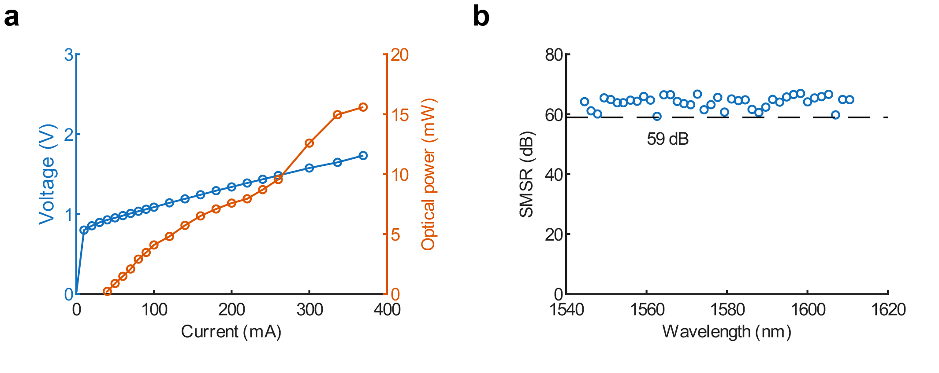
Fig. 1: Lasing performance characterization of the SILECL. a SMSR of lasing spectra. b L-I-V curves of SILECL.
Supplementary Note 2
Self-injection-locking model of the SILECL
When the TSL’s reflectivity ($R_{t}$) in the SILECL is 100%, the intra-cavity field equation of the ECL part can be expressed as^{1,2}:
$\frac{d}{dt}ε\left(t\right)=ε\left(t\right)\left[jω+\frac{1}{2}\left(G-γ\right)\left(1+jα_{g}\right)\right]$
(1)
where $ε\left(t\right)$ is the intracavity electric field, $ω$ is the angular frequency, $G$ is the stimulated emission rate, $γ$ is the intracavity loss rate of the ECL part, and $α_{g}$ is the linewidth enhancement factor. As $R_{t}$ decreases, the involvement of MRR₃ introduces a feedback term into $ε\left(t\right)$. For the all-pass MRR structure commonly used in SIL lasers^{3,4}, the feedback achieved by backscattered light is relatively low, allowing the multiple round-trips in the external cavity to be approximated as a single round-trip¹. However, for the SILECL, the Sagnac loop formed by the MMI and MRR₃ yields high reflectivity, classifying it as a strong feedback regime. By expressing the multiple round-trips within the SIL part as an infinite series and applying the slowly varying envelope approximation via a first-order Taylor expansion, the feedback term is derived⁵ and incorporated into equation (1):
$\frac{d}{dt}E\left(t\right)e^{jω_{s}t}\&= E\left(t\right)e^{jω_{s}t}\left[jω_{e}+\frac{1}{2}\left(G-γ\right)\left(1+jα_{g}\right)\right]+κ_{s}e^{-jϕ_{eff}}\left[E\left(t\right)-\hat{γ}τ_{s}\frac{dE\left(t\right)}{dt}\right]e^{jω_{s}t}$
(2)
where $ω_{s}$ is the output angular frequency after SIL, $ω_{e}$ is the output angular frequency in the non-SIL state, $E\left(t\right)$ is the slowly varying envelope of the electric field, $κ_{s}$ is the feedback coefficient, $ϕ_{eff}$ is the phase of the effective reflectivity of the SIL part, $\hat{γ}$ is the correction factor for multiple reflections, and $τ_{s}$ is the composite group delay of the SIL part. Under steady-state lasing conditions, the amplitude of the optical field is constant ($\frac{dE\left(t\right)}{dt}=0$). Therefore, equation (2) can be simplified to:
$jω_{s}=jω_{e}+\frac{1}{2}\left(G-γ\right)\left(1+jα_{g}\right)+κ_{s}e^{-jϕ_{s}}$
(3)
The real part represents the gain condition, and the imaginary part represents the phase condition. Substituting the real part equation into the imaginary part equation yields the relationship between $ω_{e}$ and $ω_{s}$:
$ω_{e}=ω_{s}+κ_{s}\left[α_{g}\cos\left(ϕ_{eff}\right)+\sin\left(ϕ_{eff}\right)\right]$
(4)
After considering the multiple intra-cavity reflections in the SIL part, $κ_{s}$ can be expressed as⁵:
$κ_{s}\left(ω_{s}\right)=\frac{1}{τ_{e}}\ln\left(\frac{r_{eff}}{r_{t}}\right)$
(5)
where $τ_{e}$ is the round-trip group delay of the ECL part, $r_{eff}$ describes the equivalent amplitude reflectivity after the superposition of the feedback light and the TSL reflected light, and $r_{t}$ is the amplitude reflectivity of the TSL. $τ_{e}$ can be expanded as the sum of the group delays of the RSOA part, the waveguide part in the ECL, and the MRR₁ and MRR₂ parts:
$τ_{e}=τ_{r}+τ_{wg}+τ_{1}+τ_{2}$
(6)
$τ_{r}=\frac{2}{c}∙n_{g,r}∙L_{r}$
(7)
$τ_{wg}=\frac{2}{c}∙n_{g,wg}∙L_{wg}$
(8)
where $n_{g,r}$ and $L_{r}$ are the group refractive index and physical length of RSOA, respectively; while $n_{g,wg}$ and $L_{wg}$ are the group refractive index and physical length of passive Si₃N₄ waveguides without MRR₁ and MRR₂ in the ECL part. To obtain $τ_{i}$, we must start from the drop-port transmission function of an add-drop MRR. Noting that the coupling regions of all MRRs in the SILECL are symmetric and assuming lossless coupling regions⁶:
$t_{drop}\left(ω_{s}\right)=-\frac{κ_{i}^{2}\sqrt{a_{i}}e^{{-jϕ_{i}}/2}}{1-t_{i}^{2}a_{i}e^{-jϕ_{i}}}$
(9)
where $κ_{i}^{2}$ is the power coupling coefficients of the MRR_{i}. $t_{i}^{2}$ is the power transmission coefficient of the MRR_{i}. $a_{i}$ is the round-trip amplitude attenuation factor in the MRR_{i}, and $ϕ_{I}$ is the round-trip phase delay of MRR_{i}. Then:
$ϕ_{i}=β_{i}L_{i}$
(10)
$a_{i}=e^{-\frac{α_{i}}{2}∙L_{i}}$
(11)
$β_{i}=\frac{ω_{s}n_{g,i}}{c}$
(12)
where $L_{i}$ is the physical circumference of MRR_{i}. $β_{i}$ is the propagation constant of MRR_{i}, $α_{i}$ is the waveguide power transmission loss in MRR_{i}, $n_{g,1}$ and $n_{g,2}$ are the group refractive indices of MRR₁ and MRR₂, respectively. Differentiating the phase of equation (9) yields $τ_{i}$:
$τ_{i}=-\frac{d\left[\arg\left(t_{drop}\right)\right]}{dϕ_{i}}\frac{dϕ_{i}}{dω}=τ_{rt}\left[\frac{1}{2}+\frac{T_{i}\cos\left(ϕ_{i}\right)-T^{2}}{1+T_{i}^{2}-2T\cos\left(ϕ_{i}\right)}\right]$
(13)
$T_{i}=t_{i}^{2}a_{i}$
(14)
$τ_{rt}=\frac{L_{i}∙n_{g,i}}{c}$
(15)
Next, neglecting the loss of the TSL, $r_{eff}$ can be expressed as⁵:
$r_{eff}=\sqrt{\frac{r_{t}^{2}+r_{s}^{2}+2r_{t}r_{s}\cos\left(ψ_{s}\right)}{1+r_{t}^{2}r_{s}^{2}+2r_{t}r_{s}\cos\left(ψ_{s}\right)}}$
(16)
where $r_{s}$ is the external cavity amplitude reflectivity, which corresponds to the drop-port transmission function of MRR₃ and can be expressed using equation (9):
$r_{s}=\left|t_{drop}\left(ω_{s}\right)\right|=-\frac{κ_{3}^{2}\sqrt{a_{3}}}{\sqrt{1+T_{3}^{2}-2T_{3}\cos\left(ϕ_{3}\right)}}$
(17)
In equation (16), $ψ_{s}$ represents the total round-trip phase shift of the external cavity part, which includes the linear propagation phase of the waveguide in the SIL part and the resonant phase of MRR₃:
$ψ_{s}=-2β_{wg}L_{ext}+π-\frac{ϕ_{3}}{2}-\arctan\left[\frac{T_{3}∙\sin\left(ϕ_{3}\right)}{1-T_{3}∙\cos\left(ϕ_{3}\right)}\right]+ϕ_{0}$
(18)
where $β_{wg}$ is the propagation constant of the single-mode straight waveguide on the Si₃N₄ chip, $L_{ext}$ is the cavity length of the SIL part excluding the MRR₃ section, and $ϕ_{0}$ is the initial phase, which can be adjusted by PS₂.
Neglecting the TSL loss, $ϕ_{eff}$ can be expressed as⁵:
$ϕ_{eff}=\arctan\left[\frac{r_{s}\left(1-r_{t}^{2}\right)\sin\left(ψ_{s}\right)}{r_{t}\left(1+r_{s}^{2}\right)+r_{s}\left(1+r_{t}^{2}\right)\cos\left(ψ_{s}\right)}\right]$
(19)
The relevant SILECL parameters utilized in the aforementioned derivations are summarized in Table 1.
Table 1 Parameters for SILECL
Parameters | Value | Unit
$$n_{g,r}$$ | $$3.5$$ | -
$$n_{g,wg}$$ | $$2.08$$ | -
$$n_{g,m_{1}}$$ | $$2.08$$ | -
$$n_{g,m_{2}}$$ | $$2.08$$ | -
$$n_{g,m_{3}}$$ | $$2.03$$ | -
$$L_{r}$$ | $$1×{10}^{-3}$$ | $$m$$
$$L_{ext}$$ | ~$3×{10}^{-3}$ | $$m$$
$$L_{wg}$$ | ~$5×{10}^{-3}$ | $$m$$
$$L_{m_{1}}$$ | $$694×{10}^{-6}$$ | $$m$$
$$L_{m_{2}}$$ | $$713×{10}^{-6}$$ | $$m$$
$$L_{m_{3}}$$ | $$5×{10}^{-3}$$ | $$m$$
$$κ_{m_{1}}^{2}$$ | $$0.1$$ | -
$$κ_{m_{2}}^{2}$$ | $$0.1$$ | -
$$κ_{m_{3}}^{2}$$ | $$0.03$$ | -
$$α_{m_{1}}$$ | $$10$$ | $${dB}/m$$
$$α_{m_{2}}$$ | $$10$$ | $${dB}/m$$
$$α_{m_{3}}$$ | $$3$$ | $${dB}/m$$
$$α_{g}$$ | $$2.5$$ | -
$$ψ_{0}$$ | $$1.5π$$ | -
$$R_{t}$$ | $$30\%$$ | -

Supplementary Note 3
FMCW instantaneous-frequency waveforms in SIL
Fig. 2 shows the instantaneous frequency waveform of the FMCW signal used in the main text in the non-SIL state and SIL state with different wavelengths. It is noted that the achievable $B$ in the SIL state was limited to under 500 MHz, falling short of the theoretical prediction. The primary reason is that a phase mismatch exists between the ECL part and the SIL part. Furthermore, as illustrated in Fig. 2a, an inherent deviation exists between the output angular frequency in the SIL state ($ω_{s}$) and the resonant angular frequency of MRR₃ ($ω_{m}$) within the locking region; consequently, the maximum mode-hop-free tuning range of $ω_{s}$ is strictly narrower than the full locking range. The $ω_{s}$ exhibits a nonlinear dependence on the $ω_{m}$ within the locking region. Since the FMCW signal is generated by tuning $ω_{m}$, this inherent deviation implies that the maximum achievable mode-hop-free tuning range of $ω_{s}$ is strictly narrower than the full static locking range. Finally, the thermal hysteresis effect prevents the local temperature from synchronizing with the rapid variations of the driving voltage⁷.
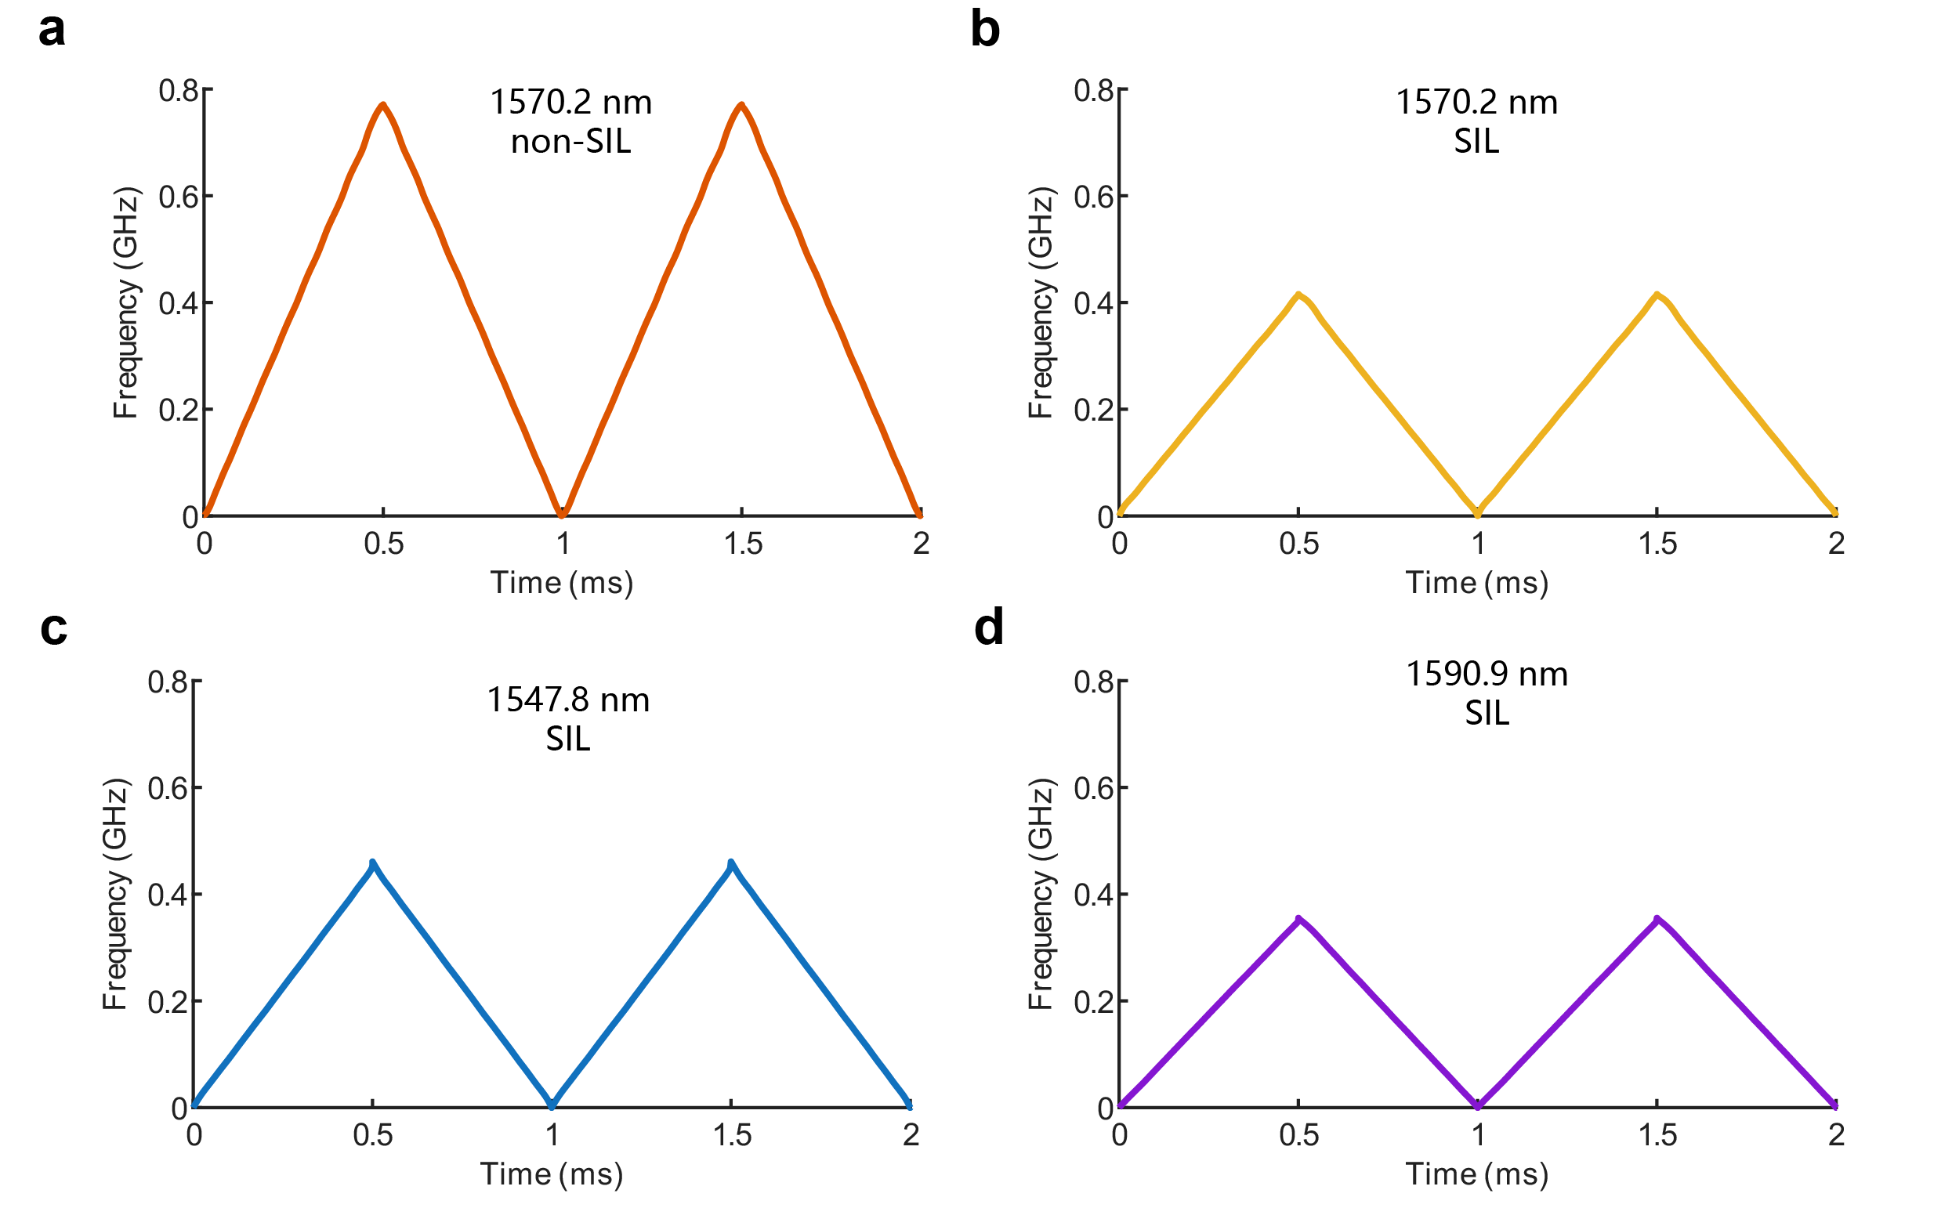
Fig. 2: The pre-distorted FMCW signals at different wavelengths and under different operating conditions. a The instantaneous frequency waveform in non-SIL state at 1570.2 nm. b The instantaneous frequency waveform in SIL state at 1570.2 nm. c The instantaneous frequency waveform in SIL state at 1547.8 nm. d The instantaneous frequency waveform in SIL state at 1590.9 nm.
Supplementary Note 4
OPA structure and dispersion
1. Waveguide dispersion
The intrinsic dispersion efficiency of the waveguide grating dictates the system's utilization of spectral resources in the longitudinal scanning dimension. The specific structural parameters are as follows: a bottom silicon waveguide thickness of 220 nm and width of 5 μm, a top Si₃N₄ perturbation thickness of 400 nm, and an interlayer silicon dioxide gap of 150 nm. The grating perturbation period within the Si3N4 layer is set to 620 nm, with a longitudinal duty cycle of 0.41.
Based on these parameters, the simulated longitudinal far-field diffraction angles were extracted across the operating wavelength range. The data demonstrate that the simulated longitudinal dispersion efficiency for the TE mode reaches 0.133°/nm, while the TM mode achieves 0.177°/nm. These theoretical values align closely with the experimentally measured efficiencies (0.135°/nm and 0.156°/nm, respectively) presented in the main text. The slight discrepancy observed in the TM mode is primarily attributed to its higher sensitivity to fabrication tolerances in the deposited film thicknesses.
2. Slanted-grating beam steering
Under extreme steering angles (the edge of the FOV), traditional straight gratings suffer a drastic drop in main lobe energy, fundamentally constrained by the envelope modulation of the element factor. The slanted grating architecture directly circumvents this diffraction envelope limitation by altering the direction of the perturbation vector, thereby "biasing" the intrinsic radiation direction.
Using a waveguide width of 5 μm, we simulated the horizontal far-field distributions () for both TE and TM modes. By explicitly configuring the grating perturbation slant angles () to ±1.78°, ±5.17°, ±8.44°, and ±11.97°, the corresponding horizontal emission centers are precisely steered to ±4.36°, ±12.60°, ±20.98°, and ±30.40°, respectively. This quantitative mapping confirms that the 2D tuning characteristics of slanted gratings successfully distribute the beam into distinct spatial sectors. To maximize the global GLSR of the entire system, we intentionally introduced a calculated degree of overlap between the FOVs of adjacent sub-arrays; during subsequent point cloud generation, only the core region with the highest GLSR in each sub-array sector is extracted and seamlessly stitched.
Supplementary Note 5
Slanted-grating sub-array performance
According to the system's symmetry, although the overall architecture equivalently contains 16 logical sub-arrays, Inputs 1-4 and Inputs 5-8 are physical mirrors of each other in terms of performance. Therefore, Fig. 3(a-d) systematically presents the core performance metrics of these 8 independent physical sub-arrays (4 tilt angles × 2 polarization states) over the broadband range of 1456 nm to 1640 nm, including SLL, GLSR, and IL.
It is noteworthy that the far-field profile of each sub-array under the TE mode exhibits a well-defined rectangular shape, which aligns perfectly with theoretical expectations. In contrast, the far-field profile of the TM mode displays irregular distortions. We hypothesize that this phenomenon stems from the grating array's relatively weak optical confinement for the TM mode, which causes the beam to undergo mode rotation during propagation. Because this rotation rate is inherently wavelength-dependent, the far-field contours appear irregular across different operating wavelengths. Fortunately, experimental observations indicate that this rotation is sufficiently gradual, thereby averting any severe degradation to the overall beam forming. Furthermore, the introduction of the slanted grating architecture does not perturb the fundamental relationship between the mode rotation rate and the wavelength. Consequently, we can still reliably leverage the slanted-grating-assisted sub-arrays to successfully synthesize a complete and seamless spatial FOV.
SLL: The test results show that the SLL of the TE mode is stably maintained between 6 and 12 dB, while the SLL of the TM mode is slightly inferior, at approximately 4 to 10 dB. The SLL is primarily limited by the accumulation of random phase errors introduced by the sidewall roughness of the underlying waveguides and the non-uniform thickness of the chip film layers. Since the mode field distribution of the TM mode is more sensitive to dimensional variations in the vertical direction, its SLL is slightly inferior to that of the TE mode.
GLSR: During the wavelength sweeping process, the measured GLSR exhibits periodic fluctuations correlated with the phase difference between array elements. This measured trend is highly consistent with our FDTD theoretical simulation results based on the high fill-factor design presented in Methods, proving that the system effectively breaks through the grating lobe limitations of conventional large-pitch arrays.
IL: The total insertion loss of the system consists primarily of four cascaded components: facet coupling loss, 1×2 MMI splitting loss, waveguide propagation loss, and grating radiation loss. Measurements indicate that the total IL for the TE mode is approximately 8 to 15 dB, while for the TM mode, it is about 10 to 20 dB. The higher loss for the TM mode is mainly constrained by the coupling efficiency bottleneck of the interlayer spot-size converters. Furthermore, the observed fluctuation in insertion loss across different operating wavelengths is also primarily attributed to the wavelength-dependent coupling profile of these spot-size converters. It is particularly worth noting that the 1×2 MMI structure currently integrated on the chip is reserved for compatibility with the future integration of an on-chip circulator. In a simplified configuration omitting this requirement, removing the MMI device reduces the insertion loss by approximately 3 dB, achieving an optimal on-chip insertion loss of around 5 dB. Under this scenario, the remaining loss of the system is primarily dominated by the facet couplers and the gratings.
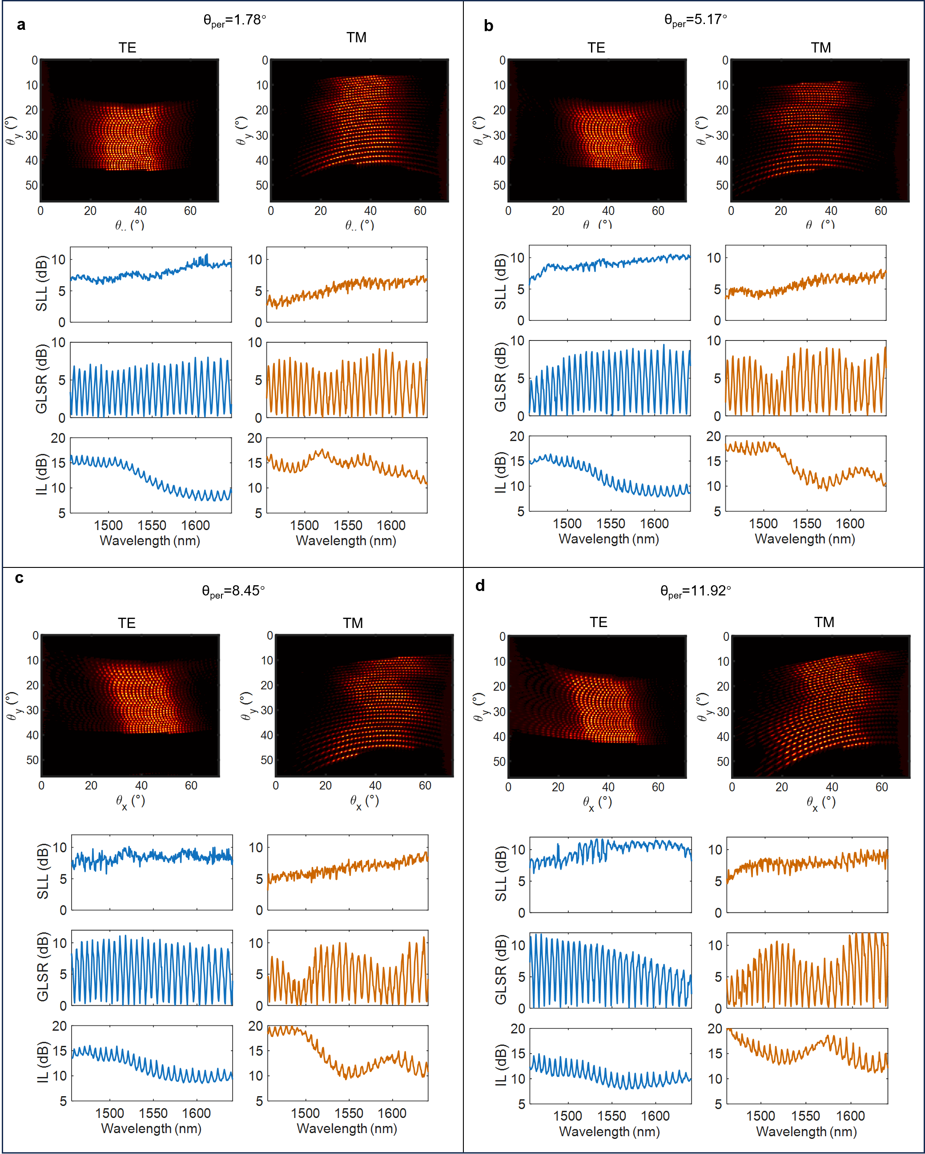
Fig. 3: Quantitative performance characterization of the slanted grating sub-arrays.a–d Measured far-field distributions, along with the quantitative analysis curves of the SLL, GLSR, and IL as a function of wavelength (swept from 1456 nm to 1640 nm) for both TE and TM polarization modes. The results correspond to the physical sub-arrays with grating tilt angles of 1.78°, 5.17°, 8.45°, and 11.92°, respectively.

Supplementary Note 6
Ranging precision for the upper and lower steps
As shown in Fig. 4, in the SIL state, the ranging precisions for the upper (1547.8 nm) and lower (1590.9 nm) steps were measured to be 1.25 cm and 0.66 cm, respectively.
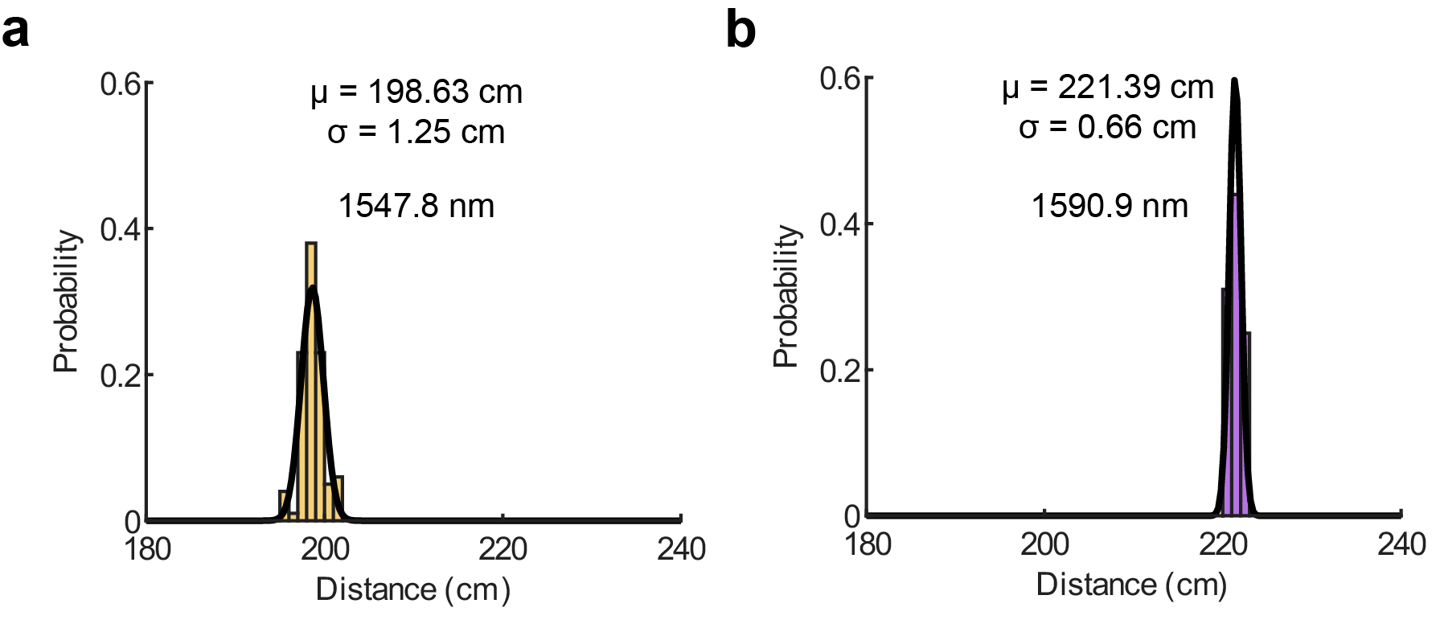
Fig. 4: Histograms of 100 consecutive distance measurements, demonstrating the ranging precision in the state at different wavelengths. a 1547.8 nm. b 1590.9 nm.

References
1. Lang, R. & Kobayashi, K. External optical feedback effects on semiconductor injection laser properties. IEEE J. Quantum Electron. 16, 347–355 (1980).
2. Henry, C. Theory of the linewidth of semiconductor lasers. IEEE J. Quantum Electron. 18, 259–264 (1982).
3. Jin, W. et al. Hertz-linewidth semiconductor lasers using CMOS-ready ultra-high-Q microresonators. Nat. Photonics 15, 346–353 (2021).
4. He, Y. et al. Chip-scale high-performance photonic microwave oscillator. Sci. Adv. 10, eado9570 (2024).
5. Fang, Z. et al. Discussions on line narrowing of self-injection locked diode lasers. Opt. Commun. 591, 132184 (2025).
6. Schwelb, O. Transmission, group delay, and dispersion in single-ring optical resonators and add/drop filters - a tutorial overview. J. Lightwave Technol. 22, 1380 (2004).
7. Tang, L. et al. Hybrid integrated low-noise linear chirp frequency-modulated continuous-wave laser source based on self-injection to an external cavity. Photonics Res. 9, 1948–1957 (2021).

