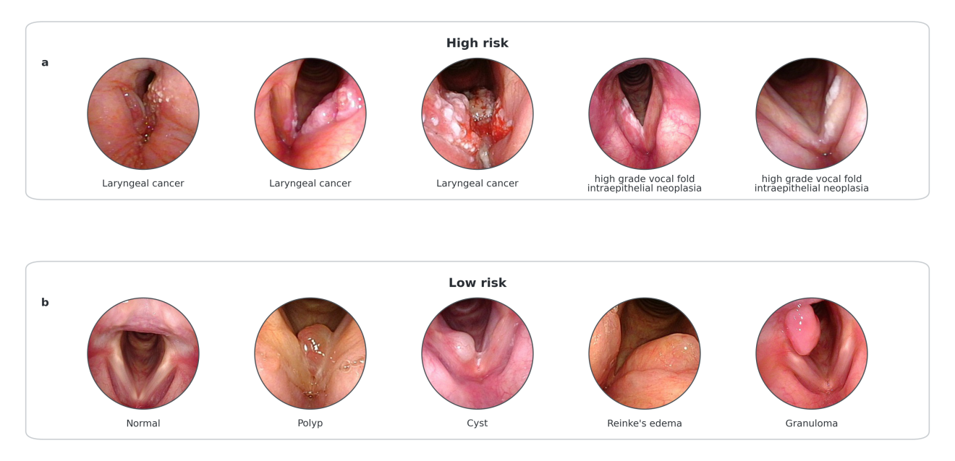
Figure 1. Representative laryngoscopic images stratified by risk category. (a) High-risk examples: laryngeal cancer and vocal-fold leukoplakia. (b) Low-risk examples: normal, polyp, cyst, Reinke's edema, and granuloma.
Supplementary Table S1. Available laryngoscopy equipment inventory.
Equipment category | Brand | Series/platform | Model
System | Olympus | VISERA ELITE | OTV-S190
System | Olympus | VISERA PRO | OTV-S7Pro
System | Olympus | VISERA PRO | CLV-S40Pro
System | Olympus | Optera / CV-170 | CV-170
Laryngoscope model | Olympus | ENF series | ENF-V4
Laryngoscope model | Olympus | ENF series | ENF-VH
Laryngoscope model | Olympus | ENF series | ENF TYPE VT2

Supplementary Note 1. ROI localization and DINOv3 point-region auxiliary
The YOLO-Pose glottic ROI module was trained using 600 annotated images. The module predicts a rotated glottic bounding box and three anatomical landmarks: the anterior commissure and the left and right posterior commissural points. A rotation-corrected ROI is then generated from the three-point geometry. ROI containment was defined as the area of intersection between the predicted ROI and the manually annotated rotated box divided by the area of the manual annotation. The prespecified acceptable threshold was 0.87.
In out-of-distribution images, such as screen photographs, the model may output three apparently plausible but anatomically displaced landmarks with relatively high detection confidence, causing the subsequent rotation-corrected ROI to capture irrelevant regions. To address this issue, we introduced the DINOv3 point–region auxiliary head as an anatomical semantic checking layer. The DINOv3 point–region auxiliary head uses a frozen DINOv3 visual backbone to extract dense image features. For each mark generated by YOLO-Pose, it extracts a rotation-aligned local patch around the point. A trainable lightweight four-class head then classifies the anatomical identity of each point as anterior commissure, left posterior commissural point, right posterior commissural point, or background. The three point-level classification scores are aggregated into a point–region score, which modifies the final ROI confidence by gating. A high point–region score indicates that all three predicted points are located in their corresponding anatomical regions and increases confidence for automatic acceptance through the reward-only gate. A low score indicates unreliable point-wise localization and redirects the image to original-image input, thereby avoiding degradation of downstream classification due to incorrect ROI cropping (Figure 2).
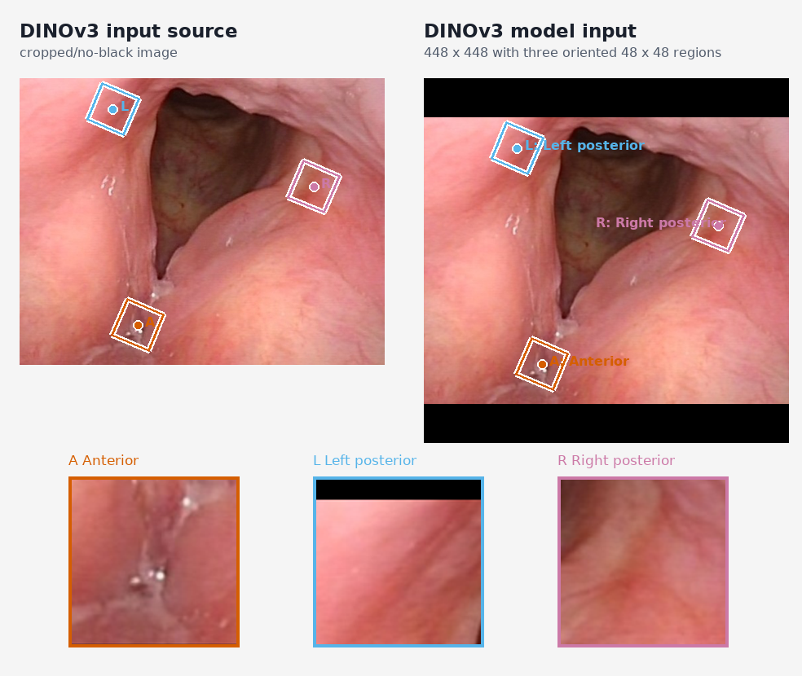
Figure 2. DINOv3-assisted anatomical checking for YOLOv5-Pose three-point localization.

Figure 3 presents one case of vocal fold leukoplakia and one case of vocal fold granuloma, both appearing as pale protruding lesions. The DINOv2 model assigned high-risk probabilities of 0.995 and 0.158, respectively. The figure provides a visual example of contrasting model responses.
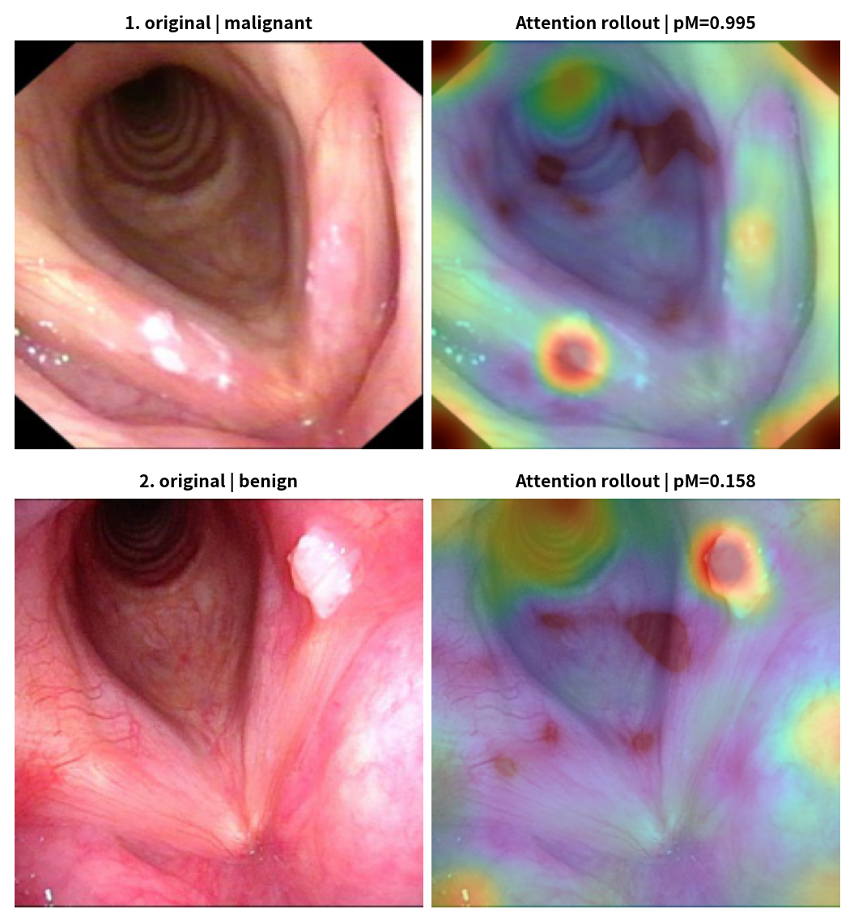
Figure 3. Attention-rollout visualizations of vocal fold leukoplakia and vocal fold granuloma

Supplement Note 2. Multitask learning with RoI-aided supervision
After completing the video-pipeline analysis, we examined whether RoI supervision improved static image classification. The multitask and classification models shared a DINOv2 backbone; the classification head continued to receive the full laryngoscopic image, whereas the RoI head learned a 16 × 16 patch-level regional probability map. Examples of manual annotation and representative outputs from the RoI branch are shown in Figures 4 and 5.
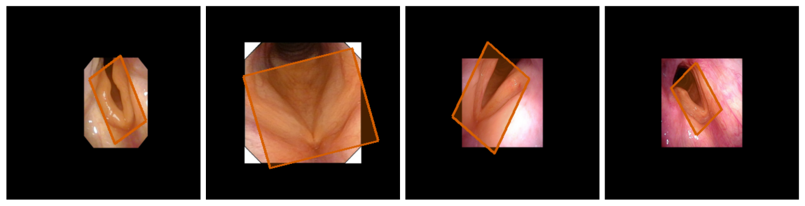
Figure 4. Example LabelMe annotations of the glottic region used for RoI-aided supervision
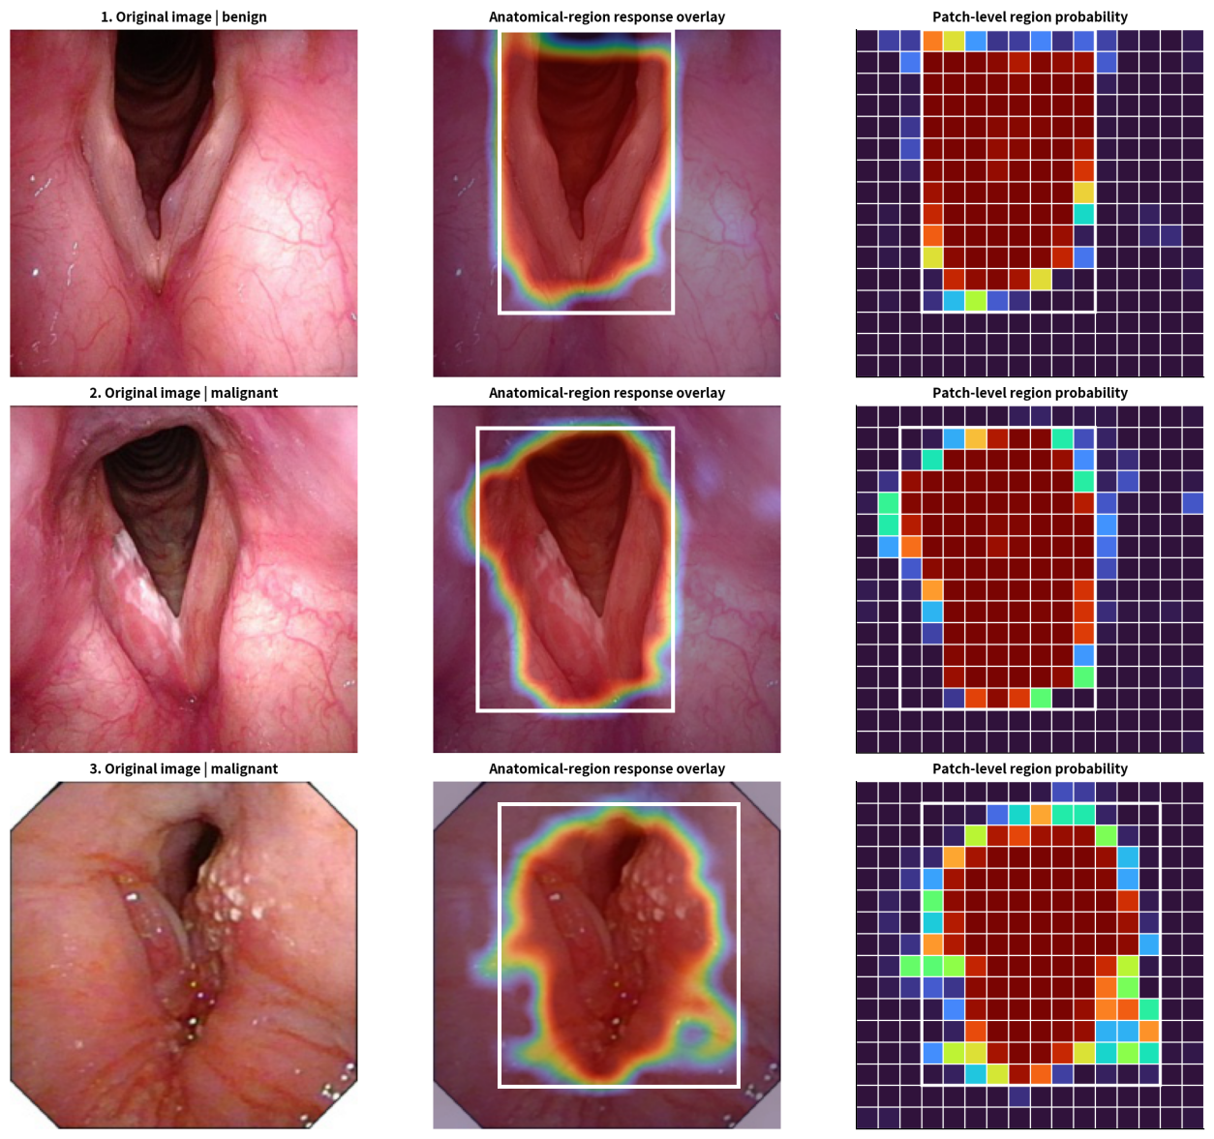
Figure 5. Representative predictions from the RoI-aided head
Results for the 12 RoI-aided strategies are shown in Supplement Table 1. At the fixed threshold of 0.5, ultra-low-learning-rate fine-tuning of Transformer block 6 achieved the highest composite score (0.967), compared with 0.964 for the locked base model. After the top-scoring model in each group had been assigned its own validation-set operating threshold by Youden's J, the paired difference in composite score between the RoI strategy and the base model was −0.002801 (95% CI, −0.010900–0.004021; 2,000 paired image-level bootstrap replicates); the RoI strategy did not significantly improve performance.
Supplement Table 1. Internal validation ranking of 12 RoI-aided multitask learning strategies
Training strategy | Composite score | AUROC | Macro-F1 | Accuracy | High-risk sensitivity | Specificity
RoI-aided supervision, ultra-low-learning-rate fine-tuning of block 6 | 0.967 | 0.992 | 0.947 | 0.966 | 0.938 | 0.973
RoI-aided supervision, ultra-low-learning-rate fine-tuning of block 8 | 0.965 | 0.991 | 0.947 | 0.966 | 0.930 | 0.975
Features from blocks 7 and 8, RoI branch only | 0.965 | 0.992 | 0.942 | 0.963 | 0.930 | 0.971
Features from block 6, RoI branch only | 0.965 | 0.992 | 0.942 | 0.963 | 0.930 | 0.971
Features from block 8, RoI branch only | 0.965 | 0.992 | 0.942 | 0.963 | 0.930 | 0.971
Glottic RoI-aided supervision, selective fine-tuning of the final block | 0.964 | 0.990 | 0.932 | 0.955 | 0.945 | 0.957
RoI-aided supervision, ultra-low-learning-rate fine-tuning of blocks 7 and 8 | 0.962 | 0.990 | 0.944 | 0.964 | 0.922 | 0.975
Glottic RoI-aided supervision, staged fine-tuning | 0.962 | 0.989 | 0.934 | 0.956 | 0.938 | 0.961
RoI-aided supervision, selective fine-tuning of block 8 | 0.955 | 0.987 | 0.925 | 0.950 | 0.922 | 0.957
RoI-aided supervision, selective fine-tuning of blocks 7 and 8 | 0.955 | 0.986 | 0.939 | 0.961 | 0.898 | 0.977
RoI-aided supervision, selective fine-tuning of block 6 | 0.953 | 0.988 | 0.910 | 0.939 | 0.930 | 0.942
Classification-head training after final-block RoI calibration | 0.855 | 0.908 | 0.811 | 0.869 | 0.789 | 0.889

