SUPPLEMENTARY FİLE
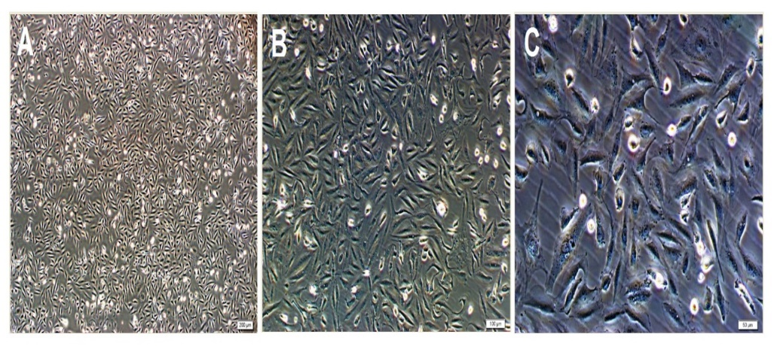
Fig. 7 Phase-contrast microscopic views (A-C) of the MDA-MB-231 breast cancer cell line are observed (Magnification: A-4X, B-10X, C-20X).

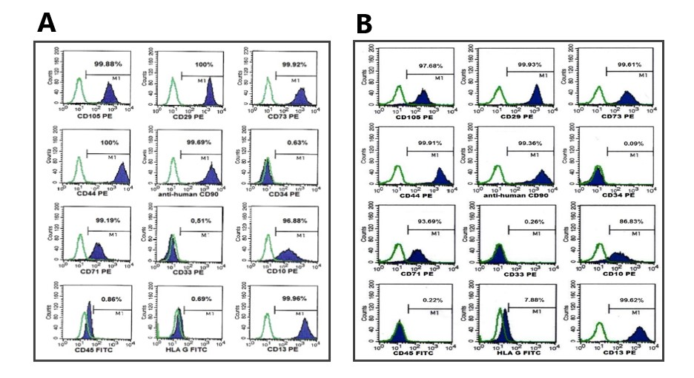
Fig. 8 Analysis of surface markers of stromal cells isolated from healthy (A) and malignant (B) breast tissue by flow cytometry method. It is observed that positive for CD105, CD29, CD73, CD44, CD90, CD71, CD10, CD13; they are negative for CD34, CD33, CD45 and HLA G.
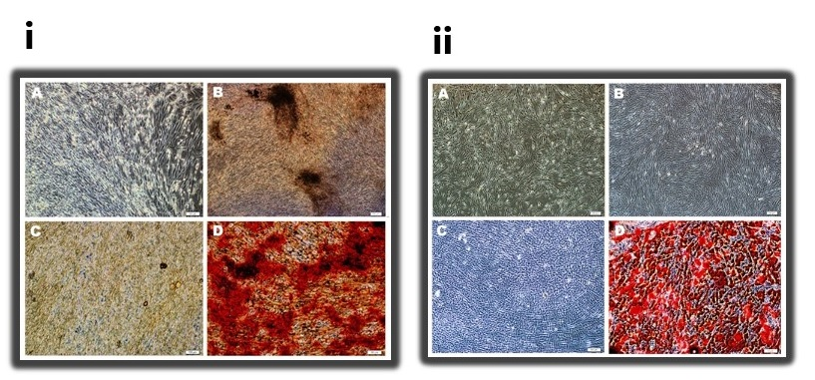
Fig. 9 (i) Bone-directed differentiation of stromal cells isolated from healthy breast tissue. A-Control, B-Pre-staining images at day 14 of groups undergoing bone differentiation in osteogenic differentiation medium; Post-staining images of calcium nodules taken into bone differentiation in C-Control, D-Osteogenic differentiation medium are observed (Augmentation: A-C: 10X, B-4X, D-20X). (ii) Bone-directed differentiation of stromal cells isolated from malignant breast tissue. A- Control, B- Pre-staining images on day 3 of the groups undergoing bone differentiation in osteogenic differentiation medium; C-Control, D- Post-staining images of calcium nodules taken into bone differentiation in osteogenic differentiation medium are observed (Magnification: A-B: 4X, C-10X, D-20X).

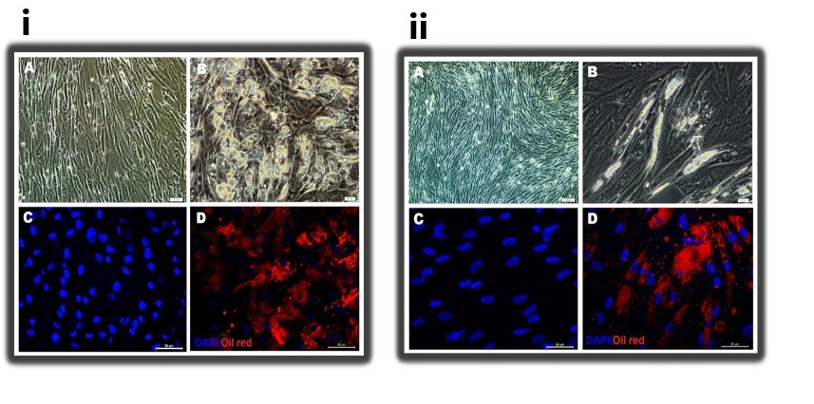
Fig. 10 Imaging of 15-day adipogenic differentiation of stromal cells isolated from healthy (i) and malignant (ii) breast tissue by phase-contrast microscopy (A-B) and immunofluorescence microscopy after Oil Red O staining (C-D). A- Control, B- Morphological images of cells directed to adipocytes in adipogenic differentiation medium; After Oil Red O staining, oil vesicles stained in the C- Control, D- group directed to adipogenic differentiation are observed (Magnification: (i): A-C-D: 20x, B-40x; (ii): A-10x, B-40x, C-D: 20x).

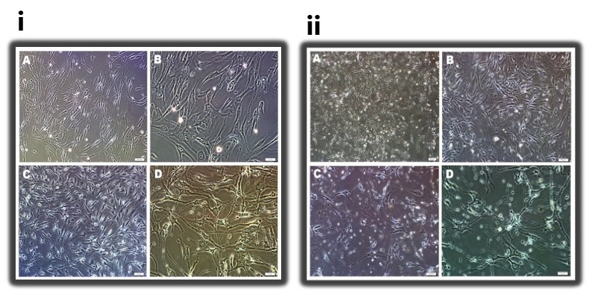
Fig. 11 Morphological images of stromal cells isolated from healthy (i) and malignant (ii) breast tissue under a phase-contrast microscope after 72 hours of incubation in a neurogenic differentiation medium. A-B- Control, C-D- Stromal cells incubated in neurogenic differentiation medium are observed to transform into neuron-like cells (Magnification: (i): A-C: 10X, B-D: 20X; (ii): A- 4X, B-C: 10X, D- 20X).

