Supplementary Material for:
Solving layered rough contact via a physics-informed operator framework
Shaoqi Huang¹, Junpeng Chen¹, Haoyu Gu¹, Shuwen Zhang¹, Xiaoshen Zhang², Chongpu Zhai^{1*}, and Minglong Xu^{1**}

¹State Key Laboratory for Strength and Vibration of Mechanical Structure, School of Aerospace Engineering, Xi’an Jiaotong University, Xi’an 710049, China.
²Xi'an Aviation Brake Technology Co., Ltd, Xi'an, Shaanxi 710065, China.

*Corresponding author. Email: zhaichongpu@xjtu.edu.cn (C.Z.); mlxu@xjtu.edu.cn (M.X.)

Section 1:
A1. Frequency-domain solution for layered media
In a homogeneous, isotropic, and continuous elastic medium, the static equilibrium of three-dimensional linear elasticity in the absence of body forces is governed by the Navier-Cauchy equation [1]
$$\begin{aligned}\left(λ+μ\right)∇\left(∇∙u\right)+μ∇^{2}u=0,\#\left(A1\right)\end{aligned}$$
where $λ=\frac{Eυ}{\left(1+υ\right)\left(1-2υ\right)}$ and $μ=\frac{E}{2\left(1+υ\right)}$ denote the Lamé constants of the material. These constants are directly linked to the elastic modulus $E$ and Poisson's ratio $υ$. To resolve the three-dimensional stress fields, it is necessary to decouple the linear coupling relationship between the normal stress and shear stress components in Eq. (A1) and the spatial derivatives of the displacement field. After taking the divergence on both sides of Eq. (A1), yielding,
$$\begin{aligned}\left(λ+2μ\right)∇^{2}\left(∇∙u\right)=0.\#\left(A2\right)\end{aligned}$$
Since $λ+2μ$ is not equal to zero, this requires that $∇^{2}\left(∇∙u\right)$ must be equal to zero, meaning that the volumetric strain $Θ=∇∙u$ must satisfy the harmonic equation, i.e., $∇^{2}Θ=0$. By substituting this relationship into Eq. (A1), the biharmonic equation of the displacement vector can be obtained,
$$\begin{aligned}∇^{4}u=0.\#\left(A3\right)\end{aligned}$$
Consequently, the normal displacement component $u_{z}\left(x,y,z\right)$ satisfies the three-dimensional biharmonic equation,
$$\begin{aligned}{\left(\frac{∂^{2}}{{∂x}^{2}}+\frac{∂^{2}}{{∂y}^{2}}+\frac{∂^{2}}{{∂z}^{2}}\right)}^{2}u_{z}\left(x,y,z\right)=0.\#\left(A4\right)\end{aligned}$$
Applying a two-dimensional Fourier transform with respect to the horizontal coordinates $x$ and $y$ transforms the spatial derivatives as $∂/∂x→iq_{x}$ and $∂/∂y→iq_{y}$. In cylindrical coordinates, the magnitude of the continuous wave vector is defined as $q=\sqrt{{q_{x}}^{2}+{q_{y}}^{2}}$. Accordingly, the governing partial differential equation reduces to a fourth-order ordinary differential equation (ODE) with constant coefficients along the depth coordinate $z$,
$$\begin{aligned}{\left(\frac{d^{2}}{{dz}^{2}}-q^{2}\right)}^{2}\hat{u_{z}}\left(q,z\right)=0.\#\left(A5\right)\end{aligned}$$
The solution of ODE governs the structural response. For the finite coating layer ($0≤z≤t$), the general solution must preserve both the pure hyperbolic modes and their linear depth variations to satisfy the mixed boundary states,
$$\begin{aligned}{\hat{u_{z}}}^{f}\left(q,z\right)=A_{f}\left(q\right)cosh\left(qz\right)+B_{f}\left(q\right)sinh\left(qz\right) \\ +C_{f}\left(q\right)qzcosh\left(qz\right)+D_{f}\left(q\right)qzsinh\left(qz\right).\#\left(A6\right)\end{aligned}$$
Conversely, for the semi-infinite underlying substrate ($z≥t$), the physical requirement of far-field displacement attenuation ($\lim_{z→∞}{u}=0$) fundamentally dictates that all exponentially growing terms must vanish. The remaining physically admissible solution reduces to exponentially decaying distributions,
$$\begin{aligned}{\hat{u_{z}}}^{s}\left(q,z\right)=\left(A_{s}+B_{s}q\left(z-t\right)\right)e^{-q\left(z-t\right)}.\#\left(A7\right)\end{aligned}$$
Similarly, assuming the indenter is modeled as an elastic half-space occupying the upper region ($z≤0$), the frequency-domain response of its normal displacement field is given by
$$\begin{aligned}{\hat{u_{z}}}^{d}\left(q,z\right)=\left(A_{d}+B_{d}qz\right)e^{qz}.\#\left(A8\right)\end{aligned}$$
The unknown integration constants ${\left[A_{f}, B_{f}, C_{f}, D_{f}, A_{s}, B_{s},A_{d}, B_{d}\right]}^{T}$ introduced in the general solutions are determined by enforcing the physical boundary conditions at the exposed top surface and the structural continuity states at the inner interface.

A2. Boundary and interfacial continuity conditions
- Free surface boundary conditions ($z=0$):
The top surface of the coating layer is subjected to an external normal contact pressure distribution, while shear tractions are assumed to vanish under frictionless contact conditions, i.e., ${\hat{σ_{zz}}}^{f}\left(q,0\right)={\hat{σ_{zz}}}^{d}\left(q,0\right)=-\hat{p_{n}} \left(q\right)$, ${\hat{σ_{rz}}}^{f}\left(q,0\right)={\hat{σ_{rz}}}^{d}\left(q,0\right)=0$.
- Bonded interfacial conditions ($z=t$):
At the interface between the thin film and the bulk substrate, a perfect mechanical bond is assumed. This structural configuration requires strict continuity of both kinematic displacement fields and dynamic traction vectors across the interface, i.e., ${\hat{u_{z}}}^{f}\left(h\right)={\hat{u_{z}}}^{s}\left(h\right)$, ${\hat{u_{r}}}^{l}\left(h\right)={\hat{u_{r}}}^{s}\left(h\right)$, ${\hat{σ_{zz}}}^{f}\left(h\right)={\hat{σ_{zz}}}^{s}\left(h\right)$, and ${\hat{σ_{rz}}}^{f}\left(h\right)={\hat{σ_{rz}}}^{s}\left(h\right)$.

A3. Frequency-domain Green's functions
For the indenter domain ($z<0$), substituting its boundary conditions into Eq. (A8) yields the stress components at the contact surface,
$$\begin{aligned}{\hat{σ_{zz}}}^{d}\left(q,0\right)=-2υ_{d}qA_{d}=-\hat{p_{n}}\left(q\right)\#\left(A9\right)\end{aligned}$$
$$\begin{aligned}{\hat{σ_{rz}}}^{d}\left(q,0\right)=2υ_{d}q\left(A_{d}+\left(1-2υ_{d}\right)B_{d}\right)=0\#\left(A10\right)\end{aligned}$$
Solving these equations yields the integration constants for the indenter, establishing the classical frequency-domain Boussinesq compliance relation for its surface normal displacement [2]
$$\begin{aligned}\hat{u_{d}} \left(q,0\right)=\hat{G_{d}}\left(q\right)\hat{p_{n}}\left(q\right)=\frac{\left(1-{υ_{d}}^{2}\right)}{E_{d}}\frac{1}{q}\hat{p_{n}}\left(q\right),\#\left(A11\right)\end{aligned}$$
Simultaneously, enforcing the boundary and interfacial continuity conditions for the layered substrate leads to a closed system of linear algebraic equations. Solving this system explicitly for the surface normal displacement at $z=0$ provides the transfer function relationship,
$$\begin{aligned}\hat{u_{f,s}}\left(q,0\right)=\hat{G_{f,s}}\left(q\right)\hat{p_{n}}\left(q\right),\#\left(A12\right)\end{aligned}$$
The exact layered Green's function compliance kernel is isolated as $\hat{G_{f,s}}\left(q\right)=γ\hat{G_{d}}Ψ\left(qt;κ;E_{f},υ_{f},E_{s},υ_{s}\right)$, where $Ψ=N\left(qt\right)/D\left(qt\right)$ represents a non-dimensional layer correction factor defined as the algebraic ratio of two transcendental functions [3], i.e.,
$$\begin{aligned}N\left(qt\right)=\left[\left(3-4υ_{f}\right)sinh\left(qt\right)+qt\right]+κ\left[2\left(1-2υ_{f}\right)sinh\left(qt\right)+2qt\right]\#\left(A13\right)\end{aligned}$$
$$\begin{aligned}D\left(qt\right)=\left[4{\left(1-υ_{f}\right)}^{2}cosh\left(qt\right)+{\left(3-4υ_{f}\right)}^{2}sinh\left(qt\right)+2\left(1-υ_{f}\right)\left(3-4υ_{f}\right)qt\right] \\ +κ\left[4{\left(1-υ_{f}\right)}^{2}\left(cosh\left(qt\right)-1\right)+4\left(1-υ_{f}\right)\left(1-2υ_{f}\right)sinh\left(qt\right)\right]\#\left(A14\right)\end{aligned}$$
The asymptotic limits naturally satisfy physical consistency: as $t→∞$, $Ψ→1$, which reduces the system to a homogeneous half-space composed of the coating material. Conversely, as $t→0$, the system scales directly into the bulk substrate behavior. Finally, invoking the principle of linear superposition for relative contact approach, the total normal displacement field in the frequency domain $\hat{u_{tot}}\left(q,0\right)$, representing total interfacial gap variation, is given by the direct summation of the individual compliance transformations
$$\begin{aligned}\hat{u_{tot}} \left(q_{x},q_{y}\right)=\left[\hat{G_{d}} \left(q_{x},q_{y}\right)+\hat{G_{l,s}} \left(q_{x},q_{y}\right)\right]\hat{p_{n}} \left(q_{x},q_{y}\right),\#\left(A15\right)\end{aligned}$$
This frequency-domain formulation provides a mathematically rigorous foundation that accommodates multiscale surface roughness without incurring the heavy computational overhead associated with spatial-domain BEM convolution integrals [4].
Section 2:
Discrete Fourier transform boundary element method
To regularize grid dependency and eliminate high-frequency numerical aliasing during discrete sampling, a piecewise-constant pressure distribution is prescribed over each discrete mesh cell of size $∆x×∆y$,
$$\begin{aligned}p_{n,ij} \left(x_{i},y_{j}\right)=p_{n,ij}rect\left(\frac{x_{i}}{∆x}\right)rect\left(\frac{y_{j}}{∆y}\right),\#\left(A16\right)\end{aligned}$$
where $rect\left(x\right)$ denotes the standard symmetric rectangular function defined as $rect\left(x\right)=1$, $\left|x\right|≤1/2$; $rect\left(x\right)=0$, $\left|x\right|>1/2$. This definition restricts the active traction bounded within the local patch of $\left[-∆x/2,∆x/2\right]×\left[-∆y/2,∆y/2\right]$. Analytical integration of this localized patch over the continuous Fourier workspace introduces a mathematical grid filter. Consequently, the exact discrete frequency-domain compliance matrix $Κ_{FFT}\left(q_{x},q_{y}\right)$ is established by scaling the continuum kernels with a ${sinc}^{2}$ shape factor, as shown in Eq. (5). Because standard Discrete Fourier Transforms (DFT) inherently assume periodic boundary conditions, a zero-padding technique is employed to simulate a non-periodic, isolated contact domain. To achieve this, the discrete pressure matrix is mapped into a zero-padded configuration $p_{n,pad} \left(x,y\right)$ that matches the true local contact pressure within the native $N_{x}×N_{y}$ domain and vanishes elsewhere, while the compliance kernel $Κ_{FFT}$ is systematically evaluated across the extended ${2N}_{x}×2N_{y}$ frequency grid. This dual expansion enables linear convolution to be computed efficiently via circular convolution using the FFT (Eq. (6)).
To resolve the elastoplastic contact configuration, the framework simultaneously enforces the KKT non-penetration conditions ($p_{n}≥0,g_{gap}≥0,$ and $p_{n}∙g_{gap}=0$) and the material plastic yield ceiling governed by the surface hardness $H_{Y}$ ($p_{n}≤H_{Y}$) using a specialized conjugate gradient solver [5]. The optimization progresses within an iterative loop where the active contact domain $Ω$ is updated whenever interpenetration or active tractions are identified (${g_{gap}}^{\left(k\right)}<0$ or $p_{n}>0$). Subsequently, a conjugate search direction $d^{\left(k\right)}$ is reconstructed within $Ω$ to compute the optimal descent step size $α$,
$$\begin{aligned}α=\frac{\sum_{Ω}^{ }{{\left({g_{gap}}^{\left(k\right)}\right)}^{2}}}{\sum_{Ω}^{ }{d^{\left(k\right)}∙∆u\left(d^{\left(k\right)}\right)}},\#\left(A17\right)\end{aligned}$$
where $∆u\left(d^{\left(k\right)}\right)$ represents the incremental displacement field generated exclusively by the search vector $d^{\left(k\right)}$ via FFT convolution. Finally, to enforce both the non-negativity boundary and the plastic flow limit simultaneously, a multi-boundary mathematical projector clips the updated pressure field [6],
$$\begin{aligned}{p_{n}}^{\left(k\right)}=max\left[0,min\left({p_{n}}^{\left(k\right)}+αd^{\left(k\right)},H_{Y}\right)\right],\#\left(A18\right)\end{aligned}$$
By freezing the elastic gradient updates for grid cells that reach the hardness threshold $H_{Y}$, the solver captures localized plastic yielding during microcontact flattening sequences, eliminating numerical instability, and preserving exceptional convergence speed throughout multiscale contact simulations.

Section 3:
This section describes the input representation, multiscale network architecture, differentiable physical operator, and optimization strategy of the proposed physics-informed hybrid neural network. The framework is developed as a surrogate for the iterative matrix-based boundary element solver and approximates the nonlinear mapping from rough-surface geometry and prescribed physical conditions to the corresponding contact-pressure and displacement fields. Mechanical consistency is introduced through an explicit Green’s-function-based FFT layer and physics-informed loss terms.
The training data are organized into spatially distributed inputs, scalar physical conditions, and BEM-derived supervisory targets. The spatial input consists of the normalized roughness height $z_{sphere}\left(x,y\right)$, the two surface-slope components $∇z_{sphere}$, and a normalized radial-coordinate field. A normalized Hertzian pressure profile is additionally generated from the prescribed normal load, spherical radius, and effective stiffness and concatenated with these fields as a load- and geometry-dependent prior channel. The BEM-derived pressure $p_{n}\left(x,y\right)$, elastic-displacement $u_{elastic}\left(x,y\right)$, and plastic-displacement $u_{plastic}\left(x,y\right)$ fields are used exclusively as supervisory targets during training and are not supplied to the inference network. The roughness height and plastic-displacement magnitude are normalized by the RMS roughness $R_{rms}$, thereby retaining information about the relative roughness amplitude. The contact-pressure field is normalized by the theoretical Hertzian peak pressure $p_{Hertz,max}$. The elastic-displacement residual is nondimensionalized within the physics loss using a sample-dependent characteristic length. The normalized Hertzian prior is expressed as
$$\begin{aligned}p_{Hertz,norm}=\sqrt{max\left[1-{\left(\frac{x}{a_{Hertz}}\right)}^{2}-{\left(\frac{y}{a_{Hertz}}\right)}^{2},0\right]}.\#\left(A19\right)\end{aligned}$$
The scalar condition vector is defined as $Χ_{FiLM}=\left[F_{norm},H_{norm},t_{norm},κ_{f,s},κ_{d,f}\right]$, where the force and hardness are log-transformed and normalized using the training-set statistics, the relative layer thickness and elastic mismatch parameter are represented on logarithmic scales. A group of two-layer MLPs of different scales, each layer containing a ReLU activation function, maps this condition vector to the channel-level FiLM coefficients. The resulting feature modulation can be expressed as
$$\begin{aligned}H_{modulated}=α_{FiLM}\left(Χ_{FiLM}\right)⨀H+β_{FiLM}\left(Χ_{FiLM}\right),\#\left(A19\right)\end{aligned}$$
where $H$ represents the intermediate latent feature tensor, the symbol $⨀$ denotes the element-wise Hadamard product, and $α_{FiLM}$ and $β_{FiLM}$ are the scaling and shifting operators mapping from the MLP, respectively. This conditioning mechanism allows a single network to represent different loading, geometric, and material configurations within the sampled parameter ranges.
The spatial representation is processed by an attention U-Net backbone with an FNO-based bottleneck. An initial double-convolution block maps the five-channel input to 32 feature channels. Three max-pooling stages subsequently reduce the spatial resolution while increasing the channel dimensions to 64, 128, and 256. The shallow encoder levels primarily retain local roughness and slope information, whereas the deeper levels provide increasingly large receptive fields for representing mesoscale contact structures. At the 32 $×$ 32 bottleneck resolution, the latent input tensor is first processed by a two-layer Fourier neural operator and is subsequently refined by a dilated double-convolution block. The resulting bottleneck representation is expressed as
$$\begin{aligned}Χ_{bottleneck}=DilatedConv\left(FNO\left(Χ_{in}\right)\right),\#\left(A20\right)\end{aligned}$$
where $Χ_{in}$ and $Χ_{bottleneck}$ denote the latent feature tensors entering and leaving the bottleneck module, respectively. The FNO block captures global spectral correlations, whereas the subsequent dilated convolution refines spatially localized features using an enlarged receptive field. In addition, additive spatial attention gates are incorporated into the U-Net skip connections. At each decoding scale, the encoder and decoder features are projected by separate 1 $×$ 1 convolutions, combined through a LeakyReLU activation, and mapped through a sigmoid function to a single-channel attention field. After local averaging, this attention field softly suppresses less relevant encoder features before they are concatenated with the decoder representation. Pixel-shuffle upsampling and residual double-convolution blocks then progressively restore the original spatial resolution.
The final decoded feature tensor is mapped to a nonnegative contact-pressure field through a 1 $×$ 1 convolution followed by a Softplus activation. The dimensional pressure is passed through a non-trainable but differentiable Green’s-function-based FFT layer. This layer encapsulates the analytical layered frequency-domain Green's functions derived from Eq. (A14), executing parallelized FFT-based circular convolutions to compute the exact continuous elastic displacement response $u_{elastic}\left(x,y\right)$ corresponding to the predicted traction distribution. The total predicted interfacial displacement field is synthesized via a fully differentiable linear superposition of this elastic response and the localized plastic residual $u_{tot}\left(x,y\right)=u_{elastic}\left(x,y\right)+u_{plastic}\left(x,y\right)$, ensuring absolute kinematic admissibility across the interface without requiring iterative numerical matrix solvers.
To guide global parameter optimization, a composite multi-task objective function balances data-driven geometric alignment with physics-based contact residuals, $L_{tot}=ω_{p_{n}}{L_{data}}^{p_{n}}+ω_{u_{tot}}{L_{data}}^{u_{tot}}+ω_{phy}L_{phy}$. Optimization stability across this highly nonlinear elastoplastic space is achieved through a two-stage sequential training schedule. During Stage 1, the network is pretrained using Adam with the physics-loss weight set to zero, and the FFT displacement layer is bypassed. This stage establishes the initial mapping from surface morphology and scalar conditions to the pressure and plastic-displacement fields. During Stage 2, a new AdamW optimizer with decoupled weight decay is initialized. A linear learning-rate warmup is applied over the first 40 epochs and is followed by cosine annealing. The global physics weight is increased smoothly through a smoothstep schedule, while the KKT-based penetration and complementarity penalties are activated through a delayed curriculum. After an initial freezing period, ReLoBRaLo dynamically adjusts selected data and physics-loss weights according to their relative optimization rates. This staged procedure progressively introduces the physics-informed penalties while limiting abrupt disturbances to the pretrained data representation.

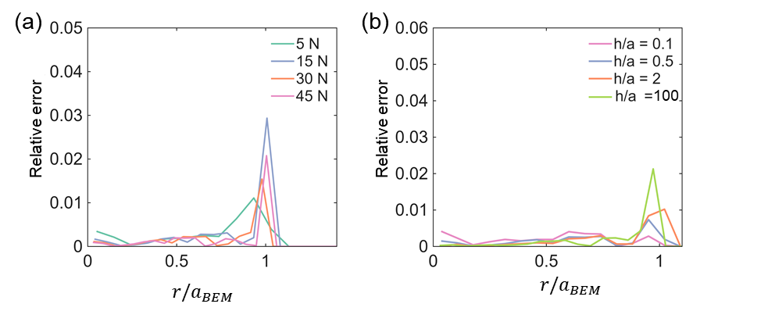
Fig. S1. Radial distributions of prediction relative error along the normalized contact domain, corresponding to Fig. 2 in the main text. (a) Relative error profiles as a function of normalized radial position $r/a_{Hertz}$ under varying normal loads ($F_{n}=$ 5, 10, 15, and 20 N). (b) Relative error profiles under varying normalized film thickness ratios ($t/a_{BEM}=$ 0.1, 0.5, 2.0, and 100). Across all cases, prediction errors remain consistently below 0.03 within the main contact region ($r/a_{Hertz}<1$), with minor localized peaks confined near the contact boundary ($r/a_{Hertz}≈1$).

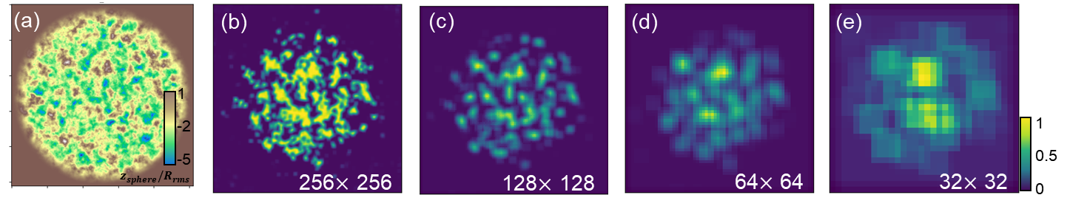
Fig. S2. Multi-scale spatial attention distributions across hierarchical feature map resolutions for a representative sample. (a) Reference contact surface topography. (b-e) Spatial attention weight maps extracted at feature resolutions of 256 $×$ 256, 128 $×$ 128, 64 $×$ 64, and 32 $×$ 32, respectively. The colorbar on the far right denotes the normalized attention weight values ranging from 0 to 1. Higher-resolution attention maps accurately capture localized micro-asperity contact interactions, whereas lower-resolution attention maps identify macroscopic stress concentration regions, confirming that the spatial attention mechanism effectively integrates physical contact features across multiple length scales.

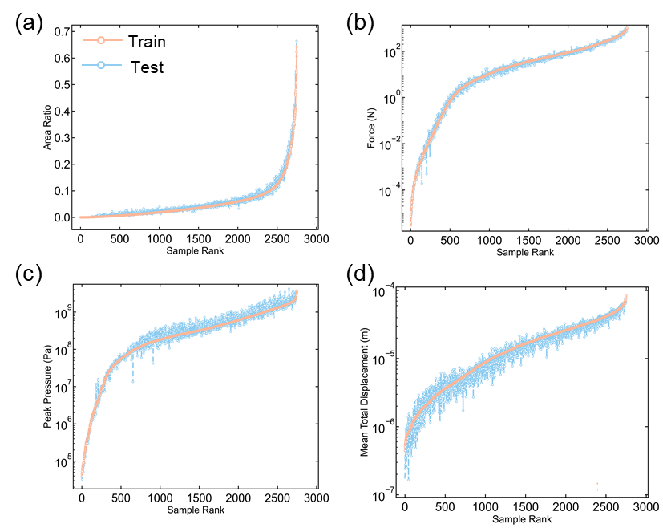
Fig. S3. Statistical comparison between training and test datasets for key contact parameters. (a) Contact area ratio distributions sorted in ascending order of sample rank. (b) Total normal force distributions. (c) Peak contact pressure distributions. (d) Mean total surface displacement distributions. The high degree of alignment between the training (blue) and test (orange) curves across all metrics confirms that the test dataset effectively covers the parameter space of the training dataset without data distribution shift.

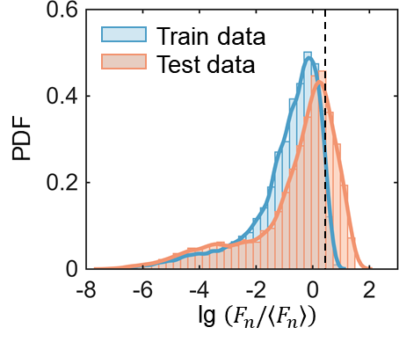
Fig. S4. Probability density distributions of normalized normal load across training and testing datasets. The histograms and corresponding fitted density curves illustrate the probability density function (PDF) of the logarithmic normalized load $lg\left(F_{n}/〈F_{n}〉\right)$, where $F_{n}$ and $〈F_{n}〉$ denote the applied normal load and its ensemble mean, respectively. The vertical dashed line marks the threshold of the primary training load range, highlighting that the test dataset extends into higher-load regimes to systematically evaluate the model generalization and extrapolation capability.

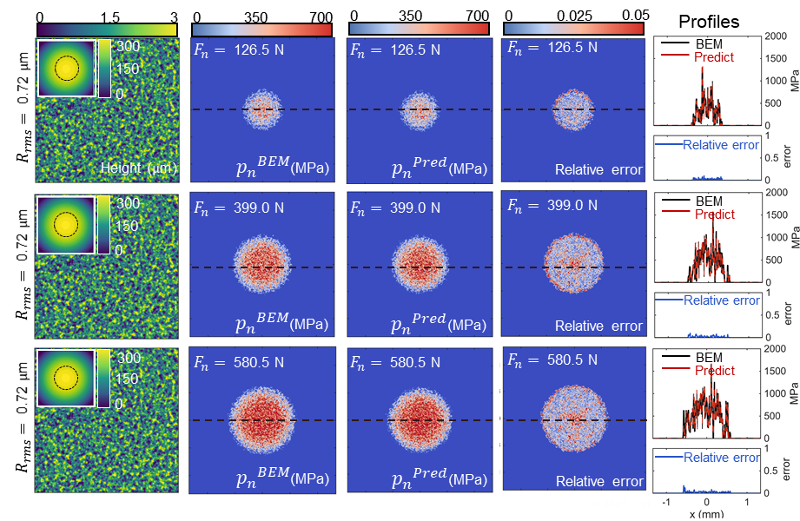
Fig. S5. Full-field contact pressure predictions under progressive normal loading compared with reference BEM simulations for a coated rough interface. The layered contact configuration comprises a spherical indenter ($R=4.6$ mm, $E_{d}=$ 109 GPa, $υ_{d}=$ 0.21), a compliant elastic film ($t=$ 1.0 mm, $E_{f}=$ 3.59 GPa, $υ_{f}=$ 0.43), and a stiff substrate ($E_{s}=$ 62.5 GPa, $υ_{s}=$ 0.37) over a computational domain of length 2.68 mm (resolution $∆x=$ 10 $μm$). Rows 1 to 3 capture the contact evolution on a single fixed rough surface ($R_{rms}=$ 0.72 mm, $D_{f}=$ 2.37) under light ($F_{n}=$ 126.5 N), medium ($F_{n}=$ 399.0 N), and heavy ($F_{n}=$ 580.5 N) normal load steps, respectively. Left column: identical surface height map across loading steps with macro-indenter profiles shown in insets. Second and third columns: full-field contact pressure distributions calculated by BEM (${p_{n}}^{BEM}$) and predicted by the model (${p_{n}}^{Pred}$), respectively. Fourth column: corresponding full-field relative error distributions. Rightmost column: cross-sectional pressure profiles extracted along the central horizontal dashed line, accompanied by local relative error distributions underneath.

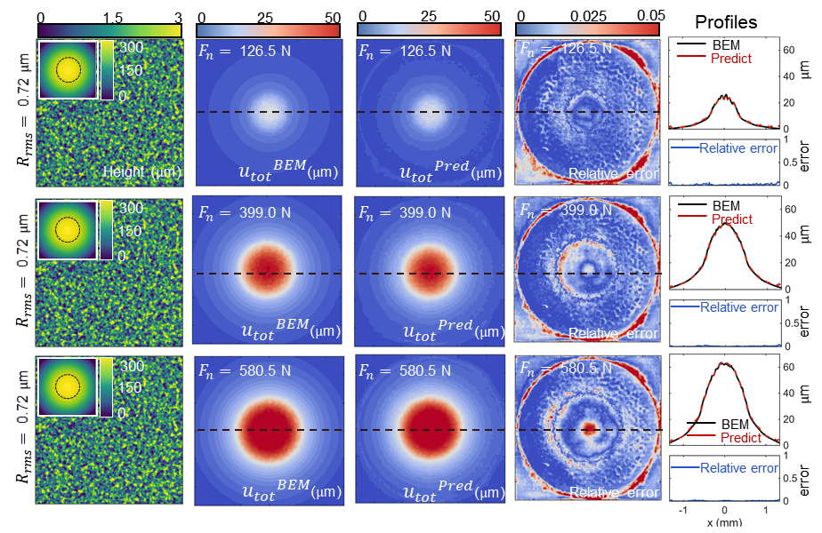
Fig. S6. Full-field predictions of total surface displacement under progressive normal loading compared with reference BEM simulations. The contact parameters and loading steps are identical to those in Fig. S4. Rows 1 to 3 illustrate the surface displacement response of the fixed rough topography ($R_{rms}=$ 0.72 mm) under normal loads of 126.5 N, 399.0 N, and 580.5 N, respectively. Left column: identical surface height map with macro-indenter profiles shown in insets. Second and third columns: full-field distributions of total surface displacement computed by BEM (${u_{tot}}^{BEM}$) and predicted by the model (${u_{tot}}^{Pred}$), respectively. Fourth column: corresponding full-field relative error distributions. Rightmost column: cross-sectional displacement profiles extracted along the central horizontal dashed line, accompanied by local relative error distributions underneath.

Table S1. Comprehensive sampling ranges and distribution strategies of topographical, geometric, and material parameters for dataset construction. Parameters are systematically categorized into surface topography variables (RMS roughness $R_{rms}$, fractal dimension $D_{f}$, roll-off wavelength $λ_{r}$, and cut-off wavelength $λ_{c}$), macroscopic contact geometry (indenter radius $R$ and layer thickness $t$), and mechanical constitutive parameters for the indenter, coating layer, and substrate ($E_{d}$, $υ_{d}$, $E_{f}$, $υ_{f}$, $E_{s}$, $υ_{s}$, and $H_{Y}$). Linear sampling distributions are applied to bounded geometric parameters and Poisson's ratios, whereas logarithmic sampling strategies are implemented across wide numerical spans, specifically for coating thickness, elastic moduli, and material hardness, to ensure uniform representation across multi-order contact mechanics regimes.
Parameters | Sampling range | Sampling distribution
RMS roughness, $R_{rms}/μm$ | 0.5 $\sim$ 5.0 | Linear
Fractal dimension, $D_{f}$ | 2.1 $\sim$ 2.5 | Linear
Roll-off wavelength, $λ_{r}/mm$ | 0.1 $\sim$ 0.2 | Linear
Cut-off wavelength, $λ_{c}/mm$ | 0.003 $\sim$ 0.008 | Linear
Curvature radius, $R/mm$ | 5.0 $\sim$ 30.0 | Linear
Film thickness, $t/mm$ | 0.01 $\sim$ 1.0 | Logarithm
Indenter modulus, $E_{d}/GPa$ | ${\text{1×}\text{10}}^{\text{9}}$ $\sim$ ${\text{4}\text{×}\text{10}}^{11}$ | Logarithm
Indenter Poisson's ratio, $υ_{d}$ | 0.2 $\sim$ 0.35 | Linear
Film modulus, $E_{f}/GPa$ | ${\text{1×}\text{10}}^{5}$ $\sim$ ${\text{1×}\text{10}}^{9}$ | Logarithm
Film Poisson's ratio, $υ_{f}$ | 0.35 $\sim$ 0.49 | Linear
Substrate modulus, $E_{s}/GPa$ | ${\text{1×}\text{10}}^{8}$ $\sim$ ${\text{4}\text{×}\text{10}}^{11}$ | Logarithm
Substrate Poisson's ratio, $υ_{s}$ | 0.3 $\sim$ 0.45 | Linear
Surface hardness, $H_{Y}/GPa$ | ${\text{1×}\text{10}}^{7}$ $\sim$ ${\text{4}\text{×}\text{10}}^{9}$ | Logarithm

References
[1] Johnson KL. Contact mechanics: Cambridge university press; 1987.
[2] Persson BN. Theory of rubber friction and contact mechanics. The Journal of Chemical Physics. 2001;115:3840-61.
[3] Persson B. Contact mechanics for layered materials with randomly rough surfaces. Journal of Physics: Condensed Matter. 2012;24:095008.
[4] Liu S, Wang Q. Studying contact stress fields caused by surface tractions with a discrete convolution and fast Fourier transform algorithm. J Trib. 2002;124:36-45.
[5] Liu S, Wang Q. Studying Contact Stress Fields Caused by Surface Tractions With a Discrete Convolution and Fast Fourier Transform Algorithm. Journal of Tribology. 2001;124:36-45.
[6] Pérez-Ràfols F, Liang X-M, Ciavarella M. General results for loading and unloading rough elasto-plastic interfaces. European Journal of Mechanics-A/Solids. 2025:105908.

