Low-Pt NiNC-supported PtNi nanoalloy oxygen reduction reaction electrocatalysts—In situ tracking of the atomic alloying process
Quanchen Feng,†,* Xingli Wang,† Malte Klingenhof,† Marc Heggen,‡ and Peter Strasser†,*
†Department of Chemistry, Chemical and Materials Engineering Division, The Electrochemical Energy, Catalysis and Materials Science Laboratory, Technische Universität Berlin, Berlin, Germany.
‡Ernst Ruska-Centre for Microscopy and Spectroscopy with Electrons, Forschungszentrum Jülich GmbH, 52425 Jülich, Germany.
*E-mail: quanchen.feng@campus.tu-berlin.de
*E-mail: pstrasser@tu-berlin.de

Experimental section

Catalyst preparation
Synthesis of NiNC-1 support material: NiNC-1 support material was synthesized by following a previously described method^{1,2} and the synthetic procedure was illustrated in Supplementary Fig. 12. Precursor mixture consisting of Ni(Ac)₂·4H₂O (23.2 mg), 1,10-phenanthroline (phen, 200 mg) and ZIF-8 (800 mg, Basolite Z1200 from BASF) was ball-milled at 400 rpm for 1 h (3 × 20 min with 15 min rest in-between) in a ZrO₂ crucible (45 cm³) filled with 100 ZrO₂ balls (5 mm diameter). This mixture was then pyrolyzed in nitrogen at 1000 °C for 1 h. The catalyst powder was collected and gently ground with a marble mortar and pestle without any post-treatment. The resultant Ni content is 1.2 wt%, and Zn content is 3.6 wt%.

Catalyst characterizations
X-ray powder diffraction (XRD) patterns were collected using a D8 Advance Diffractometer (Bruker) equipped with a Lynx Eye Detector and KFL Cu 2K X-ray tube. The measurement was carried out at a step size of 0.04°, in a 2θ range between 20 and 80°.
The metal contents of the different catalysts were determined by inductively coupled plasma mass spectroscopy (ICP-MS) using a 715-ES-ICP analysis system (Varian). The samples were prepared by dissolving the catalysts powders in a mixture of 2 mL H₂SO₄, 2 mL HNO₃ and 6 mL HCl. The solutions were heated from RT to 180 °C in 10 min using a Microwave Discover SP-D (CEM corporation), and the temperature was held at 180 °C for 20 min. After cooling down to RT, the solutions were filtered and diluted with ultrapure water to a known volume (50 mL). To estimate the concentration of the solution, 4 standard solutions of Pt and Ni with a known concentration were prepared. The concentrations of Pt were 0, 5, 10 and 20 mg/L, whereas the concentrations of Ni were 0, 10, 20 and 40 mg/L. The selected wavelengths for Pt measurement were 203.646, 204.939, 214.424, 224.552 nm, 265.945 nm and 306.471 nm. The selected wavelengths for Ni measurement were 227.021 nm, 230.299 nm, 222.295 nm, 222.486 nm, 221.648 nm, 230.078 nm, 216.555 nm and 231.604 nm.
Transmission electron microscopy (TEM) images were recorded on a FEI Tecnai G² 20 S-TWIN with a LaB₆ cathode operating with 200 kV acceleration voltage and a resolution limit of 0.24 nm. Samples were dispersed in ethanol with an ultrasonic horn (~15 min), drop casted on a Cu grid (400 mesh), and dried in air at 60 °C for 10 min.
X-ray photoelectron spectroscopy: XPS measurements were carried out in an ultrahigh vacuum (UHV) chamber at room temperature using a non-monochromatized X-ray source (Al Kα, 1486.6 eV) and a hemispherical analyzer (Phoibos 150, SPECS). The Casa XPS software was used for analyzing the obtained spectra. All spectra were aligned according to the C1s main peak which was assigned with a binding energy of 284.3 eV. The Ni/Pt atomic ratios were obtained from the area under the Ni 2p and Pt 4f peaks after normalization by their corresponding relative sensitivity factors (RSF) of 21.1 and 15.86, respectively.
High resolution TEM: HRTEM was performed using a FEI Titan 80-300 TEM with a Cs corrector for the objective lens (CEOS GmbH). The microscope was operated at 300 kV.
Scanning transmission electron microscopy (STEM) was performed using a FEI Titan 80-200 (“ChemiSTEM”) electron microscope with a Cs-probe corrector (CEOS GmbH) and an HAADF detector. The microscope was operated at 200 kV. In order to achieve “Z-Contrast” conditions, a probe semi-angle of 25 mrad and an inner collection semi-angle of the detector of 88 mrad were used. Compositional maps were obtained with energy-dispersive X-ray spectroscopy (EDX) using four large-solid-angle symmetrical Si drift detectors. For EDX elemental mapping, Pt L and Ni K peaks were used. The error of the EDX composition measurement for individual particles after a typical investigation of 15 minutes is about ±2 at.%.

Electrochemical measurements
5 mg catalyst was added to a solution of 3.98 mL ultrapure water, 10 µL 5 wt% Nafion ionomer solution and 1 mL isopropanol. The suspension was then sonicated with an ultrasonic horn sonifier for 30–40 min while immersed in an ice water bath. An aliquot of the ink was drop casted by a pipette onto a glassy carbon (GC) rotating disk electrode (RDE, diameter: 5 mm, geometrical surface area: 0.196 cm²). The film was dried at 60 °C for 8 min.
For electrochemical characterizations a conventional three electrode cell with a graphite rod as counter electrode, a mercury/mercury(I) sulfate electrode (MMS, Hg/Hg₂SO₄) in a Luggin capillary as reference electrode and a catalyst-coated GC-RDE as working electrode was used. MMS was calibrated regularly by a homemade reversible hydrogen electrode (RHE) using a polycrystalline Pt disk and continuous hydrogen bubbling. All potentials are referred to RHE. Freshly prepared 0.1 M HClO₄ diluted from concentrated HClO₄ (99.999% trace metal bases, Sigma Aldrich) with ultrapure water was used as electrolyte. The catalyst-coated RDE was controlled by a rotator from Pine Research instrument. All measurements were performed with a BioLogic SP-200 potentiostat. Gases for purging of electrolyte were H₂ (99.999%), N₂ (99.999%) and O₂ (99.998%).
To avoid bubbles to be trapped on the dry catalyst film, it was thoroughly wetted until an uniform thin water film could emerged. Then the catalyst-coated RDE was immersed into the N₂-saturated electrolyte under potential control at 0.05 V_{RHE}. For conditioning of the catalyst film, 50 potential cycles from 0.05 to 0.925 V_{RHE} at 100 mV/s were carried out. 3 potential cycles from 0.05 to 0.925 V_{RHE} at 20 mV/s were performed subsequently.
Electrochemical impedance spectroscopy (EIS): the as-measured results were iR-corrected manually after measurements, where the value of R was determined by EIS technique. A potential of 0.5 V_{RHE} was applied for 1 min, followed by an impedance measurement from 100,000 Hz to 10 Hz with an AC amplitude of 10 mV. The resistance R was then determined from the Im (Z) vs. Re (Z) plot.
ORR testing: For background correction, measurements at 1600 rpm were first carried out in N₂-saturated electrolyte. A potential of 0.05 V_{RHE} was applied for at least 30 s. Then LSV was measured between 0.05 and 1.0 V_{RHE} at 20 mV/s and repeated once. The electrode was then raised above the electrolyte. After purging of pure oxygen through the electrolyte for 10 min, the electrode was reinserted under an applied potential of 0.05 V_{RHE}, and another three LSV measurements at 20 mV/s and one LSV measurement at 5 mV/s were conducted. In the case of a noticeable decrease in diffusion limited currents, oxygen was bubbled in between the scans.
Analysis of ORR activity: First the potentials were iR-corrected. Then capacitance correction was applied. LSV curve performed in N₂-saturated electrolyte was used as background and subtracted from the LSV curve performed in O₂-saturated electrolyte at the same scan rate. ORR current (i_{ORR}, at 0.9 V_{RHE}) and diffusion limiting current (i_{L}, at 0.4 V_{RHE}) were obtained from the iR- and capacitance-corrected LSV curve. Finally the kinetic current i_{k} was calculated by Koutecky-Levich equation. The mass activity (MA) was calculated by dividing i_{k} by the Pt mass loading on the electrode. And the specific activity (SA) was was calculated by dividing i_{k} by the Pt area estimated from CO stripping method.
Stability test (RDE protocol): The stability test was performed after carrying out the activation, impedance measurement and activity measurements. The rotation was turned off, the electrode was raised from the electrolyte under potential control and N₂ was bubbled for 10 min. Then the electrode was immersed and the potential was cycled between 0.6 and 0.925 V_{RHE} at 100 mV/s for 10,000 cycles, while venting above the electrolyte with N₂. After that the potential was cycled as described in “activation”, but only 3 cycles at 100 mV/s and 3 cycles at 20 mV/s. Then impedance spectroscopy and ORR activity test after stability test were also carried out.
CO stripping: initial CO stripping measurement was performed after initial ORR test. After ORR test, N₂ was bubbled for 10 min. The electrode was reinserted under an applied potential of 0.05 V_{RHE} and the rotation was set to 400 rpm. Then CO was bubbled for another 1 min at the same rotation speed. The gas was switched back to N₂ and the electrolyte was bubbled for another 10 min to remove excess non-adsorbed CO in the electrolyte. Then the rotation was turned off and three CV cycles were recorded at 50 mV/s between 0.05 V_{RHE} and 1 V_{RHE}, while venting N₂ above the electrolyte.
Analysis of CO stripping: The CO stripping data were analyzed to calculate the CO-ECSA and the ratio of CO-ECSA/H_{upd}-ECSA. For the CO-ECSA, the positive scan of the second cycle was used as background and subtracted from the positive scan of the first cycle. Then the integral of the peak was calculated in the iR-corrected potential range from the crossing of the curves to the highest potential (~1 V_{RHE}). The integral area was normalized by the scan rate and the Pt mass loading on the electrode. A value of 420 µC/cm² was used for the electrooxidation of a monolayer of adsorbed CO. The H_{upd}-ECSA after CO stripping was calculated using the cycle after CO stripping. H_{upd}-ECSA was determined by integrating the current in the negative going sweep. Due to the low content of Pt, it is quite hard to determine the accurate potential range of H_{upd} region. For consistency and better comparison, we selected 0.4 V_{RHE} as the upper potential limit, whereas the lowest potential was chosen as lower potential limit (~0.05 V_{RHE}). Subtraction of the capacitive background current was applied. The integral area was normalized by the scan rate and the Pt mass loading on the electrode. A value of 210 µC/cm² was used for the adsorption of a hydrogen monolayer.

Supplementary Figures, Supplementary Tables and Supplementary Discussions

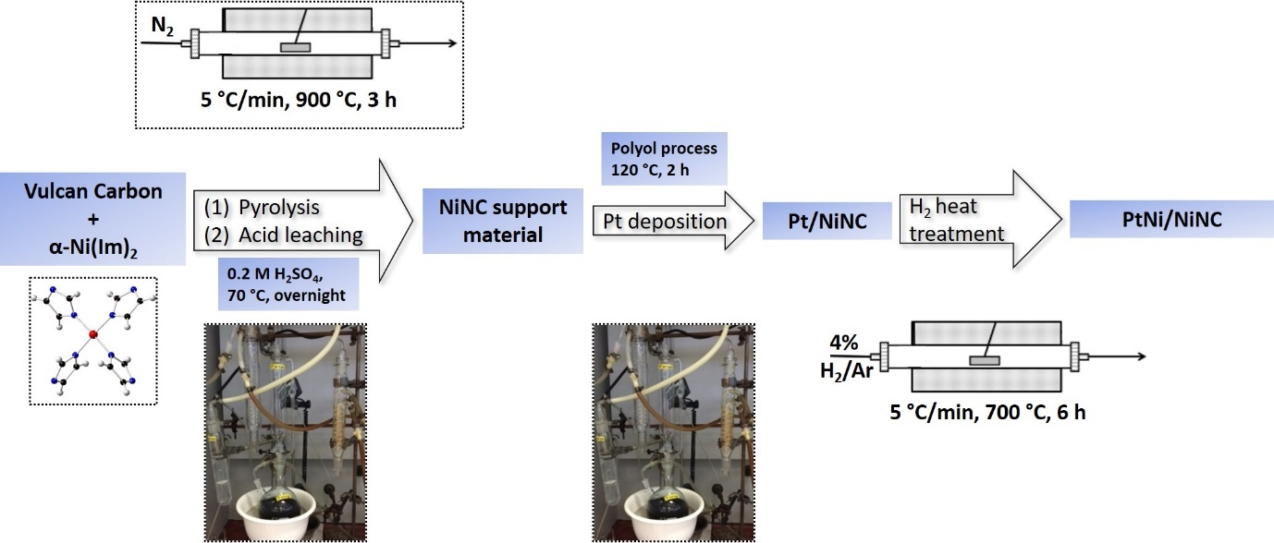
Supplementary Fig. 1 | Complete synthetic route toward PtNi/NiNC catalyst material.
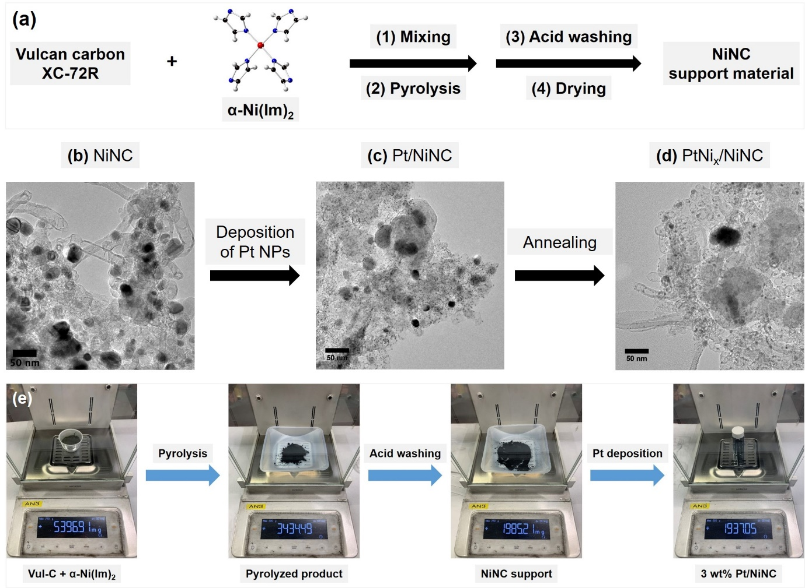
Supplementary Fig. 2 | Schematic illustration of the pyrolysis–leaching–deposition–annealing (PLDA) strategy reported in this study and demonstration of its ability to generate Pt/NiNC catalyst at gram-scale in one single batch synthesis. (a) Synthetic route and (b) TEM image of NiNC support material. (c) In situ growth of 3 wt% Pt NPs onto NiNC support, showing coexistence of smaller Pt NPs and larger Ni NPs encapsulated by thick carbon shells. (d) Formation of PtNi/NiNC after annealing. (e) Images of the products and their weights at each intermediate step: the starting homogeneous mixture of α-Ni(Im)₂ precursor and Vulcan-C, after pyrolysis, acid washing and in situ Pt deposition via polyol process.

Supplementary Discussion 1 | Importance of the green and scalable synthetic route towards active cathode catalysts for the development of PEMFC technologies.
Although so many remarkable achievements have been achieved in the development of cathode ORR electrocatalysts, approaching to a commercially viable PEMFC technology that is feasible for mass production still requires some further improvements.³⁻⁷ From a holistic perspective, energy-consuming, toxic and environmentally unfavorable synthetic procedures for the production of catalysts will largely undermine the advantages and attractiveness of this promising and green technology.⁸ Focusing solely on the performance of Pt-based ORR catalysts, but disregarding both green chemistry and scalability of their synthetic routes will not suffice to realize the large-scale production of cathode catalysts, an indispensably key constituent at the core of automotive fuel cell. At a research level, several inconspicuous and usually overlooked shortcomings involved in the small-scale “test-tube” synthesis in lab will not be negligible in the large-scale industrial production, and are not minor issues anymore. These shortcomings often include the use of toxic, expensive and hazardous chemical reagents as metal precursors, capping agents, reducing agents and solvents when preparing Pt-based ORR catalysts. Besides, elaborate synthetic strategies, which are sensitive to various experimentally synthetic parameters, make the large-scale preparation even more difficult, if not impossible.^{5,6,9,10} Consequently, designing a simple, green, robust and up-scalable synthetic route for the large-scale production of highly efficient Pt-based ORR catalyst is an important prerequisite for the genuinely commercial application of automotive fuel cells. As shown in Supplementary Figs. 2e and 20, although restricted by the limited volume of reaction flasks used in our lab synthesis, our PLDA method are still able to achieve the gram-scale synthesis in one single batch. Therefore, in terms of cost and green chemistry, our method shows great suitability for mass production.
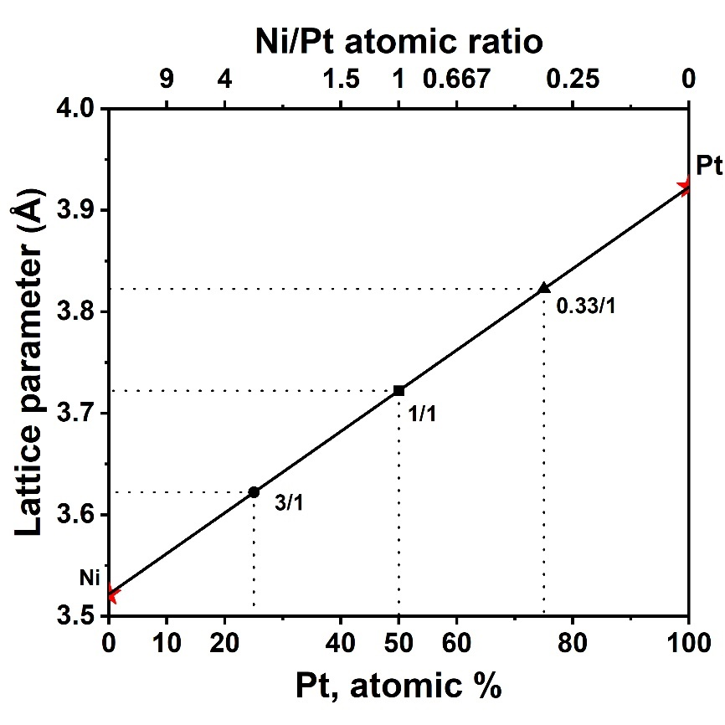
Supplementary Fig. 3 | Linear relationship of lattice parameter with alloy composition according to Vegard’s rule for solid solutions.^{11,12} Data shown on left and right Y-axis (red star symbols) are lattice parameters of pure Ni and Pt, respectively. Black solid line represents the dependence of lattice parameter on the Pt atomic percentage of Pt-Ni solid solution (disordered) alloys according to Vegard’s rule. Solid black circle, square and triangle symbols denote three cardinal compositions of FCC Pt-Ni alloys: PtNi₃, Pt₁Ni₁ and Pt₃Ni, respectively. Top X-axis displays the corresponding Ni/Pt atomic ratio at a given Pt atomic percentage derived from bottom X-axis.
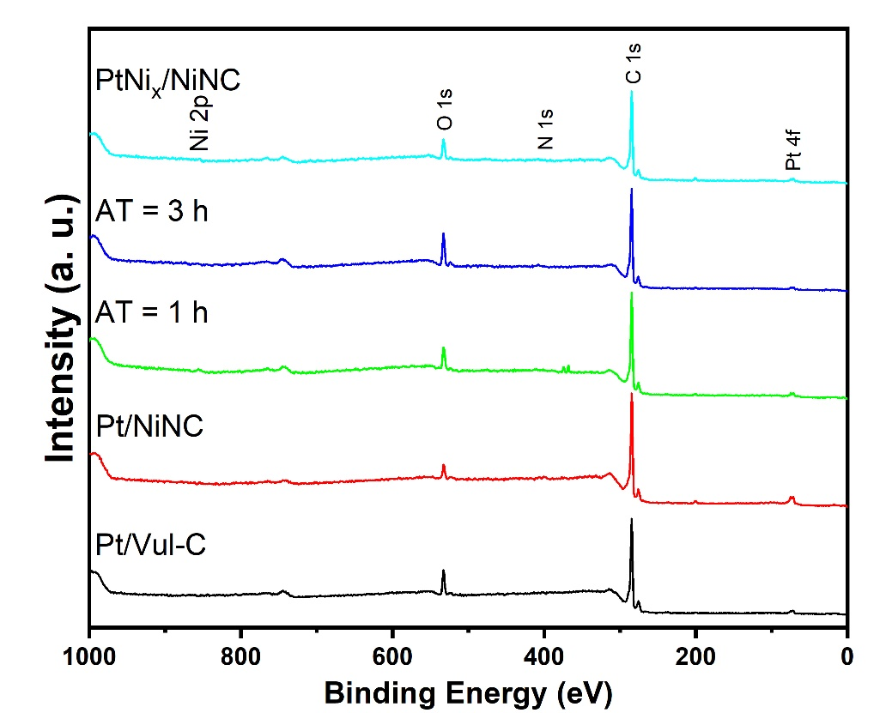
Supplementary Fig. 4 | (a) XPS survey spectra of catalyst materials derived from Pt/NiNC with different annealing time, together with one reference sample, Pt/Vul-C. For pristine Pt/NiNC catalyst, annealing time is 0 h. For final PtNi/NiNC catalyst, annealing time is 6 h.
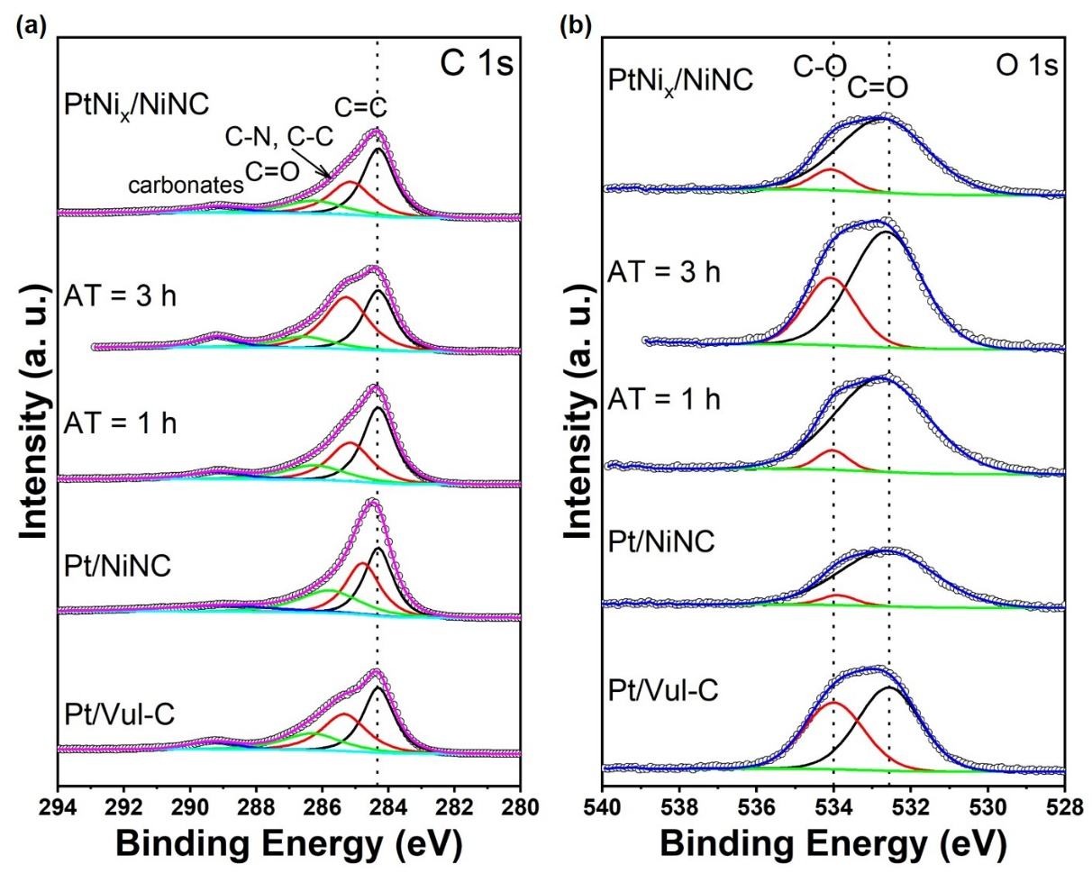
Supplementary Fig. 5 | XPS of catalysts, intermediates and reference: (a) C 1s and (b) O 1s spectra of various catalyst materials derived from pristine Pt/NiNC after different annealing time, together with one reference sample, Pt/Vul-C. For pristine Pt/NiNC catalyst, annealing time is 0 h. For final PtNi/NiNC catalyst, annealing time is 6 h. All O 1s spectra consist of two peaks which are assigned to oxygen single bonding (C-O, 534.0 eV) and double bonding (C=O, 532.6 eV) to carbon. All spectra are calibrated with the main peak of C 1s at 284.3 eV. The spectra were fitted using Casa XPS software.
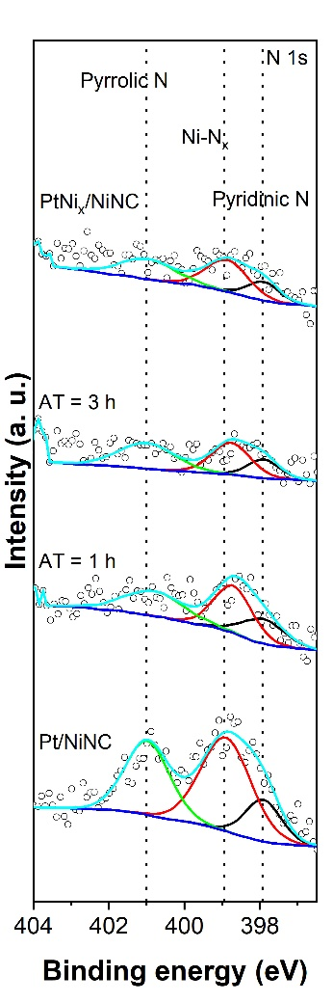
Supplementary Fig. 6 | N 1s XPS spectra of catalyst materials derived from pristine Pt/NiNC after different annealing time. For pristine Pt/NiNC catalyst, annealing time is 0 h. For final PtNi/NiNC catalyst, annealing time is 6 h.
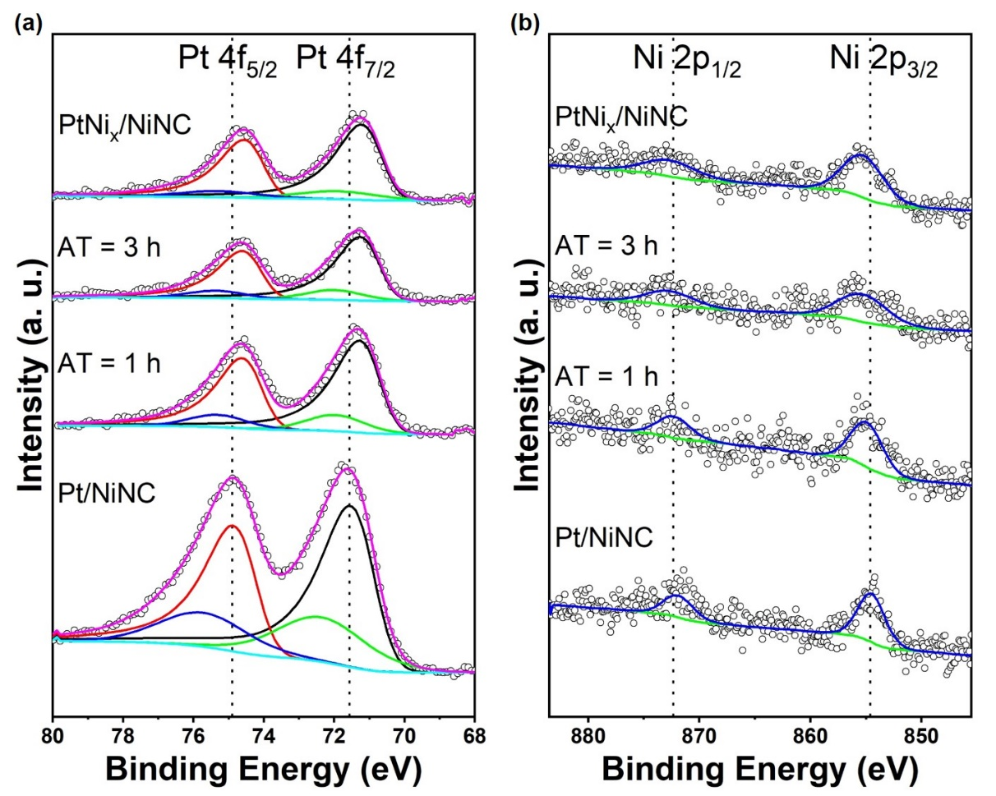
Supplementary Fig. 7 | (a) Pt 4f and (b) Ni 2p XPS spectra of catalyst materials derived from Pt/NiNC after different annealing time. For pristine Pt/NiNC catalyst, annealing time is 0 h. For final PtNi/NiNC catalyst, annealing time is 6 h.

Supplementary Table 1 | Elemental compositions (in both at% and wt%) derived from XPS for different catalyst materials. For pristine Pt/NiNC catalyst, annealing time is 0 h. For final PtNi/NiNC catalyst, annealing time is 6 h.
Samples | C  (at%) | N  (at%) | O  (at%) | Pt  (at%) | Ni  (at%) | C  (wt%) | N  (wt%) | O  (wt%) | Pt  (wt%) | Ni  (wt%)
Pt/Vul-C | 90.44 | NA | 9.27 | 0.29 | NA | 84.17 | NA | 11.50 | 4.32 | NA
Pt/NiNC | 93.14 | 1.12 | 5.01 | 0.61 | 0.12 | 83.39 | 1.17 | 5.98 | 8.94 | 0.53
AT = 1 h | 90.26 | 0.54 ↓ | 8.79 | 0.27 | 0.14 | 83.83 | 0.59 | 10.89 | 4.07 | 0.62
AT = 3 h | 88.39 | 0.40 ↓ | 10.90 | 0.17 | 0.13 | 82.74 | 0.44 | 13.60 | 2.63 | 0.59
PtNi_{x}/NiNC | 91.18 | 0.44 ↓ | 7.95 | 0.25 | 0.19 | 85.02 | 0.47 | 9.88 | 3.75 | 0.87

Supplementary Table 2 | Elemental distribution of different Pt species as derived from the fitting results. For pristine Pt/NiNC catalyst, annealing time is 0 h. For final PtNi/NiNC catalyst, annealing time is 6 h.
Samples | Pt⁰ 4f_{7/2} position | Pt⁰/Pt²⁺ | Ni 2p_{3/2} position | Pt⁰ (%) | Pt²⁺ (%)
Pt/Vul-C | 71.02 | 2.43 | NA | 70.88 | 29.12
Pt/NiNC | 71.07 | 2.66 | 854.47 | 72.69 | 27.31
AT = 1 h | 70.88 ↓ | 5.43 ↑ | 854.88 ↑ | 84.45 | 15.55
AT = 3 h | 70.89 ↓ | 5.98 ↑ | 855.29 ↑ | 85.68 | 14.32
PtNi_{x}/NiNC | 70.83 ↓ | 6.54 ↑ | 855.21 ↑ | 86.74 | 13.26

Supplementary Table 3 | Change of Ni/Pt atomic ratio versus the annealing time in hours. For pristine Pt/NiNC catalyst, annealing time is 0 h. For final PtNi/NiNC catalyst, annealing time is 6 h. By normalizing the total integral areas of Ni 2p and Pt 4f regions to their corresponding relative sensitivity factors (RSFs), the Ni/Pt atomic ratios were obtained from XPS spectra.
Samples | Total Ni 2p integral area | Total Pt 4f integral area | Ni/Pt atomic ratio
Pt/NiNC | 2485.8 | 9524.4 | 0.20
AT = 1 h | 2659.1 | 3957.8 | 0.51 ↑
AT = 3 h | 2523.6 | 2553.3 | 0.74 ↑
PtNi_{x}/NiNC | 3226.7 | 3144.6 | 0.77 ↑

Supplementary Table 4 | Metal contents in weight percentage determined by ICP for catalyst materials derived from Pt/NiNC, as well as Pt/Vul-C reference material.
Samples | Pt wt% (ICP) | Ni wt% (ICP)
Pt/Vul-C | 3.01 | NA
Pt/NiNC | 3.14 | 6.91
AT = 1 h | 2.96 | 6.57
AT = 3 h | 3.32 | 7.56
PtNi_{x}/NiNC | 3.23 ↑ | 7.42 ↑

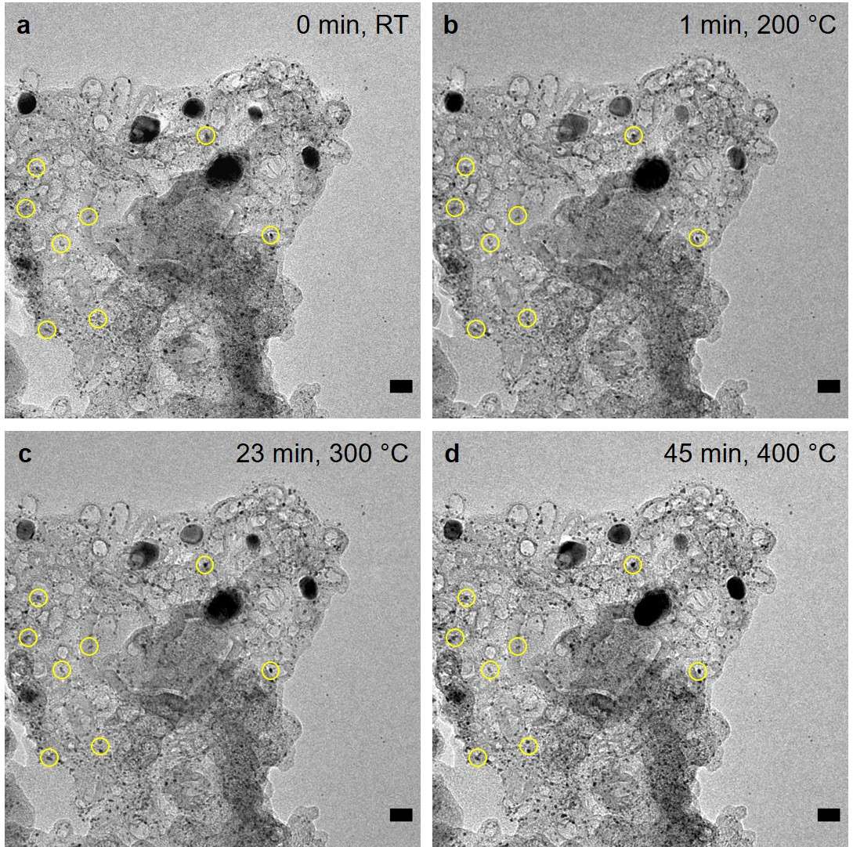
Supplementary Fig. 8 | In situ TEM image series taken below 500 °C. At lower temperatures, small Pt NPs as marked by yellow circles either agglomerated slightly or become rounded in shape, whereas Ni NPs are stable. Scale bar: 20 nm.
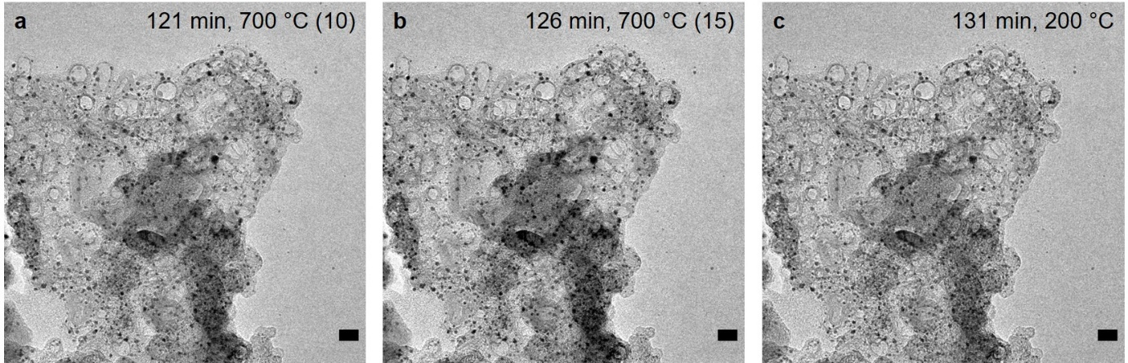
Supplementary Fig. 9 | Tracking morphological changes in real time. In situ TEM images recorded during a temperature hold of 15 min at 700 °C (a, b) and after subsequent cooling to 200 °C (c). The numbers in parentheses indicate the holding time in minutes at 700 °C. Scale bar: 20 nm.
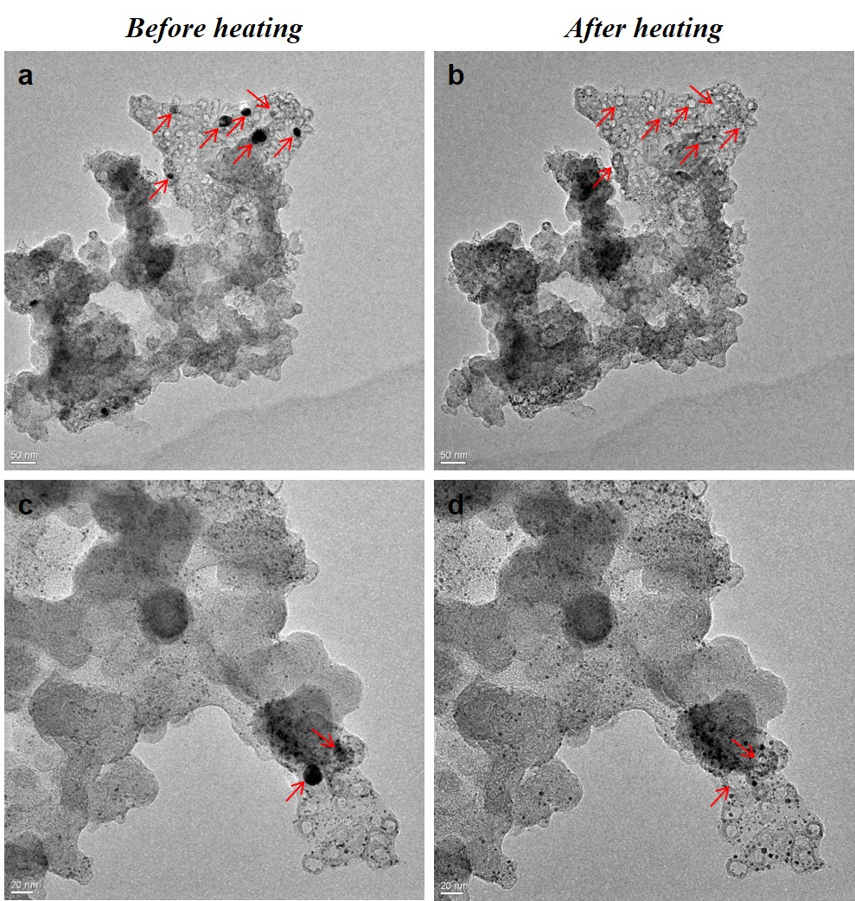
Supplementary Fig. 10 | Exclusion of beam damage misinterpretations. Impact of electron beam during in situ heating. TEM images taken (a, c) before and (b, d) after the same heating procedure from other two regions, which neither were exposed to electron beam during in situ heating experiment. Herein, similar changes are observed as in main text: after heating, these Ni NPs marked by red arrows disappear completely. From this beam control experiment, we could conclude that all changes observed in our in situ heating experiment result from heating, rather than electron beam damage.
Supplementary Discussion 2 | Experimental verification of absence of beam damage effect (relating to Supplementary Fig. 10 for Pt/NiNC and Supplementary Fig. 18 for Pt/NiNC-1)
In order to check for the influence of electron beam damage, we recorded TEM images of two other catalyst regions only briefly before and after completion of our in situ heating experiment (Supplementary Fig. 10 for Pt/NiNC and Supplementary Fig. 18 for Pt/NiNC-1). As very similar morphological changes to Pt and Ni NPs were observed on the non-irradiated regions, we are confident that the diffusion and shrinkage of Ni atoms and subsequent alloy formation originate from the thermal treatment rather than from beam effects.
Supplementary Discussion 3 | Thermal annealing of Pt/NiNC-1 in absence of C-encapsulated Ni NPs (relating to Supplementary Figs. 11–19)
To verify the dominant role of metallic Ni NPs as the source of mobile Ni atoms alloying with Pt particles during the thermal formation of PtNi nanoalloy NPs, we prepared a reference material in analogy to Pt/NiNC (synthetic process see Supplementary Figs. 11, 12), denoted as “Pt/NiNC-1”, which had a lower Ni content of only 1 wt% and contained no metallic Ni NPs present (Supplementary Fig. 11b). Key difference compared to the synthesis of Fig. 1 was the preparation and use of the lower Ni-wt% support, NiNC-1. Pt deposition on NiNC-1 and further thermal annealing of Pt/NiNC-1 was identical.
After thermal annealing of the Pt/NiNC-1 catalyst, the right shift of the Pt(111) reflection in Supplementary Fig. 13 suggested the formation of a bimetallic PtM alloy phase with a second metallic component “M”. But due to the fact that both Zn (3.6 wt%) and Ni (1.2 wt%) coexist in the pyrolyzed “NiNC-1” support material, it is unclear which metal element took part in the alloy formation and at what proportions if both do. This is the reason why we denote the annealed catalyst as “PtM_{x}/NiNC-1”, in which M represents either Zn or Ni. Importantly, the voltammetric CO stripping and associated CV measurements in alkaline electrolyte (Supplementary Fig. 19a and b) unambiguously indicate the absence of “Ni”-type CO stripping peaks and Ni²⁺/Ni³⁺ redox peaks. This implies that Ni cannot be involved in the formation of the PtM_{x} alloy phase. Overall, this control experiment confirms that Ni NPs act as the main source of Ni species in the process of alloy formation.
Supplementary Table 5 | Metal contents in wt% determined by ICP for catalyst materials derived from NiNC-1 support.
Samples | Pt wt% (ICP) | Ni wt% (ICP) | Zn wt% (ICP)
NiNC-1 | NA | 1.20 | 3.60
Pt/NiNC-1 | 2.76 | 1.09 | 2.70
PtM_{x}/NiNC-1 | 3.17 ↑ | 1.26 ↑ | 2.70
Owing to a mass loss caused by unstable volatile species during the annealing process, the contents of Pt and Ni in as-annealed samples are slightly increased.

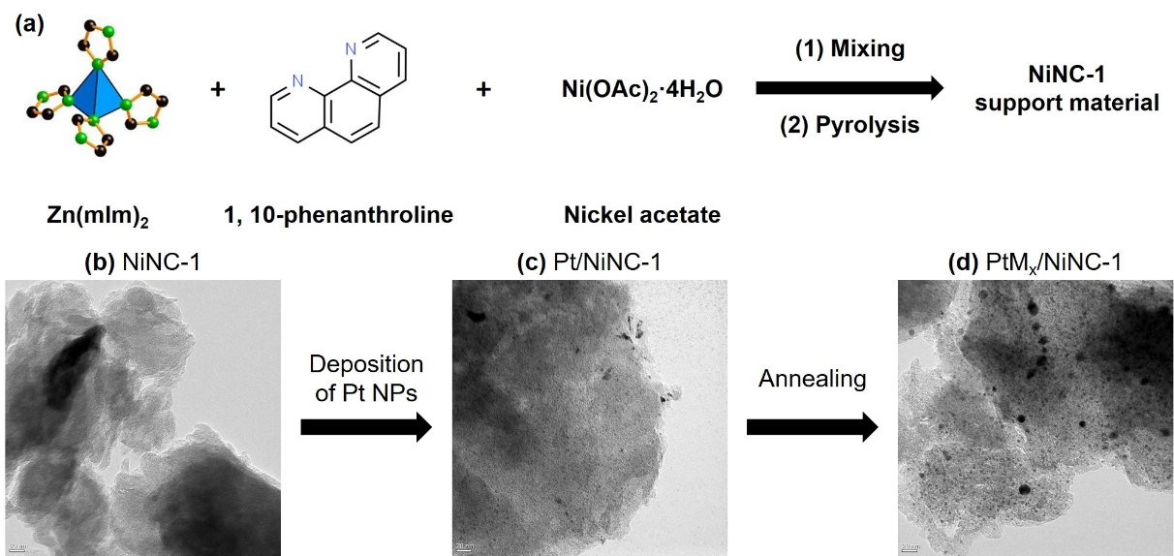
Supplementary Fig. 11 | Synthetic scheme and TEM images of the NiNC-1 support-based materials at three different steps. (a) Synthetic route of the blank NiNC-1 support material. (b) Initial NiNC-1 support material, showing no presence of Ni NPs. (c) In situ growth of 3 wt% Pt NPs on NiNC-1 support through polyol process. (d) Formation of PtM_{x}/NiNC-1 after annealing treatment. Scale bar: 20 nm.
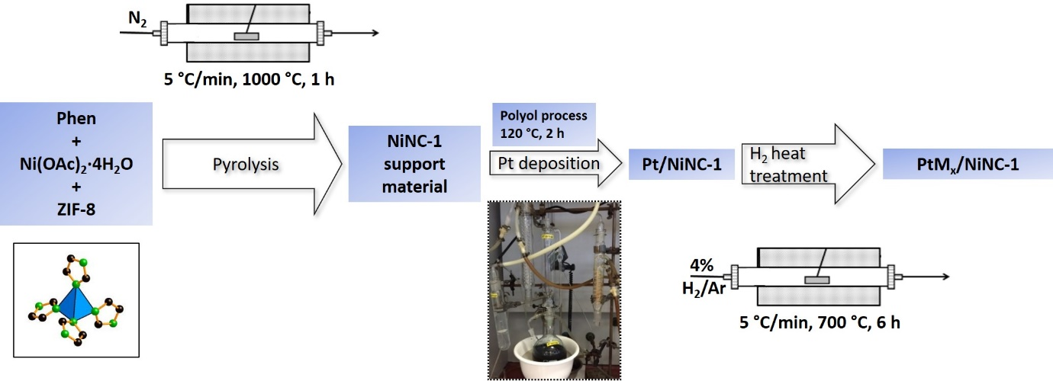
Supplementary Fig. 12 | Complete synthetic route toward PtM_{x}/NiNC-1 catalyst material.
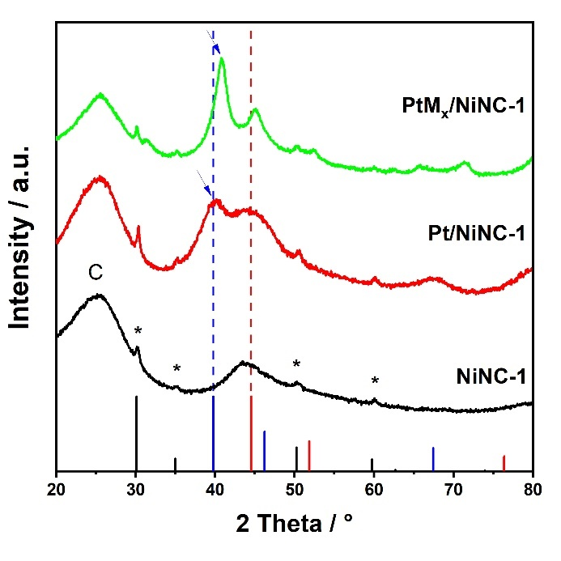
Supplementary Fig. 13 | XRD patterns of the as-prepared Ni NP-free NiNC-1 support, pristine Pt/NiNC-1 material obtained after deposition of Pt NPs, and the final as-annealed PtM_{x}/ NiNC-1 samples. Blue arrows clearly show the successful growth of Pt NPs on NiNC-1 support and the evolution from pure Pt NPs to PtM_{x} alloy phase.
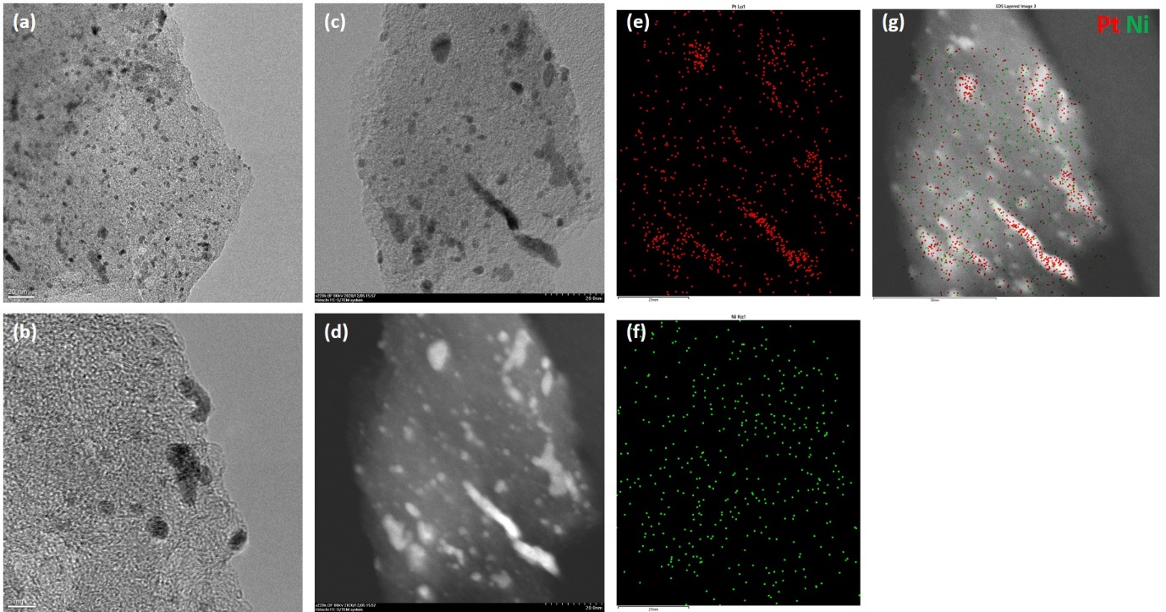
Supplementary Fig. 14 | HRTEM images of pristine Pt/NiNC-1 catalyst at lower (a) and higher (b) magnifications. HAADF STEM images at both (c) bright field (BF) and (d) dark field (DF). STEM-EDX compositional mapping profiles of the same area as in (c and d): (e) single Pt, (f) single Ni, and (g) overlapping of Pt (red) and Ni (green).
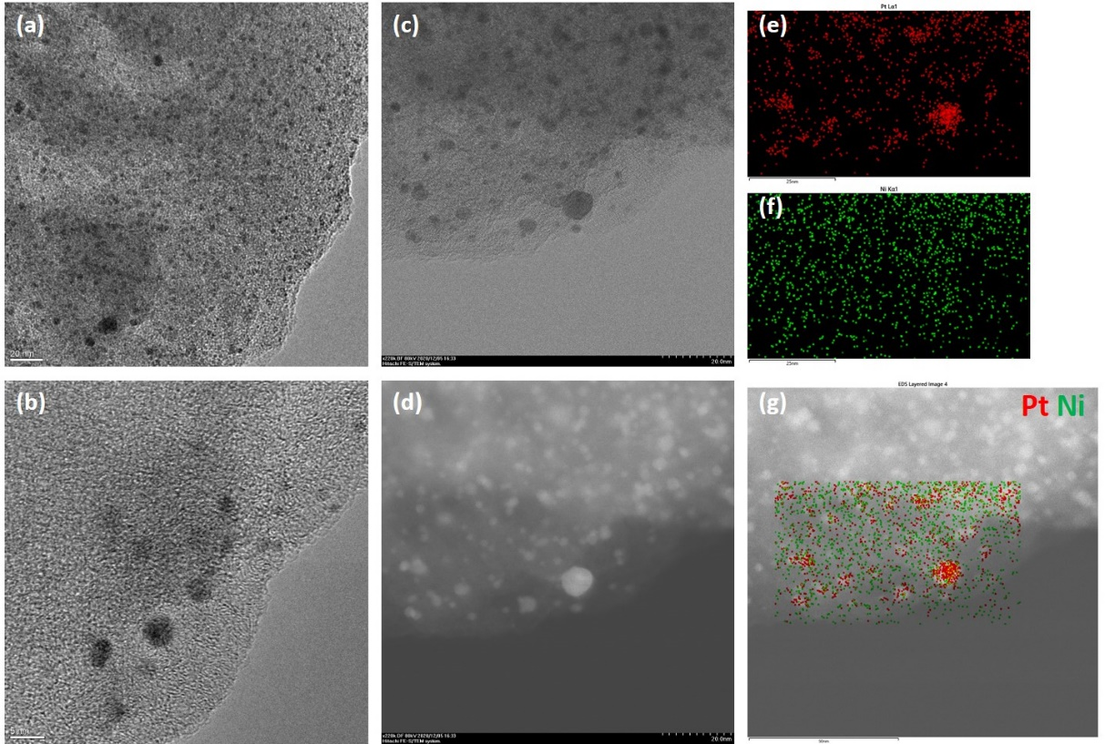
Supplementary Fig. 15 | HRTEM images of as-annealed PtM_{x}/NiNC-1 catalyst at lower (a) and higher (b) magnifications. HAADF STEM images at both (c) bright field (BF) and (d) dark field (DF). STEM-EDX compositional mapping profiles of the same area as in (c and d): (e) single Pt, (f) single Ni, and (g) overlapping of Pt (red) and Ni (green).
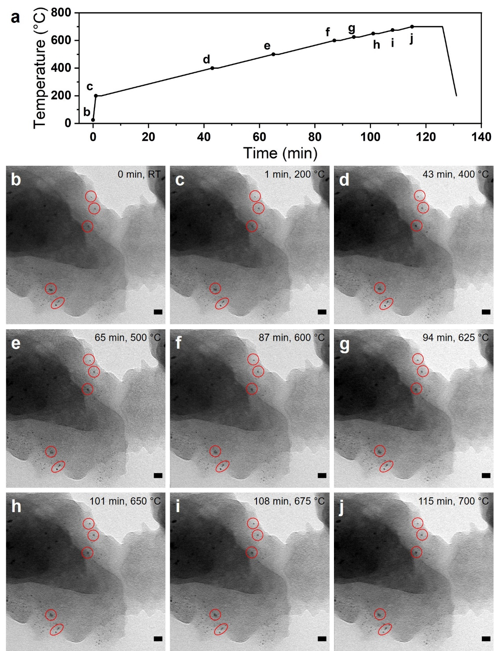
Supplementary Fig. 16 | In situ TEM imaging of the catalyst during heating from 25 °C (RT) to 700 °C under vacuum condition. (a) Temperature profile over time with marked points corresponding to the images in (b–g). Starting from 200 °C, temperature was increased in step of 100 °C (5 K/min). The specimen was annealed for 2 min at each step below 600 °C. Between 600 and 700 °C, temperature was increased in step of 25 °C and kept constant at each step for 2 min. And sample temperature was kept at final 700 °C for 11 min. Red circles in b–j mark the Pt NPs slightly agglomerated during thermal annealing. Scale bar: 20 nm.
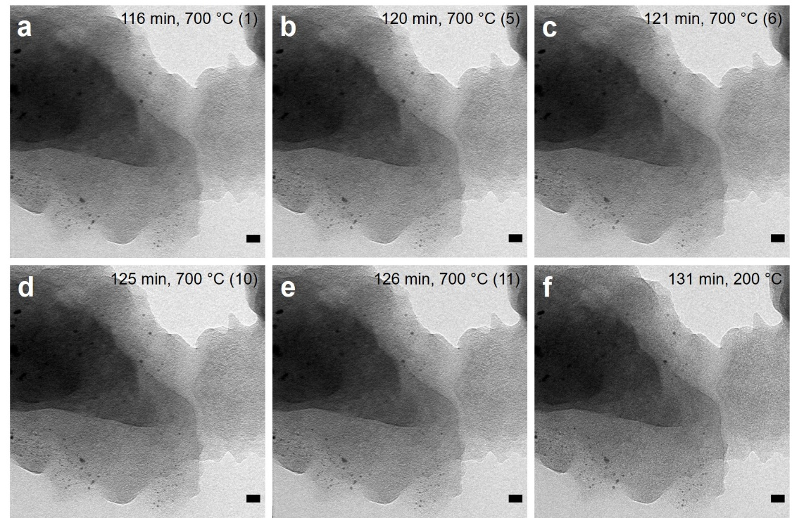
Supplementary Fig. 17 | In situ TEM images recorded during a temperature hold of 11 min at 700 °C (a–e) and after subsequent cooling to 200 °C (f). The numbers in parentheses indicate the holding time in minutes at 700 °C. Scale bar: 20 nm.
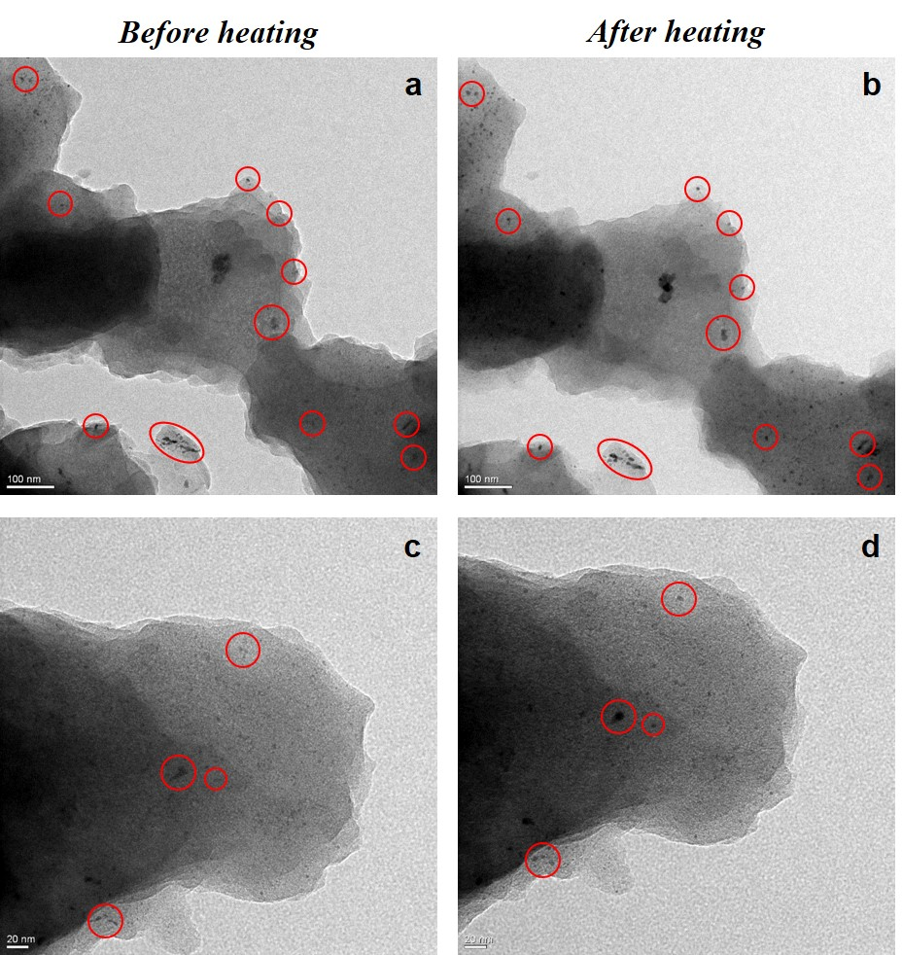
Supplementary Fig. 18 | Impact of electron beam during in situ heating and exclusion of beam damage misinterpretations. TEM images taken (a, c) before and (b, d) after the same heating procedure from other two regions, which neither were exposed to electron beam during in situ heating experiment. Herein, similar changes are observed as in Supplementary Fig. 16. From this beam control experiment, we could conclude that all changes observed in our in situ heating experiment result from heating, rather than electron beam damage.
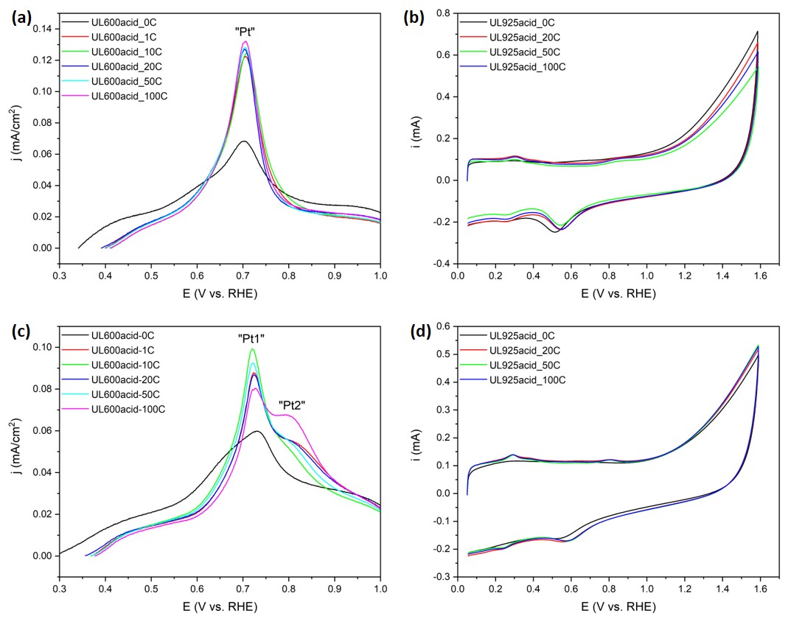
Supplementary Fig. 19 | (a, c) Pt surface area-normalized and background-subtracted CO stripping voltammetry and (b, d) CV curves in 0.1 M KOH solution for a series of catalyst films undergoing pre-treatment in acidic solution with different potential cycling numbers: (a, b) as-annealed PtM_{x}/NiNC-1 and (c, d) pristine Pt/NiNC-1 samples, respectively.
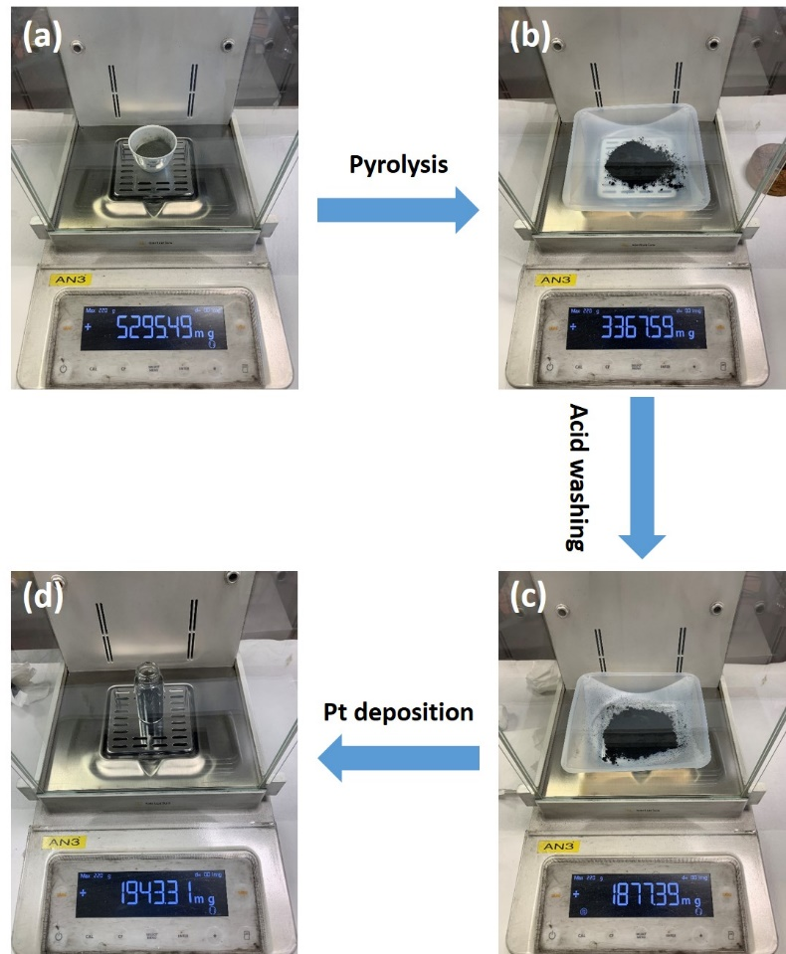
Supplementary Fig. 20 | Images of the product and its weight at each intermediate step: (a) the starting material, homogeneous mixture of α-Ni(Im)₂ precursor and Vulcan carbon in a weight ratio of 10:1; (b) after pyrolysis; (c) after acid washing and (d) after 5 wt% Pt deposition via polyol process.
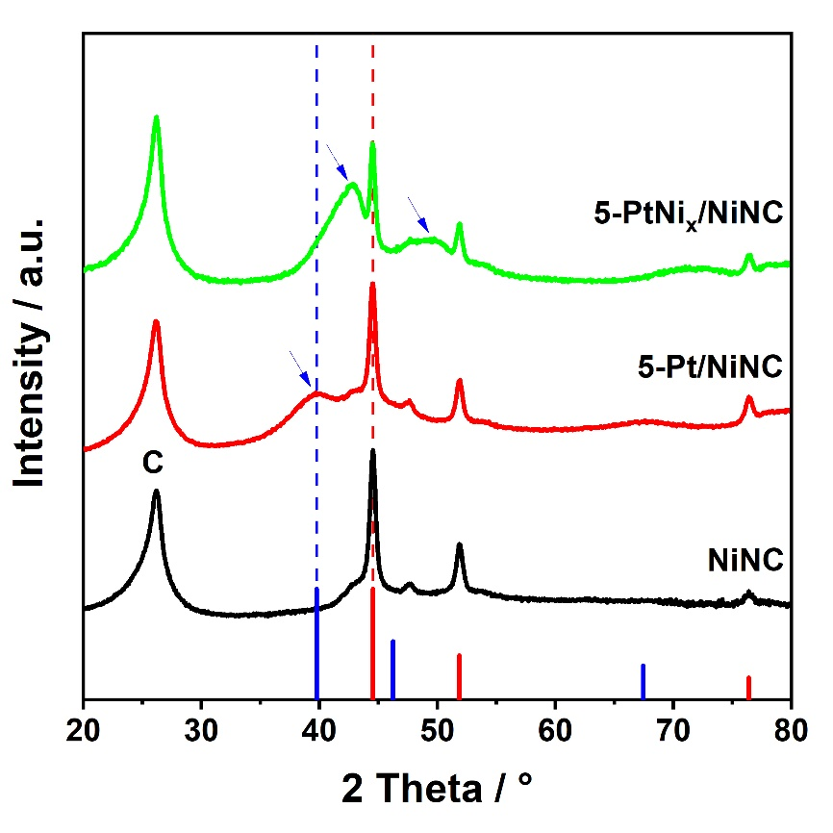
Supplementary Fig. 21 | XRD pattern of blank NiNC support, pristine 5-Pt/NiNC and as-annealed 5-PtNi/NiNC catalyst materials.
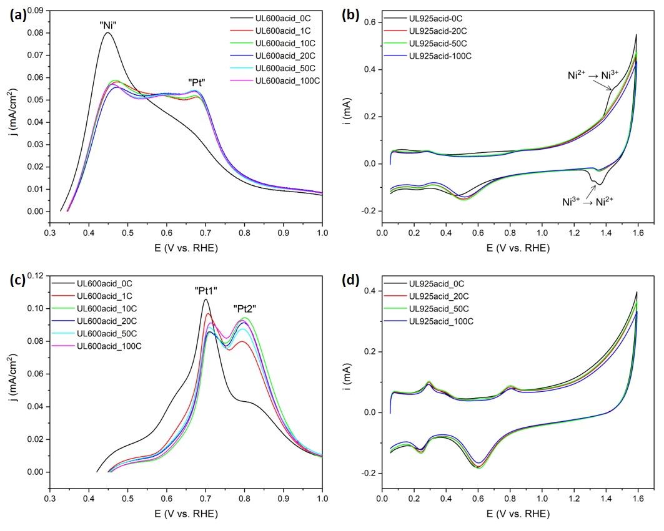
Supplementary Fig. 22 | (a, c) Pt surface area-normalized and background-subtracted CO stripping voltammetry and (b, d) CV curves in 0.1 M KOH solution for a series of catalyst films undergoing pre-treatment in acidic solution with different potential cycling numbers: (a, b) as-annealed 5-PtNi_{x}/NiNC and (c, d) pristine 5-Pt/NiNC samples, respectively.
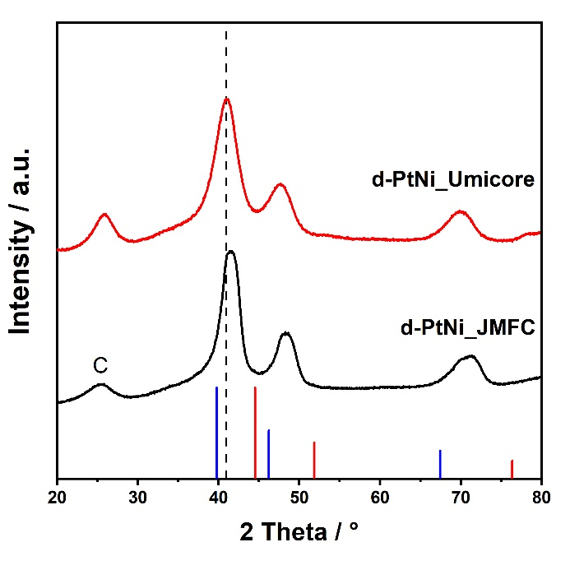
Supplementary Fig. 23 | XRD patterns of two d-PtNi reference samples from JMFC and Umicore, respectively. For d-PtNi_JMFC sample, Pt content is 28.6 wt%, and Ni content is 4.7 wt%, with a Pt/Ni atomic ratio of Pt_{1.83}Ni. For d-PtNi_Umicore sample, Pt content is 28.13 wt%, and Ni content is 3.02 wt%, with a Pt/Ni atomic ratio of Pt_{2.80}Ni. Duo to its higher Ni content in d-PtNi_JMFC, according to Vegard’s rule (Supplementary Fig. 3), it is expected that Pt(111) diffraction peak of d-PtNi_JMFC would shift to higher 2theta degree. Then this is further confirmed by our XRD results. The vertical dashed line is present as a guide for eyes.
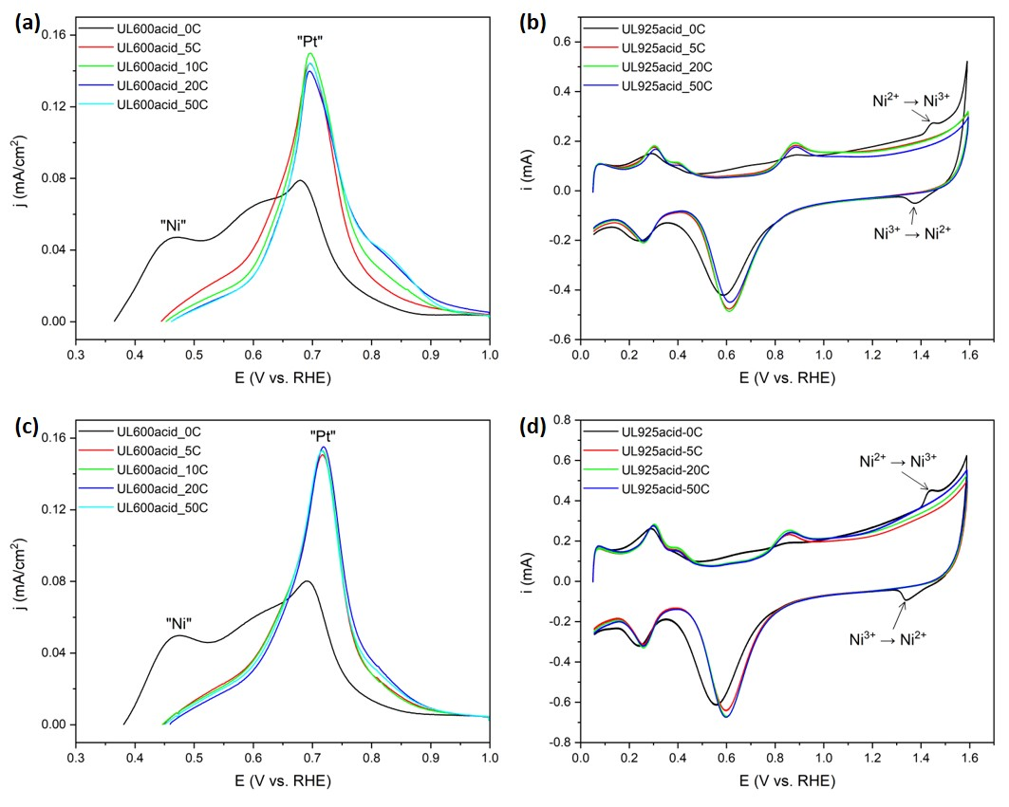
Supplementary Fig. 24 | (a, c) Pt surface area-normalized and background-subtracted CO stripping voltammetry and (b, d) CV curves in 0.1 M KOH solution for a series of catalyst films undergoing pre-treatment in acidic solution with different potential cycling numbers: (a, b) d-PtNi_JMFC and (c, d) d-PtNi_Umicore samples, respectively.
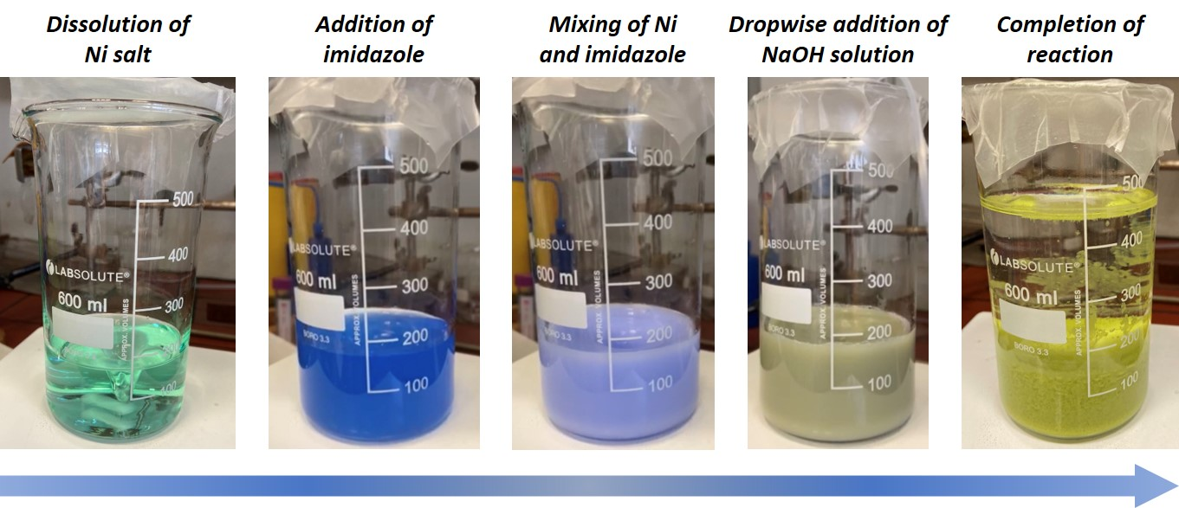
Supplementary Fig. 25 | Colour change of the reaction system during reaction time. Room temperature synthesis of α-Ni(Im)₂ precursor.
Supplementary Discussion 4 | Quantitative estimation of the contribution of accessible NiN_{x} sites to the overall activity of Pt/NiNC catalyst.
First of all, from a qualitative standpoint, due to the much lower intrinsic ORR activity of NiN_{x} sites than Pt, it is expected that these ORR-inactive NiNC sites barely contribute to the overall activity of the Pt/NiNC catalyst. Previous DFT studies suggest that this poor ORR activity results from the weak O* adsorption energy on Ni site.^{13,14} Then such a hypothesis is corroborated by our quantitative estimation result as shown below.
The geometric catalyst loading of Pt/NiNC on the GC electrode is
$$L_{catal}= \frac{\frac{5.83 mg}{4.99 mL} ×10 μL}{0.19625 {cm}^{2}}=59.5 μg/{cm}^{2}$$
And the geometric mass loading of accessible NiN_{x} sites is
$$L_{Ni site}= L_{catal}× ω_{Ni site} =59.5 ×0.53\%=0.32 μg/{cm}^{2}$$
Considering that most of Ni in NiNC support is Ni NPs, which are completely encapsulated by thick carbon layer, we prefer to use the Ni content derived from XPS technique, rather than that derived from ICP technique, as accessible Ni site, ω_{Ni site}. We would like to point to the difference in the distinct probing characteristics of both techniques: XPS is surface-sensitive with detection depth at specific photo energy, but ICP is a bulk method probing the total content of Ni species both from surface and buried under the thick carbon layer.
And the geometric molar amount of accessible NiN_{x} site is
$$n_{Ni site}= \frac{L_{Ni site}}{M_{Ni}} = \frac{0.32 μg/{cm}^{2}}{58.69 {μg}/{μmol}}=5.5×{10}^{-3} {μmol}/{{cm}^{2}}= 5.5×{10}^{-9} {mol}/{{cm}^{2}}$$
Where M_{Ni} is the molar mass of nickel.
Thus, the geometric kinetic current density from accessible NiN_{x} sites is
$$j_{Ni site}= n_{Ni site} × N_{A} ×{TOF}_{Ni site}\left[e {site}^{-1} s^{-1}\right]×e= 5.5×{10}^{-9} ×6.02 × {10}^{23} ×1.6 × {10}^{-19} ×TOF \left[A/{{cm}^{2}}\right]=53 × {10}^{-5} ×TOF \left[A/{{cm}^{2}}\right]=0.53 ×TOF \left[{mA}/{{cm}^{2}}\right]$$Where TOF is the turnover frequency, N_{A} is the Avogadro’s constant, e is the electric charge of one electron.
The overall kinetic current density, j_{K}, was calculated according to Koutecky-Levich equation:
$$\frac{1}{j_{K}}= \frac{1}{j_{0.8}} - \frac{1}{j_{D}}= \frac{1.74 ×4.82}{4.82 -1.74}=2.74 mA/{cm}^{2}$$
Where j_{0.8} is the current density at 0.8 V_{RHE}, and j_{D} is the diffusion current density.
Finally, the percentage contribution of accessible NiN_{x} sites to the overall activity can be calculated as:
$$= 100\% × \frac{j_{Ni site}}{j_{K}}=100\% × \frac{0.53 ×TOF}{2.74}=19.3 ×TOF (\%)$$
The above calculations indicate that the ORR activity contribution from NiN_{x} sites has a linear relationship with the intrinsic TOF value of NiN_{x} site. Due to the fact that the NiNC catalyst does not demonstrate any CO chemisorption, quantification of the mass-based site density derived from CO pulse chemisorption is not possible to perform. Consequently, one could not obtain the TOF value of NiN_{x} sites using CO sorption method. Although at present there is no TOF value of NiN_{x} sites from literatures, for comparison, next we use the TOF values of its iron, cobalt and copper counterparts from literature to estimate their respective percentage contribution to the overall ORR activity.¹⁴ This could provide us with some indications about the actual contribution of NiN_{x} sites. Assuming that these accessible NiN_{x} sites are substituted by same amount of their Fe counterparts, despite its highest intrinsic TOF value, it only contributes to around 3% of the overall activity. Considering the much lower intrinsic activity of NiN_{x} site than FeN_{x} site,^{13,14} we conclude that NiN_{x} sites barely contribute to the overall activity.
Supplementary Table 6 | Assumed TOF values at 0.8 V_{RHE} in 0.1 M HClO₄ electrolyte and ensuing j_{Ni site} and its contribution to the overall activity.
TOF (e site⁻¹ s⁻¹) ª | j_{Ni site} (mA/cm²) | Percentage contribution to overall j (%)
0.15 (Fe) | 0.08 | 2.91
0.029 (Co) | 0.02 | 0.56
0.006 (Cu) | 0.00 | 0.12
ª RDE measurement conditions: temperature of 25 °C; geometric catalyst loading of 800 µg/cm²; scan rate of 5 mV/s; rotation of 1600 rpm; negative going scan was used to evaluate the ORR activity.

Supplementary Discussion 5 | Advantage of our NiNC support versus conventional Vulcan carbon.
Owing to the mesoporous structure and Ni- and N-doped feature, our NiNC support exhibit several advantages versus conventional Vulcan carbon support. First, compared with undoped Vulcan carbon, NiNC support bears nitrogen functional groups that interact with the ionomer to promote its homogeneous distribution. Owing to the Coulombic attraction between the ionomer and N groups on the NiNC support, NiNC support could ensure very uniform coverage of the ionomer.¹⁵ Second, carbon supports with a mesoporous structure (with a pore opening of 4–7 nm) promise excellent ORR activity and transport properties simultaneously.¹⁶ Third, the highly graphitized carbon is more resistant to carbon corrosion.
For Pt/NiNC catalyst, due to the difficulty in obtaining an uniform catalyst film without the addition of Nafion ionomer, we only measured its performance with the addition of Nafion ionomer. As shown in Fig. 5a and d, for Pt/NiNC, albeit with ionomer, it still exhibits measurable CO signal and H_{upd} features, indicating its advantages over conventional Vulcan carbon.
To evaluate the effect of ionomer distribution on the electrochemical performance of Pt/Vul-C catalyst, we measure its ORR performance with and without the addition of Nafion ionomer. When ionomer is absent, Pt surface is free of ionomer and the poisoning effect is absent. As shown in Supplementary Fig. 26, upon the addition of Nafion ionomer, both CO signal and H_{upd} features of Pt/Vul-C were inhibited due to the poisoning effect on Pt surface. Carbon monoxide strongly adsorbs on metallic Pt surface. The weakening of CO signal demonstrated that a faction of Pt surface was fully covered by the thick ionomer layer and was not electrochemically-accessible anymore.
As shown in Supplementary Fig. 26b, both kinetic current at 0.9 V_{RHE} and diffusion current became smaller when ionomer was added. In the diffusion limiting regime, Pt particles hidden under the thick ionomer layer exhibit restricted protonic and reactant gas access, thus showing lower diffusion current density at low potential. In the kinetic regime, sulfonate groups in the perfluorosulfonic acid (PFSA) ionomer could also poison Pt surface, thus lowering its intrinsic activity.
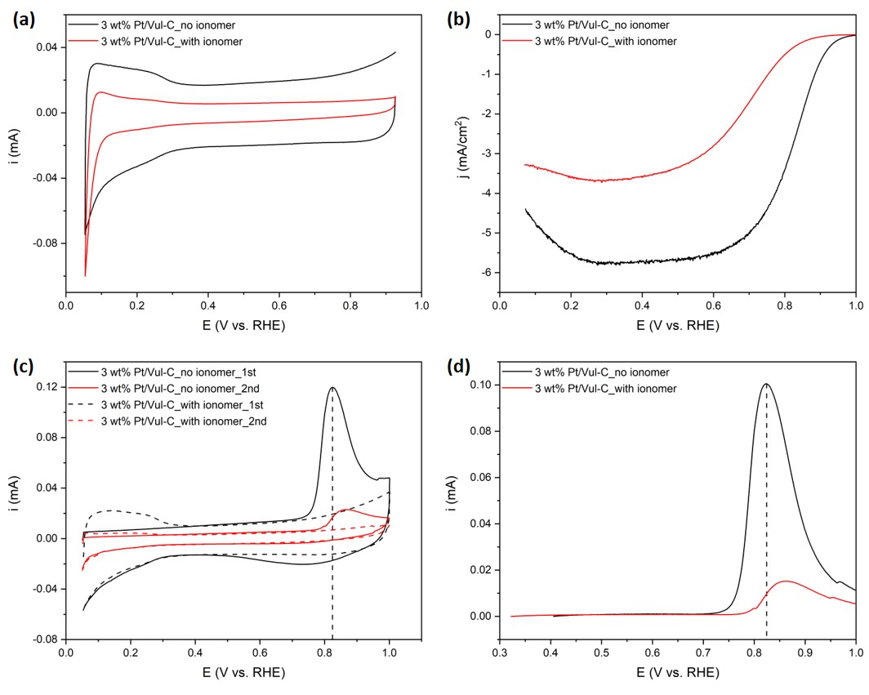
Supplementary Fig. 26 | RDE measurements of Pt/Vul-C reference catalyst both with and without the addition of Nafion ionomer: (a) CV, (b) ORR polarization, (c) first and second scans of CO striping curves and (d) background-subtracted CO stripping voltammetry curves.
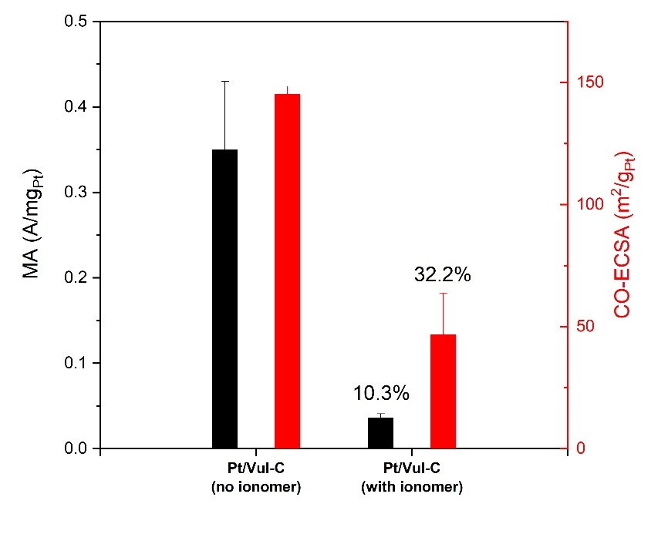
Supplementary Fig. 27 | Comparison of mass activities and CO-ECSA of Pt/Vul-C with and without the addition of Nafion ionomer.

Supplementary Table 7 | Comparison of mass activities, specific activities and CO-ECSA of Pt/Vul-C with and without the addition of Nafion ionomer.
Samples | MA (A/mg_{Pt}) | SA (mA/cm²) | CO-ECSA (m²/g_{Pt})
Pt/Vul-C  (no ionomer) | 0.35 ± 0.08 | 0.24 ± 0.05 | 145.2 ± 3.2
Pt/Vul-C  (with ionomer) | 0.036 ± 0.005  (10.3%) | 0.083 ± 0.027  (34.6%) | 46.7 ± 17.0  (32.2%)

Supplementary Discussion 6 | In situ TEM vs ex situ tube furnace thermal annealing
From XRD pattern as shown in Fig. 2a and Supplementary Fig. 28, after ex situ thermal annealing under ambient pressure for 6 h, the PtNi/NiNC catalyst after chemical dealloying continued to show weak diffraction peaks corresponding to crystalline Ni NPs. With an even shorter heating protocol, the in situ thermal annealing in the TEM holder appears to induce more severe changes on our catalyst material compared with ex situ annealing. Therefore, we conclude that in situ heating condition is much harsher than ex situ one, possibly due to the ultralow pressure under vacuum condition. Although there still exists an unavoidable gap between in situ heating and ex situ annealing experiments, these in situ TEM experiment could allow us to obtain some valuable information about how our catalyst material evolves during thermal annealing. In terms of this discrepancy, in situ environmental TEM (ETEM) technique could provide a gaseous environment and thus come more closer toward realistic ex situ annealing conditions.¹⁷
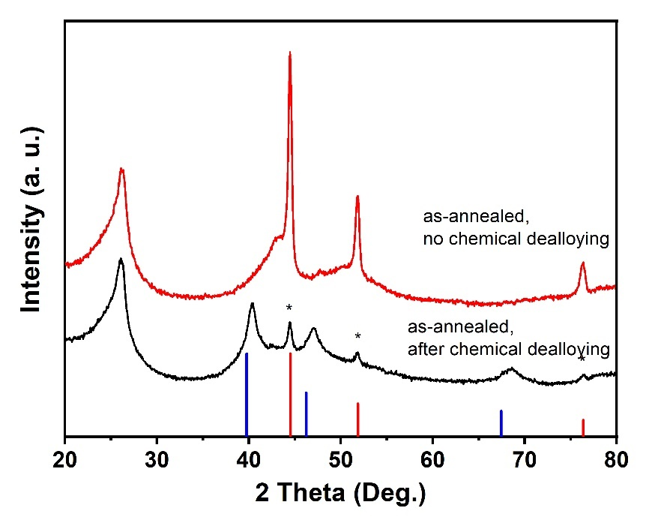
Supplementary Fig. 28 | In chemical dealloying, as-annealed PtNi/NiNC catalyst was treated with 0.1 M HClO₄ solution at 80 °C for 4 h and washed with deionized water for several times. After freeze-drying overnight, the material was annealed under 4% H₂/Ar at 500 °C for 1 h. After chemical dealloying treatment, Ni diffraction peaks as marked by asterisk symbols show greatly weakened intensities, but still exist. The weakened intensities of Ni peaks indicate that after heating treatment, some of Ni NPs diffuse through thick carbon shells, and could be subsequently removed by chemical dealloying treatment.

Supplementary Video 1
Image sequences of Pt/NiNC-7 catalyst during in situ heating TEM.
Supplementary Video 2
Image sequences of Pt/NiNC-1 catalyst during in situ heating TEM.

References
1. Zitolo, A. et al. Identification of catalytic sites for oxygen reduction in iron- and nitrogen-doped graphene materials. Nat. Mater. 14, 937–942 (2015).
2. Zitolo, A. et al. Identification of catalytic sites in cobalt-nitrogen-carbon materials for the oxygen reduction reaction. Nat. Commun. 8, 957 (2017).
3. Kodama, K., Nagai, T., Kuwaki, A., Jinnouchi, R., Morimoto, Y. Challenges in applying highly active Pt-based nanostructured catalysts for oxygen reduction reactions to fuel cell vehicles. Nat. Nanotechnol. 16, 140–147 (2021).
4. Debe, M. K. Electrocatalyst approaches and challenges for automotive fuel cells. Nature 486, 43–51 (2012).
5. Zhang, L., Xia, Y. Scaling up the Production of Colloidal Nanocrystals: Should We Increase or Decrease the Reaction Volume? Adv. Mater. 26, 2600–2606 (2014).
6. Niu, G., Ruditskiy, A., Vara, M., Xia, Y. Toward continuous and scalable production of colloidal nanocrystals by switching from batch to droplet reactors. Chem. Soc. Rev. 44, 5806–5820 (2015).
7. Roy, C. et al. Scalable Synthesis of Carbon-Supported Platinum–Lanthanide and −Rare-Earth Alloys for Oxygen Reduction. ACS Catal. 8, 2071–2080 (2018).
8. Duan, H., Wang, D., Li, Y. Green chemistry for nanoparticle synthesis. Chem. Soc. Rev. 44, 5778–5792 (2015).
9. Zhang, L. et al. Continuous and Scalable Production of Well-Controlled Noble-Metal Nanocrystals in Milliliter-Sized Droplet Reactors. Nano Lett. 14, 6626–6631 (2014).
10. Niu, G. et al. Synthesis of Pt–Ni Octahedra in Continuous-Flow Droplet Reactors for the Scalable Production of Highly Active Catalysts toward Oxygen Reduction. Nano Lett. 16, 3850–3857 (2016).
11. DeGraef, M., McHenry, M. E. Structure of Materials: An Introduction to Crystallography, Diffraction, and Symmetry. Cambrige University Press: Cambridge, 2007.
12. Cullity, B. D., Stock, S. R. Elements of X ray diffraction, 3 edn. Prentice Hall: New York, 2001.
13. Calle-Vallejo, F., Martínez, J. I., Rossmeisl, J. Density functional studies of functionalized graphitic materials with late transition metals for oxygen reduction reactions. Phys. Chem. Chem. Phys. 13, 15639–15643 (2011).
14. Luo, F. et al. P-block single-metal-site tin/nitrogen-doped carbon fuel cell cathode catalyst for oxygen reduction reaction. Nat. Mater. 19, 1215–1223 (2020).
15. Ott, S. et al. Ionomer distribution control in porous carbon-supported catalyst layers for high-power and low Pt-loaded proton exchange membrane fuel cells. Nat. Mater. 19, 77–85 (2019).
16. Yarlagadda, V. et al. Boosting Fuel Cell Performance with Accessible Carbon Mesopores. ACS Energy Lett. 3, 618–621 (2018).
17. Wei, S. et al. Direct observation of noble metal nanoparticles transforming to thermally stable single atoms. Nat. Nanotechnol. 13, 856–861 (2018).

