Supporting information

Sustainable, Short and One-Pot synthesis of a Mirabegron Advanced Intermediate free from Genotoxic compounds and Toxic Reagents
Prashant A. Patil^{1,2}, Dilip R. Birari², Pritesh B. Kardile², Mubarak Ali Sayyad², Rohit A. Dengale², Dattatray A. Chadar^{1*}.
¹ School of Science, Sandip University, Nashik-422213, Maharashtra, India.
² Department of Process Research and Development, Megafine Pharma (P) Ltd., Plot no. 31 to 35, 48 to 51,5,26 and K/201, Lakhmapur, Dindori, Nashik-422 202, Maharashtra, India.
*Corresponding authors: E-mail: dattatray.chadar@sandipuniversity.edu.in; patilprashant726@gmail.com.

Contents

Sr. No. | Contents | Page No.
1 | General remarks | 2
2 | Mirabegron 1: UV, IR, LCMS, ¹H NMR, ¹³C NMR and chiral purity by HPLC. | 3
3 | S-isomer of Mirabegron 1: LCMS, Chiral HPLC, ¹H NMR and ¹³C NMR | 9
4 | Compound 4: UV, IR, LCMS, HPLC, ¹H NMR and ¹³C NMR | 14
5 | Compound 14 (Diol impurity): UV, IR, ¹H NMR and ¹³C NMR | 19
6 | Compound 10: UV, IR, LCMS, HPLC, ¹H NMR and ¹³C NMR | 22
7 | S-isomer of compound 10: UV, IR, LCMS, ¹H NMR and ¹³C NMR | 28
8 | Gentoxic reports by DEREK & SARAH nexus | 34

- General Remarks:

Melting points were determined on an Analab melting point apparatus using open capillary tubes and are uncorrected. ¹H NMR (400 MHz) and ¹³C NMR (100 MHz) spectra were recorded on a SA-Varian Gemini 400 MHz FT NMR spectrometer. Chemical shifts (δ) are reported in ppm relative to tetramethylsilane (TMS) as internal standard. Deuterated chloroform (CDCl₃) and deuterated dimethyl sulfoxide (DMSO-d6) were used as solvents unless otherwise specified. Infrared (IR) spectra were recorded on a Perkin Elmer Spectrum 100 FT-IR spectrometer using potassium bromide (KBr) pellets. Elemental analyses were performed on a Hosli CH-Analyzer and results were within ±0.3% of theoretical values. High-resolution mass spectra (HRMS) were obtained with a Shimadzu GC-MS QP system operating at 70 eV ionization potential. Reaction progress was monitored by thin-layer chromatography (TLC) on silica gel 60F254 plates (Merck) visualized under UV light (254 and 366 nm) or by HPLC analysis on an Agilent Technologies 1200 series system. Residual solvents were analyzed by gas chromatography using an Agilent Technologies 7683B with headspace sampler. Commercial reagent-grade chemicals were used as received or prepared according to literature procedures.
All raw materials, solvents, reagents, and catalysts used for the process development studies were used as received, without further purification, unless otherwise specified.

- Mirabegron 1:

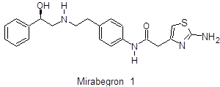
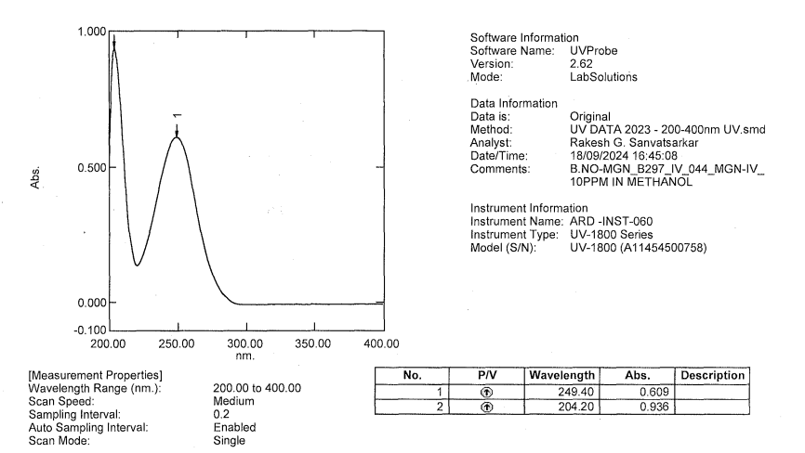

Figure S-1. UV spectra of Mirabegron 1.

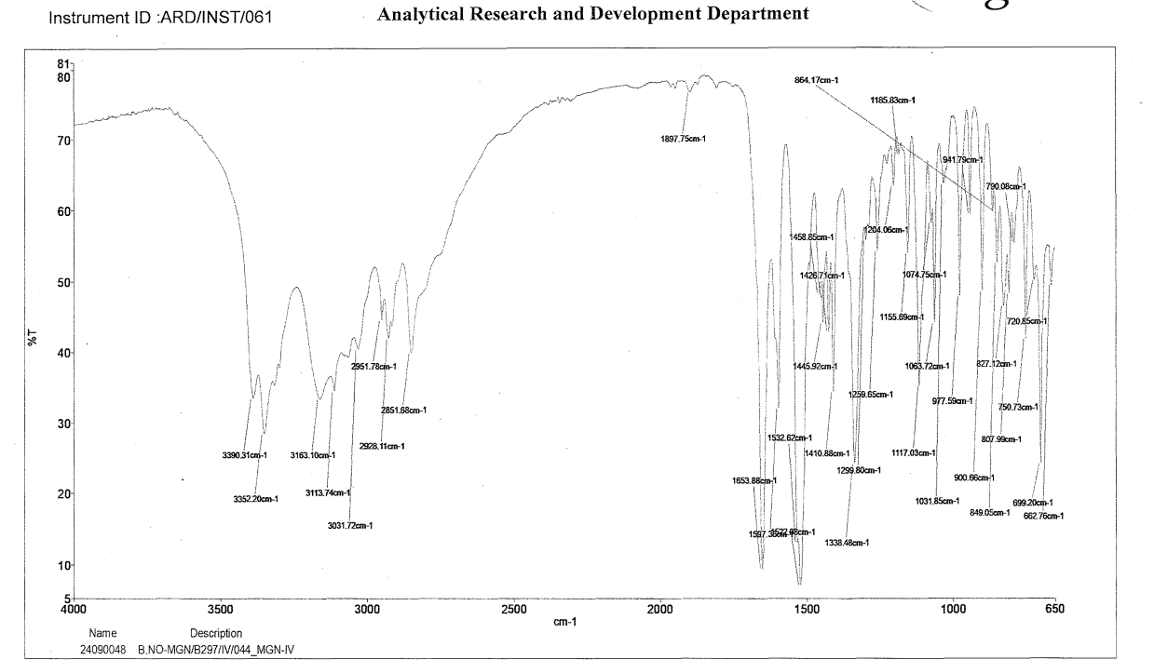
Figure S-2. IR spectra of Mirabegron 1.

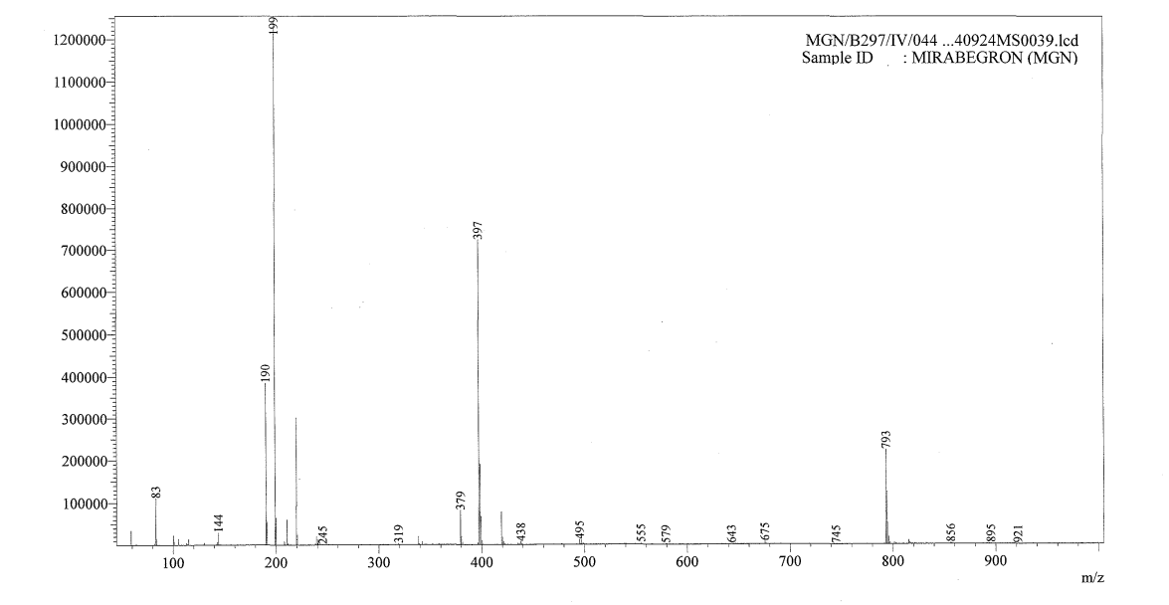

Figure S-3. UV spectra of Mirabegron 1.

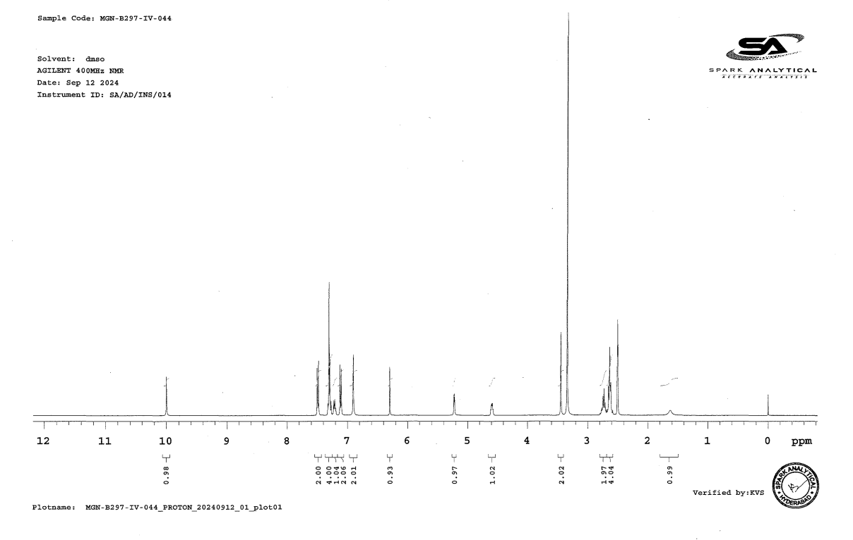

Figure S-4A. ¹H-NMR spectra of Mirabegron 1.

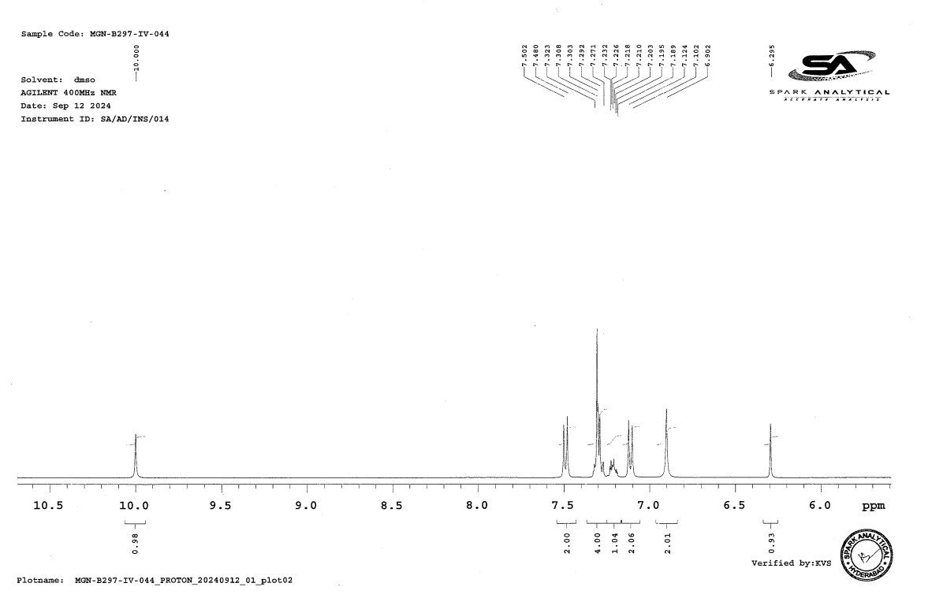
Figure S-4B. ¹H-NMR spectra of Mirabegron 1.

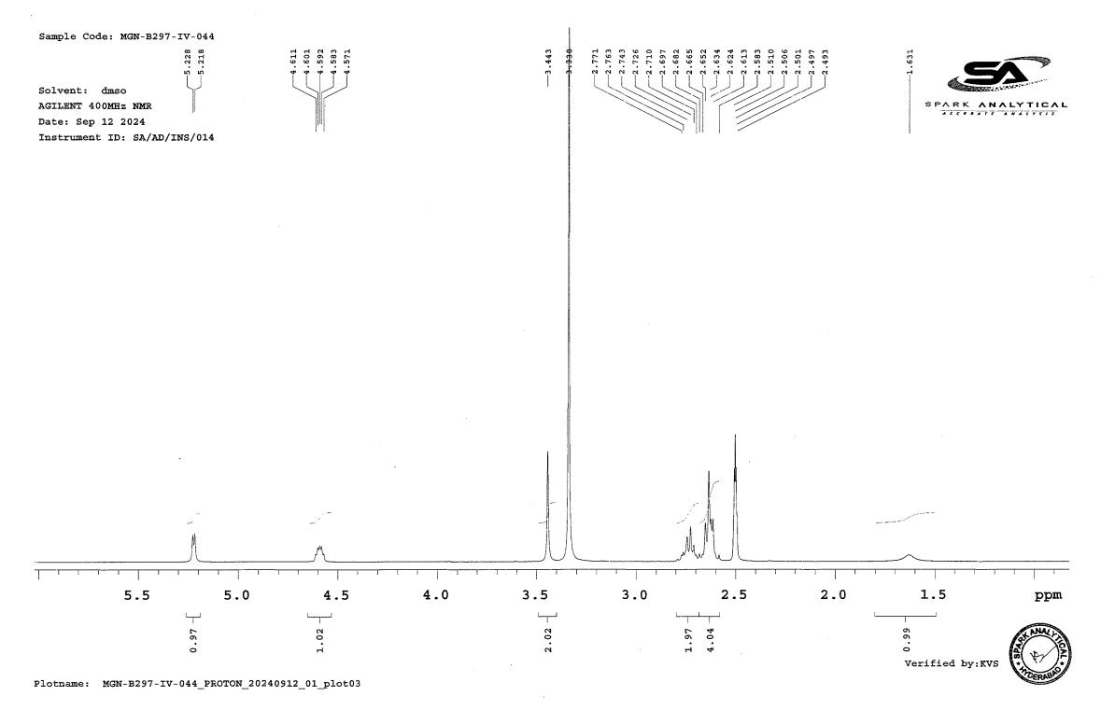

Figure S-4C. ¹H-NMR spectra of Mirabegron 1.
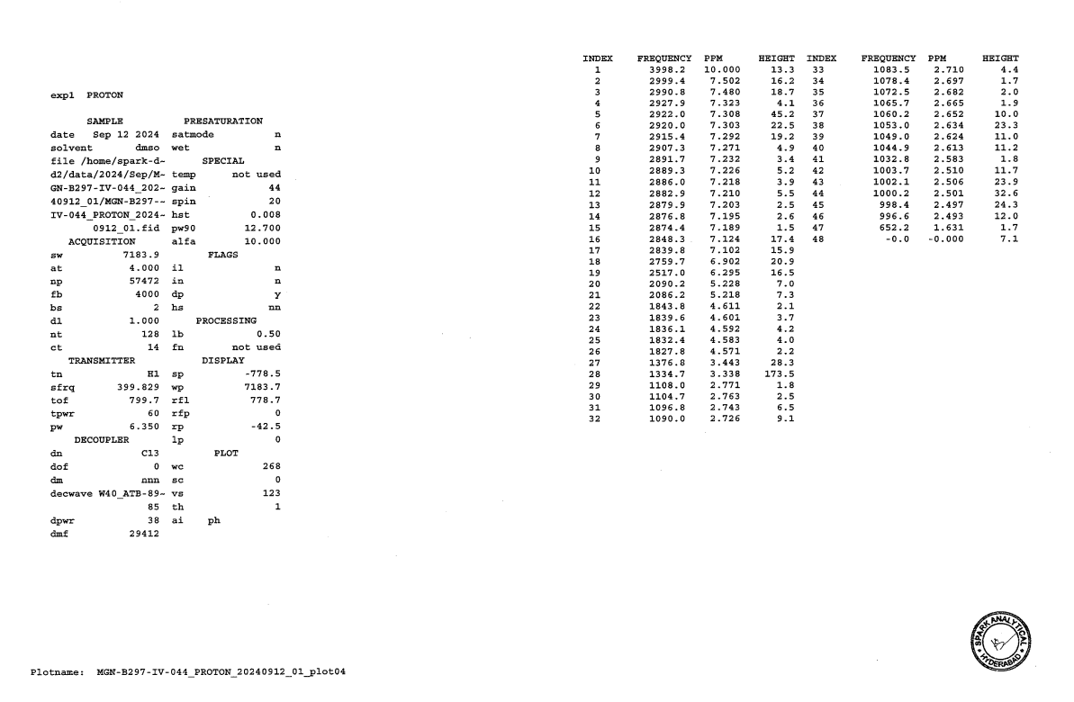
Figure S-4D. ¹H-NMR spectra of Mirabegron 1.

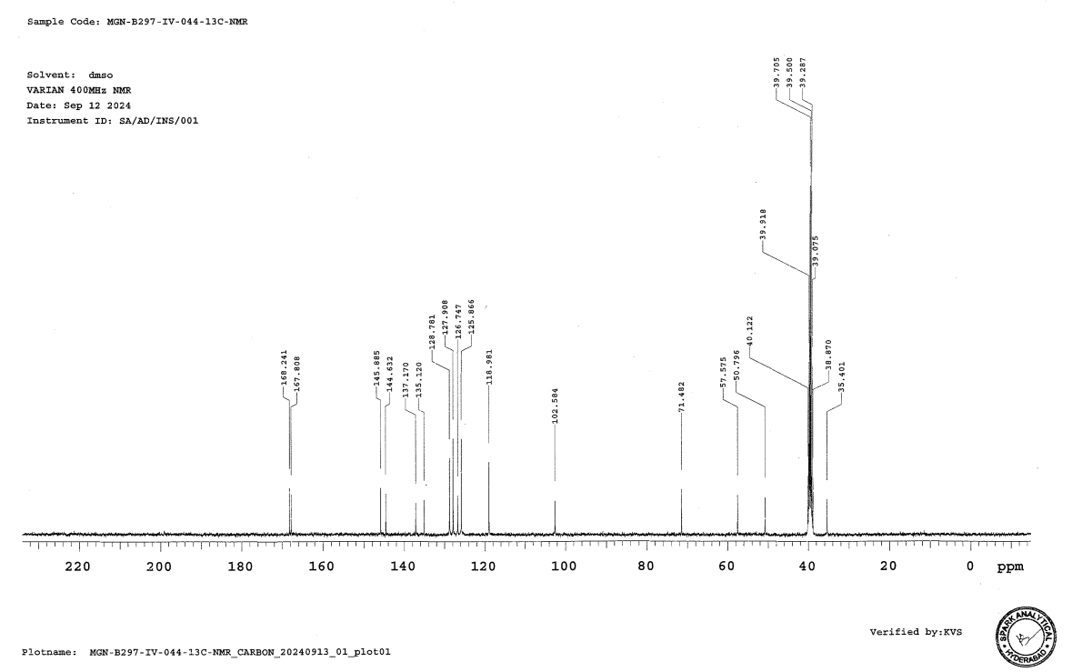
Figure S-5A. ¹³C-NMR spectra of Mirabegron 1.

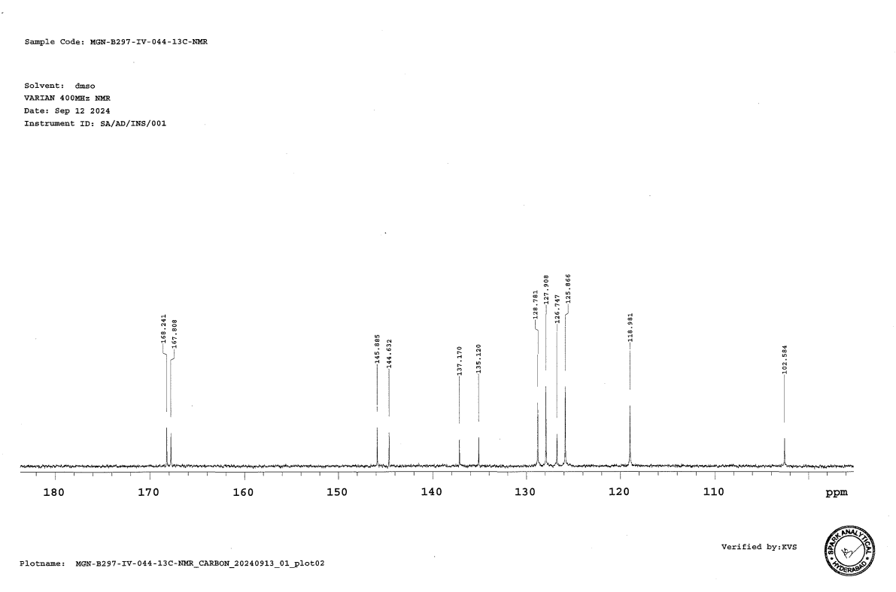
Figure S-5B. ¹³C-NMR spectra of Mirabegron 1.
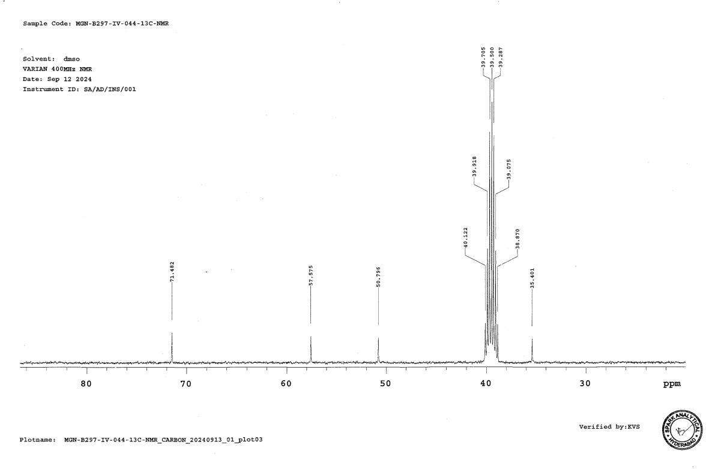
Figure S-5C. ¹³C-NMR spectra of Mirabegron 1.

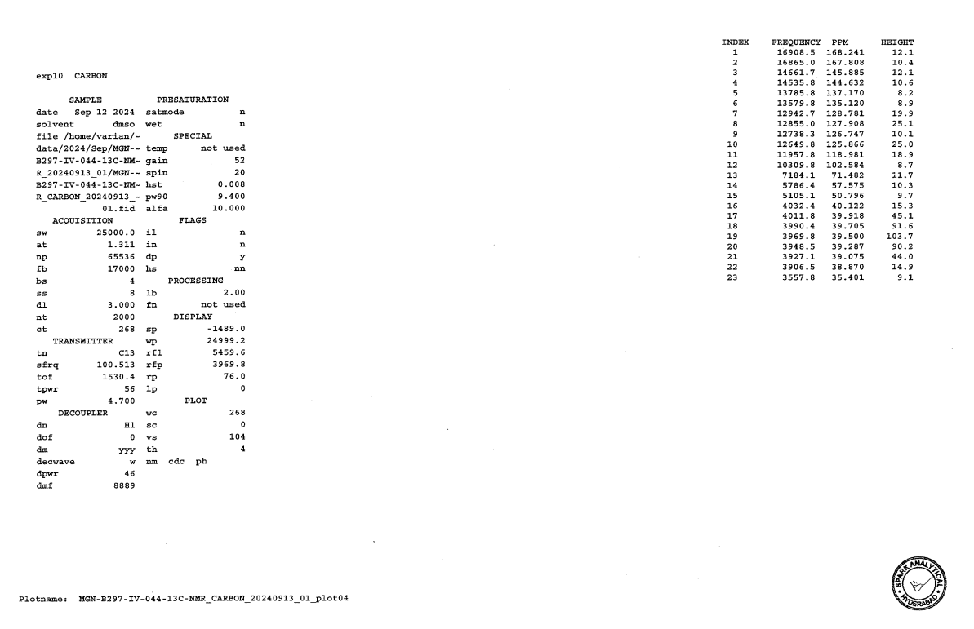
Figure S-5D. ¹³C-NMR spectra of Mirabegron 1.

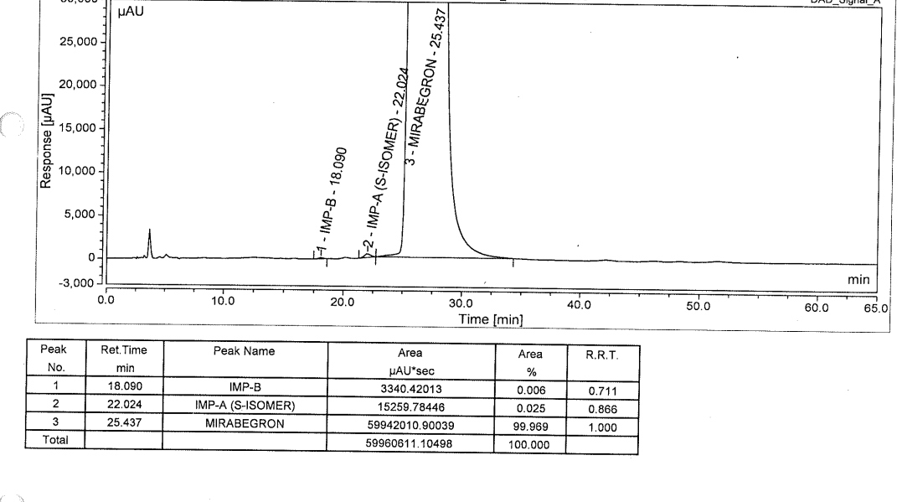
Figure S-6. Chiral purity by HPLC chromatograph of Mirabegron 1.

- S-isomer of Mirabegron1:

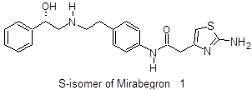
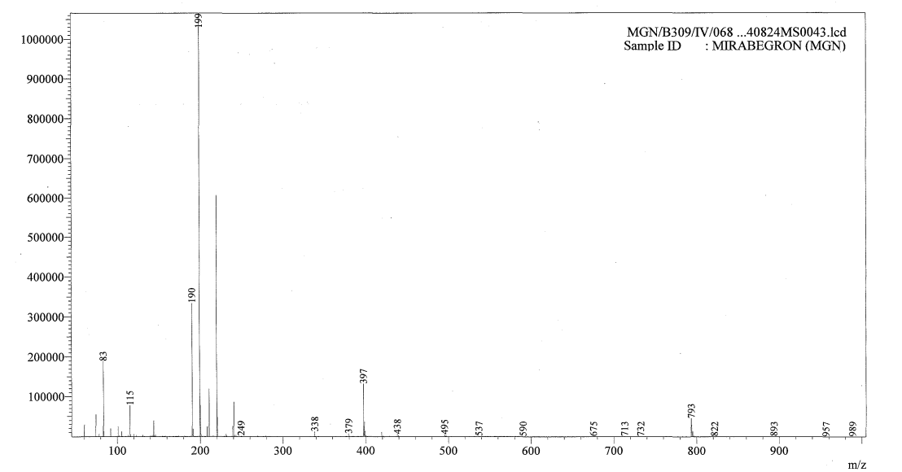
Figure S-7. Mass spectra of S-Mirabegron 1.

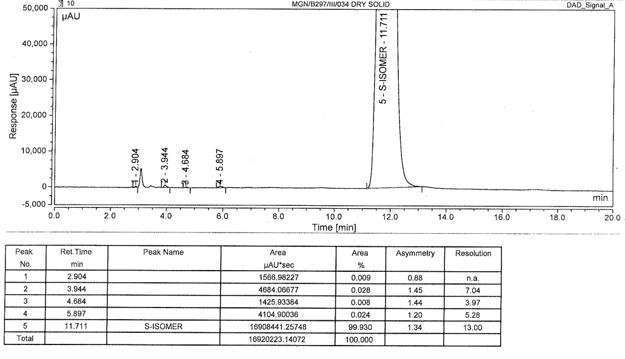
Figure S-8. Chiral purity by HPLC chromatograph of S-Mirabegron 1.

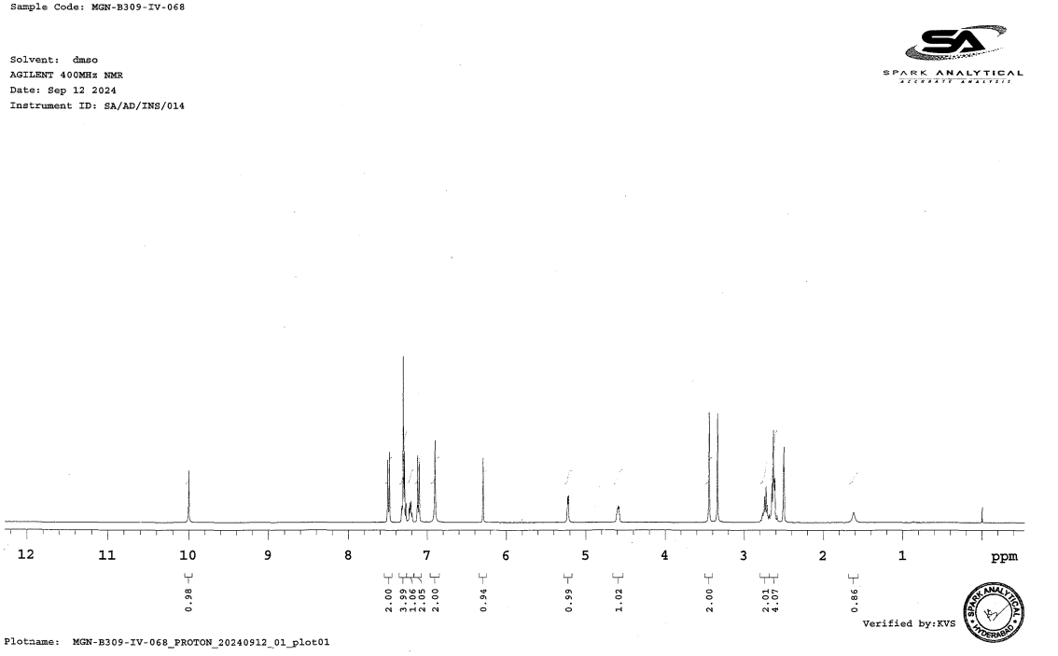
Figure S-9A. ¹H-NMR Spectra of S-Mirabegron 1.

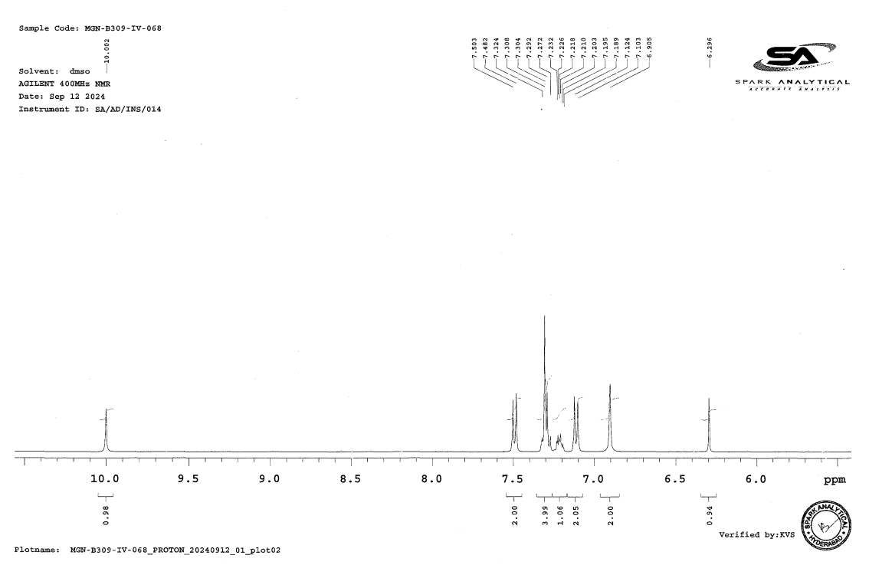
Figure S-9B. ¹H-NMR Spectra of S-Mirabegron 1.

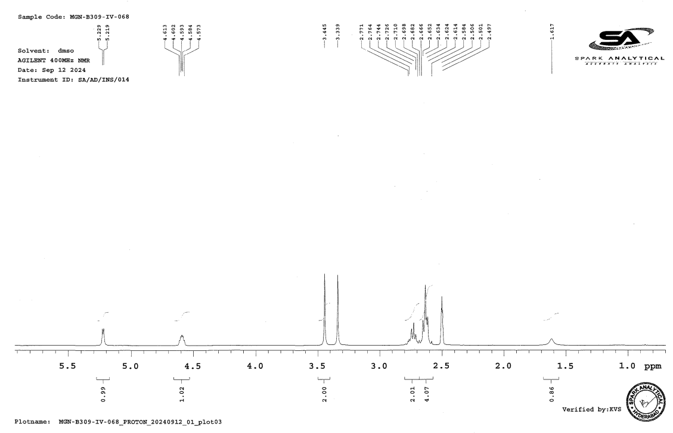
Figure S-9C. ¹H-NMR Spectra of S-Mirabegron 1.

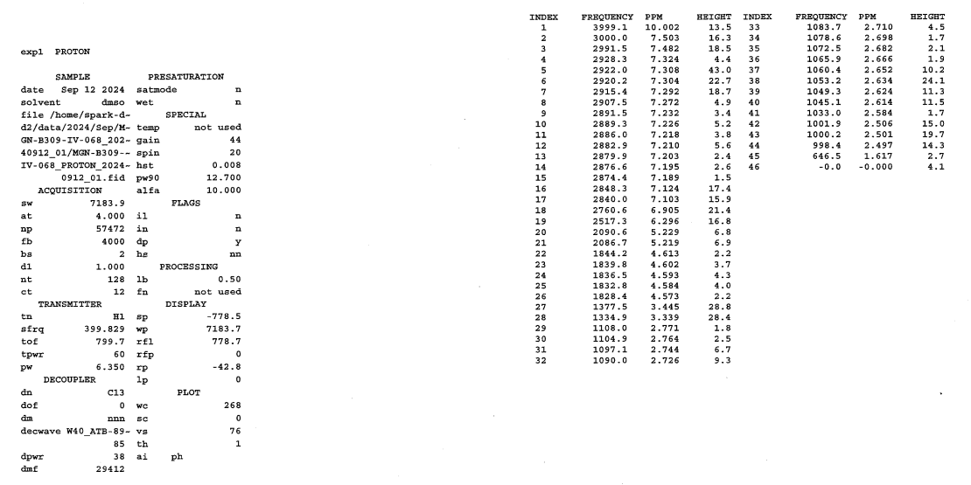
Figure S-9D. ¹H-NMR Spectra of S-Mirabegron 1.

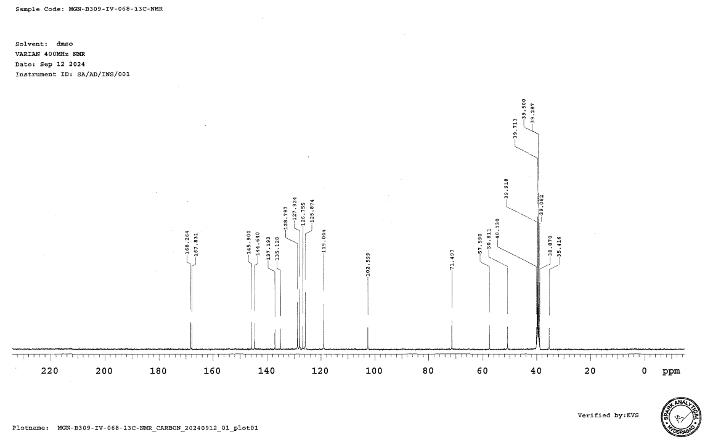
Figure S-10A. ¹³C-NMR Spectra of S-Mirabegron 1.

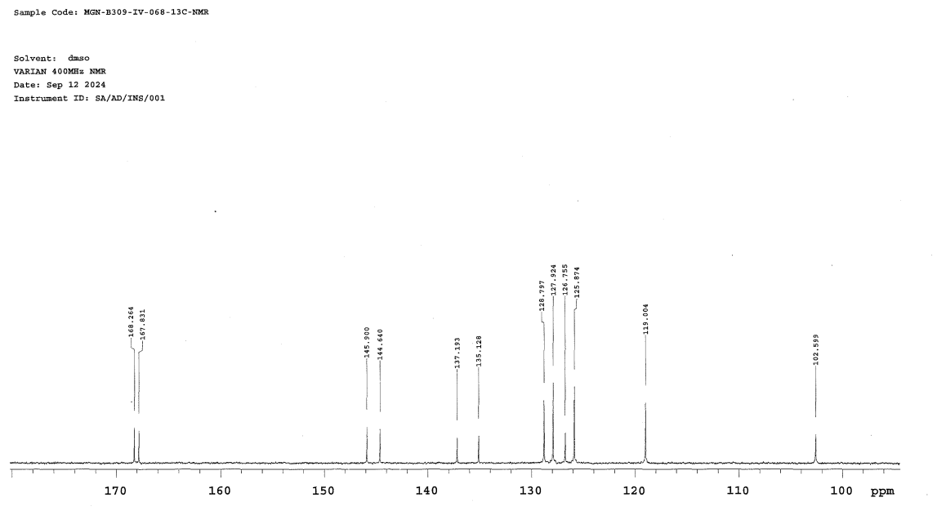
Figure S-10B. ¹³C-NMR Spectra of S-Mirabegron 1.

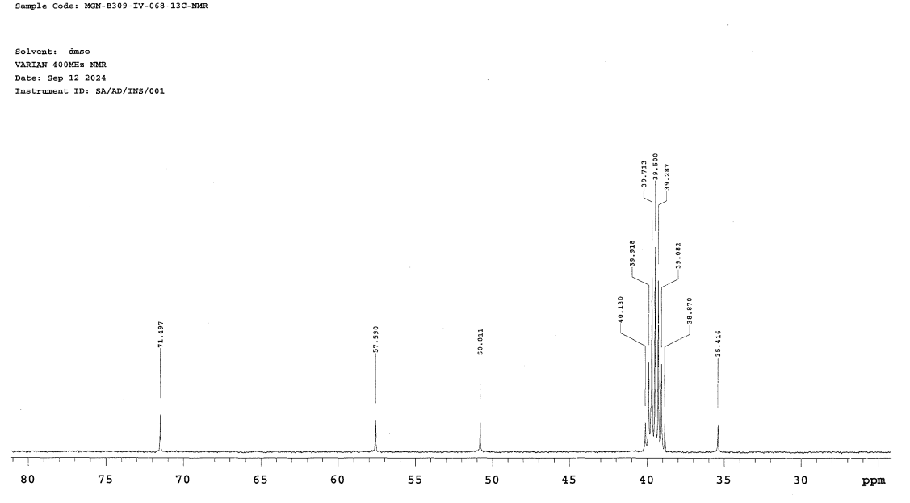
Figure S-10C. ¹³C-NMR Spectra of S-Mirabegron 1.

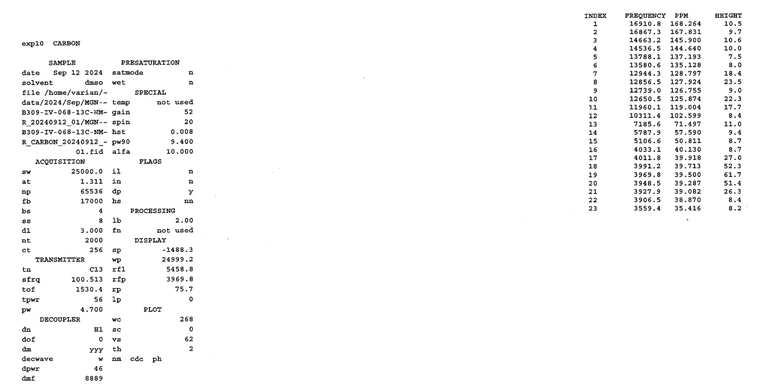
Figure S-10D. ¹³C-NMR Spectra of S-Mirabegron 1.

- Compound 4.

- UV:

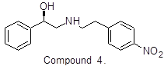
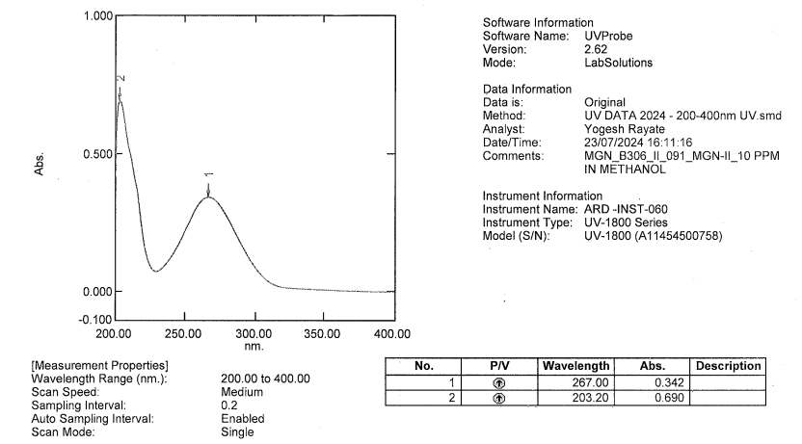
Figure S-11. UV Spectra of Compound 4.

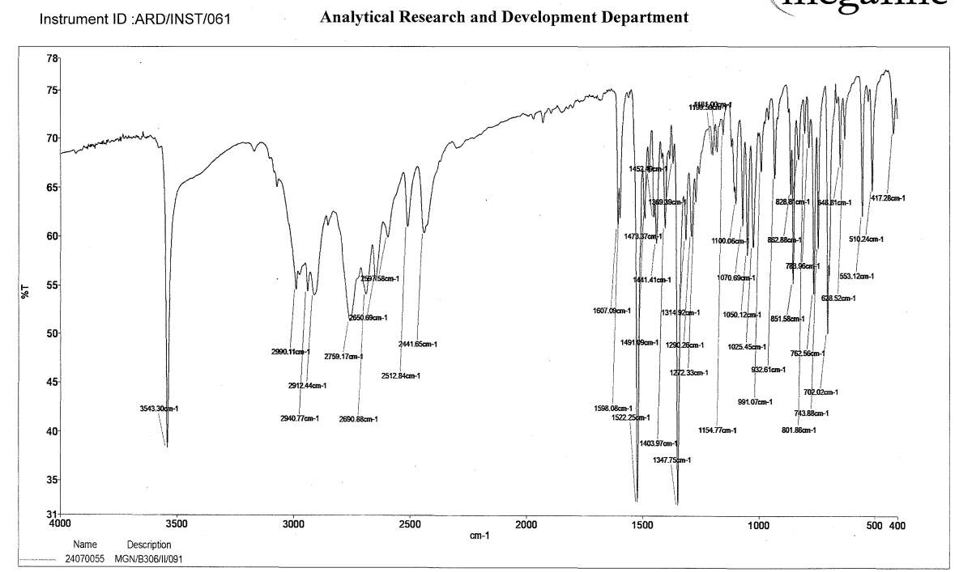
Figure S-12. IR Spectra of Compound 4.

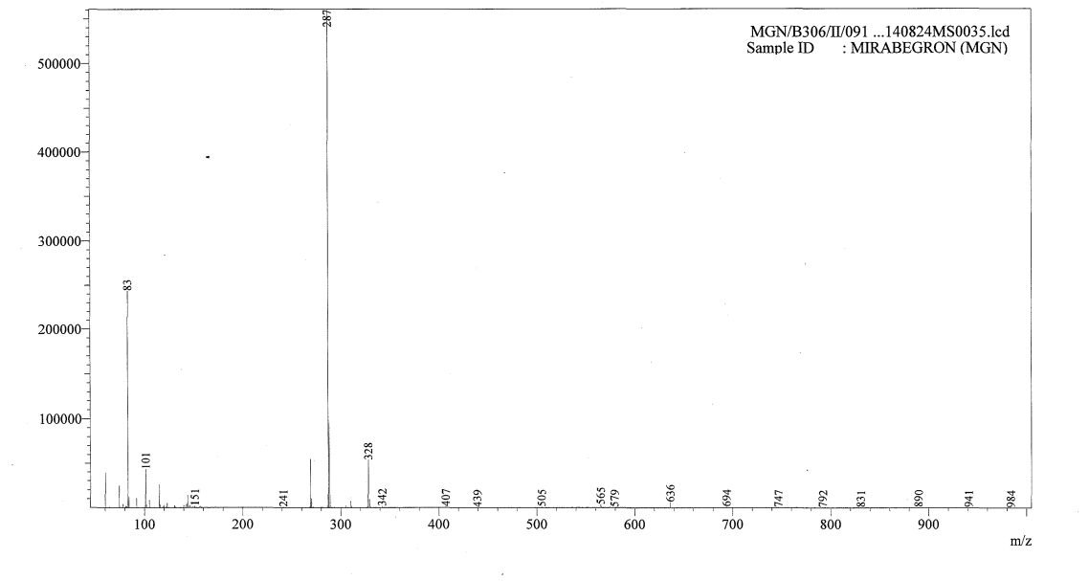
Figure S-13. Mass Spectra of Compound 4.

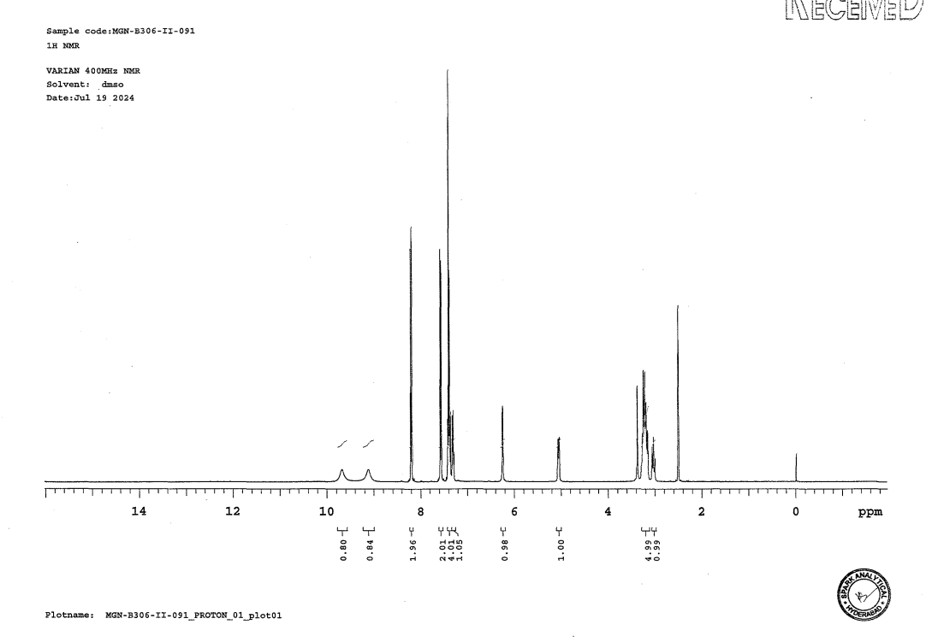 Figure S-14A. ¹H-NMR Spectra of Compound 4.

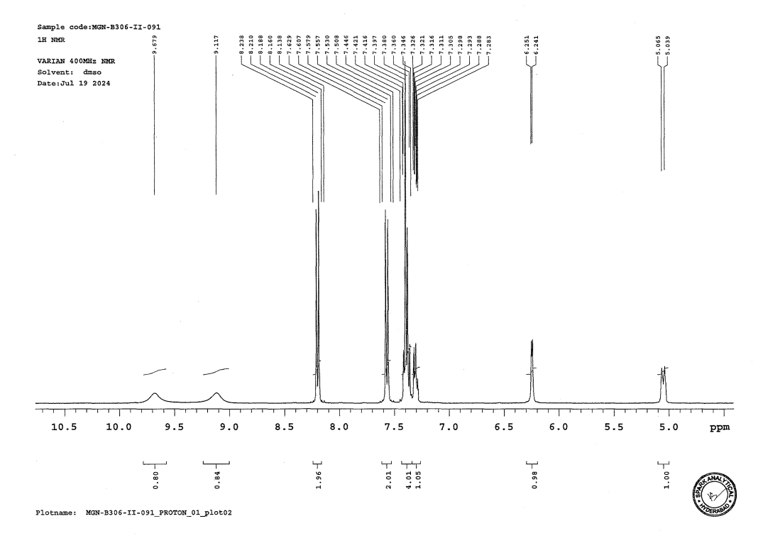
Figure S-14B. ¹H-NMR Spectra of Compound 4.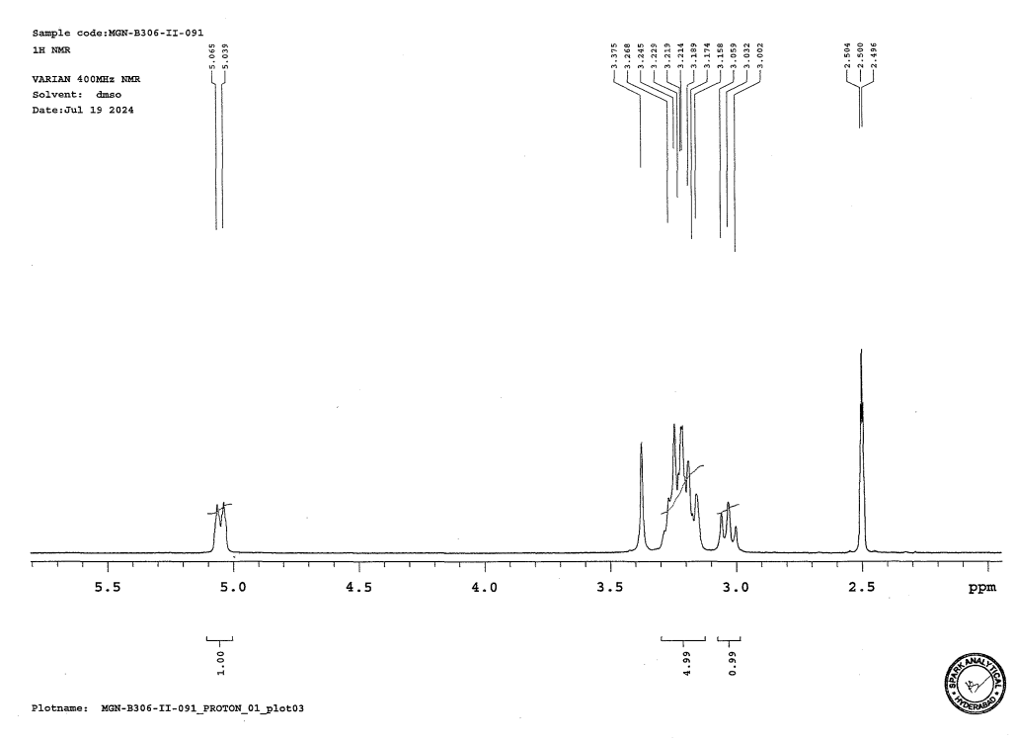
Figure S-14C. ¹H-NMR Spectra of Compound 4.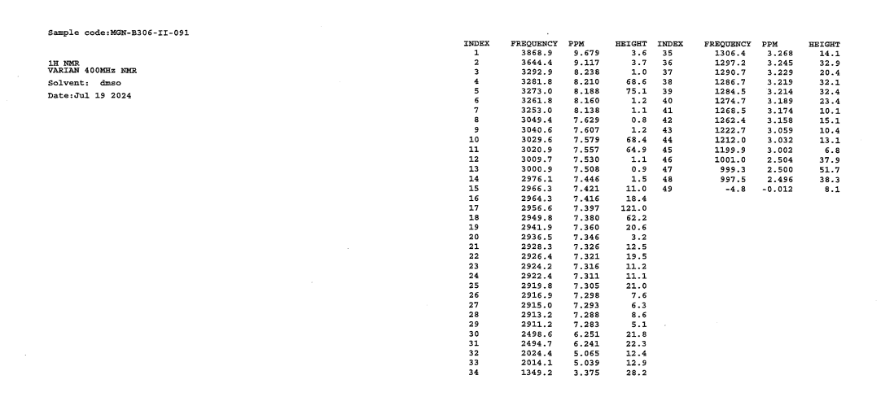
Figure S-14D. ¹H-NMR Spectra of Compound 4.

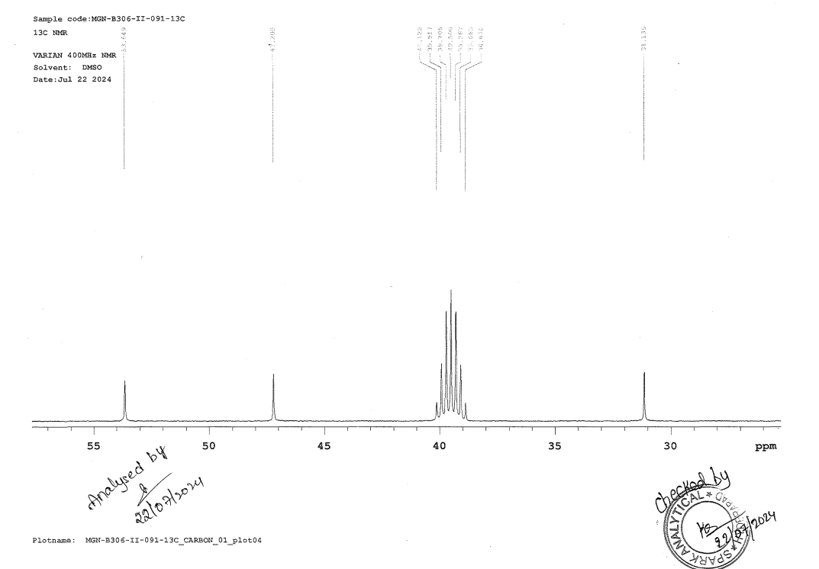
Figure S-15A. ¹³C-NMR Spectra of Compound 4.

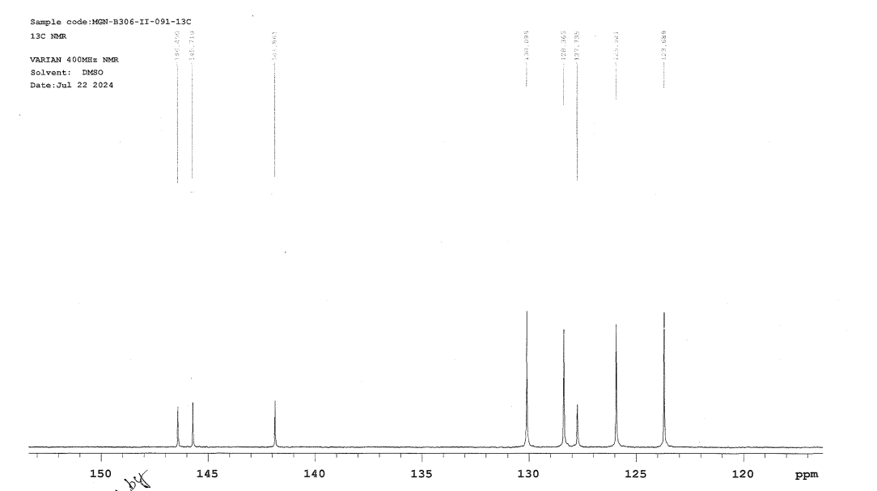
Figure S-15B. ¹³C-NMR Spectra of Compound 4.
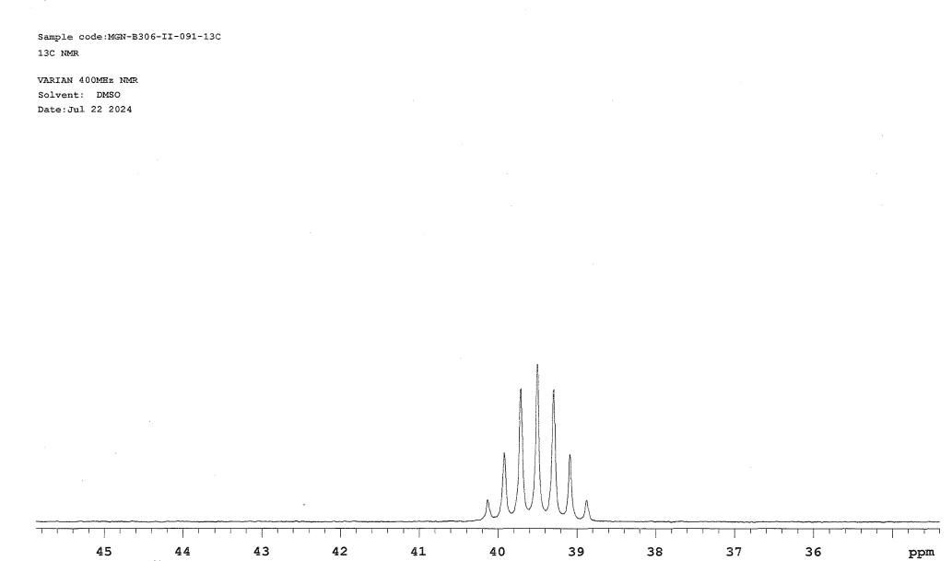
Figure S-15C. ¹³C-NMR Spectra of Compound 4.

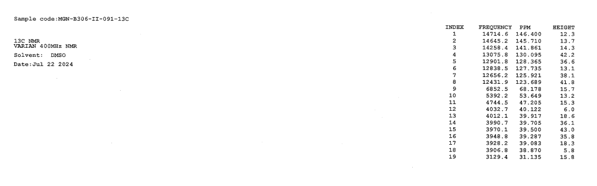
Figure S-15D. ¹³C-NMR Spectra of Compound 4.

- Compound 14 (diol impurity):

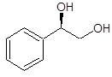
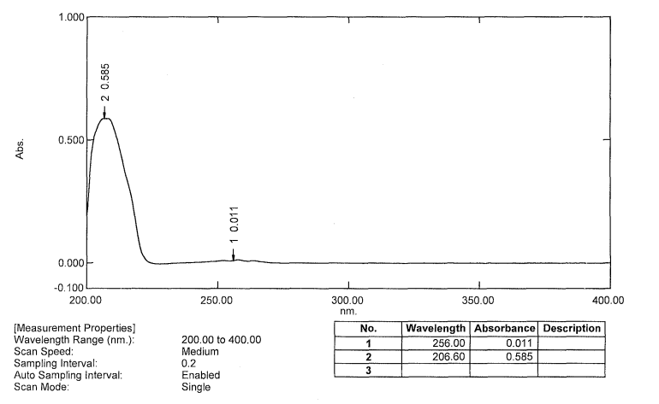
Figure S-16. UV Spectra of Compound 14.

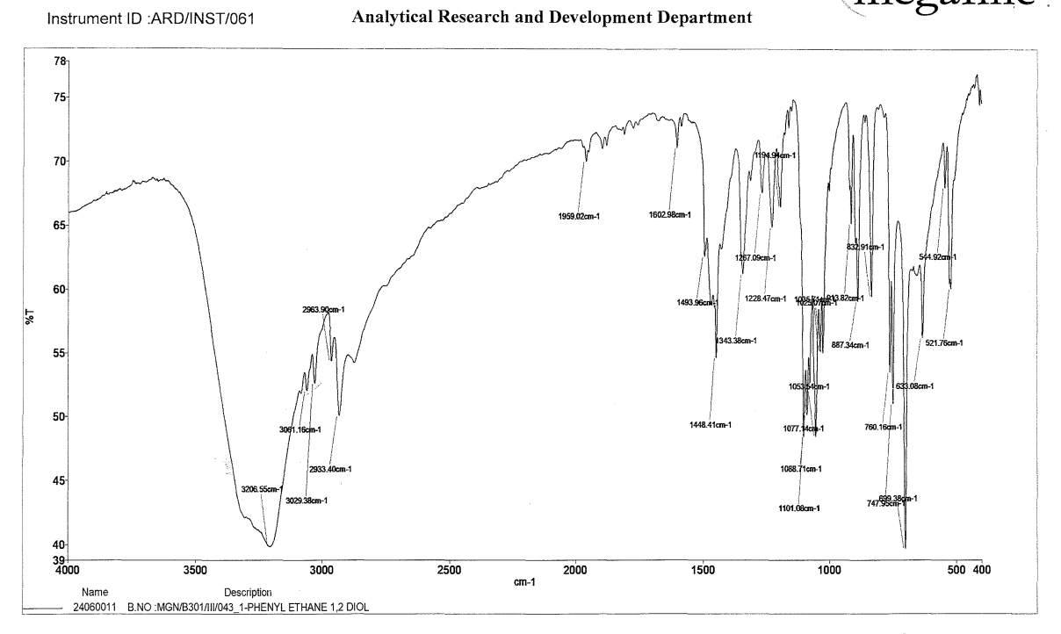
Figure S-17. IR Spectra of Compound 14.

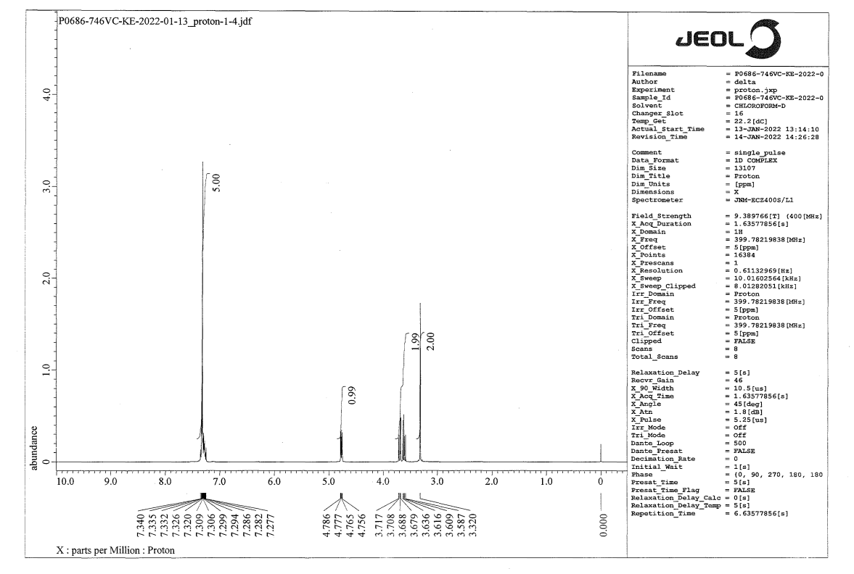
Figure S-18. ¹H-NMR Spectra of Compound 14.

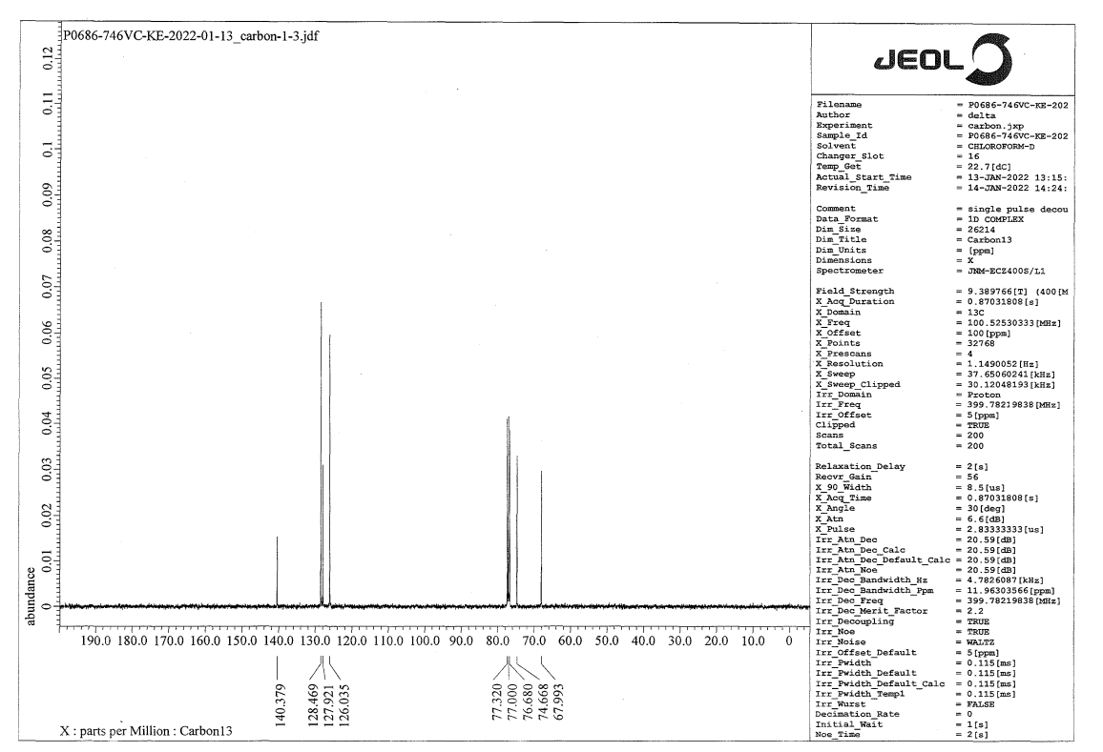
Figure S-19. ¹³C-NMR Spectra of Compound 14.

- Compound 10:

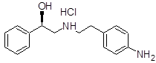
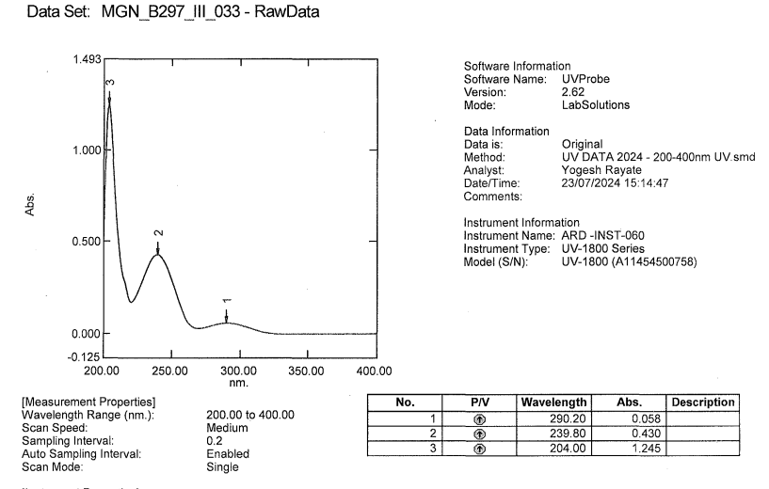
Figure S-20. UV Spectra of Compound 10.

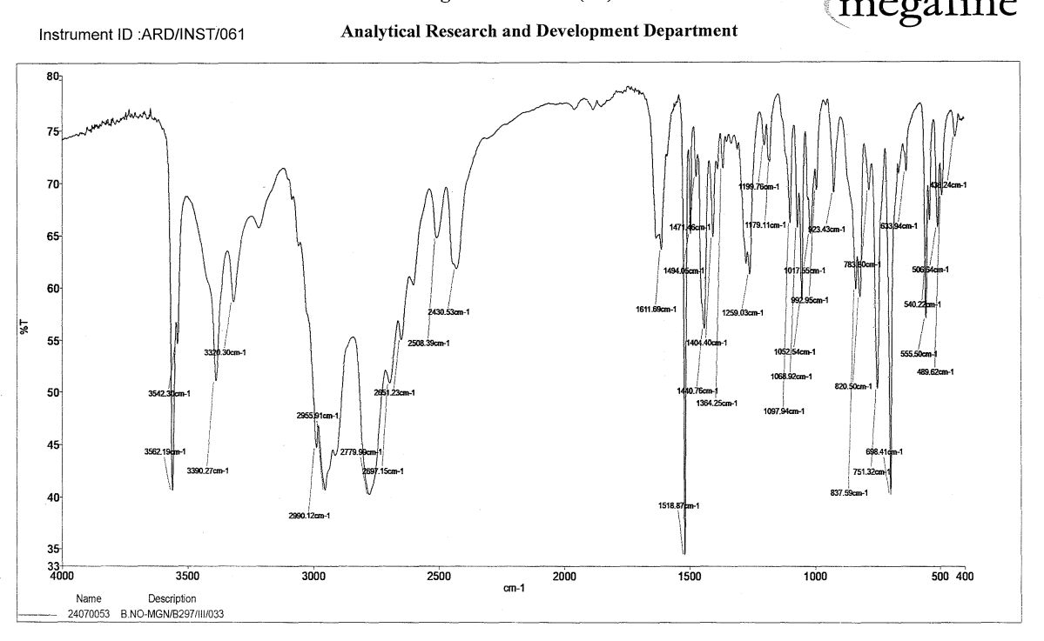
Figure S-21. IR Spectra of Compound 10.

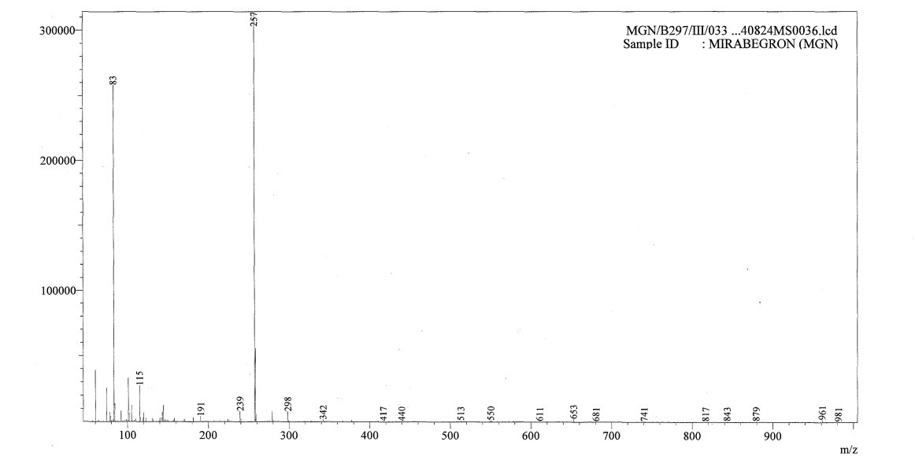
Figure S-22. Mass Spectra of Compound 10.

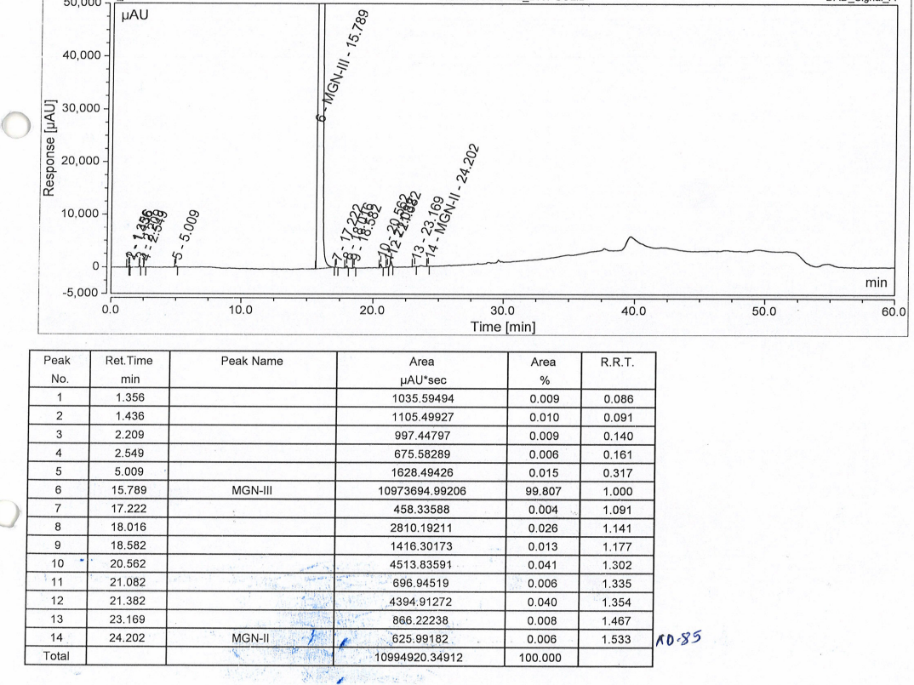
Figure S-23. Purity by HPLC Cromatograph of Compound 10.

- CHIRAL PURITY:
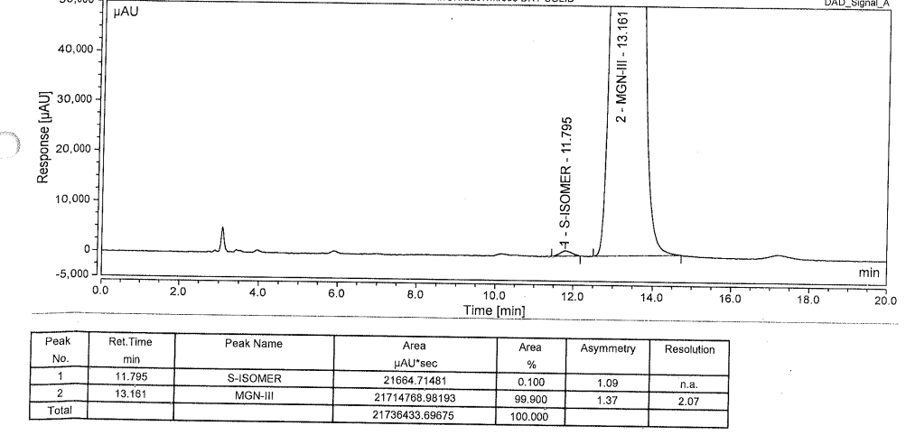

Figure S-24. Chiral Purity by HPLC Chromatograph of Compound 10.
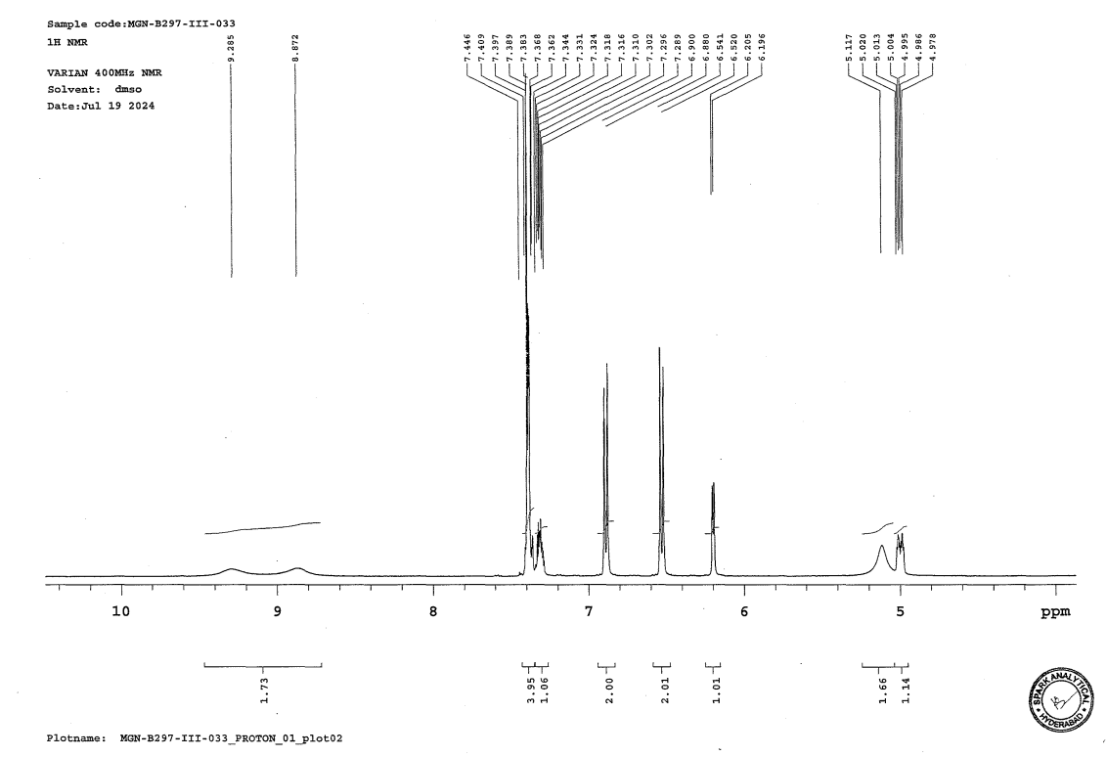
Figure S-24A. ¹H-NMR Spectra of Compound 10.

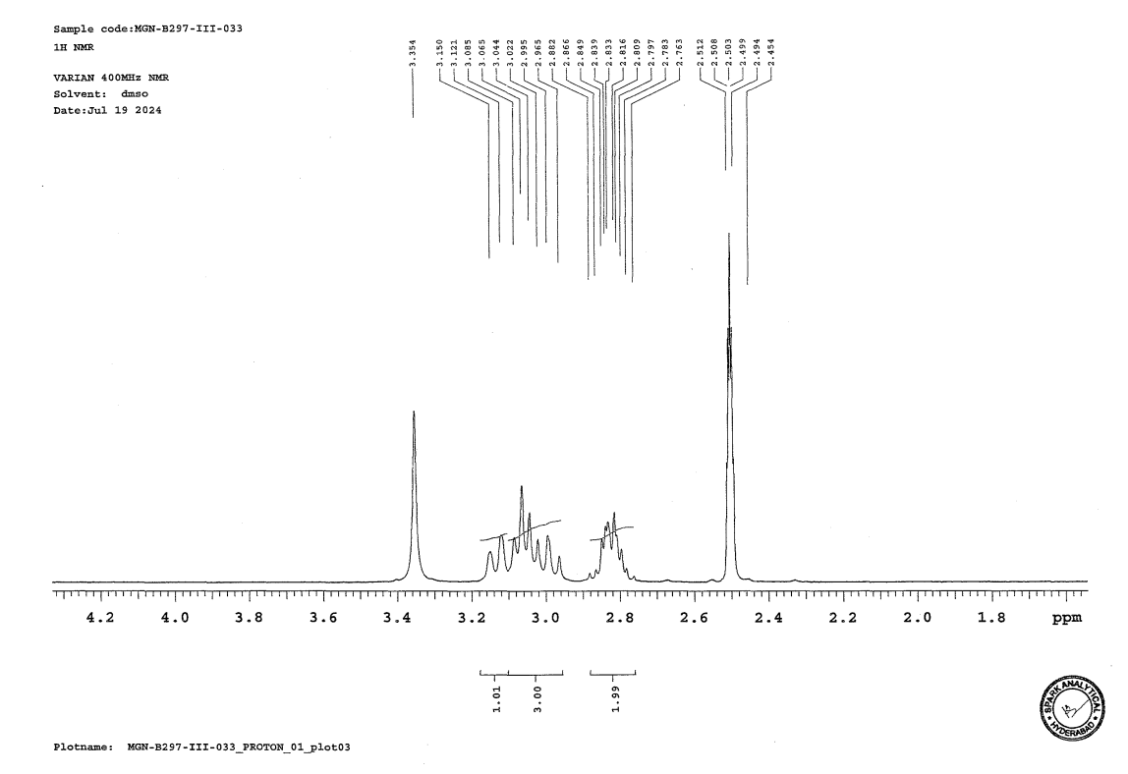

Figure S-24B. ¹H-NMR Spectra of Compound 10.

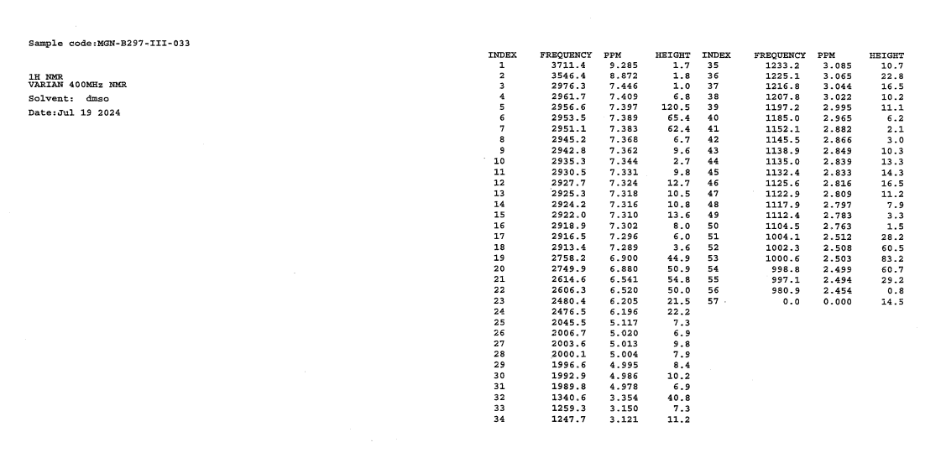
Figure S-24C. ¹H-NMR Spectra of Compound 10.

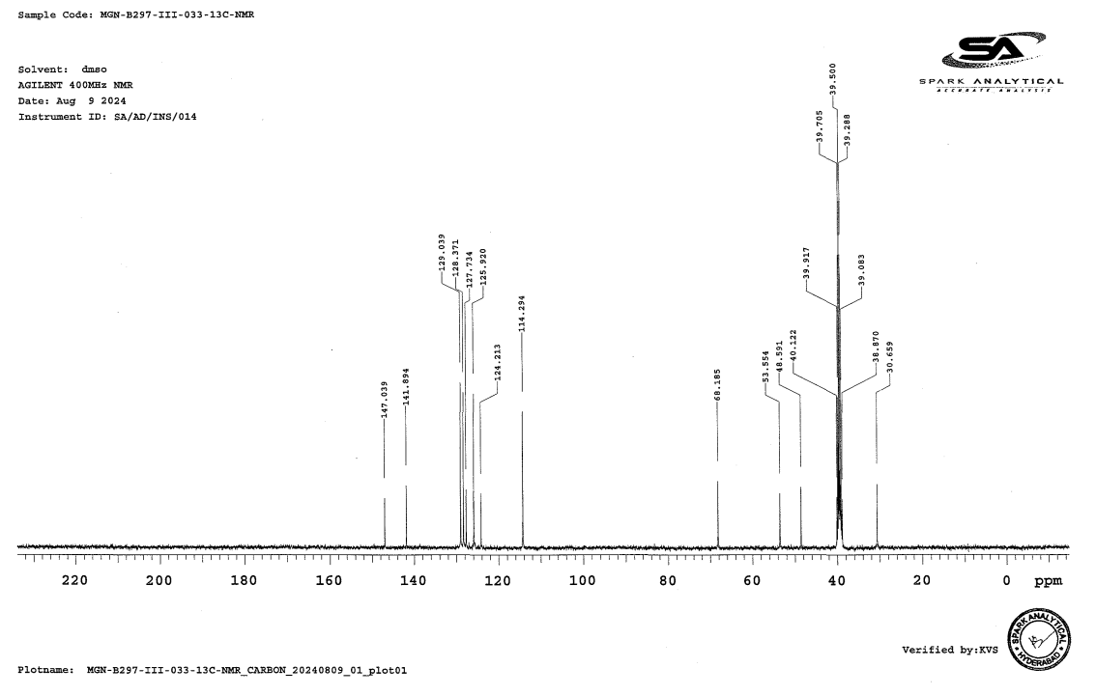
Figure S-25A. ¹³C-NMR Spectra of Compound 10.

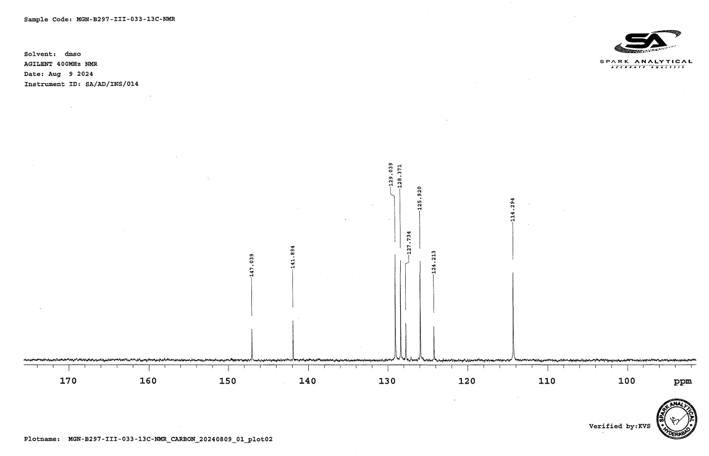
Figure S-25B. ¹³C-NMR Spectra of Compound 10.

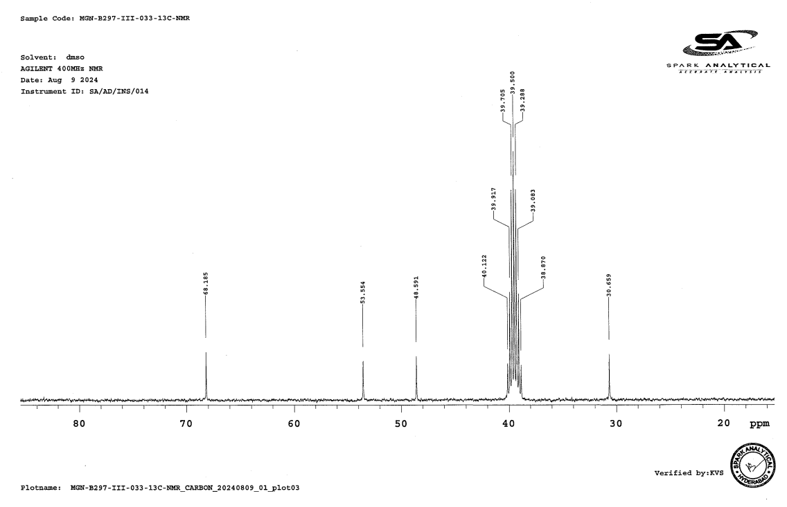
Figure S-25C. ¹³C-NMR Spectra of Compound 10.
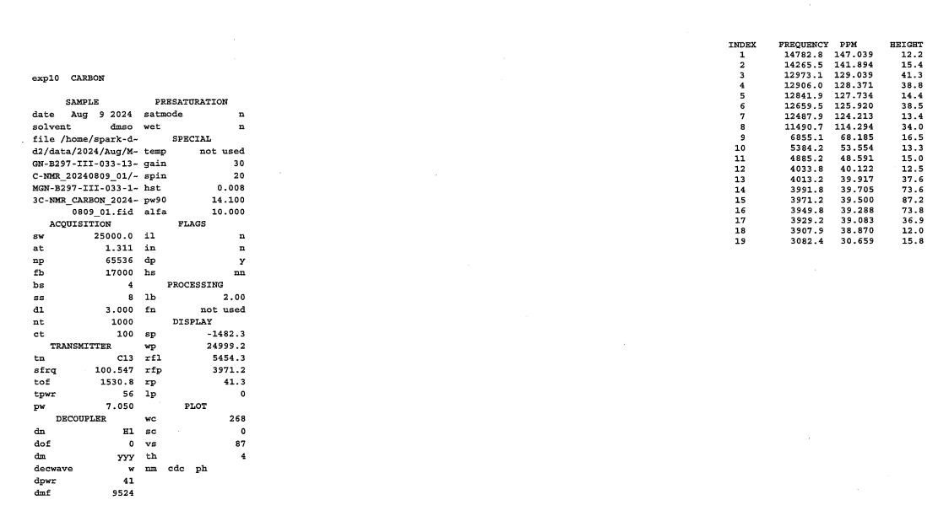
Figure S-25C. ¹³C-NMR Spectra of Compound 10.

- S-isomer of Compound 10:

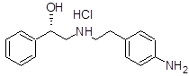
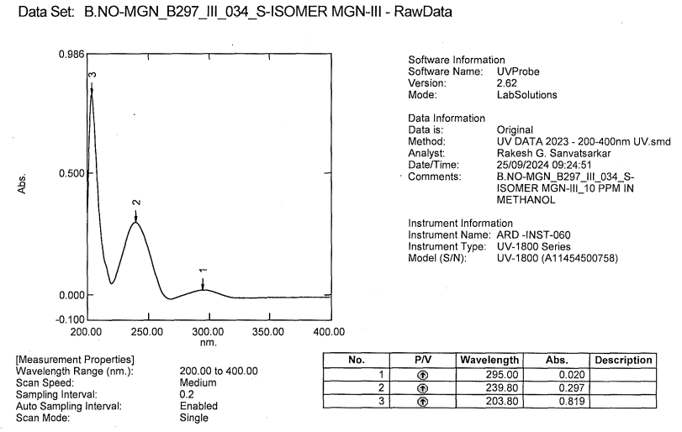
Figure S-26. UV Spectra of S-isomer of Compound 10.

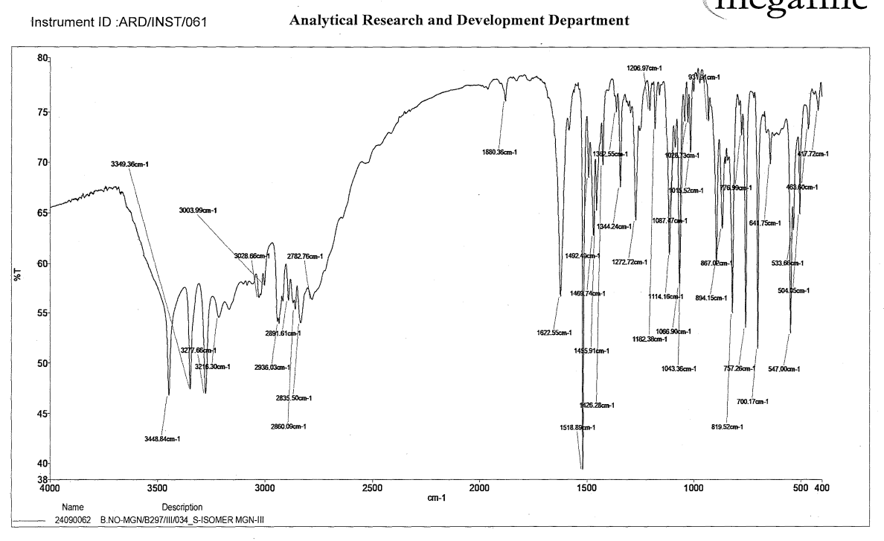
Figure S-27. IR Spectra of S-isomer of Compound 10.

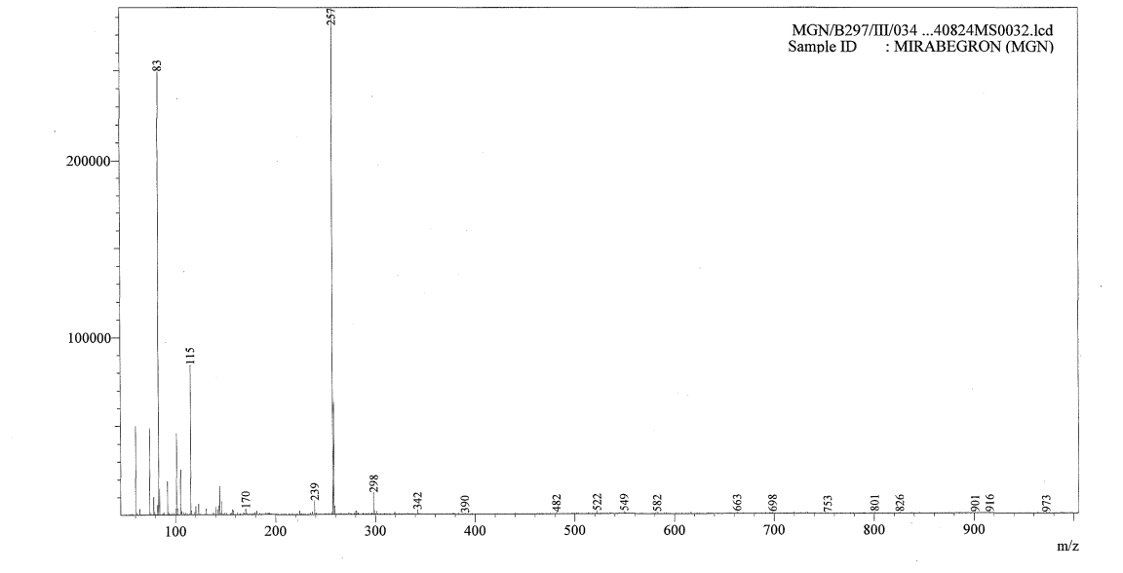
Figure S-28. Mass Spectra of S-isomer of Compound 10.

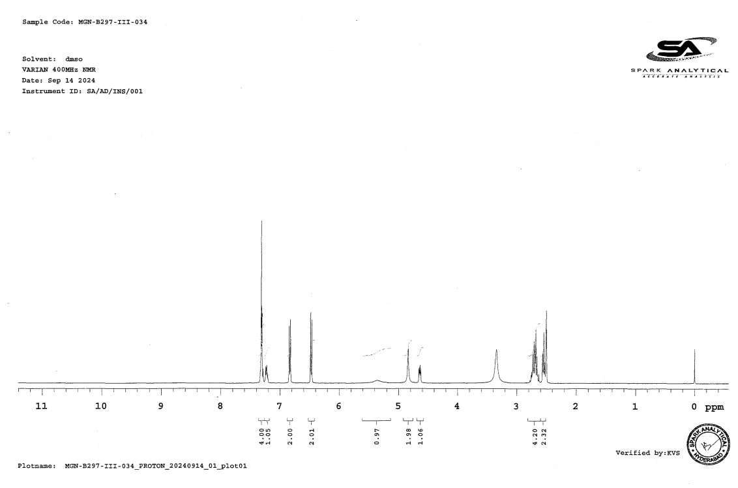
Figure S-29A. ¹H-NMR Spectra of S-isomer of Compound 10.

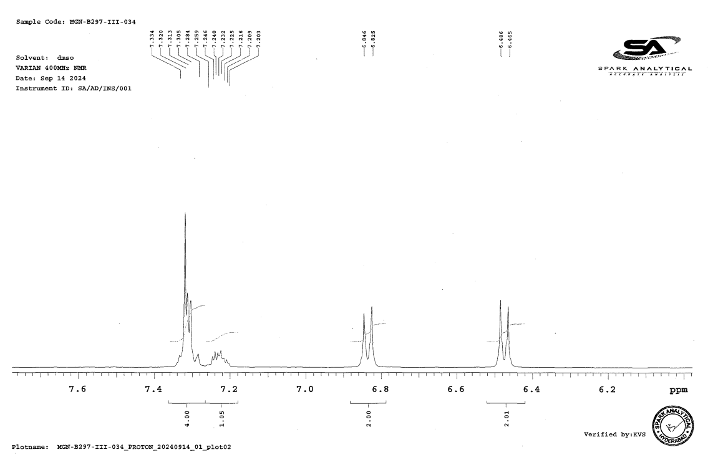
Figure S-29B. ¹H-NMR Spectra of S-isomer of Compound 10.

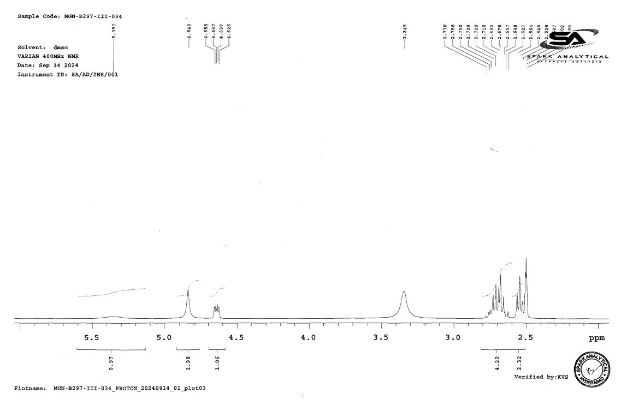
Figure S-29C. ¹H-NMR Spectra of S-isomer of Compound 10.

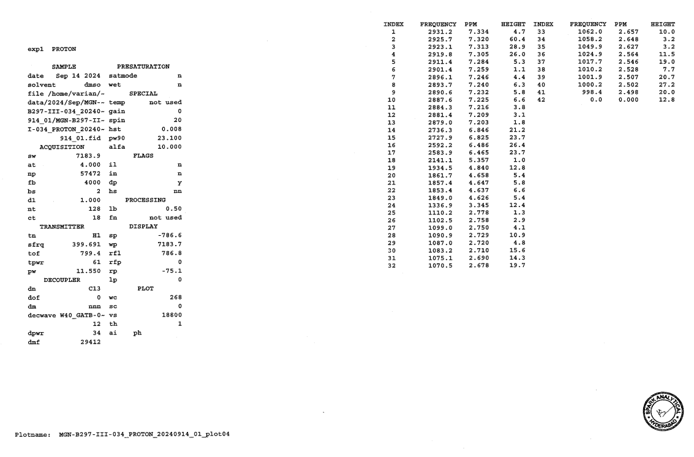
Figure S-29D. ¹H-NMR Spectra of S-isomer of Compound 10.

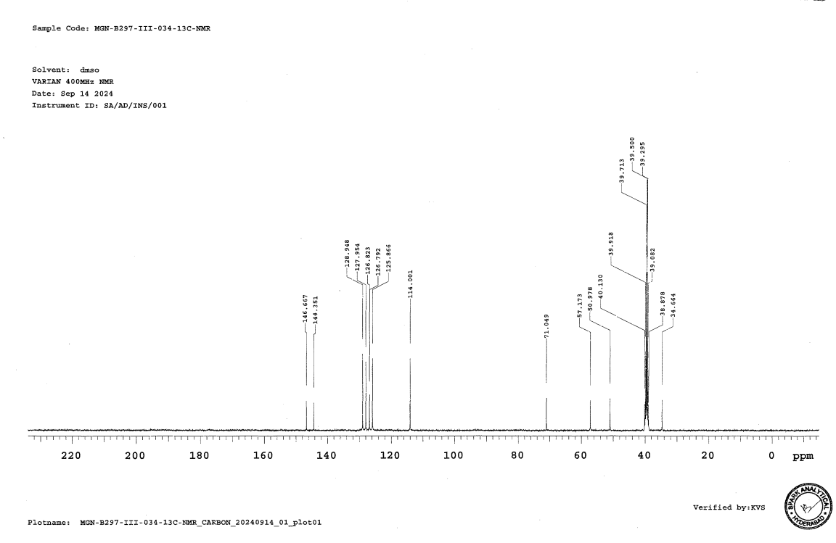
Figure S-30A. ¹³C-NMR Spectra of S-isomer of Compound 10.

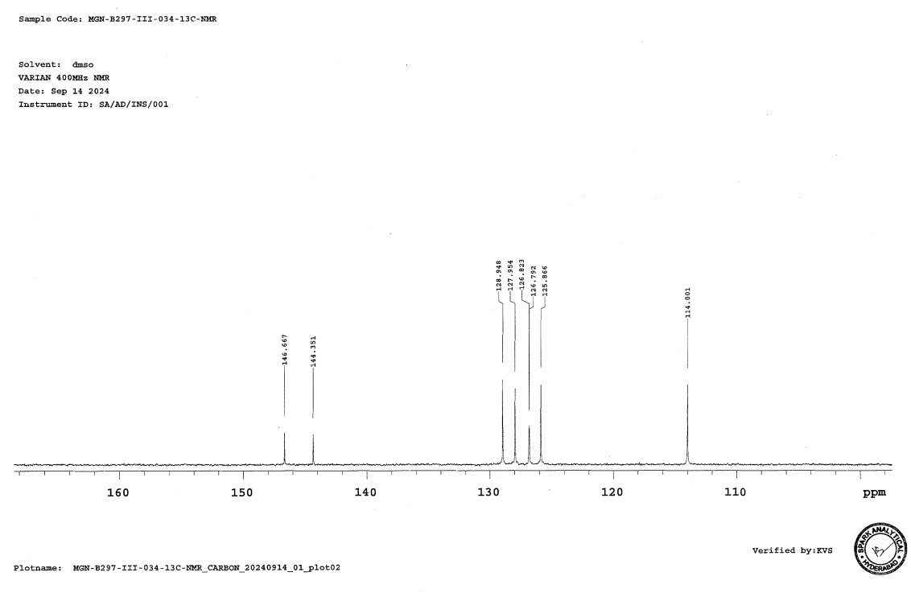
Figure S-30B. ¹³C-NMR Spectra of S-isomer of Compound 10.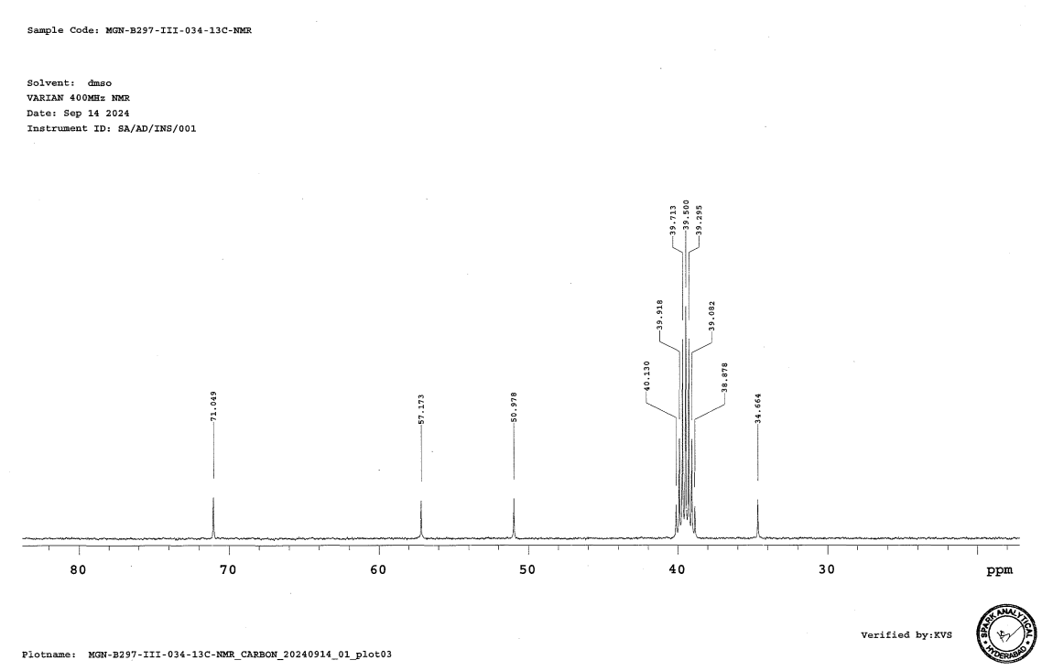

Figure S-30C. ¹³C-NMR Spectra of S-isomer of Compound 10.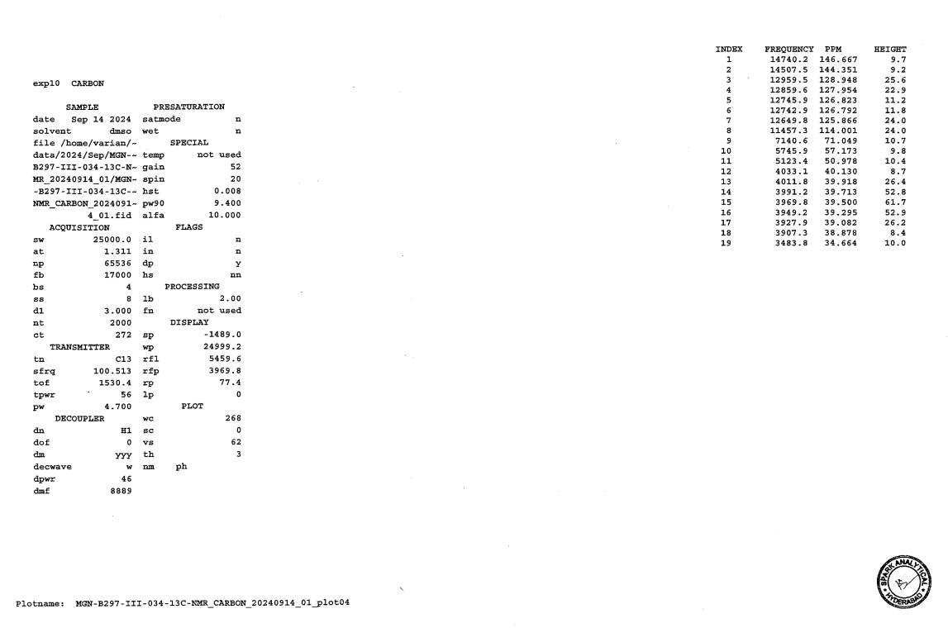
Figure S-30D. ¹³C-NMR Spectra of S-isomer of Compound 10.

- Gentoxic reports by DEREK & SARAH nexus:

8.1 Compound 9: Based on the report of GTIs by Derek & Sarah Nexus, compound 9 is considered as class 3 potential genotoxic impurity.
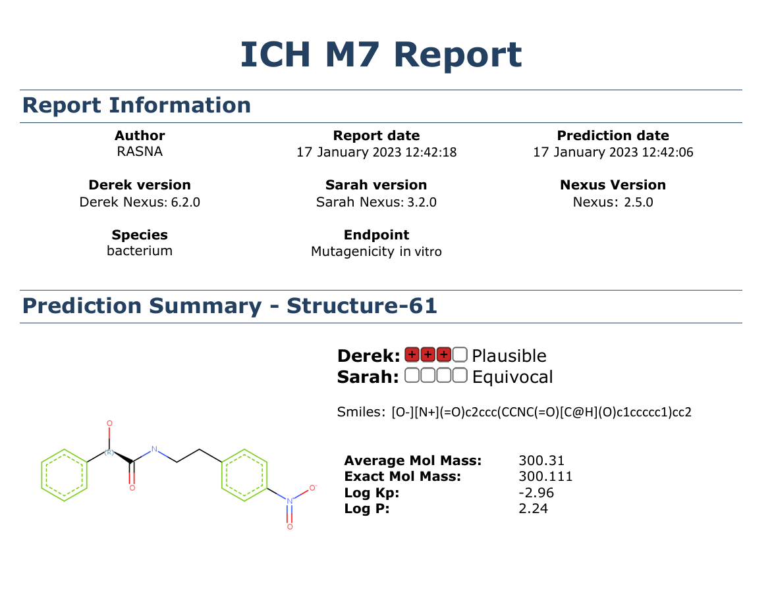
Figure S-31. GTIs report Derek & Sarah Nexus report for compound 9.

8.2 Compound 4: Based on the report of GTIs by Derek & Sarah Nexus, compound 4 is considered as class 3 potential genotoxic impurity.

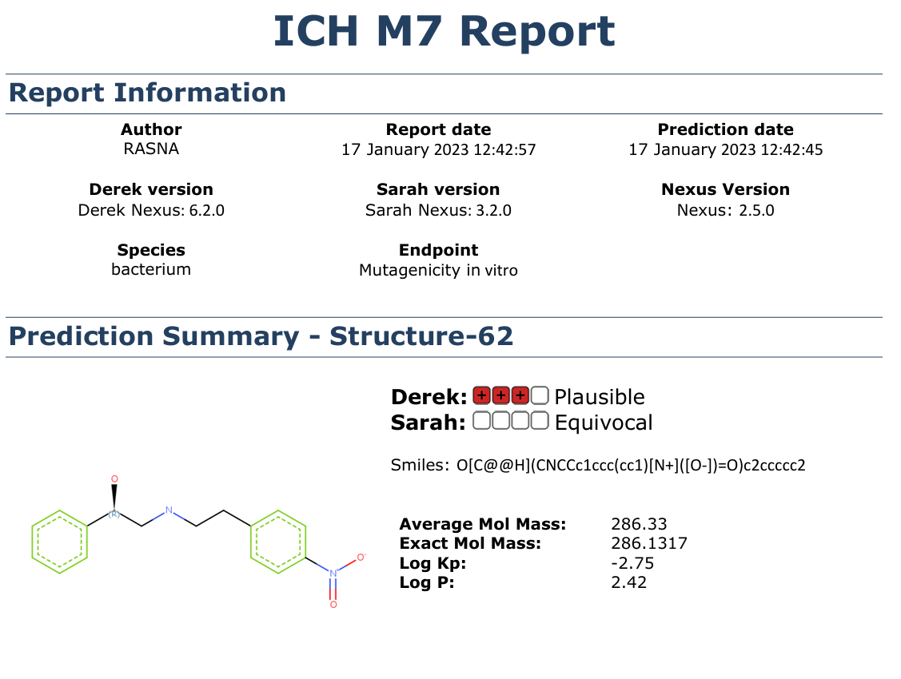
Figure S-32. GTIs report Derek & Sarah Nexus report for compound 4.

  - Diol impurity (14): Based on the report of GTIs by Derek & Sarah Nexus, compound 14 is considered as class 5 (non-genotoxic impurity).

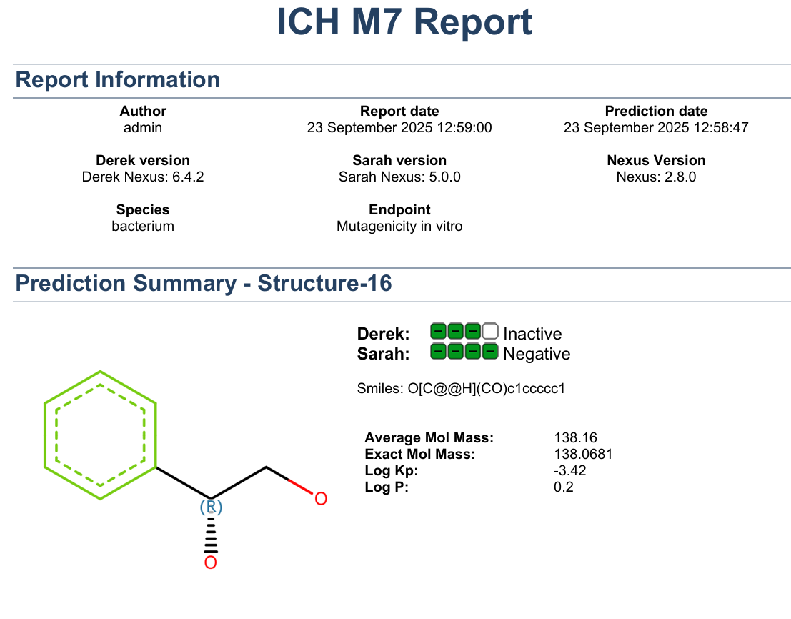
Figure S-33. GTIs report Derek & Sarah Nexus report for compound 14.

