Electronic Supplementary Material
Enhanced Sacrificial-Agent-Free Photocatalytic N₂ Reduction over a Co₃O₄/ZnS Heterojunction
Catalysis Letters
Shenbin Fu, Xinjie Wang, Zhengcheng Liu, Jiahui Hao, Wenjing Li, Xinchang Chen, Jiajun Li and Qikun Zhang*
College of Chemistry, Chemical Engineering and Materials Science, State Key Laboratory of Fluorine-Containing Functional Membrane Materials, Shandong Normal University, Jinan 250014, P. R. China
*Corresponding author: zhangqk@sdnu.edu.cn
S1. Supplementary Experimental Setup, Instrumentation, and Reaction Conditions
Table S1 Supplementary reaction setup and operating conditions
Item | Supplementary information
Photocatalytic reactor | Quartz reactor; the reactor diameter was approximately 5.6 cm and the reaction-solution volume was 100 mL.
Light source | 300 W Xe lamp (CEL-HXF300, Beijing China Education Au-light Co., Ltd., China).
Reaction temperature | Maintained at approximately 25 °C by circulating cooling water.
Gases | High-purity N₂ and Ar (99.999%).
Upstream gas purification | Before entering the reactor, N₂ was passed through an upstream purification/absorption bottle containing 10 mL of absorption solution to reduce trace ammonia-containing contaminants in the gas feed.
Off-gas absorption | The reactor outlet was connected to an absorption bottle containing 100 mL of absorption solution to capture NH₃ potentially carried out by the gas stream and to minimize interference from ambient ammonia.
N₂ pre-purge | N₂ was introduced for 1 h before irradiation to remove residual air and establish sufficient contact between N₂ and the reaction system.
N₂ supply | N₂ was continuously introduced at approximately 2–3 bubbles s⁻¹ during the reaction.
Sample pretreatment | Catalyst (50 mg) was added to 100 mL of deionized water, ultrasonically dispersed for 30 min, and stirred in the dark before irradiation.
Reaction time | Reaction-time screening was conducted at 0.5, 1, 2, 3, and 4 h. A reaction time of 3 h was used for catalytic performance comparison and cycling tests.
Post-treatment | After reaction, the catalyst was removed by membrane filtration before ammonia quantification.

S1.1 Main Instrumentation
Table S2 Main instruments used in this study
Measurement/equipment | Manufacturer or model
X-ray diffraction (XRD) | Rigaku, Japan
X-ray photoelectron spectroscopy (XPS) | Rigaku, Japan
Scanning electron microscopy (SEM) | Hitachi High-Technologies, Japan
Transmission/high-resolution transmission electron microscopy (TEM/HRTEM) | JEOL, Japan
Electrochemical workstation | Princeton VersaSTAT3
Xe lamp light source | CEL-HXF300, Beijing China Education Au-light Co., Ltd., China
UV–Vis spectrophotometer | Beijing Purkinje General Instrument Co., Ltd., China
Muffle furnace | TG30L-14, Shanghai Muffle Furnace Technology Co., Ltd., China

S2. Determination of NH₃ by the Indophenol Blue Spectrophotometric Method
Ammonia generated in the reaction solution was quantified using the indophenol blue spectrophotometric method. After completion of the photocatalytic reaction, the solid catalyst was removed and the clarified reaction solution was collected for color development. The sample was sequentially treated with the salicylic acid color-development system, sodium nitroprusside solution, and sodium hypochlorite solution, followed by color development at room temperature for 1 h. After color development, water was used as the reference and the absorbance was measured at 697.5 nm. The ammonia concentration in the sample was then determined from the calibration curve.
In this method, the salicylic acid system forms the colored product, sodium nitroprusside acts as a catalyst, and sodium hypochlorite provides the oxidizing conditions. To minimize background errors in trace-ammonia determination, calibration standards, blanks, and reaction samples were subjected to identical color-reagent volumes, reaction times, and matrix conditions.
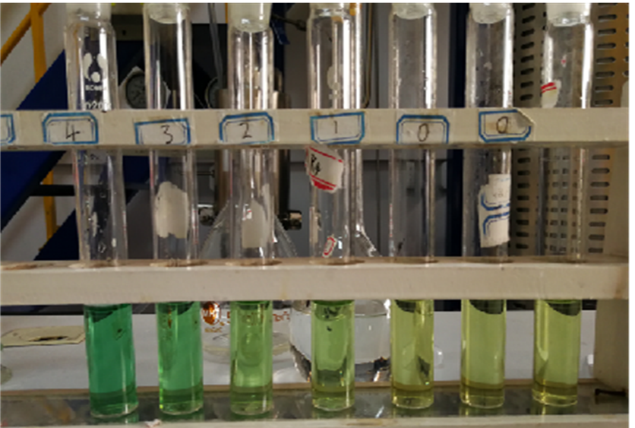
Fig. S1 Color changes of samples after indophenol blue color development (original experimental record)
S2.1 Standard Calibration Curve
The calibration curve used for ammonia quantification was fitted according to the following linear equation:
A = 0.74949 C + 0.0274 (R² = 0.99912)
where A is the absorbance at 697.5 nm and C is the NH₃–N concentration (mg L⁻¹), as labeled in the original calibration plot. The linear relationship indicates a good response over the investigated concentration range.
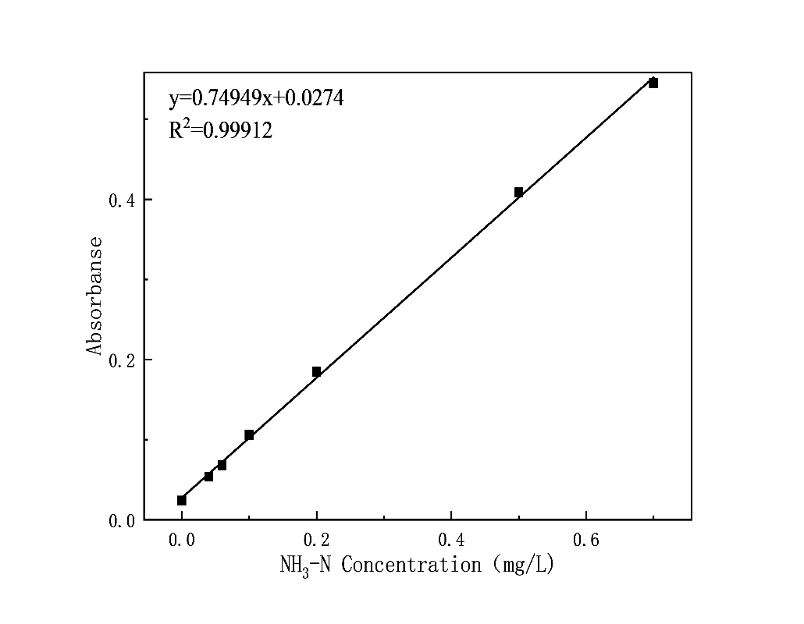
Fig. S2 Standard calibration curve for the indophenol blue method
S2.2 Calculation of the NH₃ Formation Rate
After subtraction of the corresponding blank, the NH₃ formation rate was calculated as follows:
r(NH₃) = C × V / (m × t)
where C is the blank-corrected NH₃ concentration, V is the reaction-solution volume, m is the catalyst mass, and t is the irradiation time. When repeated aliquot withdrawal was performed without equivalent liquid replenishment, the cumulative sampling volume was considered when calculating the final NH₃ amount.
S3. Supplementary Conditions for Reaction Time and Catalyst Dosage
Table S3 Supplementary reaction-time and catalyst-dosage conditions
Factor | Experimental setting | Supplementary description
Irradiation time | 0.5, 1, 2, 3, and 4 h | N₂ was continuously supplied during the reaction. The increase in NH₃ formation became less pronounced after 3 h; therefore, 3 h was selected as the principal reaction time.
Catalyst dosage | 0, 10, 20, 50, and 100 mg | The reaction volume was 100 mL. NH₃ formation increased markedly up to a catalyst dosage of 50 mg, whereas the additional increase became smaller at 100 mg.
Standard reaction conditions | 50 mg catalyst, 100 mL water, 300 W Xe lamp, N₂ atmosphere, approximately 25 °C, 3 h | These conditions were used for comparison of different Co₃O₄/ZnS compositions and for cycling-stability measurements.

S4. Supplementary Photoelectrochemical Measurement Information
Table S4 Supplementary parameters for photoelectrochemical measurements
Item | Parameter
Working-electrode preparation | Catalyst (5 mg) was dispersed in 0.8 mL absolute ethanol and 0.2 mL Nafion solution by ultrasonication. An aliquot of 100 μL was drop-cast onto ITO conductive glass and dried.
Electrochemical configuration | Three-electrode system: catalyst/ITO working electrode, Pt-sheet counter electrode, and Ag/AgCl reference electrode.
Electrolyte | 0.5 mol L⁻¹ Na₂SO₄.
Electrochemical workstation | Princeton VersaSTAT3.
Bias for transient photocurrent | 0.5 V vs. Ag/AgCl.
Light/dark cycle | 30 s dark / 30 s light for four consecutive cycles.
Light source | 300 W Xe lamp.

S5. Raw Data for Cycling Stability
The Co₃O₄/ZnS = 2:1 sample was subjected to five consecutive photocatalytic cycles. The NH₃ formation rates are listed below.
Table S5 NH₃ formation rates during five consecutive photocatalytic cycles
Cycle | NH₃ formation rate (μg h⁻¹ gcat⁻¹) | Activity relative to the first cycle (%)
1 | 612.7 | 100.0
2 | 610.2 | 99.6
3 | 609.8 | 99.5
4 | 604.3 | 98.6
5 | 602.7 | 98.4

The average NH₃ formation rate over the five cycles was 607.94 μg h⁻¹ gcat⁻¹, with a standard deviation of 4.37 μg h⁻¹ gcat⁻¹. The activity retention after the fifth cycle was approximately 98.4% relative to the first cycle.
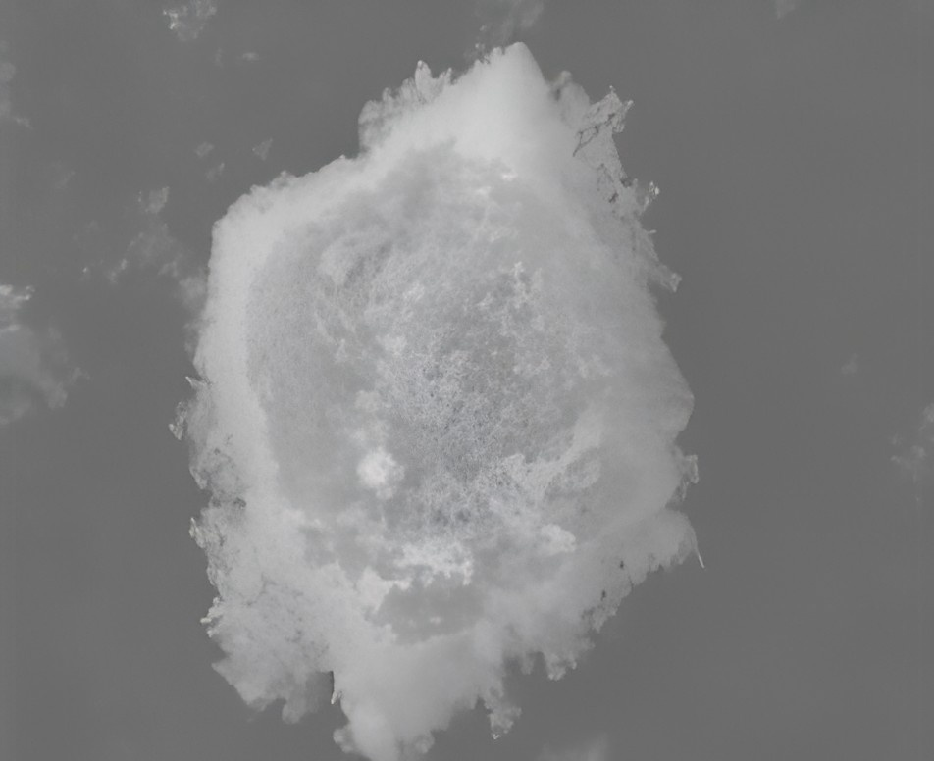
Fig. S3 EDS mapping image of Co₃O₄/ZnS = 2:1

