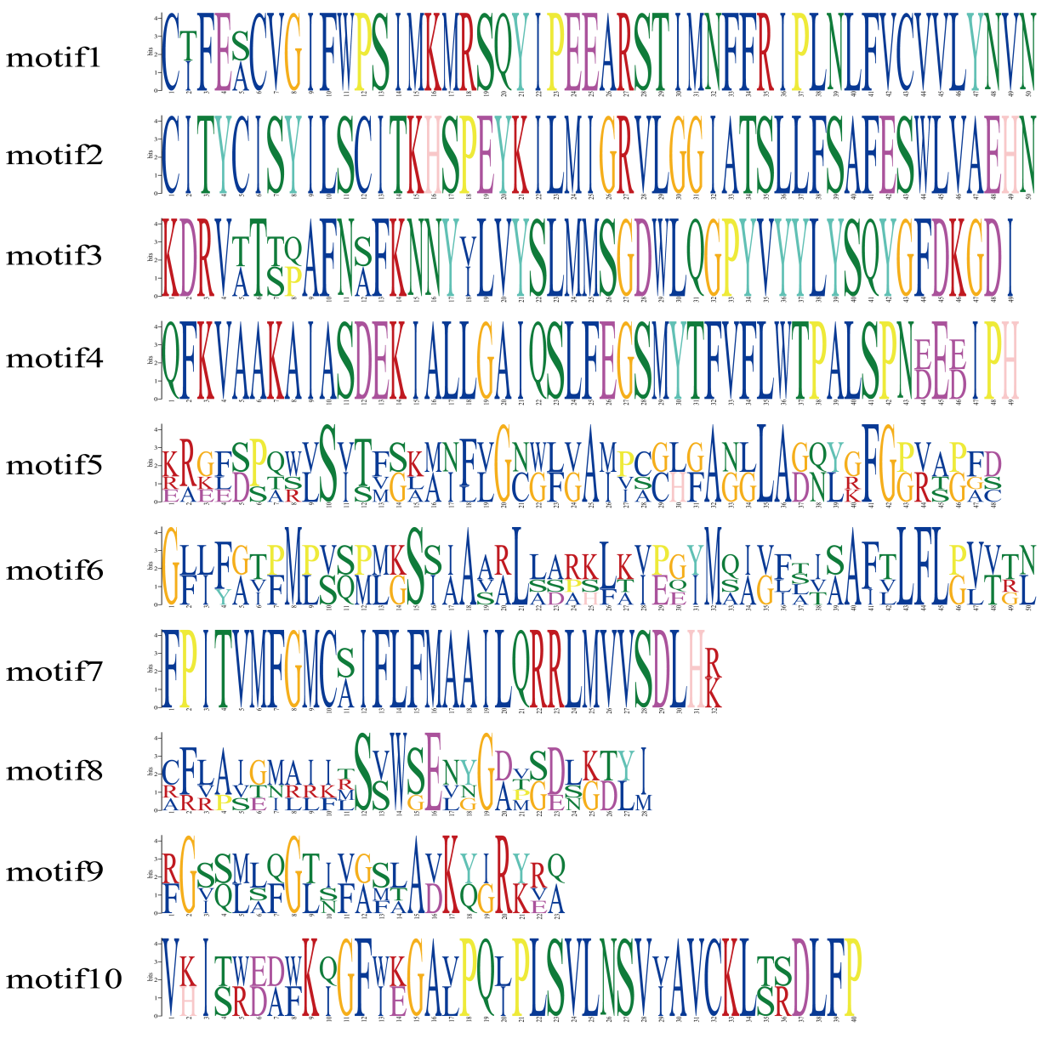
Fig. S1 Sequence logos of 10 conserved motifs in the rice OsMOT protein family
Ten highly conserved amino acid motifs (motif 1–10) were identified in the OsMOT protein family using the MEME (Multiple Em for Motif Elicitation) algorithm. Each motif is presented as a sequence logo, where the height of each letter is proportional to the degree of amino acid conservation at the corresponding position. Amino acids are color-coded by their physicochemical properties: hydrophobic residues are shown in black, polar neutral residues in green, negatively charged acidic residues in red, and positively charged basic residues in blue.

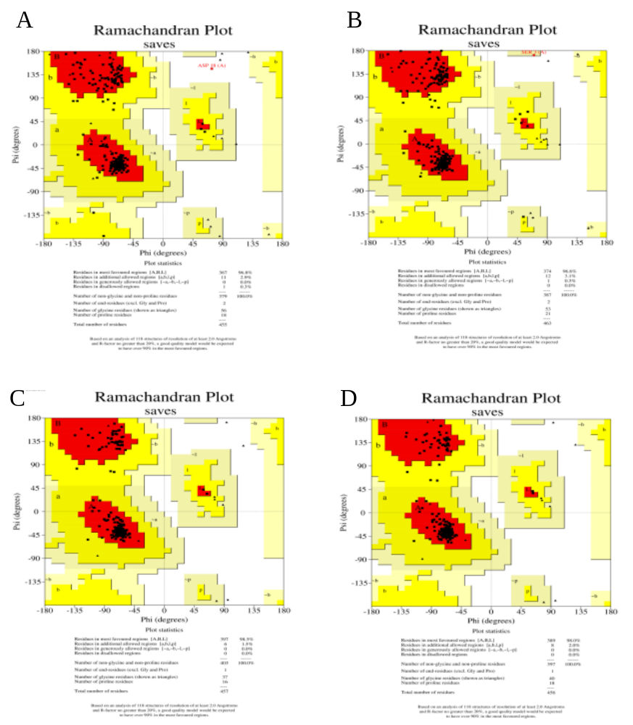
Fig. S2 machandran plot analysis for stereochemical quality validation of OsMOT structural models. Ramachandran plots were generated using the SAVES server to evaluate the backbone dihedral angle (φ/ψ) distribution and stereochemical rationality of AlphaFold3-predicted OsMOT protein structures. Panels correspond to A. OsMOT1;1, B. OsMOT1;2, C. OsMOT2;1, and D. OsMOT2;2. The plot is divided into four regions: red for most favored regions, yellow for additional allowed regions, pale yellow for generously allowed regions, and white for disallowed regions.

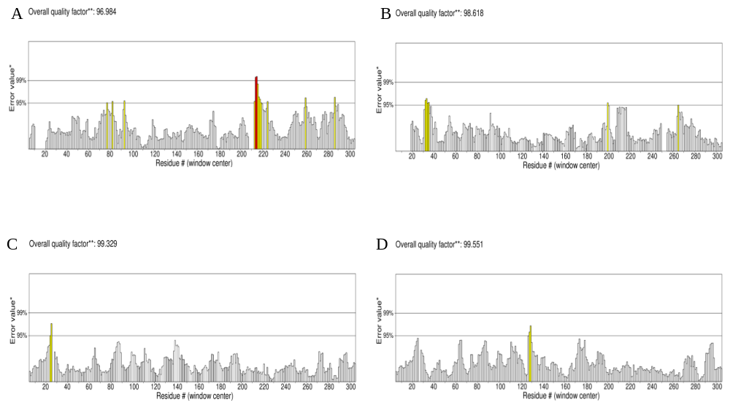
Fig. S3 ERRAT overall quality factor assessment of OsMOT protein structural models
ERRAT analysis was performed using the SAVES server to evaluate the overall structural quality of AlphaFold3-predicted OsMOT protein models based on non-bonded atomic interaction statistics. Panels correspond to A OsMOT1;1, B OsMOT1;2, C OsMOT2;1, and D OsMOT2;2. The y-axis represents the environmental error value calculated with a sliding window centered on each residue. Horizontal lines indicate the 95% and 99% confidence thresholds for structural error rejection.

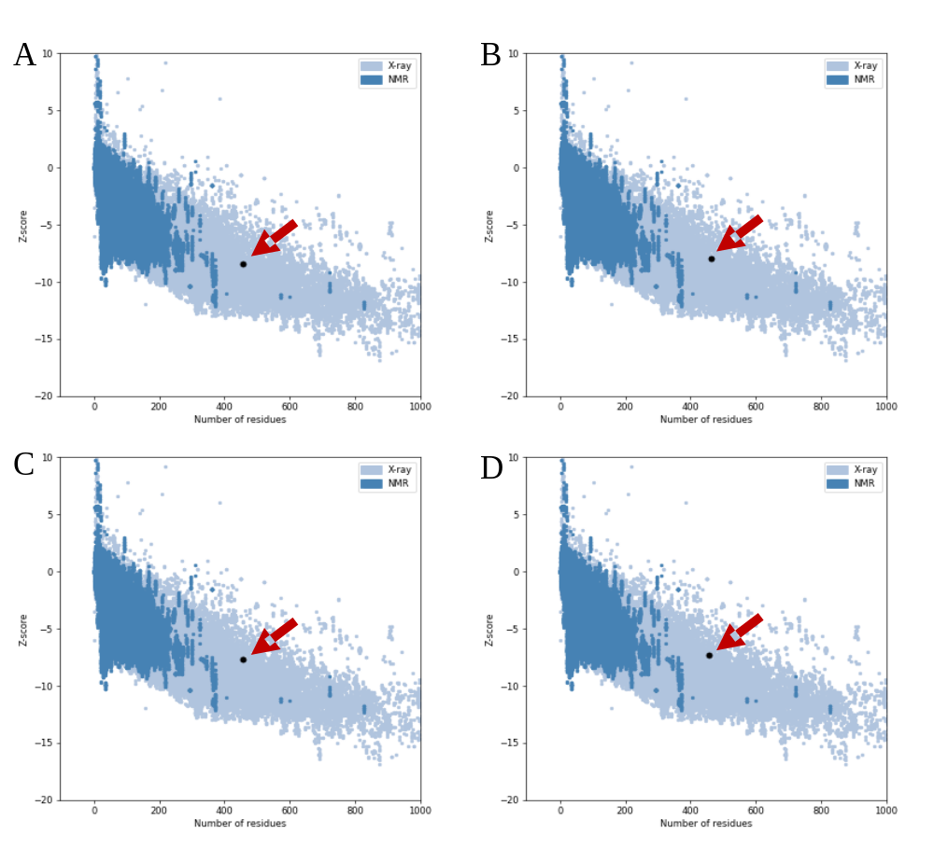
Fig. S4 Z-score evaluation of OsMOT protein models using ProSA-web
ProSA-web was used to calculate Z-scores for AlphaFold3-predicted OsMOT structural models to assess global structural quality. Panels correspond to A OsMOT1;1, B OsMOT1;2, C OsMOT2;1, and D OsMOT2;2. The background scatter points represent experimentally solved X-ray (light blue) and NMR (dark blue) protein structures. Black dots with red arrows denote the Z-score of each OsMOT model.

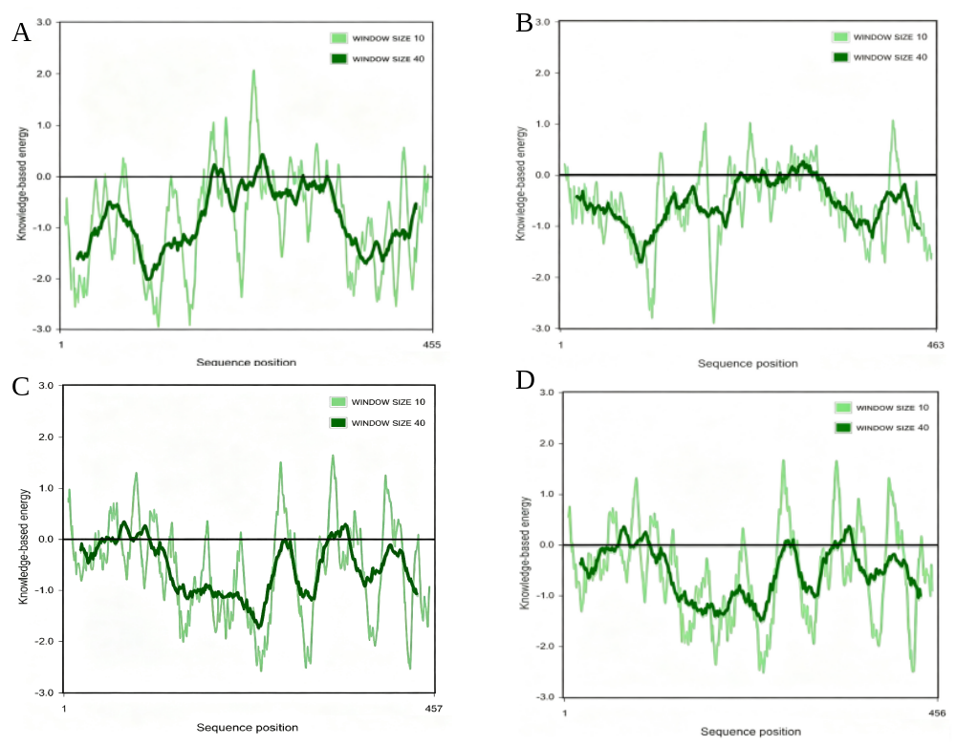
Fig. S5 Local structural quality evaluation of OsMOT models via knowledge-based energy profiles
Knowledge-based energy analysis was performed using ProSA-web to assess the residue-level local folding quality of AlphaFold3-predicted OsMOT structural models. Panels correspond to A OsMOT1;1, B OsMOT1;2, C OsMOT2;1, and D OsMOT2;2.
The x-axis represents the residue position along the protein sequence. The y-axis shows the knowledge-based energy value calculated with sliding windows: light green lines indicate the energy profile with a window size of 10, and dark green lines indicate the smoothed energy profile with a window size of 40. The black horizontal line marks the zero-energy baseline, where negative values correspond to favorable local structural environments.

