Supplementary Information
Table S1. Primers used in this study.
Primer name |  | Sequence (5'→3') | Product size (bp) | Application
Pycom07g02010-F | TAGATGCACGTTTTGATGCGT |  | 72 | RT-qPCR
Pycom07g02010-R | GATATCCCGACCCCGTCCT |  | 72 | RT-qPCR
Pycom07g02010- F | ATGAGGTATCCACCCATTTACTTCC |  | 931 | Cloning of CDS
Pycom07g02010- R | TTAAACTGGCTGGCCTGAACTG |  | 931 | Cloning of CDS
Pycom15g31000- F | ATGCTCTTCACTCTGACCTCTCCA |  | 1543 | Cloning of CDS
Pycom15g31000- R | TTAAGCCTTAGGCCTTCCGAA |  | 1543 | Cloning of CDS
Table S2 Comparison of phenotypic index of in vitro plantlets with different subculture times
Plantlets | Height/cm | Stem diameter/cm | Leaf length/cm | Leaf width/cm | Leaf shape index | Leaf area（cm²）
Newly established in vitro plantlets | 1.56 ± 0.42a | 0.26±0.03a | 0.81±0.10a | 0.64±0.12a | 1.03±0.33a | 0.39±0.03a
Long-term subcultured in vitro plantlets | 1.79±0.35a | 0.35±0.04a | 0.84±0.06a | 0.84±0.35a | 0.87±0.32a | 0.50±0.26a
Transplanted newly established plantlets | 6.11±2.24a | 0.56±0.02a | 3.73±0.62a | 2.37±0.38a | 1.15±0.19a | 3.38±0.29a
Transplanted long-term subcultured plantlets | 6.22±1.31a | 0.66±0.07a | 3.39±0.25a | 2.18±0.1a | 1.19±0.36a | 2.79±0.63a
Note: Different lower-case letters showed significant difference (P < 0.05).

Table S3 Analysis of anatomical structure data of leaf and stem
Plantlets | Palisade tissue  /μm | Spongy tissue  /μm | Palisade spongy ratio (P/S) | Phloem area/ mm² | Xylem area /mm² | Medullary area /mm² | Timber ratio
Newly established in vitro plantlets | 9.56±1.41a | 19.23±0.64a | 0.49±0.05a | 5.62±0.76a | 3.32±0.49a | 3.29±0.29a | 1.17±0.16a
Long-term subcultured in vitro plantlets | 10.07±1.75a | 20.75±0.76a | 0.48±0.03a | 5.82±0.25a | 3.87±0.32a | 2.91±0.25a | 1.16±0.02a
Note: Different lower-case letters showed significant difference (P < 0.05).
Table S4 Geometric means of fluorescence histograms of newly established and long-term subcultured 'Qingzhen D1' plantlets
Plant material | Geometric mean
Newly established in vitro plantlets | 12772±1438 a
Long-term subcultured in vitro plantlets | 13228±1320 a
Note: Different lower-case letters showed significant difference (P < 0.05).
Table S5 Statistical result of sequencing data
Clean reads | GC(%) | Sequencing Depth | Q30(%) | Cover ratio (%) | Mapping rate (%)
New1  New2  New3  New4  New5  New6  Long1  Long2  Long3  Long4  Long5  Long6 | 38.13  38.23  38.15  37.98  38.16  38.00  37.85  38.23  38.11  37.99  38.02  38.31 | 9.75  10.06  9.44  9.32  9.02  9.47  9.56  9.70  10.30  9.92  8.50  9.24 | 90.73  92.63  91.56  92.71  92.75  91.30  91.14  91.34  90.96  91.39  91.38  92.84 | 95.04  94.81  94.69  94.65  94.58  94.48  94.57  94.64  95.04  94.79  94.27  94.41 | 97.25  97.36  97.28  97.35  97.32  97.34  97.29  97.17  97.04  97.32  97.19  97.28
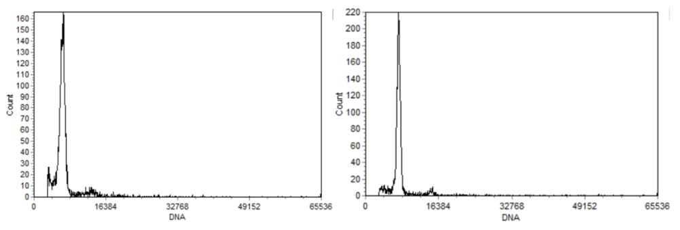
Fig. S1 Histogram of chromosome ploidy in leaf cells of newly established (A) and long-term subcultured (B) 'Qingzhen D1' by flow cytometry
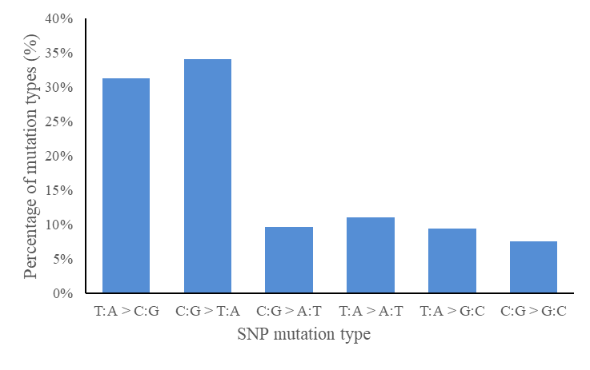
Fig. S2 SNPs mutation spectrum
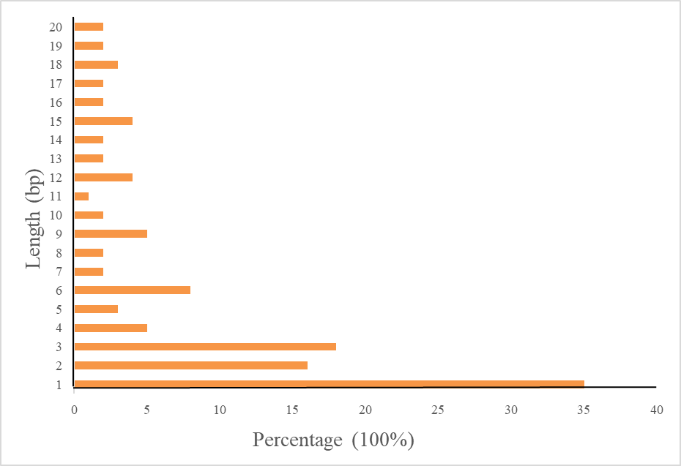
Fig. S3 Indels length distribution map

