Supplementary Note 1. Dataset Curation and Class Definition from the COSMIC Cancer Mutation Census

1. Data Dictionary and Curation (cmc_export.tsv)
Variants were obtained from the COSMIC Cancer Mutation Census (CMC) v100 on March 22, 2024. We used the following fields:
- GENE_NAME: gene symbol.
- CGC_TIER: Cancer Gene Census tier.
- Mutation AA: protein-level amino-acid change reported in HGVS-compliant notation.
- MUTATION_SIGNIFICANCE_TIER: CMC mutation significance tier:
  - High significance.
  - Medium significance.
  - Low significance.
  - Other: No predicted significance (other mutations).
Methodological Note: Entries were deduplicated based on the unique tuple (GENE_NAME, CGC_TIER, Mutation AA, MUTATION_SIGNIFICANCE_TIER). Additionally, protein substitutions were restricted to those adhering to the standard HGVS pattern p.<amino_acid><position><amino_acid>, ensuring uniform downstream parsing.

2. Initial Class Distribution
Classes were defined based on the intersection of CGC Tier and Mutation Significance:
- Driver Class: Defined as instances where CGC_TIER == 1 and MUTATION_SIGNIFICANCE_TIER == '1'.
- Non-Driver Class: Defined as instances where CGC_TIER == 1 and MUTATION_SIGNIFICANCE_TIER == 'Other'.
Preliminary data collection identified 232 driver and 73,761 non-driver variants, indicating substantial class imbalance.

3. Comparative Analysis with Prior Work
Although the raw CMC data suggested an apparent increase in driver variants relative to Meirson et al. (232 vs. 205), subsequent sequence-level validation identified 27 variants (11.6\%) that could not be reliably mapped to the annotated protein sequence (e.g., out-of-range positions or sequence--isoform inconsistencies). After excluding these cases, the resulting dataset comprised 205 driver variants across 45 Tier 1 genes, consistent with the composition reported by Meirson et al.

4. Gene-level distribution
Driver variants were concentrated in a small subset of Tier 1 genes, including PIK3CA (20), NRAS (17), CTNNB1 (15), HRAS (13), and TP53 (13).
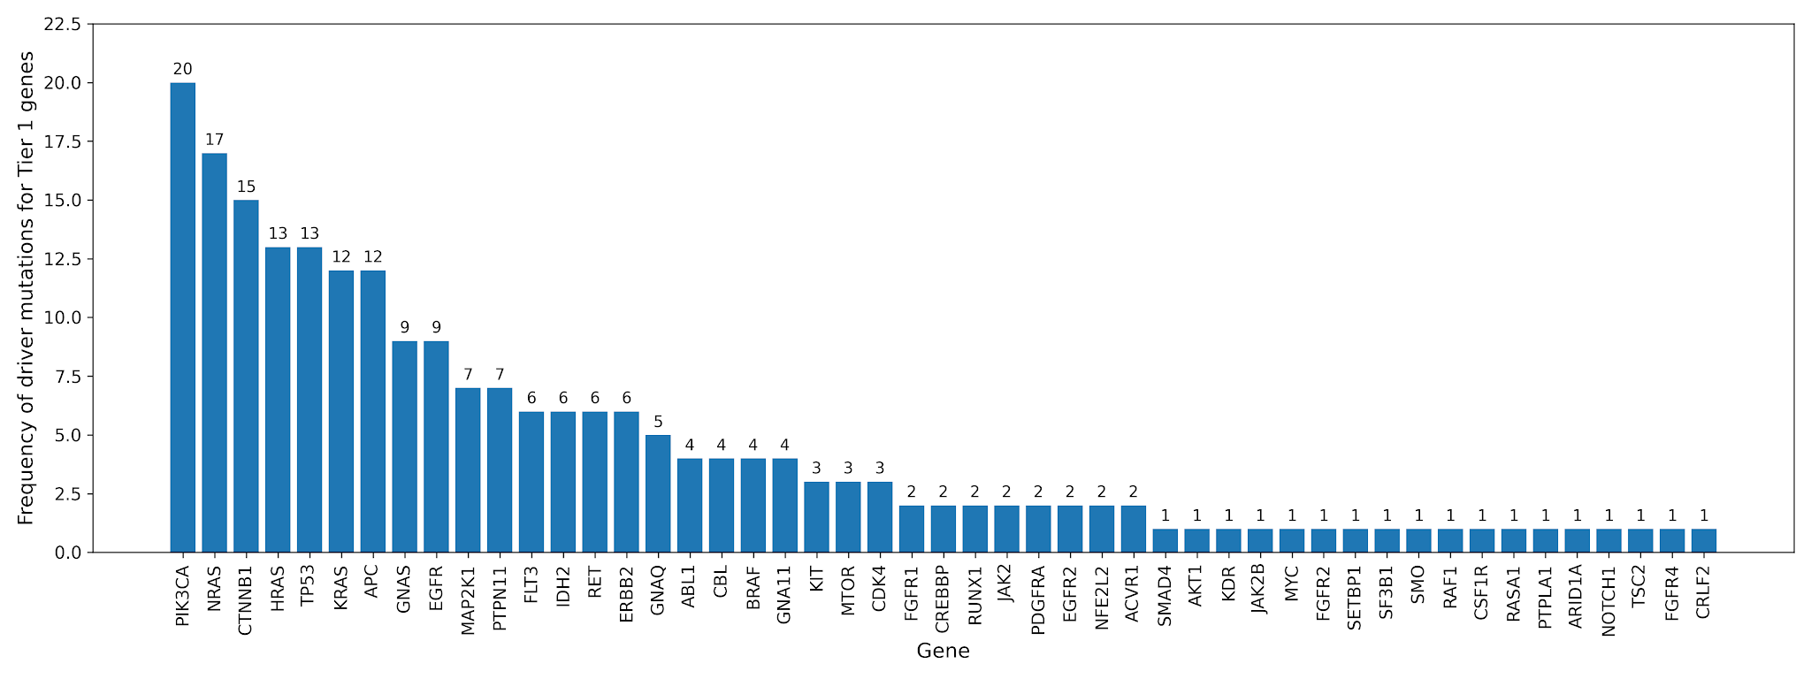
Figure 1. Frequency of driver mutations for Tier 1 genes.

References
- Meirson, T., Bomze, D., Schueler-Furman, O., Stemmer, S.M., & Markel, G. (2023). Systemic structural analysis of alterations reveals a common structural basis of driver mutations in cancer. NAR Cancer, 5(1), zcac040.

