Supplementary materials

Table 1: event counts

definition | region | Reference | HW_only | O3_only | Compound | Mixed_noncompound
cat_p90_lag0 | POOLED | 1545 | 95 | 129 | 56 | 0
cat_p90_lag0 | Marrakech Safi | 314 | 14 | 23 | 14 | 0
cat_p90_lag0 | Oriental | 310 | 18 | 23 | 14 | 0
cat_p90_lag0 | Rabat Sale Kenitra | 308 | 20 | 29 | 8 | 0
cat_p90_lag0 | Souss Massa | 305 | 23 | 29 | 8 | 0
cat_p90_lag0 | Tangier Tetouan Al Hoceima | 308 | 20 | 25 | 12 | 0
cat_p90_lag1 | POOLED | 1545 | 95 | 129 | 56 | 0
cat_p90_lag1 | Marrakech Safi | 314 | 14 | 23 | 14 | 0
cat_p90_lag1 | Oriental | 310 | 18 | 23 | 14 | 0
cat_p90_lag1 | Rabat Sale Kenitra | 308 | 20 | 29 | 8 | 0
cat_p90_lag1 | Souss Massa | 305 | 23 | 29 | 8 | 0
cat_p90_lag1 | Tangier Tetouan Al Hoceima | 308 | 20 | 25 | 12 | 0
cat_p90_lag2 | POOLED | 1545 | 95 | 129 | 56 | 0
cat_p90_lag2 | Marrakech Safi | 314 | 14 | 23 | 14 | 0
cat_p90_lag2 | Oriental | 310 | 18 | 23 | 14 | 0
cat_p90_lag2 | Rabat Sale Kenitra | 308 | 20 | 29 | 8 | 0
cat_p90_lag2 | Souss Massa | 305 | 23 | 29 | 8 | 0
cat_p90_lag2 | Tangier Tetouan Al Hoceima | 308 | 20 | 25 | 12 | 0
cat_p90_lag3 | POOLED | 1545 | 95 | 129 | 56 | 0
cat_p90_lag3 | Marrakech Safi | 314 | 14 | 23 | 14 | 0
cat_p90_lag3 | Oriental | 310 | 18 | 23 | 14 | 0
cat_p90_lag3 | Rabat Sale Kenitra | 308 | 20 | 29 | 8 | 0
cat_p90_lag3 | Souss Massa | 305 | 23 | 29 | 8 | 0
cat_p90_lag3 | Tangier Tetouan Al Hoceima | 308 | 20 | 25 | 12 | 0
cat_p90_lag01 | POOLED | 1453 | 99 | 190 | 81 | 2
cat_p90_lag01 | Marrakech Safi | 296 | 16 | 34 | 19 | 0
cat_p90_lag01 | Oriental | 295 | 17 | 33 | 19 | 1
cat_p90_lag01 | Rabat Sale Kenitra | 284 | 21 | 46 | 14 | 0
cat_p90_lag01 | Souss Massa | 290 | 22 | 40 | 12 | 1
cat_p90_lag01 | Tangier Tetouan Al Hoceima | 288 | 23 | 37 | 17 | 0
cat_p90_lag03 | POOLED | 1297 | 103 | 292 | 125 | 8
cat_p90_lag03 | Marrakech Safi | 266 | 18 | 53 | 28 | 0
cat_p90_lag03 | Oriental | 272 | 15 | 48 | 29 | 1
cat_p90_lag03 | Rabat Sale Kenitra | 243 | 22 | 75 | 25 | 0
cat_p90_lag03 | Souss Massa | 264 | 19 | 58 | 17 | 7
cat_p90_lag03 | Tangier Tetouan Al Hoceima | 252 | 29 | 58 | 26 | 0
cat_p90_lag07 | POOLED | 1104 | 79 | 429 | 193 | 20
cat_p90_lag07 | Marrakech Safi | 232 | 17 | 71 | 44 | 1
cat_p90_lag07 | Oriental | 243 | 10 | 68 | 43 | 1
cat_p90_lag07 | Rabat Sale Kenitra | 190 | 18 | 116 | 41 | 0
cat_p90_lag07 | Souss Massa | 229 | 13 | 84 | 25 | 14
cat_p90_lag07 | Tangier Tetouan Al Hoceima | 210 | 21 | 90 | 40 | 4
cat_p75_lag01 | POOLED | 1165 | 48 | 478 | 128 | 6
cat_p75_lag01 | Marrakech Safi | 238 | 8 | 92 | 27 | 0
cat_p75_lag01 | Oriental | 240 | 5 | 88 | 30 | 2
cat_p75_lag01 | Rabat Sale Kenitra | 224 | 11 | 106 | 23 | 1
cat_p75_lag01 | Souss Massa | 231 | 16 | 99 | 17 | 2
cat_p75_lag01 | Tangier Tetouan Al Hoceima | 232 | 8 | 93 | 31 | 1

Figure 2: sensitivity analysis by lag specifications

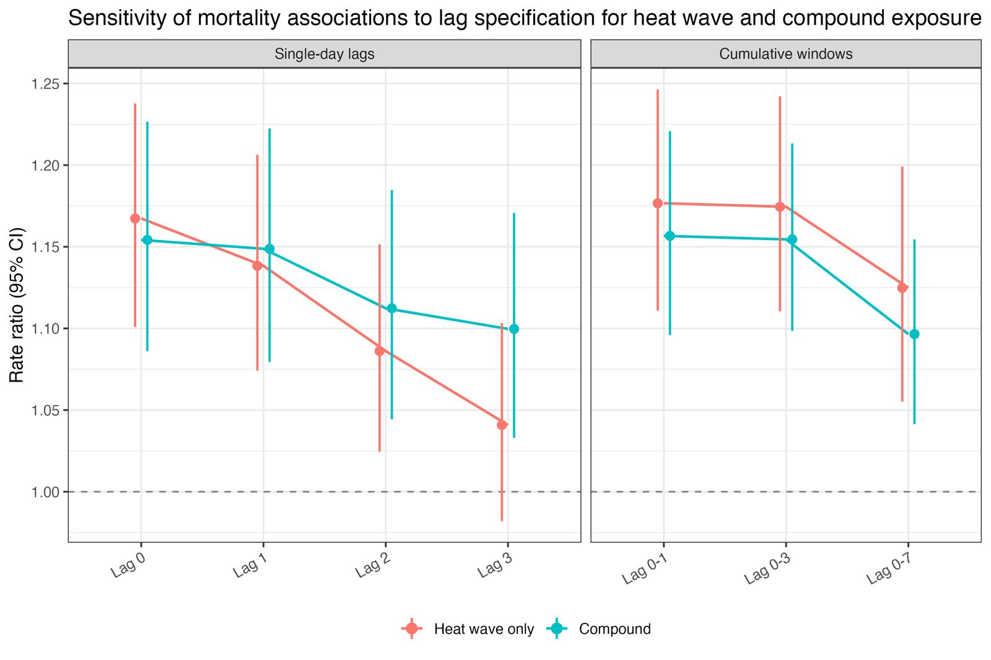
Table 2: interaction metrics

analysis | RERI_point | AP_point | SI_point | RERI_lcl | RERI_ucl | AP_lcl | AP_ucl | SI_lcl | SI_ucl | RERI_pval_depart_zero | n_boot_valid | n_boot_total
PRIMARY_lag0 | -0.029931931562646286 | -0.02593296199565187 | 0.8374466520146385 | -0.1323397750707036 | 0.07752562367625597 | -0.11895552695903859 | 0.06450434440341919 | 0.41881094202065666 | 1.770719230987898 | 598 | 2000 | 2000
PRIMARY_lag1 | -0.020559092894681497 | -0.017896535997986025 | 0.8785885688176359 | -0.12307849847295137 | 0.08527715342676814 | -0.11115766266730516 | 0.07143979994338483 | 0.41701281654567834 | 2.029535286836497 | 752 | 2000 | 2000
PRIMARY_lag01 | -0.04014309589249576 | -0.034705486687267015 | 0.7960434029312572 | -0.14273310583988602 | 0.0497227159555111 | -0.12694437980820808 | 0.041793289697827384 | 0.4357101437425007 | 1.3832358556676063 | 399 | 2000 | 2000

