Electronic Supplementary Materials
Supplementary Table S1. Data dictionary, analytical classification, and completeness assessment of variables included in the pooled Red Sokoto buck semen preservation dataset
Variable | Description | Variable type | Analytical role | Values/range | Final analytical observations (n) | Missing values, n (%) | Remarks
Extender | Semen extender formulation used for preservation of pooled Red Sokoto buck semen | Categorical | Treatment/fixed-effect predictor | 5%D, EYC, NS, SC, TJ, TJD, TJDEY, TJEYNS, TJNS, TJSC, TJSCEY | 108 | 0 (0.00) | Complete; represents experimental semen extender treatment groups
Experiment | Independent pooled semen preservation batch conducted using ejaculates collected from five bucks | Categorical | Random-effect/grouping variable | Experiment 1–2 | 108 | 0 (0.00) | Complete; included to account for experimental batch-level variation
Storage duration (h) | Duration of liquid semen preservation before semen quality assessment | Ordered categorical | Time/fixed-effect predictor | 24, 48, and 72 h | 108 | 0 (0.00) | Complete; evaluates temporal deterioration during storage
Replicate | Independent technical laboratory replicate within each extender–storage duration combination | Categorical | Technical replicate variable | Replicates 1–3 | 108 | 0 (0.00) | Complete; represents repeated laboratory measurements
Sperm motility (%) | Percentage of motile sperm cells following preservation | Continuous | Primary semen quality outcome | 0–90% | 108 | 9 (8.33) | Missing values occurred only for SC extender in Experiment 2; zero values retained as biologically valid observations
Live sperm count | Number of viable sperm cells observed during viability assessment | Continuous/count | Secondary viability measurement | 97–2115* | 108 | 0 (0.00) | Complete; used for estimation of sperm viability percentage
Dead sperm count | Number of non-viable sperm cells observed during viability assessment | Continuous/count | Secondary viability measurement | 10–62 | 108 | 0 (0.00) | Complete; used for estimation of sperm mortality percentage
Live sperm (%) | Percentage of viable sperm cells calculated from live/dead staining assessment | Continuous | Secondary semen quality outcome | 62.42–99.11% | 108 | 0 (0.00) | Complete; represents sperm membrane integrity/viability
Dead sperm (%) | Percentage of non-viable sperm cells calculated from live/dead staining assessment | Continuous | Secondary semen quality outcome | 0.89–37.58% | 108 | 0 (0.00) | Complete; represents sperm mortality after preservation
Footnote: EYC = egg yolk citrate extender (control). Other abbreviations represent experimental extender formulations evaluated for liquid semen preservation. Ejaculates collected from five Red Sokoto bucks were pooled before allocation into extender treatments; therefore, treatment effects represent pooled semen responses rather than individual buck-level variation. Experimental batch was included as a random effect during mixed-effects modelling. Zero sperm motility values represented complete loss of sperm movement following storage and were retained as biologically valid observations.
*The maximum value for live sperm count should be verified from the original laboratory records before final submission to confirm whether 2115 represents the true recorded count or a data-entry formatting issue.

Supplementary Table S2. Data validation and cleaning summary of the pooled Red Sokoto buck semen preservation dataset before statistical analysis
Data quality parameter | Assessment performed | Result | Final decision/action
Initial dataset size | Number of observations available after merging sperm motility and live/dead viability datasets | 126 observations | Dataset subjected to validation before statistical analysis
Variable structure assessment | Verification of required analytical variables, including extender formulation, experimental batch, storage duration, technical replicate, sperm motility, and viability parameters | 9 variables confirmed | Dataset structure accepted for downstream processing
Variable coding validation | Assessment of treatment, time, batch, and replicate coding consistency | 11 extender formulations, 3 storage durations (24, 48, and 72 h), 2 experimental batches, and 3 technical replicates confirmed | Coding structure retained
Missing value assessment | Evaluation of missing observations across semen quality outcomes | Missing values detected only for sperm motility (9/108 observations after cleaning); live and dead sperm percentages were complete | Missing values retained and handled during statistical modelling without imputation
Biological validity assessment | Verification that sperm motility, live sperm percentage, and dead sperm percentage values were within biologically acceptable limits (0–100%) | No invalid biological values detected | All valid measurements retained
Zero-value assessment | Evaluation of zero sperm motility observations | Zero motility values represented complete loss of sperm movement during preservation | Retained as true biological outcomes
Duplicate assessment | Duplicate records defined using unique experimental identifiers: extender × experimental batch × storage duration × replicate | 18 duplicated records detected | Duplicate records reviewed before correction
Duplicate classification | Determination of whether duplicated observations represented additional experimental measurements | Duplicates identified as merge-generated repeated entries rather than independent observations | Duplicate copies excluded; first valid occurrence retained
Final analytical dataset | Number of observations remaining after duplicate correction | 108 unique observations | Used for descriptive statistics, visualization, and inferential modelling
Final duplicate verification | Reassessment using extender × experimental batch × storage duration × replicate combinations | No remaining duplicate combinations detected | Dataset approved for final statistical analysis
Footnote: The initial dataset contained duplicate records introduced during merging of sperm motility and live/dead viability datasets. Duplicates were identified using the predefined experimental identifiers (extender formulation × experimental batch × storage duration × technical replicate) rather than outcome measurements. Because these duplicated entries did not represent additional biological or technical replicates, only the first occurrence was retained. The final cleaned dataset contained 108 unique experimental observations and was used for all subsequent analyses. Ejaculates from five Red Sokoto bucks were pooled before extender allocation; therefore, experimental batch, rather than individual buck identity, represented the grouping structure during statistical modelling.

Supplementary Table S3. Experimental design structure and analytical framework of the pooled Red Sokoto buck semen preservation study
Experimental component | Variable/parameter | Structure/levels | Observations (n) | Analytical role
Final analytical dataset | Unique experimental observations | Extender × experimental batch × storage duration × replicate combinations | 108 | Dataset used for descriptive analyses and statistical modelling
Treatment factor | Extender formulation | 11 formulations (5%D, EYC, NS, SC, TJ, TJD, TJDEY, TJEYNS, TJNS, TJSC, TJSCEY) | 9–18 observations per extender | Fixed-effect predictor assessing preservation performance
Experimental batch | Experiment | Two independent pooled semen processing batches | 54 observations per batch | Random-effect grouping variable accounting for experimental variation
Storage duration | Storage time | 24, 48, and 72 h | 36 observations per storage period | Fixed-effect predictor assessing time-dependent semen quality changes
Laboratory replication | Replicate | Three technical replicate measurements | Replicates 1–3 | Accounts for repeated laboratory measurements
Treatment–time structure | Extender × storage duration | 33 extender–storage combinations | 3–6 observations per combination | Evaluates extender-specific preservation trends over time
Experimental combination | Extender × storage duration × experiment | 36 available combinations | Three replicate measurements per combination | Represents final experimental units for modelling
Primary outcome | Sperm motility (%) | Continuous semen quality trait | 99 available observations | Functional indicator of sperm preservation
Secondary outcome | Live sperm (%) | Continuous semen viability trait | 108 available observations | Indicator of sperm viability after preservation
Secondary outcome | Dead sperm (%) | Continuous semen mortality trait | 108 available observations | Indicator of sperm deterioration after preservation
Footnote: EYC = egg yolk citrate extender (control). Ejaculates collected from five Red Sokoto bucks were pooled before allocation into extender treatments; therefore, individual buck effects were not modelled. Experimental batch was included as a random effect to account for variation between independent pooled semen processing batches. The final analytical dataset contained 108 unique observations after removal of merge-generated duplicate entries.
Supplementary Table S4. Extender-specific semen quality changes during 72 h liquid preservation of pooled Red Sokoto buck semen
Extender | Storage duration (h) | n | Sperm motility (%) Mean ± SD | 95% CI | Live sperm (%) Mean ± SD | 95% CI | Dead sperm (%) Mean ± SD | 95% CI
5%D | 24 | 3 | 61.67 ± 2.89 | 54.5–68.8 | 91.00 ± 2.97 | 83.6–98.4 | 9.00 ± 2.97 | 1.61–16.4
 | 48 | 3 | 41.67 ± 2.89 | 34.5–48.8 | 82.70 ± 2.91 | 75.5–89.9 | 17.30 ± 2.91 | 10.1–24.5
 | 72 | 3 | 3.33 ± 5.77 | -11.0–17.7 | 74.84 ± 6.87 | 57.8–91.9 | 25.16 ± 6.87 | 8.10–42.2
EYC | 24 | 3 | 88.33 ± 2.89 | 81.2–95.5 | 92.02 ± 1.97 | 87.1–96.9 | 7.98 ± 1.97 | 3.08–12.9
 | 48 | 3 | 82.67 ± 4.62 | 71.2–94.1 | 85.14 ± 1.61 | 81.1–89.1 | 14.86 ± 1.61 | 10.9–18.9
 | 72 | 3 | 45.00 ± 8.66 | 23.5–66.5 | 77.72 ± 2.56 | 71.4–84.1 | 22.28 ± 2.56 | 15.9–28.6
NS | 24 | 3 | 45.00 ± 5.00 | 32.6–57.4 | 89.17 ± 2.32 | 83.4–94.9 | 10.83 ± 2.32 | 5.06–16.6
 | 48 | 3 | 30.00 ± 5.00 | 17.6–42.4 | 82.17 ± 3.09 | 74.5–89.9 | 17.83 ± 3.09 | 10.1–25.5
 | 72 | 3 | 5.00 ± 5.00 | -7.42–17.4 | 71.46 ± 1.58 | 67.5–75.4 | 28.54 ± 1.58 | 24.6–32.5
SC | 24 | 3–6 | 41.67 ± 2.89 | 34.5–48.8 | 87.14 ± 3.82 | 83.1–91.2 | 12.86 ± 3.82 | 8.85–16.9
 | 48 | 3–6 | 18.33 ± 2.89 | 11.2–25.5 | 80.43 ± 3.59 | 76.7–84.2 | 19.57 ± 3.59 | 15.8–23.3
 | 72 | 3–6 | 11.67 ± 2.89 | 4.50–18.8 | 68.26 ± 3.36 | 64.7–71.8 | 31.74 ± 3.36 | 28.2–35.3
TJ | 24 | 3 | 41.67 ± 2.89 | 34.5–48.8 | 88.10 ± 0.81 | 86.1–90.1 | 11.90 ± 0.81 | 9.90–13.9
 | 48 | 3 | 21.67 ± 2.89 | 14.5–28.8 | 83.95 ± 1.59 | 80.0–87.9 | 16.05 ± 1.59 | 12.1–20.0
 | 72 | 3 | 0.00 ± 0.00 | 0.0–0.0 | 70.57 ± 5.24 | 57.6–83.6 | 29.43 ± 5.24 | 16.4–42.4
TJD | 24 | 3 | 43.33 ± 5.77 | 29.0–57.7 | 89.04 ± 1.02 | 86.5–91.6 | 10.96 ± 1.02 | 8.42–13.5
 | 48 | 3 | 26.67 ± 2.89 | 19.5–33.8 | 87.85 ± 1.41 | 84.4–91.3 | 12.15 ± 1.41 | 8.66–15.6
 | 72 | 3 | 3.33 ± 5.77 | -11.0–17.7 | 77.11 ± 0.51 | 75.8–78.4 | 22.89 ± 0.51 | 21.6–24.2
TJDEY | 24 | 3 | 73.33 ± 2.89 | 66.2–80.5 | 93.65 ± 1.33 | 90.3–96.9 | 6.35 ± 1.33 | 3.06–9.65
 | 48 | 3 | 51.67 ± 2.89 | 44.5–58.8 | 85.94 ± 1.53 | 82.1–89.7 | 14.06 ± 1.53 | 10.3–17.9
 | 72 | 3 | 13.33 ± 5.77 | -1.01–27.7 | 79.48 ± 1.98 | 74.6–84.4 | 20.52 ± 1.98 | 15.6–25.4
TJEYNS | 24 | 3 | 50.00 ± 5.00 | 37.6–62.4 | 92.34 ± 0.74 | 90.5–94.2 | 7.66 ± 0.74 | 5.81–9.51
 | 48 | 3 | 28.33 ± 7.64 | 9.36–47.3 | 85.48 ± 1.94 | 80.7–90.3 | 14.52 ± 1.94 | 9.70–19.3
 | 72 | 3 | 3.33 ± 2.89 | -3.84–10.5 | 77.25 ± 6.23 | 61.8–92.7 | 22.75 ± 6.23 | 7.28–38.2
TJNS | 24 | 3 | 38.33 ± 7.64 | 19.4–57.3 | 88.53 ± 1.55 | 84.7–92.4 | 11.47 ± 1.55 | 7.61–15.3
 | 48 | 3 | 21.67 ± 2.89 | 14.5–28.8 | 86.25 ± 0.95 | 83.9–88.6 | 13.75 ± 0.95 | 11.4–16.1
 | 72 | 3 | 8.33 ± 2.89 | 1.16–15.5 | 74.59 ± 4.10 | 64.4–84.8 | 25.41 ± 4.10 | 15.2–35.6
TJSC | 24 | 3 | 61.67 ± 2.89 | 54.5–68.8 | 90.51 ± 0.75 | 88.6–92.4 | 9.49 ± 0.75 | 7.63–11.4
 | 48 | 3 | 48.33 ± 2.89 | 41.2–55.5 | 85.99 ± 1.36 | 82.6–89.4 | 14.01 ± 1.36 | 10.6–17.4
 | 72 | 3 | 3.33 ± 5.77 | -11.0–17.7 | 77.01 ± 3.18 | 69.1–84.9 | 22.99 ± 3.18 | 15.1–30.9
TJSCEY | 24 | 3 | 88.33 ± 2.89 | 81.2–95.5 | 94.88 ± 4.14 | 84.6–105.0 | 5.12 ± 4.14 | -5.17–15.4
 | 48 | 3 | 71.67 ± 2.89 | 64.5–78.8 | 88.46 ± 1.03 | 85.9–91.0 | 11.54 ± 1.03 | 8.98–14.1
 | 72 | 3 | 35.00 ± 0.00 | 35.0–35.0 | 81.89 ± 3.55 | 73.1–90.7 | 18.11 ± 3.55 | 9.29–26.9
Footnote: Values are presented as mean ± standard deviation with corresponding 95% confidence intervals. Confidence intervals were calculated from observed replicate measurements and were not constrained to biological limits during statistical summarisation; therefore, lower or upper confidence limits outside the possible biological range (0–100%) reflect statistical uncertainty due to small replicate numbers rather than true biological values. Semen ejaculates from five Red Sokoto bucks were pooled before extender allocation. EYC = egg yolk citrate extender.

Supplementary Table S5. Diagnostic assessment of semen quality outcomes before linear mixed-effects modelling of pooled Red Sokoto buck semen preservation data
Semen quality outcome | Shapiro–Wilk p-value | Distribution assessment | Levene’s test p-value | Variance homogeneity | IQR outliers (n) | Standardized residual outliers (n) | Modelling implication
Sperm motility (%) | 0.0006 | Departure from normality detected | 0.764 | Assumption satisfied | 0 | 0 | Linear mixed-effects modelling considered appropriate with residual diagnostics
Live sperm (%) | 0.0042 | Departure from normality detected | 0.899 | Assumption satisfied | 0 | 0 | Linear mixed-effects modelling considered appropriate with residual diagnostics
Dead sperm (%) | 0.0042 | Departure from normality detected | 0.899 | Assumption satisfied | 0 | 0 | Linear mixed-effects modelling considered appropriate with residual diagnostics
Footnote: Normality was assessed using the Shapiro–Wilk test complemented by visual inspection of distributional diagnostic plots. Homogeneity of variance was assessed using Levene’s test. Potential influential observations were evaluated using standardized residuals (> |3|) and the interquartile range method. Diagnostic plots were reviewed during model evaluation but were not included in the supplementary materials because no biologically implausible observations requiring exclusion were identified.

Supplementary Table S6. Composite ranking of extender formulations based on overall sperm motility, viability, mortality, and storage stability during liquid preservation of pooled Red Sokoto buck semen
Overall rank | Extender | Mean motility (%) | Mean live sperm (%) | Mean dead sperm (%) | Motility SD | Viability SD | Mortality SD | Overall interpretation
1 | TJSCEY | 65 | 88.4 | 11.6 | 23.7 | 6.28 | 6.28 | Best overall preservation profile
2 | EYC | 72 | 85 | 15 | 21 | 6.45 | 6.45 | Highest overall sperm motility
3 | TJDEY | 46.1 | 86.4 | 13.6 | 26.5 | 6.3 | 6.3 | Strong viability preservation
4 | TJEYNS | 27.2 | 85 | 15 | 20.8 | 7.32 | 7.32 | Moderate preservation profile
5 | TJD | 24.4 | 84.7 | 15.3 | 17.9 | 5.76 | 5.76 | Good viability stability
6 | TJNS | 22.8 | 83.1 | 16.9 | 13.7 | 6.86 | 6.86 | Moderate stability
7 | TJSC | 37.8 | 84.5 | 15.5 | 26.7 | 6.21 | 6.21 | Intermediate preservation performance
8 | NS | 26.7 | 80.9 | 19.1 | 18 | 8 | 8 | Lower preservation performance
9 | 5%D | 35.6 | 82.8 | 17.2 | 25.9 | 8.07 | 8.07 | Moderate preservation decline
10 | SC | 23.9 | 78.6 | 21.4 | 13.9 | 8.72 | 8.72 | Poor viability preservation
11 | TJ | 21.1 | 80.9 | 19.1 | 18.2 | 8.4 | 8.4 | Lowest overall preservation ranking
Footnote: Extender formulations were ranked using a composite preservation index integrating mean sperm motility, sperm viability, sperm mortality, and stability of semen quality parameters during storage. Higher sperm motility and viability, lower sperm mortality, and reduced variability across storage duration contributed to improved ranking. EYC = egg yolk citrate extender.

Supplementary Table S7. Correlation analysis among sperm motility and viability characteristics of pooled Red Sokoto buck semen during liquid preservation
Variable 1 | Variable 2 | n | Pearson r (95% CI) | Pearson p-value | Spearman ρ | Spearman p-value | Interpretation
Sperm motility (%) | Live sperm (%) | 99 | 0.756 (0.656–0.829) | <0.001 | 0.787 | <0.001 | Strong positive association
Sperm motility (%) | Dead sperm (%) | 99 | −0.756 (−0.829 to −0.656) | <0.001 | −0.787 | <0.001 | Strong negative association
Live sperm (%) | Dead sperm (%) | 108 | −1.000 (−1.000 to −1.000) | <0.001 | −1.000 | <0.001 | Complementary mathematical relationship
Footnote: Pearson correlation coefficients describe linear associations among semen quality parameters, whereas Spearman coefficients describe rank-based monotonic relationships. Positive values indicate direct associations, whereas negative values indicate inverse associations. The perfect inverse correlation between live and dead sperm percentages reflects their complementary derivation from the same viability assessment rather than an independent biological association.

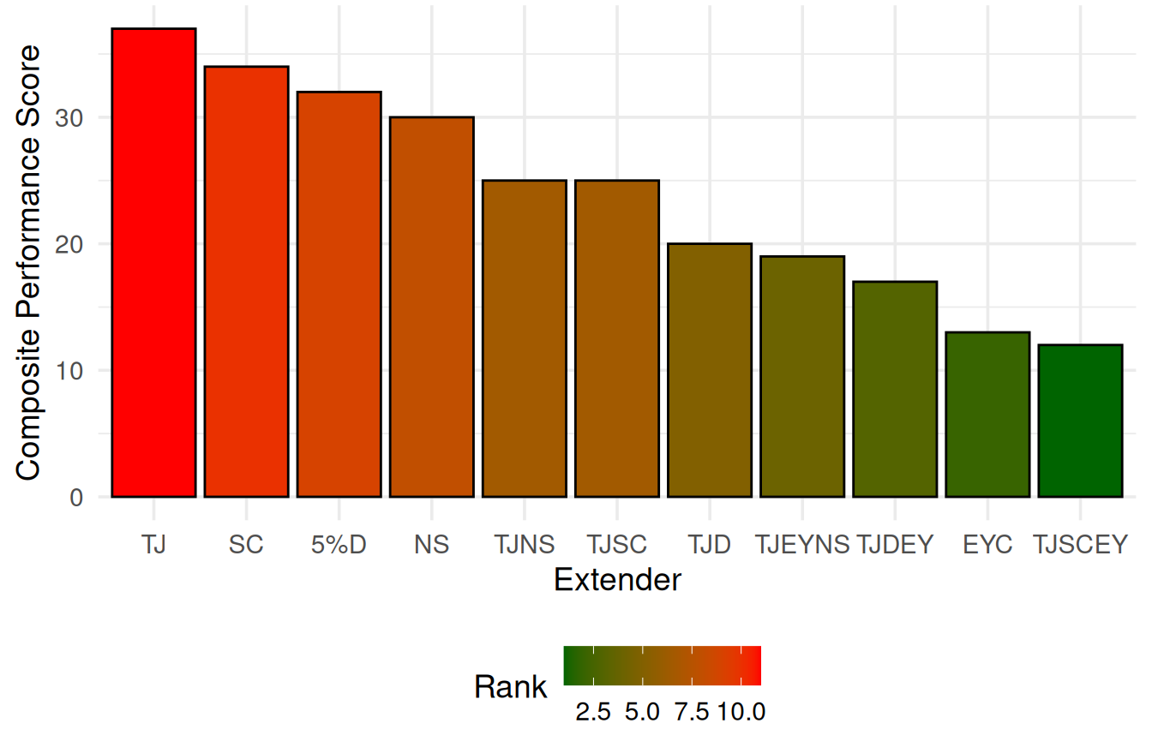
Supplementary Figure S1. Composite preservation performance ranking of extender formulations during liquid storage of pooled Red Sokoto buck semen. Bars represent overall preservation scores calculated from sperm motility, viability, mortality, and storage stability indices. Lower composite scores indicate superior overall preservation performance based on combined semen quality parameters. EYC = egg yolk citrate extender.

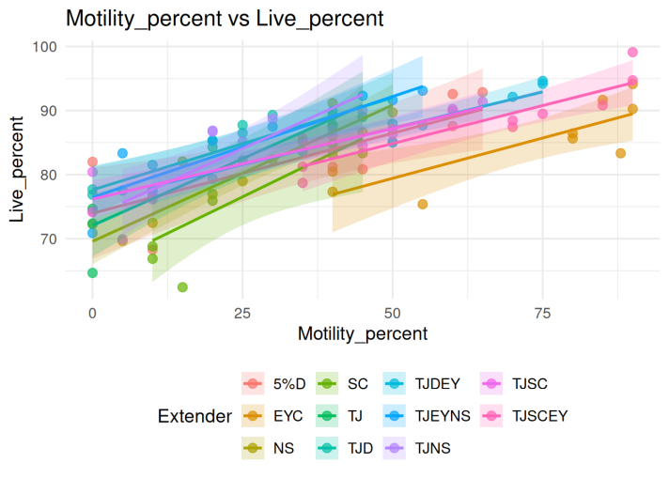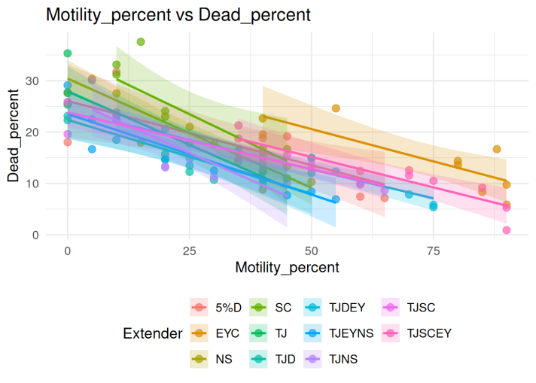
A. Sperm motility (%) and live sperm (%) B. Sperm motility (%) and dead sperm (%)
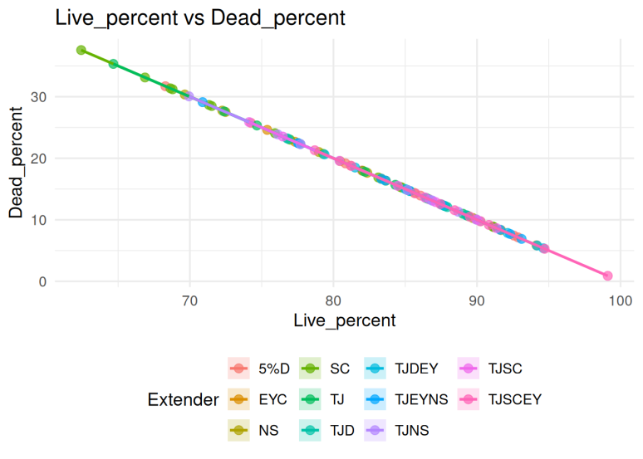
C. Relationship between live sperm (%) and dead sperm (%)
Supplementary Figure S2. Relationship among sperm motility and viability characteristics during liquid preservation of pooled Red Sokoto buck semen. Scatter plots illustrate correlations among semen quality parameters across extender formulations and storage durations. Panels represent: (A) relationship between sperm motility (%) and live sperm (%), (B) relationship between sperm motility (%) and dead sperm (%), and (C) relationship between live sperm (%) and dead sperm (%). Points represent individual semen quality observations, with fitted regression lines and confidence bands indicating the direction and strength of linear associations. EYC = egg yolk citrate extender.

