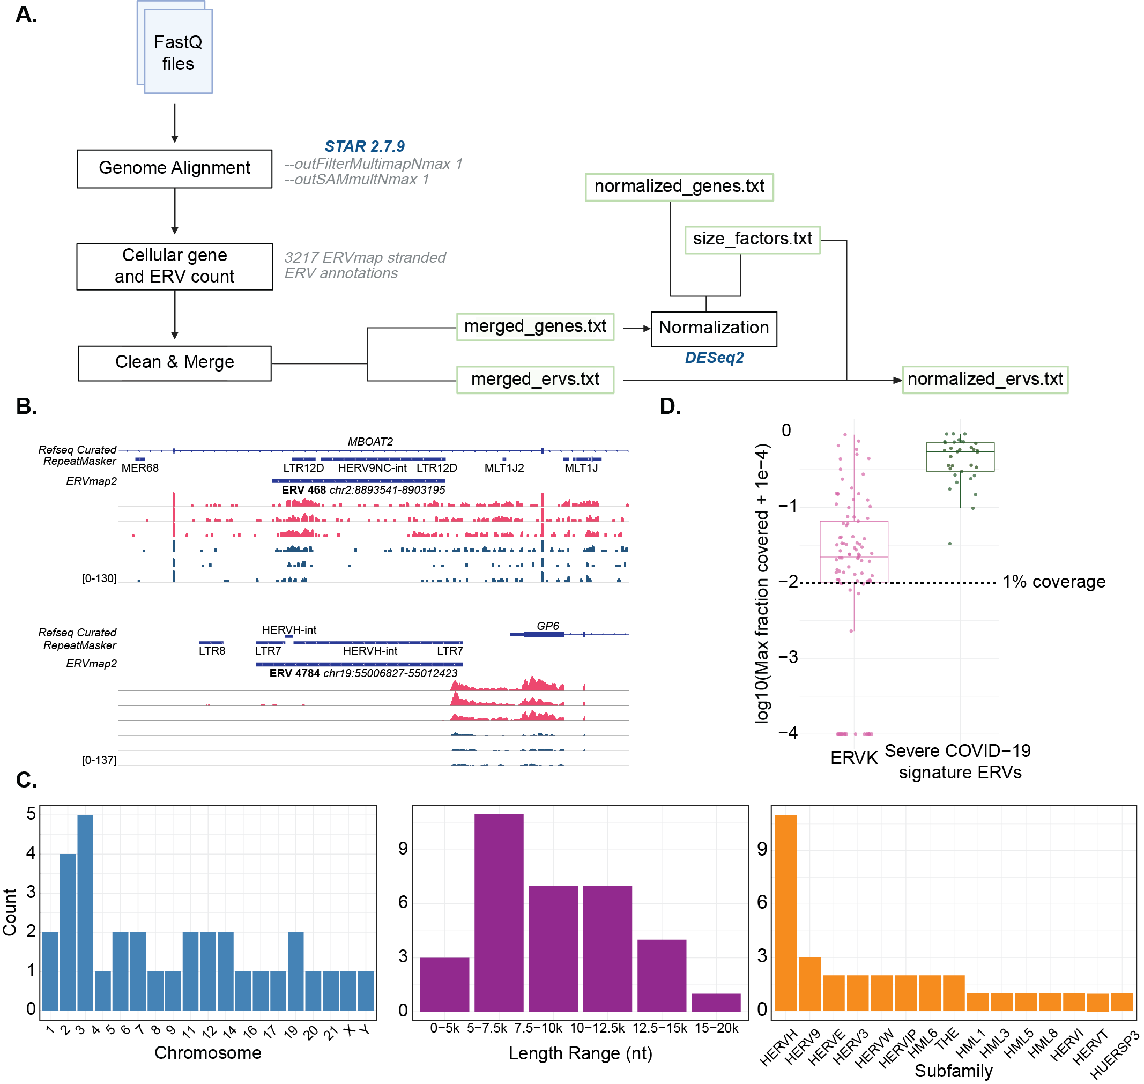
Fig. S1. Characterization of ERVs detected in severe COVID-19 patients. (A) Workflow of the ERVmap2 pipeline. (B) Read coverage for ERV 468 and 4784, illustrating non-ERV-specific expression patterns in severe COVID-19 patients (pink) and healthy controls (dark blue). (C) From left to right: histograms showing the chromosomal distribution, length, and group classification of the 33 severe COVID-19 signature ERVs. (D) Comparison of maximum fraction coverage between ERVK loci (n = 93, pink) and severe COVID-19 signature ERVs (n = 33, green) across all samples in the cohort.

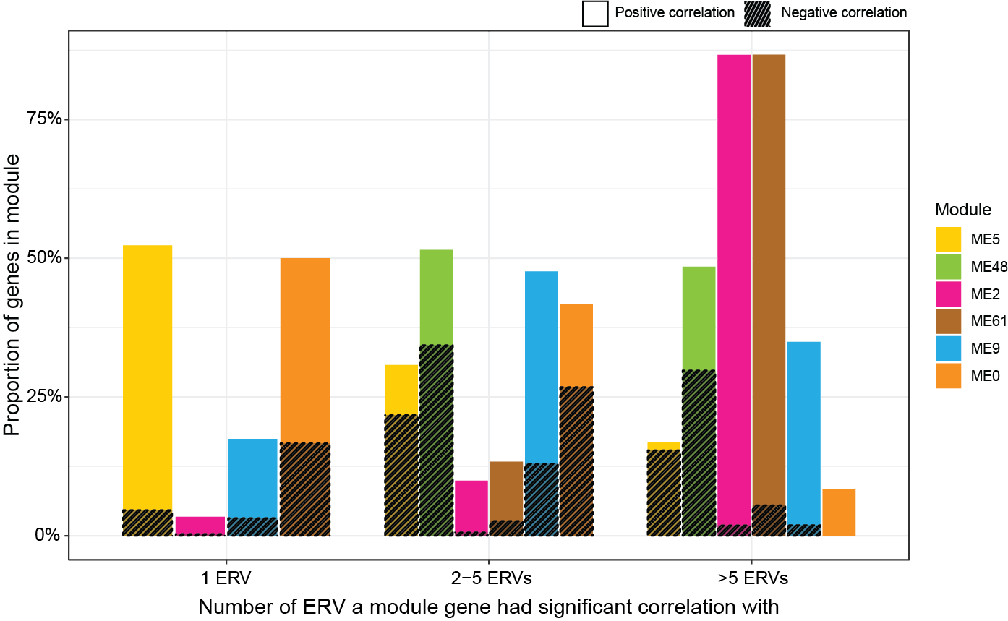
Fig. S2. ME2 genes correlate with the largest number of signature ERVs among all module eigengenes. Bar plot showing the proportion of genes representing the top five enriched Reactome pathways for each ME that significantly correlated (positively or negatively) (adjusted p < 0.05) with upregulated signature ERVs in severe COVID-19.
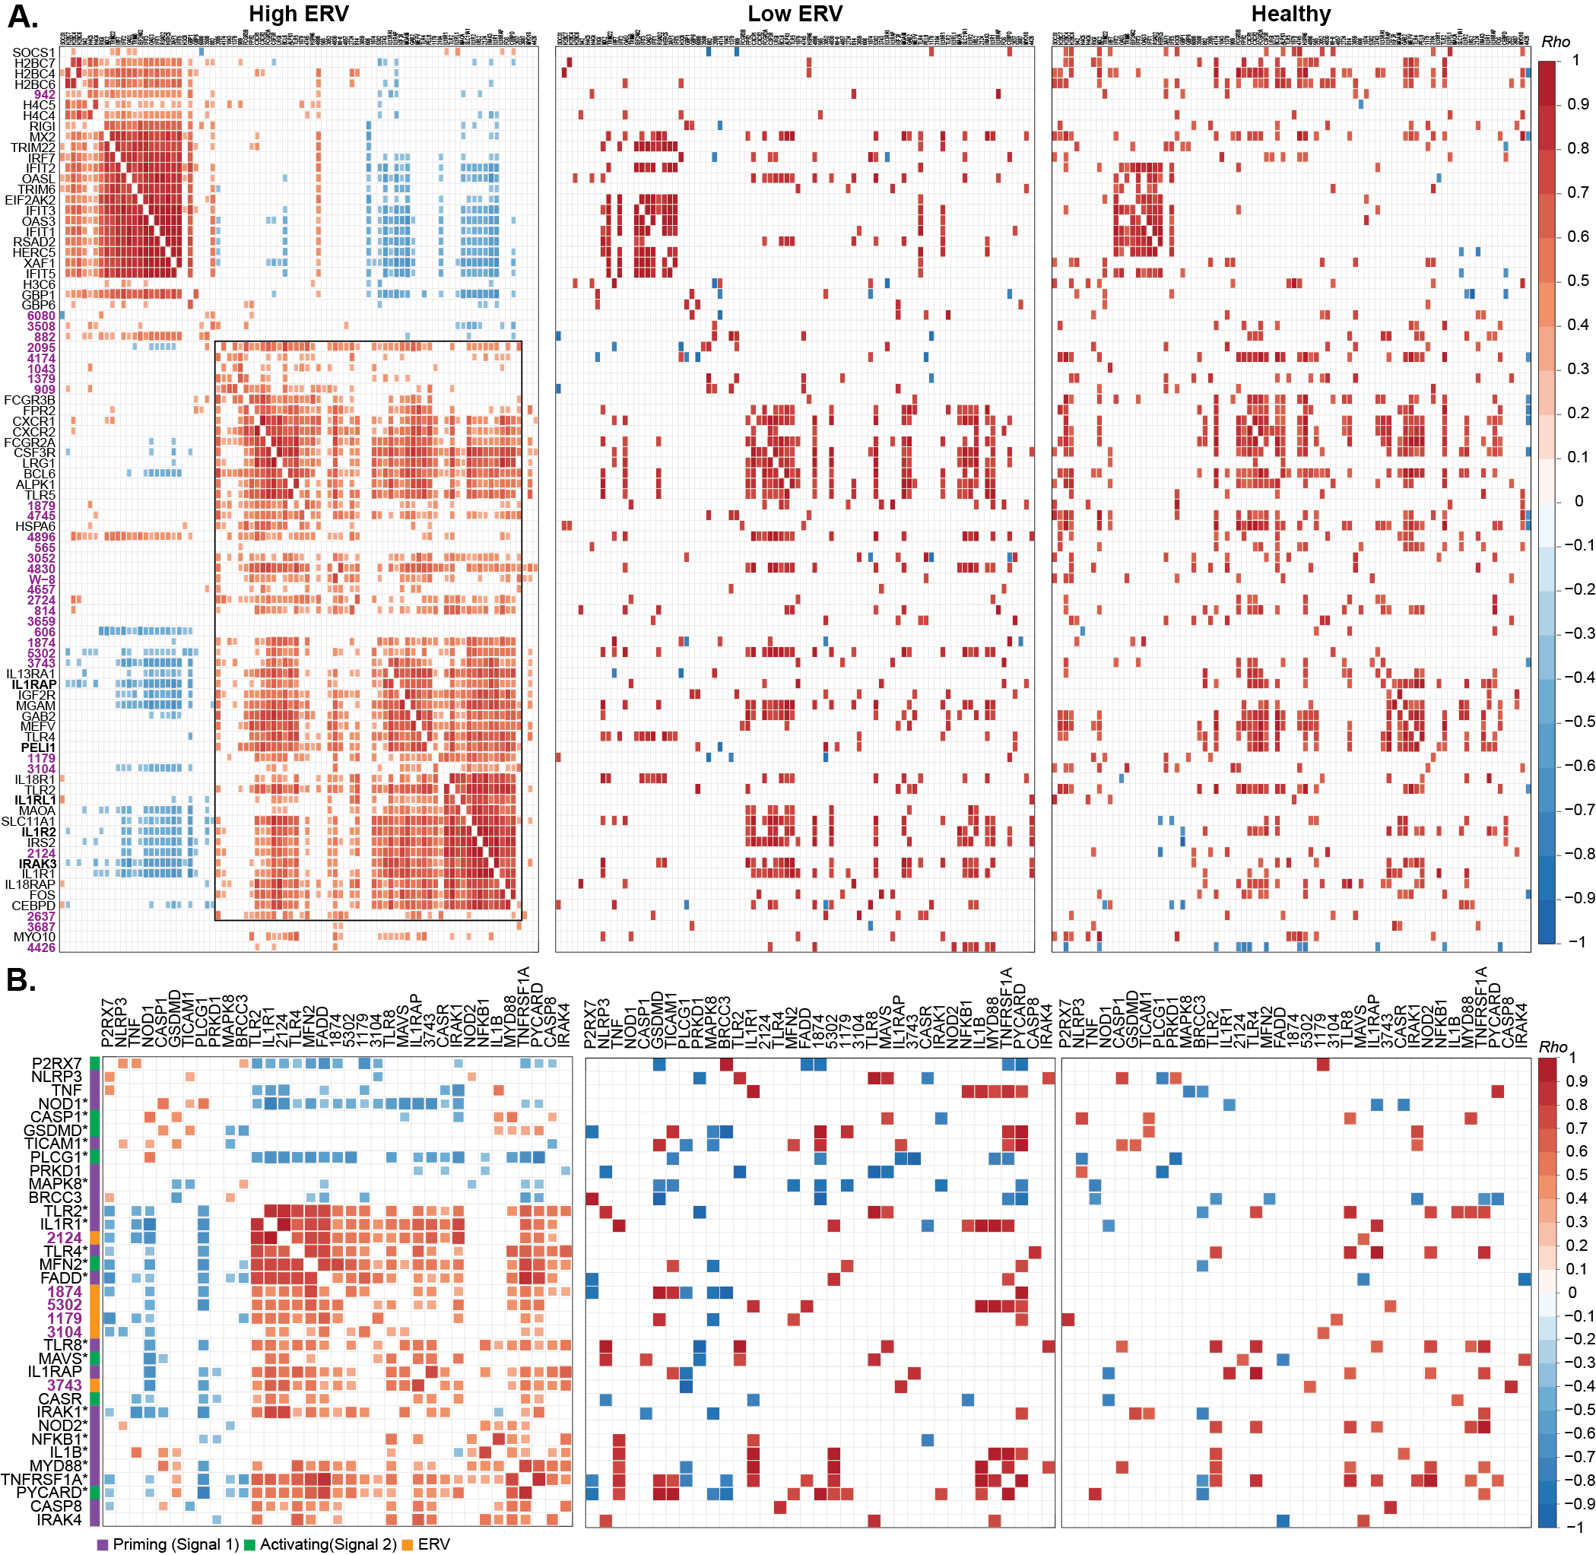
Fig. S3 Upregulated signature ERVs correlate with inflammatory genes in severe COVID-19 patients. (A) Heatmap showing Spearman correlations between upregulated Reactome genes and the 30 upregulated signature ERVs in ERV-high, ERV-low, and healthy groups. ERV names are shown in purple, and IL-1 signaling genes are highlighted in bold. (B) Heatmap showing Spearman correlations between ERVs and NLRP3 inflammasome activation genes in severe COVID-19 patients, grouped by ERV-high, ERV-low, and healthy groups. Genes upregulated in severe COVID-19 compared with healthy controls were annotated with asterisks (Wilcoxon rank-sum test, p < 0.05).

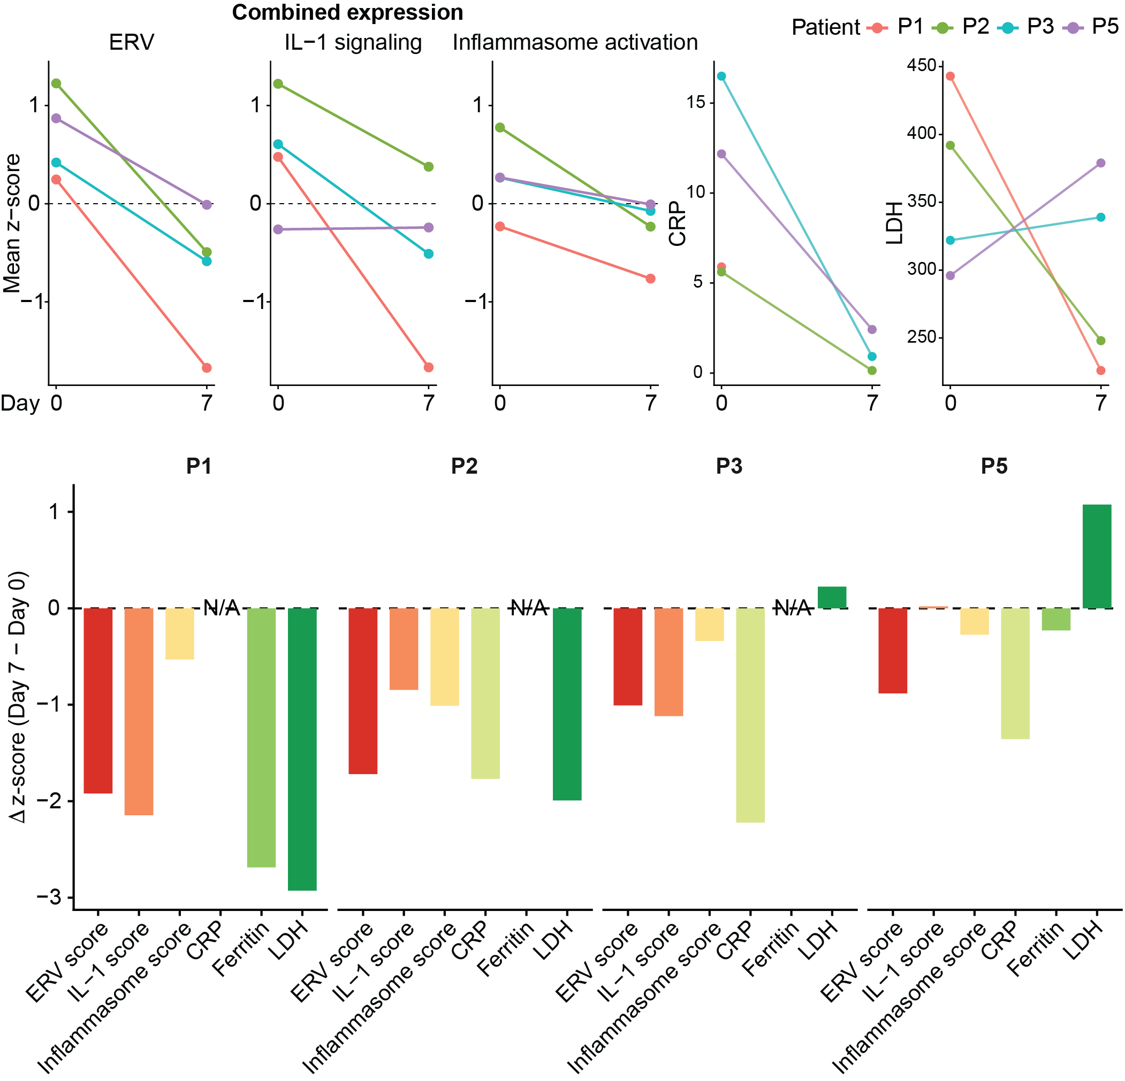
Fig. S4. Decreases in ERV expression paralleled changes in inflammatory processes and clinical markers. Top: Paired comparison of measurements at day 0 and day 7 for, from left to right, the combined expression of decreased signature ERVs, selected IL-1 signaling genes, NLRP3 inflammasome-associated genes, and the clinical markers CRP and LDH. Bottom: Changes in these features across individual patients, calculated as day 7 minus day 0 delta values.
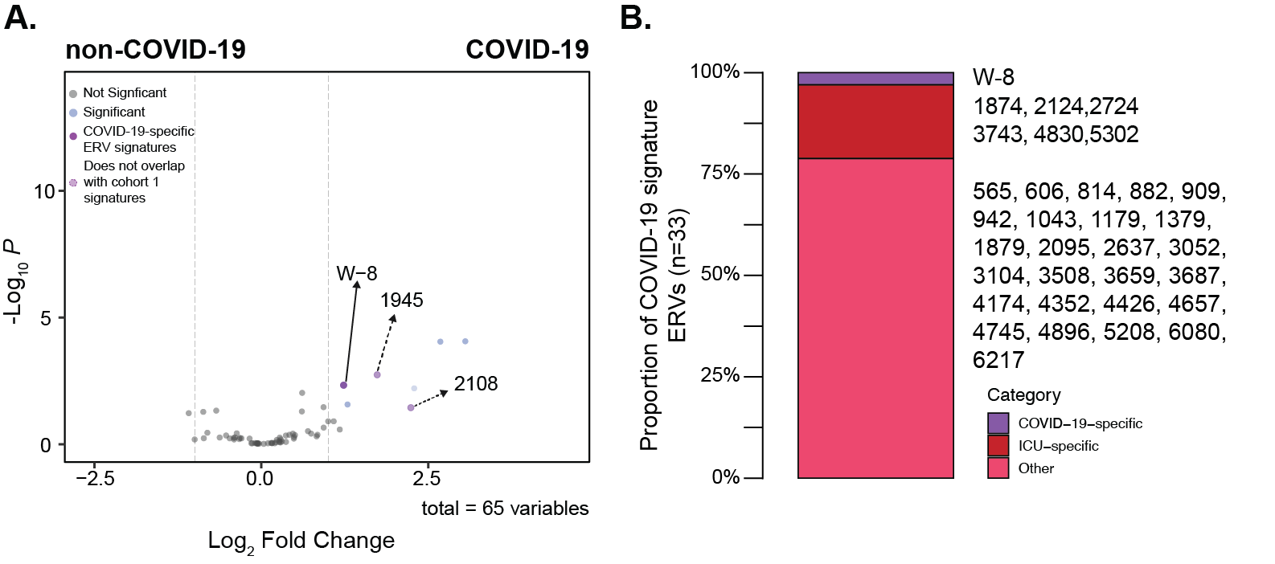
Fig. S5. Identification of COVID-19-specific signature ERV. (A) Volcano plot showing differential expression of ERVs between COVID-19 and non-COVID-19 patients. (B) Bar plot showing the proportion of severe COVID-19 signature ERVs that are ICU-specific and/or COVID-19-specific.

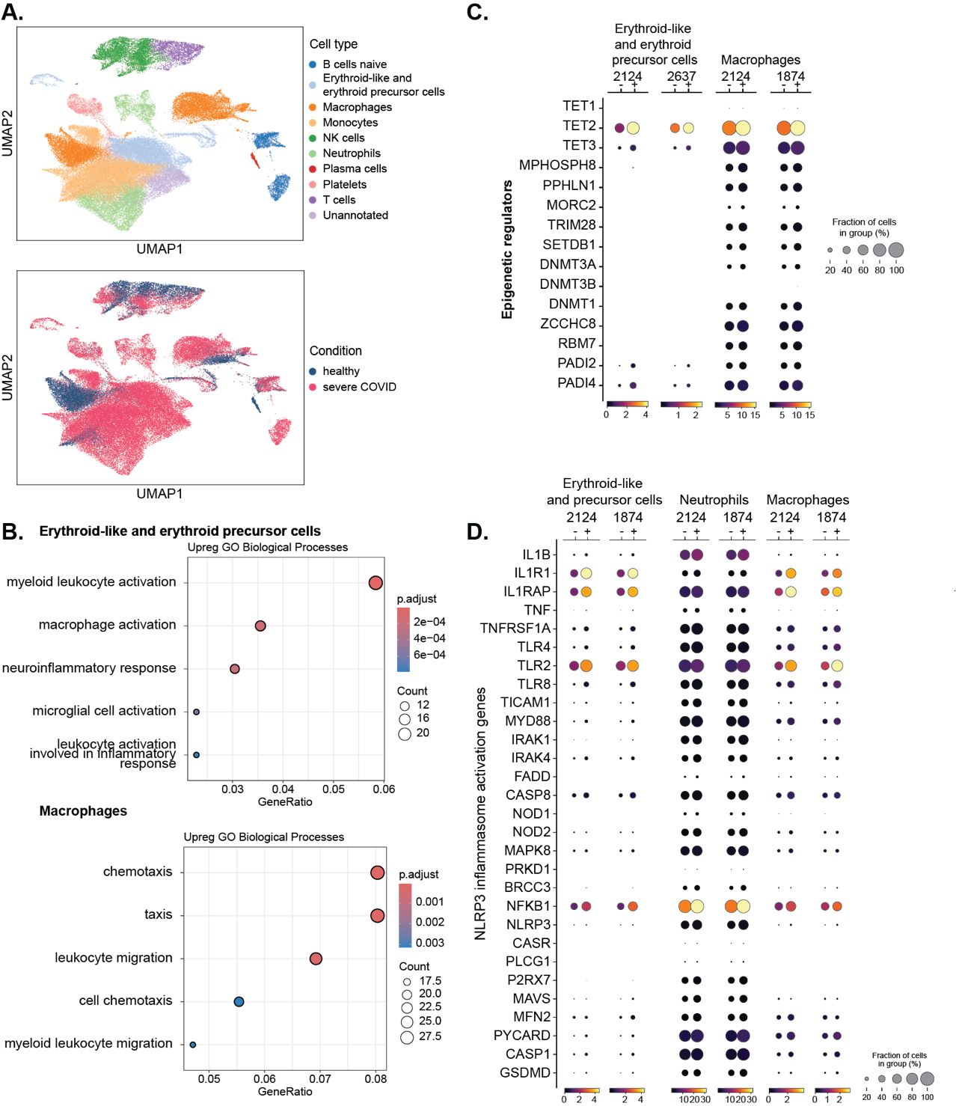
Fig. S6. Immune cells expressing signature ERVs show heightened expression of innate immune activation genes. (A) UMAP of whole-blood cells showing 14 clusters with cell type annotations (top) and disease conditions (bottom). (B) GO enrichment analysis of genes significantly upregulated in erythroid-like and erythroid precursor cells and macrophages from severe COVID-19 patients (adjusted p-value < 0.05, log2 fold change > 1). (C) Dot plots comparing the expression of epigenetic regulator genes in erythroid-like and erythroid precursor cells and macrophages that either express (+) or do not express (–) signature ERVs. (D) Dot plots comparing the expression of NLRP3 inflammasome activation genes in erythroid-like and erythroid precursor cells, neutrophils, and macrophages that either express (+) or do not express (–) signature ERVs.
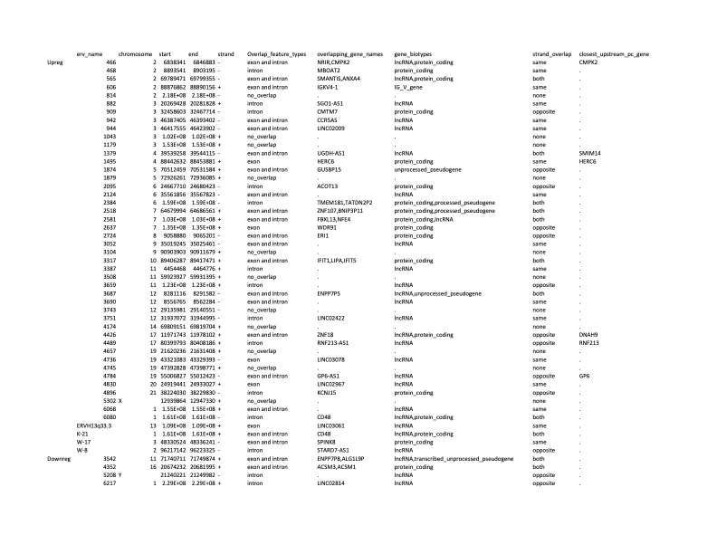
Table S1. Summary table of overlapping and upstream features of all DE-ERVs.

Table S2. Spearman correlation between excluded DE-ERVs and other genomic features.
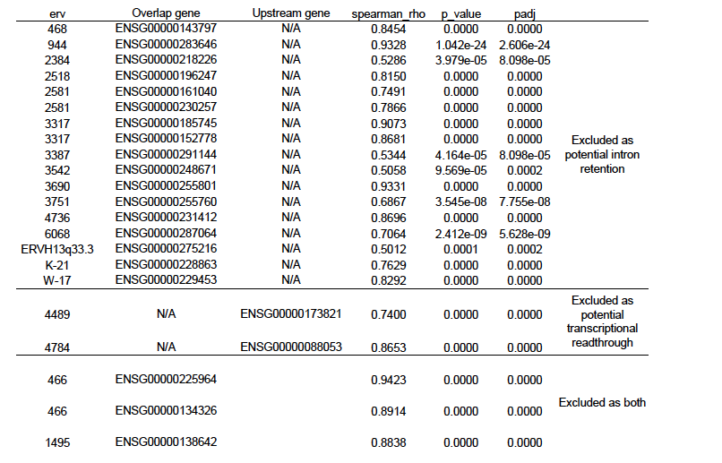

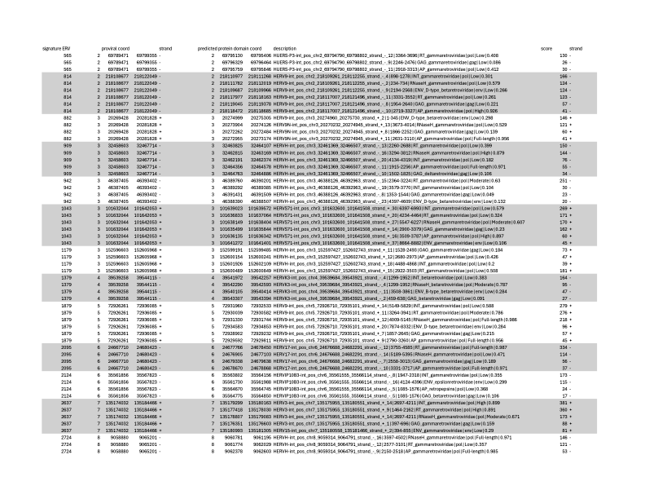
Table S3. HERVarium protein domain predictions with COVID-19 signature ERVs.

