Supplementary Figures:
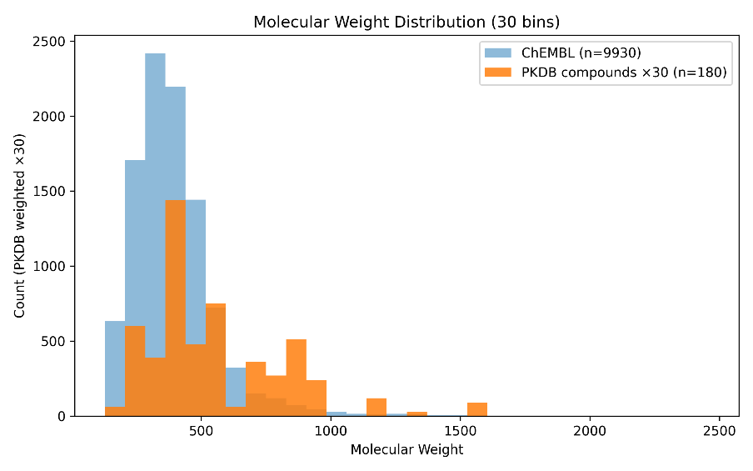
Supplementary Figure 1: Histogram of molecular weights of clinical stage compounds from ChEMBL and the cases from the PK database (multiplied by 30 to visualize comparative distributions)

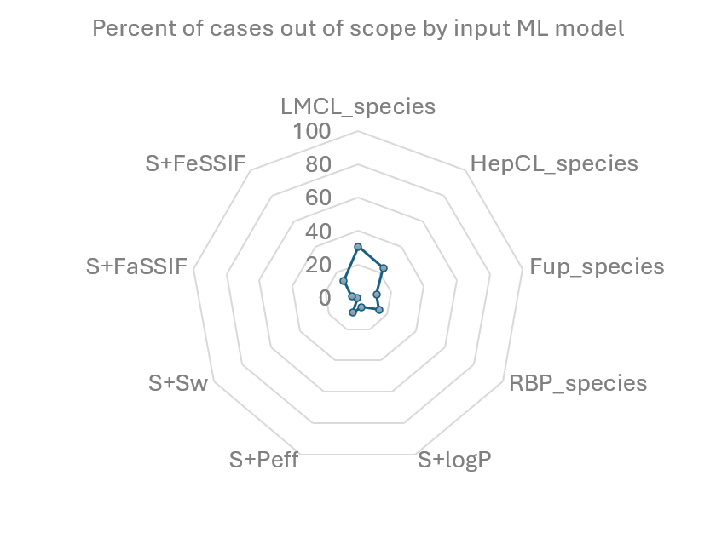
Supplementary Figure 2: Out of Scope (OoS) analysis. The ADMET Predictor software flags ML model predictions as OoS if a compound has any descriptor values outside the range of the compounds used to train the model. The nine major ML models used to parameterize HTPK are shown in the radar plot, with the percent of cases (n=180) that were flagged as OoS for each model.
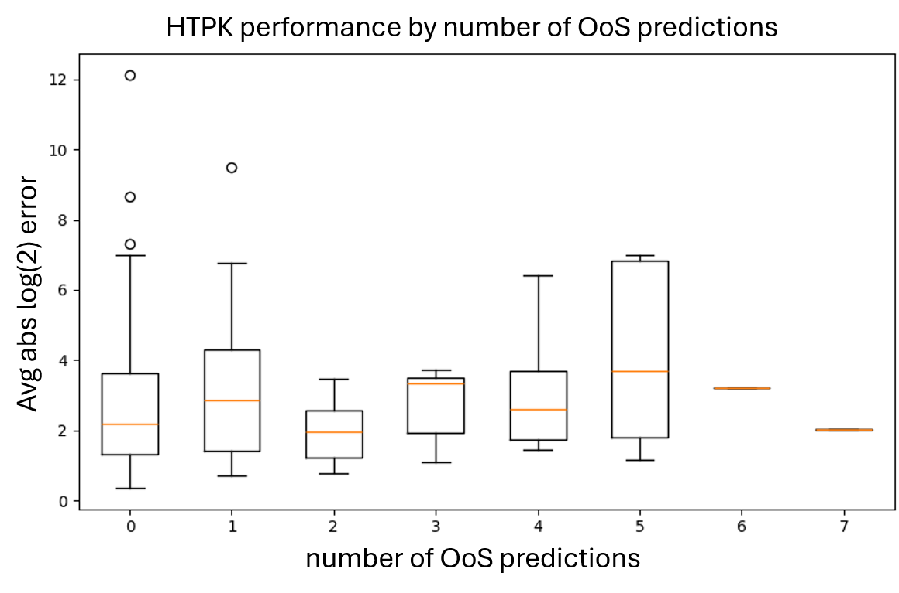
Supplementary Figure 3: HTPK performance by number of out of scope (OoS) predictions. HTPK was performed using species-specific liver microsome clearance models and the average absolute log(2) error is shown for all cases grouped by number of OoS predictions for the following models: LMCL, fup, RBP, permeability, log P, aqueous solubility, solubility factor, and FaSSIF/FeSSIF solubility.

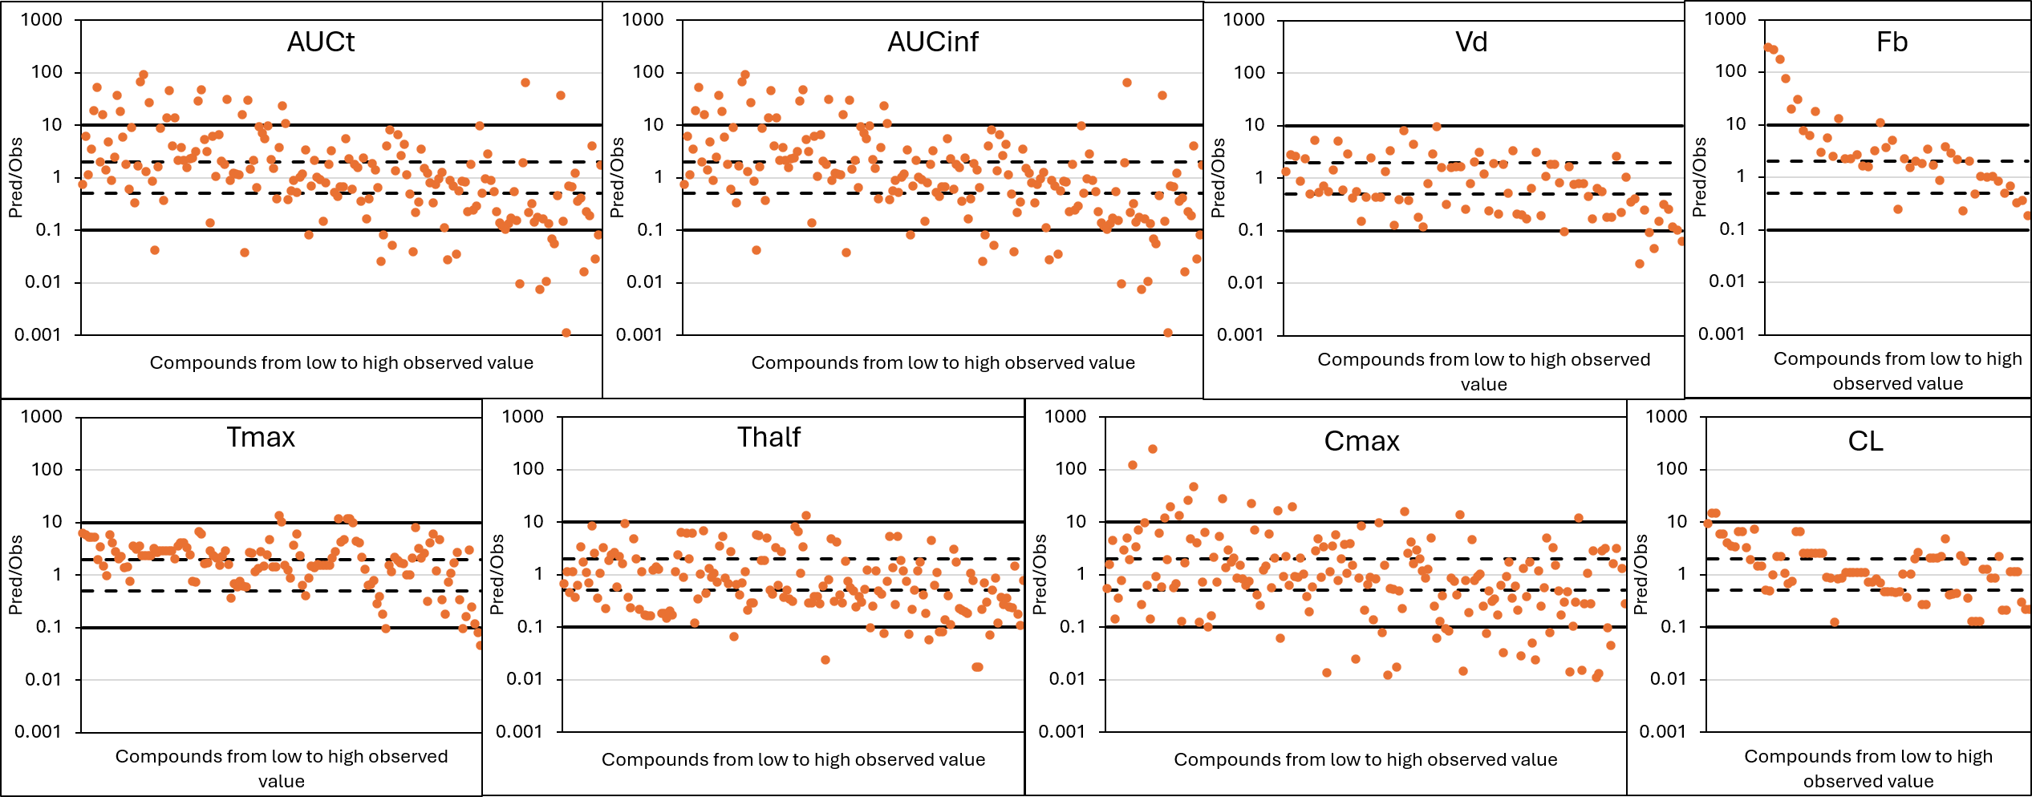
Supplementary Figure 4: Predicted vs Observed plots for HTPK endpoints. The predicted/observed value is shown for each case for the indicated PK endpoint. Data is organized from lowest to highest observed value, as estimated by Pkanalix from fitted curves. Solid line represents 10-fold error and the dotted line represents 2-fold error.
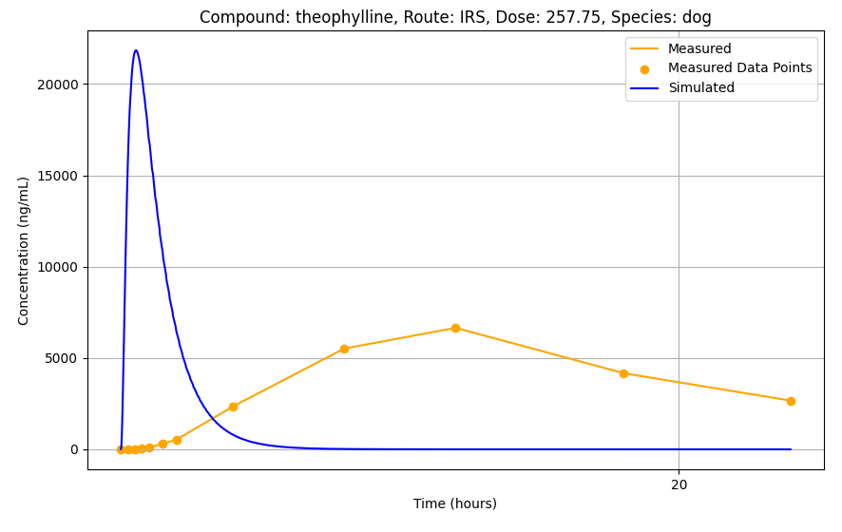
Supplementary Figure 5: Comparison of HTPK-simulated Cp-time curve (blue) and curve fitted to measured data (yellow) for dogs treated orally with theophylline. Upon careful inspection of the primary literature, the formulation was found to be extended release, which HTPK does not model.

