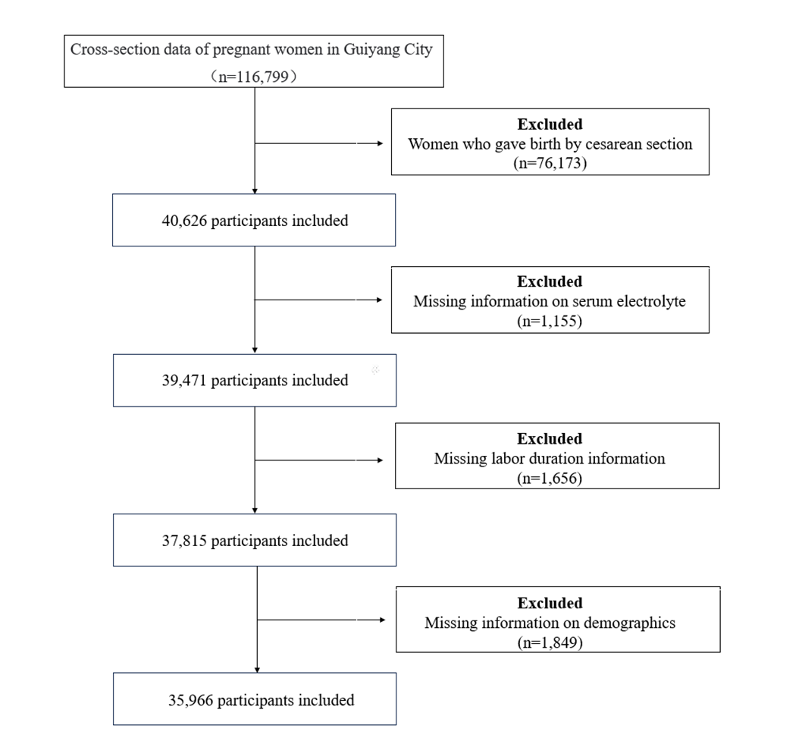
Figure S1 Flowchart of the study.

Table S1a The relationship between serum electrolyte levels and prolongation of the first stage of labor (excluding multiple pregnancies)
Outcomes |  | RR (95％CI) | P
K⁺ | 1 quantile(ref.)
 | 2 quantiles | 0.957 (0.762, 1.202) | 0.705
 | 3 quantiles | 0.974 (0.781, 1.213) | 0.813
 | 4 quantiles | 0.933 (0.745, 1.168) | 0.545
 | Per unit increase | 0.954 (0.744, 1.223) | 0.708
Na⁺ | 1 quantile(ref.)
 | 2 quantiles | 0.798 (0.660, 0.964) | 0.02
 | 3 quantiles | 0.778 (0.609, 0.993) | 0.044
 | 4 quantiles | 0.819 (0.661, 1.014) | 0.067
 | Per unit increase | 0.967 (0.937, 0.998) | 0.038
Cl⁻ | 1 quantile(ref.)
 | 2 quantiles | 1.022 (0.829, 1.261) | 0.836
 | 3 quantiles | 0.962 (0.774, 1.196) | 0.725
 | 4 quantiles | 0.978 (0.785, 1.217) | 0.84
 | Per unit increase | 0.992 (0.969, 1.016) | 0.512
Ca²⁺ | 1 quantile(ref.)
 | 2 quantiles | 0.901 (0.725, 1.121) | 0.349
 | 3 quantiles | 0.827 (0.662, 1.033) | 0.095
 | 4 quantiles | 0.875 (0.707, 1.084) | 0.222
 | Per unit increase | 0.668 (0.341, 1.308) | 0.239
Mg²⁺ | 1 quantile(ref.)
 | 2 quantiles | 1.133 (0.918, 1.399) | 0.245
 | 3 quantiles | 0.969 (0.781, 1.202) | 0.773
 | 4 quantiles | 0.878 (0.701, 1.100) | 0.259
 | Per unit increase | 0.752 (0.332, 1.706) | 0.496

Table S1b The relationship between serum electrolyte levels and prolongation of the second stage of labor (excluding multiple pregnancies)
Outcomes |  | RR(95％CI) | P
K⁺ | 1 quantile(ref.)
 | 2 quantiles | 1.108 (0.893, 1.375) | 0.352
 | 3 quantiles | 1.138 (0.917, 1.413) | 0.239
 | 4 quantiles | 1.015 (0.812, 1.270) | 0.895
 | Per unit increase | 1.016 (0.805, 1.283) | 0.893
Na⁺ | 1 quantile(ref.)
 | 2 quantiles | 1.360 (1.110, 1.665) | 0.003
 | 3 quantiles | 1.320 (1.034, 1.687) | 0.026
 | 4 quantiles | 1.541 (1.242, 1.912) | <0.001
 | Per unit increase | 1.062 (1.031, 1.094) | <0.001
Cl⁻ | 1 quantile(ref.)
 | 2 quantiles | 0.979 (0.784, 1.221) | 0.849
 | 3 quantiles | 1.272 (1.029, 1.572) | 0.026
 | 4 quantiles | 1.268 (1.024, 1.570) | 0.029
 | Per unit increase | 1.038 (1.014, 1.062) | 0.002
Ca²⁺ | 1 quantile(ref.)
 | 2 quantiles | 0.856 (0.695, 1.055) | 0.145
 | 3 quantiles | 0.820 (0.666, 1.010) | 0.062
 | 4 quantiles | 0.684 (0.553, 0.846) | <0.001
 | Per unit increase | 0.255 (0.134, 0.486) | <0.001
Mg²⁺ | 1 quantile(ref.)
 | 2 quantiles | 0.779 (0.625, 0.970) | 0.026
 | 3 quantiles | 0.976 (0.797, 1.194) | 0.813
 | 4 quantiles | 0.887 (0.719, 1.094) | 0.262
 | Per unit increase | 0.774 (0.361, 1.661) | 0.511

Table S2a The relationship between serum electrolyte levels and prolongation of the first stage of labor (excluding cases of kidney diseases)
 |  | RR (95％CI) | P
K⁺ | 1 quantile(ref.)
 | 2 quantiles | 0.959 (0.765, 1.203) | 0.719
 | 3 quantiles | 0.974 (0.783, 1.213) | 0.817
 | 4 quantiles | 0.927 (0.741, 1.160) | 0.506
 | Per unit increase | 0.946 (0.739, 1.211) | 0.662
Na⁺ | 1 quantile(ref.)
 | 2 quantiles | 0.811 (0.671, 0.979) | 0.03
 | 3 quantiles | 0.775 (0.607, 0.990) | 0.041
 | 4 quantiles | 0.819 (0.661, 1.015) | 0.068
 | Per unit increase | 0.967 (0.937, 0.998) | 0.039
Cl⁻ | 1 quantile(ref.)
 | 2 quantiles | 1.023 (0.830, 1.261) | 0.831
 | 3 quantiles | 0.956 (0.769, 1.188) | 0.686
 | 4 quantiles | 0.979 (0.786, 1.218) | 0.846
 | Per unit increase | 0.992 (0.969, 1.015) | 0.504
Ca²⁺ | 1 quantile(ref.)
 | 2 quantiles | 0.894 (0.719, 1.111) | 0.311
 | 3 quantiles | 0.828 (0.663, 1.033) | 0.094
 | 4 quantiles | 0.871 (0.705, 1.078) | 0.204
 | Per unit increase | 0.673 (0.345, 1.313) | 0.246
Mg²⁺ | 1 quantile(ref.)
 | 2 quantiles | 1.141 (0.925, 1.408) | 0.219
 | 3 quantiles | 0.970 (0.78, 1.204) | 0.784
 | 4 quantiles | 0.891 (0.712, 1.116) | 0.315
 | Per unit increase | 0.862 (0.383, 1.937) | 0.719

Table S2b The relationship between serum electrolyte levels and prolonged second stage of labor (excluding cases of kidney diseases)
 |  | RR(95％CI) | P
K⁺ | 1 quantile(ref.)
 | 2 quantiles | 1.100 (0.887, 1.364) | 0.384
 | 3 quantiles | 1.135 (0.915, 1.407) | 0.249
 | 4 quantiles | 1.146 (0.947, 1.301) | 0.889
 | Per unit increase | 1.028 (0.816, 1.296) | 0.812
Na⁺ | 1 quantile(ref.)
 | 2 quantiles | 1.354 (1.106, 1.657) | 0.003
 | 3 quantiles | 1.325 (1.039, 1.690) | 0.023
 | 4 quantiles | 1.542 (1.245, 1.911) | <0.001
 | Per unit increase | 1.063 (1.032, 1.095) | <0.001
Cl⁻ | 1 quantile(ref.)
 | 2 quantiles | 0.967 (0.776, 1.204) | 0.763
 | 3 quantiles | 1.249 (1.012, 1.541) | 0.039
 | 4 quantiles | 1.251 (1.012, 1.546) | 0.039
 | Per unit increase | 1.036 (1.013, 1.060) | 0.002
Ca²⁺ | 1 quantile(ref.)
 | 2 quantiles | 0.857 (0.697, 1.054) | 0.143
 | 3 quantiles | 0.818 (0.665, 1.006) | 0.057
 | 4 quantiles | 0.673 (0.545, 0.832) | <0.001
 | Per unit increase | 0.246 (0.130, 0.466) | <0.001
Mg²⁺ | 1 quantile(ref.)
 | 2 quantiles | 0.785 (0.631, 0.976) | 0.03
 | 3 quantiles | 0.970 (0.793, 1.186) | 0.765
 | 4 quantiles | 0.891 (0.723, 1.098) | 0.279
 | Per unit increase | 0.756 (0.362, 1.579) | 0.456

Table S3a The relationship between serum electrolyte levels and prolongation of the first stage of labor (excluding induced labor)
 |  | RR (95％CI) | P
K⁺ | 1 quantile(ref.)
 | 2 quantiles | 0.946 (0.752, 1.190) | 0.637
 | 3 quantiles | 0.971 (0.778, 1.212) | 0.797
 | 4 quantiles | 0.927 (0.740, 1.162) | 0.511
 | Per unit increase | 0.954 (0.742, 1.226) | 0.711
Na⁺ | 1 quantile(ref.)
 | 2 quantiles | 0.816 (0.674, 0.987) | 0.036
 | 3 quantiles | 0.766 (0.598, 0.982) | 0.036
 | 4 quantiles | 0.822 (0.662, 1.020) | 0.076
 | Per unit increase | 0.968 (0.937, 0.999) | 0.044
Cl⁻ | 1 quantile(ref.)
 | 2 quantiles | 1.044 (0.845, 1.290) | 0.69
 | 3 quantiles | 0.948 (0.763, 1.179) | 0.633
 | 4 quantiles | 0.987 (0.792, 1.231) | 0.91
 | Per unit increase | 0.993 (0.970, 1.017) | 0.551
Ca²⁺ | 1 quantile(ref.)
 | 2 quantiles | 0.886 (0.711, 1.104) | 0.28
 | 3 quantiles | 0.840 (0.672, 1.049) | 0.125
 | 4 quantiles | 0.871 (0.703, 1.079) | 0.205
 | Per unit increase | 0.677 (0.345, 1.328) | 0.256
Mg²⁺ | 1 quantile(ref.)
 | 2 quantiles | 1.140 (0.922, 1.410) | 0.226
 | 3 quantiles | 0.986 (0.794, 1.225) | 0.897
 | 4 quantiles | 0.890 (0.709, 1.116) | 0.312
 | Per unit increase | 0.795 (0.358, 1.768) | 0.574

Table S3b The relationship between serum electrolyte levels and prolonged second stage of labor (excluding induced labor)
 |  | RR(95％CI) | P
K⁺ | 1 quantile(ref.)
 | 2 quantiles | 1.100 (0.870, 1.390) | 0.426
 | 3 quantiles | 1.131 (0.898, 1.424) | 0.297
 | 4 quantiles | 1.049 (0.828, 1.328) | 0.694
 | Per unit increase | 1.049 (0.822, 1.339) | 0.7
Na⁺ | 1 quantile(ref.)
 | 2 quantiles | 1.404 (1.134, 1.739) | 0.002
 | 3 quantiles | 1.360 (1.048, 1.765) | 0.021
 | 4 quantiles | 1.658 (1.323, 2.078) | <0.001
 | Per unit increase | 1.073 (1.040, 1.107) | <0.001
Cl⁻ | 1 quantile(ref.)
 | 2 quantiles | 0.886 (0.698, 1.125) | 0.321
 | 3 quantiles | 1.296 (1.042, 1.610) | 0.02
 | 4 quantiles | 1.286 (1.029, 1.607) | 0.027
 | Per unit increase | 1.042 (1.017, 1.068) | <0.001
Ca²⁺ | 1 quantile(ref.)
 | 2 quantiles | 0.844 (0.679, 1.050) | 0.128
 | 3 quantiles | 0.773 (0.621, 0.964) | 0.022
 | 4 quantiles | 0.672 (0.538, 0.839) | <0.001
 | Per unit increase | 0.251 (0.127, 0.496) | <0.001
Mg²⁺ | 1 quantile(ref.)
 | 2 quantiles | 0.732 (0.581, 0.922) | 0.008
 | 3 quantiles | 0.936 (0.758, 1.155) | 0.537
 | 4 quantiles | 0.882 (0.710, 1.095) | 0.257
 | Per unit increase | 1.000 (0.398, 2.515) | >0.999

