Supplementary document

SEARCH STRATEGY

PUBMED:
- ("prostate cancer" OR "prostate cancers" OR "prostate carcinoma" OR "prostate carcinomas" OR "prostate malignancy" OR "prostate malignancies" OR "prostate tumor" OR "prostate tumors" OR "prostate neoplasm" OR "prostate neoplasms" OR "prostatic cancer" OR "prostatic cancers" OR "prostatic carcinoma" OR "prostatic carcinomas" OR "prostatic malignancy" OR "prostatic malignancies" OR "prostatic tumor" OR "prostatic tumors" OR "prostatic neoplasm" OR "prostatic neoplasms")
AND
("prostatectomy without biopsy"[tiab:~0] OR "prostatectomy without biopsies"[tiab:~0] OR "prostatectomy without prior biopsy"[tiab:~0] OR "prostatectomy without prior biopsies"[tiab:~0] OR "prostatectomy without preoperative biopsy"[tiab:~0] OR "prostatectomy without preoperative biopsies"[tiab:~0] OR "biopsy-free prostatectomy"[tiab:~0] OR "biopsies-free prostatectomy"[tiab:~0] OR "biopsy-free radical prostatectomy"[tiab:~0] OR "biopsies-free radical prostatectomy"[tiab:~0] OR "prostatectomy without prostate biopsy"[tiab:~0] OR "prostatectomy without prostate biopsies"[tiab:~0] OR "without prior biopsy"[tiab:~0] OR "no prior biopsy"[tiab:~0] OR "without preoperative biopsy"[tiab:~0] OR "without diagnostic biopsy"[tiab:~0] OR "without histologic confirmation"[tiab:~0] OR "without histological confirmation"[tiab:~0] OR "without histopathological confirmation"[tiab:~0] OR "without histologic diagnosis"[tiab:~0] OR "without histological diagnosis"[tiab:~0] OR "without histopathological diagnosis"[tiab:~0] OR "direct prostatectomy"[tiab:~0] OR "direct radical prostatectomy"[tiab:~0] OR "upfront prostatectomy"[tiab:~0] OR "upfront radical prostatectomy"[tiab:~0] OR "primary prostatectomy"[tiab:~0] OR "primary radical prostatectomy"[tiab:~0] OR "prostatectomy without biopsy"[tiab:~0] OR "radical prostatectomy without biopsy"[tiab:~0] OR "prostatectomy-first approach"[tiab:~0] OR "radical prostatectomy-first approach"[tiab:~0])

COCHRANE:
- ("prostate cancer" OR "prostate cancers" OR "prostate carcinoma" OR "prostate carcinomas" OR "prostate malignancy" OR "prostate malignancies" OR "prostate tumor" OR "prostate tumors" OR "prostate neoplasm" OR "prostate neoplasms" OR "prostatic cancer" OR "prostatic cancers" OR "prostatic carcinoma" OR "prostatic carcinomas" OR "prostatic malignancy" OR "prostatic malignancies" OR "prostatic tumor" OR "prostatic tumors" OR "prostatic neoplasm" OR "prostatic neoplasms")
AND
("prostatectomy without biopsy" OR "prostatectomy without biopsies" OR "prostatectomy without prior biopsy" OR "prostatectomy without prior biopsies" OR "prostatectomy without preoperative biopsy" OR "prostatectomy without preoperative biopsies" OR "biopsy-free prostatectomy" OR "biopsies-free prostatectomy" OR "biopsy-free radical prostatectomy" OR "biopsies-free radical prostatectomy" OR "prostatectomy without prostate biopsy" OR "prostatectomy without prostate biopsies" OR "without prior biopsy" OR "no prior biopsy" OR "without preoperative biopsy" OR "without diagnostic biopsy" OR "without histologic confirmation" OR "without histological confirmation" OR "without histopathological confirmation" OR "without histologic diagnosis" OR "without histological diagnosis" OR "without histopathological diagnosis" OR "direct prostatectomy" OR "direct radical prostatectomy" OR "upfront prostatectomy" OR "upfront radical prostatectomy" OR "primary prostatectomy" OR "primary radical prostatectomy" OR "prostatectomy without biopsy" OR "radical prostatectomy without biopsy" OR "prostatectomy-first approach" OR "radical prostatectomy-first approach")

EMBASE:
- ('prostate cancer' OR 'prostate cancers' OR 'prostate carcinoma' OR 'prostate carcinomas' OR 'prostate malignancy' OR 'prostate malignancies' OR 'prostate tumor' OR 'prostate tumors' OR 'prostate neoplasm' OR 'prostate neoplasms' OR 'prostatic cancer' OR 'prostatic cancers' OR 'prostatic carcinoma' OR 'prostatic carcinomas' OR 'prostatic malignancy' OR 'prostatic malignancies' OR 'prostatic tumor' OR 'prostatic tumors' OR 'prostatic neoplasm' OR 'prostatic neoplasms')
AND
('prostatectomy without biopsy' OR 'prostatectomy without biopsies' OR 'prostatectomy without prior biopsy' OR 'prostatectomy without prior biopsies' OR 'prostatectomy without preoperative biopsy' OR 'prostatectomy without preoperative biopsies' OR 'biopsy-free prostatectomy' OR 'biopsies-free prostatectomy' OR 'biopsy-free radical prostatectomy' OR 'biopsies-free radical prostatectomy' OR 'prostatectomy without prostate biopsy' OR 'prostatectomy without prostate biopsies' OR 'without prior biopsy' OR 'no prior biopsy' OR 'without preoperative biopsy' OR 'without diagnostic biopsy' OR 'without histologic confirmation' OR 'without histological confirmation' OR 'without histopathological confirmation' OR 'without histologic diagnosis' OR 'without histological diagnosis' OR 'without histopathological diagnosis' OR 'direct prostatectomy' OR 'direct radical prostatectomy' OR 'upfront prostatectomy' OR 'upfront radical prostatectomy' OR 'primary prostatectomy' OR 'primary radical prostatectomy' OR 'radical prostatectomy without biopsy' OR 'prostatectomy-first approach' OR 'radical prostatectomy-first approach')

GOOGLE SCHOLAR:
- With the exact phrase: "prostatectomy without biopsy" OR "prostatectomy without biopsies" OR "prostatectomy without prior biopsy" OR "prostatectomy without prior biopsies" OR "prostatectomy without preoperative biopsy" OR "prostatectomy without preoperative biopsies" OR "biopsy-free prostatectomy" OR "biopsies-free prostatectomy" OR "biopsy-free radical prostatectomy" OR "biopsies-free radical prostatectomy" OR "prostatectomy without prostate biopsy" OR "prostatectomy without prostate biopsies" OR "without prior biopsy" OR "no prior biopsy" OR "without preoperative biopsy" OR "without diagnostic biopsy" OR "without histologic confirmation" OR "without histological confirmation" OR "without histopathological confirmation" OR "without histologic diagnosis" OR "without histological diagnosis" OR "without histopathological diagnosis" OR "direct prostatectomy" OR "direct radical prostatectomy" OR "upfront prostatectomy" OR "upfront radical prostatectomy" OR "primary prostatectomy" OR "primary radical prostatectomy" OR "prostatectomy without biopsy" OR "radical prostatectomy without biopsy" OR "prostatectomy-first approach" OR "radical prostatectomy-first approach"
- With at least one of the words: "prostate cancer" OR "prostate cancers" OR "prostate carcinoma" OR "prostate carcinomas" OR "prostate malignancy"
- Without the words: Prevalence, epidemiology, case reports

DATABASE

○ PUBMED: 168
○ EMBASE: 283
○ COCHRANE: 35
○ GOOGLE SCHOLAR: 136
■ SUM: 622

SUPPLEMENTARY RESULTS
Restricting the Chaloupka et al. (2023) cohort to its strictly imaging-defined subgroup (n = 33) yielded a csPCa proportion of 95.3% (95% CI 89.0–98.1), while the DerSimonian–Laird model with Hartung–Knapp adjustment produced an estimate of 92.0% (95% CI 84.4–96.0). Leave-one-out estimates ranged from 92.5% to 95.0%. On the Baujat plot, the largest study (Li et al., 2026 [23]; 100% csPCa) contributed most to the pooled estimate, whereas two small, lower-yield studies (Magdaleno [11] and Xing [10]) accounted for most of the heterogeneity (Supplementary Fig. 1). Egger’s test showed no evidence of funnel plot asymmetry for csPCa (p = .27), and the corresponding funnel plot was visually symmetric (Supplementary Fig. 2A). In contrast, Egger’s test indicated funnel plot asymmetry for PSM (p = .002). However, this finding should not be interpreted as definitive evidence of publication bias or small-study effects, because Egger’s regression may be unreliable in meta-analyses of proportions, particularly when few studies and zero-event cohorts are included (Supplementary Fig. 2B).

Reference: Chaloupka M, Apfelbeck M, Pyrgidis N, Marcon J, Weinhold P, Stief CG (2023) Radical prostatectomy without prior biopsy in patients with high suspicion of prostate cancer based on multiparametric magnetic resonance imaging and prostate-specific membrane antigen positron emission tomography: a prospective cohort study. Cancers 15:1266.

Supplementary Figure 1. Baujat plot.

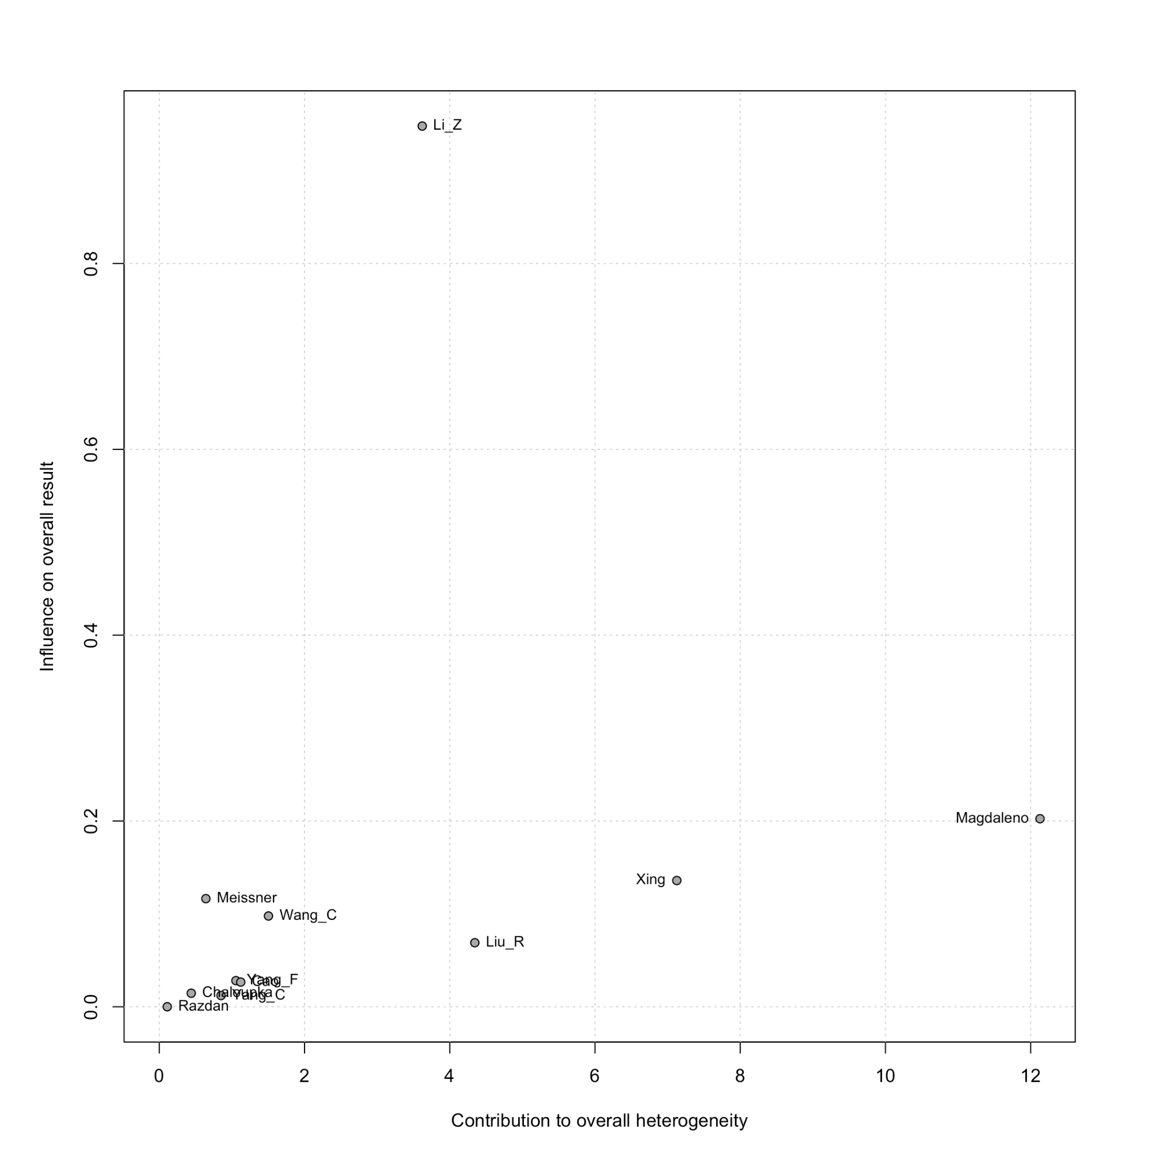

Supplementary Figure 2A. Funnel plot of csPCa on final pathology among patients undergoing biopsy-free RP.
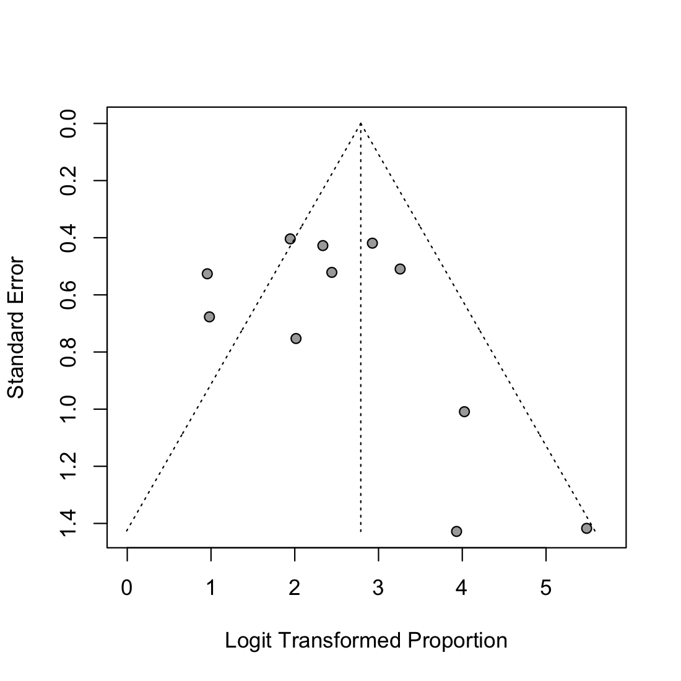

Supplementary Figure 2B. Funnel plot of PSM.
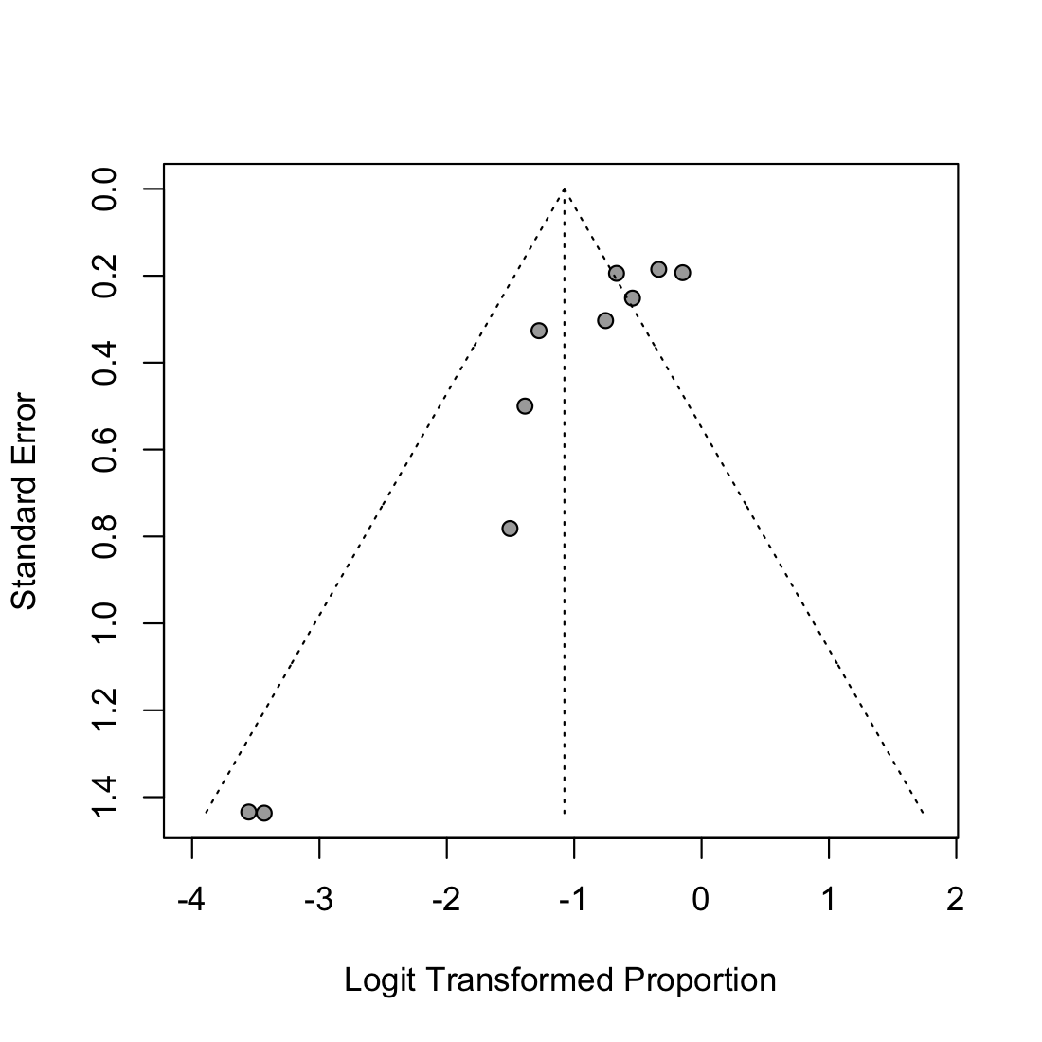

Supplementary Figure 3. Risk of bias.
