Electronic supplementary information

First Scalable 18650 Aqueous-based Supercapacitors Using Hydrophobicity of Anti-corrosion Graphite Passivation Layer

EXPERIMENTAL SECTION
Chemicals and materials
Graphite (particle size of <20 μm, Sigma-Aldrich), Activated carbon (TF-B520, MTI), Carbon black (Super P, TIMCAL), N-methyl pyrrolidinone (99.5% 1-Methyl-2-Pyrrolidone, QRec), Polyvinylidene fluoride (PVDF, Mw ∼534,000, Sigma-Aldrich), Sodium sulfate (Na₂SO₄, CARLO ERBA) were used without any purification. Deionised water was purified using Milli-Q system (DI water, 15 MΩ cm, Millipore). Aluminium foil (thickness of 18 µm, GELON LIB) was used as a current collector.

Electrode preparation
The current collector was modified by coating the graphite as a protective layer on top and bottom of aluminium (Al) foil surface. Firstly, the graphite slurry was prepared by mixing graphite with conductive carbon black (Super P) and polyvinylidene fluoride (PVDF) binder in a weight ratio of 83:7:10 in N-methyl pyrrolidinone (NMP). The total solid content is about 20% and then kept stirred for 10 h to obtain a homogenous slurry. The as-prepared graphite slurry was coated onto the surface of Al foil using a roll-to-roll coating machine as shown in Fig S1a. Secondly, the as-modified current collector was dried at 120ºC under vacuum for 24 h before coating an active material, activated carbon. Then, the activated carbon slurry was prepared by following the same slurry preparation as the graphite (using activated carbon instead of graphite) but the solid content of activated carbon slurry is about 15%. The homogeneous activated carbon slurry was coated onto the top and bottom surfaces of Al foil by using a roll-to-roll coating machine as demonstrated in Fig S1b. Then, the electrode was dried at 120 °C under vacuum for 48 h. In addition to the modified electrode, the activated carbon was coated onto Al foil (without graphite coating) for comparing the electrochemical performances of the electrodes (Fig. S2). Note, all the as-prepared electrodes were pressed at 1 ton before the electrochemical measurement and the active mass loading of all the as-prepared electrodes is about 3.5 mg cm⁻².
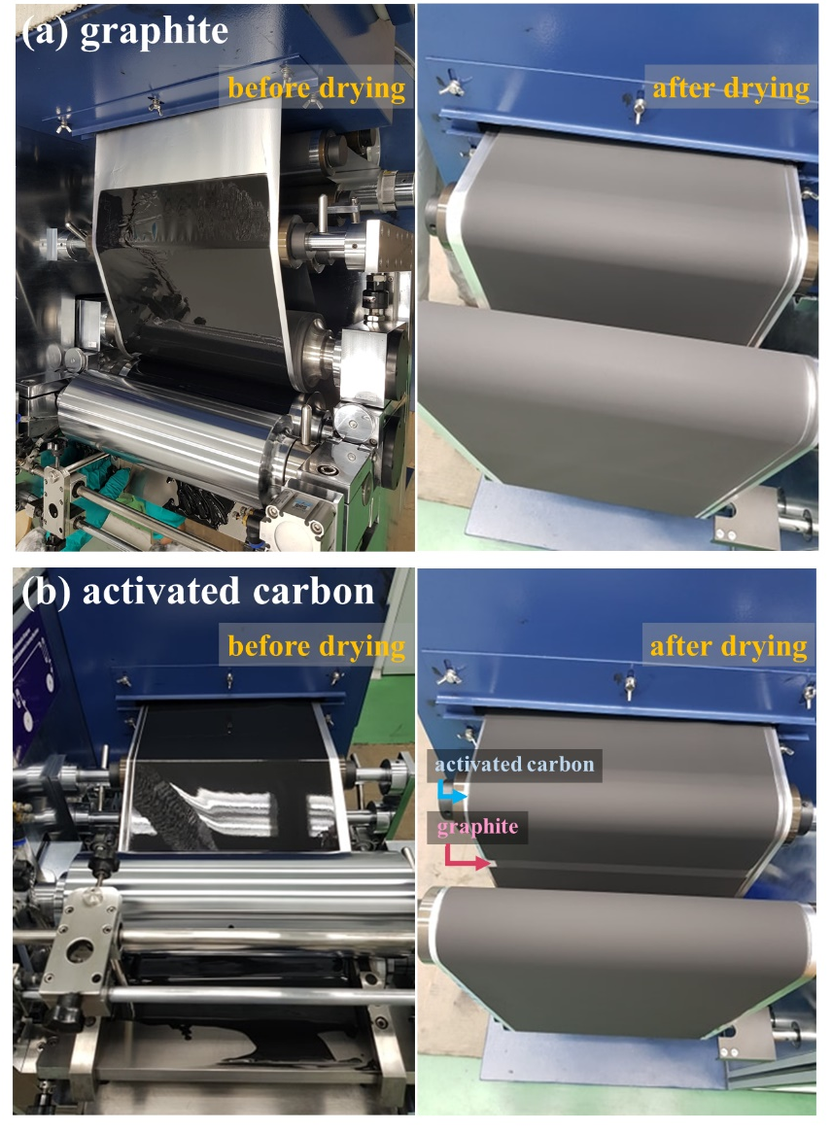
Figure S1. Electrode preparation using a roll-to-roll coating machine of (a) graphite on bare aluminium foil and (b) activated carbon coated on graphite coated aluminium foil.

Figure S2. Electrode preparation of activated carbon coated on bare aluminium foil using a roll-to-roll coating machine.

Cell Assembly
The 18650 cylindrical cell fabrication was demonstrated briefly in Fig. S3. Firstly, the as-prepared electrodes were slit and cut into the size of 26. 3 cm (Length) x 5.6 cm (Width) as demonstrated in Fig. S3a. The hydrolyzed polyethylene (PE) with a thickness of 175 µm was used as a separator with a size of 70 cm (L) x 5.8 cm (W). Then, the two symmetric electrodes and a separator were rolled together by using a winding machine in which the as-rolled electrodes were shown in Fig. S3b. Then, the as-rolled electrodes were put into the case and weld with the case and the cap (Fig. S3c). Finally, each cell was injected with 1 M Na₂SO₄ electrolyte fully (ca. 5 g of the electrolyte). Prior to measurement, all the as-assembled cylindrical cells were aged for 2 days.

Figure S3. 18650 cylindrical cell fabrication; (a) slitting of electrode, (b) the as-winded electrodes coupled with a separator, and (c) the as-welded electrodes with the case.

The electrochemical measurement
The electrochemical evaluation was firstly carried out in a three-electrode configuration in 50 mL of 1 M Na₂SO₄ electrolyte. The as-prepared electrodes were then cut into 1 cm² and then used as a working electrode. The polycrystalline platinum and the mercury/mercury sulfate (Hg/Hg₂SO₄) electrode were used as counter electrode and reference electrode, respectively. The electrochemical performance of the as-prepared electrodes was investigated by cyclic voltammetry (CV) and galvanostatic charge/discharge (GCD) with recording between -0.6 and 0.3 V vs. Hg/Hg₂SO₄. The EIS was carried out in a frequency range from 50 kHz to 0.01 Hz at the open circuit potential with a voltage amplitude of 10 mV. Note, prior to electrochemical measurement, the as-prepared electrodes were activated via CV at a scan rate of 10 mV s⁻¹ for 20 cycles. The 18650 cylindrical cells were then investigated for the rate capability and stability via GCD method by using the battery tester (Neware, Gelon, Hong Kong).

The electrochemical calculation
For three-electrode configuration
The specific capacitance of the prepared samples can be calculated from both CV and GCD following equation (S1) and (S2)¹⁻³;

For CV
$C_{CV}= \int{\frac{IdV/v}{m∆V}}$ (S1)
where I is the response current, ∫𝐼𝑑𝑉/𝑣 (Coulomb) is the integrated area of the CV (discharge process) which refers to the total amount of charge on the surface of the electrode, ∆𝑉 is the potential window, and m is the mass loading of active material.

For GCD
$C_{GCD}=\frac{I∆t}{∆V}$ (S2)
where I is the applied current density, ∆𝑉 is the potential window of discharge, Δt is the discharge time.

To further analyse the impedance data, the real and imaginary parts of the complex capacitance were then calculated by the following equation (S3) and (S4), respectively.^{2, 4}
𝐶'(𝜔) = ‒ 𝑍"(𝜔)/{𝜔|𝑍(𝜔)|²} (S3)
𝐶"(𝜔) = 𝑍'(𝜔)/{𝜔|𝑍(𝜔)|² (S4)
where 𝜔 = 2𝜋𝑓 (angular frequency), Zʹ and Z" represent the real and imaginary parts of the complex impedance Z, respectively.

Relaxation time constant (τ₀)
The τ₀ can be obtained from the reciprocal of the peak frequency (𝑓₀) in the plot between normalized capacitance (C″(ɷ)) and frequency according to the equation below (S5);⁵
𝜏₀ = 1/(2𝜋𝑓₀) (S5)

For supercapacitor device
The capacity (mAh) of as-assembled 18650 cylindrical cell was obtained from the battery tester, then it was conversed to the capacitance (F) by following equation below (S6);⁶

$F=\frac{mAh}{dV\left(V\right)}∙\frac{1 A}{1000 mA}∙\frac{3600 s}{1 h}=\frac{i(A)∙dt(s)}{dV\left(V\right)}$ (S6)

where F is total cell capacitance, i is an applied current, t is discharge time, and ∆𝑉 is the potential window of discharge.

Equivalent series resistance (ESR) and equivalent distributed resistance (EDR)
The as-fabricated devices were further evaluated the resistance via GCD method according to the IEC 62391-1 standard. The ESR was calculated from the IR drop at the beginning of the discharge at 100 mA after holding at 1 V for 30 min as well as the EDR was calculated from the discharge profile (see Fig. S9), using the equations below;⁷
$ESR=\frac{∆V_{ESR}}{\left|I_{discharge}\right|}$ (S7)
$EDR=\frac{∆V_{EDR}}{\left|I_{discharge}\right|}$ (S8)

Characterisations
Textural properties of the activated carbon and graphite powder were studied by N₂ adsorption/desorption measurement at 77K (BELSORP-mini, MicrotracBEL Crop). Prior to measurement, all the samples were degassed at 373 K for 48 h. The specific surface area was calculated by Brunauer-EmmetteTeller (BET) model. The total pore volume was calculated from the amount of N₂ adsorbed at a relative pressure (P/P₀) of 0.95. The pore diameter was calculated from D_{P} = 4V_{total}/S_{BET}. Furthermore, the as-prepared electrode
The cross-sectional morphology of the as-prepared electrodes was investigated by Field-emission scanning electron microscopy using the beam energy of 1.0 keV (FESEM, JSM7001F, JEOL Ltd.).
The crystalline oxide products grown on Al foil surface have been identified by X-ray diffraction (XRD) patterns from powder X-ray diffraction (PXRD, Bruker D8 ADVANCE) using CuKα radiation (λ = 1.5418 Å, 40 kV, 40 mA) with a step size of 0.01° within the 2θ region of 10-40°. The identification of the XRD patterns was identified using the JCPDS data (JCPDS 11-0517).⁸
Contact angle tests were carried out to identify the properties of the current collector surfaces in a comparison between with and without graphite coating layer in which 1M Na₂SO₄ was dropped (10 µL) on the surface of current collectors. The droplet images were taken by the Ossila con angle machine.

Figure S4. N₂ adsorption/desorption isotherms of (a) activated carbon and (b) graphite powder.

Table S1. N₂ adsorption/desorption data
Sample | BET surface area (m²/g) | Total BJH pore volume (cm³/g) | Average BJH pore diameter (nm)
Activated carbon | 2,158.85 | 1.01 | 1.87
Graphite | 8.46 | 0.02 | 9.48

Figure S5. CV curves and specific capacitances as a function of scan rates of (a-b) AC-GP and (c-d) AC-Al.

The as-prepared electrodes were further investigated at different scan rates from 10 to 100 mV s⁻¹. The AC-GP exhibits a remained nearly rectangular shape of CV profile even at a scan rate of 100 mV s⁻¹ (Fig. S5a), maintaining 74% capacitance retention (Fig. S5b), in which the specific capacitances of AC-GP are 105.3, 101.8, 93.1, 84.9, and 77.6 F g⁻¹ at scan rates of 10, 25, 50 ,75, and 100 mV s⁻¹, respectively. On the other hand, the AC-Al shows a significant distortion of CV profiles during an increase of scan rate (Fig. S5c) and maintains only 18% of the capacitance retention (Fig. S5d) in which specific capacitances are 42.1, 29.5, 17.2, 11.1, and 7.3 F g⁻¹ at scan rates of 10, 25, 50,75, and 100 mV s⁻¹, respectively. This due to that the AC-Al possesses higher internal resistance as compared to AC-GP as a result of the resistive oxide layer and void space at the interface between the electrode material layer and current collector.

Figure S6. (a) real and (b) imaginary parts of the normalised capacitances as a function of frequencies.

The plot between the normalised real part capacitances and frequencies refers to the capacitive behaviour and resistive behaviour of the electrodes at which high-frequency region shows a resistor behaviour due to the fast polarization while the capacitive behaviour presents at lower frequencies due to a slower polarization, thus electrolytic ions have enough time to diffuse through the electrode. The transition region from the resistive behaviour to capacitive behaviour of AC-GP is shifted to a higher frequency as compared with AC-Al, meaning that the system of AC-GP is able to react to a faster changing polarization due to its higher conductivity.⁹
Moreover, the Bode plots of normalised imaginary part capacitances (see Fig. S6b) can be used to further study the kinetics of the electrodes as defined by the relaxation time constant (𝜏₀) which refers to the minimum time required to discharge stored energy as obtained from the peak frequency (𝑓₀, 𝜏₀=1/𝑓₀).¹⁰ The AC-GP exhibits a lower 𝜏₀ (3.30 s) as compared to AC-Al (6.19 s), indicating a faster charge-discharge capability due to lower internal resistance.

Figure S7. GCD curves at different current densities of symmetric cylindrical cells of (a) AC-GP and (b) AC-Al.

Figure S8. Charging and discharging voltage curve at a dwelling time of 30 min of (a) AC-GP and (b) AC-Al used for EDR and ESR evaluation.

The equivalent series resistance (ESR) represents the sum of the resistances of the device including the bulk electrolyte, the resistance of the electrode, as well as the contact resistance between the electrode and the current collector. However, some supercapacitors exhibit the equivalent distributed resistance (EDR) which is the ESR plus an ionic resistance from the electrolyte for the charge redistribution process within the pores of the electrode.⁷ The ESR and EDR were calculated by following the equations (S7) and (S8). The AC-GP shows smaller ESR (0.2 Ω) than AC-Al (0.6 Ω). Besides, the EDR values of AC-GP and AC-Al are 1.6 and 2.0 Ω, respectively, indicating that the same resistance from the ions within the porous material (1.4 Ω) due to the same electrode material (activated carbon).

References
1. F.-L. Meng, H.-X. Zhong, Q. Zhang, K.-H. Liu, J.-M. Yan and Q. Jiang, J. Mater. Chem. A, 2017, 5, 18972-18976.
2. N. Ma, S. Kosasang, A. Krittayavathananon, N. Phattharasupakun, S. Sethuraman and M. Sawangphruk, Chem. Commun., 2019, 55, 1213-1216.
3. S. Zhu, L. Li, J. Liu, H. Wang, T. Wang, Y. Zhang, L. Zhang, R. S. Ruoff and F. Dong, ACS Nano, 2018, 12, 1033-1042.
4. K. Lee, H. Lee, Y. Shin, Y. Yoon, D. Kim and H. Lee, Nano Energy, 2016, 26, 746-754.
5. D. Bhattacharjya, C.-H. Kim, J.-H. Kim, I.-K. You, J. B. In and S.-M. Lee, Appl. Surf. Sci., 2018, 462, 353-361.
6. G. G. Amatucci, F. Badway, A. Du Pasquier and T. Zheng, J. Electrochem. Soc., 2001, 148, A930.
7. A. Noori, M. F. El-Kady, M. S. Rahmanifar, R. B. Kaner and M. F. Mousavi, Chem. Soc. Rev., 2019, 48, 1272-1341.
8. J. Gangwar, B. K. Gupta, P. Kumar, S. K. Tripathi and A. K. Srivastava, Dalton Trans., 2014, 43, 17034-17043.
9. L. Borchardt, D. Leistenschneider, J. Haase and M. Dvoyashkin, Adv. Energy Mater., 2018, 8, 1800892.
10. J. Yu, M. Wang, P. Xu, S.-H. Cho, J. Suhr, K. Gong, L. Meng, Y. Huang, J.-H. Byun, Y. Oh, Y. Yan and T.-W. Chou, Carbon, 2017, 119, 332-338.

