Supplemental Material

Supplemental Figures

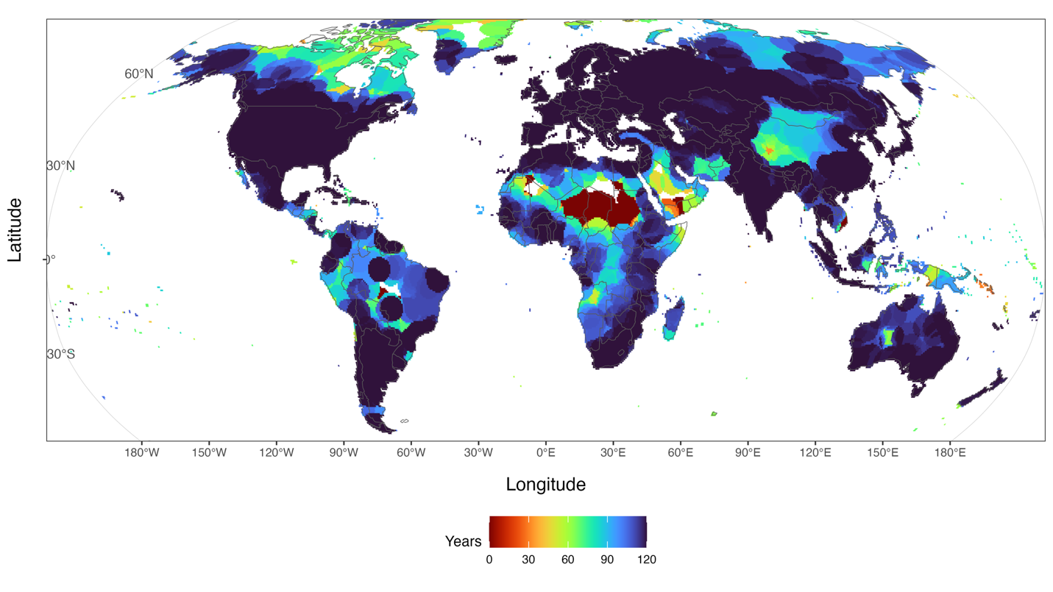
Supplemental Figure 1. Record length (number of years) available in the CRU dataset.
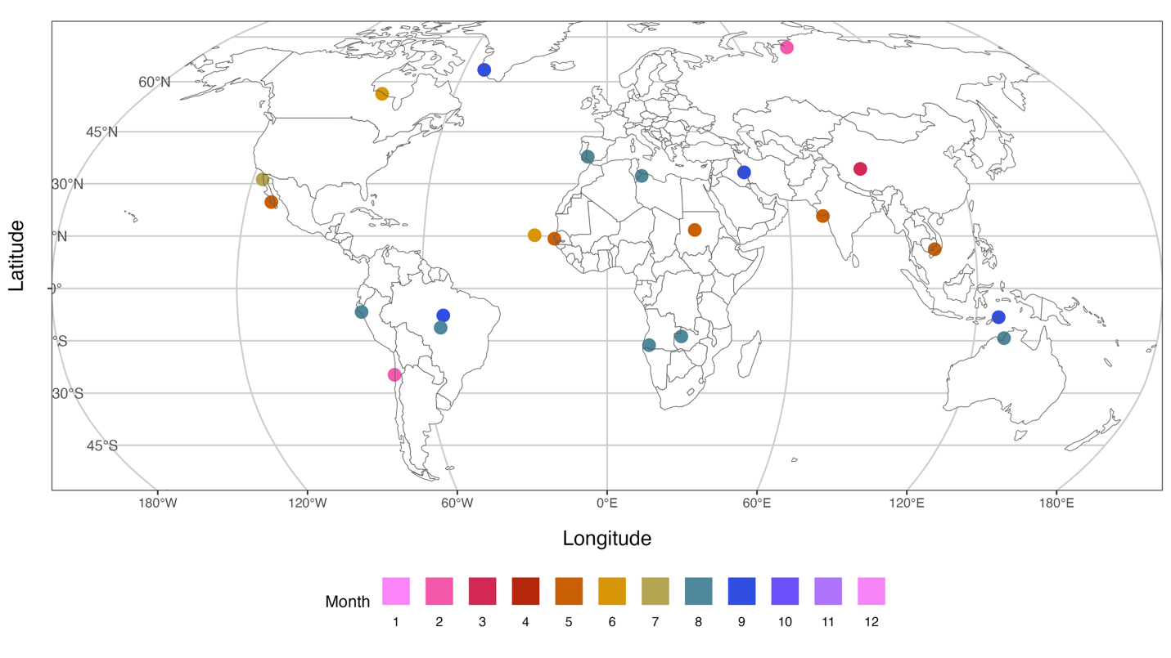
Supplemental Figure 2. All case study locations. Similar to Fig. 7, but without filtering for data anomalies. The color scheme shows the month of maximum bimodality based on the Dip Test and Bimodality Coefficient for the 3-month accumulation period using CRU data.

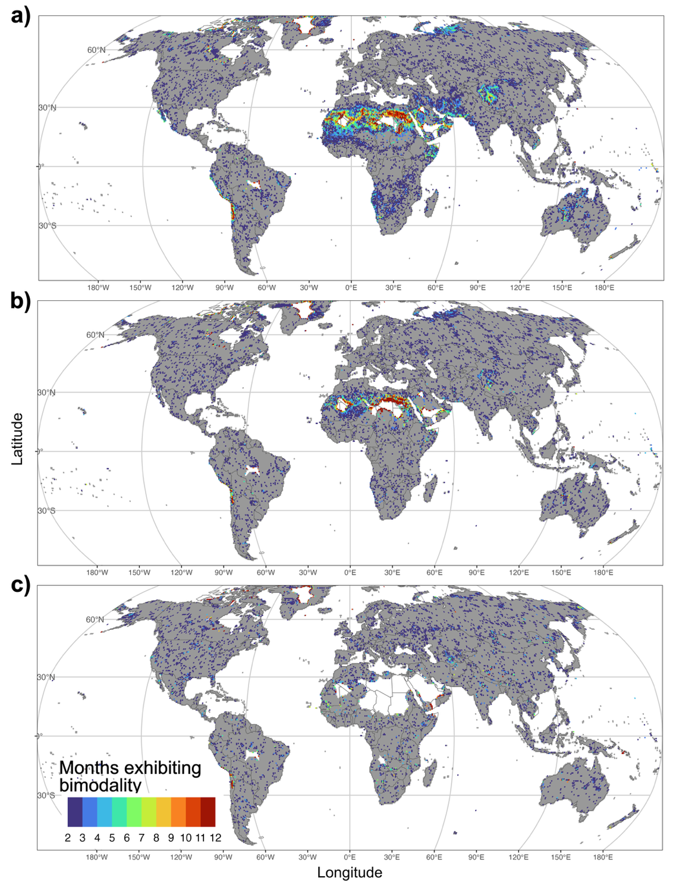

Supplemental Figure 3. Proportion of months with bimodality, as measured by the Chen-Hall test for CRU data. Organized as Figure 4, with accumulation periods of (a) 3, (b) 6, and (c) 12 months. Filtered to only display locations with two or more months exhibiting bimodality to remove noise.

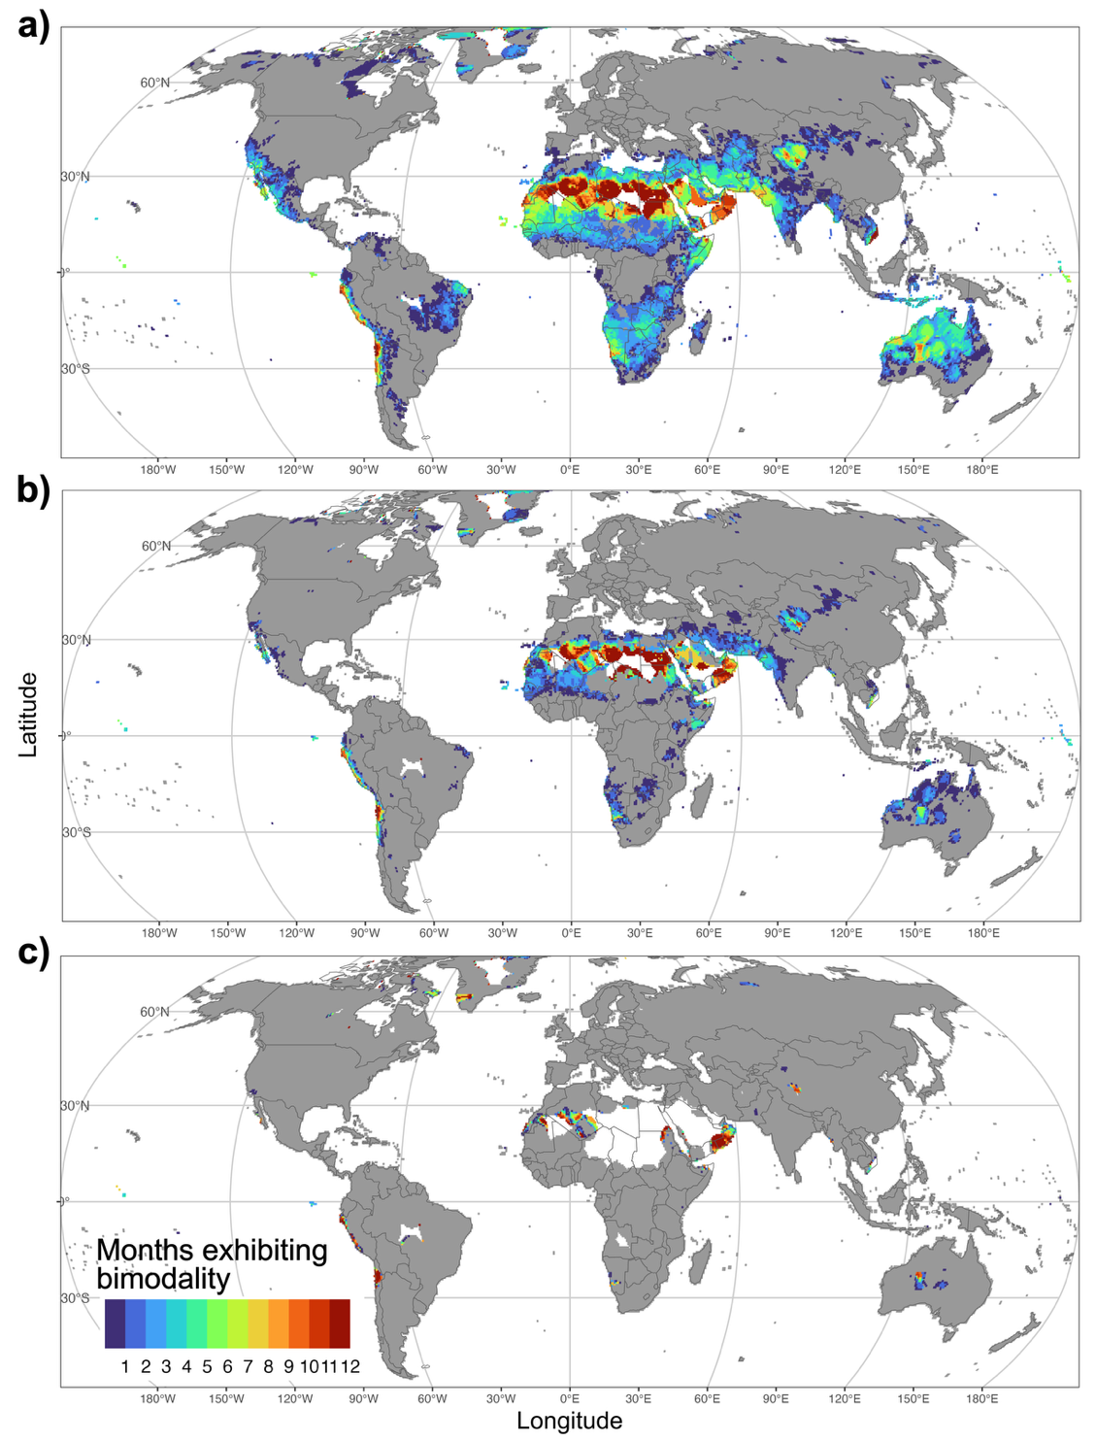

Supplemental Figure 4. Proportion of months with bimodality, as measured by the Bimodality Coefficient for CRU data. Organized as Figure 4, with accumulation periods of (a) 3, (b) 6, and (c) 12 months.

Supplemental Tables

Table S1. All case study sites, showing their location, climate grouping, month of maximum bimodality, proportion of zero values during that month of maximum bimodality, and whether the case study was retained after checking for data errors. All information is based on the SPI-3 using CRU data.

Country | Latitude | Longitude | Koppen-Geiger | Koppen-Geiger Primary | Koppen-Geiger Subgroup | Month | Zero Fraction  (%) | Retained
Russia | 71.25 | 82.25 | Dfc | Cold | No dry season, cold summer | 2
Greenland | 63.75 | -51.75 | ET | Polar | Tundra | 9 |  | Y
Canada | 56.25 | -88.25 | Dfc | Cold | No dry season, cold summer | 6
Spain | 37.75 | -6.75 | Csa | Temperate | Dry summer,  hot summer | 8 |  | Y
China | 34.25 | 86.75 | ET | Polar | Tundra | 3
Iran | 33.25 | 46.75 | Csa | Temperate | Dry summer,  hot summer | 9 | 32.5 | Y
Libya | 32.25 | 11.75 | BWh | Arid | Desert, hot | 8 | 19.0 | Y
Mexico | 31.25 | -116.75 | Bsh | Arid | Steppe, hot | 7 | 7.5 | Y
Mexico | 24.75 | -111.75 | BWh | Arid | Desert, hot | 5 | 27.0 | Y
India | 20.75 | 71.25 | Aw | Tropical | Savannah | 5 | 20.8 | Y
Sudan | 16.75 | 28.75 | BWh | Arid | Desert, hot | 5
Cape Verde | 15.25 | -23.75 | BWh | Arid | Desert, hot | 6 | 34.7 | Y
Senegal | 14.25 | -17.25 | Bsh | Arid | Steppe, hot | 5 | 60.7 | Y
Vietnam | 11.25 | 106.75 | Am | Tropical | Monsoon | 5
Peru | -6.75 | -79.75 | BWh | Arid | Desert, hot | 8 |  | Y
Brazil | -7.75 | -53.25 | Am | Tropical | Monsoon | 9
Timor-Leste | -8.25 | 127.25 | Aw | Tropical | Savannah | 9
Brazil | -11.25 | -54.25 | Aw | Tropical | Savannah | 8 |  | Y
Zambia | -13.75 | 24.25 | Cwa | Temperate | Dry winter,  hot summer | 8 | 78.3 | Y
Australia | -14.25 | 129.75 | Aw | Tropical | Savannah | 8 |  | Y
Angola | -16.25 | 13.75 | BSh | Arid | Steppe, hot | 8 |  | Y
Chile | -24.75 | -70.75 | BWk | Arid | Steppe, cold | 2 |  | Y

