Additional file 1: e-Supplement

Bayesian Reanalysis of Prone Positioning During VV-ECMO for ARDS: Posterior Probabilities and Likelihood Ratios
1. Detailed Methods and Risk of Bias Assessment
The 2 RCTs were assessed as having low risk of bias using the RoB 2 tool. The 6 observational studies were assessed using the ROBINS-I tool; 5 had moderate risk of bias and 1 had serious risk of bias.
1.1 Randomized Controlled Trials (RCTs)
Tool: RoB 2 (Risk of Bias 2 tool, Cochrane)
Results:
Schmidt et al. 2023
Overall Risk of Bias: Low
Domain Assessments:
Randomization process: Low
Deviations from intended interventions: Low
Missing outcome data: Low
Measurement of the outcome: Low
Selection of the reported result: Low
Hongjie Tong et al. 2024
Overall Risk of Bias: Low
Domain Assessments:
Randomization process: Low
Deviations from intended interventions: Low
Missing outcome data: Low
Measurement of the outcome: Low
Selection of the reported result: Low
D1-D5 represent the five RoB 2 domains: (D1) bias arising from the randomization process, (D2) deviations from intended interventions, (D3) missing outcome data, (D4) measurement of the outcome, and (D5) selection of the reported result.
Schmidt 2023 and Hongjie Tong 2024 were rated as low risk across all domains.
Figure S1. Risk of Bias Assessment Summary for Randomized Controlled Trials (RoB 2). Domain-level judgments for the two included RCTs. All domains were rated low risk of bias.
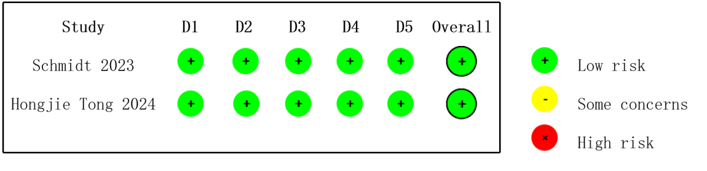

1.2 Observational Studies
Tool: ROBINS-I (Risk Of Bias In Non-randomised Studies of Interventions)
Results Summary:
Overall judgements (last column): five studies graded as moderate risk; Bruno Garcia et al., 2020 rated serious due to major confounding by indication and selection bias arising from post-ECMO sedation choice.
Table S2. Risk of Bias Assessment Summary for Observational Studies (ROBINS-I). Domain-level judgments for the six included observational studies.
Study(Year) | Design/Setting | 1. Bias Due to Confounding | 2. Selection of Participants | 3. Classification of Interventions | 4. Deviations from Intended Interventions | 5. Missing Data | 6. Measurement of Outcomes | 7. Selection of Reported Result | Overall
Rilinger et al., 2020 | Retrospective cohort (Single-Centre) | Low | Low | Low | Low | Low | Low | Low | Moderate
Garcia et al., 2020 | Retrospective cohort (Single-Centre) | Serious | Serious | Moderate | Low | Low | Low | Low | Serious
Chen et al., 2022 | Retrospective cohort (Single-Centre) | Low | Low | Low | Low | Low | Low | Low | Moderate
Petit et al., 2022 | Retrospective cohort (Single-Centre) | Low | Low | Low | Low | Low | Moderate | Moderate | Moderate
Tang X et al., 2024 | Prospective cohort (Single-Centre) | Low | Low | Low | Low | Low | Low | Low | Moderate
Martinez et al., 2021 | Retrospective cohort (Single-Centre) | Moderate | Moderate | Low | Low | Low | Low | Moderate | Moderate

2. Supplementary Tables
Table S1. Pooled Bayesian Sensitivity Analysis Results
Prior | Outcome | Median RR | 95% CrI | P(RR>1) | Median τ | 95% CrI for τ
Vague (near-non-informative) | ECMO Weaning | 1.166 | 0.828-1.514 | 0.866 | 0.265 | 0.026-0.774
Vague (near-non-informative) | Survival | 1.165 | 0.723-1.654 | 0.816 | 0.293 | 0.030-0.977
Skeptical | ECMO Weaning | 1.066 | 0.893-1.241 | 0.769 | 0.280 | 0.038-0.735
Skeptical | Survival | 1.058 | 0.876-1.243 | 0.727 | 0.305 | 0.039-0.888
Optimistic | ECMO Weaning | 1.193 | 0.985-1.434 | 0.966 | 0.237 | 0.021-0.682
Optimistic | Survival | 1.201 | 0.975-1.464 | 0.960 | 0.245 | 0.023-0.819
Historical | ECMO Weaning | 1.172 | 0.930-1.436 | 0.923 | 0.247 | 0.023-0.702
Historical | Survival | 1.177 | 0.906-1.472 | 0.907 | 0.259 | 0.025-0.847
3. Publication Bias Assessment
Publication bias was assessed using funnel plot inspection and Egger’s regression test. For the ECMO weaning outcome, Egger’s test did not detect statistically significant funnel asymmetry (intercept 0.58, p = 0.13). However, visual inspection of the funnel plot (Figure S3) suggests possible small-study effects. For the survival outcome, Egger’s test was also non-significant (intercept 0.40, p = 0.29).
Figure S3. Funnel plot (with pseudo-95% and 99% CI lines) of log risk ratio against standard error for the ECMO weaning outcome. Each circle represents one study. The dashed line indicates the pooled log RR. The deficit of studies in the lower-left quadrant is consistent with possible publication bias (Egger test: p = 0.13).

Figure S4. Funnel plot (with pseudo-95% and 99% CI lines) of log risk ratio against standard error for the survival outcome (one endpoint per study). No significant asymmetry was detected (Egger test: p = 0.29).

4. Study Selection Process (PRISMA 2020)

Figure S5. PRISMA 2020 Study Selection Flow Diagram

The study selection process followed the PRISMA 2020 guidelines. This study is a secondary Bayesian reanalysis of aggregate data from previously published studies identified from the two most recent systematic reviews on prone positioning during VV-ECMO for ARDS. No new systematic literature search was performed. A total of 1,046 patients from eight studies (2 RCTs, 6 observational) were included.

5. Complete Statistical Code (Python)
The full Python code implementing all Bayesian meta-analyses, study-specific analyses, sensitivity analyses, and publication bias assessment is provided as a separate file (Statistical Code.py) in the submission package.
Note: Data from PyMC MCMC (4 chains, 12,000 iterations). τ = between-study SD (heterogeneity). Vague (near-non-informative): N(0, 10); Skeptical: N(0, 0.1); Optimistic: N(0.20, 0.15); Historical: N(0.15, 0.2). Priors on log-RR scale.

