Supplementary materials

Table S1: Summary of common molecular docking programs
Program | Year Published | Organisation | Description | Webservice | License
AutoDock⁴⁴ | 1990 | The Scripps Research Institute | Automated docking of ligand to macromolecule by Lamarckian Genetic Algorithm and Empirical Free Energy Scoring Function | No | Open source (GNU GPL)
AutoDock vina³⁹ | 2010 | The Scripps Research Institute | New generation of AutoDock | No | Open source (Apache License)
UCSF DOCK⁴⁵ | 1988 | University of California-San Francisco | Based on Geometric Matching Algorithm | No | Freeware for academic use
FlexX⁴⁶ | 2001 | BioSolveIT | Incremental build based docking program | No | Commercial
FRED⁴⁷ | 2003 | OpenEye Scientific | Systematic,exhaustive,nonstochastic examination of all possible poses within the protein active site combined with scoring Function | No | Freeware for academic use
Glide⁴⁸ | 2004 | Schrödinger | Exhaustive search based docking program | No | Commercial
GOLD⁴⁹ | 1995 | Collaboration between the University of Sheffield, GlaxoSmithKlineplc and CCDC | Genetic algorithm based, flexible ligand, partial flexibility for protein | No | Commercial
LeDock⁵⁰ | 2016 | Lephar | Program for fast and accurate flexible docking of small molecules into a protein | No | Freeware for academic use
LigandFit⁵¹ | 2003 | BioVia | CHARMm based docking program | No | Commercial
MOE | 2008 | Chemical Computing Group | Docking application within MOE; choice of placement methods (including alpha sphere methods) and scoring functions (including London dG) | No | Commercial
PSI-DOCK¹⁴ | 2006 | Peking University | Pose-Sensitive Inclined (PSI)-DOCK | No | Academic
rDock¹⁶ | 1998 (commercial)2006 (academic)^{[14]}2012 (open source)^{[15]} | Vernalis R&D(commercial)University of York (academic)University of Barcelona (open source) | HTVS process of small molecules against proteins and nucleic acids, binding mode prediction | No | Open source (GNU LGPL) (formerly commercial, academic)
SEED¹⁸ | 1999 | University of Zurich | Automated docking of fragments with evaluation of free energy of binding including electrostatic solvation effects in the continuum dielectric approximation (generalized Born) | No | Open source (GNU GPL)
smina¹⁹ | 2012 | University of Pittsburgh | A customized fork of AutoDock vinawith a better support scoring function and a high-performance energy minimization | No | Open source (Apache License)
Surflex-Dock⁵² | 2003 | Tripos | Based on an idealized active site ligand (a protomol) | No | Commercial
SwissDock⁵³ | 2011 | Swiss Institute of Bioinformatics | Webservice to predict interaction between a protein and a small molecule ligand | Available | Free to use webservice for academic usage

Figure S1
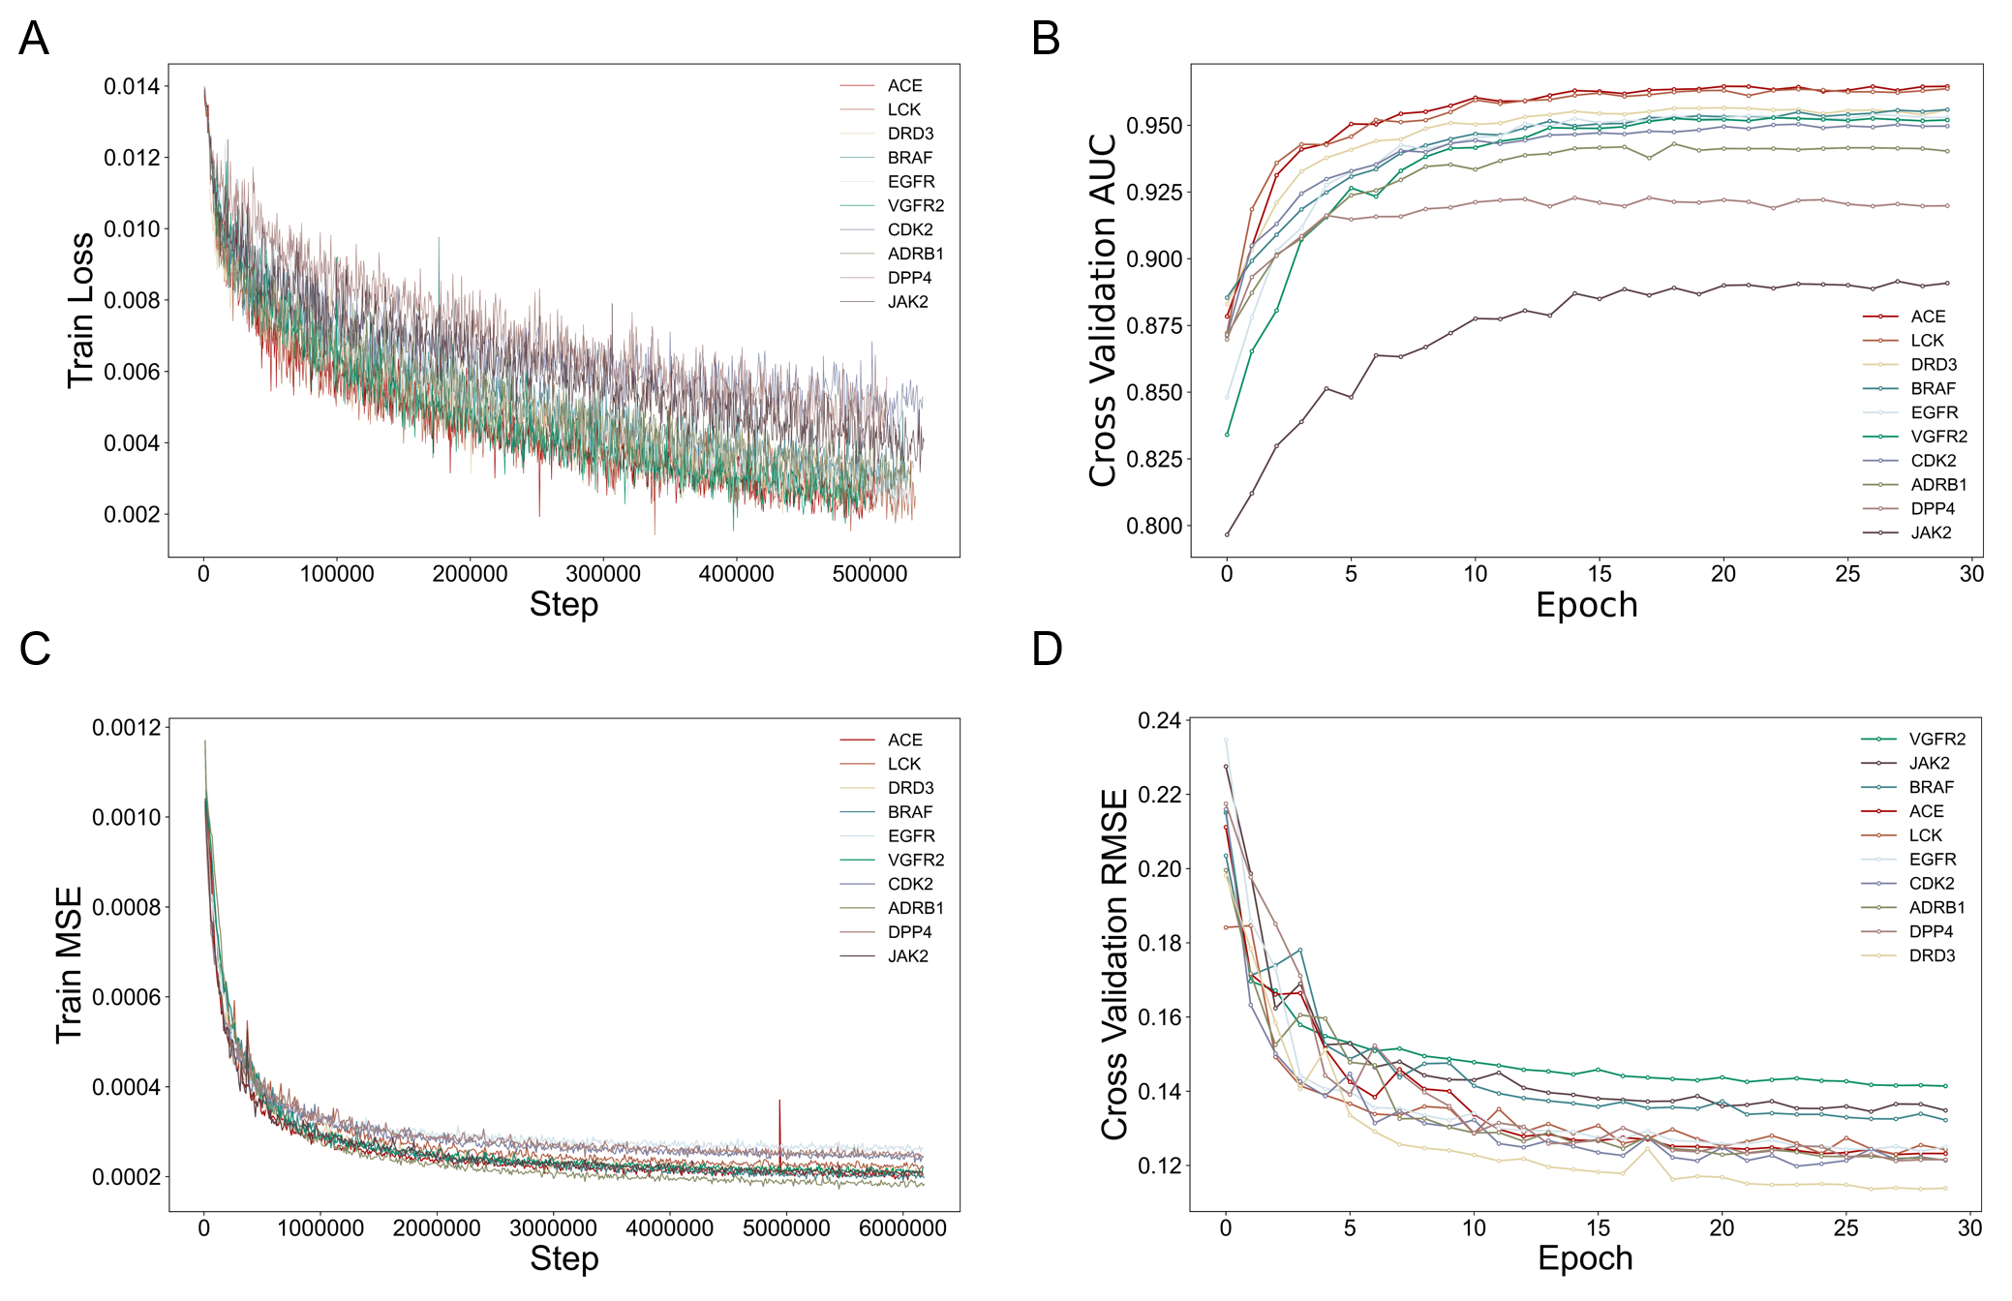
Figure S1: The train Loss(classification model), validation AUC(classification model), train MSE(regression model) and validation RMSE(regression model) of 10 selected targets

Figure S2
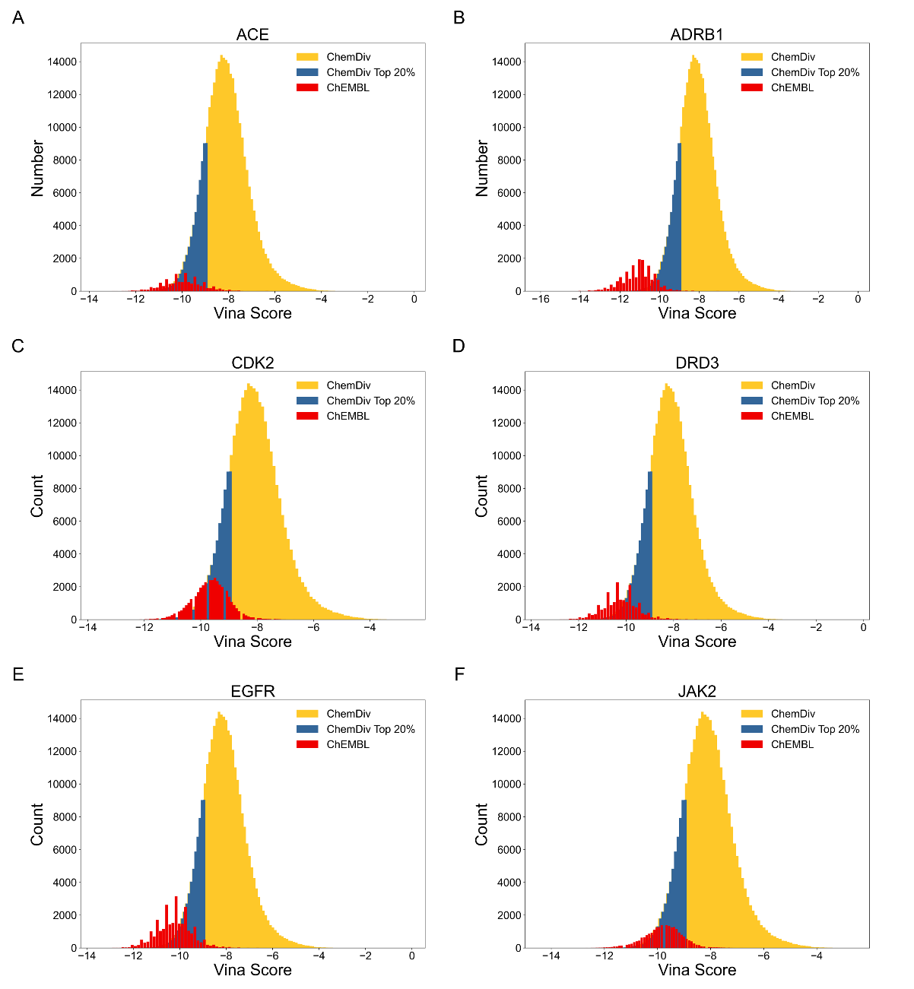
Figure S2: Docking score distribution of ChEMBL recalled and ChemDiv compounds.

Figure S3
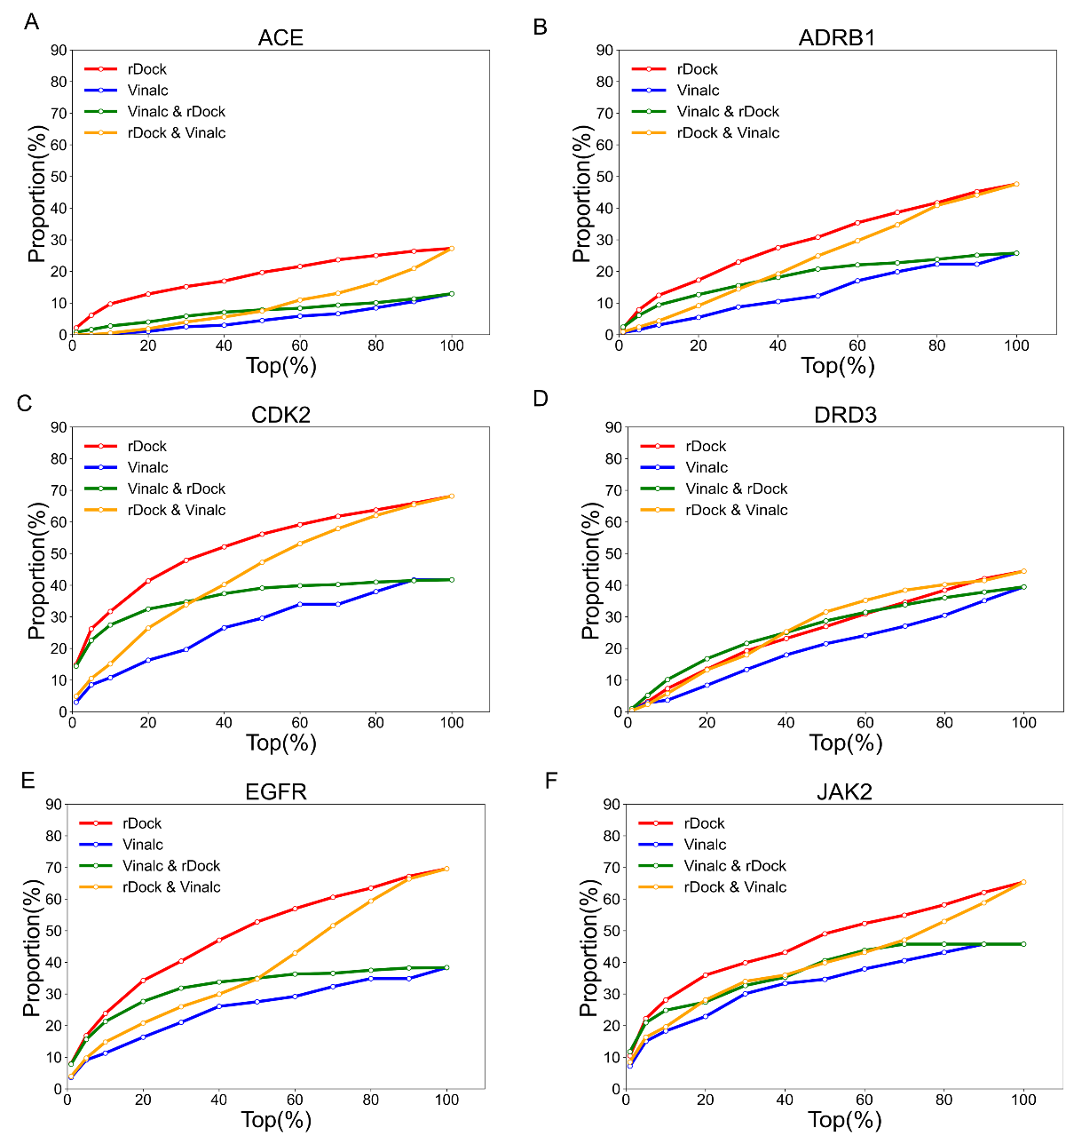
Figure S3: Enrichment ratio of DUD-E active compound for two docking programs.

