Streptomyces pimoensis sp. nov., isolated from the Taklimakan desert in Xinjiang, China
Ping Zhang . Xinrong Luo . Zhanwen Liu . Zhanfeng Xia . Xiaoxia Luo
. Chuanxing Wan . Lili Zhang*

Author affiliations: College of Life Science, Key Laboratory of Protection and Utilization of Biological Resources in Tarim Basin of Xinjiang Production & Construction Corps, Tarim University, Alar 843300, PR China.
*Communication author: Lili Zhang, E-mail: zhang63lyly@sina.com
Ping Zhang, E-mail: zhang_ping16@sina.com

（E. coli）G⁻ （E. faecalis）G⁺ （S. aureus）G⁺

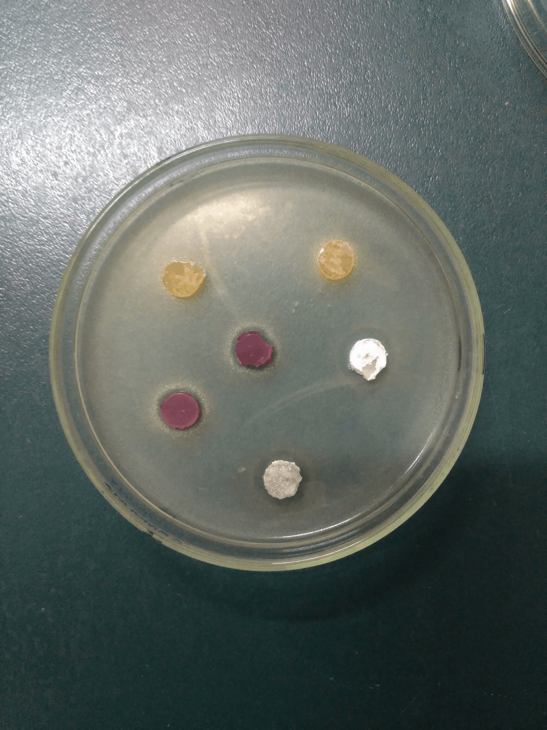
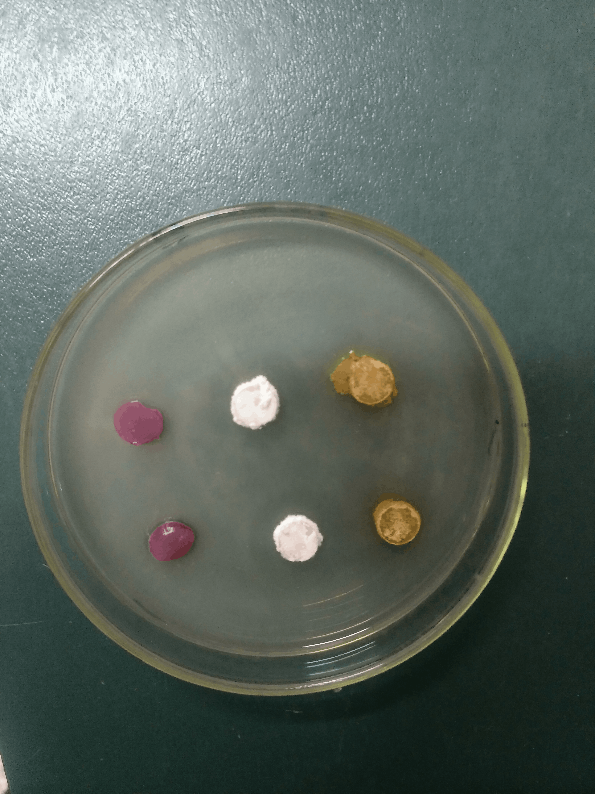
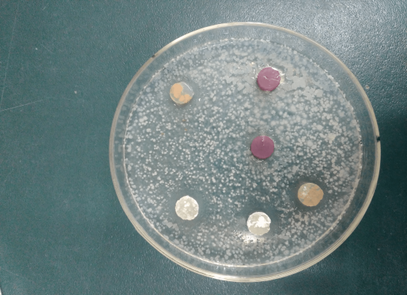
1
1
2
2
2
2
1
1
1
1
22
23

Supplementary Fig. S1 Primary screening for antimicrobialactivity by TRM75549^{T} against.
1. TRM75549^{T} inhibits E. coli with an average diameter of 2 cm, inhibits E. faecalis with an average diameter of 1.5 cm, and inhibits S. aureus with an average diameter of 1.3 cm;
2. Streptomyces flavoviridis DSM 40153^{T} inhibits E.coli with an average diameter of 1.1cm, and inhibits E. faecalis, with an average diameter of 1.3 cm, but S.aureus has no obvious transparent circle.

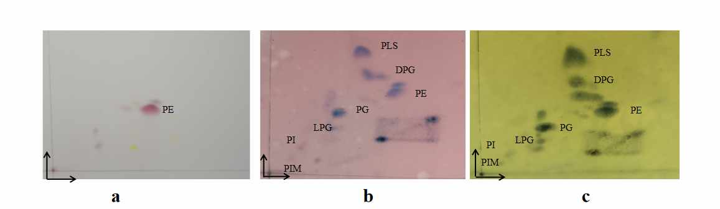
Supplementary Fig. S2 Two-dimensional TLC plates of polar lipids extracted from strain TRM75549^{T}.
Polar lipids after staining with ninhydrin (a), anisaldehyde (b), molybdophosphoric acid (c). DPG, diphosphatidylglycerol; PE, phosphatidylethanolamine; PI, phosphatidyl inositol; PG, phosphatidylglycerol; PIM, phosphatidylinositol mannosides ; PLS, phospholipids; LPG, lyso-phosphatidylglycerol.
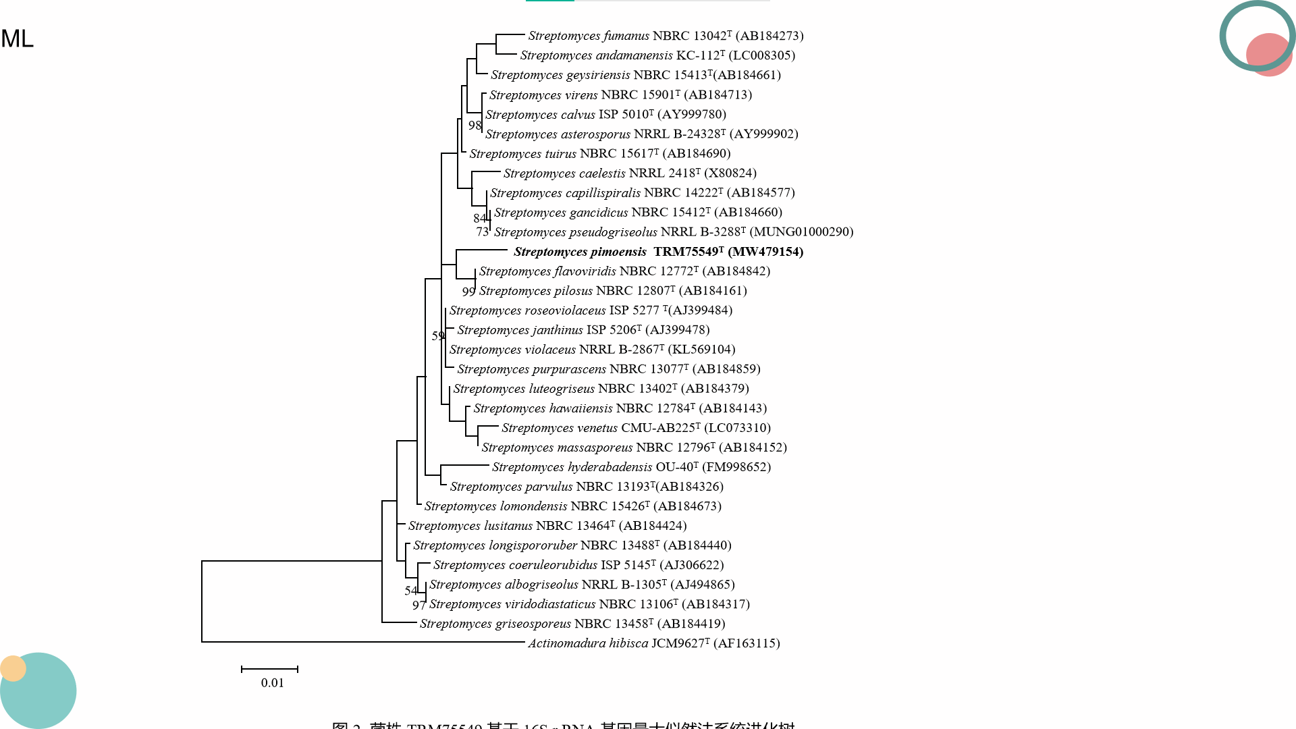
Supplementary Fig. S3 Maximum-likelihood tree based on 16S rRNA gene sequences, illustrating the positions of strain TRM75549^{T} and related taxa. Numbers at nodes are percentage bootstrap values based on 1000 resampled datasets; only values above 50% are indicated. Bar, 0.01 substitutions per nucleotide position.

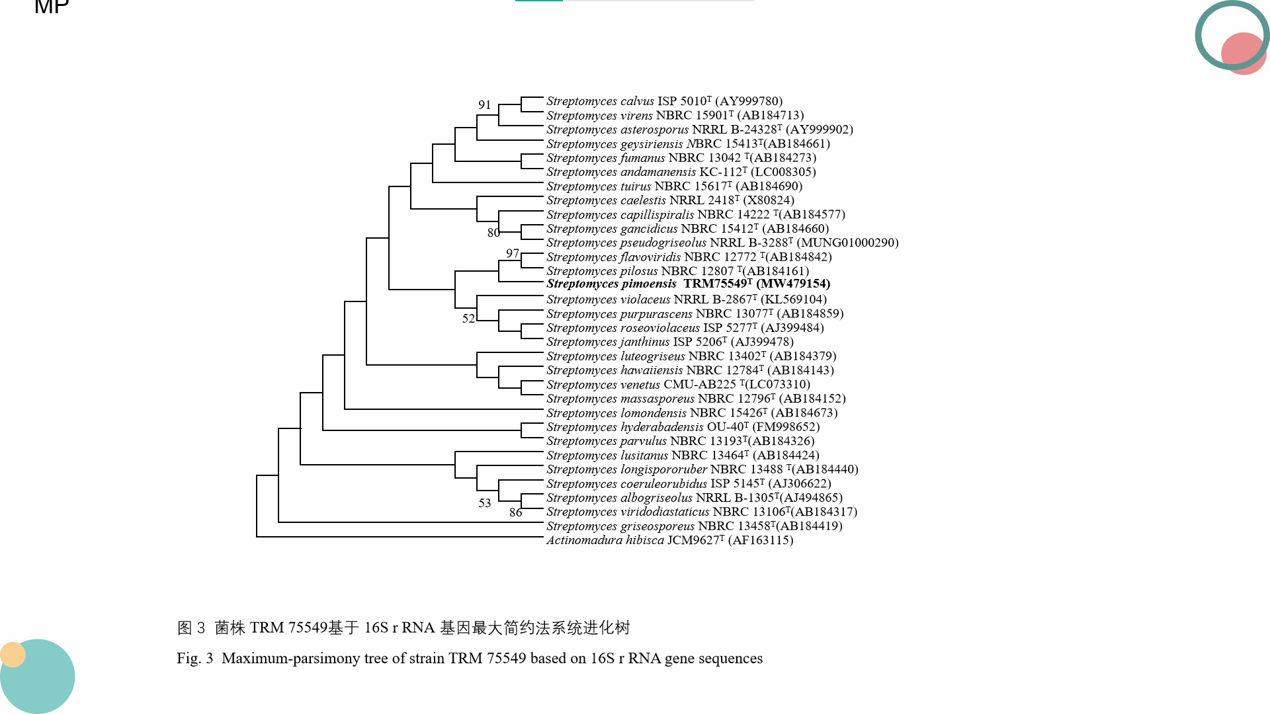

Supplementary Fig. S4 Maximum-parsimony tree based on 16S rRNA gene sequences, illustrating the positions of strain TRM75549^{T} and related taxa. Numbers at nodes are percentage bootstrap values based on 1000 resampled datasets; only values above 50% are indicated.

Supplementary Table S1. Growth and cultural characteristics of: 1, TRM75549^{T;} 2, Streptomyces flavoviridis DSM 40153^{T}.

Medium | 1 | 2
ISP 1  Growth  Aerial mycelium  Substrate mycelium | Good  Grayish white  Pale yellow | Moderate  Grayish white  saffron yellow
ISP 2  Growth  Aerial mycelium  Substrate mycelium | Moderate  Grayish white  white | Good  Grayish white  saffron yellow
ISP 3  Growth  Aerial mycelium  Substrate mycelium | Poor  pale green  kelly green | Good  pebble grey  saffron yellow
ISP 4  Growth  Aerial mycelium  Substrate mycelium | Good  Grayish white  Pale yellow | Good  pebble grey  saffron yellow
ISP 5  Growth  Aerial mycelium  Substrate mycelium | Good  Yellowish white  kelly green | Good  white  saffron yellow
ISP 6  Growth  Aerial mycelium  Substrate mycelium | Poor  Grayish white  Greyish yellow | Good  pebble grey  saffron yellow
ISP 7  Growth  Aerial mycelium  Substrate mycelium | Good  Grayish white  Greyish yellow | Good  white  saffron yellow
Gauze's No. 1 agar  Growth  Aerial mycelium  Substrate mycelium | Good  Grayish white  kelly green | Good  Yellowish white  saffron yellow

