Supplementary Material
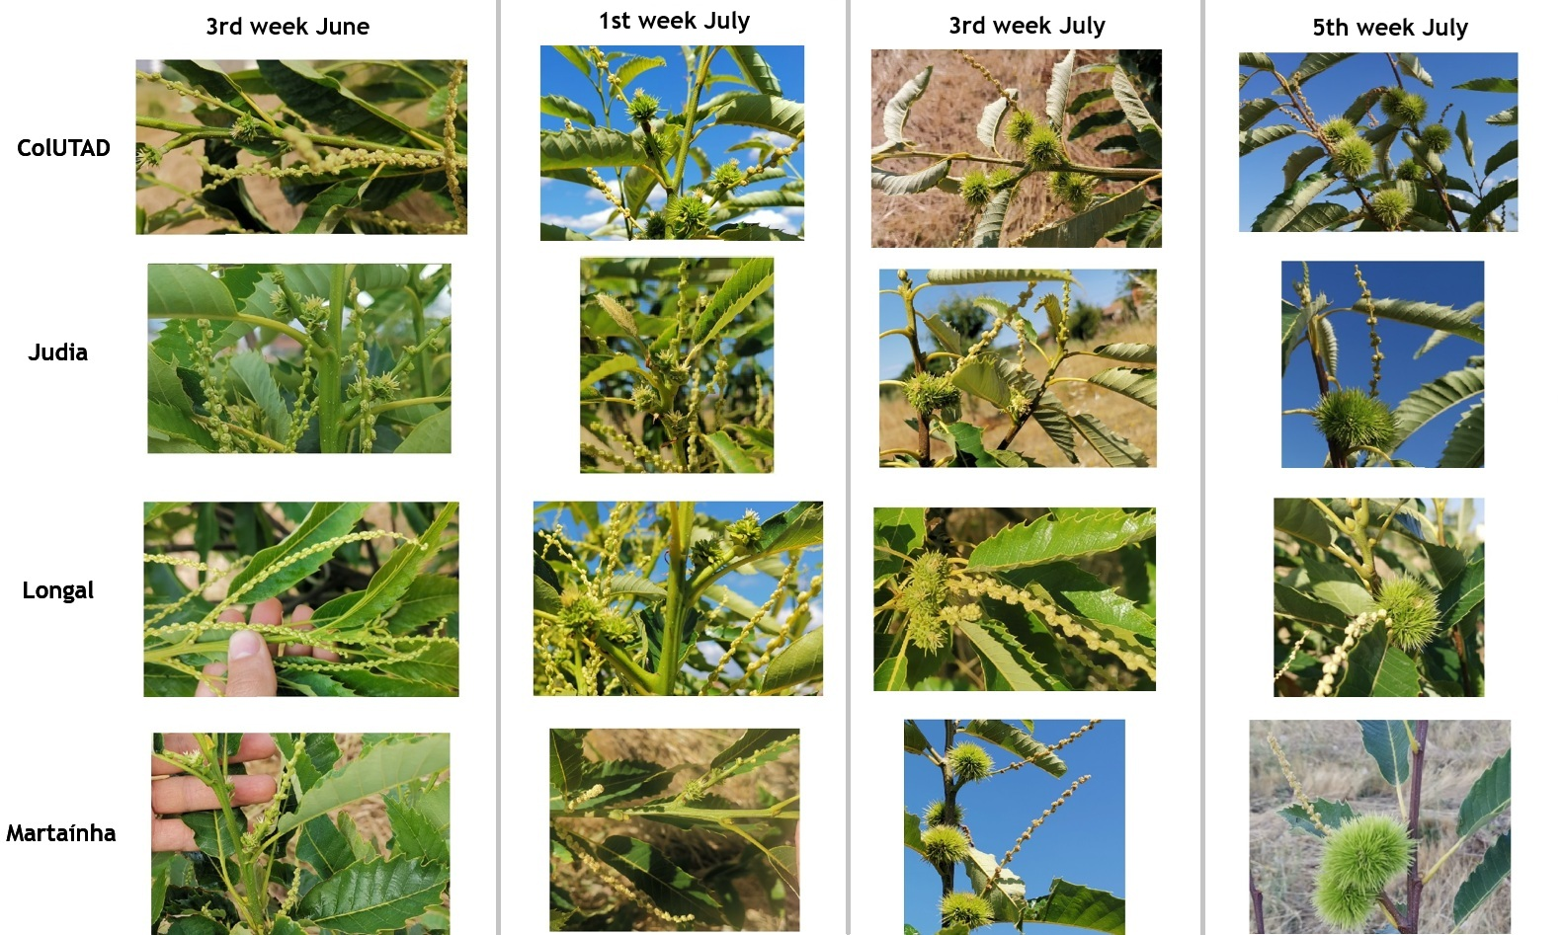
Supplementary Figure 1. Phenological progression of ColUTAD, Judia, Longal and Martaínha at Carrazedo de Montenegro during four observation periods between mid-June and late July 2024. Rows represent cultivars, and columns represent observation weeks. Photographs show representative differences in reproductive development and bur formation among cultivars under the same site conditions.
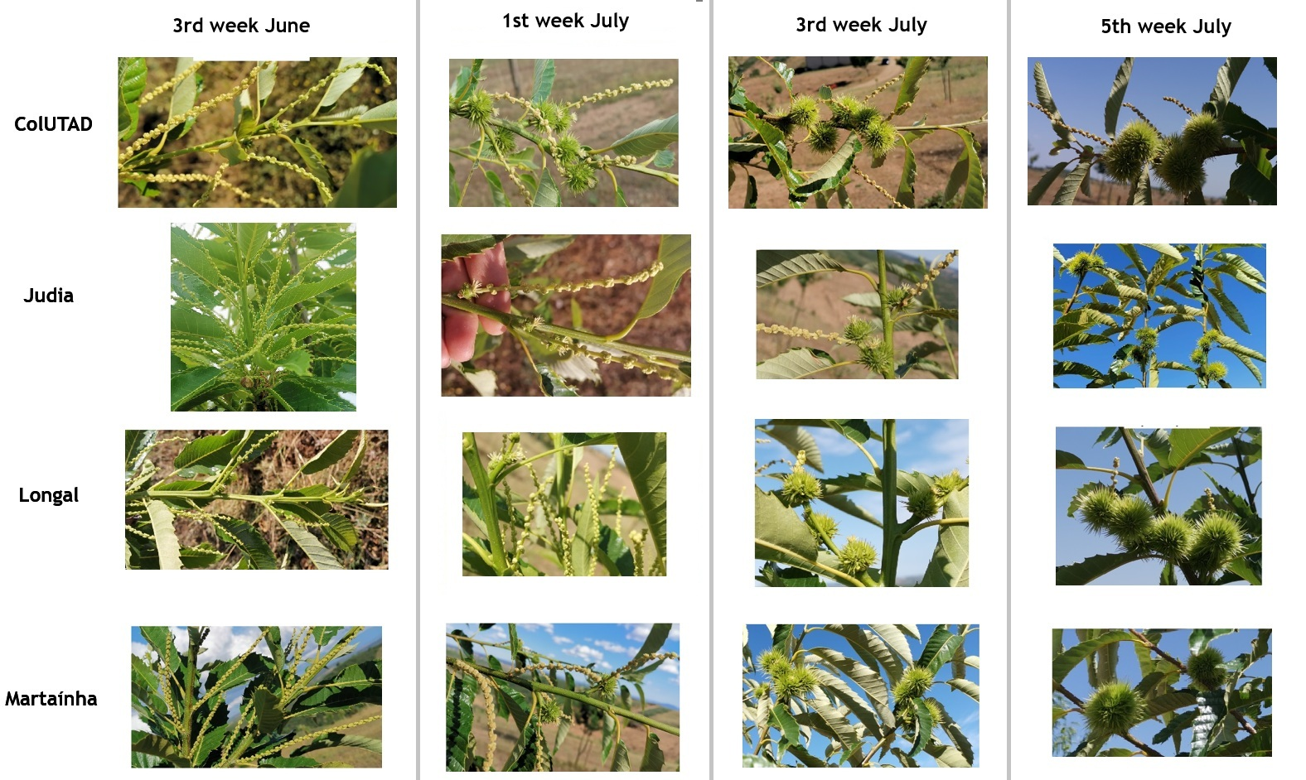
Supplementary Figure 2. Phenological progression of ColUTAD, Judia, Longal and Martaínha at Parada during four observation weeks spanning mid-June to late July 2024. Rows represent cultivars and columns represent observation weeks. Photographs show representative differences in reproductive development and bur formation among cultivars under the same site conditions.
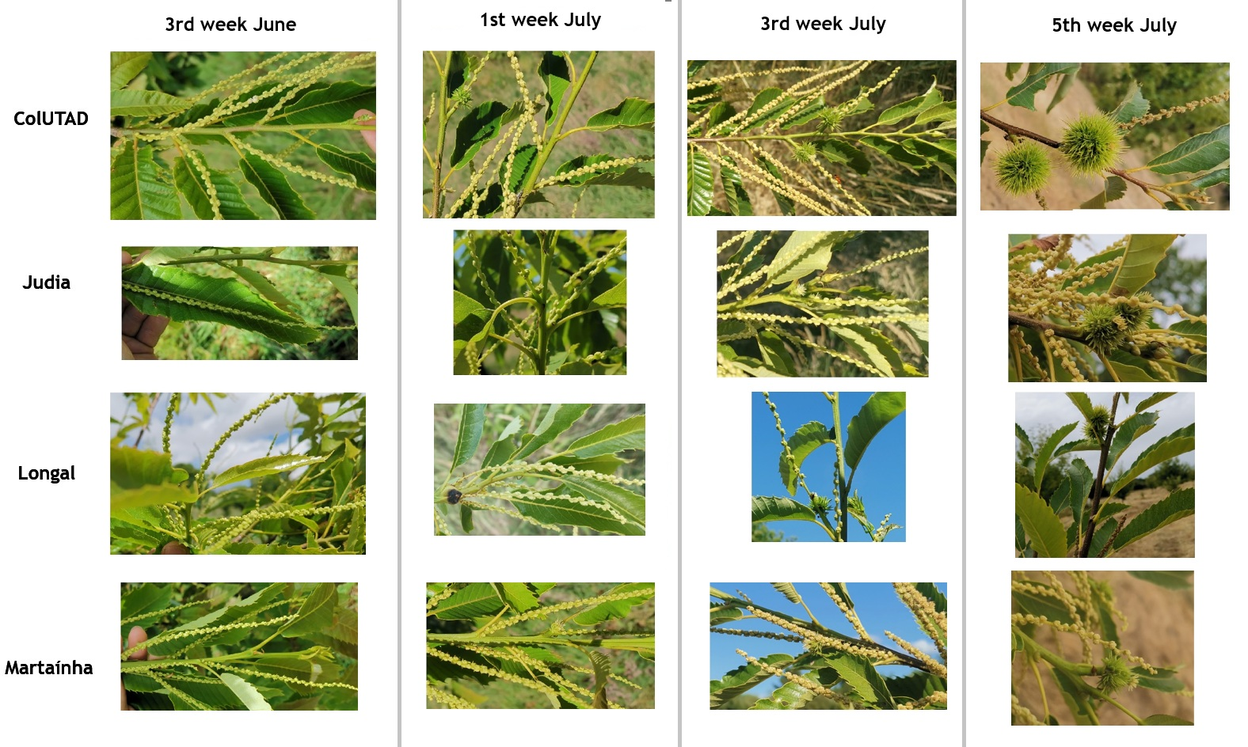
Supplementary Figure 3. Phenological progression of ColUTAD, Judia, Longal and Martaínha at Penela da Beira during four observation weeks spanning mid-June to late July 2024. Rows represent cultivars and columns represent observation weeks. Photographs show representative differences in reproductive development and bur formation among cultivars under the same site conditions.
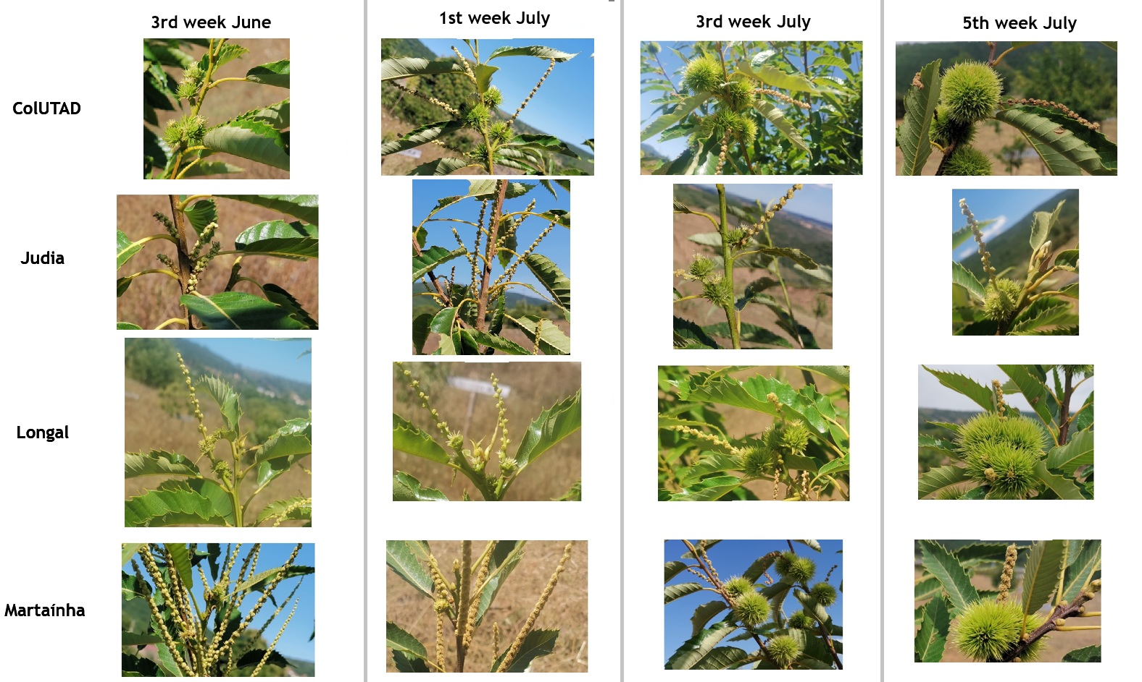
Supplementary Figure 4. Phenological progression of ColUTAD, Judia, Longal and Martaínha at Marvão during four observation weeks spanning mid-June to late July 2024. Rows represent cultivars and columns represent observation weeks. Photographs show representative differences in reproductive development and bur formation among cultivars under the same site conditions.

