Supplementary Methods
S1. Calculation of HOMA-IR
The homeostatic model assessment of insulin resistance (HOMA-IR) was calculated from fasting plasma glucose and fasting insulin concentrations as follows:
HOMA-IR = [fasting insulin (μU/mL) × fasting plasma glucose (mmol/L)] / 22.5
Because HOMA-IR was right-skewed, values were natural-log transformed before subsequent analyses. The transformed HOMA-IR values were then regressed on body mass index (BMI), and the residuals were standardised to a mean of zero and a standard deviation of one before use as a response variable in reduced rank regression (RRR).
S2. Preprocessing of the metabolic-inflammatory response variables
Four prespecified metabolic-inflammatory response variables were used in RRR: high-sensitivity C-reactive protein (hs-CRP), HOMA-IR, the triglyceride-to-high-density lipoprotein cholesterol ratio (TG/HDL-C), and serum uric acid.
Before analysis, hs-CRP was transformed as ln(hs-CRP + 1), whereas HOMA-IR and TG/HDL-C were natural-log transformed. Serum uric acid was retained on its original scale. To reduce the contribution of general adiposity, each transformed biomarker was separately regressed on BMI. The resulting residuals were standardised to a mean of zero and a standard deviation of one.
These standardised BMI-residualised biomarkers represented complementary domains of inflammation, insulin resistance, lipid metabolism, and urate metabolism and were used as the four response variables in RRR.
S3. Energy adjustment and standardisation of food-group intakes
Individual food items were aggregated into 32 predefined food groups. Food-group intakes were expressed in grams per day and adjusted for total energy intake using the residual method.
For each food group, a linear regression model was fitted with food-group intake as the dependent variable and total energy intake as the independent variable. Energy-adjusted intake was calculated as the regression residual plus the expected food-group intake at the mean total energy intake of the derivation sample.
All energy-adjustment coefficients and the means and standard deviations used to standardise the energy-adjusted food-group variables were estimated exclusively among the 4,956 participants without prevalent T2DM in the 2009 development set.
The same coefficients, means, and standard deviations were then applied without re-estimation to the held-out 2009 sample, the full eligible 2009 cross-sectional sample, and the 2006 dietary data. No predictor-preprocessing parameters were re-estimated in the held-out sample or in the 2006 data.
S4. Reduced rank regression and construction of the C-DMIP
RRR was conducted using the 32 energy-adjusted and standardised food-group variables as predictors and the four standardised BMI-residualised metabolic-inflammatory biomarkers as response variables. All predictor-preprocessing parameters and RRR weights were estimated only among participants without prevalent T2DM in the 2009 development set.
The first RRR factor was retained as the China-specific Dietary Metabolic-Inflammatory Pattern (C-DMIP) because it represented the leading dietary dimension of variation in the fitted response scores. Because the sign of an RRR factor is arbitrary, the first factor was oriented so that higher scores were positively correlated with the mean of the four standardised response variables.
For the primary C-DMIP score, food groups with absolute standardised RRR weights below 0.5 standard deviations of the distribution of the 32 weights were assigned a weight of zero. The RRR model was not refitted after truncation. Twenty food groups were retained in the primary score.
For participant i, the raw C-DMIP score was calculated as:
C-DMIPᵢ = Σⱼ₌₁³² wⱼ zᵢⱼ
where wj is the fixed RRR weight for food group j, and zij is the energy-adjusted and standardised intake of food group j for participant i.
The fixed 2009 derivation-set preprocessing parameters and truncated RRR weights were applied unchanged to all eligible participants in 2009 and to the 2006 dietary data. No new RRR model was estimated using the 2006 data.
After raw scores had been calculated, C-DMIP scores were standardised within the corresponding wave-specific eligible sample. The 2009 score was standardised using the distribution among 7,928 eligible participants, and the 2006 score was standardised using the distribution among 6,863 eligible participants. Regression estimates were therefore interpreted per one-standard-deviation increment in the score within the corresponding survey wave.
S5. Variance decomposition of the reduced rank regression
Two complementary measures were used to describe the variance captured by RRR. First, the proportion of variance in the RRR-fitted response scores attributable to each factor was calculated. This measure describes the relative importance of each factor within the component of the response variables that was predictable from dietary intake.
Second, the proportion of variance in each original metabolic-inflammatory response variable explained by the first factor was calculated separately. This measure reflects the absolute explanatory power of the retained dietary pattern for the original biomarkers. The proportion of variance in the 32 food-group predictors explained by the first factor was also calculated. Results are presented in Supplementary Table S7.
S6. Internal assessment of biomarker coherence
Biomarker coherence of the C-DMIP was assessed in the held-out 2009 sample of 2,407 participants, which was not used to estimate predictor-preprocessing parameters or RRR weights. Each of the four standardised BMI-residualised response variables was modelled separately as the dependent variable in linear regression, with the standardised C-DMIP score entered as the exposure.
Models were adjusted for age, sex, current smoking, and total energy intake. Community-level cluster-robust standard errors with an HC1 finite-sample correction were used to account for within-community correlation. Regression coefficients were expressed per one-standard-deviation increment in the C-DMIP score, based on the score distribution in the held-out sample.
The held-out assessment was limited to biomarker coherence. Associations between the C-DMIP and prevalent T2DM were subsequently estimated in the full eligible 2009 cross-sectional sample, which included participants used for pattern derivation; these outcome analyses were therefore treated as full-sample association analyses following pattern derivation rather than as an independent out-of-sample outcome assessment.
S7. Alternative weight-truncation thresholds
Robustness of the C-DMIP to the choice of food-group weight threshold was evaluated by constructing four score versions:
• an untruncated score retaining all 32 food groups;
• a score retaining food groups with absolute standardised weights of at least 0.3 standard deviations;
• the primary score retaining food groups with absolute standardised weights of at least 0.5 standard deviations; and
• a score retaining food groups with absolute standardised weights of at least 0.7 standard deviations.
Weights below the specified threshold were assigned a value of zero without refitting RRR. Pearson correlation coefficients between each alternative score and the primary C-DMIP score were calculated. Results are presented in Supplementary Table S8.
S8. Province-normalised C-DMIP scores
To distinguish within-province variation in the C-DMIP from between-province variation, province-normalised scores were calculated separately within each of the nine provinces.
For participant i residing in province p, the province-normalised score was calculated as:
zᵢₚ = (xᵢₚ − x̄ₚ) / sₚ
where xip is the participant's original C-DMIP score, x̄p is the mean C-DMIP score in province p, and sp is the corresponding province-specific standard deviation.
The province-normalised scores therefore had a mean of zero and a standard deviation of one within each province. Associations of these scores with prevalent T2DM were estimated in the common complete-case cross-sectional sample using the Model 3 covariate specification and community-level cluster-robust standard errors.
In the held-out sample, associations of the province-normalised scores with hs-CRP, HOMA-IR, TG/HDL-C, and serum uric acid were re-estimated using the same covariate adjustment, score scaling, and community-level cluster-robust standard-error procedures used for the original C-DMIP score.
S9. Community-level cluster-robust inference
The CHNS used a multistage cluster-sampling design in which participants were nested within communities. To account for correlation among participants sampled from the same community, primary logistic and linear regression models used community-level cluster-robust standard errors with an HC1 finite-sample correction.
The HC1 correction scales the conventional cluster-robust variance estimate to account for the number of observations and model parameters. Confidence intervals and p values were calculated using these corrected standard errors.
Interactions between the standardised C-DMIP score and subgroup variables were evaluated using product terms. Interaction p values were obtained from community-level cluster-robust Wald tests. Statistical significance within an individual subgroup was not interpreted as evidence of effect modification unless the corresponding interaction test was statistically significant.
S10. Community-level cluster bootstrap for AUC comparison
Apparent discriminative performance of models containing the C-DMIP or the Dietary Inflammatory Index (DII) was evaluated using the area under the receiver operating characteristic curve (AUC).
To preserve the clustered structure of the CHNS data, uncertainty in the difference between the two AUCs was evaluated using a community-level cluster bootstrap with 1,000 iterations. In each iteration, communities rather than individual participants were sampled with replacement, and all participants belonging to each selected community were included in the bootstrap sample.
Two otherwise identical Model 3 logistic regression models were refitted in each bootstrap sample: one containing the standardised C-DMIP score and the other containing the standardised DII score. The difference in AUC was calculated as:
ΔAUC = AUC(C-DMIP) − AUC(DII)
The 95% confidence interval was obtained from the bootstrap distribution of the AUC differences. The bootstrap p value was calculated from the empirical distribution of the differences across the 1,000 bootstrap samples. This comparison was descriptive and limited to the analytic sample.
S11. Alternative definitions of T2DM
The primary operational definition of T2DM included fasting plasma glucose ≥7.0 mmol/L, HbA1c ≥6.5%, self-reported physician-diagnosed diabetes, or current use of glucose-lowering medication.
Two alternative definitions were evaluated in the common complete-case cross-sectional sample:
• a definition excluding HbA1c, based on fasting plasma glucose, self-reported physician diagnosis, or glucose-lowering medication use; and
• an HbA1c-only definition based on HbA1c ≥6.5%.
The same C-DMIP score, analytic sample, covariates, and community-level cluster-robust standard-error procedures were used in these sensitivity analyses. Results are presented in Supplementary Table S5.
S12. Alternative adiposity-adjustment specifications
The primary fully adjusted model simultaneously included BMI and waist circumference to account for general and central adiposity.
Sensitivity analyses were conducted using four adiposity-adjustment specifications:
• BMI and waist circumference;
• BMI without waist circumference;
• waist circumference without BMI; and
• neither BMI nor waist circumference.
All models retained age, sex, urban or rural residence, educational attainment, current smoking, alcohol consumption, and total energy intake. The same common complete-case sample of 7,846 participants with 790 prevalent T2DM cases was used in all specifications. Results are presented in Supplementary Table S5.
Supplementary Table S1. Food-group weights contributing to the China-specific Dietary Metabolic-Inflammatory Pattern
Food group | Code | Standardised RRR weight | Status
Tofu and soy products | fg6 | 0.077 | Retained
Alcoholic beverages | fg30 | 0.072 | Retained
Fatty pork | fg16 | 0.069 | Retained
White rice | fg1 | 0.067 | Retained
Lean pork | fg17 | 0.052 | Retained
Organ meats | fg21 | 0.047 | Retained
Fish | fg22 | 0.046 | Retained
Nuts and seeds | fg15 | 0.031 | Retained
Dark non-leafy vegetables | fg9 | 0.024 | Retained
Tea | fg28 | 0.022 | Retained
Processed meat | fg20 | 0.022 | Retained
Animal fats | fg27 | −0.023 | Retained
Dark leafy vegetables | fg8 | −0.025 | Retained
Fresh fruit | fg14 | −0.025 | Retained
Pickled vegetables | fg12 | −0.027 | Retained
Fried wheat products | fg3 | −0.040 | Retained
Potatoes and tubers | fg5 | −0.040 | Retained
Eggs | fg24 | −0.065 | Retained
Cruciferous vegetables | fg11 | −0.067 | Retained
Wheat-based staples | fg2 | −0.100 | Retained
Whole grains | fg4 | 0 | Thresholded
Dried legumes | fg7 | 0 | Thresholded
Light-coloured vegetables | fg10 | 0 | Thresholded
Mushrooms and seaweed | fg13 | 0 | Thresholded
Poultry | fg18 | 0 | Thresholded
Beef and lamb | fg19 | 0 | Thresholded
Shellfish | fg23 | 0 | Thresholded
Milk and dairy products | fg25 | 0 | Thresholded
Vegetable oils | fg26 | 0 | Thresholded
Sugar-sweetened beverages | fg29 | 0 | Thresholded
Snacks and desserts | fg31 | 0 | Thresholded
Instant and convenience foods | fg32 | 0 | Thresholded
Notes: RRR weights were derived using BMI-residualised hs-CRP, HOMA-IR, TG/HDL-C, and serum uric acid as response variables. Food groups with absolute standardised weights below 0.5 SD of the distribution of the 32 food-group weights were assigned a weight of zero without refitting the RRR model. Twenty of the 32 food groups were retained in the primary C-DMIP score.
Abbreviations: BMI, body mass index; C-DMIP, China-specific Dietary Metabolic-Inflammatory Pattern; HDL-C, high-density lipoprotein cholesterol; HOMA-IR, homeostatic model assessment of insulin resistance; hs-CRP, high-sensitivity C-reactive protein; RRR, reduced rank regression; SD, standard deviation; TG, triglycerides.
Supplementary Table S2. Geographic distribution and province-normalised analyses of C-DMIP
A. Province-level C-DMIP scores and T2DM prevalence in the eligible 2009 cross-sectional sample
Province | Region | n | T2DM cases | Mean C-DMIP | T2DM prevalence, %
Hunan | South | 1011 | 80 | 0.172 | 7.9
Guangxi | South | 981 | 51 | 0.156 | 5.2
Guizhou | South | 702 | 50 | 0.141 | 7.1
Jiangsu | South | 1030 | 107 | 0.073 | 10.4
Hubei | South | 808 | 80 | 0.038 | 9.9
Liaoning | North | 771 | 100 | 0.002 | 13.0
Heilongjiang | North | 843 | 69 | −0.087 | 8.2
Henan | North | 901 | 105 | −0.272 | 11.7
Shandong | North | 881 | 160 | −0.284 | 18.2
North overall |  | 3396 | 434 | −0.167 | 12.8
South overall |  | 4532 | 368 | 0.117 | 8.1
Province-level correlation: Pearson r = −0.766 (95% CI, −0.948 to −0.208; p = 0.016; nine provinces).
B. Association with prevalent T2DM before and after province normalisation
Exposure | n | Events | OR (95% CI) | P value
Original C-DMIP | 7846 | 790 | 0.900 (0.818–0.991) | 0.032
Province-normalised C-DMIP | 7846 | 790 | 1.040 (0.957–1.130) | 0.351
C. Associations with metabolic-inflammatory response variables in the held-out sample
Response variable | Original C-DMIP β per 1-SD | P value | Province-normalised C-DMIP β per 1-SD | P value
hs-CRP | 0.026 | 0.027 | 0.003 | 0.814
HOMA-IR | −0.028 | 0.061 | −0.031 | 0.033
TG/HDL-C | 0.063 | <0.001 | 0.017 | 0.252
Serum uric acid | 0.163 | <0.001 | 0.046 | 0.007
Notes: Province-normalised scores were standardised within each province. Panel A is descriptive and based on nine province-level observations. Panel B used the Model 3 covariate specification with community-level cluster-robust standard errors. Panel C was based on the held-out sample (n = 2407); β coefficients are expressed per one-SD increment in the corresponding score.
Abbreviations: C-DMIP, China-specific Dietary Metabolic-Inflammatory Pattern; CI, confidence interval; HDL-C, high-density lipoprotein cholesterol; HOMA-IR, homeostatic model assessment of insulin resistance; hs-CRP, high-sensitivity C-reactive protein; OR, odds ratio; SD, standard deviation; T2DM, type 2 diabetes mellitus; TG, triglycerides.
Supplementary Table S3. Comparison of C-DMIP and the Dietary Inflammatory Index for prevalent T2DM
A. Quartile-based associations with prevalent T2DM
Quartile | C-DMIP OR (95% CI) | P value | DII OR (95% CI) | P value
Q1 | 1.00 (reference) | — | 1.00 (reference) | —
Q2 | 1.013 (0.815–1.260) | 0.906 | 1.163 (0.925–1.461) | 0.196
Q3 | 0.788 (0.607–1.024) | 0.075 | 1.049 (0.802–1.372) | 0.728
Q4 | 0.863 (0.678–1.099) | 0.231 | 0.906 (0.706–1.165) | 0.442
B. Simultaneous model including both dietary indices
Dietary index | OR per 1-SD (95% CI) | P value
C-DMIP | 0.899 (0.816–0.989) | 0.030
DII | 0.971 (0.891–1.059) | 0.506
C. Discriminative performance for prevalent T2DM
Model | AUC
C-DMIP model | 0.758
DII model | 0.756
Difference in AUCs (C-DMIP − DII) = 0.0015; community-level cluster-bootstrap 95% CI, −0.0003 to 0.0051; p = 0.174.
D. Correlation between C-DMIP and DII
Correlation | r | P value
Pearson correlation | −0.052 | <0.001
Notes: All regression and AUC analyses used the fixed complete-case sample of 7846 participants with 790 prevalent T2DM cases. Models were adjusted for age, sex, urban/rural residence, educational attainment, BMI, waist circumference, smoking, alcohol consumption, and total energy intake, with community-level cluster-robust standard errors. The AUC difference was evaluated using community-level cluster bootstrap resampling with 1000 iterations. Geographic variables were not included in these comparisons.
Abbreviations: AUC, area under the receiver operating characteristic curve; BMI, body mass index; C-DMIP, China-specific Dietary Metabolic-Inflammatory Pattern; CI, confidence interval; DII, Dietary Inflammatory Index; OR, odds ratio; SD, standard deviation; T2DM, type 2 diabetes mellitus.
Supplementary Table S4. Subgroup associations between C-DMIP and prevalent T2DM
Subgroup | n | Events | OR per 1-SD (95% CI) | P value | P for interaction
Overall | 7846 | 790 | 0.900 (0.818–0.991) | 0.032 | —
Sex |  |  |  |  | 0.599
Male | 3630 | 400 | 0.919 (0.816–1.034) | 0.159
Female | 4216 | 390 | 0.862 (0.749–0.991) | 0.037
Age |  |  |  |  | 0.969
<60 years | 5741 | 410 | 0.896 (0.805–0.996) | 0.043
≥60 years | 2105 | 380 | 0.894 (0.764–1.045) | 0.160
BMI category |  |  |  |  | 0.061
<24 kg/m² | 4702 | 312 | 0.821 (0.714–0.944) | 0.006
≥24 kg/m² | 3144 | 478 | 0.959 (0.860–1.069) | 0.451
BMI tertiles |  |  |  |  | —
Low (13.7–21.6 kg/m²) | 2616 | 139 | 0.875 (0.710–1.080) | 0.214
Middle (>21.6–24.6 kg/m²) | 2617 | 223 | 0.815 (0.689–0.965) | 0.017
High (>24.6–42.7 kg/m²) | 2613 | 428 | 0.966 (0.856–1.089) | 0.568
Urban/rural residence |  |  |  |  | 0.368
Rural | 5463 | 461 | 0.935 (0.833–1.049) | 0.250
Urban | 2383 | 329 | 0.836 (0.711–0.984) | 0.031
Smoking status |  |  |  |  | 0.869
Non-smoker | 5437 | 536 | 0.893 (0.797–1.000) | 0.051
Current smoker | 2409 | 254 | 0.911 (0.794–1.045) | 0.185
Alcohol consumption |  |  |  |  | 0.263
Non-drinker | 5109 | 472 | 0.945 (0.851–1.049) | 0.289
Current drinker | 2737 | 318 | 0.847 (0.719–0.997) | 0.045
Notes: Odds ratios and 95% confidence intervals were estimated per one-SD increment in C-DMIP using the Model 3 covariate specification. Models adjusted for age, sex, urban/rural residence, educational attainment, BMI, waist circumference, smoking status, alcohol consumption, and total energy intake, except that the corresponding stratification variable was omitted from the adjustment set. Community-level cluster-robust standard errors with HC1 correction were used. Interaction p values were obtained from community-level cluster-robust Wald tests for product terms. No statistically significant interaction was observed. The BMI-tertile analysis was exploratory, and no overall interaction test was reported.
Abbreviations: BMI, body mass index; C-DMIP, China-specific Dietary Metabolic-Inflammatory Pattern; CI, confidence interval; OR, odds ratio; SD, standard deviation; T2DM, type 2 diabetes mellitus.
Supplementary Table S5. Sensitivity analyses of C-DMIP and prevalent T2DM
A. Alternative definitions of type 2 diabetes mellitus
T2DM definition | n | Events | OR per 1-SD (95% CI) | P value
Primary definition | 7846 | 790 | 0.900 (0.818–0.991) | 0.032
Definition excluding HbA1c | 7846 | 575 | 1.002 (0.904–1.111) | 0.970
HbA1c-based definition only | 7846 | 547 | 0.791 (0.708–0.885) | <0.001
B. Alternative adjustment for adiposity
Adiposity adjustment | n | Events | OR per 1-SD (95% CI) | P value
BMI and waist circumference | 7846 | 790 | 0.900 (0.818–0.991) | 0.032
BMI only | 7846 | 790 | 0.884 (0.806–0.970) | 0.009
Waist circumference only | 7846 | 790 | 0.900 (0.817–0.992) | 0.033
Neither BMI nor waist circumference | 7846 | 790 | 0.834 (0.762–0.913) | <0.001
Notes: Odds ratios and 95% confidence intervals were estimated per one-SD increment in C-DMIP using the fixed complete-case cross-sectional sample. The primary T2DM definition included fasting plasma glucose ≥7.0 mmol/L, HbA1c ≥6.5%, self-reported physician diagnosis, or use of glucose-lowering medication. The definition excluding HbA1c was based on fasting plasma glucose, self-reported diagnosis, or glucose-lowering medication, whereas the HbA1c-only definition used HbA1c ≥6.5%.
All models were adjusted for age, sex, urban/rural residence, educational attainment, smoking status, alcohol consumption, and total energy intake. BMI and waist circumference were additionally included as indicated in Panel B. Community-level cluster-robust standard errors with HC1 correction were used.
Abbreviations: BMI, body mass index; C-DMIP, China-specific Dietary Metabolic-Inflammatory Pattern; CI, confidence interval; HbA1c, glycated haemoglobin; OR, odds ratio; SD, standard deviation; T2DM, type 2 diabetes mellitus.
Supplementary Table S6. Geographic adjustment of C-DMIP–T2DM associations within urban and rural strata
Residence stratum | n | Events | Model 3 OR (95% CI) | Model 4: + north–south region OR (95% CI) | Model 5: + province fixed effects OR (95% CI)
Rural | 5463 | 461 | 0.935 (0.833–1.049) | 1.010 (0.889–1.148) | 1.031 (0.900–1.182)
Urban | 2383 | 329 | 0.836 (0.711–0.984) | 0.911 (0.787–1.056) | 0.993 (0.847–1.165)
Notes: Odds ratios and 95% confidence intervals were estimated per one-SD increment in C-DMIP. Model 3 adjusted for age, sex, educational attainment, BMI, waist circumference, smoking status, alcohol consumption, and total energy intake. Urban/rural residence was omitted because analyses were stratified by residence. Model 4 additionally included north–south region, whereas Model 5 replaced the regional indicator with province fixed effects. All models used community-level cluster-robust standard errors with HC1 correction.
Abbreviations: BMI, body mass index; C-DMIP, China-specific Dietary Metabolic-Inflammatory Pattern; CI, confidence interval; OR, odds ratio; SD, standard deviation; T2DM, type 2 diabetes mellitus.
Supplementary Table S7. Variance decomposition of the reduced rank regression
A. Proportion of fitted-response variance captured by each RRR factor in the development set
RRR factor | Proportion of fitted-response variance, % | Interpretation
Factor 1: C-DMIP | 66.2 | Retained as the primary dietary pattern
Factor 2 | 19.6 | Not retained
Factor 3 | 9.1 | Not retained
Factor 4 | 5.1 | Not retained
B. Variance in the original response variables explained by the first RRR factor
Response variable | R² | Correlation with C-DMIP, r
BMI-residualised hs-CRP | 0.006 | 0.075
BMI-residualised HOMA-IR | 0.000 | −0.002
BMI-residualised TG/HDL-C | 0.016 | 0.125
BMI-residualised serum uric acid | 0.059 | 0.242
Mean across the four responses | 0.020 | —
C. Variance in food-group predictors explained by the first RRR factor
Metric | Value
Variance in the 32 food-group predictors explained by Factor 1, % | 5.6
Notes: The RRR model was derived in development-set participants without prevalent T2DM (n = 4956). Panel A reports the proportion of variance in the RRR-fitted response scores attributable to each RRR factor. The first factor accounted for 66.2% of the fitted-response variance and was retained as C-DMIP. The 66.2% value should not be interpreted as the proportion of variance in the original metabolic-inflammatory biomarkers explained by C-DMIP. As shown in Panel B, the first factor explained an average of 2.0% of the variance in the original response variables. The largest contribution was observed for serum uric acid, whereas essentially no variance in HOMA-IR was explained. Panel C reports the variance in the 32 food-group predictors explained by the first factor.
Abbreviations: BMI, body mass index; C-DMIP, China-specific Dietary Metabolic-Inflammatory Pattern; HDL-C, high-density lipoprotein cholesterol; HOMA-IR, homeostatic model assessment of insulin resistance; hs-CRP, high-sensitivity C-reactive protein; RRR, reduced rank regression; TG, triglycerides; T2DM, type 2 diabetes mellitus.
Supplementary Table S8. Robustness of C-DMIP to alternative RRR weight-truncation thresholds
C-DMIP version | Food groups retained, n | Correlation with the primary score, r
Untruncated score | 32 | 0.988
≥0.3-SD threshold | 24 | 0.991
≥0.5-SD threshold (primary) | 20 | 1.000
≥0.7-SD threshold | 13 | 0.973
Notes: Alternative C-DMIP scores were calculated by applying different truncation thresholds to the standardised RRR food-group weights. Food groups with absolute standardised weights below the specified threshold were assigned a weight of zero without refitting the RRR model. The primary C-DMIP used a threshold of ≥0.5 SD and retained 20 of the 32 candidate food groups. All alternative versions were highly correlated with the primary score (r = 0.973–0.991), indicating that participant rankings were largely insensitive to the choice of truncation threshold.
Abbreviations: C-DMIP, China-specific Dietary Metabolic-Inflammatory Pattern; RRR, reduced rank regression; SD, standard deviation.

Supplementary Figure S1. Province-level association between mean C-DMIP score and T2DM prevalence
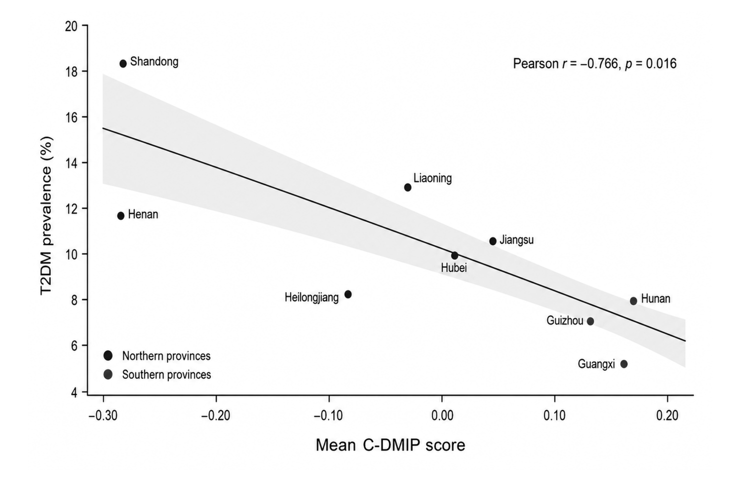
Supplementary Figure S1. Province-level association between mean C-DMIP score and T2DM prevalence. Each point represents one of the nine participating provinces in the eligible 2009 cross-sectional sample and is labelled by province. The x-axis shows the province-specific mean C-DMIP score, and the y-axis shows the observed prevalence of T2DM. Provinces are grouped as northern or southern according to the regional classification used in the main analysis. The province-specific mean C-DMIP score was inversely correlated with T2DM prevalence (Pearson r=−0.766, 95% CI −0.948 to −0.208; p=0.016). This province-level association is descriptive and should not be interpreted as an individual-level association. Abbreviations: C-DMIP, China-specific Dietary Metabolic-Inflammatory Pattern; CI, confidence interval; T2DM, type 2 diabetes mellitus.
Supplementary Figure S2. Receiver operating characteristic curves for C-DMIP and DII models
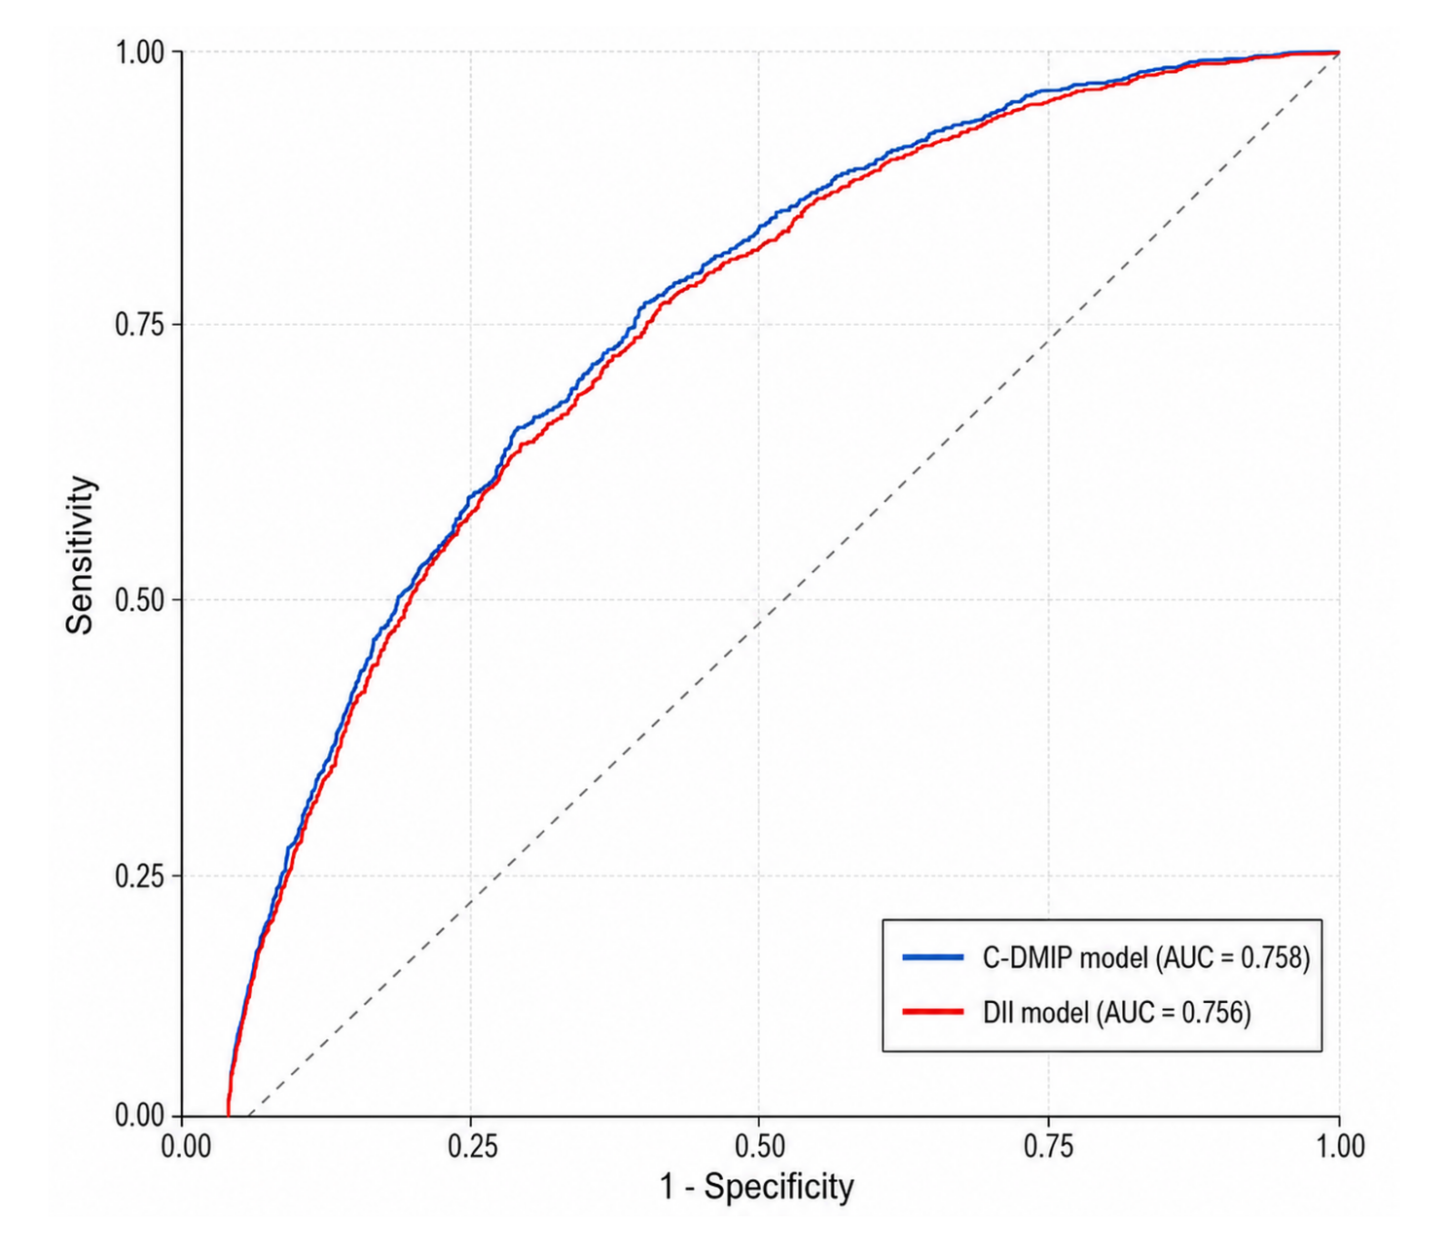
Supplementary Figure S2. Receiver operating characteristic curves for C-DMIP and DII models. Receiver operating characteristic curves compare the apparent in-sample discrimination of otherwise identical Model 3 logistic regression models containing either the standardised C-DMIP score or the standardised DII score for prevalent T2DM. Analyses were conducted in the common complete-case cross-sectional sample of 7,846 participants, including 790 prevalent T2DM cases. Model 3 adjusted for age, sex, urban or rural residence, educational attainment, BMI, waist circumference, current smoking, alcohol consumption and total energy intake. The AUC was 0.758 for the C-DMIP model and 0.756 for the DII model. The AUC difference (C-DMIP − DII) was 0.0015 (community-level cluster-bootstrap 95% CI −0.0003 to 0.0051; p=0.174). Abbreviations: AUC, area under the receiver operating characteristic curve; BMI, body mass index; C-DMIP, China-specific Dietary Metabolic-Inflammatory Pattern; CI, confidence interval; DII, Dietary Inflammatory Index; T2DM, type 2 diabetes mellitus. The diagonal dashed line represents chance discrimination (AUC = 0.5).

