Cytotoxic and antibacterial diketopiperazine cyclic dipeptides from Streptomyces canescens associated with marine sponge Haliclona caerulea

B
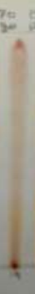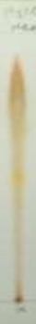
C
A
Fig.S1. Silica gel TLC of the Haliclona-associated bacteria ethyl acetate extract of strain AHL 19, eluted by A: n-hexane: ethyl acetate (8:2); B: n-hexane: ethyl acetate (3:7); C: ethyl acetate: MeOH (9.5: 0.5) as mobile phase and was sprayed with 0.5% anisaldehyde in sulfuric acid/ethanol

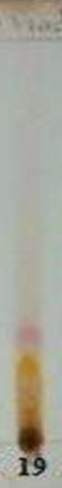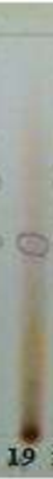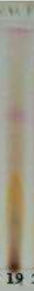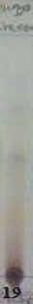
E
C
D
A
B
Fig.S2. Silica gel TLCs of the fractions of Haliclona-associated bacteria strains AHL 19 eluted by A: n-hexane: ethyl acetate (2:8), aq. MeOH fraction; B: n-hexane: ethyl acetate (6:4), DCM fraction; C: n-hexane: ethyl acetate (4:6), DCM fraction; D: n-hexane: ethyl acetate,(8:2), DCM fraction; E: n-hexane: ethyl acetate (8:2), n-hexane fraction, were sprayed with 0.5% anisaldehyde in sulfuric acid/ethanol.

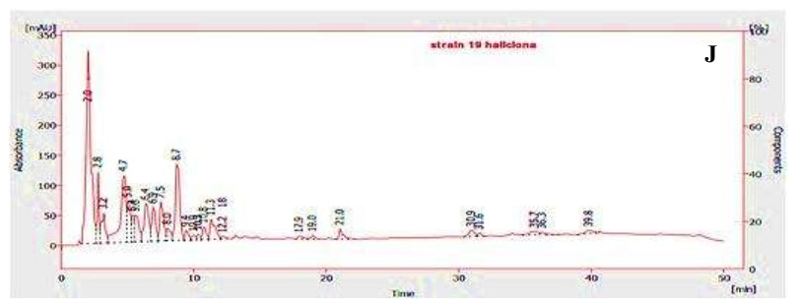
A
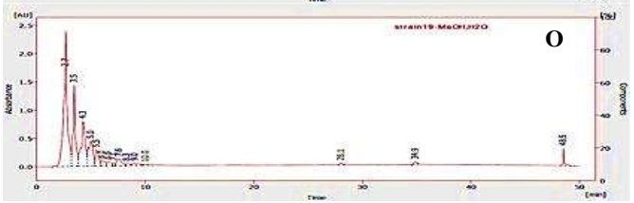
B
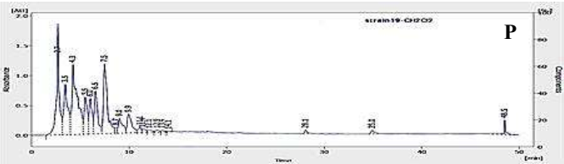
C
Fig S3. HPLC chromatograms of A) ethyl acetate extract, B) 90% aq. MeOH fraction C) DCM fraction of strain AHL19

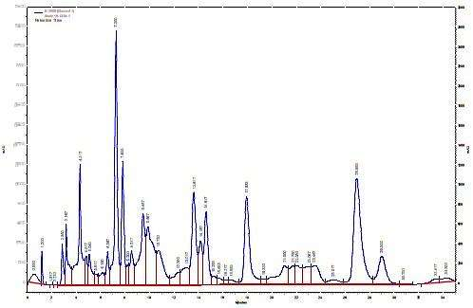
Fig S4. Semi-preparative HPLC chromatogram of the DCM fraction of strain AHL 19

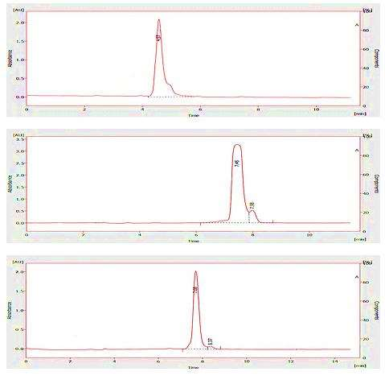
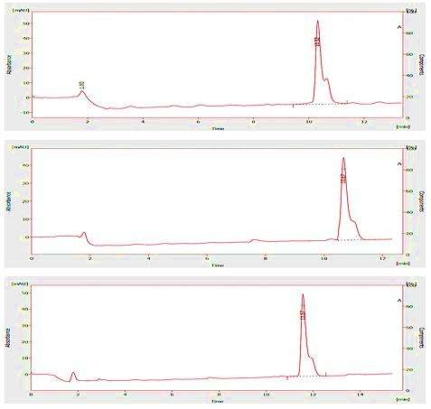
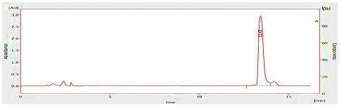
Fig S5. HPLC chromatogram of pure compounds of DCM fraction of AHL 19

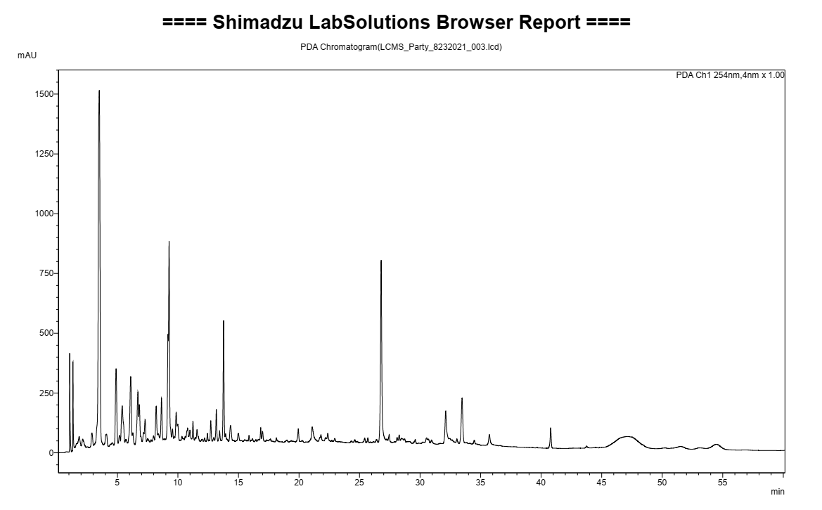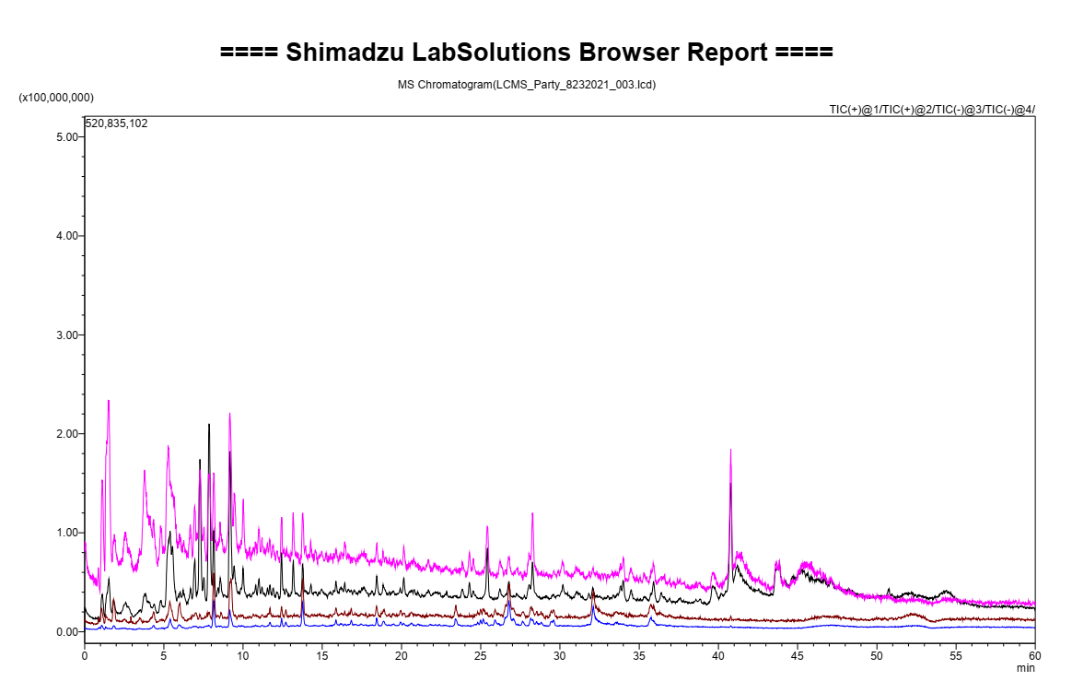
A
B
Fig S6. A) PDA and B) TIC chromatograms from LC/MS analysis of the DCM fraction of strain AHL19

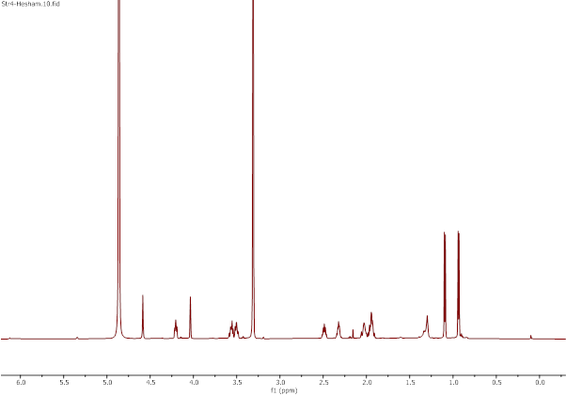
Figure S7. ¹HNMR (600MHz, CD₃OD) spectrum of compound 1

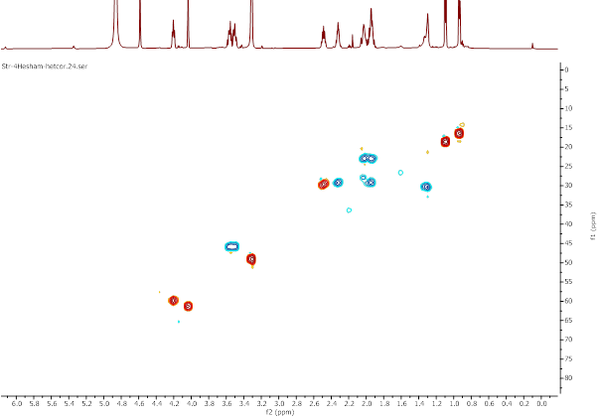
Figure S8. HETCOR spectrum of compound 1
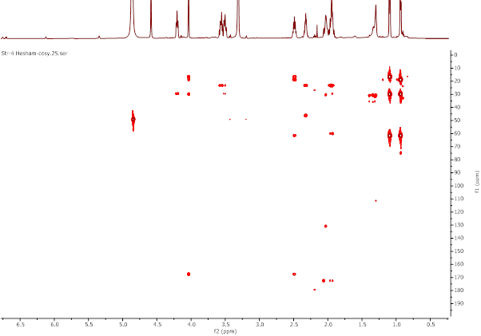
Figure S9. HMBC spectrum of compound 1
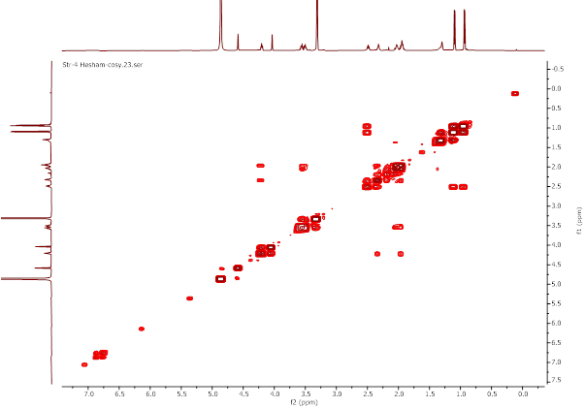
Figure S10. ¹H-¹H COSY spectrum of compound 1
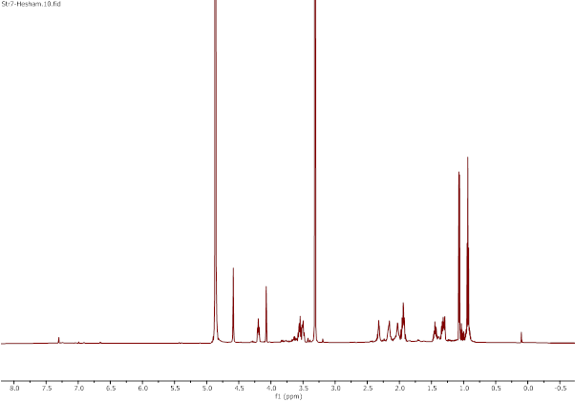
Figure S11. ¹HNMR (600MHz, CD₃OD) spectrum of compound 2
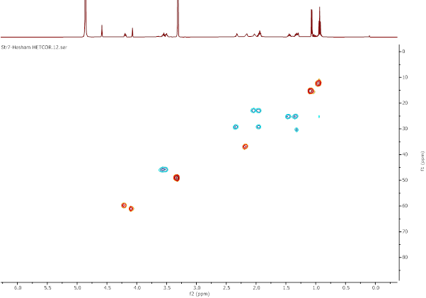
Figure S12. HETCOR spectrum of compound 2
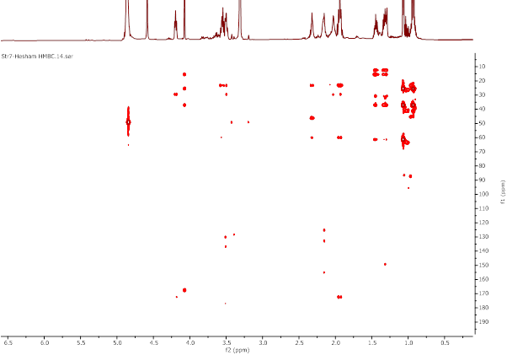
Figure S13. HMBC spectrum of compound 2
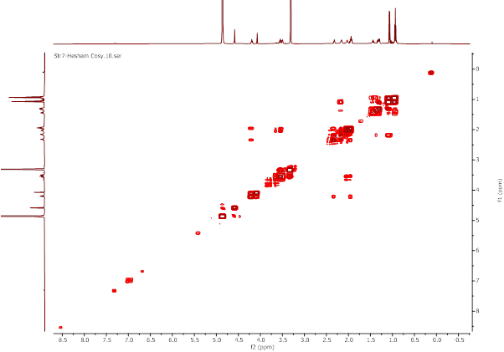
Figure S14. ¹H-¹H COSY spectrum of compound 2

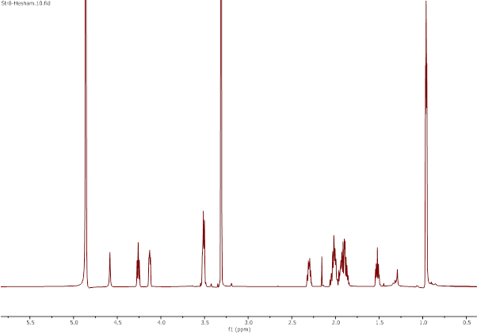
Figure S15. ¹HNMR (600MHz, CD₃OD) spectrum of compound 3
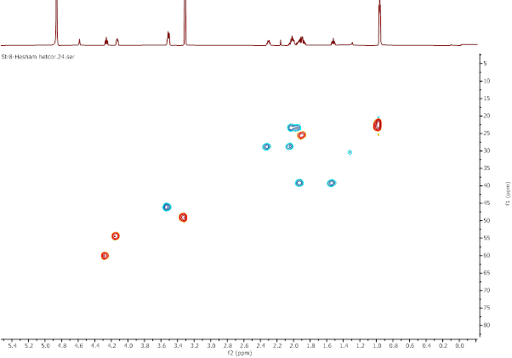
Figure S16. HETCOR spectrum of compound 3
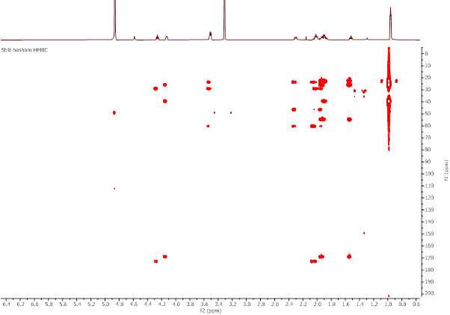
Figure S17. HMBC spectrum of compound 3
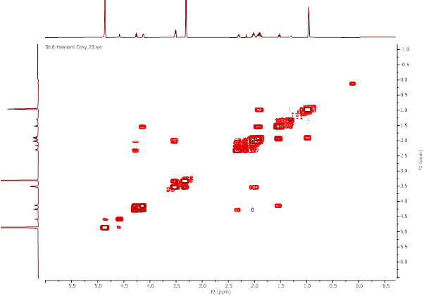
Figure S18. ¹H-¹H COSY spectrum of compound 3
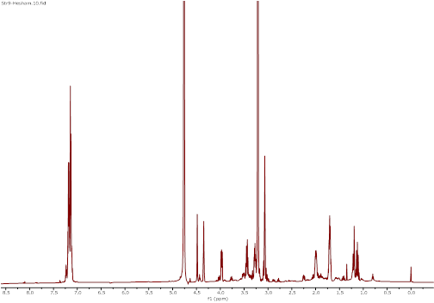
Figure S19. ¹HNMR (600MHz, CD₃OD) spectrum of compound 4
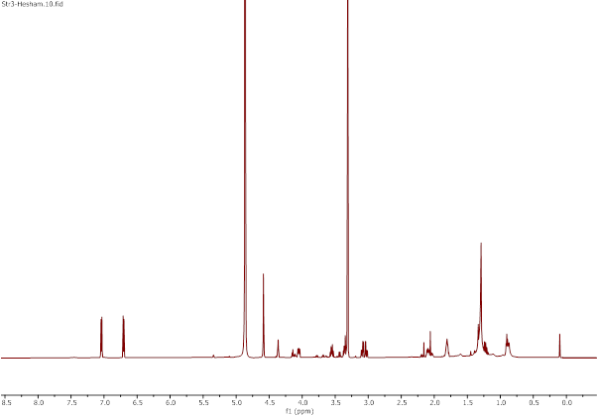
Figure S20. ¹HNMR (600MHz, CD₃OD) spectrum of compound 5
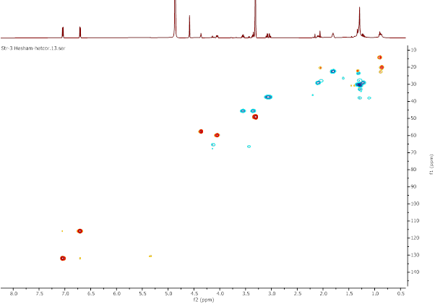
Figure S21. HETCOR spectrum of compound 5
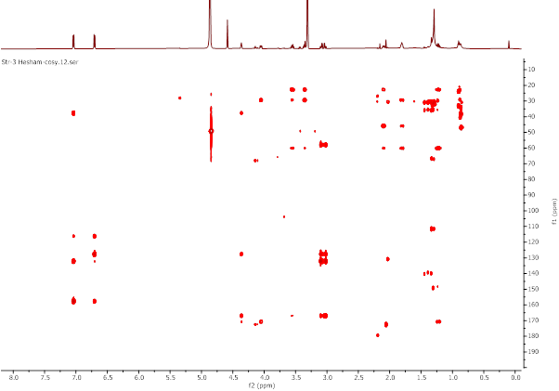
Figure S22. HMBC spectrum of compound 5
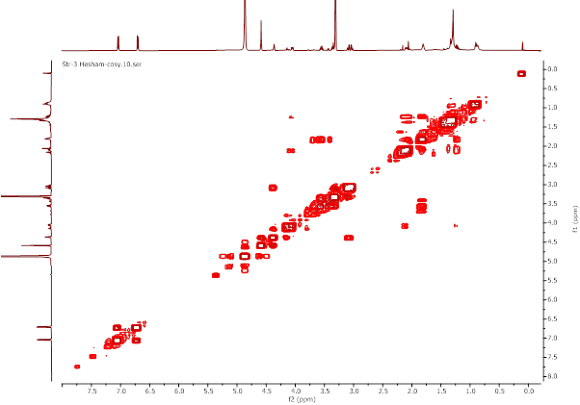
Figure S23. ¹H-¹H COSY spectrum of compound 5

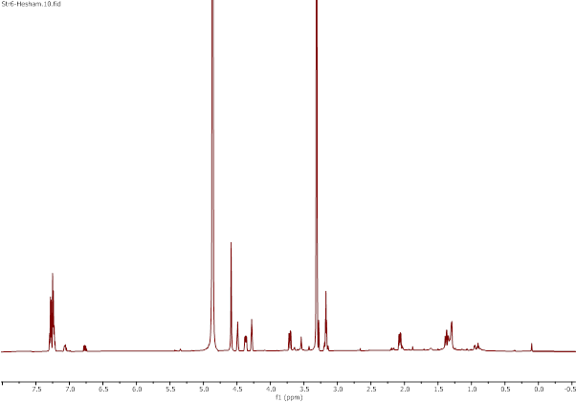
Figure S24. ¹HNMR (600MHz, CD₃OD) spectrum of compound 6
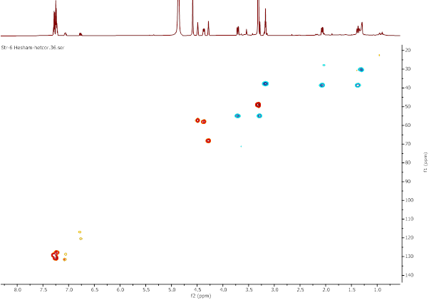
Figure S25. HETCOR spectrum of compound 6

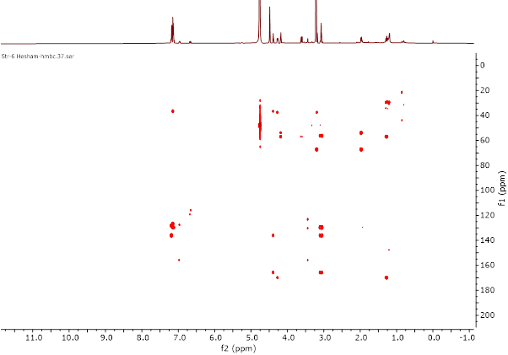
Figure S26. HMBC spectrum of compound 6

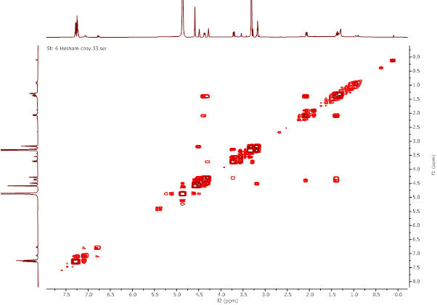
Figure S27. ¹H-¹H COSY spectrum of compound 6

Table S1. ¹H NMR Data (MD₃OD, 600 MHz) of Compounds 1-6, (δ in ppm, J in Hz).
Position | 1 | 2 | 3 | 4 | 5 | 6
3 | 3.46, dt, 11.8, 7.7, 7.7  3.40, ddd, 11.8, 8.6, 3.2 Hz | 3.46, dt, 13.1, 8.2, 8.2 Hz  3.40, tt, 8.9, 4.4 Hz | 3.41, m | 3.45, dt, 12.0, 8.5, 8.5 Hz  3.25, td, 12.5, 12.0, 6.5 | 3.45, dt, 12.0, 8.5, 8.5 Hz,  3.25, m | 3.61, dd, 13.2, 5.1 Hz  3.20, m (overlaps with solvent)
4 | 1.93, m  1.83, m | 1.93, m  1.84, m | 1.91, m  1.84, m | 1.70, m | 1.70, m | 4.17, t, 5.1 Hz
5 | 2.23, m  1.85, m | 2.23, m  1.84, m | 2.20, dt, 10.1, 6.3, 6.3  1.92, m | 2.00, m  1.12, m | 2.00, m  1.13, m | 1.97, dd, 12.6, 6.0 Hz  1.27, td, 12.6, 12.6, 5.1 Hz
6 | 4.10, t,7.2 Hz | 4.10, dd, 9.5, 6.5 Hz | 4.16, t, 7.9 Hz | 3.97, dd, 11.1, 6.3 Hz | 3.95, dd, 11.2, 6.3 Hz | 4.27, dd, 12.0, 6.0 Hz
9 | 3.94, s | 3.97, s | 4.03, dd, 9.1, 3.4 Hz | 4.35, t, 5.0 Hz | 4.26, t, 5.1 Hz | 4.40, t, 5.8 Hz
10 | 2.40, hept, 7.0 Hz | 2.06, m | 1.81, m  1.42, m | 3.05, t, 5.0 Hz | 2.99, dd, 14.2, 5.2Hz  2.93, dd, J = 14.2, 4.6 Hz, | 3.07, t, 5.8 Hz
11 | 1.00, d, 7.0 Hz | 1.35, m  1.22, m | 1.78, m
12 |  | 0.83, t, 7.5 Hz | 0.86, d, 6.6 Hz
Me-10 | 0.83, d, 7.0 Hz | 0.97, d, 7.1 Hz
Me-11 |  |  | 0.86, d, 6.6 Hz
Ar
2’ |  |  |  | 7.15, m | 6.95, d, 8.1 Hz, | 7.15, m
3’ |  |  |  |  | 6.60, d, 8.1 Hz,
4’

Table S2. ¹³C NMR Data (MeOD, 600 MHz) of Compounds 1-3, 5, and 6 (δ_{C} in ppm).
Position | 1 | 2 | 3 | 5 | 6
1 | 166.1 | 166.1 | 167.6 | 165.6 | 165.7
3 | 44.5 | 44.6 | 45.0 | 44.6 | 53.6
4 | 21.7 | 21.7 | 22.3 | 21.3 | 67.1
5 | 28.1 | 28.0 | 27.5 | 27.9 | 37.5
6 | 58.7 | 58.5 | 58.8 | 58.6 | 56.8
7 | 171.2 | 171.0 | 171.5 | 169.8 | 169.7
9 | 60.0 | 60.0 | 53.2 | 56.4 | 56.1
10 | 28.4 | 35.7 | 37.8 | 36.2 | 36.5
11 | 17.2 | 24.0 | 24.4
12 |  | 11.0 | 21.0
Me-10 | 15.2 | 14.0
Me-11 |  |  | 21.0
Ar
1’ |  |  |  | 126.8 | 136.0
2’ |  |  |  | 130.7 | 129.5
3’ |  |  |  | 114.6 | 127.9
4’ |  |  |  | 156.4 | 126.6

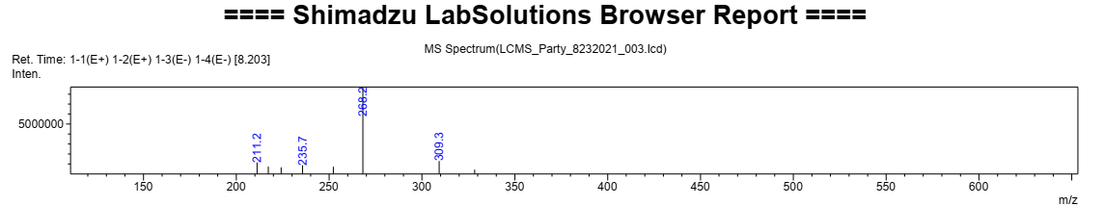
Fig. S28. LC-ESI-MS of compound 2 in positive ion mode

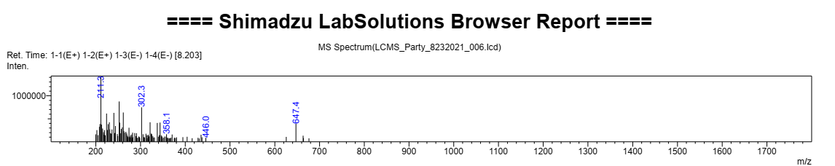 Fig. S29. LC-ESI-MS of compound 3 in positive ion mode
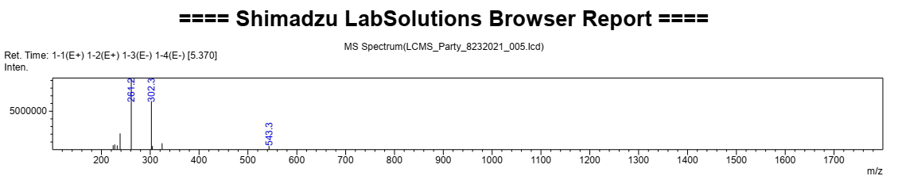
Fig. S30. LC-ESI-MS of compound 5 in positive ion mode

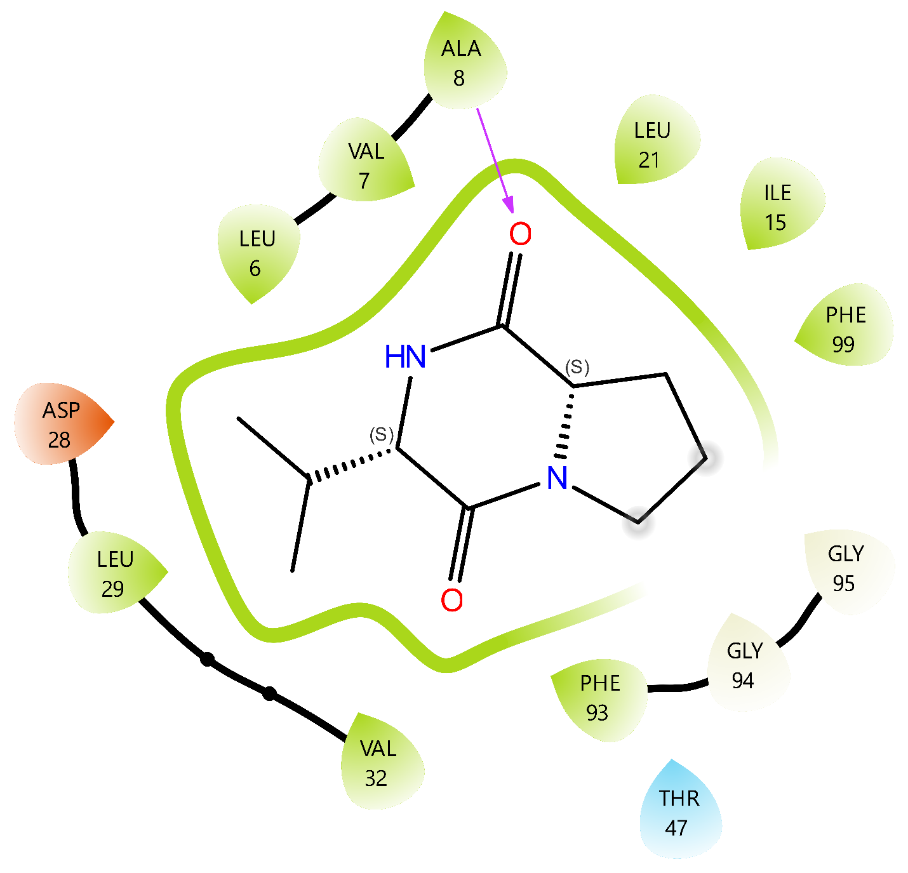
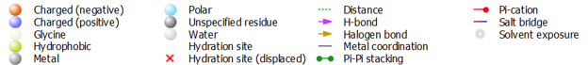

Figure S31. The interactions constructed between the compound 1 and DHFR.

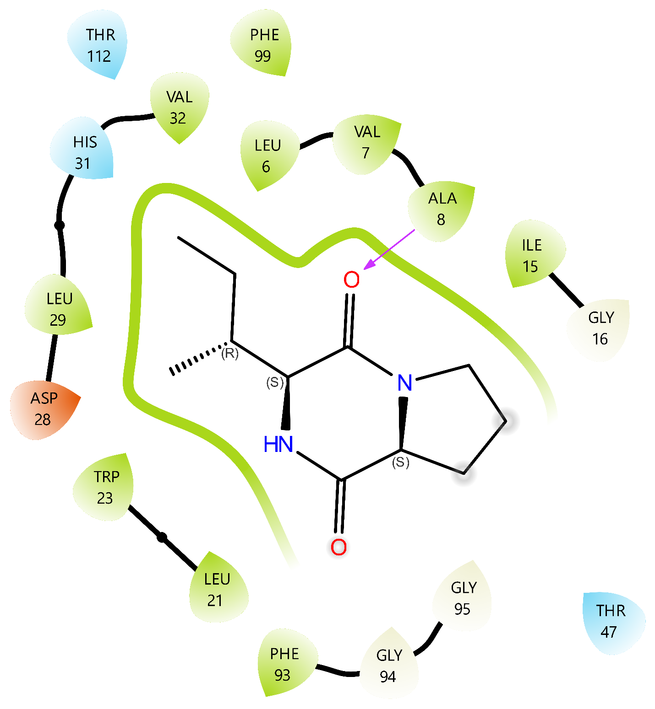
Figure S32. The interactions constructed between the compound 2 and DHFR.

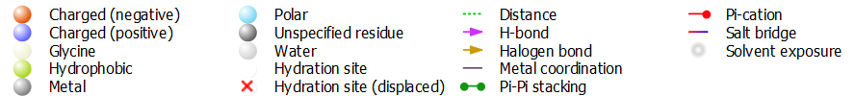
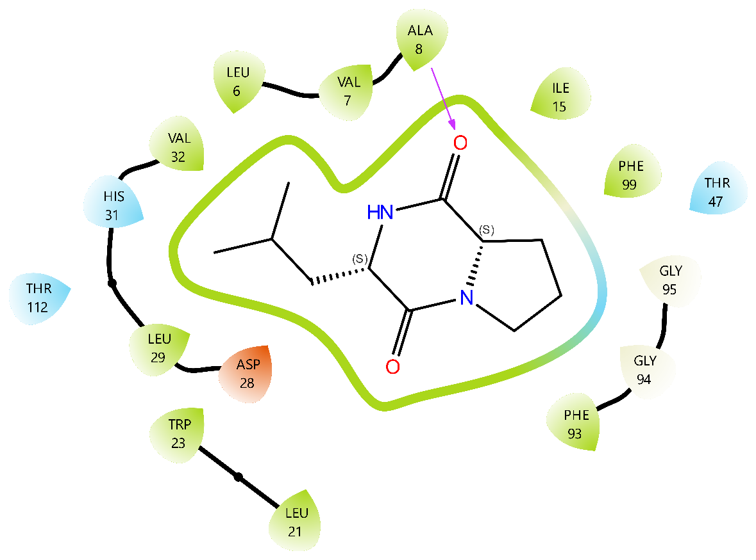
Figure S33. The interactions constructed between the compound 3 and DHFR.

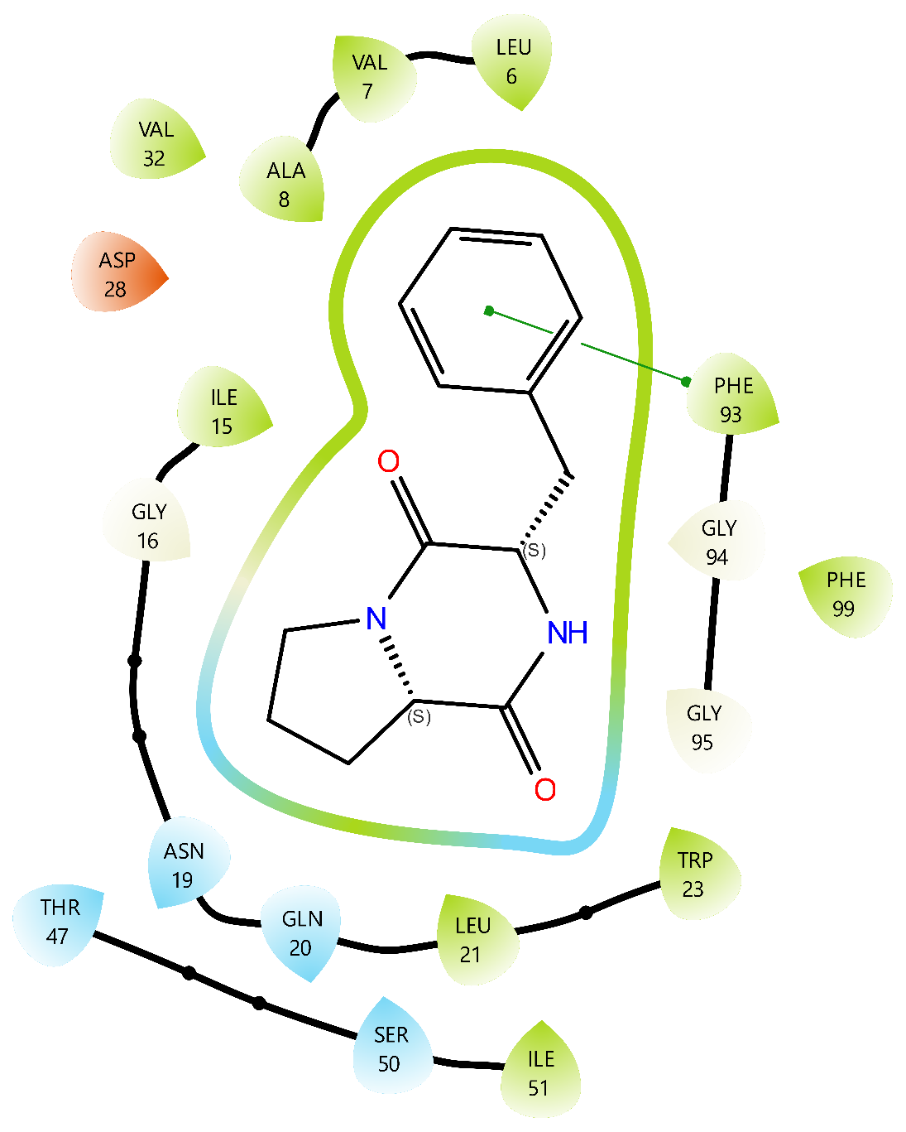
Figure S34. The interactions constructed between the compound 4 and DHFR.

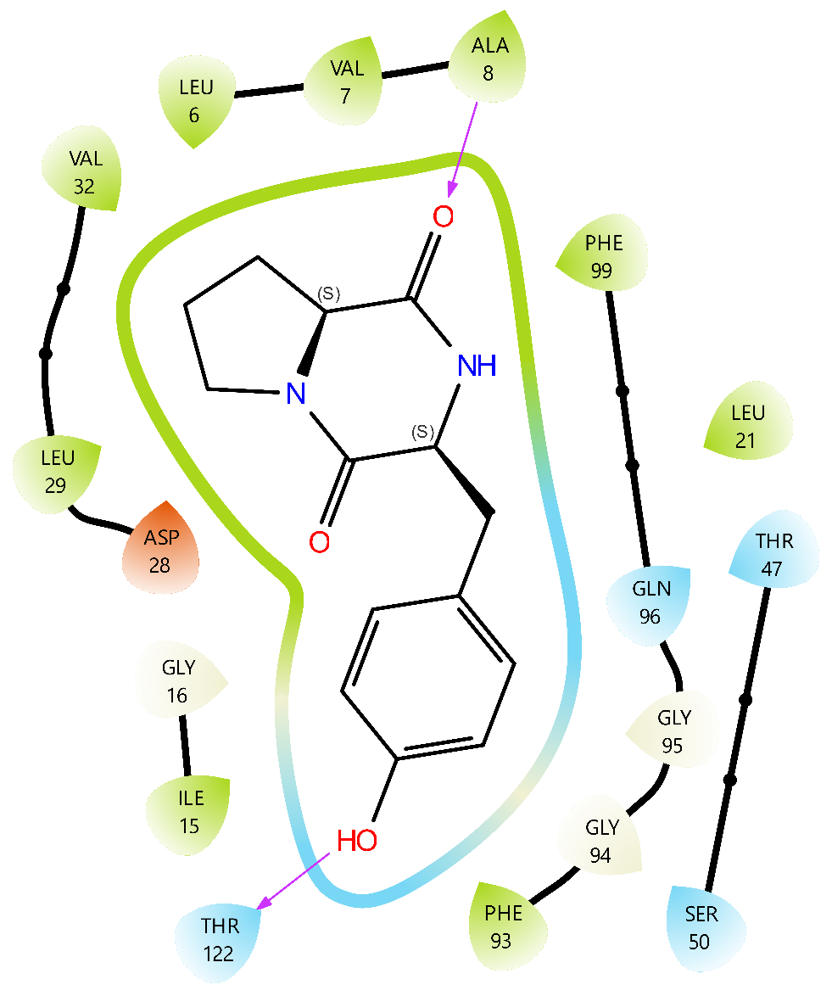

Figure S35. The interactions constructed between the compound 5 and DHFR.

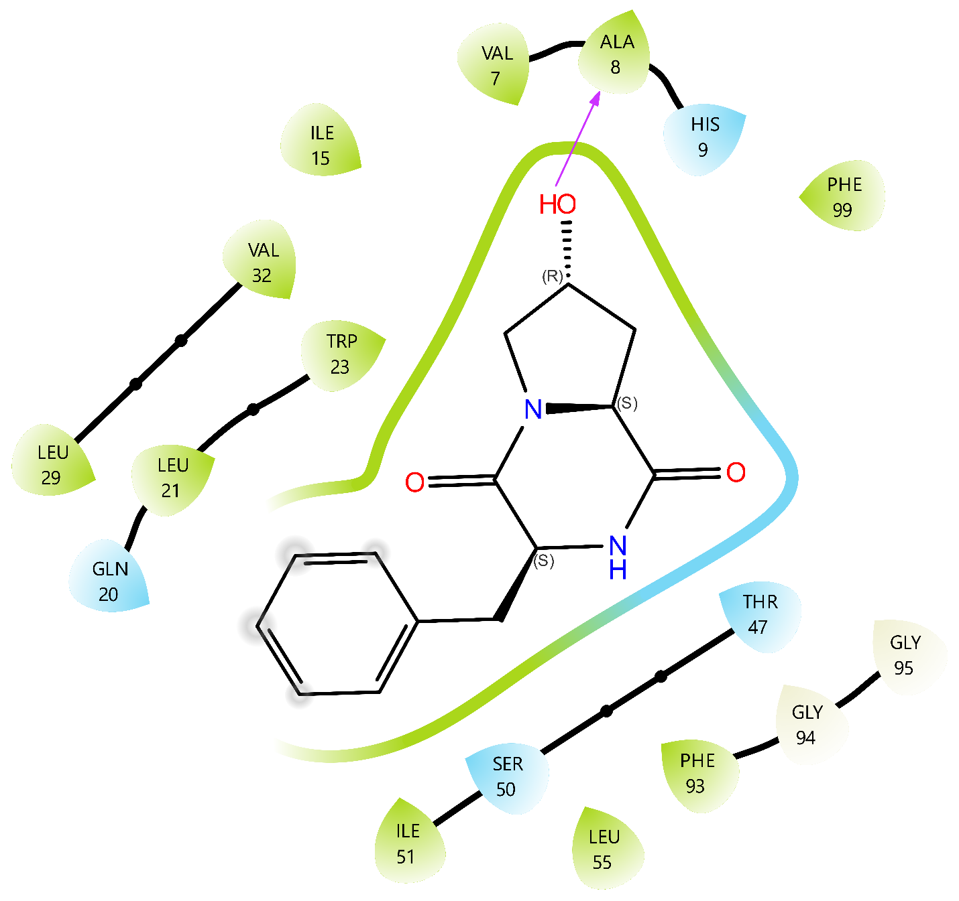

Figure S36. The interactions constructed between the compound 6 and DHFR.

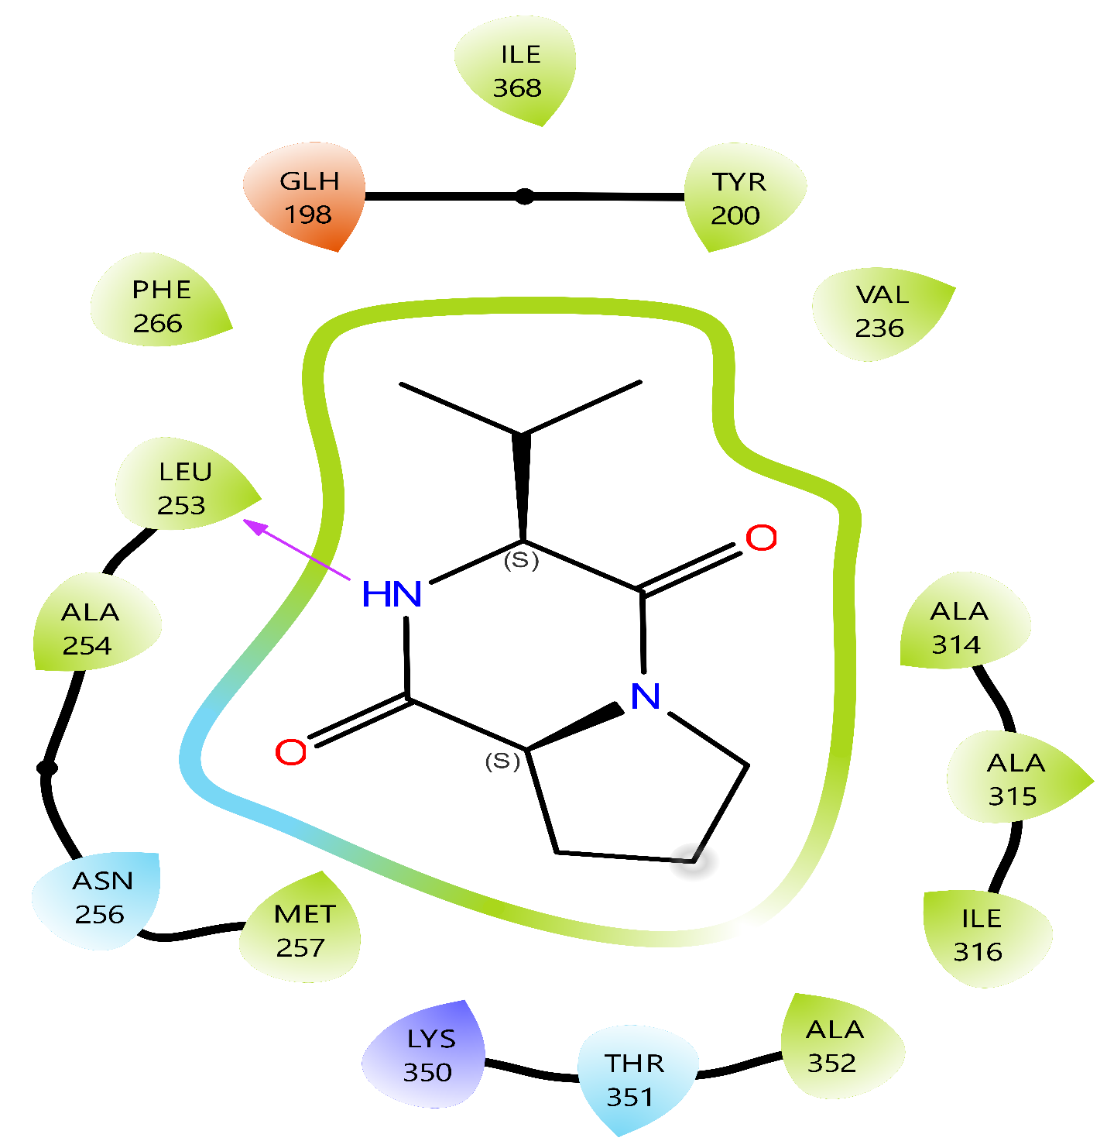

Figure S37. The interactions constructed between the compound 1 and Tubulin B.

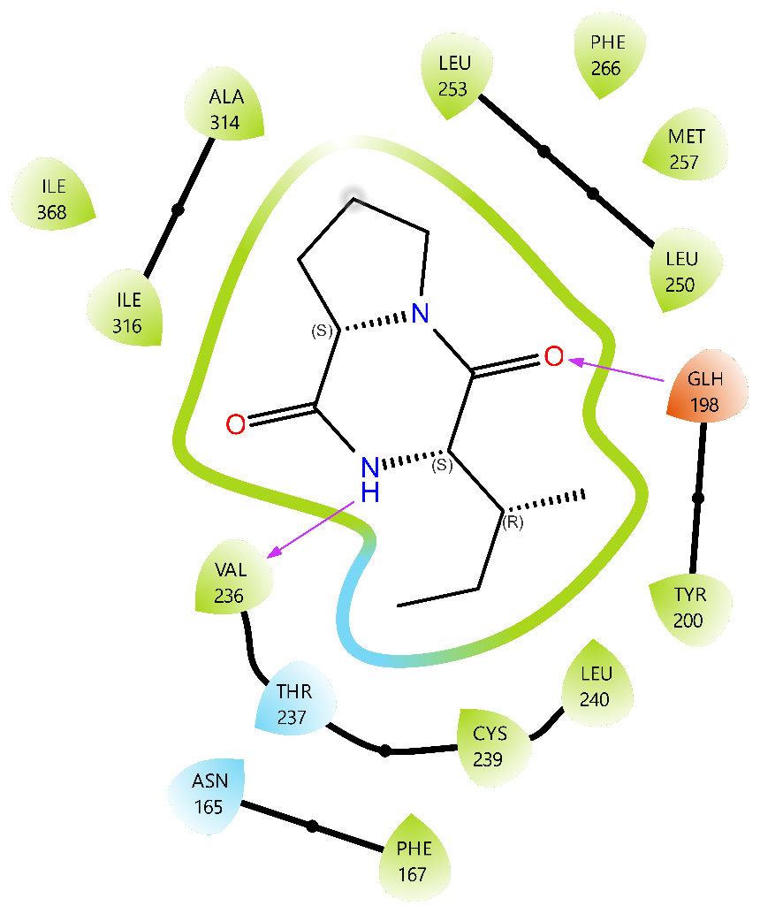

Figure S38. The interactions constructed between the compound 2 and Tubulin B.

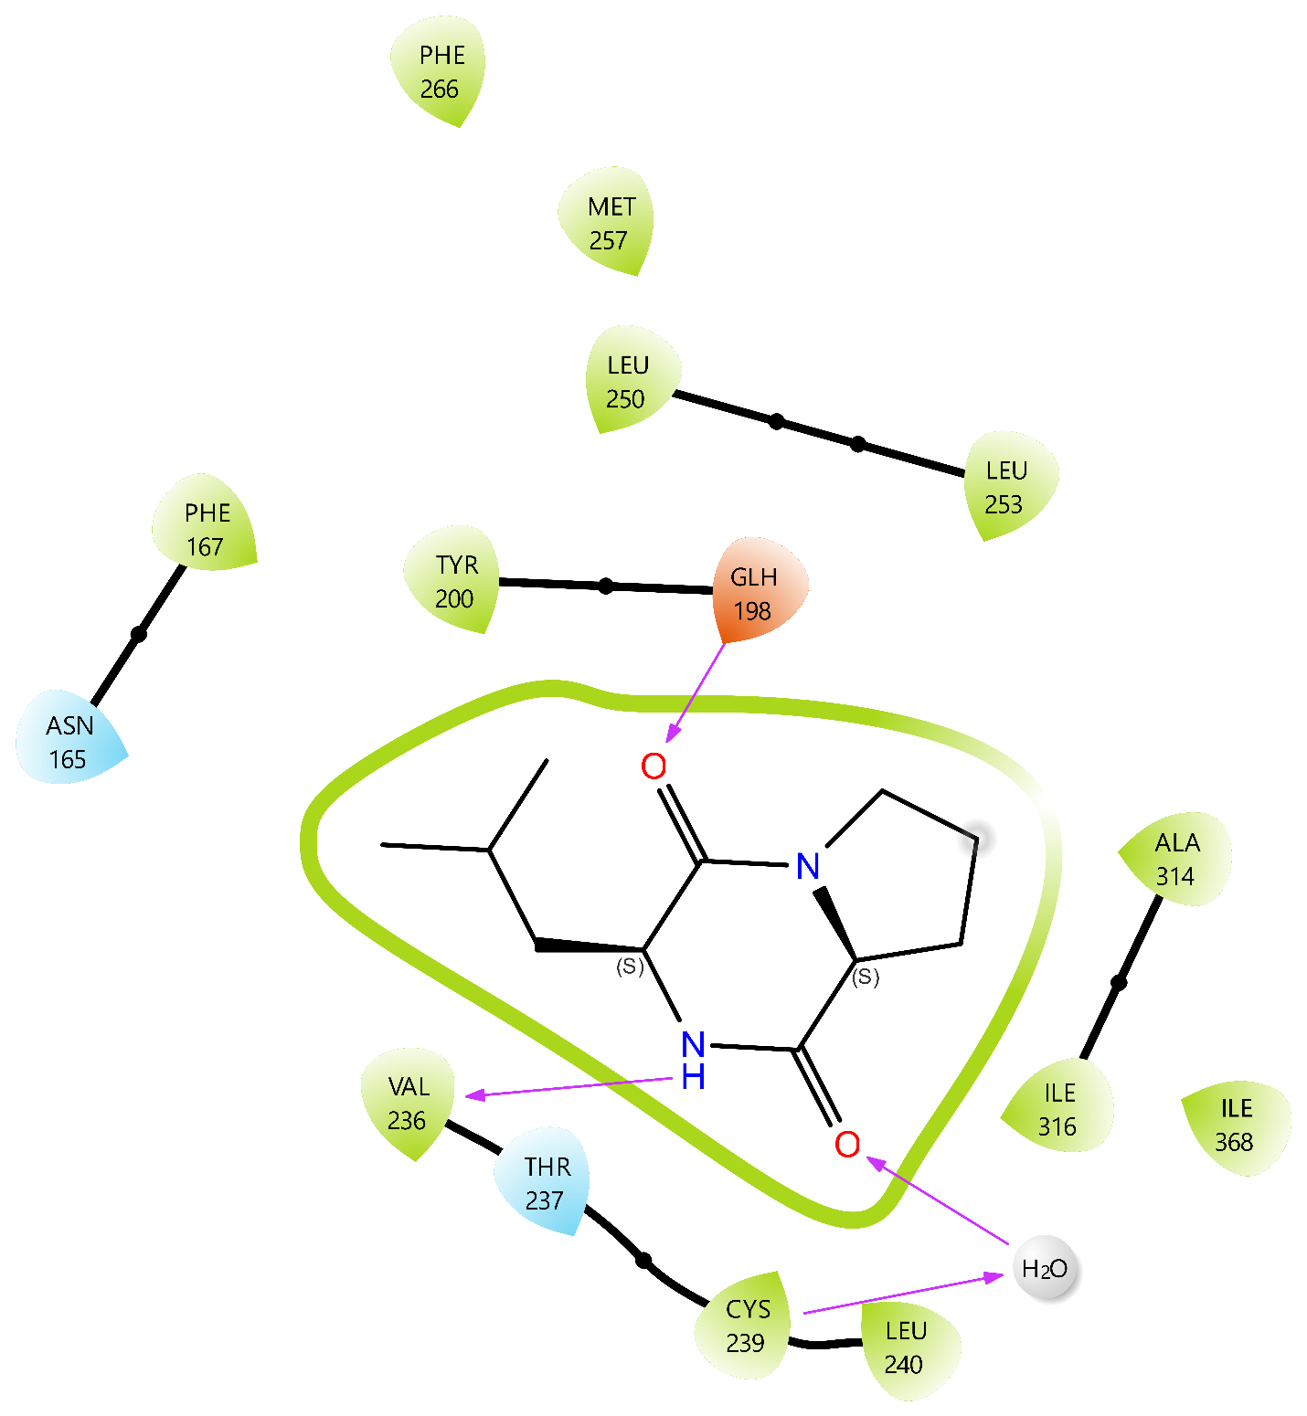

Figure S39. The interactions constructed between the compound 3 and Tubulin B.
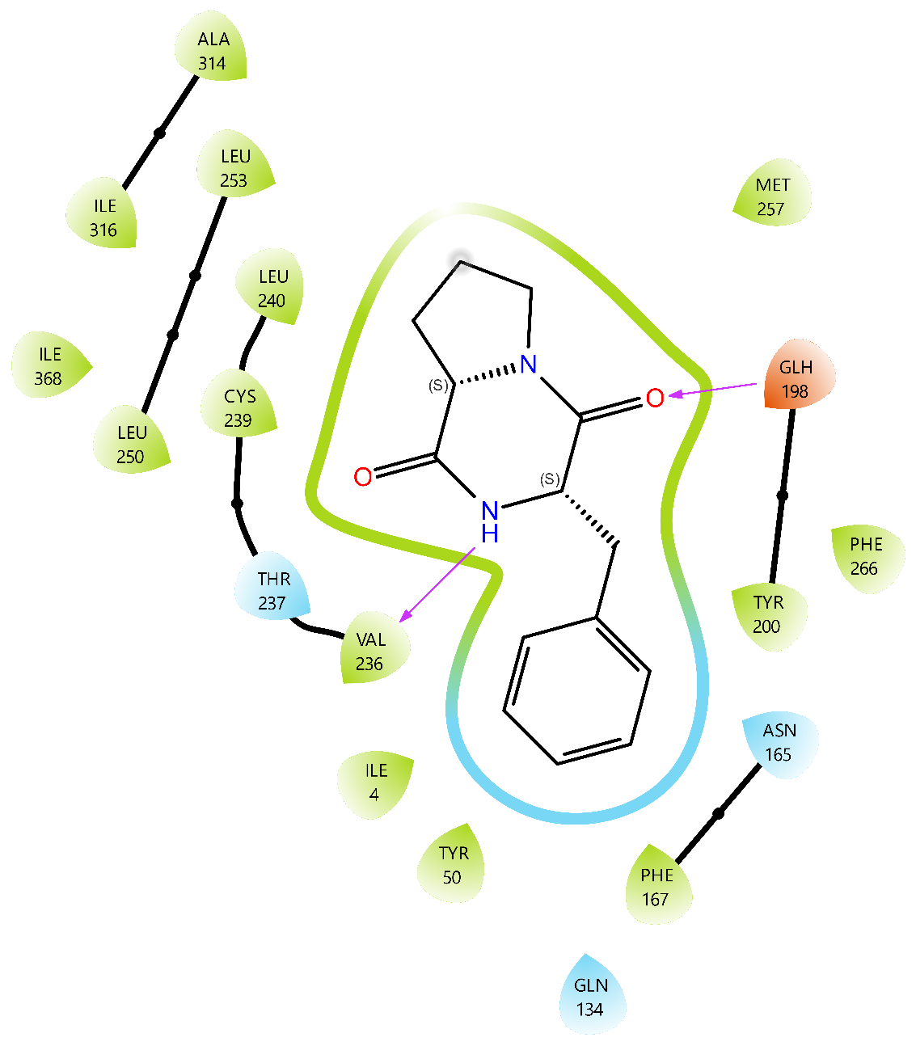

Figure S40. The interactions constructed between the compound 4 and Tubulin B.
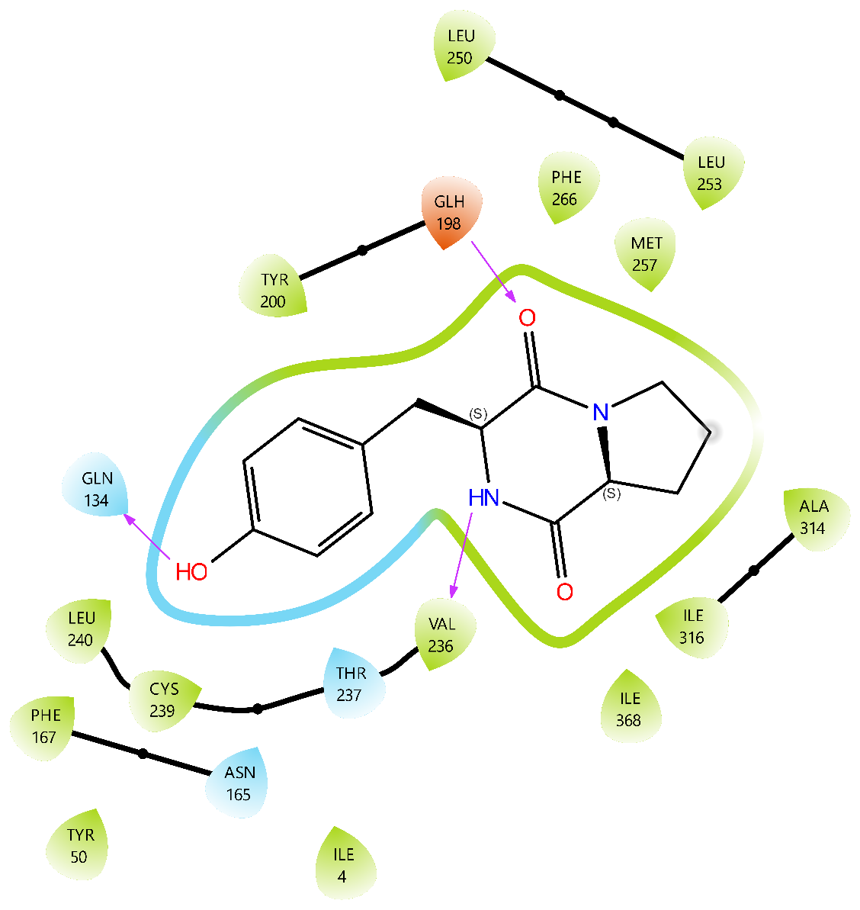

Figure S41. The interactions constructed between the compound 5 and Tubulin B.

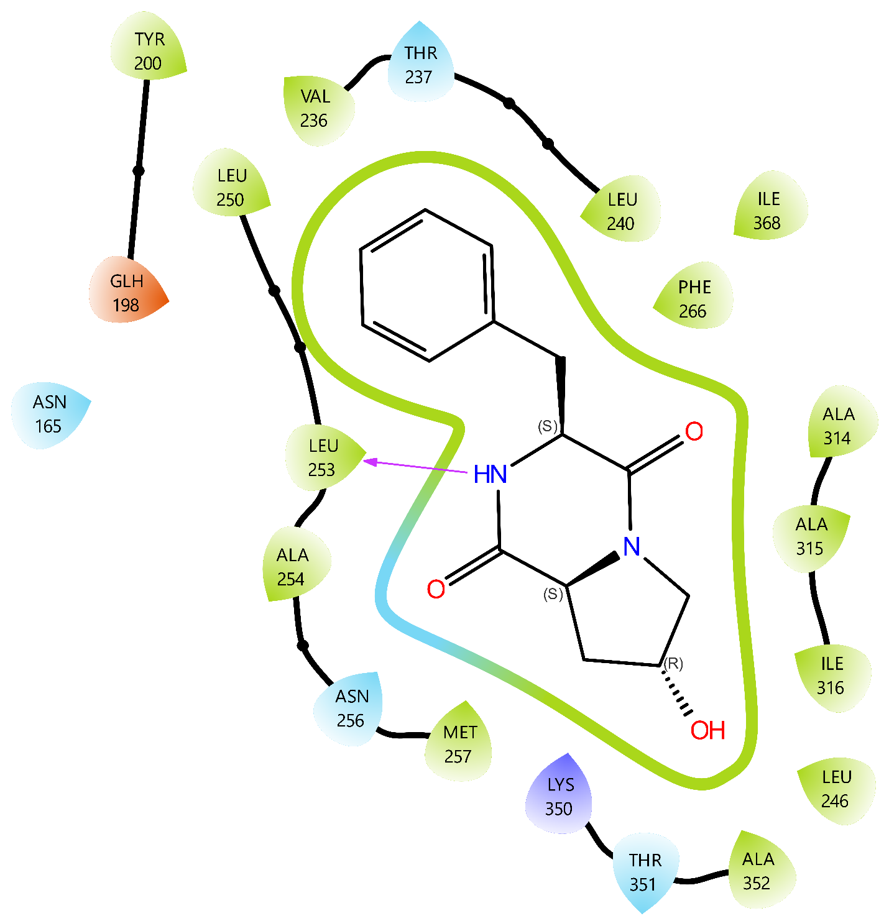

Figure S42. The interactions constructed between the compound 6 and Tubulin B.

