Some Representative Spectra
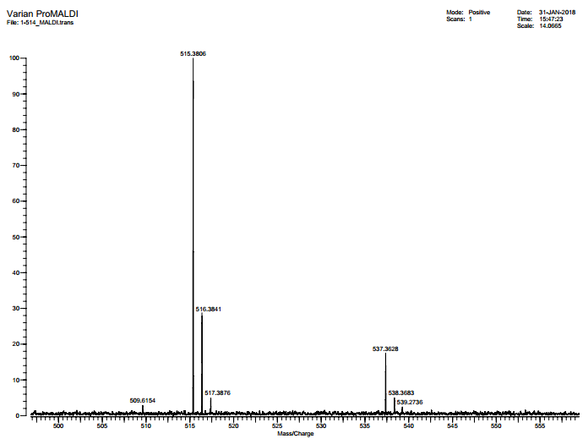
HRMS Spectrum of Compound 2
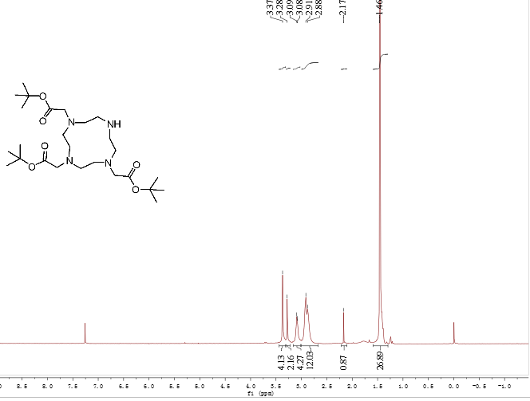¹H NMR Spectrum of Compound 2

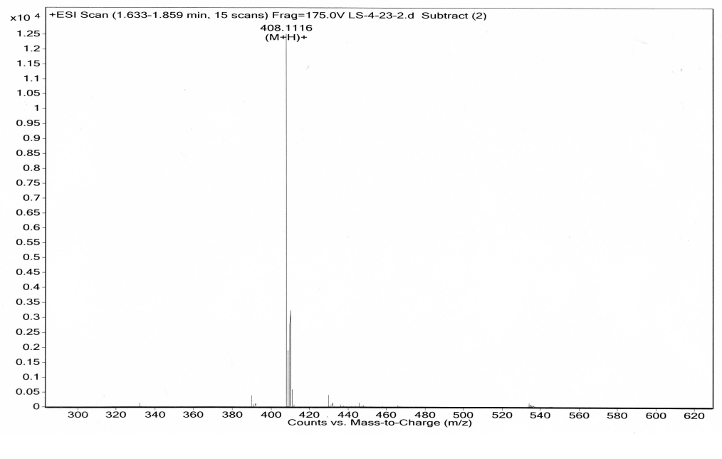
HRMS Spectrum of Compound 2a
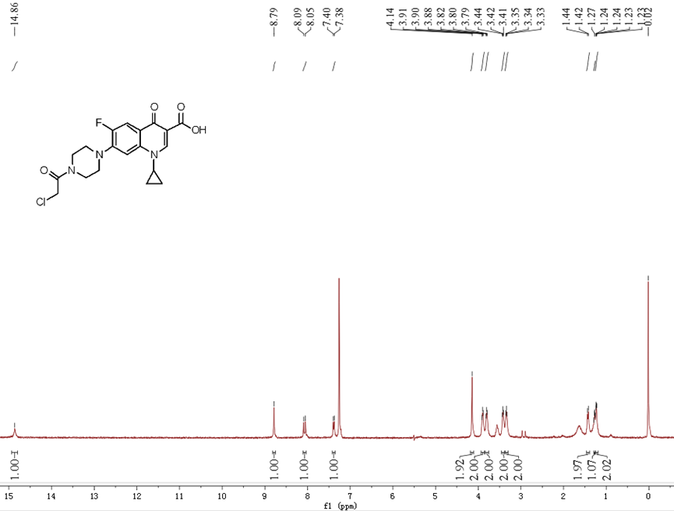
¹H NMR Spectrum of Compound 2a
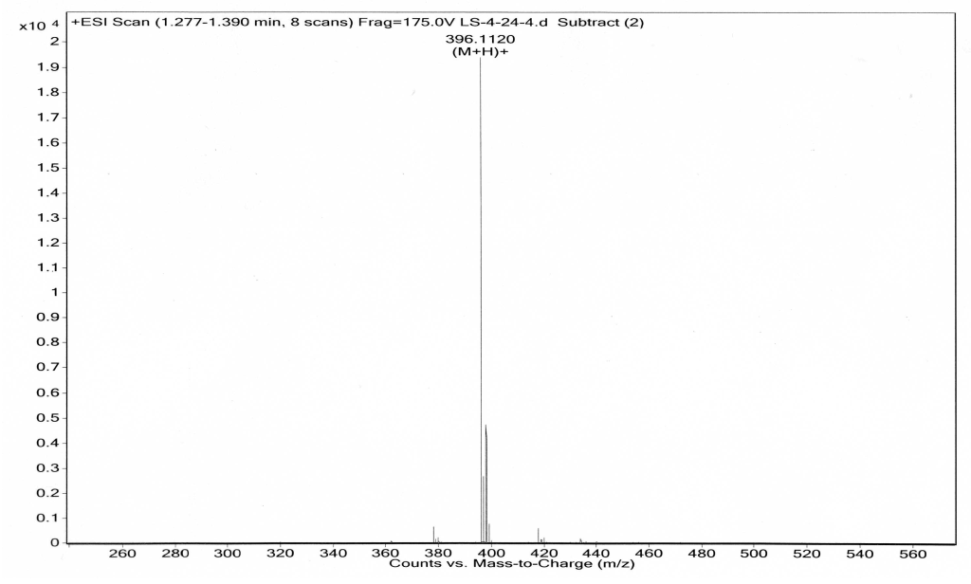
HRMS Spectrum of Compound 2b
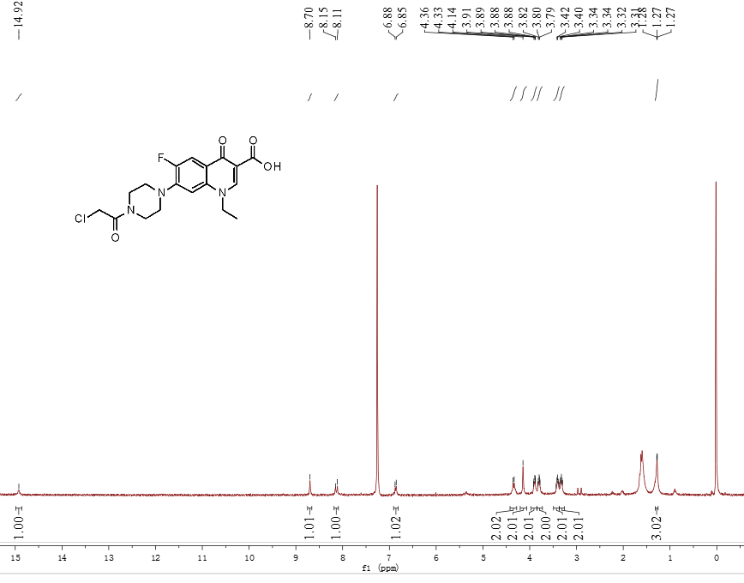
¹H NMR Spectrum of Compound 2b
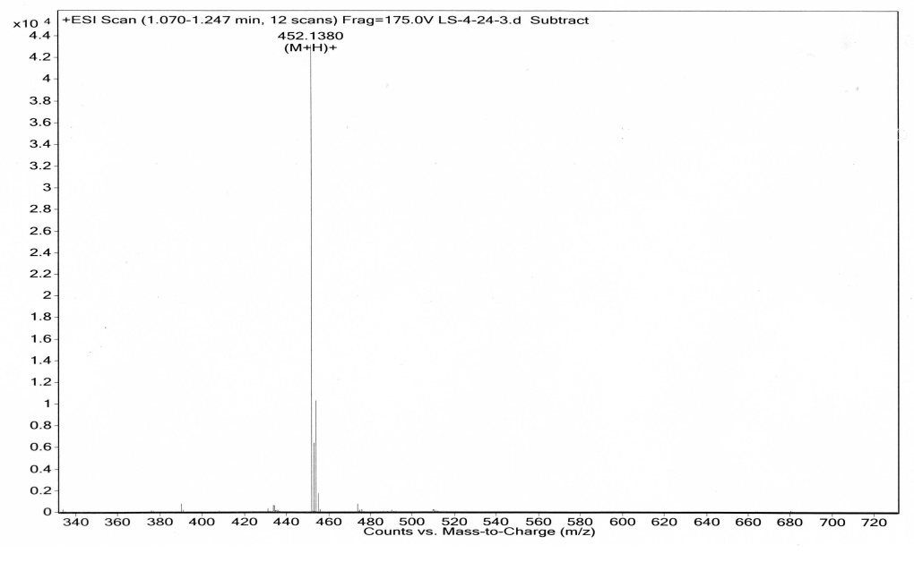

HRMS Spectrum of Compound 2c
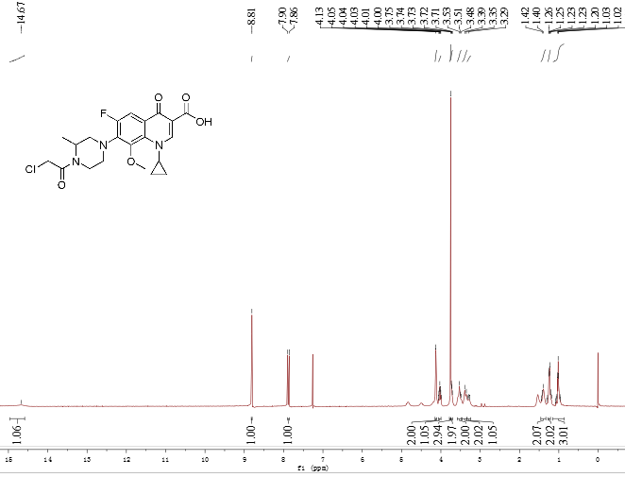
¹H NMR Spectrum of Compound 2c
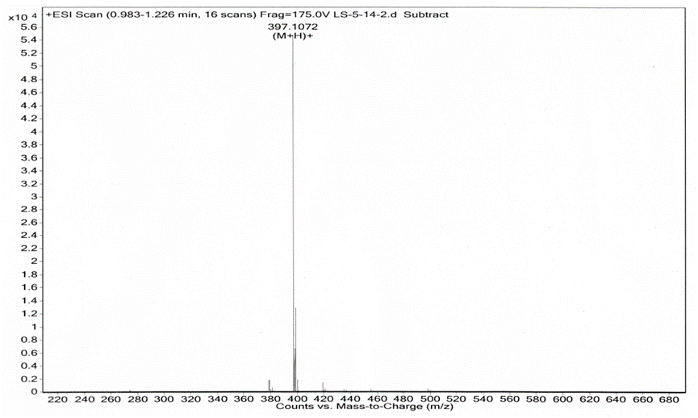
HRMS Spectrum of Compound 2d
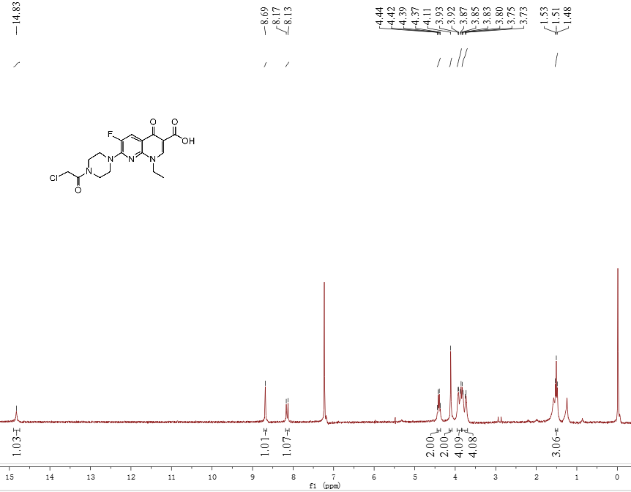
¹H NMR Spectrum of Compound 2d
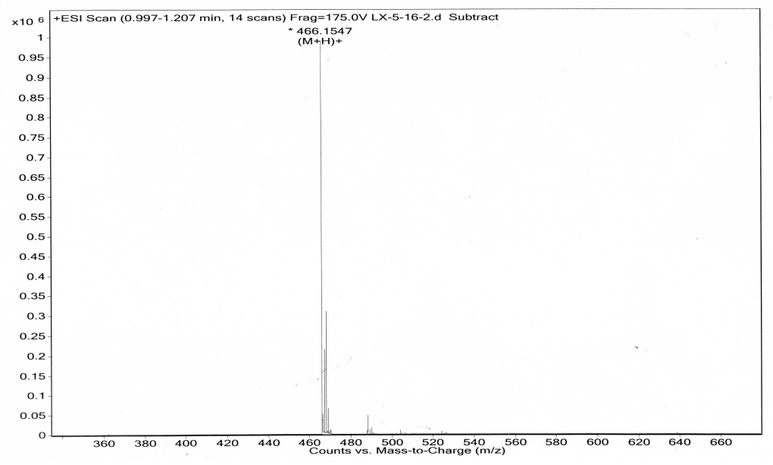
HRMS Spectrum of Compound 2e
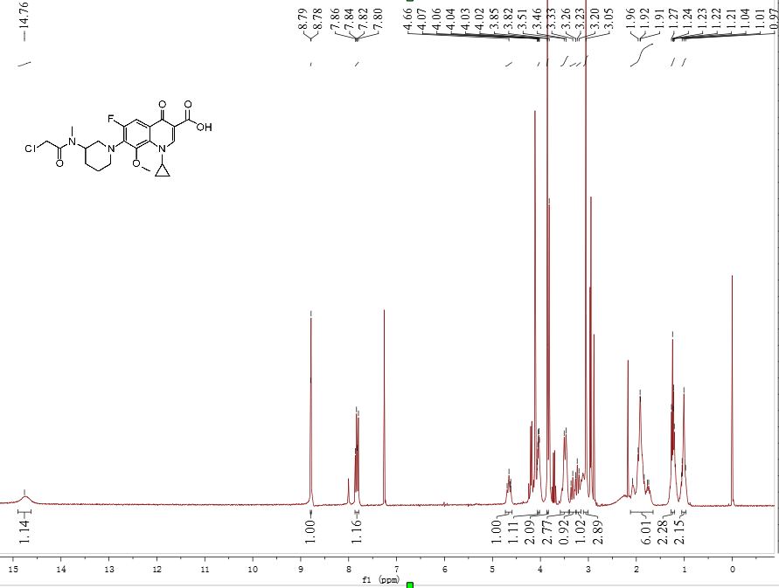
¹H NMR Spectrum of Compound 2e
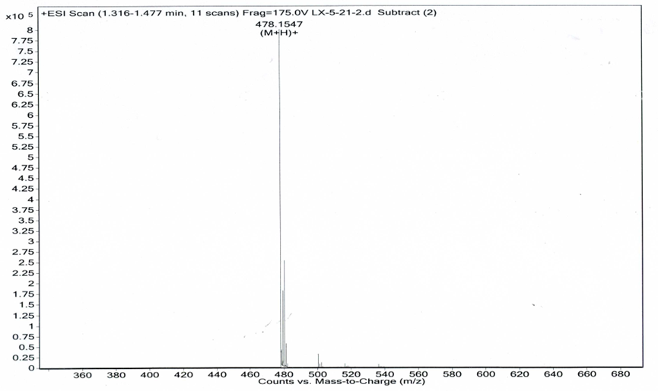
HRMS Spectrum of Compound 2f
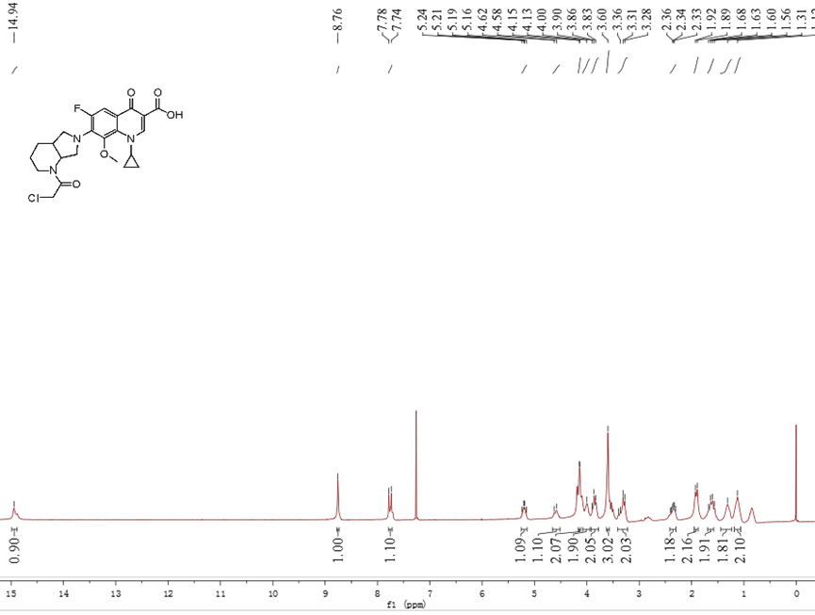
¹H NMR Spectrum of Compound 2f
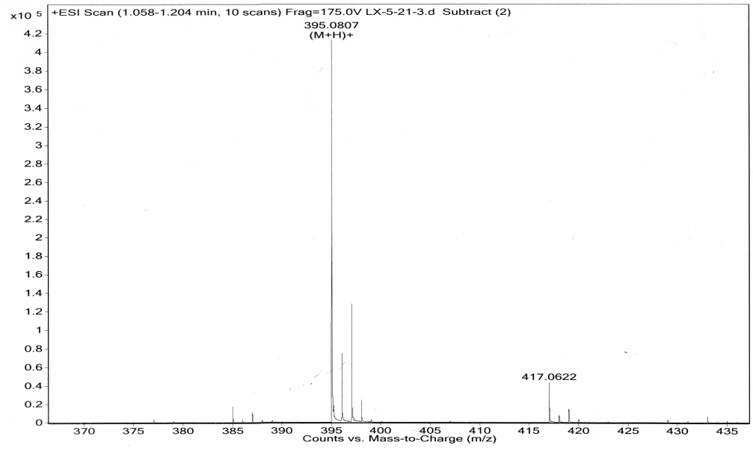
HRMS Spectrum of Compound 2g
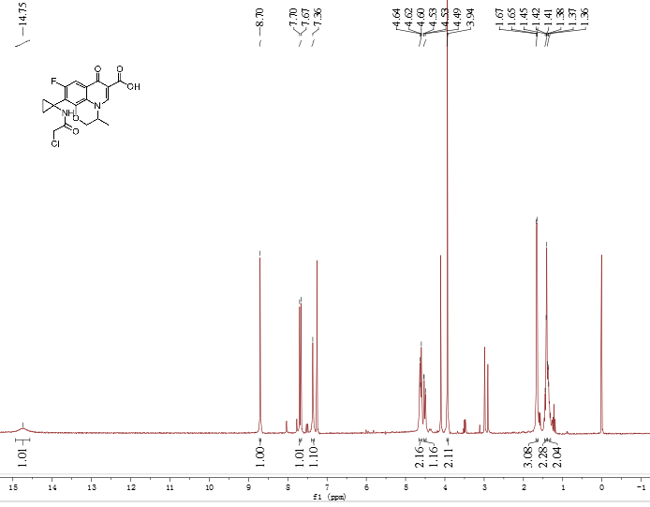
¹H NMR Spectrum of Compound 2g

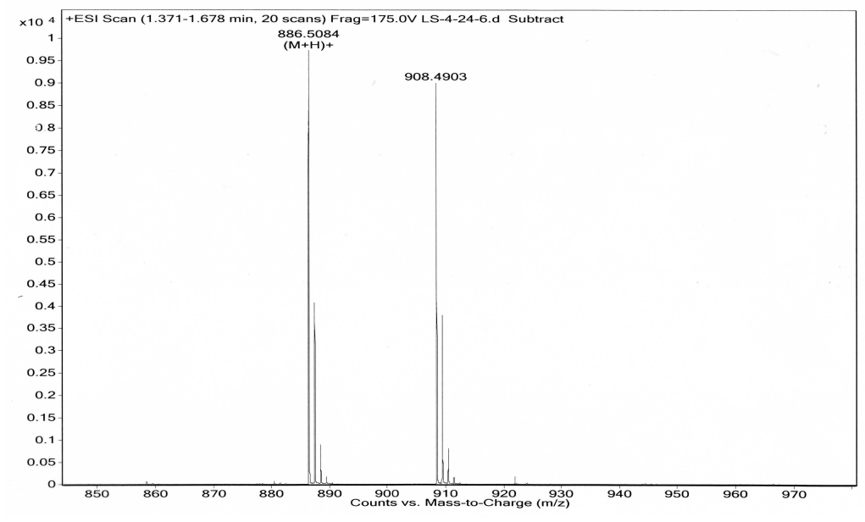
HRMS Spectrum of Compound 3a
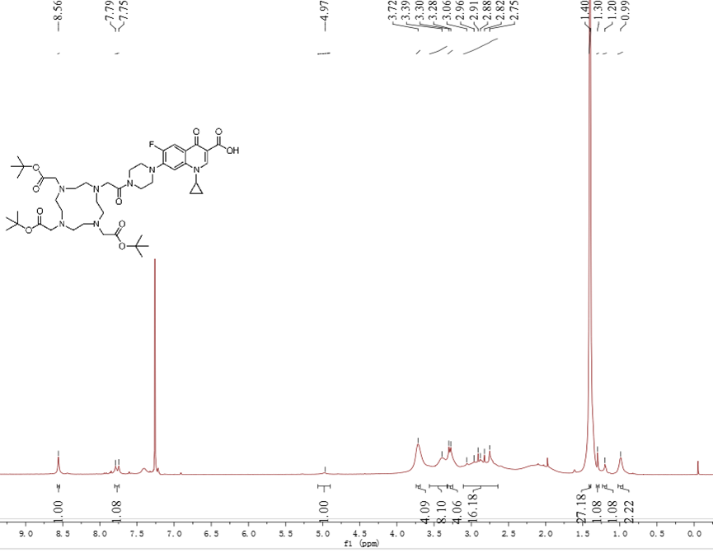
¹H NMR Spectrum of Compound 3a
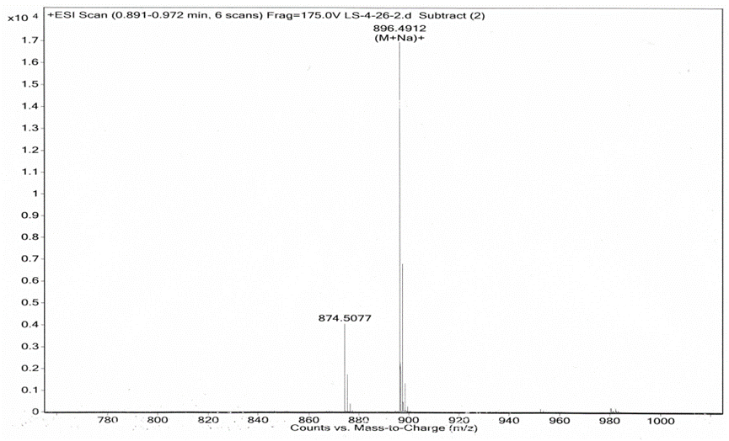
HRMS Spectrum of Compound 3b
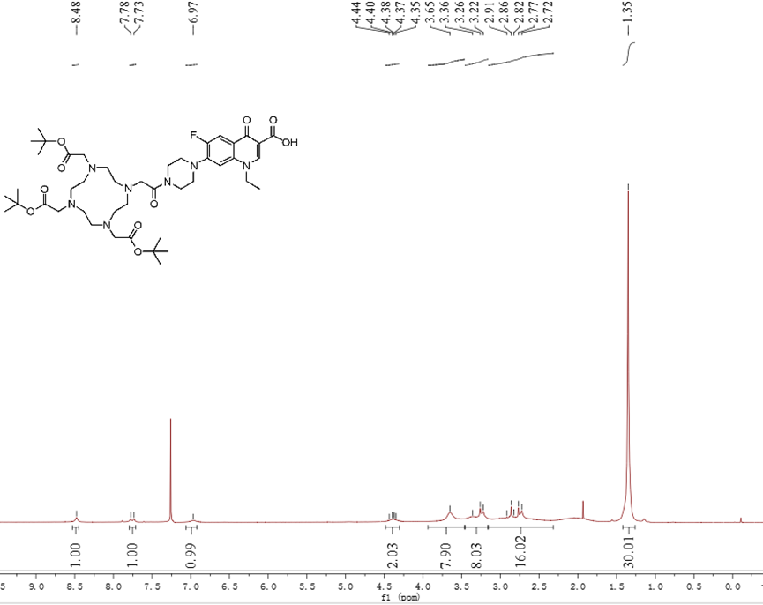
¹H NMR Spectrum of Compound 3b
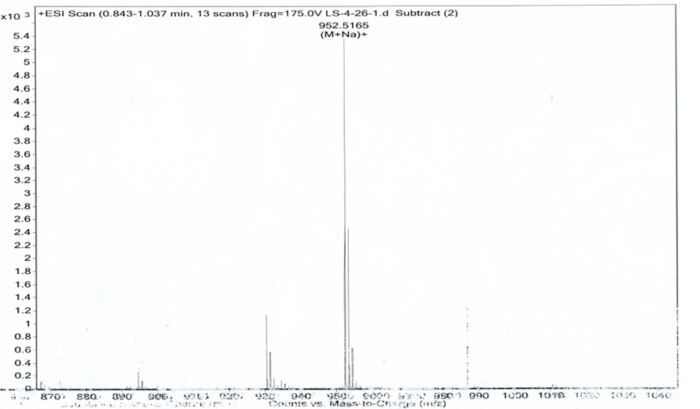
HRMS Spectrum of Compound 3c
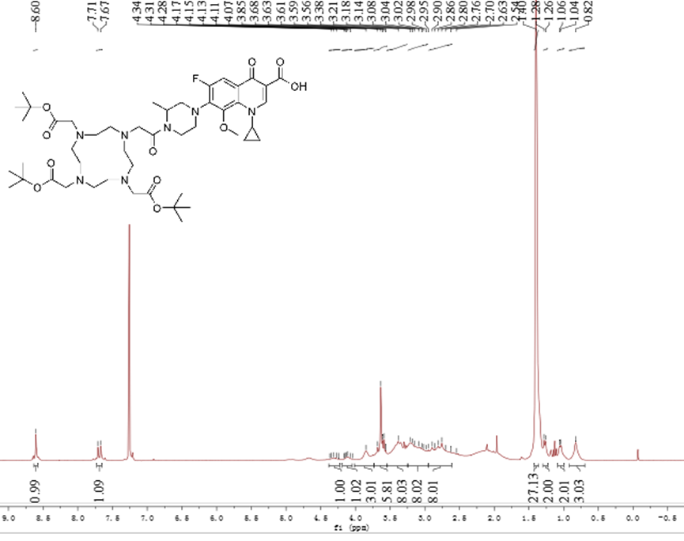
¹H NMR Spectrum of Compound 3c
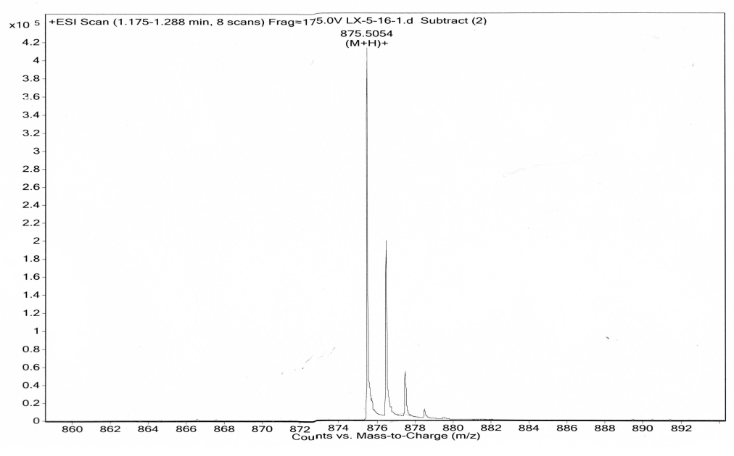
HRMS Spectrum of Compound 3d
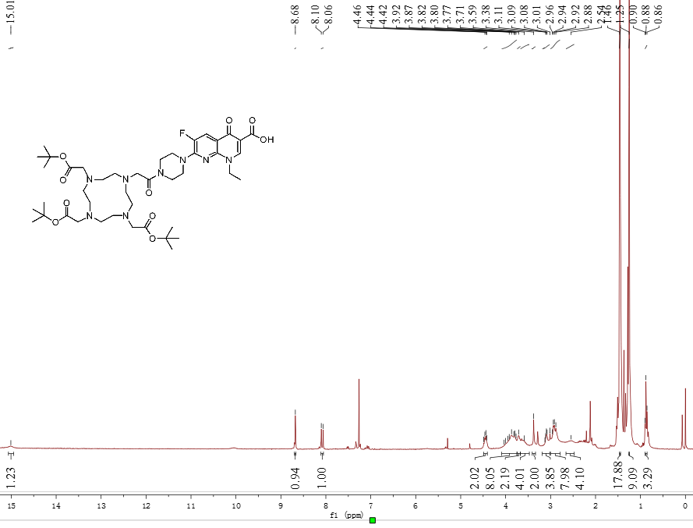
¹H NMR Spectrum of Compound 3d
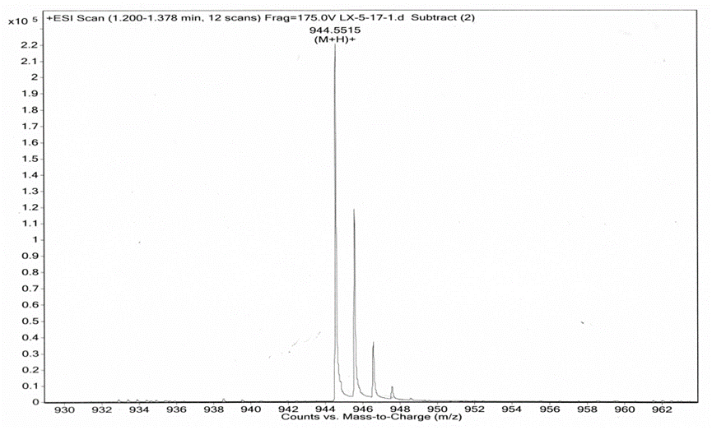
HRMS Spectrum of Compound 3e
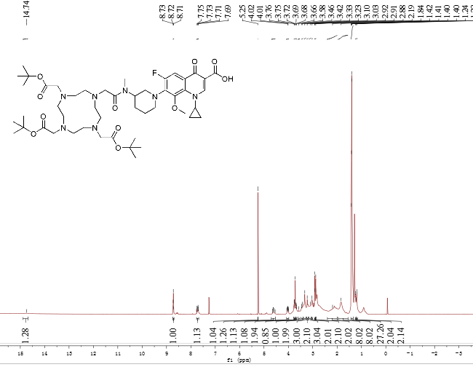
¹H NMR Spectrum of Compound 3e
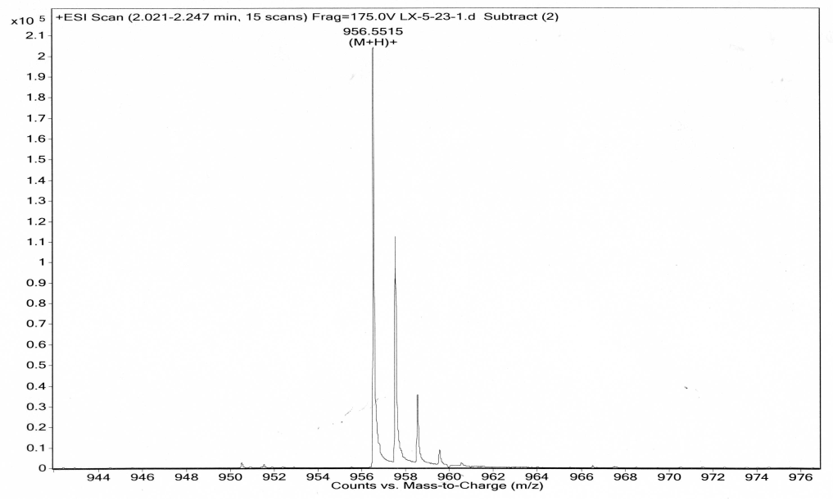
HRMS Spectrum of Compound 3f
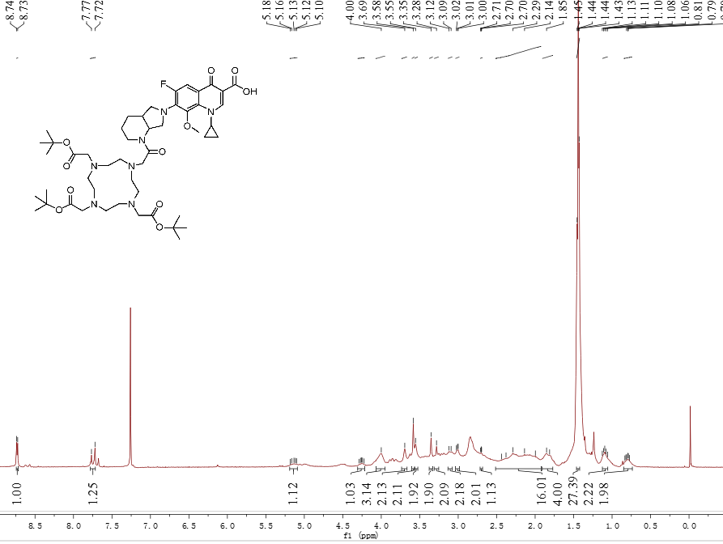
¹H NMR Spectrum of Compound 3f
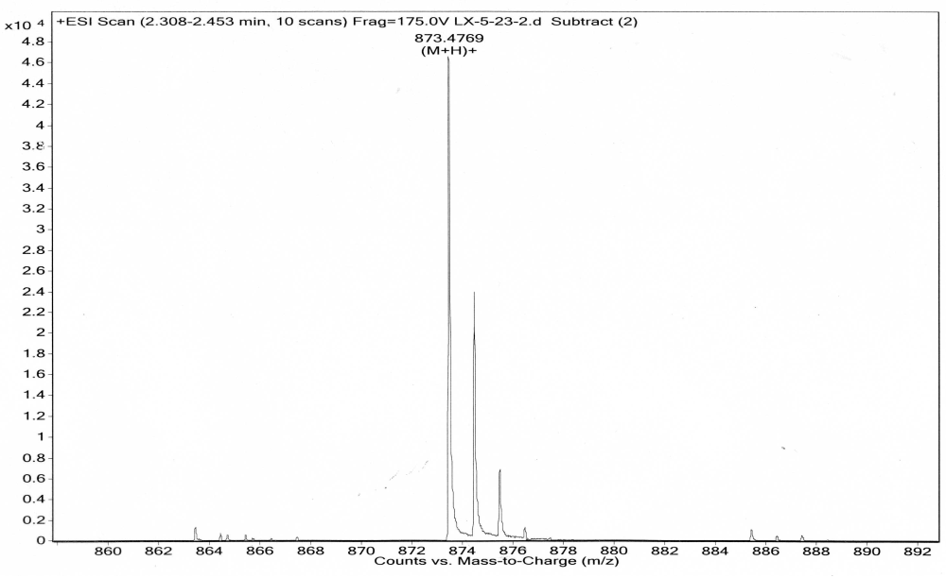
HRMS Spectrum of Compound 3g
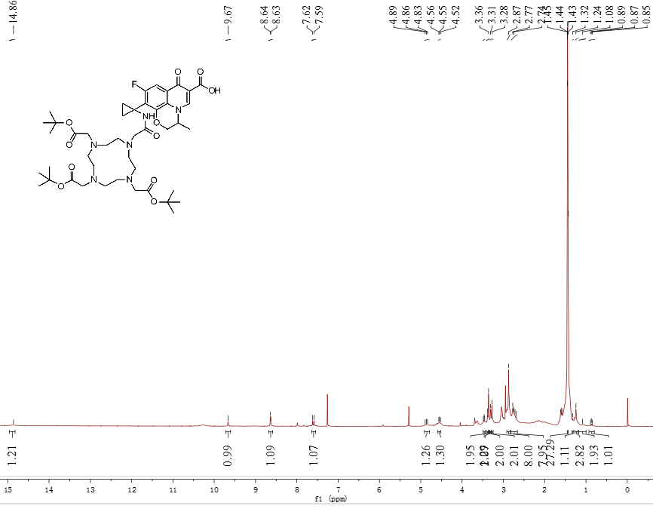
¹H NMR Spectrum of Compound 3g
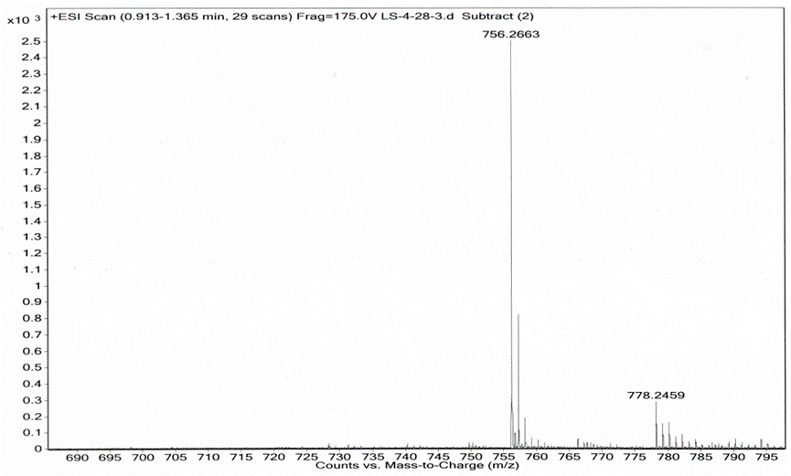
HRMS Spectrum of Compound 4a
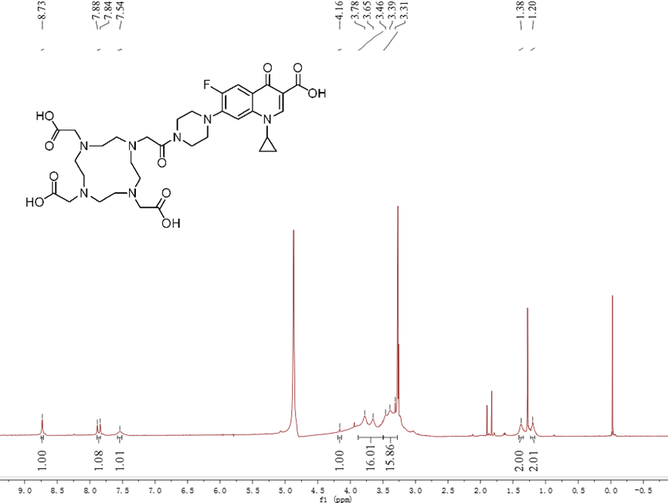
¹H NMR Spectrum of Compound 4a
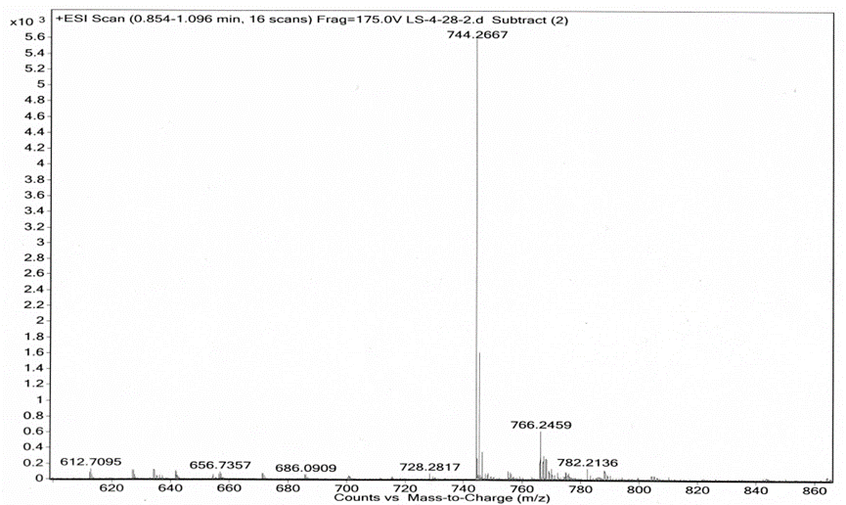
HRMS Spectrum of Compound 4b
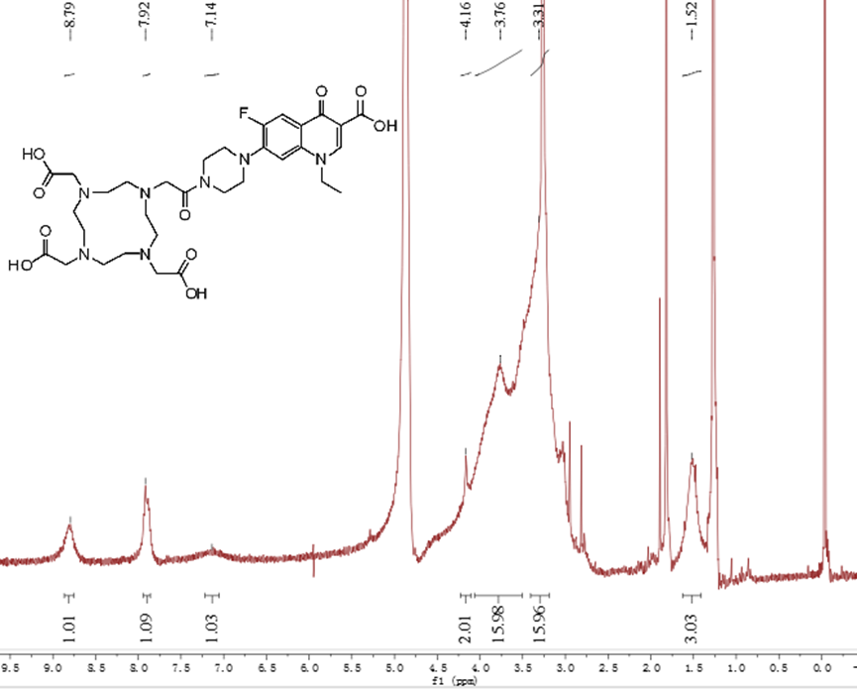
¹H NMR Spectrum of Compound 4b
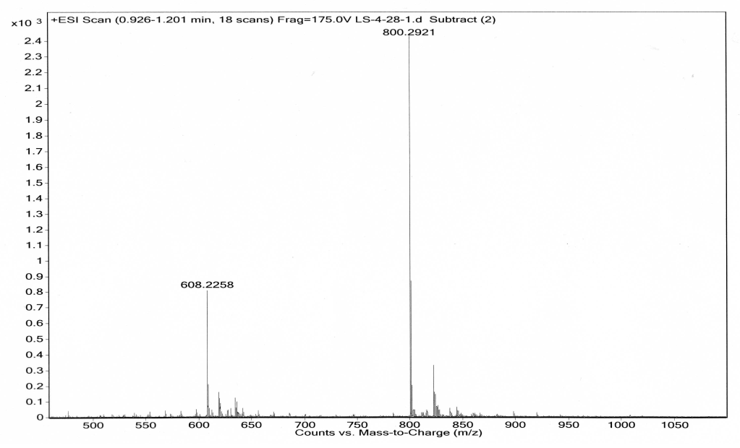
HRMS Spectrum of Compound 4c
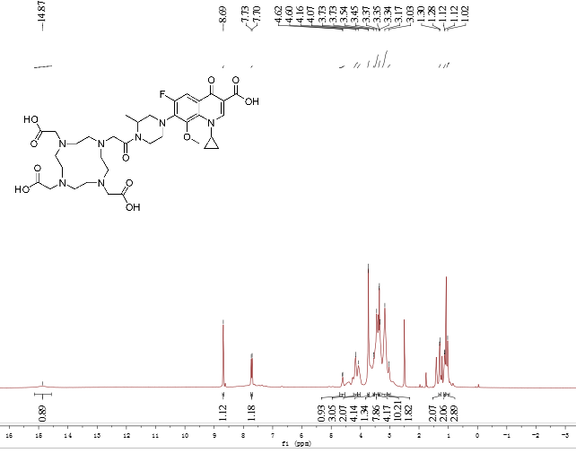
¹H NMR Spectrum of Compound 4c
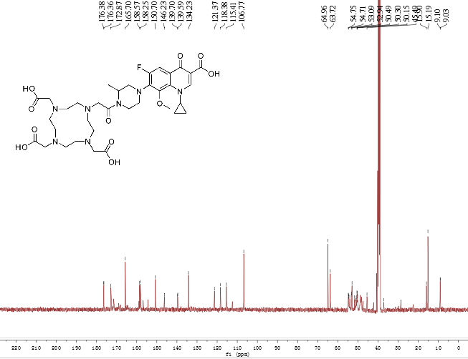
¹³ C NMR Spectrum of Compound 4c

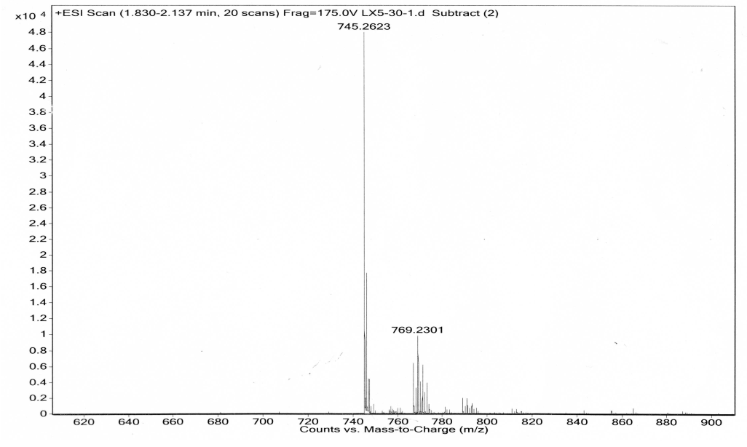
HRMS Spectrum of Compound 4d
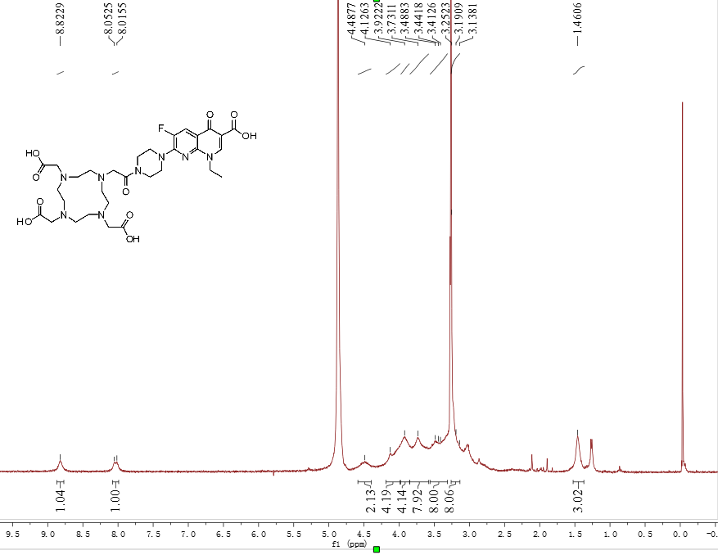
¹H NMR Spectrum of Compound 4d
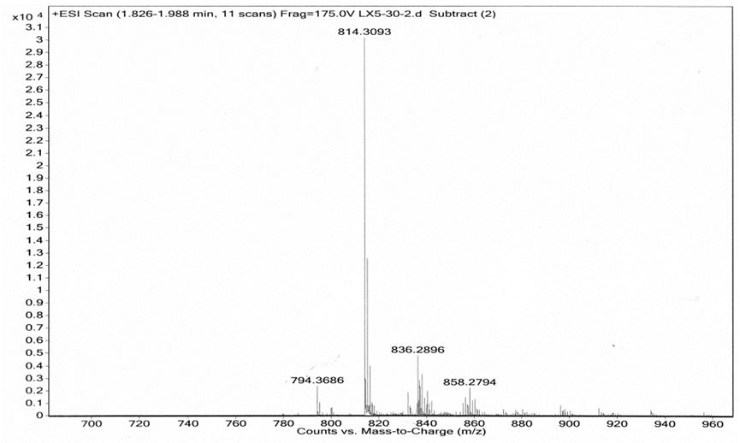
HRMS Spectrum of Compound 4e
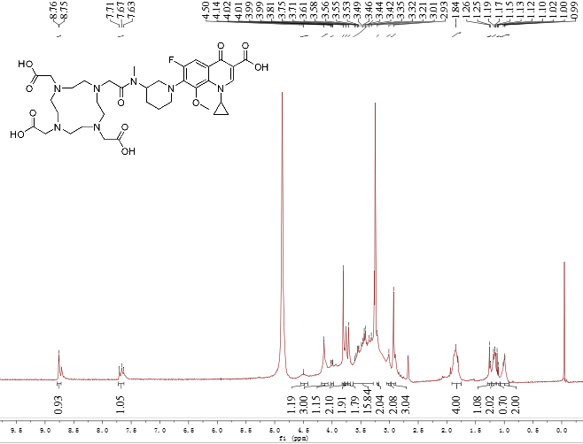
¹H NMR Spectrum of Compound 4e
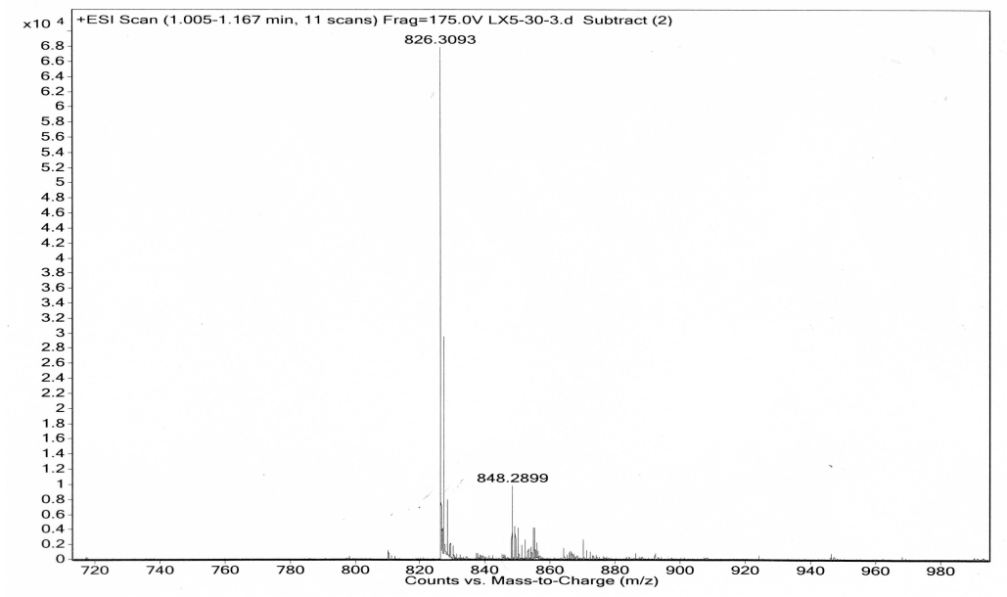
HRMS Spectrum of Compound 4f
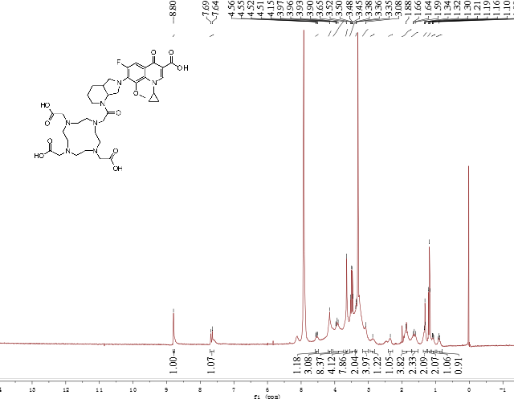
¹H NMR Spectrum of Compound 4f

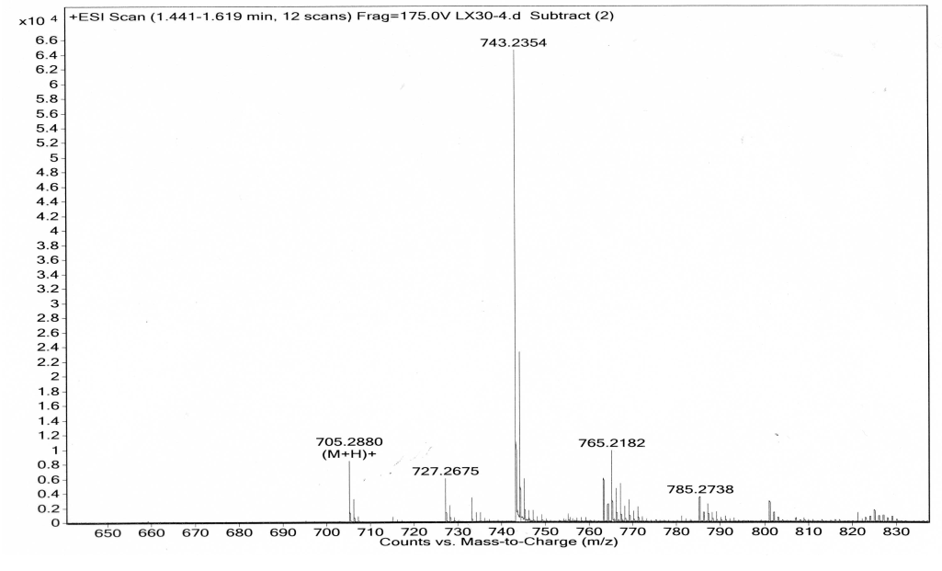
HRMS Spectrum of Compound 4g
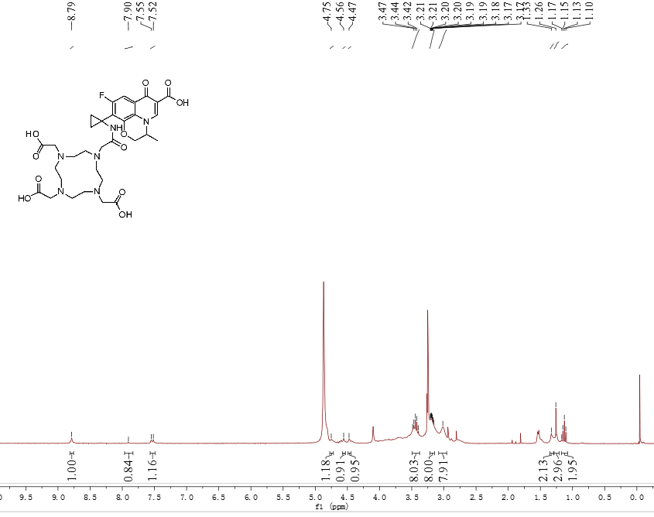
¹H NMR Spectrum of Compound 4g

