Supplementary Material
A UV–Comfort Co-occurrence Index reveals erythemal exposure opportunity on the South Atlantic coast
Figure S1. IVCC sensitivity to Wc formulation and parameter choice. (A–B) Comparison of the Gaussian, stepwise, and linear Wᶜ formulations (A–B) and sensitivity of the co-occurrence estimate to AT₀ and σ parameters (C–D).
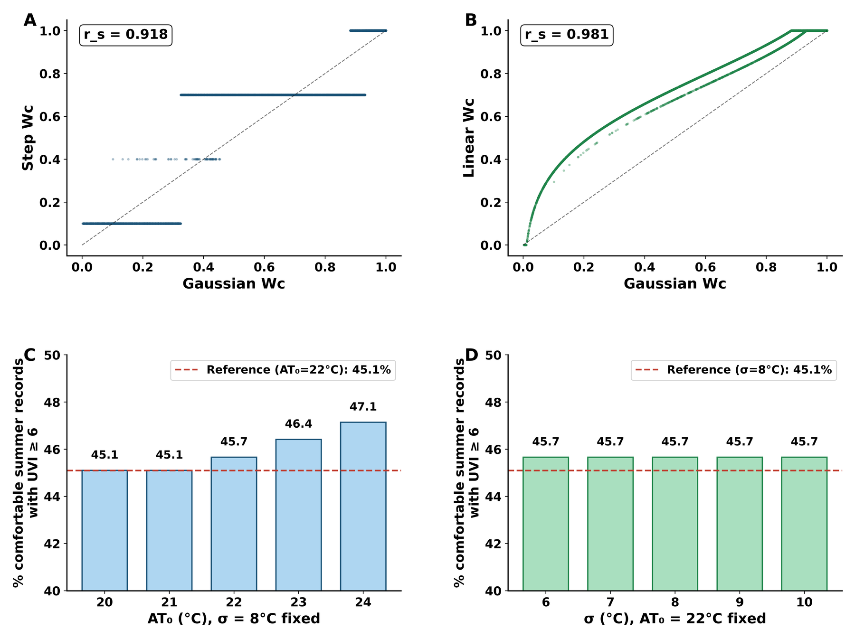

Figure S2. Role of solar geometry and cloud cover in the AT–UVI correlation. (A) Spearman correlations before and after partial SZA control. (B) Co-occurrence under clear-sky vs overcast conditions. (C) Permutation test distribution.
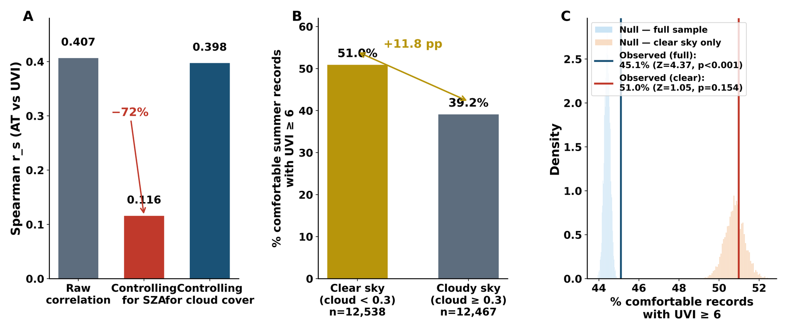

Table S1. Minimum erythemal dose (MED) by skin phototype (Fitzpatrick, 1988).
Phototype | Description | MED (J m⁻²)
I | Always burns, never tans | 200
II | Usually burns, sometimes tans | 250
III | Sometimes burns, always tans | 300
IV | Rarely burns, always tans | 450
V | Very rarely burns, tans easily | 600

