Supplementary information
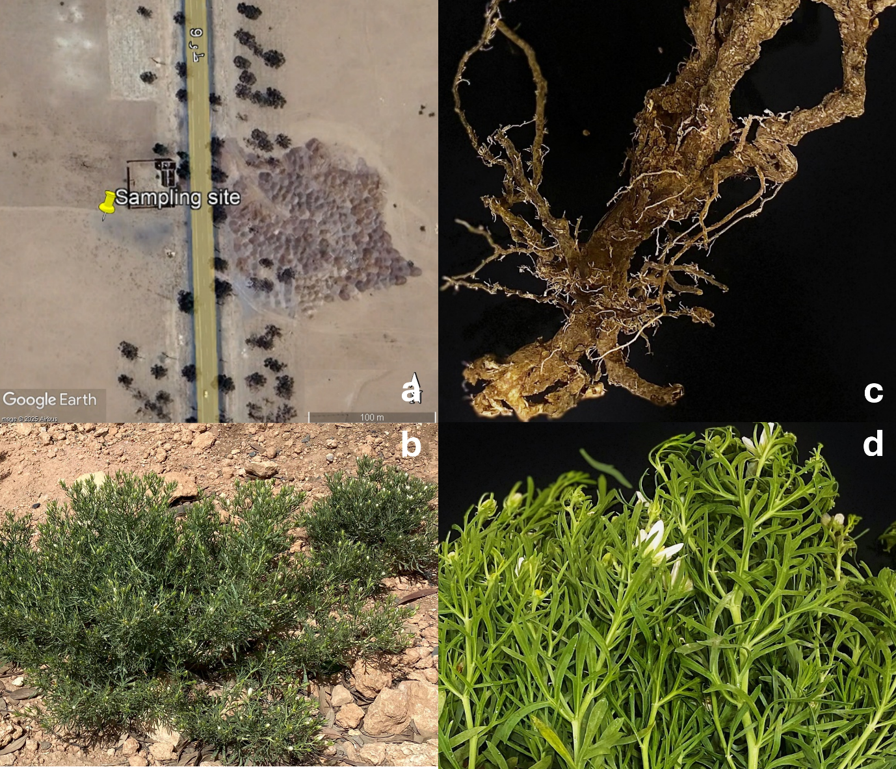

Figure S1. Map and photographs of the sampling site and Peganum harmala specimens. (a) Geographic location of the sampling site in RHAMNA–Benguerir (Nazlat Laâdem, Morocco). (b) Representative P. harmala specimen from the first sampling campaign. (c) Root system of P. harmala. (d) Shoot system of P. harmala from the first sampling campaign.
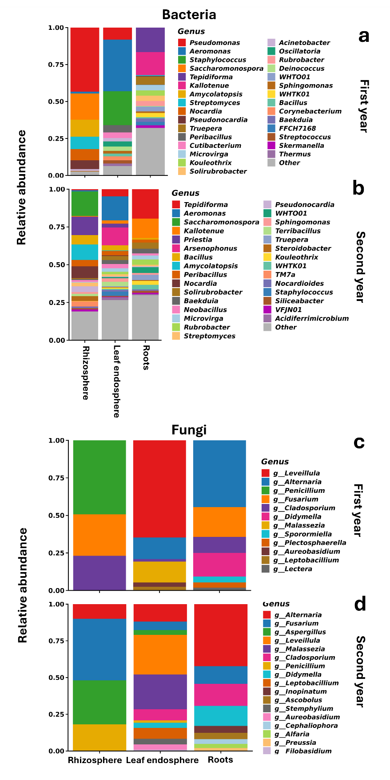
Figure S2. Cross-kingdom genus-level composition of bacterial and fungal communities associated with Peganum harmala across three compartments and two growing seasons. Relative abundances of the top 20 dominant taxa across roots, leaf endosphere, and rhizosphere over two consecutive years, showing (a) bacterial and (b) fungal genera, respectively. The upper panels represent the first year, and the lower panels represent the second year. Bars indicate mean relative abundances, and remaining taxa are grouped as “Others.” Colour coding corresponds to genus-level taxonomy.
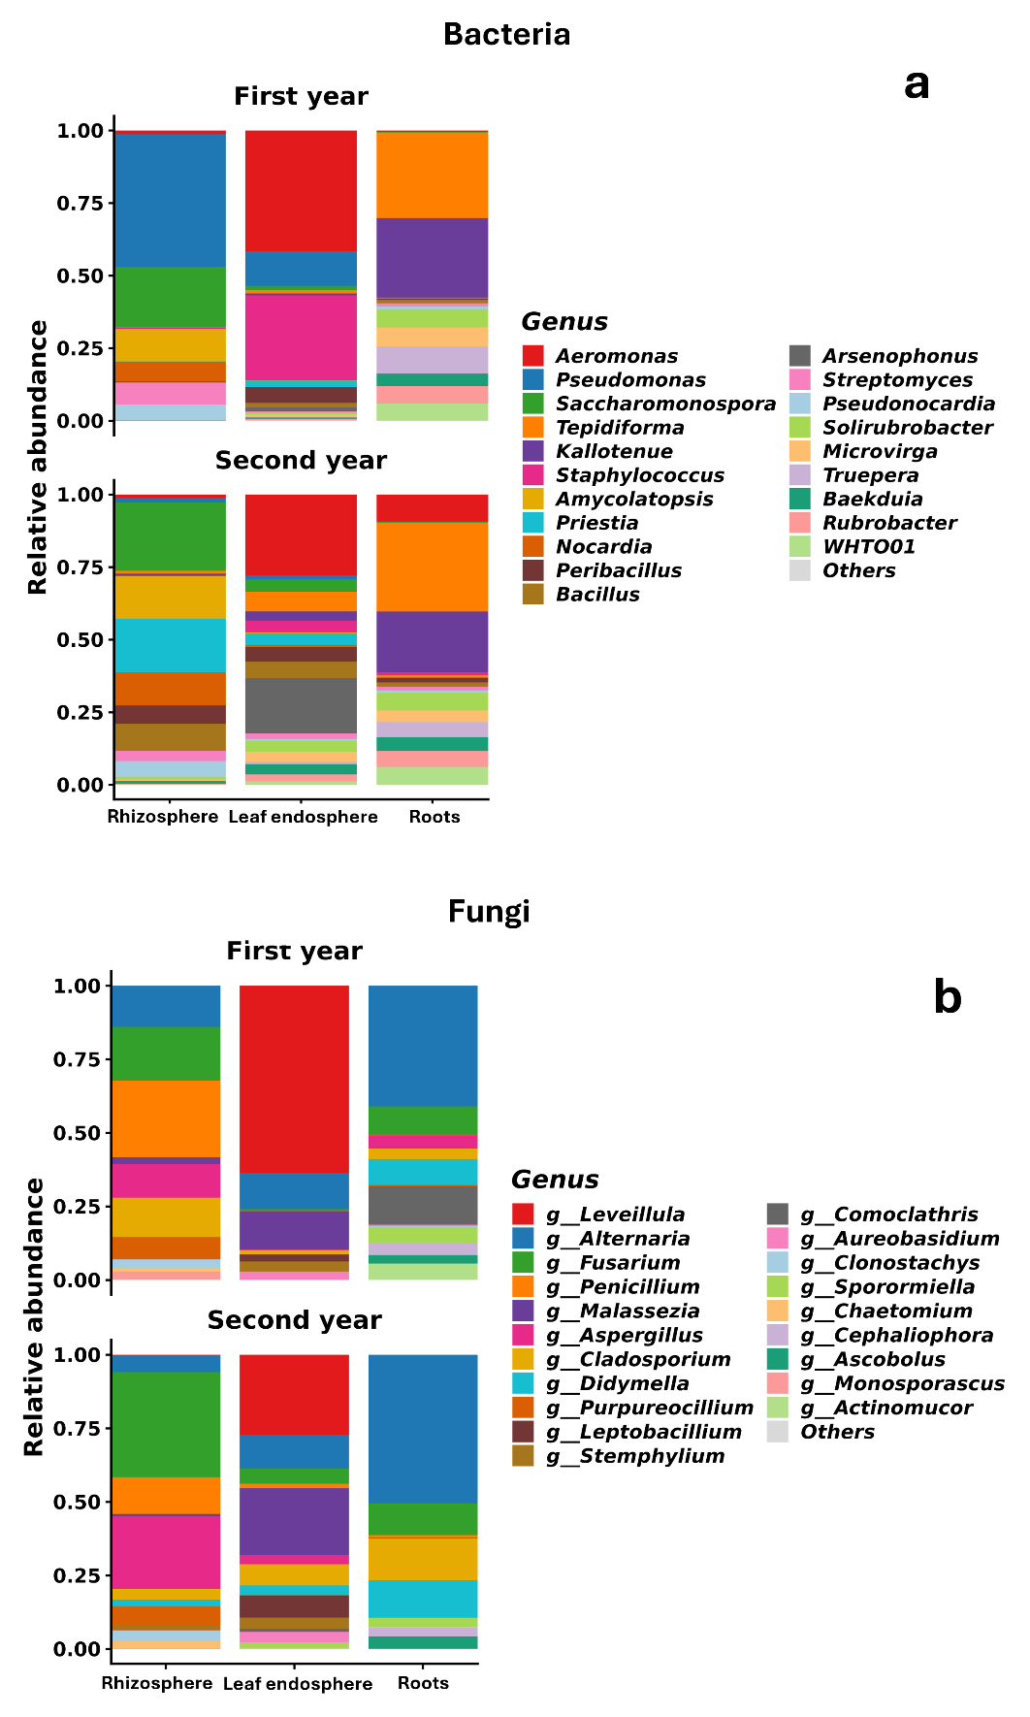
Figure S3. Genus-level taxonomic profiles illustrating compartmental divergence and core microbiome architecture associated with Peganum harmala. Compartment-resolved relative abundances of bacterial communities in the first year (a) and second year (b), and fungal communities in the first year (c) and second year (d), across roots, leaf endosphere, and rhizosphere. Core genera are indicated based on their persistence across compartments.
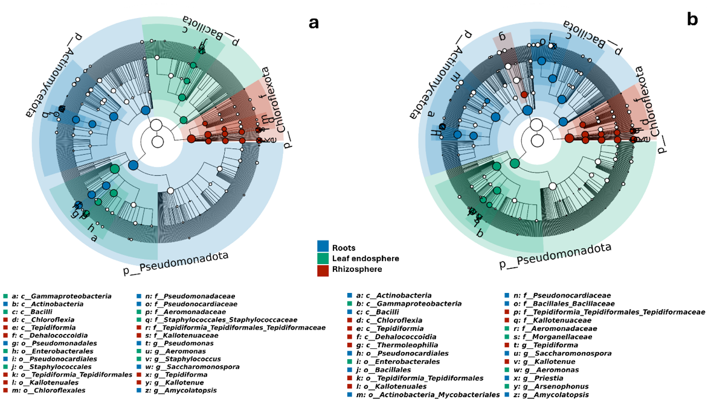
Figure S4. Phylogenetic biomarker landscape of bacterial communities associated with Peganum harmala identified using LEfSe analysis. Cladograms display bacterial community biomarkers for the first year (a) and second year (b). Taxa are organized hierarchically from phylum (inner ring) to genus (outer ring). Nodes are coloured according to compartment-specific enrichment (blue = roots, green = leaf endosphere, red = rhizosphere), and node size reflects the magnitude of the LDA score (threshold: LDA > 2.0). Background shading indicates phylum-level taxonomy, while cross-referenced letters identify discriminant taxa.
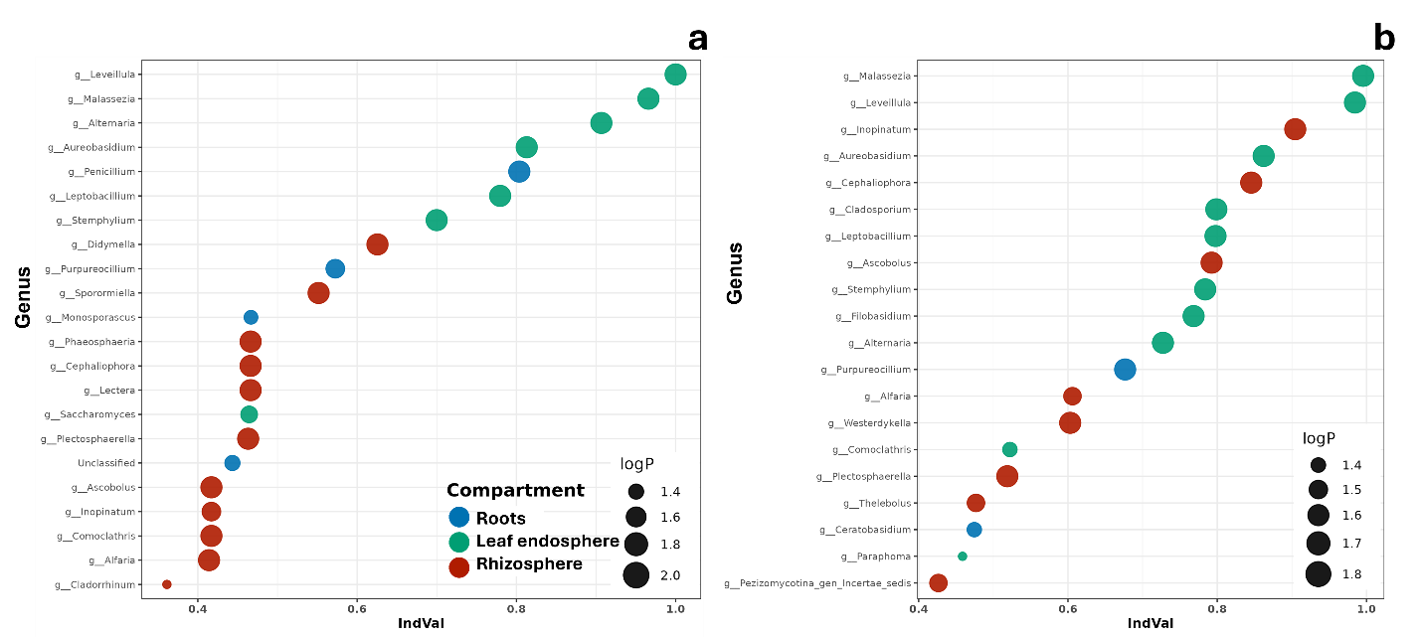
Figure S5. Compartment-specific indicator genera of fungal communities associated with Peganum harmala across two growing seasons. Indicator species (IndVal) analysis of fungal communities for the first year (a) and second year (b). Each point represents a genus-level taxon, positioned by IndVal score (x-axis) and coloured according to its strongest compartmental association (blue = roots; green = leaf endosphere; red = rhizosphere). Point size reflects −log10(permutation p-value). Only significant indicator taxa (permutation test, p < 0.05) are shown.

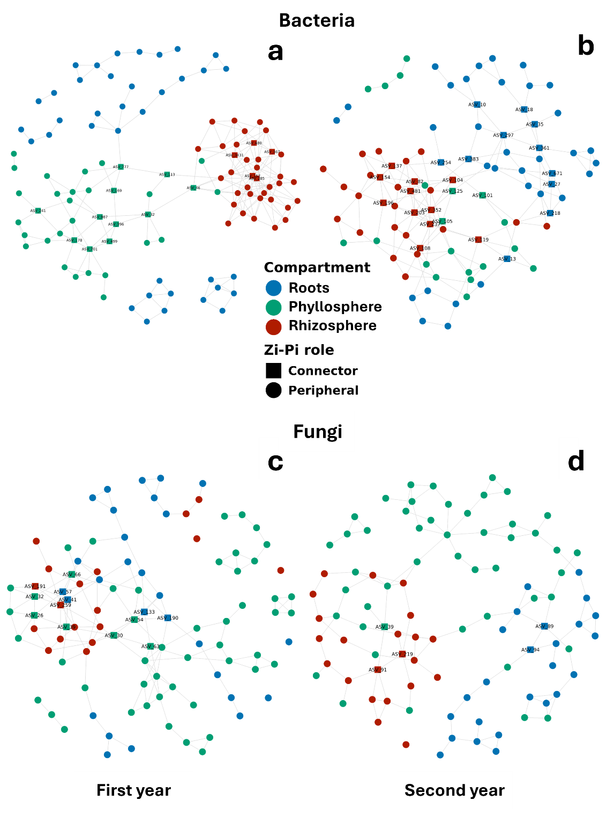
Figure S6. Compartment-specific indicator taxa and co-occurrence network architecture of bacterial and fungal communities associated with Peganum harmala across two growing seasons. Fungal IndVal analyses (a–b) represent the first and second year, respectively. Each point represents a genus-level taxon, coloured by its compartment of maximum association (blue = roots, green = leaf endosphere, red = rhizosphere), with size proportional to −log10(p-value). In network representations, nodes are classified as connector hubs (squares; Pi > 0.62) or peripheral nodes (circles). Edges represent significant co-occurrences (SparCC |ρ| > 0.6, p < 0.05).

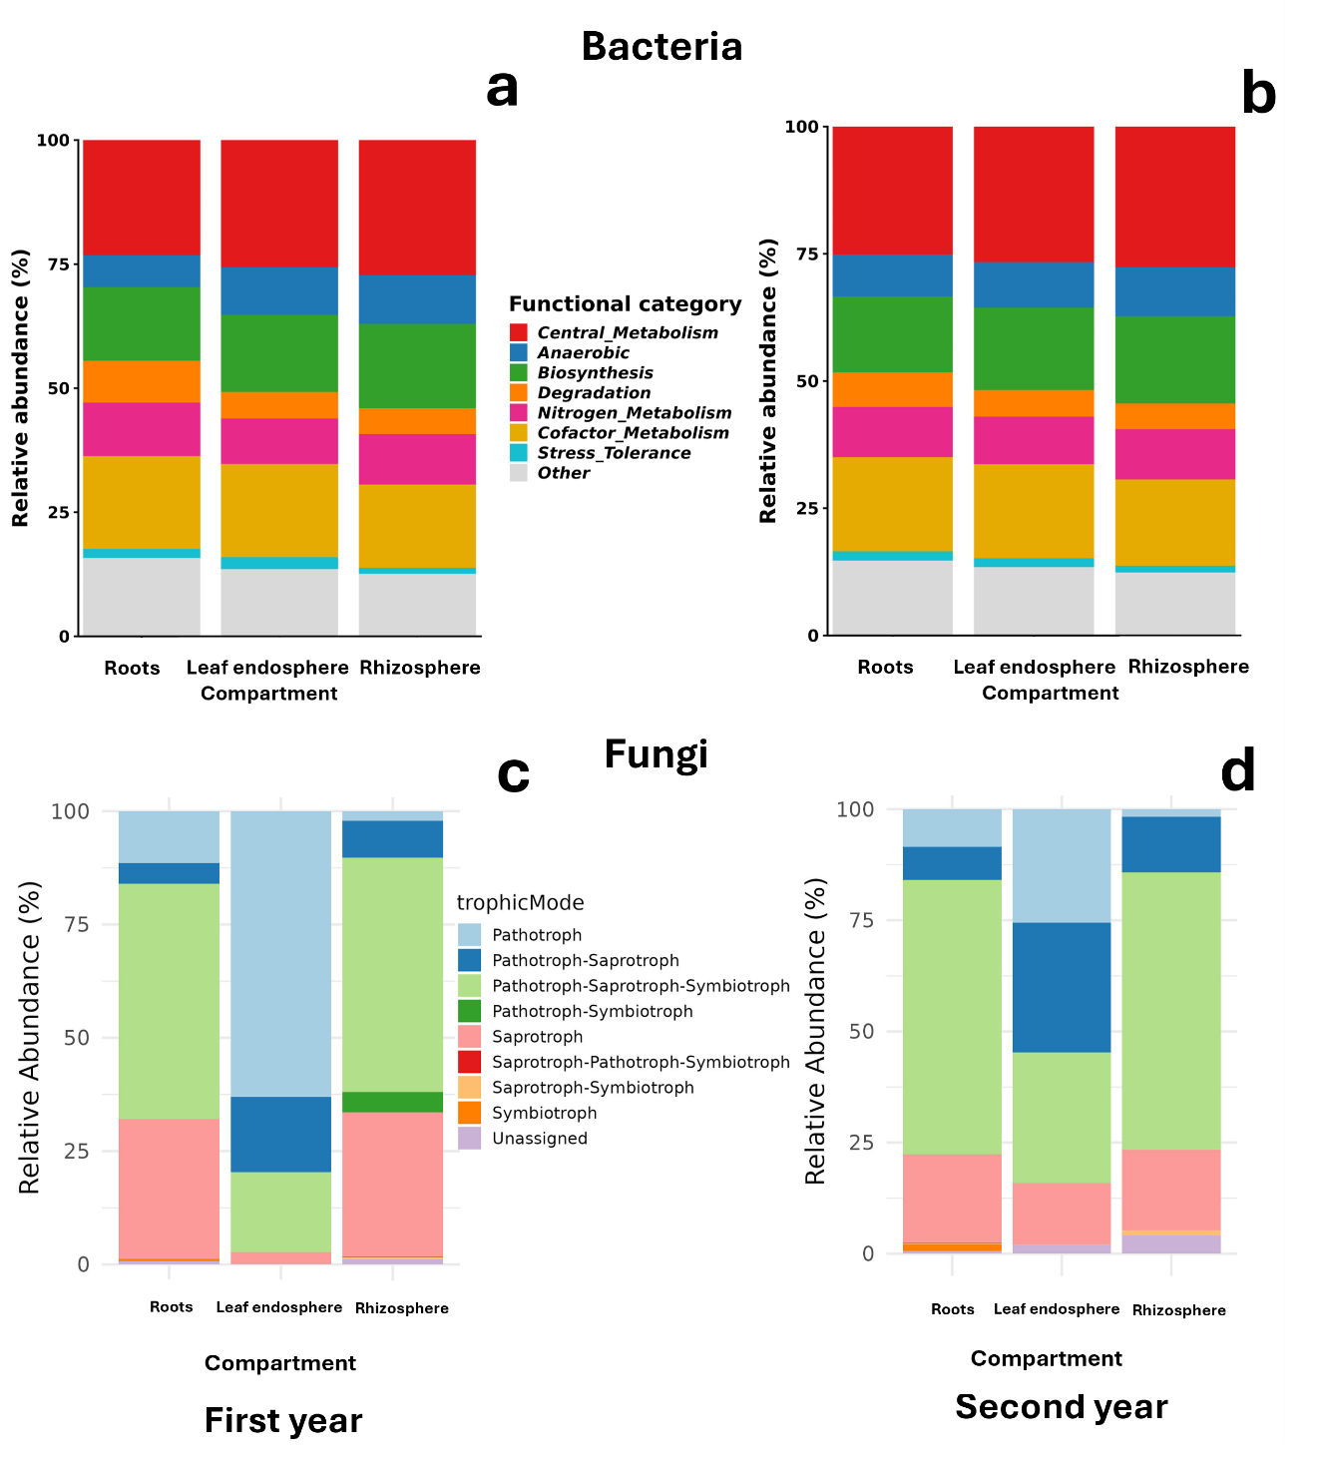
Figure S7. Functional potential and trophic guild structure of the bacterial and fungal metacommunity associated with Peganum harmala. PICRUSt2-predicted bacterial metabolic pathway categories across roots, leaf endosphere, and rhizosphere in the first year (a) and second year (b), including central metabolism, anaerobic metabolism, biosynthesis, degradation, nitrogen metabolism, cofactor metabolism, stress tolerance, and other functions. FUNGuild trophic mode distributions are shown for the first year (c) and second year (d). All values are expressed as relative abundance (%).
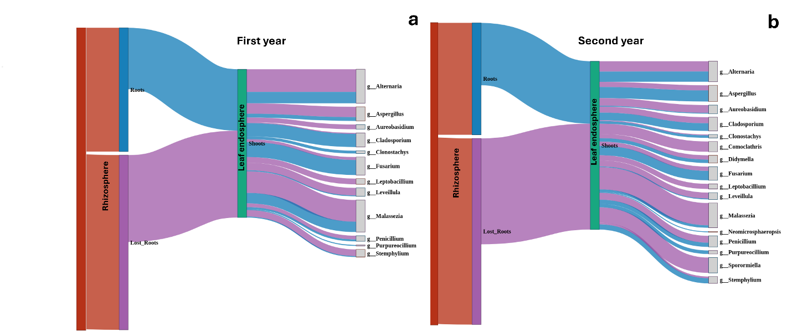
Figure S8. Metacommunity source–sink dynamics of fungal communities associated with Peganum harmala based on Sankey flow analysis across three compartments and two growing seasons. Alluvial diagrams illustrate fungal community flows for the first year (a) and second year (b), tracking shared genera from the rhizosphere to roots and subsequently to the leaf endosphere. “Lost_Roots” denotes rhizospheric genera absent from root endospheres. Ribbon width is proportional to the relative abundance of shared genera.

