Table S1. The detail definition and classification of covariates.

Variables | Definitions or Classification
Sex | Male, Female.
Race | Non-Hispanic White, Non-Hispanic Black, Mexican American, Other Race.
Education attainment | High school or less, More than high school.
Marital status | Married or living with partner, Living alone.
PIR | Low (PIR ≤1), Middle (1< PIR < 4), and High (PIR ≥4).
Smoking status | Never smoking: <100 cigarettes in lifetime;  Former smoking: >100 cigarettes in life and smoke not at all now;  Now smoking: >100 cigarettes in lifetime.
Drinking status | Never: consumed fewer than 12 drinks in their lifetime;  Former: consumed at least 12 drinks in one year but did not drink in the last year or did not drink in the last year but had at least 12 drinks in their lifetime;  Heavy: consumed at least 3 drinks per day for females, at least 4 drinks per day for males, or engaged in binge drinking on 5 or more days per month;  Moderate: consumed at least 2 drinks per day for females, at least 3 drinks per day for males, or engaged in binge drinking on at least 2 days per month;  Mild : consumed at most 1 drink per day for females, at most 2 drinks per day for males.
BMI | weight (kg)/height (m²).
Laboratory tests | The Specific method can be found in this webpage  (https://wwwn.cdc.gov/nchs/nhanes/continuousnhanes/labmethods.aspx?BeginYear=1999)
Abbreviations: PIR, poverty income ratio; BMI, body mass index.
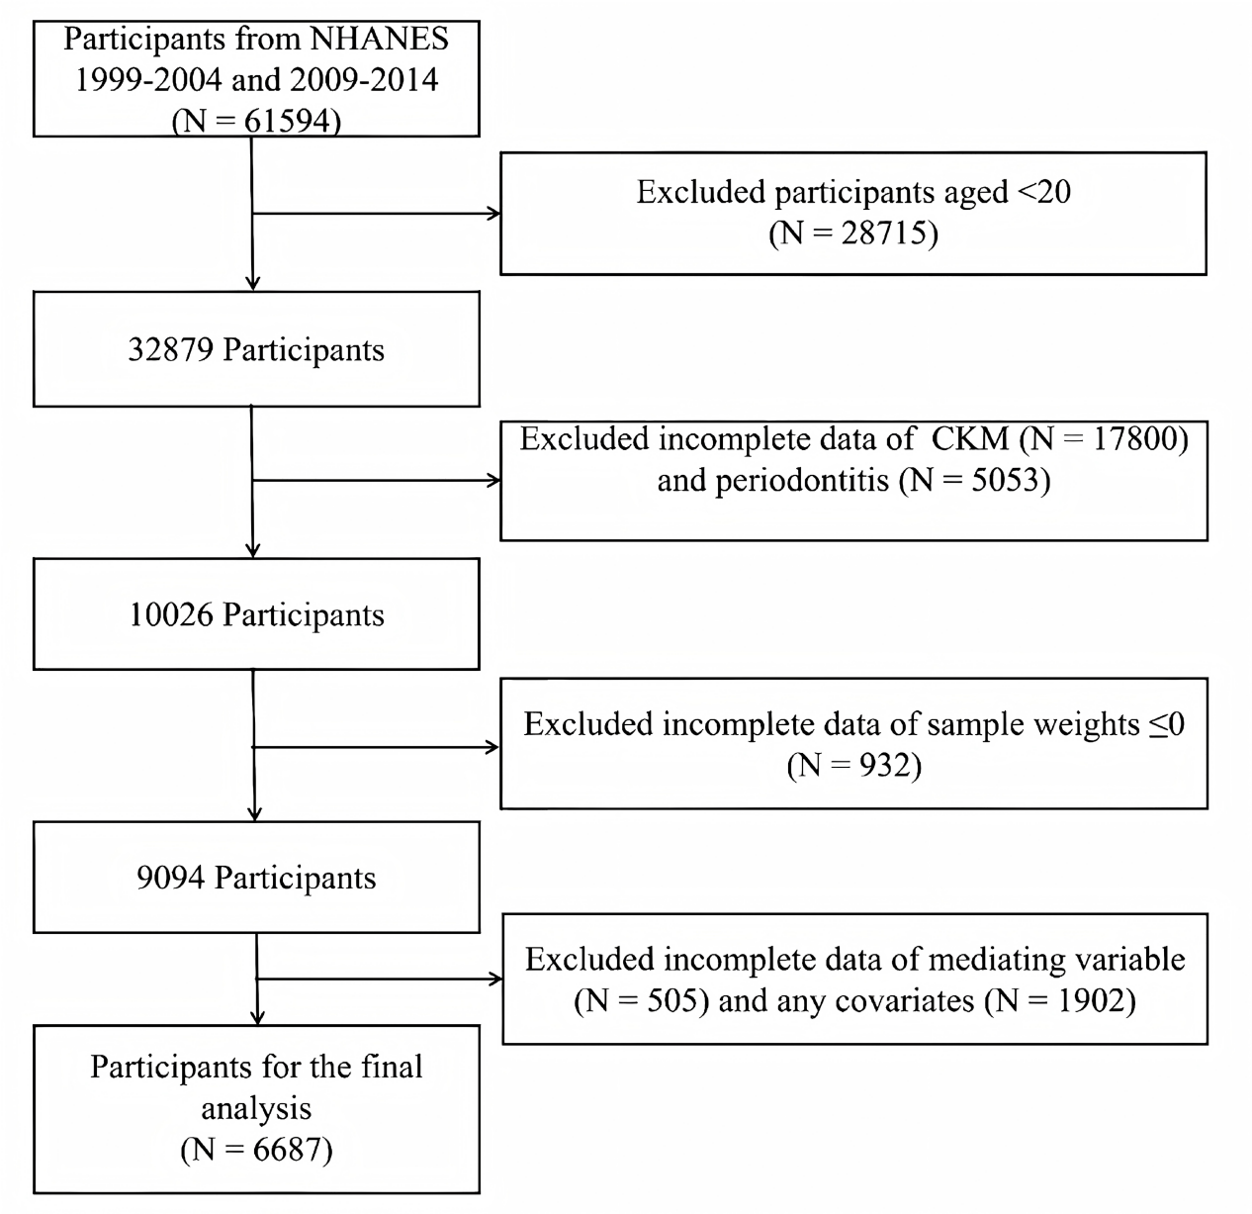
Figure S1. Flow diagram of study cohort selection.
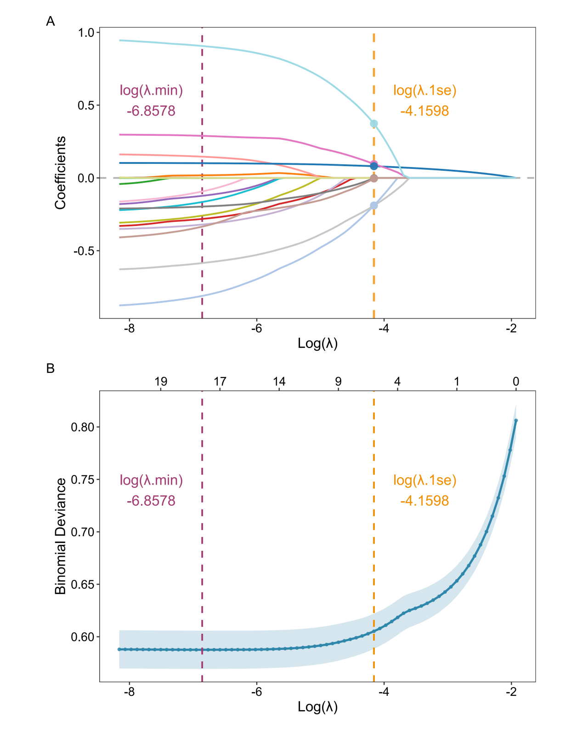
Figure S2. Identification of all-cause mortality risk-related factors using LASSO penalized regression. (A) Coefficient paths for each variable across Log Lambda. (B) Cross-validation error curve versus Log Lambda.

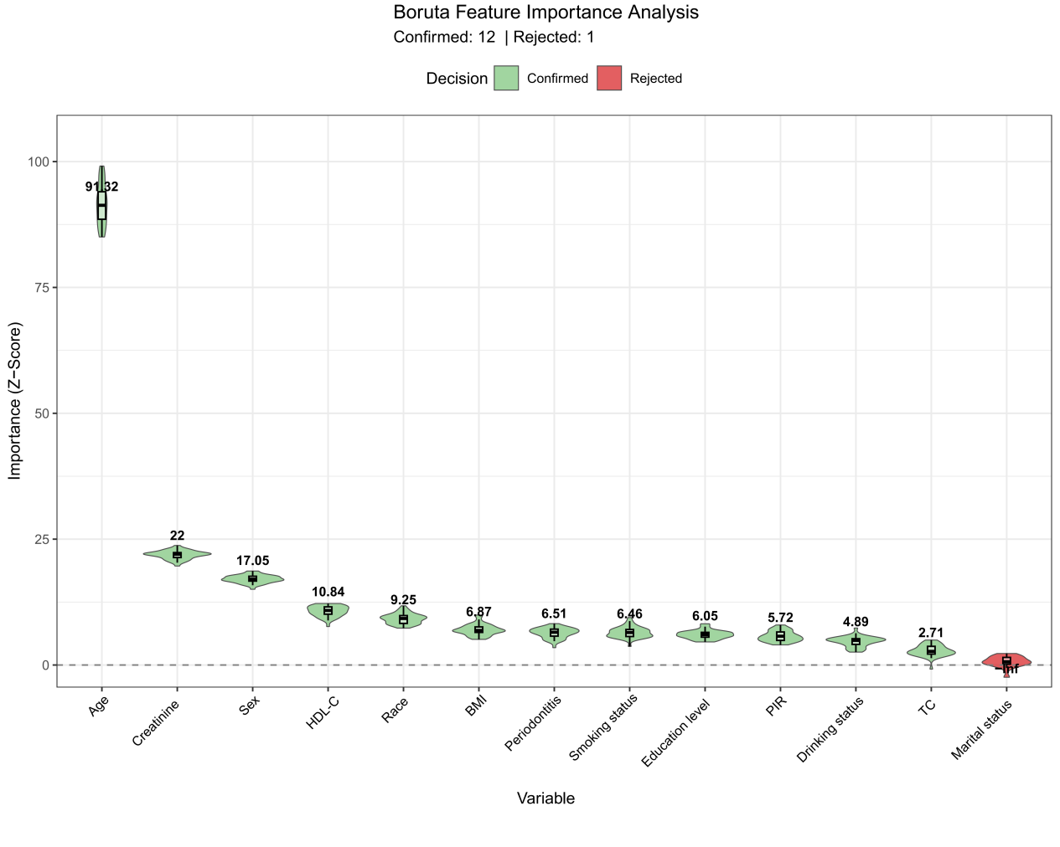
Figure S3. Boruta algorithm–based feature selection for variables associated with all‑cause mortality risk.

