Table 1.Weighted characteristics of the study populationª.
Characteristics | Periodontal status |  |  |  |  | P value
Characteristics | Overall  (N = 6687) | No  (N =4383) | Mild  (N = 298) | Moderate  (N = 1571) | Severe  (N = 435) | P value
Age (years) | 48.02 (0.32) | 45.50 (0.38) | 46.93 (0.81) | 55.98 (0.47) | 55.07 (0.73) | < 0.001
Sex (%) |  |  |  |  |  | < 0.001
Male | 3474 (53.33) | 2072 (50.56) | 169 (56.54) | 909 (57.75) | 324 (74.74)
Female | 3213 (46.67) | 2311 (49.44) | 129 (43.46) | 662 (42.25) | 111 (25.26)
Race (%) |  |  |  |  |  | < 0.001
Non-Hispanic White | 3234 (71.66) | 2302 (74.73) | 120 (63.53) | 666 (65.28) | 146 (57.66)
Non-Hispanic Black | 1200 (10.26) | 683 ( 8.74) | 69 (15.69) | 319 (12.49) | 129 (19.93)
Mexican American | 1313 ( 7.94) | 845 ( 7.10) | 81 (12.40) | 297 ( 9.39) | 90 (11.12)
Other Race | 940 (10.13) | 553 ( 9.43) | 28 ( 8.38) | 289 (12.85) | 70 (11.29)
Education level (%) |  |  |  |  |  | < 0.001
High school or less | 3190 (39.66) | 1849 (35.21) | 170 (46.28) | 886 (49.77) | 285 (60.88)
More than high school | 3497 (60.34) | 2534 (64.79) | 128 (53.72) | 685 (50.23) | 150 (39.12)
Marital status (%) |  |  |  |  |  | 0.001
Married or living with partner | 4494 (69.80) | 2999 (71.20) | 192 (66.52) | 1024 (67.18) | 279 (61.84)
Living alone | 2193 (30.20) | 1384 (28.80) | 106 (33.48) | 547 (32.82) | 156 (38.16)
PIR (%) |  |  |  |  |  | < 0.001
Low | 1194 (12.01) | 656 ( 9.98) | 60 (13.80) | 367 (17.06) | 111 (20.92)
Middle | 3514 (49.66) | 2218 (47.40) | 179 (57.91) | 863 (53.93) | 254 (59.77)
High | 1979 (38.33) | 1509 (42.62) | 59 (28.28) | 341 (29.01) | 70 (19.30)
Smoking status (%) |  |  |  |  |  | < 0.001
Never | 3631 (53.56) | 2586 (57.59) | 173 (56.43) | 724 (43.22) | 148 (31.94)
Now | 1284 (19.93) | 713 (17.46) | 65 (23.36) | 357 (24.10) | 149 (37.77)
Former | 1772 (26.51) | 1084 (24.96) | 60 (20.21) | 490 (32.68) | 138 (30.29)
Drinking status (%) |  |  |  |  |  | 0.001
Never | 895 (10.68) | 574 (10.43) | 40 ( 9.45) | 236 (12.28) | 45 ( 9.01)
Mild | 2353 (37.47) | 1592 (38.54) | 93 (35.31) | 528 (35.38) | 140 (31.37)
Moderate | 932 (16.67) | 690 (17.87) | 35 (16.09) | 163 (13.80) | 44 (10.65)
Heavy | 1294 (20.01) | 810 (19.15) | 79 (26.04) | 298 (20.20) | 107 (27.37)
Former | 1213 (15.16) | 717 (14.00) | 51 (13.10) | 346 (18.35) | 99 (21.60)
BMI (kg/m²) | 29.54 (0.11) | 29.52 (0.12) | 30.63 (0.44) | 29.33 (0.24) | 29.78 (0.49) | 0.047
TC (mg/dl) | 200.79 (0.70) | 201.16 (0.83) | 202.61 (2.80) | 199.38 (1.43) | 199.32 (2.89) | 0.611
HDL-C (mg/dl) | 51.76 (0.28) | 51.70 (0.30) | 49.54 (0.93) | 52.85 (0.69) | 50.07 (0.94) | 0.022
Creatinine (mg/dl) | 0.86 (0.00) | 0.85 (0.01) | 0.86 (0.01) | 0.88 (0.01) | 0.91 (0.01) | < 0.001
KDMAgeAccel | 0.63 (0.27) | 0.64 (0.30) | 1.32 (0.87) | -0.03 (0.54) | 2.62 (1.06) | 0.141
PhenoAgeAccel | 0.24 (0.09) | -0.03 (0.11) | 0.79 (0.27) | 0.61 (0.19) | 2.28 (0.28) | < 0.001
Abbreviations: N, number; PIR, poverty income ratio; BMI, body mass index; TC, total cholesterol; HDL-C, high-density lipoprotein cholesterol; KDM, Klemera–Doubal method.
ªValues are weighted means (standardized errors) or number of participants (weighted percentages) unless otherwise indicated.

Table 2. Weighted cox regression analysis of the association between periodontitis and mortality riskª.
Characteristic | Model 1  HR (95%CI), P value | Model 2  HR (95%CI), P value | Model 3  HR (95%CI), P value
All-cause mortality
Periodontal status
No
Yes | 2.65 (2.20,3.20), < 0.001 | 1.38 (1.14,1.67), 0.001 | 1.21 (1.01,1.44), 0.043
Periodontitis by CDC-AAP
No | Reference | Reference | Reference
Mild | 1.19 (0.76,1.87), 0.437 | 0.98 (0.61,1.59), 0.942 | 0.93 (0.59,1.48), 0.762
Moderate | 3.08 (2.53,3.75), <0.001 | 1.47 (1.18,1.82), <0.001 | 1.27 (1.03,1.57), 0.024
Severe | 3.14 (2.25,4.38), <0.001 | 1.38 (0.97,1.98), 0.077 | 1.19 (0.85,1.66), 0.316
P for trend | < 0.001 | < 0.001 | 0.039
Cardiovascular mortality
Periodontal status
No
Yes | 3.67 (2.62,5.14), <0.0001 | 1.48 (1.06,2.08), 0.023 | 1.41 (1.03,1.93), 0.032
Periodontitis by CDC-AAP
No | Reference | Reference | Reference
Mild | 2.63 (1.36,5.08), 0.004 | 1.71 (0.82,3.55), 0.152 | 1.78 (0.88,3.57), 0.107
Moderate | 3.73 (2.46,5.65), <0.001 | 1.41 (0.92,2.16), 0.118 | 1.33 (0.89,1.99), 0.167
Severe | 5.25 (3.00,9.20), <0.001 | 1.52 (0.83,2.76), 0.172 | 1.36 (0.76,2.44), 0.300
P for trend | <0.001 | 0.049 | 0.109
Abbreviations: PIR, poverty income ratio; BMI, body mass index; TC, total cholesterol; HDL-C, high-density lipoprotein cholesterol; HR, hazard ratio; CI, confidence interval.
ªModel 1: unadjusted; Model 2: adjusted for age, sex, race, education level, marital status; Model 3: adjusted for age, sex, race, education level, marital status, PIR, BMI, smoking status, drinking status, TC, HDL-C, and creatinine.
Table 3. Mediation analyses for associations between periodontal status (no/yes) and mortality risk.
Mediator | Total effect |  | Direct effect |  | Indirect effect |  | Proportion  Mediated (%)
Mediator | HR (95% CI) | P value | HR (95% CI) | P value | HR (95% CI) | P value | Proportion  Mediated (%)
All-cause mortality
PhenoAgeAccel | 1.22 (1.06–1.41) | 0.004 | 1.19 (1.04–1.37) | 0.016 | 1.03 (1.02–1.05) | <0.001 | 16.3%
KDMAgeAccel | 1.22 (1.055–1.40) | 0.008 | 1.20 (1.04–1.39) | 0.016 | 1.01 (1.00–1.02) | 0.034 | 6.3%
Cardiovascular mortality
PhenoAgeAccel | 1.44 (1.07–1.95) | 0.020 | 1.37 (1.02–1.84) | 0.036 | 1.05 (1.025–1.091) | <0.001 | 16.5%
KDMAgeAccel | 1.452 (1.08–1.95) | 0.014 | 1.427 (1.07–1.92) | 0.018 | 1.02 (1.00–1.04) | 0.050 | 5.4%
Adjusted for age, sex, race, education level, marital status, PIR, BMI, smoking status, drinking status, TC, HDL-C, and creatinine.
Abbreviations: PIR, poverty income ratio; BMI, body mass index; TC, total cholesterol; HDL-C, high-density lipoprotein cholesterol; CI, confidence interval.

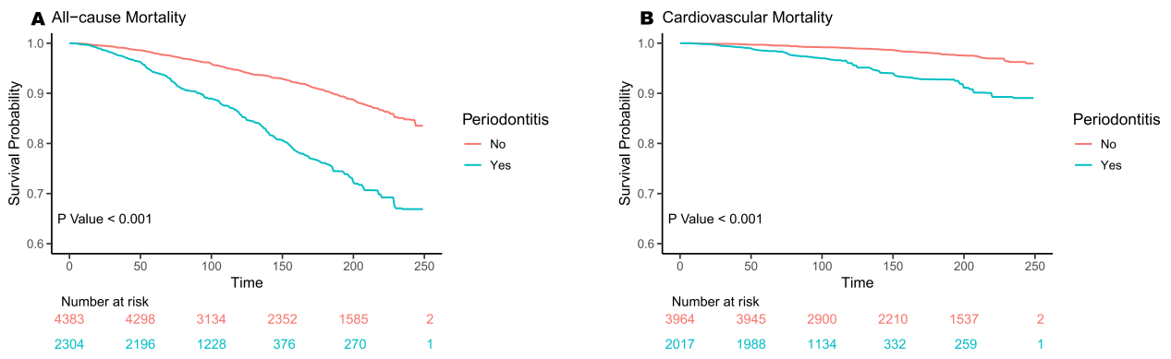
Figure 1. Kaplan‒Meier survival curve for all-cause mortality (A) and cardiovascular mortality (B).

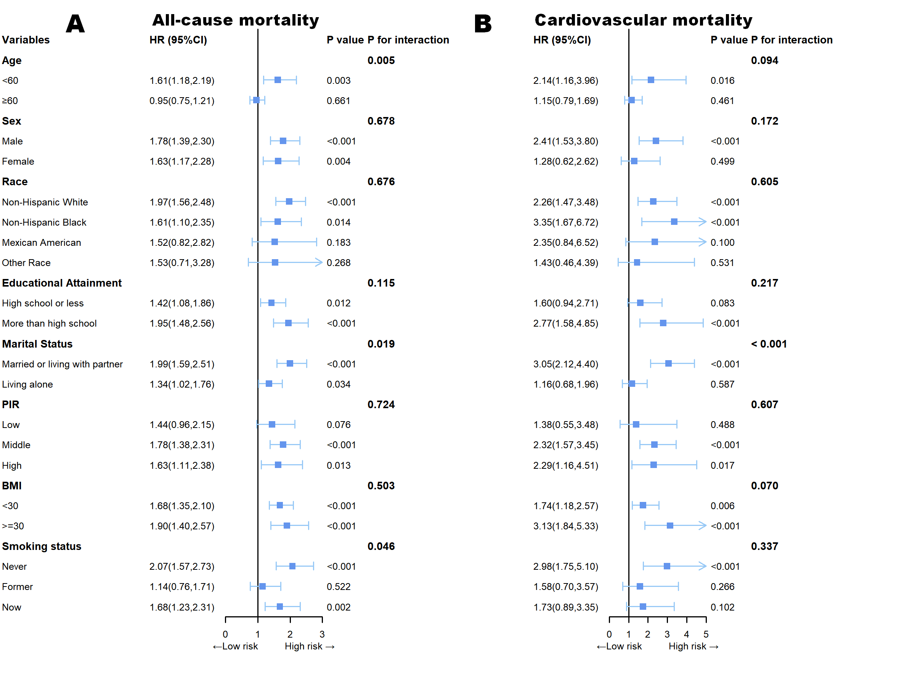
Figure 2. Subgroup analysis of the associations periodontal status (no/yes) and all-cause mortality (A) and cardiovascular mortality (B).

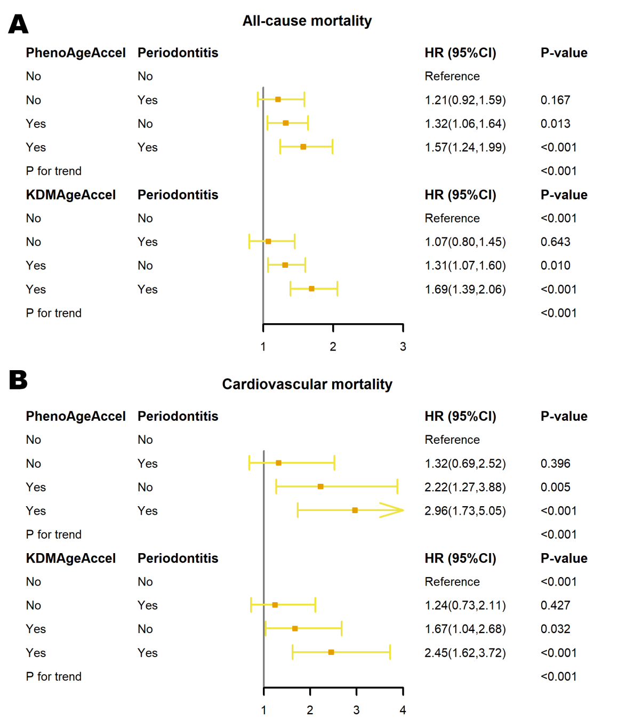
Figure 3. Joint analysis of different accelerated aging phenotypes and periodontitis with all-cause mortality (A) and cardiovascular mortality (B).

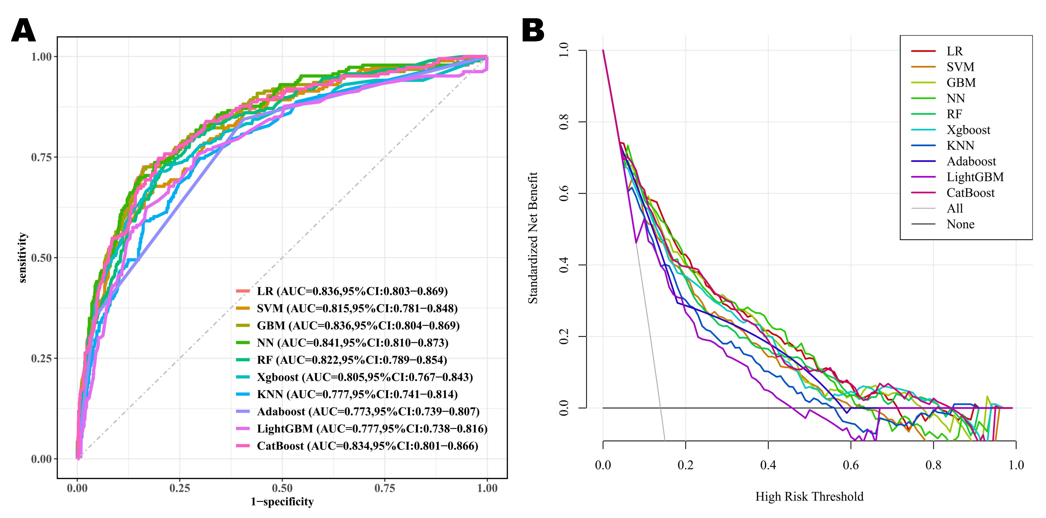
Figure 4. Discrimination and clinical utility analyses of the diagnostic model. (A) Discrimination Analysis. Receiver Operating Characteristic (ROC) curves illustrating the diagnostic performance. (B) Clinical Utility Analysis. Decision Curve Analysis (DCA) demonstrating the net benefit across different threshold probabilities.

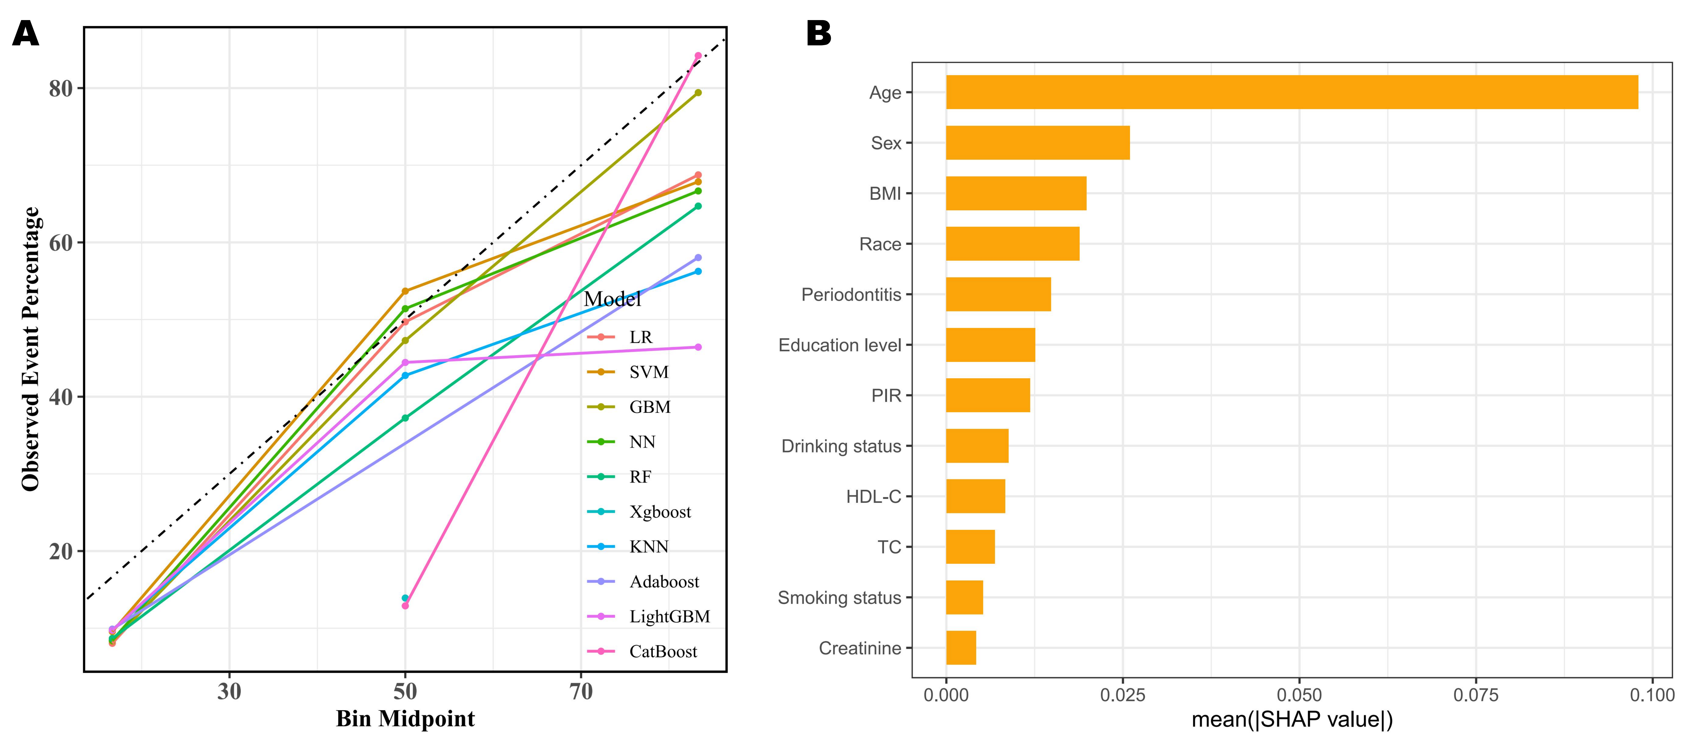
Figure 5. Model calibration and interpretability analysis. (A) Calibration Analysis. Plots evaluating the agreement between predicted probabilities and actual observations. (B) Feature importance ranking based on SHAP values.

