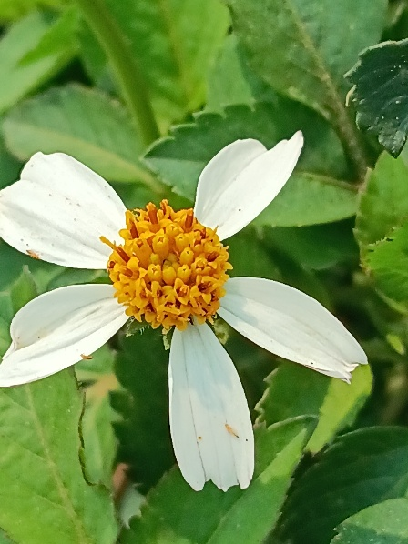
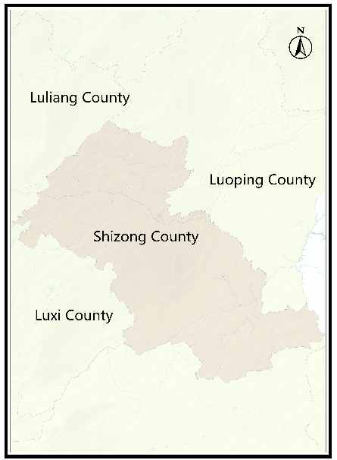
a b

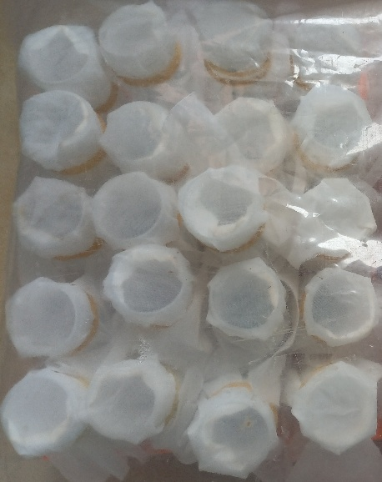
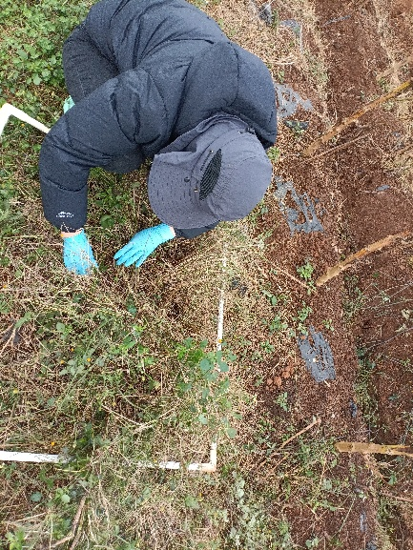
c d

Figure S1. Study area (a), survey of weed hosts of WFT (b), collection of weed litter (c), rearing of WFT in a 50 mL tube (d).

Figure S2. Temperature and humidity of study sites.

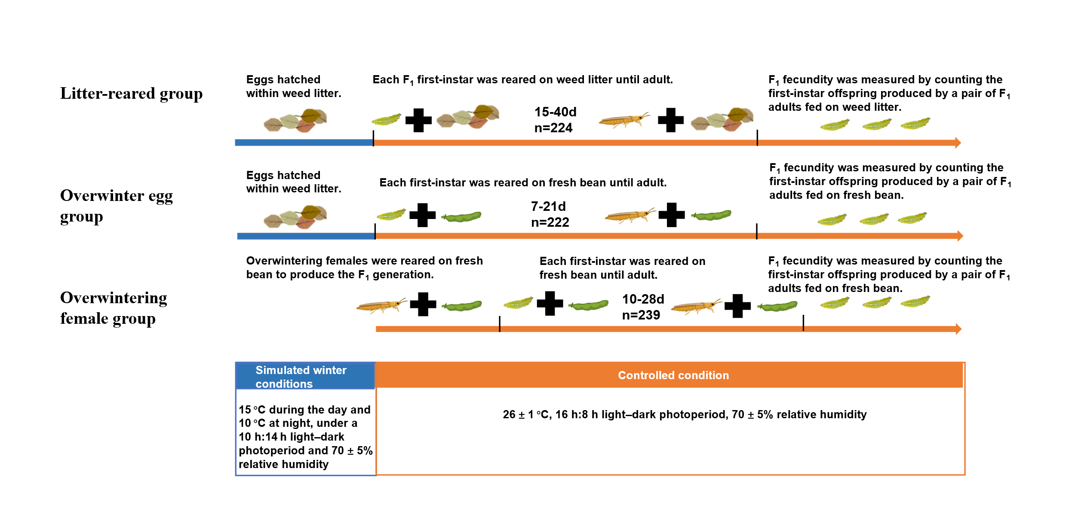
Figure S3. Procedures for overwintering egg experiments and overwintering female experiments.

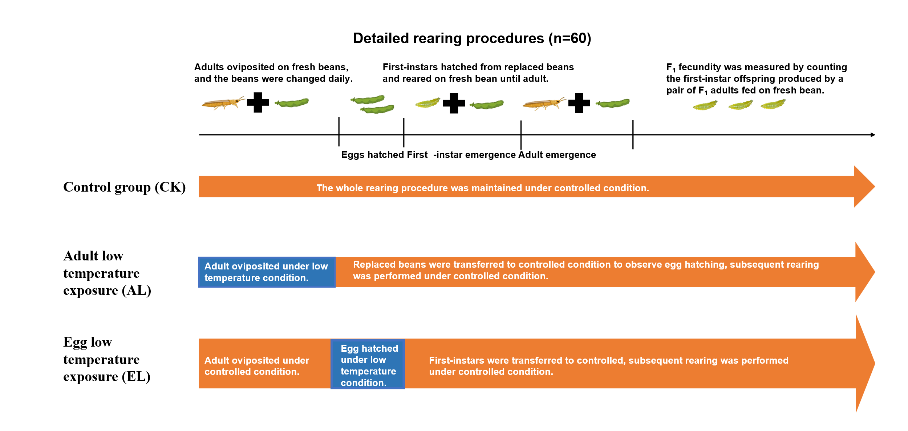

Figure S4. Procedures for low-temperature exposure experiments.

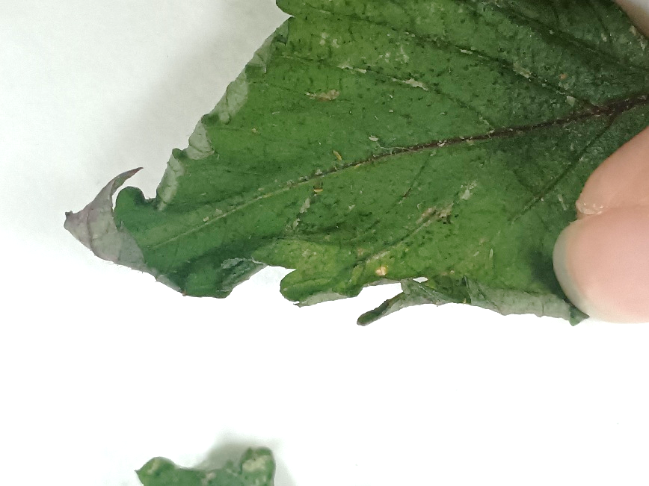
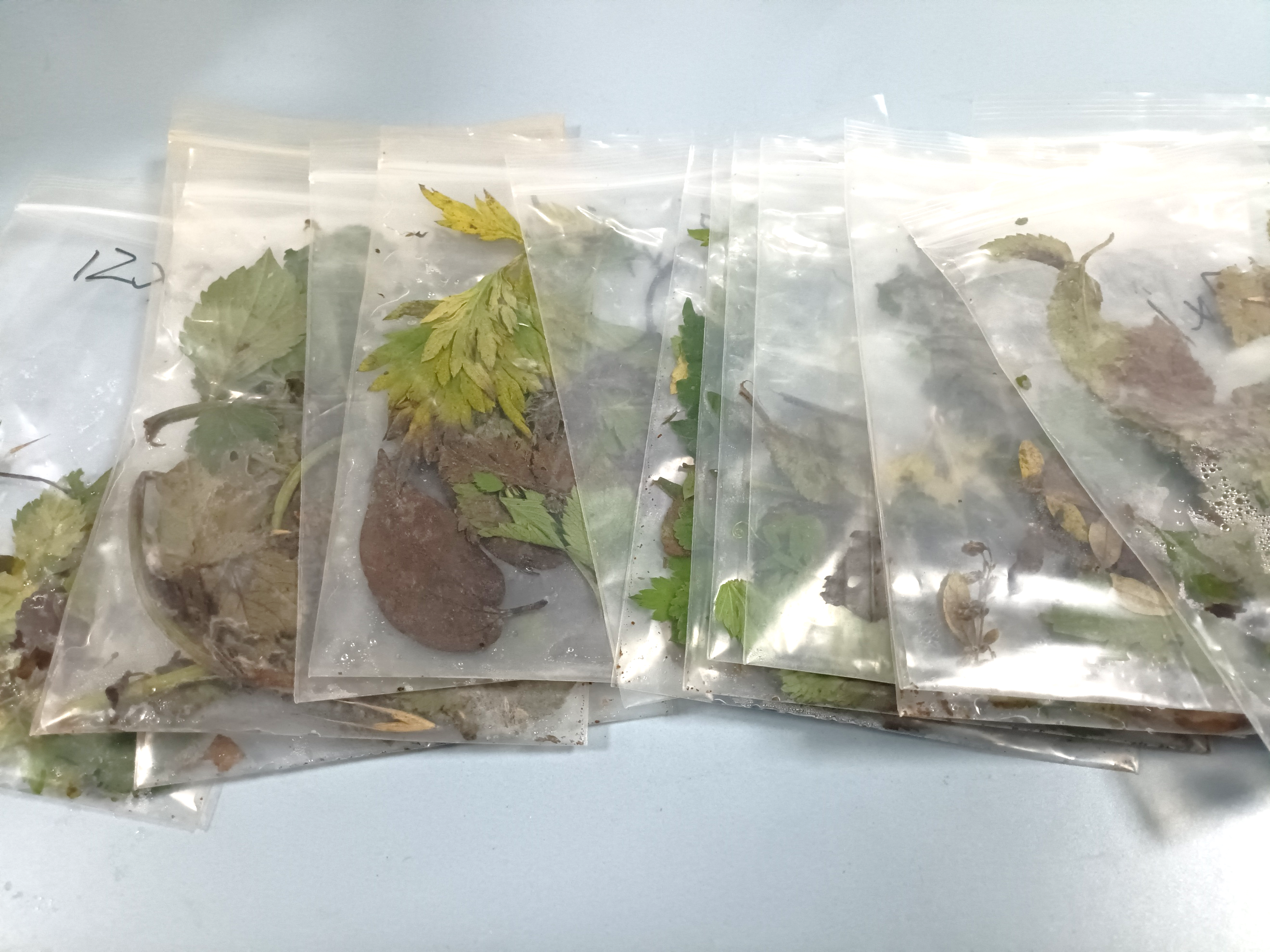
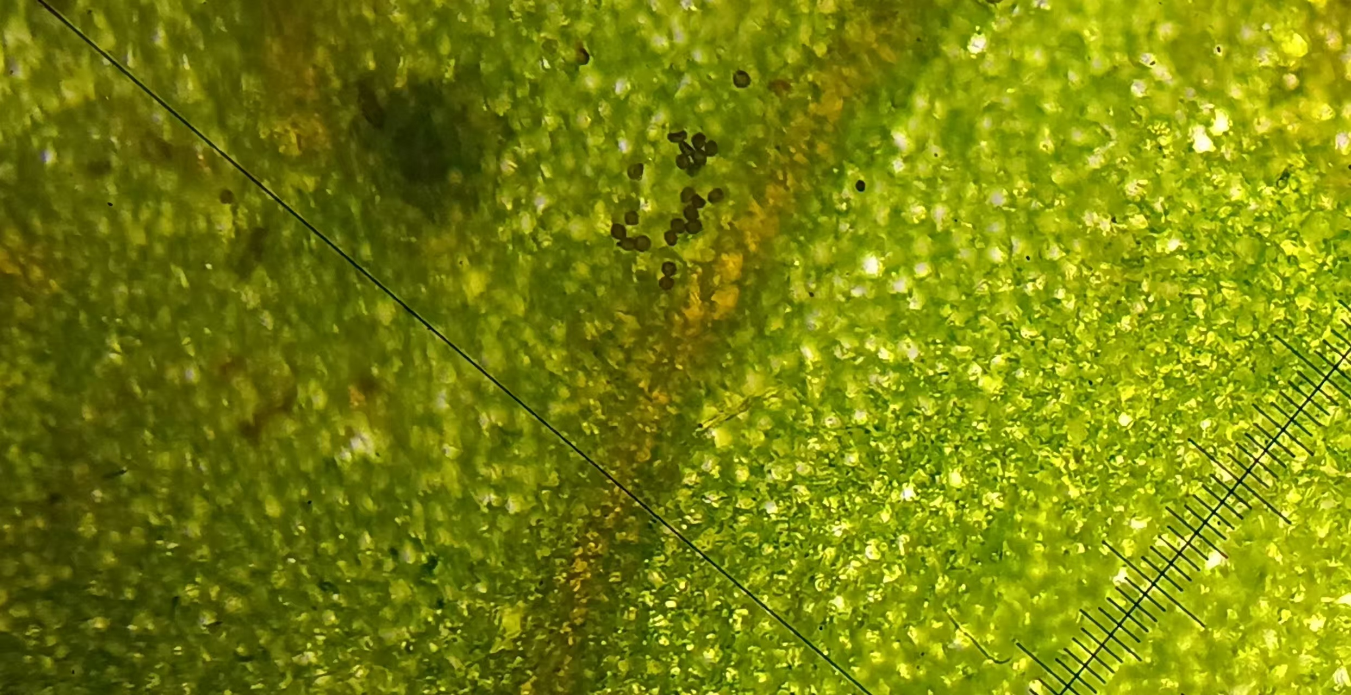
a c

b

Figure S5. Overwintering eggs of WFT in weed litter and their hatched offspring. (a) Weed litter samples were collected from field habitats during winter, which served as the source of WFT eggs. (b) WFT eggs (indicated by white circle) were observed under a stereomicroscope after dissecting leaf tissues; the eggs were bean‑shaped and embedded in the mesophyll. (c) Newly hatched first‑instars (F₁) (indicated by orange circle) emerged from overwintering eggs, showing active movement and feeding behavior.

Table S1: GPS coordinates of the sampling areas in Shizong County, Qujing City, Yunnan Province, China. A total of 50 sites were chosen, with six 1 m × 1 m quadrats established at each site.
Area | Number | Longitude (E) | Latitude (N) | Area | Number | Longitude (E) | Latitude (N)
Sanjia | S1 | 103.99 | 24.76 | Hongtu | S25 | 103.90 | 24.70
Sanjia | S2 | 103.99 | 24.76 | Hongtu | S26 | 103.90 | 24.69
Sanjia | S3 | 103.99 | 24.76 | Hongtu | S27 | 103.90 | 24.70
Sanjia | S4 | 103.99 | 24.77 | Hongtu | S28 | 103.91 | 24.69
Sanjia | S5 | 103.99 | 24.77 | Hongtu | S29 | 103.91 | 24.69
Sanjia | S6 | 103.99 | 24.77 | Hongtu | S30 | 103.91 | 24.69
Sanjia | S7 | 103.99 | 24.77 | Wulong | S31 | 103.91 | 24.76
Sanjia | S8 | 103.99 | 24.77 | Wulong | S32 | 103.91 | 24.77
Sanjia | S9 | 103.99 | 24.77 | Wulong | S33 | 103.91 | 24.77
Sanjia | S10 | 103.99 | 24.77 | Wulong | S34 | 103.91 | 24.77
Sanjia | S11 | 103.99 | 24.76 | Wulong | S35 | 103.91 | 24.77
Sanjia | S12 | 103.99 | 24.76 | Wulong | S36 | 103.91 | 24.77
Sanjia | S13 | 103.99 | 24.77 | Wulong | S37 | 103.91 | 24.77
Sanjia | S14 | 103.99 | 24.77 | Wulong | S38 | 103.91 | 24.77
Sanjia | S15 | 104.00 | 24.77 | Wulong | S39 | 103.91 | 24.77
Sanjia | S16 | 104.00 | 24.77 | Wulong | S40 | 103.91 | 24.77
Sanjia | S17 | 104.00 | 24.77 | Wulong | S41 | 103.91 | 24.76
Qifa | S18 | 103.87 | 24.70 | Wulong | S42 | 103.91 | 24.76
Qifa | S19 | 103.87 | 24.70 | Wulong | S43 | 103.91 | 24.76
Qifa | S20 | 103.87 | 24.70 | Wulong | S44 | 103.90 | 24.76
Qifa | S21 | 103.88 | 24.70 | Wulong | S45 | 103.90 | 24.76
Qifa | S22 | 103.87 | 24.71 | Guanzhuang | S46 | 104.09 | 24.81
Qifa | S23 | 103.88 | 24.70 | Guanzhuang | S47 | 104.09 | 24.82
Qifa | S24 | 103.88 | 24.70 | Guanzhuang | S48 | 104.10 | 24.82
 |  |  |  | Guanzhuang | S49 | 104.10 | 24.81
 |  |  |  | Guanzhuang | S50 | 104.09 | 24.81

Table S2. The weeds found in the investigation area, their status as hosts of WFT and their importance value. Cells highlighted in red indicate that the corresponding weed species was dominant in that month (IV>20).
Species | Host of WFT | Weed importance value (IV)
Species | Host of WFT | Dec. | Jan. | Mar. | Apr. | Jun. | Aug. | Oct. | Nov.
Veronica persica | √ |  |  | 5.97 | 0.15 |  |  | 7.72 | 0.23
Plantago virginica |  |  |  | 0.58 |  |  | 0.10
Lamium amplexicaule |  |  |  | 0.79
Clinopodium chinense | √ |  |  |  | 0.38 |  | 0.22 |  | 0.23
Stachys kouyangensis |  |  |  |  |  |  |  |  | 0.47
Clinopodium gracile |  |  |  | 0.45
Prunella vulgaris |  |  |  | 0.18 |  | 0.10
Euphorbia esula |  |  |  |  | 0.15
Vicia cracca | √ | 5.30 | 7.73 | 4.74 | 8.24 |  | 0.33 | 8.33 | 9.47
Trifolium repens | √ | 1.04 | 1.45 | 5.27 | 4.24 | 1.85 | 1.19 | 10.97 | 4.14
Kummerowia striata |  |  |  |  |  |  |  | 14.38
Medicago polymorpha | √ |  |  | 2.21 |  | 1.25 | 0.35
Vicia sepium | √ |  |  | 6.84 | 1.11 |  | 0.10 | 6.76
Impatiens balsamina | √ |  |  |  |  |  |  | 6.76
Echinochloa crus-galli |  |  |  |  |  |  |  | 18.91
Bromus catharticus |  | 1.50 |  | 3.00 | 0.26 | 4.95 | 3.74 | 11.19 | 1.38
Setaria viridis |  | 2.25 |  | 0.80 |  | 4.37 | 2.66 | 9.24 | 2.40
Pennisetum alopecuroides |  |  |  |  |  |  | 0.56 |  | 0.29
Muhlenbergia huegelii |  | 3.32 |  |  |  |  | 0.98 | 12.90 | 0.65
Paspalum dilatatum |  | 3.85 |  |  |  | 0.17 | 3.00 | 11.47 | 0.23
Imperata cylindrica |  |  |  |  |  |  | 0.15
Eleusine indica |  | 0.25 |  |  |  | 0.96 | 1.48 | 14.50 | 0.52
Paspalum distichum |  | 4.13 |  |  |  |  | 3.87 | 8.63 | 3.04
Avena fatua |  | 1.60 |  | 1.06 |  | 0.47 | 0.18
Polypogon monspeliensis |  |  |  | 0.18
Setaria plicata |  | 1.30
Sida acuta |  |  |  |  |  |  | 0.25
Malva sinensis |  |  |  | 0.24 |  |  | 0.10
Malvastrum coromandelianum | √ |  |  |  | 0.20 |  |  | 10.90
Malva verticillata | √ |  |  |  |  | 0.11
Artemisia argyi | √ | 20.09 | 8.70 | 26.98 | 46.98 | 31.17 | 14.92 | 19.77 | 31.18
Bidens alba | √ | 26.84 | 49.04 | 1.02 | 2.15 | 33.47 | 40.23 | 45.51 | 58.67
Galinsoga quadriradiata | √ | 12.47 | 22.72 | 1.01 | 0.64 | 1.13 | 9.28 | 12.56 | 5.65
Erigeron acris | √ |  |  | 2.65 | 1.93 | 1.56
Youngia japonica |  |  |  | 0.09 | 0.35
Ageratum conyzoides | √ |  |  |  |  |  | 0.10 | 6.86 | 0.50
Praxelis clematidea |  |  |  |  |  |  |  | 5.65 | 0.23
Sonchus oleraceus | √ | 0.50 | 1.39 | 3.42 | 4.26 | 0.69 | 0.50 | 6.76 | 1.48
Senecio vulgaris | √ |  |  | 0.66 | 1.00 | 0.09 | 0.10 |  | 0.23
Bidens bipinnata |  |  |  |  |  |  |  |  | 0.44
Taraxacum officinale | √ |  |  | 1.69 | 0.92 | 0.52 | 0.12
Artemisia caruifolia |  |  |  | 0.23
Pseudognaphalium affine | √ |  | 0.20 | 3.47 | 8.15 | 0.34
Erigeron sumatrensis |  |  |  |  |  |  | 0.10 |  | 0.26
Sigesbeckia orientalis | √ |  |  |  |  |  | 0.10 | 9.81 | 0.76
Carpesium cernuum |  |  |  |  |  |  |  | 5.65
Dichrocephala benthamii | √ |  |  |  |  | 0.09 | 0.25
Ageratina adenophora |  |  |  |  |  | 0.63 | 0.13
Symphyotrichum subulatum |  |  |  | 0.09
Justicia procumbens |  |  |  |  |  |  |  | 8.42 | 0.47
Fagopyrum dibotrys | √ |  |  |  |  | 3.26 | 1.54
Persicaria nepalensis | √ |  |  |  |  |  |  | 9.87 | 0.70
Rumex acetosa | √ |  |  | 0.11 | 0.15 |  | 0.20
Fagopyrum gracilipes | √ |  |  |  |  |  |  | 9.63 | 0.52
Rumex japonicusHoutt |  |  |  |  | 0.43
Verbena officinalis | √ | 0.95 |  | 0.30 | 0.31 | 2.97 | 3.87 | 10.69 | 4.01
Geranium carolinianum | √ |  |  | 4.27 | 4.63 | 1.76 | 1.81 | 6.59 | 1.98
Lindernia nummulariifolia |  |  |  |  |  |  | 0.10
Equisetum hyemale |  |  |  |  |  |  | 0.30 | 6.76 | 1.42
Rubia cordifolia |  | 0.34 | 0.57 |  |  | 0.14
Agrimonia pilosa |  |  |  |  |  |  | 0.13
Potentilla rosulifera | √ |  |  |  | 2.28 | 0.86 | 0.65
Nicandra physalodes | √ |  |  |  |  | 0.34
Solanum aculeatissimum |  | 0.50 |  |  |  | 0.43 |  |  | 0.70
Solanum americanum | √ | 7.52 | 3.43 |  | 0.77 | 0.97 | 0.41 | 10.60 | 1.34
Nothosmyrnium japonicum |  |  | 0.20 | 0.12 |  | 0.26
Centella asiatica |  |  |  |  | 0.15 | 0.28
Cnidium monnieri |  |  |  | 0.09 | 0.15 |  | 0.35 |  | 0.26
Schoenoplectus tabernaemontani |  |  |  |  |  | 0.22 | 0.82 | 13.38 | 0.29
Cardamine hirsuta |  |  |  | 0.18
Capsella bursa-pastoris | √ | 3.02 | 3.92 | 11.43 | 0.96 |  | 1.29 | 4.26 | 1.84
Brassica rapa |  |  |  | 0.14 |  | 0.15
Myosoton aquaticum | √ |  | 0.64 | 4.48 | 0.15 | 1.36 | 0.10 | 6.43 | 0.84
Mazus pumilus |  |  |  |  |  |  |  |  | 0.52
Chenopodium album | √ |  |  | 3.64 | 8.91 | 1.51 | 1.46 | 7.50
Dysphania ambrosioides |  |  |  |  |  |  |  |  | 0.23
Alternanthera philoxeroides |  |  |  |  |  | 0.30 | 0.73 | 27.62 | 2.00
Amaranthus tricolor | √ |  |  |  |  | 0.62 | 0.10
Ipomoea purpurea | √ | 3.25 |  |  |  | 0.17 | 0.53 | 7.76 | 1.52
Commelina communis | √ |  |  |  |  | 0.13 | 0.30 | 13.97
Cynoglossum amabile |  |  |  |  |  |  | 0.13
Trigonotis peduncularis | √ |  |  | 1.64 |  | 0.28 | 0.10
Cynoglossum lanceolatum | √ |  |  |  |  | 0.09

