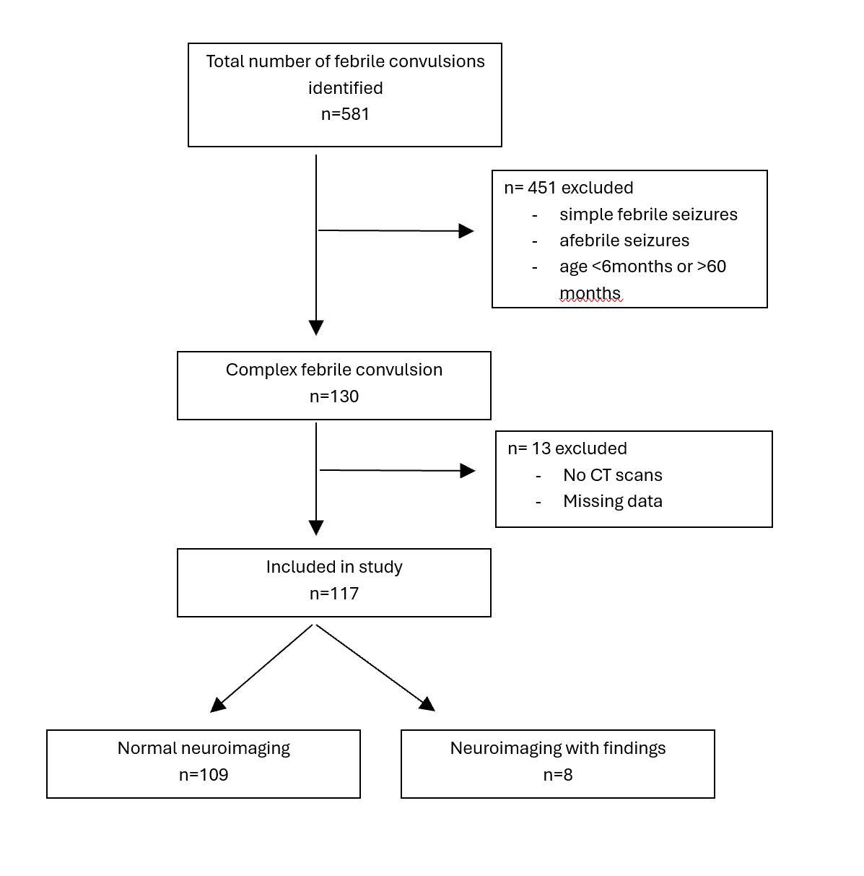
Table 1. A flowchart of study inclusion and exclusion criteria

