Supplementary Information

Nonvolatile ferroelectric domain wall memory integrated on silicon
Haoying Sun^{1,2,3}, Jierong Wang^{1,2,3}, Yushu Wang^{1,2}, Jiahui Gu^{1,2}, Jiangfeng Yang^{1,2}, Yuwei Liu^{1,2}, Tianyi Gao^{1,2}, Hanyu Fu^{1,2}, Yufeng Hao^{1,2}, Zhengbin Gu^{1,2} and Yuefeng Nie^{1,2,}*

¹ National Laboratory of Solid State Microstructures, College of Engineering and Applied Sciences, Nanjing 210093, P. R. China
² Collaborative Innovation Center of Advanced Microstructures, Nanjing University, Nanjing 210093, P. R. China
³ These authors contributed equally: Haoying Sun, Jierong Wang
Authors to whom correspondence should be addressed: ynie@nju.edu.cn

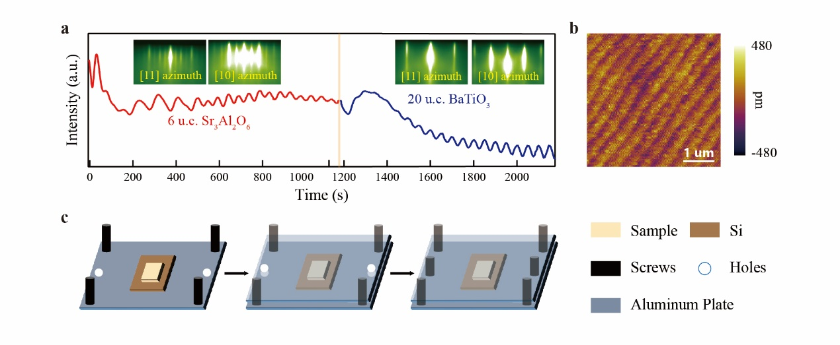
Figure S1 | Freestanding BaTiO₃ (BTO) films preparation. a, RHEED oscillation curves for 20 u.c. BTO thin film grown on STO substrate with 6 u.c. SAO sacrificial layer. Insets are corresponding RHEED diffraction patterns. b, AFM image for as-grown 20 u.c. BTO/SAO/STO heterostructure showing clear steps and terraces. c, Schematics of clamping device used for fixing the heterostructure and Si substrate during transferring process.

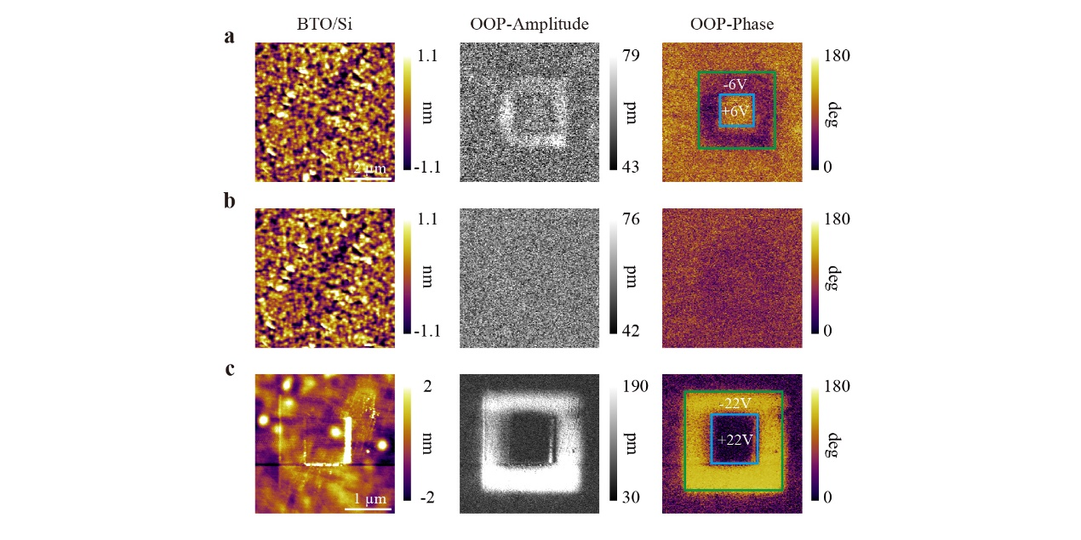
Figure S2 | Thickness-dependent stability variations of out-of-plane polarization in BTO membranes on Si. a,b, VPFM results for freestanding 20 u.c. BTO/Si immediately after domain switching (a) and an hour after domain switching (b). Faint phase contrast between upward (negative-biased region) and downward (positive-biased region) polarization appears instantly after switching in a but fades away quickly in b. c, VPFM results for freestanding 160 u.c. BTO/Si after domain switching. The results sustain for more than one hour. Note that the applied bias voltages are both above their coercive field.

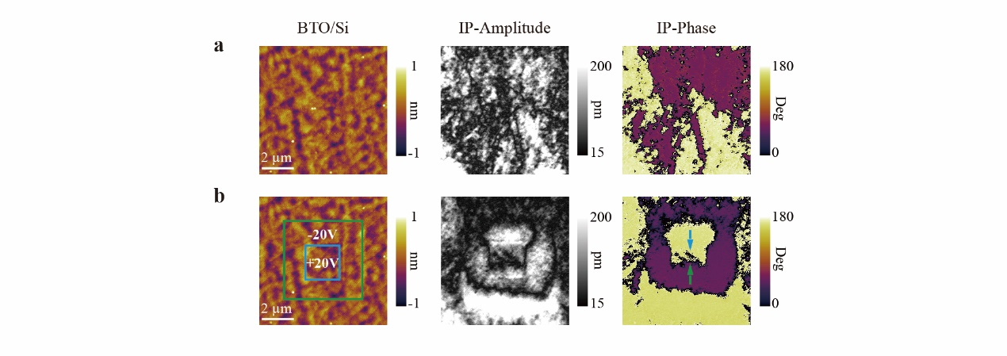
Figure S3 | In-plane domain switching for 160 u.c. BTO membrane on Si. a, The initial in-plane multidomain state. b, The switched domain state after applied bias voltages of ±20V using trailing field method. The switched domains deviate from the poled regions, due to that the in-plane polarization is actually switched by the trailing field of the biased tip.

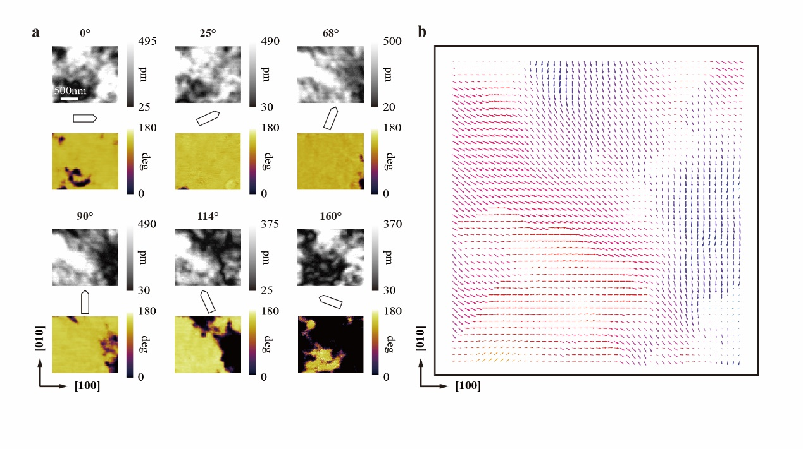
Figure S4 | Construction of an in-plane piezoresponse vector map. a, LPFM amplitude (upper image) and phase (lower image) results for freestanding 20 u.c. BTO/Si measured at six different rotating angles in the same region. Angle values denote the angles between the cantilever and the BTO [100] direction during LPFM scanning. b, Polarization mapping result for this region by fitting the data obtained in a. Distinct a-axis and b-axis polarization are displayed in b, with the lengths of the arrows representing the amplitudes of the polarization.

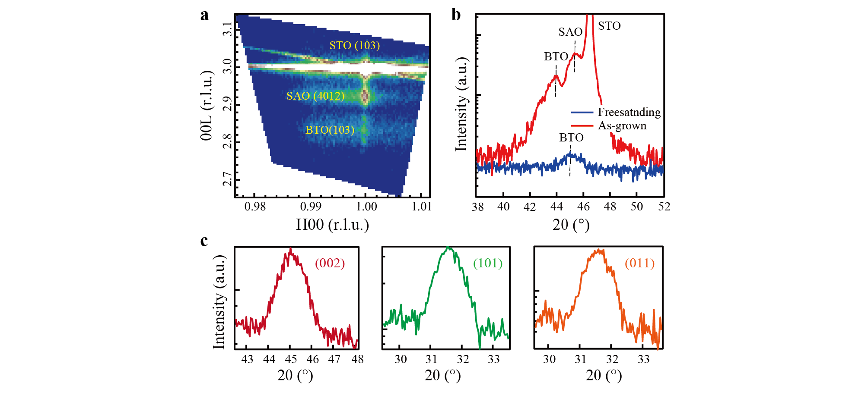
Figure S5 | XRD measurements for 15 u.c. BTO before and after transferring. a, RSM scans around (103) substrate diffraction of as-grown 15 u.c. BTO/SAO/STO indicate coherently strained BTO film. b, High-resolution XRD 2θ-ω scans around (002) substrate peak for 15 u.c. BTO/SAO/STO and freestanding 15 u.c. BTO membrane. Obvious peak shift can be observed. c, Corresponding 2θ-ω scans along (002), (101) and (011) diffractions for 15 u.c. BTO/Si to determine the lattice parameters (a, b and c) of BTO membrane.
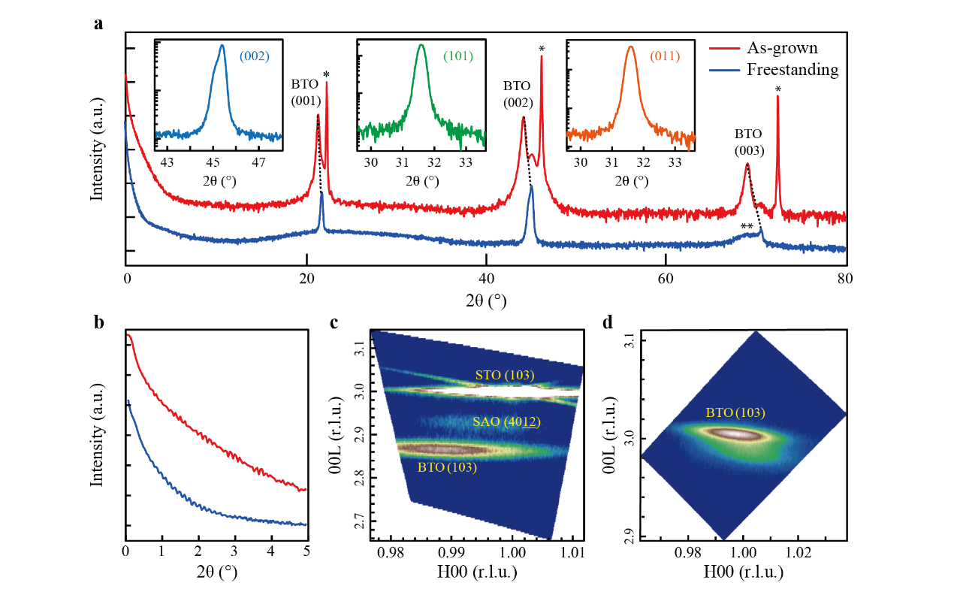
Figure S6 | XRD measurements for 160 u.c. BTO before and after transferring. a, 2θ-ω scans for 160 u.c. BTO before and after transferring. Asterisks (*) denote STO substrate diffraction peaks. Double-asterisk (**) denotes Si (004) diffraction peak of BTO/Si. The three insets demonstrate 2θ-ω scans for freestanding 160 u.c. BTO membrane around (002), (101) and (011) diffractions. b, Obvious Kiessig fringes at low angles for 160 u.c. BTO before and after transferring. c, RSM around (103)-diffraction peak of STO substrate for 160 u.c. BTO/SAO/STO shows evident strain relaxation. d, RSM around (103)-diffraction peak of 160 u.c. BTO membrane on Si.

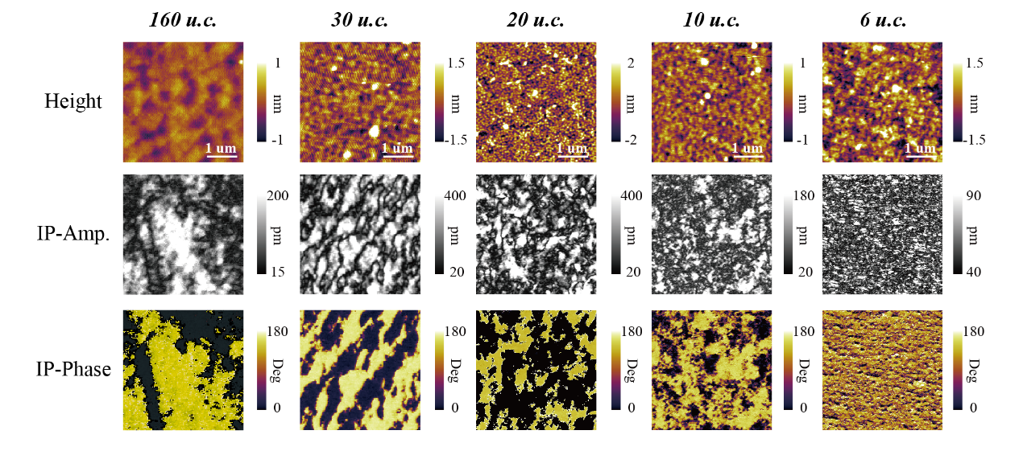
Figure S7 | Thickness dependence of in-plane domain structures. In-plane domain structures acquired by LPFM for freestanding BTO membranes of various thicknesses, demonstrating the overall tendency of increased domain wall density with decreased film thickness.

