Supplementary Figures

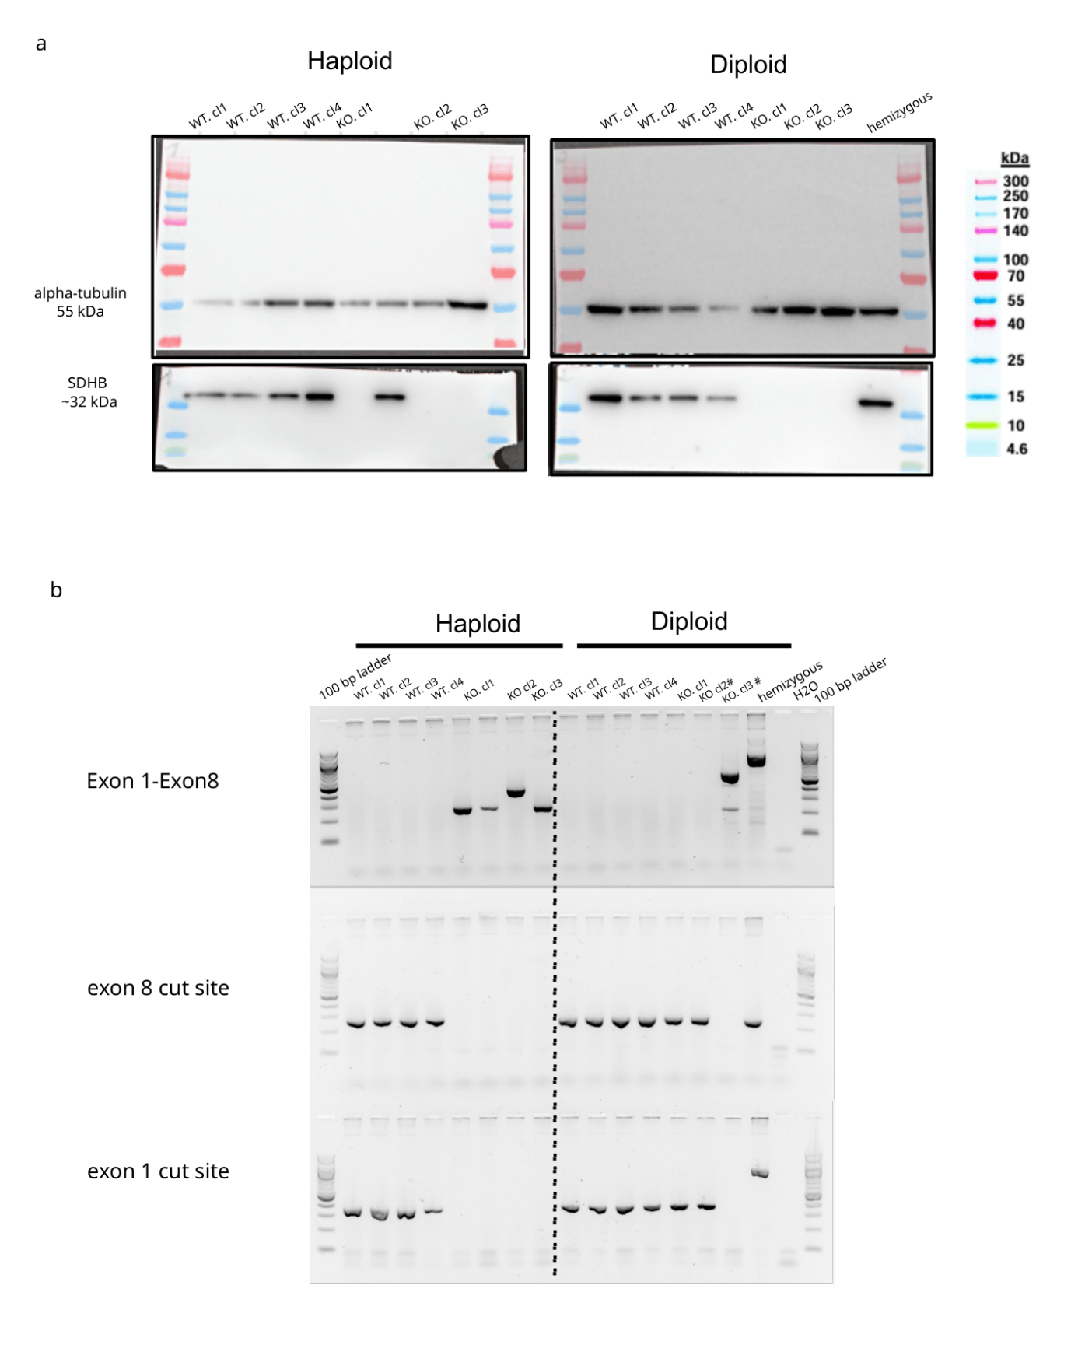
Figure S1. Validation of SDHB knockout and hemizygous HAP1-LIG4KO-Cas9 clones by western blot and breakpoint PCR. (a) Western blot analysis of SDHB protein expression (anti-SDHB, ~32 kDa) and alpha-tubulin loading control (~55 kDa) in haploid (left) and diploid (right) HAP1-LIG4KO-Cas9 clones. Wild-type clones (WT cl1-4) show robust SDHB expression in both ploidy backgrounds. Knockout clones (KO cl1-3) show complete loss of SDHB protein. The hemizygous clone retains SDHB protein expression consistent with one intact allele. (b) Breakpoint PCR confirmation of SDHB deletion status in haploid and diploid clones. Three primer sets were used: Exon 1-Exon 8 spanning PCR (top) producing a short amplicon only when the region between exon 1 and exon 8 is deleted; exon 8 cut site PCR (middle) amplifying the downstream boundary; and exon 1 cut site PCR (bottom) amplifying the upstream boundary. Diploid clones marked # (KO cl2#, cl3#) represent frameshift-mediated knockouts generated with exon2 gRNA. These clones lack the Exon 1-Exon 8 deletion product and retain intact exon 1 and exon 8 boundary sequences, consistent with small indels at the cut site rather than large deletion. The hemizygous clone shows a deletion product in the Exon 1-Exon 8 PCR confirming deletion of one allele, while retaining signal in the exon 8 and exon 1 cut site PCRs confirming presence of an intact second allele. H₂O negative control shows no amplification.

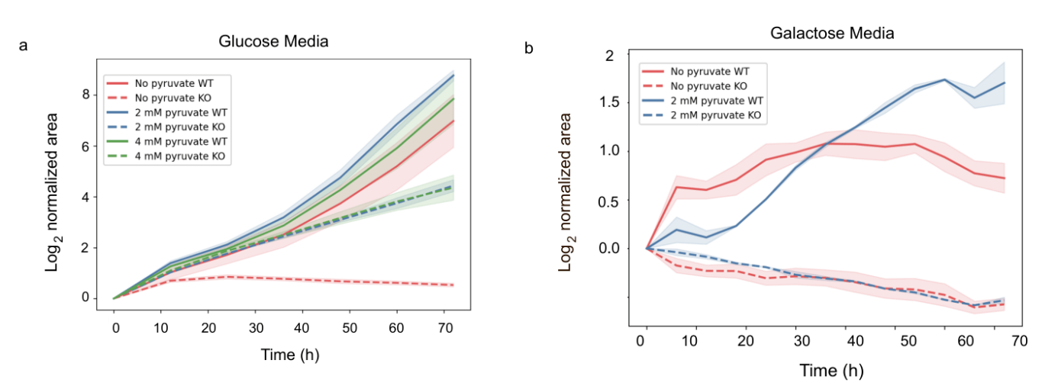

Figure S2. Proliferation of diploid HAP1-LIG4KO-Cas9 wild-type and SDHB knockout cells in glucose and galactose media across pyruvate concentrations. (a) Log₂ normalized area curves of diploid WT and KO cells cultured in glucose-based media (DMEM, 25 mM glucose, 10% FBS) supplemented with 0 mM (no pyruvate), 2 mM, or 4 mM sodium pyruvate over 72 hours. (b) Log₂ normalized area curves of diploid WT and KO cells cultured in galactose-based media (DMEM, 10 mM galactose, 10% FBS) supplemented with 0 mM or 2 mM sodium pyruvate over 72 hours. WT cells are shown as solid lines and KO cells as dashed lines. Shaded areas represent standard deviation across n=2 biological clones. The decreasing Log₂ normalized area is from the shrinking area of detached dead cells compared to the first timepoint used for normalization.

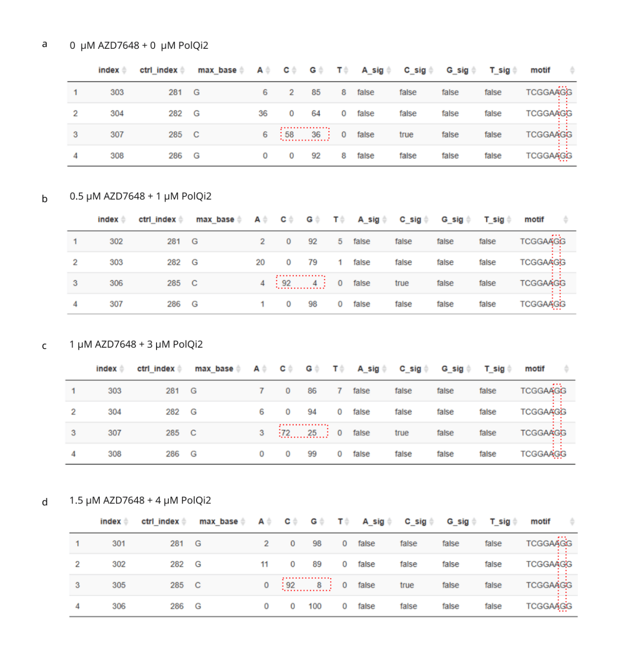
Fig. S3. MultiEditR analysis of HDR efficiency across 2iHDRi inhibitor concentrations in haploid HAP1-LIG4KO-Cas9 cells. MultiEditR output tables showing Sanger sequencing-based quantification of HDR efficiency at the target ctrl_index G>C substitution (highlighted in red) across four 2iHDRi inhibitor concentrations. The percentage of reads showing the target C base at the position of interest reflects HDR efficiency. (a) No inhibitor (0 µM AZD7648 + 0 µM PolQi2): HDR efficiency ~58% (C=58 at target position, row 3). (b) Low inhibitor concentration (0.5 µM AZD7648 + 1 µM PolQi2): HDR efficiency ~92% (C=92 at target position, row 3). (c) Mid inhibitor concentration (1 µM AZD7648 + 3 µM PolQi2): HDR efficiency ~72% (C=72 at target position, row 3). (d) High inhibitor concentration (1.5 µM AZD7648 + 4 µM PolQi2): HDR efficiency ~92% (C=92 at target position, row 3). HDR efficiency plateaus at the lowest inhibitor concentration tested (0.5 µM AZD7648 + 1 µM PolQi2).

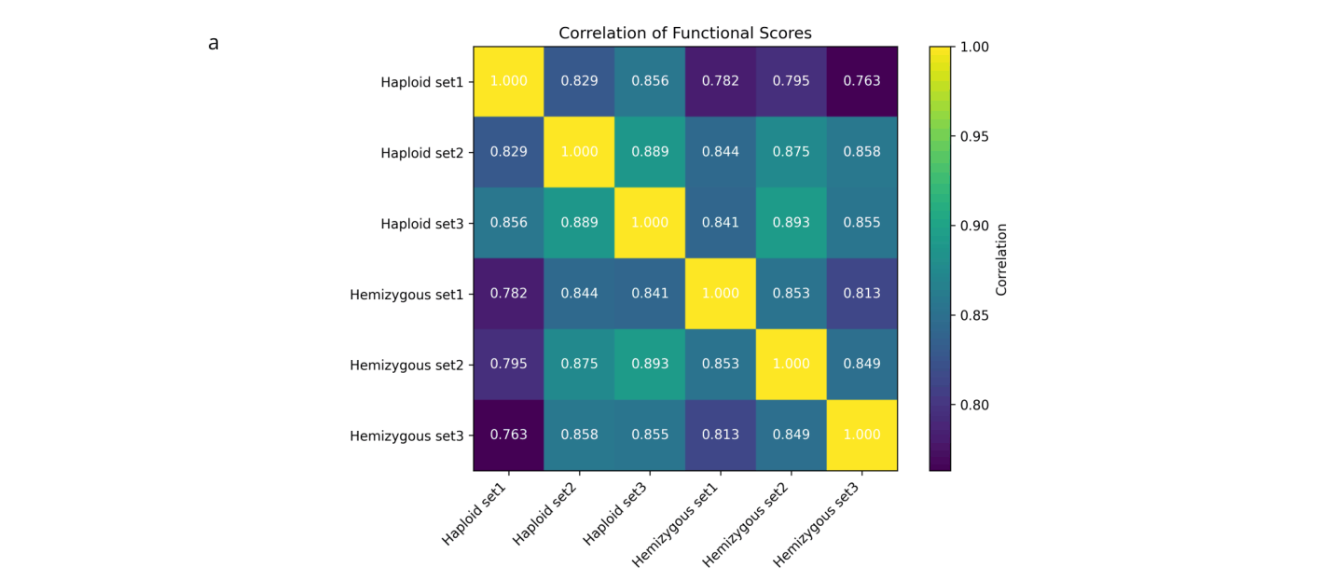
Fig. S4 Pearson correlation matrix of robust-normalized functional scores across biological replicates and ploidy states. Pairwise Pearson correlation coefficients between robust-normalized functional scores for all 317 (1 variant absent in haploid experiment) variants across three biological replicates in haploid cells and hemizygous cells . Color scale represents Pearson r values from 0.70 (dark purple) to 1.00 (yellow).
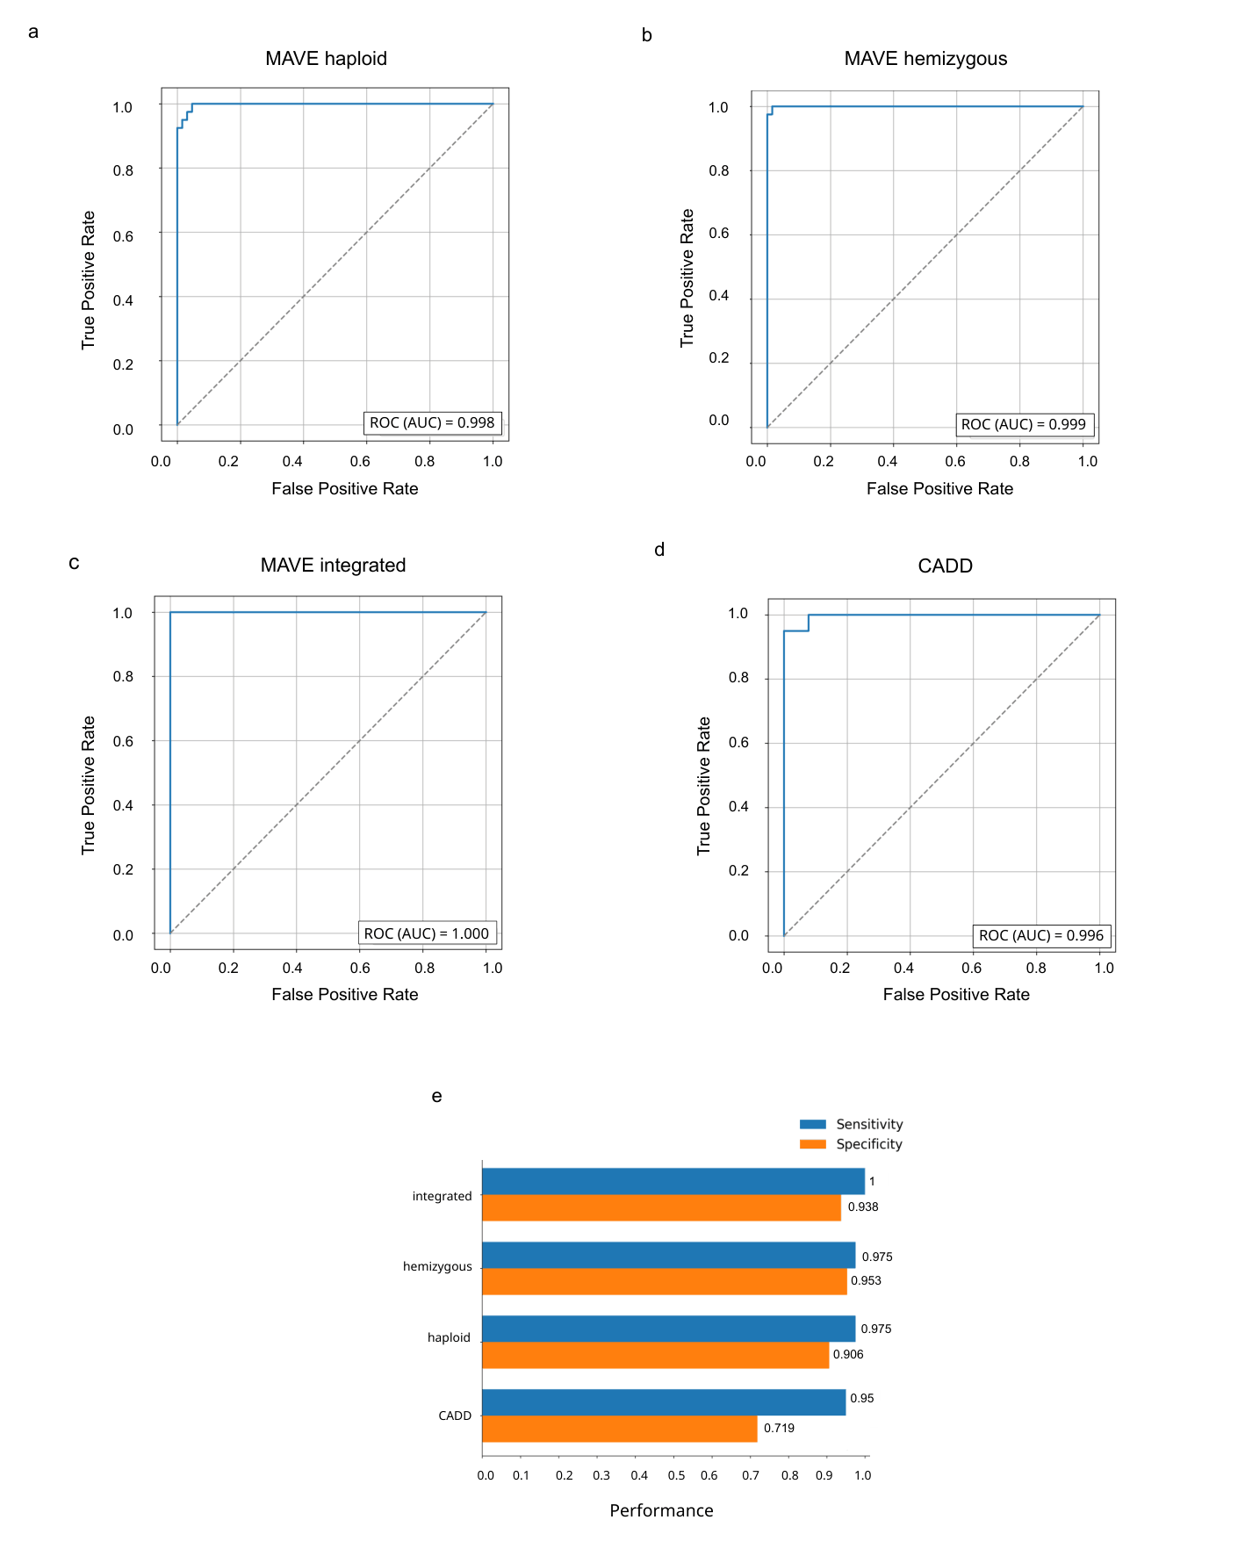
Fig. S5 Receiver operating characteristic ROC analysis of MAVE-derived pathogenicity scores and in-silico CADD. ROC curves comparing the performance of MAVE-based variant effect scores and CADD in discriminating functionally-normal from functionally-abnormal variants. (a) MAVE scores for haploid variants, (b) MAVE scores for hemizygous variants, and (c) MAVE scores for integrated variants (d) CADD scores. The true positive rate (sensitivity) is plotted against the false positive rate (1 − specificity) across score thresholds. The dashed diagonal line represents the performance expected by random classification. (e) Modified adjusted-sensitivity and adjusted-specificity, including unclassified ground-truth variants, and calibrated on medium-stringent ground-truth annotations, are shown for the haploid, hemizygous, integrated, and CADD methods.
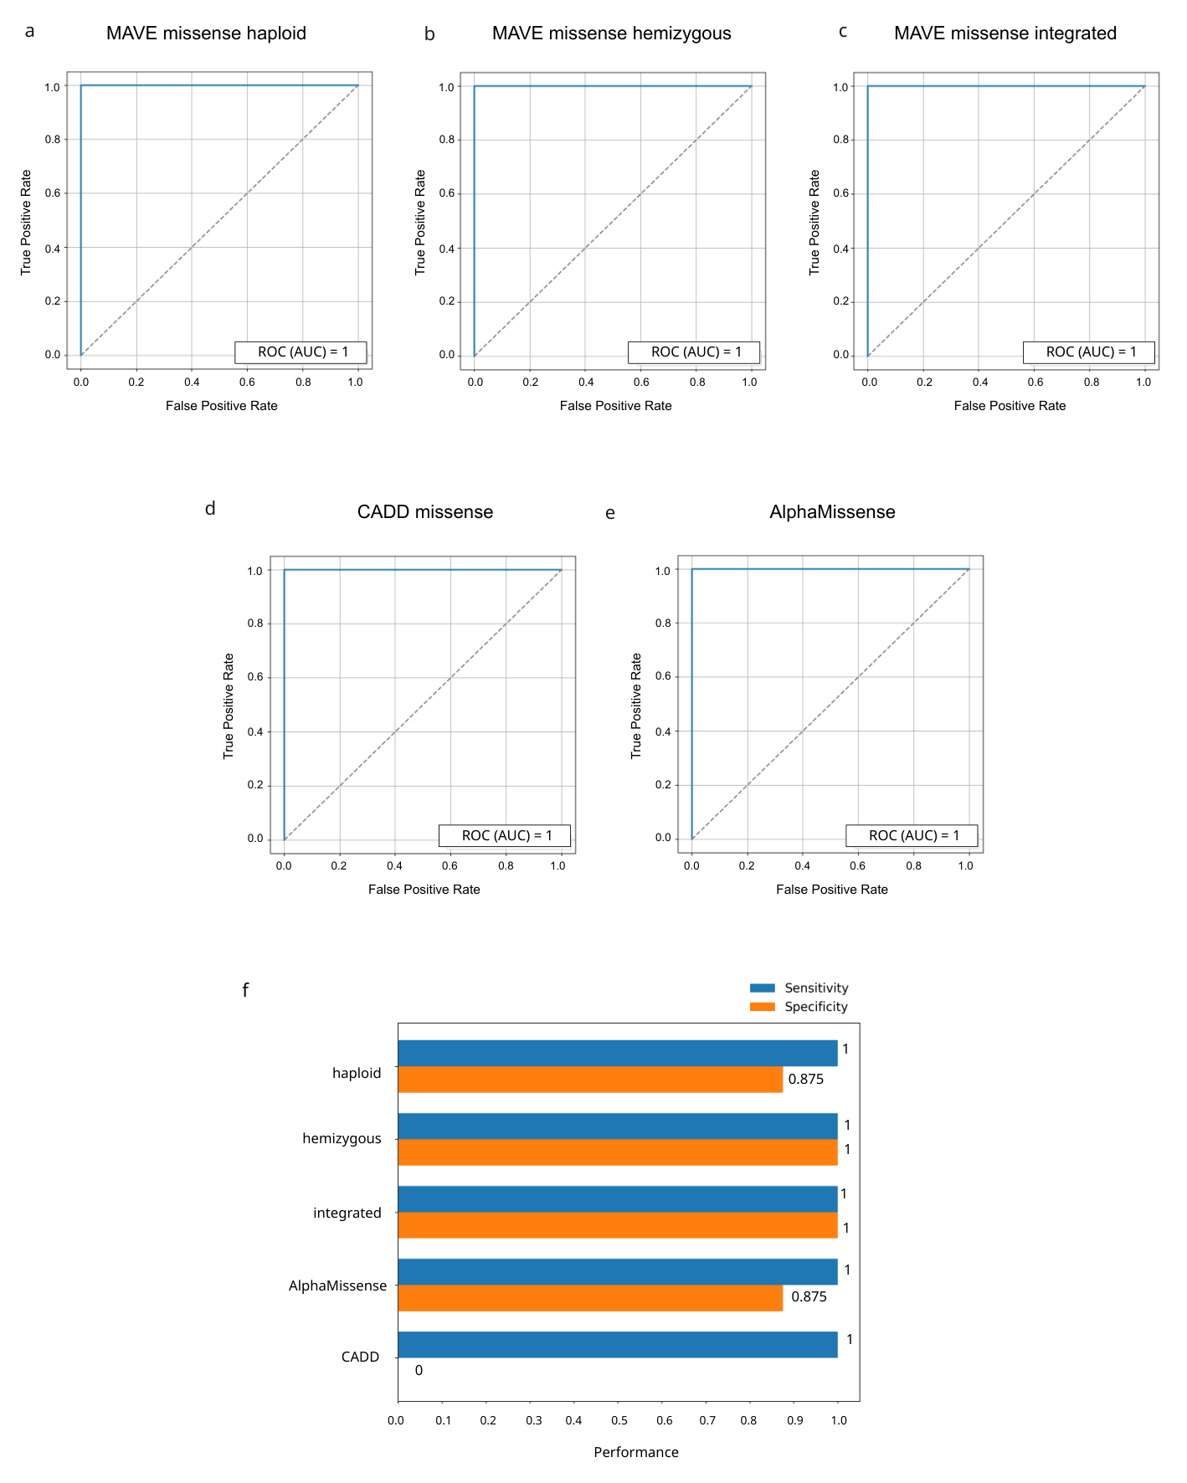
Fig. S6 ROC curves comparing the performance of MAVE-based missense variant effect scores and CADD in discriminating pathogenic from benign variants. (a) MAVE missense scores in the haploid dataset, (b) MAVE missense scores in the hemizygous dataset, (c) integrated MAVE missense scores, (d) CADD missense scores, and (e) AlphaMissense missense scores. The true positive rate (sensitivity) is plotted against the false positive rate (1 − specificity) across all score thresholds. The dashed diagonal line indicates the performance expected from random classification. (f) Modified adjusted-sensitivity and adjusted-specificity, including unclassified ground-truth variants, and calibrated on medium-stringent missense ground-truth annotations, are shown for the haploid, hemizygous, integrated, AlphaMissense and CADD methods.

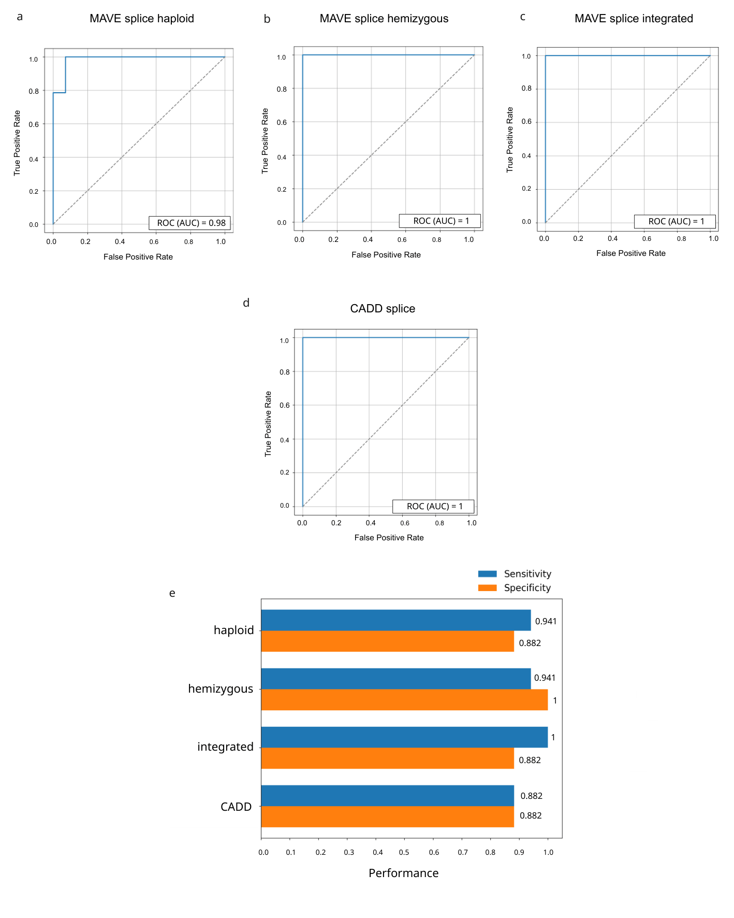
Fig. S7 ROC curves comparing the performance of MAVE-based splice variant effect scores and CADD in discriminating pathogenic from benign variants. (a) MAVE splice scores in the haploid dataset, (b) MAVE splice scores in the hemizygous dataset, (d) integrated MAVE splice scores, (e) CADD splice scores. The true positive rate (sensitivity) is plotted against the false positive rate (1 − specificity) across all score thresholds. The dashed diagonal line indicates the performance expected from random classification. (e) Modified adjusted-sensitivity and adjusted-specificity, including unclassified ground-truth variants, and calibrated on medium-stringent splice ground-truth annotations, are shown for the haploid, hemizygous, integrated, and CADD methods.
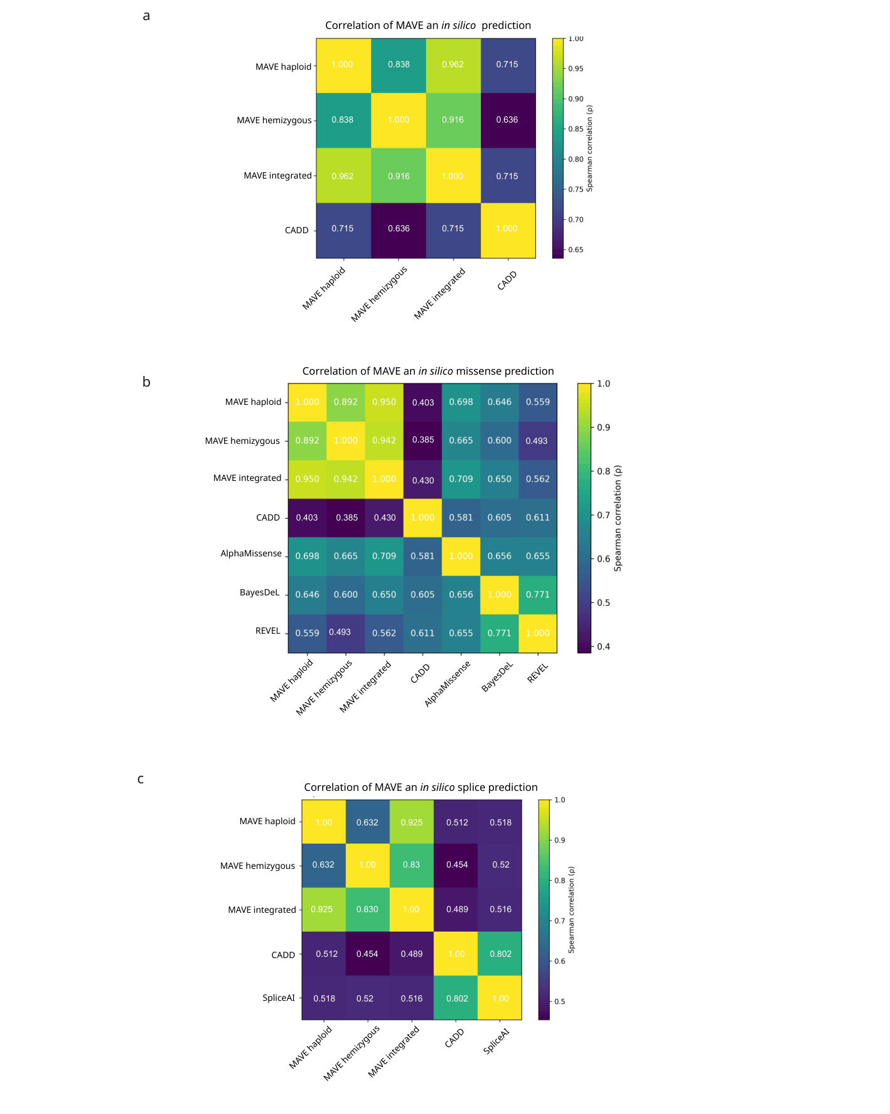
Figure S8. Spearman correlation matrices between MAVE-derived functional scores and in-silico predictors across variant consequence classes. (a) Correlation between MAVE classifiers (haploid, hemizygous, integrated) and CADD across all 318 variants. (b) Correlation between MAVE classifiers and in-silico prediction tools CADD, AlphaMissense, BayesDel, and REVEL restricted to missense variants (n=187). (c) Correlation between MAVE classifiers in-silico prediction tools CADD and SpliceAI restricted to splice, intronic, polypyrimidine tracts and donor/acceptor variants. All correlations computed on continuous posterior probability scores and in-silico scores. Color scale represents Spearman values from 0.40 (dark purple) to 1.00 (yellow).

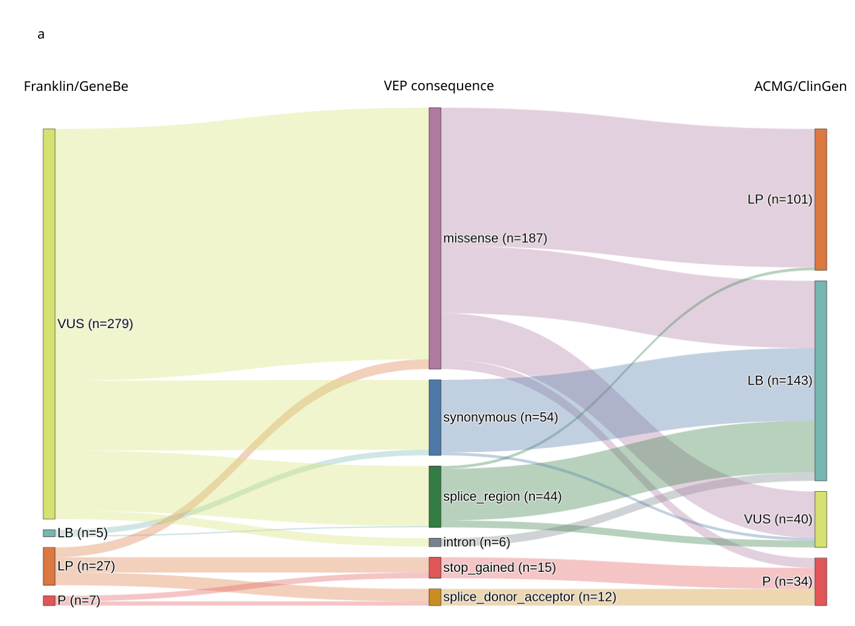
Figure S9. Relationship between VEP consequence categories and ACMG/ClinGen classification.Sankey diagram illustrating the relationship between Franklin/GeneBe variant classifications (left), grouped VEP consequence categories (middle), and final ACMG/ClinGen classifications (right). VEP consequences were grouped into six categories: stop gained, splice donor/acceptor, missense, splice region, synonymous, and intron. Node labels indicate the number of variants in each category, and ribbon widths are proportional to the number of variants transitioning between categories.

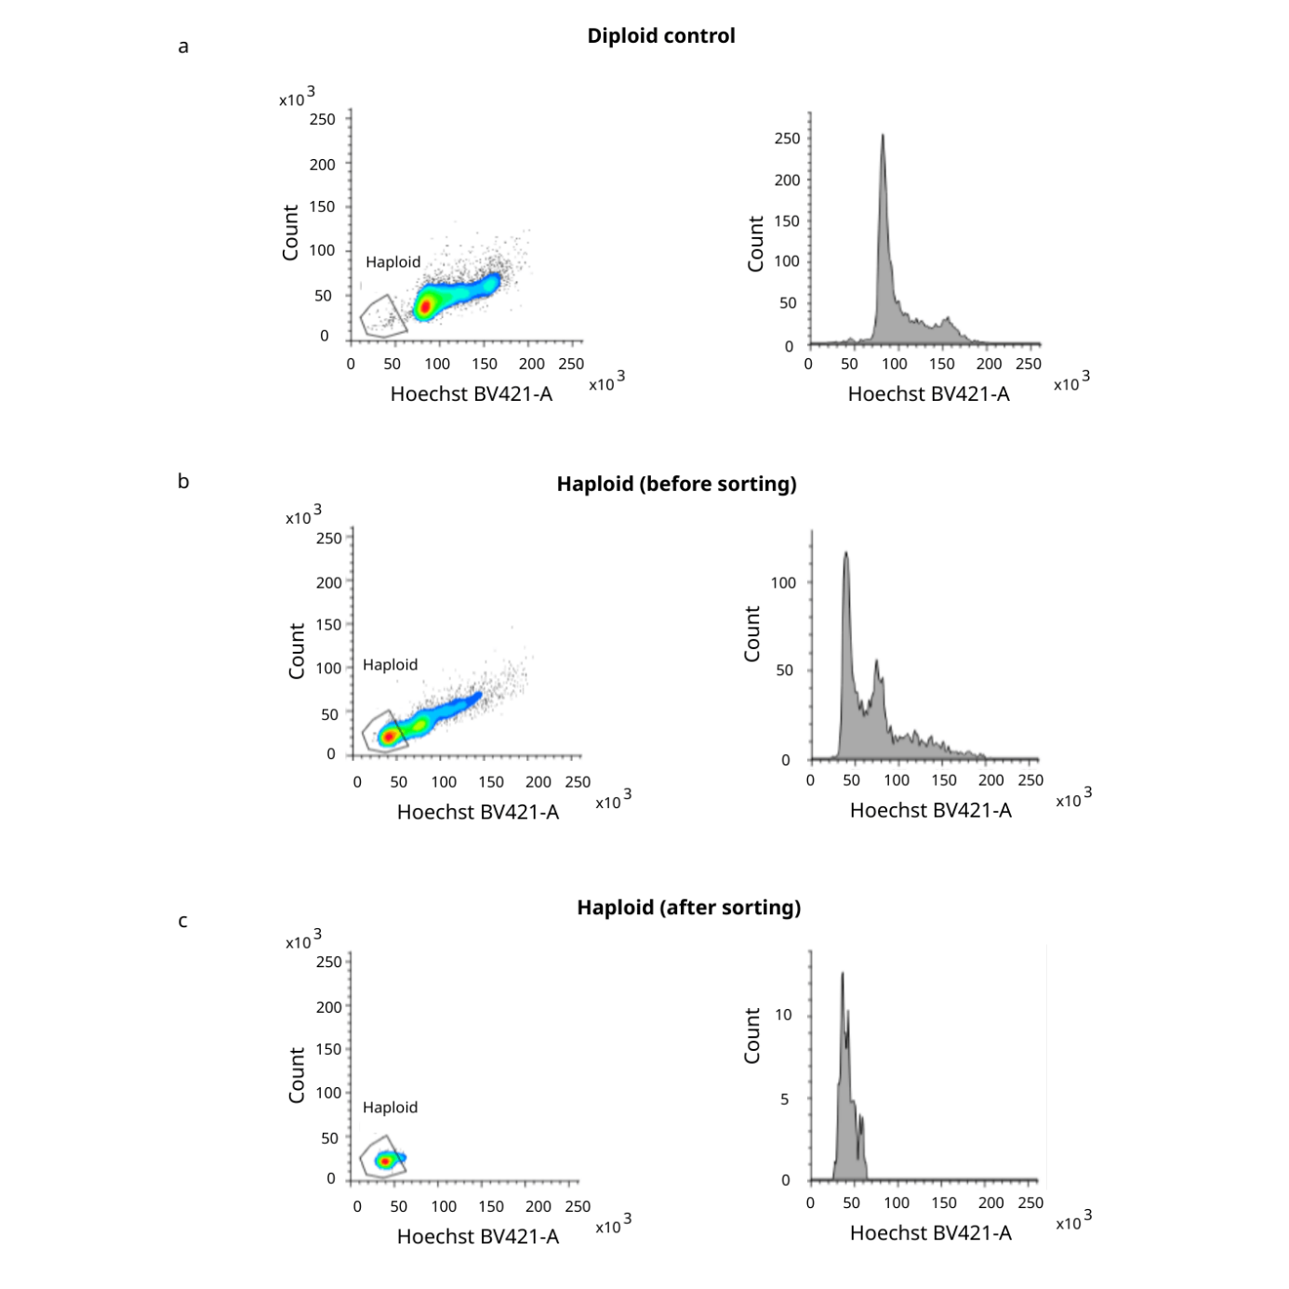
Fig S10. FACS-based isolation of haploid HAP1-LIG4KO-Cas9 cells by DNA content. Hoechst 33342 DNA content profiles of single cells shown as dot plots (SSC-A vs Hoechst BV421-A, left) and histograms (count vs Hoechst BV421-A, right). The haploid sort gate is indicated on each dot plot. (a) Diploid control cells showing a single 2N population with 1.36% of single cells falling within the haploid gate, confirming gate specificity. (b) Representative pre-sort haploid cell population showing a bimodal DNA content distribution with distinct 1N and 2N peaks; 40.58% of single cells fall within the haploid gate. (c) Post-sort haploid population showing successful enrichment of the 1N fraction with 95% of sorted events within the haploid gate and a single sharp peak in the DNA content histogram. Cells were stained with Hoechst 33342 and sorted on a BD FACSMelody cell sorter (BD Biosciences). Doublets were excluded prior to analysis using a Hoechst BV421-A vs Hoechst BV421-W gate.

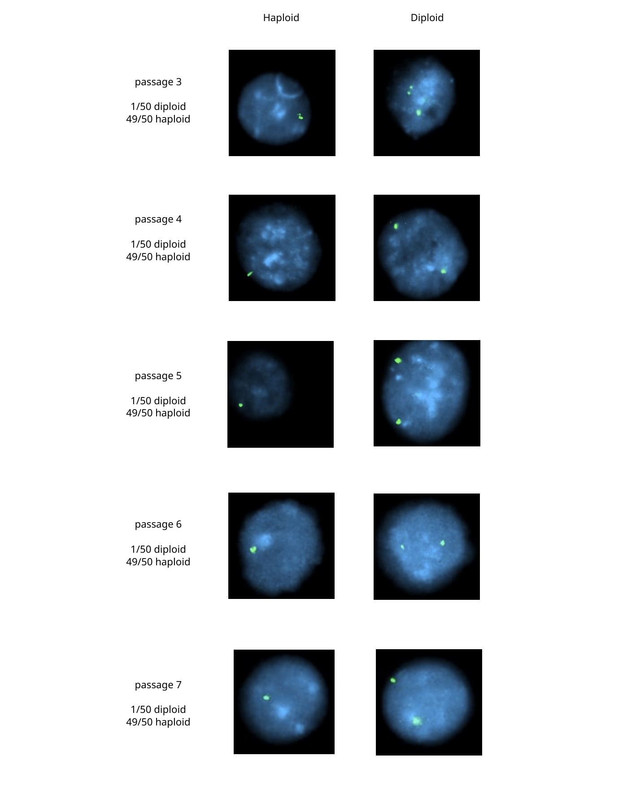
Fig. S11 FISH verification of haploid status in HAP1-LIG4KO-Cas9 cells across sequential passages.
Representative interphase FISH images from HAP1-LIG4KO-Cas9 cells at passages 3-7 following FACS sorting. Cells were hybridized with a BAC-based SDHB locus-specific probe (RP11-1146K14, ATTO488, green; Empire Genomics) and counterstained with DAPI (blue). Representative haploid cells (left column, one green signal) and diploid cells (right column, two green signals) are shown for each passage. Fifty interphase nuclei were scored per passage. Haploid purity was 49/50 (98%) at each passage examined, confirming stable maintenance of the haploid state across sequential passaging. Images acquired using Keyence fluorescence microscope at 60x oil immersion objective.

