Appendix A: observation instruction and form
Semi-structured observation
This type of observation is semi-structured using an observation form.
You observe (watch) and listen for a certain period of time (15-60 minutes) to what is being said in the situation under observation. This process is entirely open and flexible. You observe everything that happens before, during, and after the Jonas case. The observations are recorded either on the spot or shortly after.
- If possible, observe in pairs, independently observing the situation, and also independently working out your observations.
- Observers focus on all participants and the facilitator of the game. If more than one observant is available: Both observers focus on all participants and the facilitator of the game.
- Write up your notes as soon as possible after the observations.
- Ensure that your report of the observations includes at least the following two parts:
a. Your detailed observations
b. Your interpretation
- If more than one observant is available: Compare the collected data and try to reach as much agreement as possible regarding the observations.
In semi-structured (non-systematic) observation, you do not know exactly what information you want or what is important in advance. You are only focused on a few themes beforehand, for example, the communication between the players of the game, the cooperation process, and the type of communication used. Descriptions in this type of observation are vivid and realistic.
Non-participant, external, or detached observation occurs when the observer does not participate in the activities of the people being observed. The subjects are observed ‘from the outside,’ and the researcher remains as much as possible outside the research situation. For example, you might sit three meters behind the players on a chair, observing the gameplay and the communication (both non-verbal and verbal communication between the participants).
The group will choose their own chair, during the game. The tutor will do the observations, this is ‘overt observation’. Overt participation could lead to the subjects altering their behavior because they realize they are being observed. In practice, this research effect diminishes somewhat when the observation is prolonged. The subjects become accustomed to the researcher’s presence and resume their ‘normal’ behavior. In (overt or covert) external observation, the researcher can observe either directly or indirectly. In this project, we choose direct observation. Direct means that you are present at the research site, but you do not participate in the conversations.
Within observation, medical and allied health students playing a role of a professional are here referred to as professional & attention is given to six themes:
- 1. Participants’ view on collaboration - collaborative leadership
(Consider: monodisciplinary thinking, sharing a lot of information but not asking for or integrating information from others, do the parents or the patient need to advocate for themselves? Do professionals listen to each other? Shared responsibility? Are the formulated goals focused on the patient and aligned with the patient?)
- 2. Structure - team functioning
(Consider: Is there a chairperson? Structured discussion? Minute-taker? Does each professional have the opportunity to speak? Timekeeping? Is all important input provided before the goal is formulated? Who is responsible for the goals and monitoring? Are the goals achievable for the client? If not, does someone address this? Are the professional’s cultural background and working style considered?)
- 3. Collaboration process: Role clarification
(Consider: Are roles clarified? For example, what does a dietitian do? Was there an introduction round with role clarification? Was a chairperson appointed, and was this role executed well? Was someone responsible for evaluation and monitoring? Do the parents know the roles and tasks of the professionals? Do professionals reintroduce themselves when speaking during the game?)
- 4. Collaboration process: Handling interprofessional conflict
(Consider: Do professionals stick to their own information, only set goals within their own profession, not integrate information from other disciplines, raise their voices or seek confrontation to defend their point, try to convince the parents without giving reasons or considering each other's perspectives? Do they get stuck in conflict or keep revisiting it? Are there good meeting techniques and a good chairperson?)
- 5. Outcomes - (Shared) decision making and goal setting
(Consider: Do the parents or patient have their turn? Is the discussion started with input from the parents or patient? Are the patient’s wishes asked? Is the discussion ‘patient-centered’? Are observations of caregivers checked with the patient? Did test results form the basis of the discussion? Are goals set by professionals instead of the patient? Is the patient part of the discussion? Do they understand all the terms? In what situations does the patient get sufficient input?)
- 6. Outcomes - Interpersonal communication
(Consider: Use of jargon, talking about ‘he’ instead of the patient’s name, they’ instead of parents, do the parents indicate that they do not understand the information? At the end, do professionals explain to the parents what they ‘discovered/decided’? Do professionals ask each other to clarify questions?)
For each observation, indicate which of the themes the observation relates to and who performed the action or made the statement.
T1 – P2: First observation on theme 1; conducted by participant 2 (non-verbal information is written in parentheses).
Just before the game starts, draw the table layout at the top of your observation form so that it is always clear which participant is sitting were. This ensures that the observations can be easily compared afterward.
Mapping out the seating arrangement of the participants around the table, so you can identify who is sitting where during the observation. This is important for accurately linking observations (such as who says or does what) to the correct person.
The arrangement could look like this:
- Draw a simple circle or rectangle to represent the table.
- Mark the positions of the participants around the table.
- Label each spot with a number or name to indicate who is sitting where.

For example:
Position 1: speech–language therapist,
Position 2: parent,
Position 3: foster parent where Jonas stays for the weekends,
Position 4: audiologist,
Position 5: teacher/day carer,
Position 6: physiotherapist,
Position 7: psychologist,
Position 8: general practitioner,
Position 9: secretary describing decisions and reasoning for these decisions

Observations (and interpretations) | Verbatim description in quotation  Pay attention to body language
- Vision of the participants on collaboration
- Vision of the participants on collaboration
- Structure - team functioning
- Collaboration process - role clarification
- Collaboration process - handling interprofessional conflict
- Outcomes - (Shared) decision making and goal setting
- Outcomes - Interpersonal communication

Appendix B: Pre- and post-assignment competency reflections
The IPEC competency framework
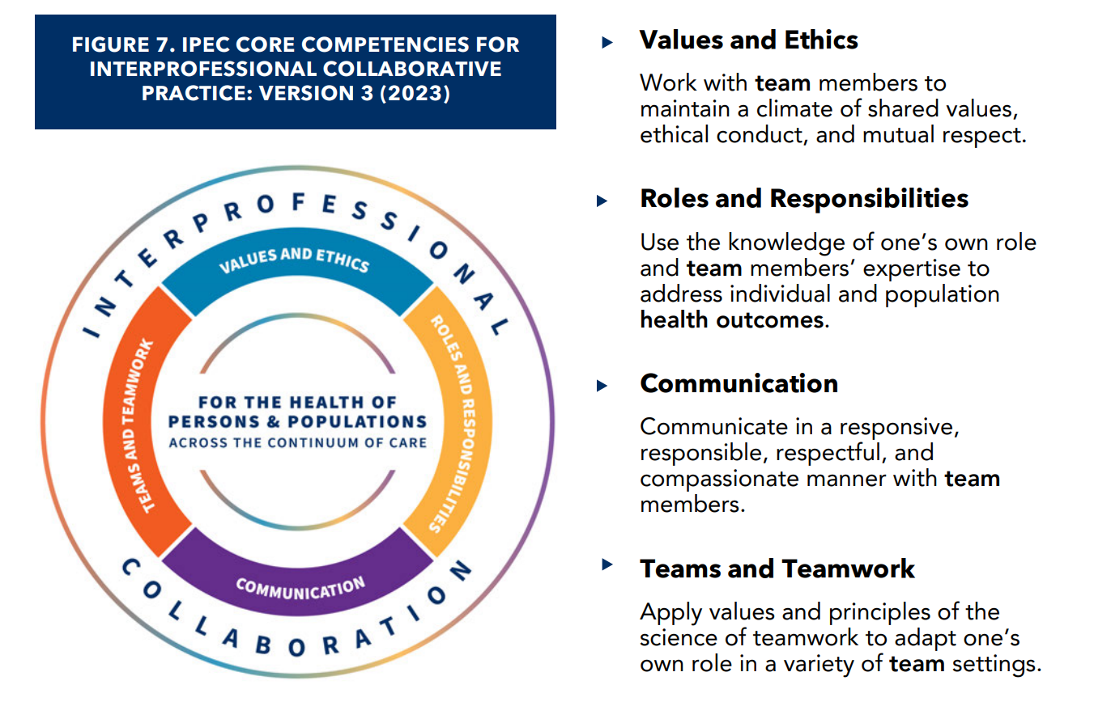
Based on the four IPEC competencies, questions were formulated. Four questions of the pre- and post-assignment competency reflections, reflecting the core competencies of interprofessional collaboration, and one general question about their perceived ability were scored on a 10 point scale, where a score of 10 reflects the highest competency level.
- I work with team members to maintain a climate of shared values, ethical conduct, and mutual respect.
- I use the knowledge of one’s own role and team members’ expertise to address individual and population health outcomes.
- I communicate in a responsive, responsible, respectful, and compassionate manner with team members..
- I apply values and principles of the science of teamwork to adapt one’s own role in a variety of team settings.
- I am confident in my ability to collaborate interprofessional.

Appendix role description
- For the detailed role description we refer to the appendix of the Deckers & van Zaalen (2024) article: DOI: 10.3390/healthcare12060681

