Supplementary material

Supplementary Section S1. Disease-specific ecological assumptions

Supplementary Section S2. Restoration intensity levels

Supplementary Section S3. Bayesian Belief Network Parameterisation

Supplementary Section S4. Ecological regulation recovery plots

Supplementary Section S5. One-at-a-time (OAT) sensitivity analysis

Supplementary Section S6. Funding simulation scenarios – Direct-contact zoonotic system
Supplementary Section S7. Validation
Supplementary Section S8. RESTOREID DST: Decision-support interface
Supplementary section S9. Limitations to the generalisation of the BBN models
Supplementary section S10. Expert questionnaire

Supplementary Methods S1. Disease-specific ecological assumptions

Rodent-borne diseases

Rodent-borne diseases are frequently associated with habitat degradation, biodiversity loss, and the proliferation of disturbance-adapted reservoir species. The rodent disease model therefore focused on habitat quality, biodiversity recovery, rodent abundance, and ecological regulation. Restoration was assumed to reduce disease hazard indirectly through trophic restructuring, increased biodiversity, and reduced dominance of competent reservoir hosts. This framework reflects ecological mechanisms proposed for hantaviruses, arenaviruses, and other rodent-associated zoonoses.

Tick-borne diseases

Tick-borne disease dynamics are strongly influenced by host movement, vegetation structure, and landscape connectivity. Restoration may initially increase wildlife host connectivity and habitat suitability for ticks before longer-term trophic regulation emerges. The tick model therefore incorporated nonlinear restoration responses, host connectivity, delayed ecological regulation, and prolonged stabilization trajectories. These assumptions reflect ecological processes observed in Lyme disease, tick-borne encephalitis, and other tick-associated zoonoses.

Mosquito-borne diseases

Mosquito-borne diseases are particularly sensitive to hydrological conditions and restoration intensity. Restoration activities such as wetland rehabilitation, floodplain reconnection, and peatland rewetting may initially increase standing water availability and vector habitat suitability before ecological regulation mechanisms become established. The mosquito model therefore incorporated hydrological recovery, standing-water dynamics, restoration intensity, and delayed ecological regulation. This framework reflects ecological processes relevant to West Nile virus, Rift Valley fever, Japanese encephalitis, and related mosquito-borne diseases.

Direct-contact multi-host zoonoses

Direct-contact zoonotic systems are often driven by interactions among wildlife, domestic animals, and humans that are amplified by habitat disturbance, fragmentation, and ecological disruption. Restoration may reduce spillover risk by restoring habitat integrity, reducing human–wildlife contact rates, and promoting more stable ecological communities. The direct-contact model therefore focused on disturbance, host diversity, contact rates, multi-host amplification processes, and ecological regulation. These assumptions are relevant to systems such as Nipah virus and other wildlife-associated spillover diseases characterized by direct transmission pathways.

Supplementary Methods S2. Restoration intensity levels

Restoration intensity was treated as an ordered categorical variable with four levels, none, low, moderate, and high, representing positions along the restorative continuum as defined by Gann et al. (2019) and operationalised following the intervention continuum framework of Krishnan and Osuri (2023). The restorative continuum encompasses the full range of ecosystem restoration activities ordered by the degree to which they recover biodiversity, ecosystem health and integrity, and human well-being, from management activities aimed primarily at reducing threats at one end, to full ecological restoration aimed at recovering ecosystems to pre-degradation condition at the other. Rather than treating restoration as a passive–active dichotomy, the intervention continuum framework positions restoration strategies along a gradient of intervention intensity, with ecological outcomes accruing differentially depending on the intensity and type of intervention applied. The four model categories were defined as follows and are intended to represent generalised positions on this continuum rather than specific management prescriptions, in order to support cross-system comparison across the diversity of ecosystems and disease contexts modelled here (Table S2_1).

Table S2_1. Operational definitions of restoration intensity categories.
Category | Ecological state | Intervention examples | Key ecological properties encoded in model
None | Degraded, unmanaged baseline. Ongoing disturbance, fragmentation, or degradation with no active intervention. | Abandoned agricultural land, degraded wetland, fragmented forest with no management. | Low habitat quality; high disturbance; low biodiversity; weak ecological regulation; low hydrological functioning.
Low | Early-stage or minimal intervention. Threat removal or passive recovery initiated but structural and functional recovery negligible. Corresponds broadly to assisted natural regeneration or protection-only approaches. | Fencing, invasive species control, cessation of drainage, rewilding without active planting. | Early transitional state; partial re-wetting or vegetation recovery beginning; host communities and vectors beginning to respond before regulatory processes establish.
Moderate | Intermediate intervention. Active restoration under way but ecological processes, trophic interactions, and structural complexity incompletely recovered. Corresponds broadly to active restoration with partial functional recovery. | Native planting, partial hydrological restoration, habitat connectivity improvement, selective species reintroduction. | Transitional ecological state; peak standing water or host connectivity in vector-borne systems; ecological regulation recovering but not established; highest uncertainty in outcomes.
High | Advanced restoration trajectory. Intensive, landscape-scale intervention with substantial recovery of ecological processes, trophic structure, habitat connectivity, and biodiversity within the 15-year modelling horizon. Represents progress toward, but not necessarily attainment of, a mature ecosystem state, which may require decades to centuries depending on ecosystem type and regional context. Corresponds to full ecological restoration sensu Gann et al. (2019) or rewilding sensu Carver et al. (2021). | Full hydrological rehabilitation, landscape-scale habitat restoration, predator recovery programmes, long-term active management and monitoring. | Substantially recovered ecological state within the modelled timeframe; strong but still-developing ecological regulation; vector habitat or reservoir host density suppressed relative to baseline; risk declining toward or below no-restoration baseline. Mature ecosystem equilibrium is not assumed to be reached within 15 years.

It is important to note that high restoration intensity as modelled in this study represents an advanced recovery trajectory within the 15-year policy-relevant timeframe of the simulations, not the attainment of a mature ecosystem state. Ecological restoration is a process rather than a fixed endpoint, and full structural and functional recovery, particularly in temperate forests, peatlands, and complex wetland systems, typically requires decades to centuries beyond initial intervention, with recovery rates varying substantially by ecosystem type, degradation history, and regional climate context. The 15-year horizon was selected to align with the timeframe of the UN Decade on Ecosystem Restoration (2021–2030) and the Kunming-Montreal Global Biodiversity Framework targets, and reflects a policy-relevant window over which restoration outcomes are most likely to be monitored and evaluated in practice. Within this horizon, high restoration intensity is best interpreted as representing the upper bound of ecologically achievable recovery under sustained, well-resourced intervention, a trajectory toward ecosystem maturity rather than its realisation. The temporal stabilisation node in each model explicitly encodes this distinction, with probability mass concentrated in the 8–15 year windows under strong ecological regulation, reflecting ongoing recovery rather than a stable mature endpoint.
References supporting the levels
Gann, G.D. et al. (2019). International principles and standards for the practice of ecological restoration. Second edition. Restoration Ecology, 27(S1), S1–S46. ScienceDirect
Krishnan, A. and Osuri, A.M. (2023), Beyond the passive–active dichotomy: aligning research with the intervention continuum framework of ecological restoration. Restor Ecol, 31: e13828. https://doi.org/10.1111/rec.13828
For the high restoration / rewilding end of the continuum: Carver, S. et al. (2021). Guiding principles for rewilding. Conservation Biology, 35(6), 1882–1893.
For the none / degraded baseline: The UN Decade on Ecosystem Restoration defines ecosystem restoration as the process of halting and reversing degradation, resulting in improved ecosystem services and recovered biodiversity, implying that the no-restoration baseline represents the continued degradation trajectory against which all restoration intensities are compared.

Supplementary Methods S3. Bayesian Belief Network Parameterisation

OVERVIEW OF THE MODELLING FRAMEWORK

Four Bayesian Belief Network (BBN) models were constructed to represent disease hazard across four zoonotic transmission systems: mosquito-borne, tick-borne, rodent-borne, and direct-contact multi-host zoonoses. Each model shares a common structural logic, restoration intensity acts as the primary intervention node, propagating through a system-specific set of ecological mediating nodes to a binary disease-risk outcome, but the causal pathways, node states, and conditional probability tables (CPTs) differ according to the known ecological mechanisms of each transmission system.

All models were implemented in R using the bnlearn and gRain packages. Uncertainty was propagated through a Monte Carlo (MC) procedure in which CPT parameters were sampled from ecologically justified ranges on each of 1,000 iterations, the network was re-fitted, and disease-risk queries were recorded for each restoration scenario. The resulting distributions of disease hazard across iterations constitute the 95% uncertainty intervals reported throughout.

NODE STATES AND DAG STRUCTURE

Each model comprises between seven and nine nodes. All nodes are discrete with two to four states. The directed acyclic graph (DAG) for each system encodes the causal sequence from restoration through ecological mediators to disease hazard and temporal stabilisation. Table S2 summarises the shared and system-specific nodes across the four models.

TABLE S3_1. Node states across the four disease-system models.
Node | Mosquito | Tick | Rodent | Direct-contact zoonoses
Restoration_Intensity | none/low/moderate/high
Ecological mediator 1 | Hydrological_Recovery (low/mod/high) | Host_Connectivity (low/mod/high) | Habitat_Quality (low/mod/high) | Habitat_Disturbance (low/mod/high)
Ecological mediator 2 | Standing_Water (low/mod/high) | Predator_Recovery (low/mod/high) | Rodent_Abundance (low/mod/high) | Host_Diversity  (low/mod/high)
Ecological mediator 3 | Ecological_Regulation (weak/mod/strong) | Ecological_Regulation (weak/mod/strong) | Ecological_Regulation (weak/mod/strong) | Human_Wildlife_Contact (low/mod/high)
Ecological mediator 4 | - | - | - | MultiHost_Amplification (low/high)
Ecological mediator 5 | - | - | - | Resilient_Ecological_Regulation (low/high)
Disease hazard outcome | Mosquito_Disease_Risk (absent/present) | Tick_Disease_Risk (absent/present) | Rodent_Disease_Risk (absent/present) | Direct_Transmission_Risk (absent/present)
Temporal node | Time_to_Stable_State (4 windows) | Time_to_Stable_State (4 windows) | Time_to_Stable_State (4 windows) | Time_to_Stable_State (4 windows)

GENERAL PARAMETERISATION PRINCIPLES

Conditional probability tables (CPTs) were parameterised using a hybrid approach combining ecological theory, published empirical evidence, and structured expert elicitation. For each CPT, probability ranges were defined for each conditional scenario (e.g., disease hazard given high standing water and strong ecological regulation). These ranges represent the plausible bounds of the ecological relationship given available evidence, rather than point estimates, and are explicitly propagated as uncertainty through the Monte Carlo procedure.

The following principles were applied consistently across all four models:

1. Monotonic priors where justified. Where strong empirical or theoretical evidence supports a directional relationship for example, increasing restoration intensity consistently reducing habitat disturbance CPT ranges were constructed to preserve directionality across all Monte Carlo iterations after normalisation.

2. Wider ranges for uncertain or contested relationships. Nodes where ecological evidence is ambiguous or system-specific, notably host diversity effects on multi-host disease amplification, were assigned wider, partially overlapping probability ranges, producing broader uncertainty intervals in the output.

3. Normalisation to unity on every iteration. After sampling, each conditional probability vector was normalised to sum to 1.0. A floor of 0.01 was applied before normalisation to prevent zero-probability states, which would render those states structurally impossible and produce unrealistic inference.

4. Array fill-order consistency. R fills multi-dimensional arrays column-major (first dimension varies fastest). All CPT construction loops were ordered to match the declared dim and dimnames exactly, with the outermost loop corresponding to the last (slowest) dimension. This is documented explicitly in the code for each CPT.

5. System-specific ecological mechanisms take precedence. Where the general restoration trajectory (more restoration = better outcomes) conflicts with known system-specific dynamics, such as the transitional risk amplification in mosquito and tick systems, the CPT ranges were constructed to encode the ecologically correct non-monotonic relationship.

SYSTEM-SPECIFIC CPT PARAMETERISATION

Mosquito-borne disease system

The mosquito-borne model encodes the following causal sequence: Restoration_Intensity → Hydrological_Recovery → Standing_Water → Mosquito_Disease_Risk, with Ecological_Regulation as a parallel pathway from Restoration_Intensity that modifies disease hazard jointly with standing water. The expected pattern is a strong risk hump peaking at moderate restoration, followed by decline below the no-restoration baseline at high restoration intensity.

Hydrological_Recovery | Region_Context, Restoration_Intensity

This CPT encodes the effect of restoration on hydrological functioning, modified by regional context. The probability of high hydrological recovery increases monotonically with restoration intensity across all regional contexts. Regional context modifies the baseline: high-risk regions have a slightly elevated probability of low recovery under all restoration scenarios, reflecting underlying land degradation or climatic stress that limits hydrological recovery potential.

TABLE S3_2: CPT parametrisation for hydrological recovery
Conditioning scenario | P(low recovery) | P(mod recovery) | P(high recovery) | Ecological rationale
No restoration | 0.60–0.80 | 0.15–0.30 | 0.05–0.15 | Degraded hydrology; no recovery pathway
Low restoration | 0.20–0.35 | 0.35–0.50 | 0.25–0.40 | Partial drainage rehabilitation
Moderate restoration | 0.05–0.20 | 0.25–0.40 | 0.45–0.65 | Substantial hydrological re-wetting
High restoration | 0.05–0.15 | 0.20–0.35 | 0.55–0.75 | Full hydrological equilibrium

Standing_Water | Hydrological_Recovery, Restoration_Intensity

This CPT is the primary driver of the risk hump. The key ecological assumption is that standing water availability does not increase monotonically with restoration. Instead, low and moderate restoration intensities generate peak standing water by re-wetting soils and creating shallow impoundments before mature emergent vegetation and drainage systems have established. High restoration suppresses standing water through hydrological equilibrium and vegetation-mediated drainage, returning standing water availability to below the no-restoration baseline.

TABLE S3_3: CPT parametrisation for standing water with hydrological recovery and restoration intensity
Restoration scenario | P(low SW) | P(mod SW) | P(high SW) | Mechanism
None (baseline) | 0.25–0.40 | 0.40–0.55 | 0.10–0.20 | Moderate unmanaged water retention
Low (rising limb) | 0.10–0.20 | 0.35–0.50 | 0.35–0.50 | Re-wetting without vegetation control
Moderate [PEAK] | 0.02–0.08 | 0.15–0.28 | 0.65–0.82 | Maximum re-wetting, immature vegetation
High (recovery) | 0.35–0.55 | 0.30–0.45 | 0.05–0.15 | Mature wetland suppresses standing water

A secondary adjustment of +0.10 to the low-standing-water state and +0.08 to the high-standing-water state was applied for low and high hydrological recovery respectively, before normalisation, to encode the direct effect of hydrological state on water availability independent of restoration intensity.

Ecological_Regulation | Restoration_Intensity

Ecological regulation represents the capacity of biotic communities, including predator guilds, diverse invertebrate communities, and complex food webs, to suppress vectorial capacity. This node increases monotonically with restoration intensity, reflecting the progressive establishment of regulatory species assemblages as habitat complexity increases. The weak regulation probability under no restoration (0.78–0.85) ensures that the no-restoration scenario is characterised by near-complete regulatory failure.

Mosquito_Disease_Risk | Standing_Water, Ecological_Regulation

This CPT encodes the joint effect of vector habitat availability and ecological regulation on disease hazard. The critical cell is high standing water combined with strong ecological regulation, which is set to low disease-risk probability (P(present) = 0.08–0.18). This cell is the mechanistic basis for the post-hump risk decline: as high restoration simultaneously suppresses standing water and builds strong regulation, the probability of disease presence declines substantially below the no-restoration baseline. The peak risk cell (high standing water, weak regulation) is set to P(present) = 0.88–0.95.

TICK-BORNE DISEASE SYSTEM

The tick-borne model encodes a trophic lag mechanism: Restoration_Intensity → Host_Connectivity and Predator_Recovery in parallel, with disease hazard determined jointly by these two pathways via Tick_Disease_Risk | Host_Connectivity, Predator_Recovery. The key ecological assumption is that vegetation and host recovery outpaces predator recovery, generating a window of elevated risk at low-to-moderate restoration intensity before trophic regulation suppresses tick burden.

Host_Connectivity | Restoration_Intensity

Host connectivity encodes the hump shape for tick systems. Under no restoration, connectivity is low because the landscape is degraded and host populations are sparse. Low restoration generates the connectivity peak as vegetation regeneration creates suitable habitat for deer, rodents, and other tick hosts that colonise new scrub-edge environments. Moderate and high restoration progressively reduce connectivity as trophic regulation returns and mature vegetation reduces tick-suitable edge habitat.

Table S3_4 CPT parametrisation for host connectivity and restoration intensity
Restoration scenario | P(low connectivity) | P(mod connectivity) | P(high connectivity) | Mechanism
None | 0.55–0.72 | 0.18–0.30 | 0.05–0.15 | Degraded, low host density
Low [PEAK] | 0.05–0.12 | 0.18–0.30 | 0.60–0.78 | Host colonisation of scrub-edge habitat
Moderate | 0.08–0.18 | 0.22–0.35 | 0.50–0.68 | Elevated; predators beginning to establish
High | 0.15–0.30 | 0.38–0.52 | 0.25–0.42 | Trophic regulation suppresses host density

Predator_Recovery | Restoration_Intensity

Predator recovery is deliberately lagged relative to host connectivity recovery. The probability of weak predator recovery remains high through low (0.68–0.76) and moderate (0.48–0.56) restoration, ensuring that the hump peak is not prematurely suppressed by top-down regulation. Only at high restoration does strong predator recovery become the dominant state (0.56–0.64), with remaining uncertainty reflecting the inherently slow timescales of trophic cascade establishment.

Tick_Disease_Risk | Host_Connectivity, Predator_Recovery

The peak risk cell (high connectivity, weak predators) is set to P(present) = 0.86–0.95. The recovery cell (high connectivity, strong predators) is set to P(present) = 0.18–0.32, demonstrating that trophic suppression can substantially reduce risk even when host connectivity remains elevated. All intermediate combinations are assigned broad, overlapping ranges reflecting genuine uncertainty in predator-mediated tick suppression at intermediate states.

RODENT-BORNE DISEASE SYSTEM

The rodent-borne model encodes the simplest and most direct causal pathway: Restoration_Intensity → Habitat_Quality → Rodent_Abundance → Rodent_Disease_Risk, with Ecological_Regulation as a parallel outcome node. The expected pattern is a steep, monotonic risk decline reflecting progressive suppression of disturbance-adapted rodent reservoir hosts as habitat quality improves.

Habitat_Quality | Region_Context, Restoration_Intensity

Habitat quality increases monotonically and steeply with restoration. Under no restoration, low quality is overwhelmingly probable (0.62–0.80), reflecting degraded and fragmented habitat with high soil disturbance, low structural complexity, and sparse native vegetation. Under high restoration, high quality is the dominant state (0.55–0.75), reflecting mature diverse habitat with structural complexity that supports diverse competitor communities. High-risk regional contexts receive an additional +0.10 probability mass on low habitat quality, representing anthropogenic pressure that constrains restoration outcomes.

Rodent_Abundance | Habitat_Quality

This CPT encodes the dilution and suppression mechanism. High habitat quality supports diverse predator and competitor communities that suppress rodent dominance, producing a steep gradient from high abundance under low habitat quality (P(high) = 0.72–0.80) to low abundance under high habitat quality (P(low) = 0.68–0.76). The steepness of this gradient, relative to the multi-host system, is the mechanistic basis for the steep risk decline. Noise of ±0.03 is applied to reflect natural variation in rodent population dynamics.

Rodent_Disease_Risk | Rodent_Abundance

This is a tight, near-deterministic relationship reflecting the direct link between reservoir density and transmission probability in rodent-borne systems (hantavirus, arenavirus, and similar pathogens). High rodent abundance produces P(present) = 0.86–0.94; low abundance produces P(absent) = 0.88–0.96. The moderate abundance state retains genuine uncertainty (P(present) = 0.42–0.48), consistent with the threshold dynamics observed empirically in rodent spillover systems.

DIRECT-CONTACT MULTI-HOST ZOONOSES

The direct-contact model is the most complex, encoding a multi-step pathway from restoration through landscape disturbance, host diversity, and human-wildlife contact to multi-host amplification and spillover risk. The expected pattern is a gradual, weakly predictable risk decline with very broad uncertainty, consistent with the ecological complexity of Nipah-like, henipavirus, and filovirus spillover systems.

Habitat_Disturbance | Region_Context, Restoration_Intensity

Restoration reduces habitat disturbance by reducing fragmentation and edge effects. The disturbance CPT is monotonically decreasing with restoration: high disturbance probability ranges from 0.55–0.75 under no restoration to 0.05–0.15 under high restoration. This is the primary pathway through which restoration reduces spillover risk in this system.

Human_Wildlife_Contact | Habitat_Disturbance, Restoration_Intensity

Human-wildlife contact is the primary proximate driver of spillover risk in direct-contact systems. Contact rates are jointly determined by habitat disturbance (through edge effects and interface creation) and restoration intensity (through reduction of fragmentation). High restoration suppresses contact probability substantially (P(low contact) = 0.55–0.75), while high disturbance adds a +0.10 penalty to high contact probability regardless of restoration level. The interaction between these two parents is the mechanistic basis for the gradual but incomplete risk decline.

MultiHost_Amplification | Host_Diversity, Human_Wildlife_Contact

This is the most uncertain CPT in the entire model suite, deliberately encoding the weak and ambiguous nature of host diversity effects in multi-host spillover systems. Unlike the dilution effect in vector-borne systems, high host diversity in direct-contact systems can either suppress transmission (dilution among less-competent hosts) or amplify it (more competent reservoir species present). The CPT is constructed to reflect this ambiguity:

- High contact + low diversity: P(high amplification) = 0.85–0.95. Clear signal — few hosts but frequent exposure.
- Low contact + high diversity: P(low amplification) = 0.70–0.88. Dilution effect active, low exposure.
- High contact + high diversity: P(high amplification) = 0.45–0.70. Genuinely ambiguous — competing mechanisms.
- All mid-range combinations: Near 50:50 split with wide ranges. Maximum uncertainty at intermediate states.

This design produces the characteristic broad uncertainty envelopes in the direct-contact system output and ensures that the model does not overstate predictive confidence in a system where empirical evidence is genuinely limited.

Resilient_Ecological_Regulation | Restoration_Intensity, Host_Diversity

Ecological regulation in this system represents structural complexity of the mature ecosystem, including predator return, diverse community interactions, and reduced edge effects. Regulation increases with restoration intensity, but the host diversity bonus is deliberately small and noisy (sampled from 0.03–0.12) to encode the weak and unpredictable nature of diversity effects in multi-host systems.

TIME_TO_STABLE_STATE PARAMETERISATION

The Time_to_Stable_State node encodes four stabilisation windows: 1–3, 4–7, 8–12, and 13–15 years. Its parent nodes and probability ranges differ across systems to reflect system-specific stabilisation dynamics. In all systems, weak ecological regulation produces rapid stabilisation at a degraded state (mass concentrated in the 1–3 year window), while strong regulation produces delayed but resilient stabilisation.

TABLE S3_5. Time_to_Stable_State probability ranges by system and regulation state.
(← denotes the dominant stabilisation window for each combination)

System / regulation | P(1–3 yr) | P(4–7 yr) | P(8–12 yr) | P(13–15 yr)
Mosquito — weak regulation | 0.38–0.52 | 0.28–0.38 | 0.08–0.18 | 0.03–0.10
Mosquito — strong regulation | 0.03–0.09 | 0.10–0.20 | 0.42–0.56 ← | 0.24–0.38
Tick — weak regulation | 0.38–0.52 | 0.24–0.34 | 0.06–0.14 | 0.02–0.08
Tick — strong regulation | 0.02–0.06 | 0.05–0.12 | 0.22–0.34 | 0.52–0.68 ←
Rodent — weak regulation | 0.48–0.62 | 0.24–0.34 | 0.06–0.14 | 0.02–0.08
Rodent — strong regulation | 0.03–0.09 | 0.10–0.20 | 0.42–0.56 ← | 0.24–0.38
Zoonotic — no restoration | 0.38–0.52 | 0.25–0.35 | 0.10–0.20 | 0.04–0.12
Zoonotic — high rest + high reg | 0.03–0.10 | 0.10–0.20 | 0.25–0.38 | 0.38–0.55 ←

The tick system is most delayed (dominant mass at 13–15 years under strong regulation), reflecting the decadal timescales of trophic cascade establishment. The rodent and mosquito systems peak at 8–12 years, reflecting vegetation succession and hydrological maturation respectively. The direct-contact system shows broader, flatter distributions consistent with weak predictability of multi-host system stabilisation.

MONTE CARLO UNCERTAINTY PROPAGATION

On each of 1,000 iterations, all CPT parameters were independently sampled from their specified ranges using uniform random draws (runif in R, e.g. set.seed(123)). Sampled values were floored at 0.01 and normalised to unity within each conditional probability vector. A complete BBN was then fitted using custom.fit() from bnlearn and compiled to a junction tree using as.grain() from gRain. Disease hazard (the term ‘risk’ in the equations below represent disease hazard) and stabilisation probabilities were queried under a high-risk regional context for each of the four restoration scenarios using setEvidence() and querygrain().

The resulting 1,000 disease-risk values per scenario were summarised as the mean and 2.5th–97.5th percentile interval (95% uncertainty interval, UI). These intervals represent the combined effect of parameter uncertainty across all CPTs and should be interpreted as reflecting the plausible range of outcomes given current ecological knowledge, rather than as frequentist confidence intervals.

FUNDING SCENARIO SIMULATION

The ecological legacy weighting approach used to model sequential restoration transitions is formalised as follows. Let R₁ denote Phase 1 restoration intensity, R₂ denote Phase 2 restoration intensity, and t*denotes the transition year (5 or 10) within the 15-year horizon T = 15.

The legacy weight wt*was defined as the cumulative probability of stabilisation by year t* under Phase 1 restoration, derived from the Time_to_Stable_State posterior distribution:

$$w\left(t^{*}\right)= \sum_{k:midpoint\left(k\right)≤t^{*}}{P\left(Time_to_Stable_State=k \right|R_{1}, High_Risk_Region)}$$

where stabilisation window midpoints were assigned as 2 years (1–3 yr window), 5.5 years (4–7 yr), 10 years (8–12 yr), and 14 years (13–15 yr).

A time discount term δ t* = (T- t* )/T was applied to reflect that Phase 2 has fewer years in which to redirect the restoration trajectory when the transition is late.

Final disease hazard under the transition scenario was computed as:

$$Risk_{transition}=w\left(t^{*}\right)∙Hazard_{R_{1}}+\left(1-w\left(t^{*}\right)\right)∙[δ(t^{*})∙Hazard_{R_{2}}+(1-δ^{*})∙Hazard_{R_{1}}]$$

where Hazard R₁ and Hazard R₂ are the mean disease hazard probabilities queried from the BBN under sustained Phase 1 and Phase 2 restoration respectively. This formulation ensures that: (i) ecosystems with high legacy weight (early stabilisation under Phase 1) are resistant to redirection by Phase 2; (ii) late transitions $t^{*} =10$ leave less time for Phase 2 to take effect via the $δt^{*}$ discount; and (iii) the model degrades gracefully to $Hazard_{R_{1}}$ when $w\left(t^{*}\right)=1,$ (fully stabilised under Phase 1) and to a discounted mixture when $w\left(t^{*}\right)=0,$ (fully unstabilised at transition). All transition scenarios were run across 1,000 Monte Carlo iterations, with the legacy weight and time discount recomputed from the sampled Time_to_Stable_State distribution on each iteration.

All models were run in R 4.5.3 with bnlearn 5.1 and gRain 1.4.6. Full annotated code is available in the project repository.

Supplementary Methods S4. Trade-off recovery plots

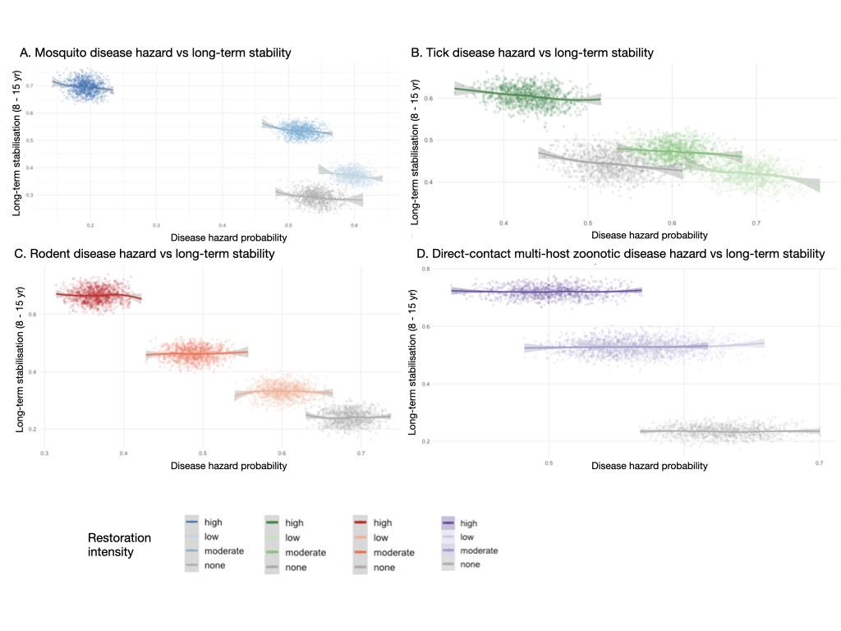

Supplementary Figure 1: Disease transmission hazard probability versus long-term ecological stabilisation across four zoonotic disease systems and restoration intensities.

Each panel shows the joint distribution of disease transmission hazard probability (x-axis) and long-term ecological stabilisation probability (y-axis; cumulative probability of stabilisation within the 8–15 year window) across 1,000 Monte Carlo simulation iterations, stratified by restoration intensity. Points represent individual simulation iterations; lines and shaded bands show LOESS smoothed trends with 95% confidence intervals. Colour denotes restoration intensity within each system-specific palette: dark shades indicate high restoration intensity; light shades indicate low and moderate intensities; grey indicates no restoration.

Panel A (Mosquito-borne): High restoration (dark blue) is associated with both the lowest hazard and the highest long-term stabilisation, occupying the upper-left quadrant. Lower restoration intensities cluster toward higher hazard and lower stabilisation, consistent with the hump mechanism in which partial restoration sustains vector habitat before regulatory processes establish.

Panel B (Tick-borne): Scenarios form distinct clusters with a broadly negative relationship between hazard and stabilisation across restoration levels, though with substantially wider scatter than the mosquito system, reflecting the broader uncertainty characteristic of trophic-lag dynamics. High restoration (dark green) achieves the most favourable hazard–stabilisation combination, but the overlap between moderate and low restoration clusters indicates weaker scenario separation.

Panel C (Rodent-borne): The clearest separation among restoration intensities, consistent with the direct and well-supported habitat–rodent–hazard pathway. High restoration (dark red) produces low hazard and high stabilisation; no restoration (grey) produces high hazard and low stabilisation. The steep negative slope within each restoration cluster reflects the tight coupling between reservoir suppression and ecological stabilisation.

Panel D (Direct-contact zoonoses): Clusters show minimal horizontal separation across the hazard axis, consistent with the weak and poorly predictable restoration sensitivity characteristic of multi-host spillover systems. Stabilisation probabilities differ more clearly across restoration levels than hazard probabilities, indicating that restoration advances ecological recovery even when spillover hazard reduction is limited. The near-horizontal LOESS trends confirm that hazard and stabilisation are only weakly coupled in this system.

Across all panels, high restoration consistently occupies the most favourable region of the hazard–stabilisation space (low hazard, high stabilisation), while no restoration occupies the least favourable region. The degree of cluster separation varies substantially among systems, reflecting the system-specific predictability of restoration outcomes identified in the main analysis.

Supplementary Methods S5. One-at-a-time (OAT) sensitivity analysis

SENSITIVITY ANALYSIS PARAMETERS

A one-at-a-time (OAT) sensitivity analysis was conducted to identify which CPT parameter groups most strongly influenced disease-risk predictions. For each system, 12 sensitivity parameters were defined, each corresponding to a full conditional distribution (one column of the relevant CPT matrix) rather than a single cell value. This full-column perturbation approach was adopted because single-cell perturbation causes adjacent cells to absorb the change after normalisation, producing near-zero swings in the output, a known artefact of sensitivity analysis in normalised probability tables.

For each sensitivity parameter, two alternative distributions were specified: a lower-bound (ecologically pessimistic) distribution and an upper-bound (optimistic) distribution. The analysis proceeded as follows:

1. All CPT parameters were fixed at their mid-range values (midpoint of each sample_prob range).
2. One CPT column was set to its lower-bound distribution; all others remained at midpoints. Disease hazard was queried.
3. The same column was set to its upper-bound distribution. Disease hazard was queried again.
4. The swing was computed as risk(upper) − risk(lower), signed to preserve direction.
5. Parameters were ranked by absolute swing magnitude.

Sensitivity was evaluated at the ecologically most informative restoration scenario for each system: moderate restoration for mosquito, rodent, and direct-contact systems; low restoration (the hump peak) for the tick system. Results are presented as tornado plots in Supplementary Figure S2, with bars spanning the risk range from lower to upper bound assumption and the dashed baseline indicating mid-range risk.

SENSITIVITY ANALYSIS RESULTS

One-at-a-time sensitivity analysis revealed that disease-risk predictions were driven by distinct parameter groups across the four systems, with implications for both model interpretation and field monitoring priorities (Supplementary Figure S2). In mosquito-borne systems, the largest sensitivity was associated with uncertainty in the suppressive effect of mature ecological regulation on disease hazard under high standing-water conditions (swing = +0.062), rather than with the standing-water CPT parameters themselves, indicating that the predicted post-hump risk decline is robust to hydrological assumptions but sensitive to uncertainty in regulatory efficacy. In tick-borne systems, the dominant parameter was the peak-risk cell at high host connectivity and weak predator recovery (swing = +0.090), confirming that the amplitude of the transitional risk hump depends primarily on the strength of the connectivity–predation interaction rather than on connectivity or predation recovery rates individually. Rodent-borne disease predictions were most sensitive to the disease CPT at moderate rodent abundance (swing = +0.141), suggesting that the intermediate transmission zone rather than the habitat-quality-to-rodent-abundance pathway represents the greatest source of predictive uncertainty in this system. In contrast, direct-contact zoonotic systems showed dominant sensitivity in the spillover probability given amplification state (swing = +0.170), with contact-rate and regulation parameters contributing negligible variance, consistent with the interpretation that outcome uncertainty in multi-host systems is governed by stochastic spillover dynamics rather than by landscape-scale ecological processes. Across all systems, parameters representing the final transmission step contributed disproportionate sensitivity relative to upstream ecological drivers, suggesting that empirical investment in transmission-interface parameters would most efficiently reduce predictive uncertainty in restoration-health modelling framework

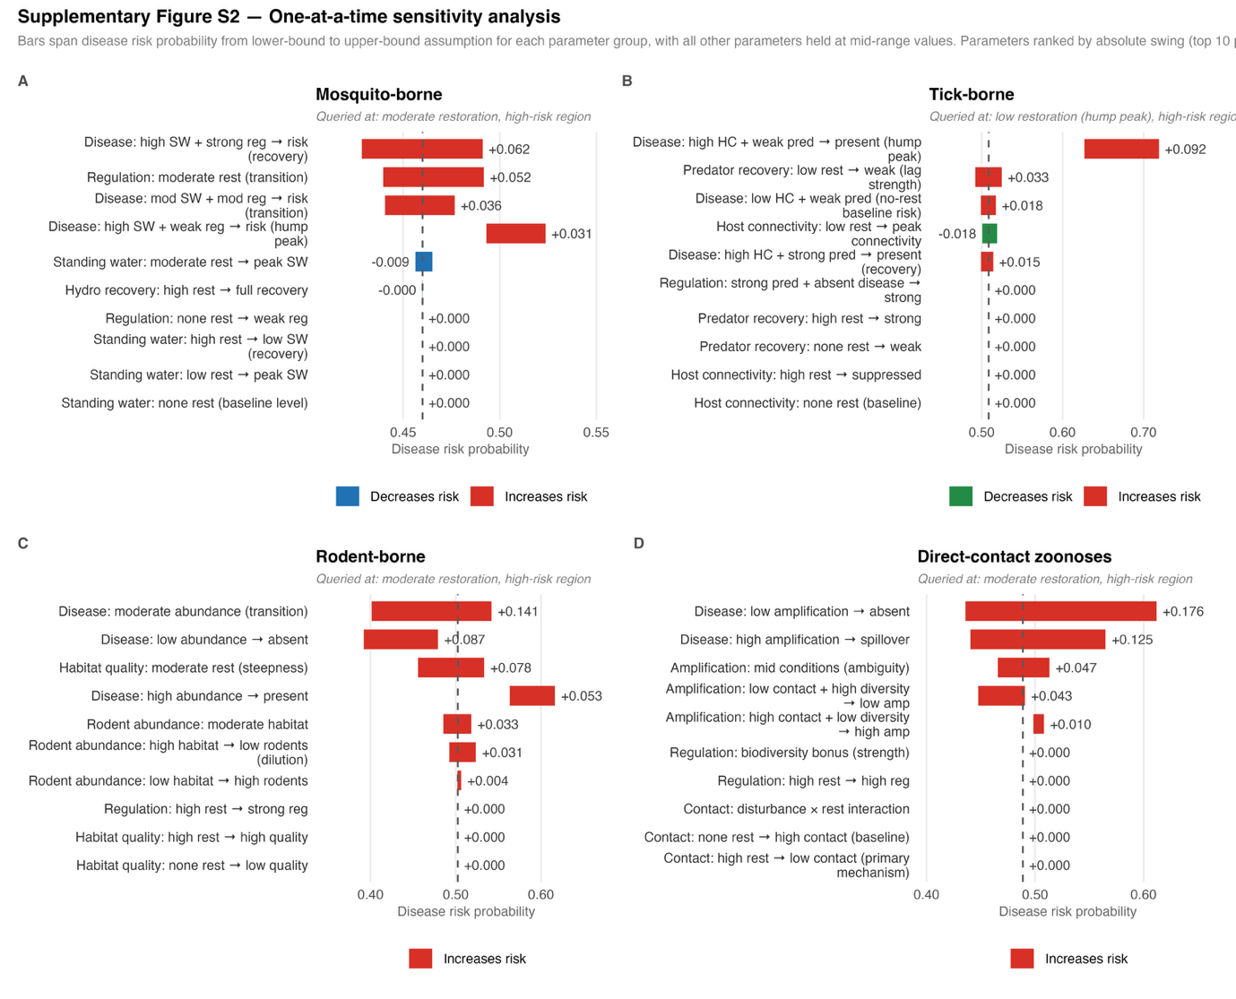
Supplementary figure 2: Tornado plots of the One-at-a-time sensitivity analysis of the four disease systems

Supplementary section 6. Funding simulation scenarios for direct-contact multi-host zoonoses

Across all scenarios, mean disease hazard remained confined to a narrow band between 0.499 and 0.578, in marked contrast to the substantial scenario-dependent variation observed in the vector-borne and rodent-borne systems (main text Figure 3). The sustained high-restoration baseline produced a mean risk of 0.499 (95% UI: 0.468–0.528). Funding collapse scenarios increased mean risk only modestly above this baseline, to 0.511 (95% UI: 0.481–0.539) when collapse occurred at Year 10 and 0.551 (95% UI: 0.524–0.575) when collapse occurred at Year 5. Ramp-up scenarios produced a similarly muted response: transitioning from low to high restoration at Year 5 yielded a mean risk of 0.540 (95% UI: 0.514–0.566), only marginally lower than the equivalent transition delayed to Year 10 (0.578; 95% UI: 0.552–0.603), and transitioning from moderate to high restoration produced comparable results regardless of transition timing (0.523 at Year 5 versus 0.544 at Year 10).

Notably, several ramp-up scenarios produced mean risk estimates higher than the sustained high-restoration baseline and, in some cases, higher than the corresponding funding collapse scenarios, a pattern that would be counterintuitive if restoration intensity were the dominant driver of spillover risk in this system. This is consistent with the model's explicit parameterisation of host diversity effects on multi-host amplification as weak and ambiguous (Supplementary Section S3): unlike the more direct mechanistic pathways in the rodent-borne and vector-borne systems, restoration in direct-contact zoonotic systems acts on spillover risk indirectly and incompletely, through reductions in habitat disturbance and human-wildlife contact that are themselves subject to considerable uncertainty. Other ecological and social drivers not captured by restoration intensity alone, including host community composition, reservoir species behaviour, and the stochastic nature of human-wildlife contact events, exert comparable or greater influence on spillover probability in this system. Consequently, the funding transition timing effects that were strongly time-sensitive in mosquito- and tick-borne systems are correspondingly weak and inconsistent here, and the ranking of scenarios should not be interpreted as reflecting a reliable causal ordering of restoration funding strategies for direct-contact zoonotic disease management. These results reinforce the broader conclusion that restoration-health relationships are highly system-dependent, and that multi-host spillover systems in particular require management strategies that extend beyond landscape-scale restoration intensity alone.

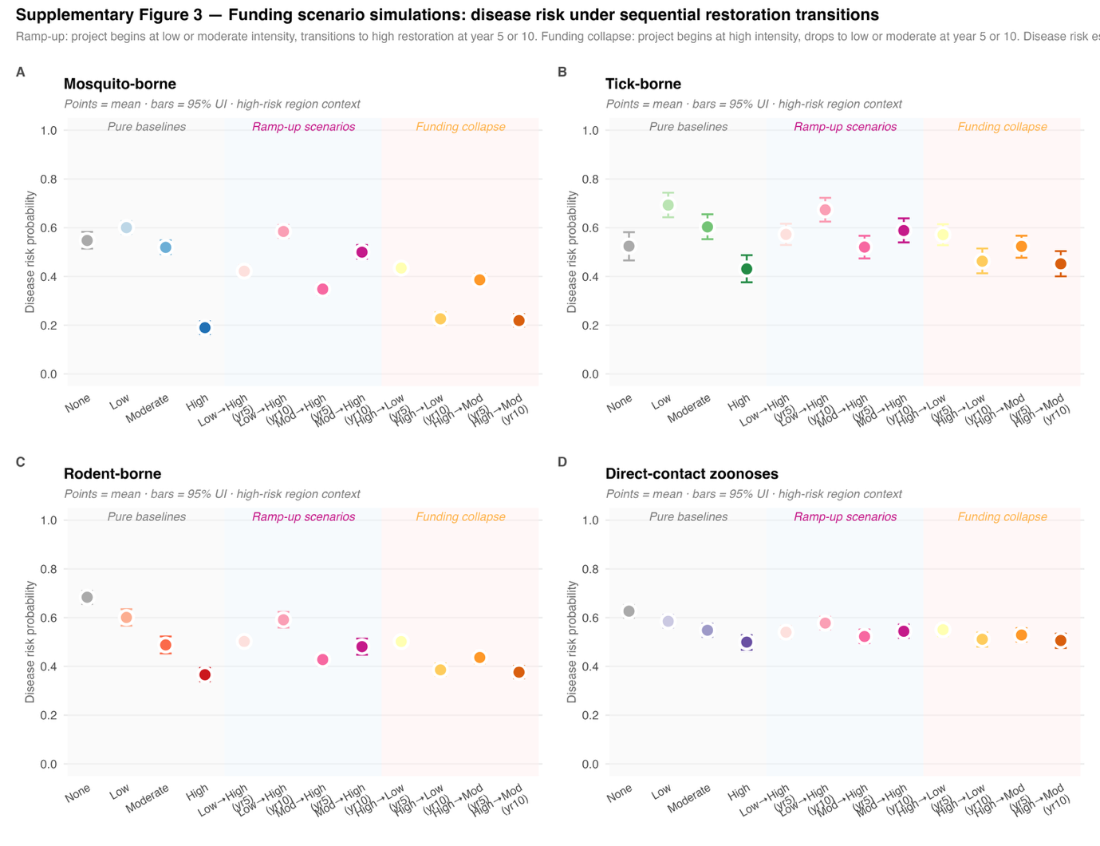
Supplementary figure 3: Funding scenario simulations : Disease risk under sequential restoration transitions

Table S6_1: Mean (and credible interval) risks of transition across different funding scenario changes across the different disease systems
 | scenario | scenario_type | phase1 | phase2 | transition | mean_risk | lower_risk | upper_risk
system
Direct-contact zoonoses | High (15 yr) | Pure baseline | high | high | 0 | 0.499 | 0.468 | 0.528
Direct-contact zoonoses | High→Low (yr 10) | Funding collapse | high | low | 10 | 0.511 | 0.481 | 0.539
Direct-contact zoonoses | High→Low (yr 5) | Funding collapse | high | low | 5 | 0.551 | 0.524 | 0.575
Direct-contact zoonoses | Low→High (yr 10) | Ramp-up | low | high | 10 | 0.578 | 0.552 | 0.603
Direct-contact zoonoses | Low→High (yr 5) | Ramp-up | low | high | 5 | 0.540 | 0.514 | 0.566
Direct-contact zoonoses | Moderate→High (yr 10) | Ramp-up | moderate | high | 10 | 0.544 | 0.517 | 0.571
Direct-contact zoonoses | Moderate→High (yr 5) | Ramp-up | moderate | high | 5 | 0.523 | 0.495 | 0.551
Mosquito-borne | High (15 yr) | Pure baseline | high | high | 0 | 0.190 | 0.164 | 0.216
Mosquito-borne | High→Low (yr 10) | Funding collapse | high | low | 10 | 0.226 | 0.201 | 0.253
Mosquito-borne | High→Low (yr 5) | Funding collapse | high | low | 5 | 0.434 | 0.413 | 0.457
Mosquito-borne | Low→High (yr 10) | Ramp-up | low | high | 10 | 0.585 | 0.559 | 0.611
Mosquito-borne | Low→High (yr 5) | Ramp-up | low | high | 5 | 0.422 | 0.398 | 0.446
Mosquito-borne | Moderate→High (yr 10) | Ramp-up | moderate | high | 10 | 0.500 | 0.473 | 0.529
Mosquito-borne | Moderate→High (yr 5) | Ramp-up | moderate | high | 5 | 0.348 | 0.325 | 0.371
Rodent-borne | High (15 yr) | Pure baseline | high | high | 0 | 0.366 | 0.339 | 0.394
Rodent-borne | High→Low (yr 10) | Funding collapse | high | low | 10 | 0.386 | 0.362 | 0.412
Rodent-borne | High→Low (yr 5) | Funding collapse | high | low | 5 | 0.502 | 0.480 | 0.525
Rodent-borne | Low→High (yr 10) | Ramp-up | low | high | 10 | 0.591 | 0.559 | 0.624
Rodent-borne | Low→High (yr 5) | Ramp-up | low | high | 5 | 0.502 | 0.479 | 0.525
Rodent-borne | Moderate→High (yr 10) | Ramp-up | moderate | high | 10 | 0.481 | 0.448 | 0.514
Rodent-borne | Moderate→High (yr 5) | Ramp-up | moderate | high | 5 | 0.428 | 0.405 | 0.450
Tick-borne | High (15 yr) | Pure baseline | high | high | 0 | 0.431 | 0.376 | 0.487
Tick-borne | High→Low (yr 10) | Funding collapse | high | low | 10 | 0.463 | 0.413 | 0.515
Tick-borne | High→Low (yr 5) | Funding collapse | high | low | 5 | 0.571 | 0.528 | 0.614
Tick-borne | Low→High (yr 10) | Ramp-up | low | high | 10 | 0.674 | 0.625 | 0.723
Tick-borne | Low→High (yr 5) | Ramp-up | low | high | 5 | 0.573 | 0.529 | 0.616
Tick-borne | Moderate→High (yr 10) | Ramp-up | moderate | high | 10 | 0.588 | 0.540 | 0.638
Tick-borne | Moderate→High (yr 5) | Ramp-up | moderate | high | 5 | 0.520 | 0.474 | 0.567

Supplementary Section S7. Validation
MAPPING PREDICTED TRAJECTORIES TO EMPIRICAL EVIDENCE
The predicted trajectory for each disease system was assessed against published empirical evidence as follows.
Mosquito-borne diseases: risk hump
The predicted pattern of transient risk amplification during partial wetland restoration before long-term suppression is well documented in the empirical literature. Re-flooding of rice fields in California has been shown to produce order-of-magnitude increases in Culex tarsalis larval abundance, with mosquito densities peaking during transitional hydrological conditions before mature vegetation establishes. Knight et al. (2003) documented that emergent vegetation in constructed treatment wetlands substantially enhanced mosquito production, and that risk was highest during intermediate stages of vegetation establishment before open-water and deep-channel design features could suppress larval habitat. Hanford et al. (2020) demonstrated experimentally that wetland management practices intended to support conservation objectives increased larval mosquito abundance relative to undrained reference wetlands, consistent with the predicted transitional risk amplification mechanism. Collectively, these studies support the model's central assumption that hydrological re-wetting generates peak vector habitat before mature ecological regulation emerges, and that risk declines as wetland complexity increases.
Tick-borne diseases: hump at low restoration
The predicted hump at low restoration intensity, driven by increased host connectivity before predator recovery, maps directly onto the white-tailed deer and Ixodes tick recolonisation literature in the northeastern United States (Barbour and Fish 1993; Levi et al. 2012). The transition of agricultural land to suburban areas across the northeastern United States led to reforestation and a subsequent increase in white-tailed deer abundance through creation of suitable habitat, which preceded the recovery of predator communities and was associated with the geographic expansion of tick-borne disease hazard. Forest fragmentation increases edge habitat and favours white-tailed deer through increased forage quality and predator release, raising host connectivity and tick burdens before trophic regulation re-establishes, precisely the mechanism encoded in the tick-borne model CPTs. Levi et al. (2012) further demonstrated that increases in Lyme disease across the northeastern and midwestern United States coincided with the decline of key small-mammal predators rather than deer abundance alone, consistent with the model's assumption that predator recovery lags host connectivity recovery and that trophic regulation is the delayed suppressive mechanism.
Rodent-borne diseases: monotonic decline
The predicted steep, monotonic risk decline driven by biodiversity recovery and rodent suppression is supported by the dilution effect literature. Keesing et al. (2006)demonstrated that higher host species diversity reduces disease hazard through encounter reduction and susceptible host regulation, with more diverse communities consistently producing lower tick infection prevalence and lower rodent reservoir densities. LoGiudice et al. (2003) provided direct empirical support that vertebrate biodiversity buffers human exposure to Lyme disease, with diverse host communities producing significantly lower Borrelia infection prevalence in ticks through dilution of the white-footed mouse reservoir. Keesing and Ostfeld (2021) synthesised evidence that dilution effects, the suppression of disease hazard by diverse host communities, operate across a wide variety of ecological systems, consistent with the model's assumption that biodiversity recovery progressively reduces rodent reservoir dominance. The comparative steepness of the rodent decline relative to the multi-host system reflects the more direct and predictable pathway from habitat quality to rodent suppression, which is better supported empirically than the more variable diversity effects in multi-host spillover systems.
Direct-contact zoonoses: gradual decline with wide uncertainty
The predicted gradual, weakly predictable risk decline with broad uncertainty envelopes is consistent with the general finding that restoration outcomes in complex multi-host spillover systems are highly context dependent. Keesing (2025) reviewed the relationship between ecosystem restoration and zoonotic disease hazard, concluding that the scientific literature remains scattered and inconclusive, with fundamental gaps in understanding of how restoring biodiversity affects emergence risk, consistent with the model's deliberately broad uncertainty parameterisation for this system. Ecke et al. (2025) similarly highlighted that the mitigating effects of ecosystem restoration on zoonotic spillover are challenged by a lack of conceptual frameworks, and specifically identified time lags between restoration and recovery as a critical consideration, directly mirroring the model's finding that stabilisation in this system is the least predictable of the four. The predicted pattern of declining but persistently uncertain risk is therefore consistent with the current state of empirical evidence for multi-host systems, which supports the directionality of the restoration effect but cannot constrain its magnitude.
References for validation:
Barbour, AG, and D. Fish. 1993. ‘The Biological and Social Phenomenon of Lyme Disease’. Science 260 (5114): 1610–16. 8503006, pp. 1610–16. PubMed. https://doi.org/10.1126/science.8503006.
Ecke, Frauke, Jan C. Semenza, Elena Buzan, et al. 2025. ‘Adaptive Ecosystem Restoration to Mitigate Zoonotic Risks’. Nature Ecology & Evolution 9 (11): 1979–88. https://doi.org/10.1038/s41559-025-02869-3.
Hanford, Jayne K., Cameron E. Webb, Dieter F. Hochuli, and Jason Rohr. 2020. ‘Management of Urban Wetlands for Conservation Can Reduce Aquatic Biodiversity and Increase Mosquito Risk’. Journal of Applied Ecology 57 (4): 794–805. https://doi.org/10.1111/1365-2664.13576.
Keesing, F., R. D. Holt, and R. S. Ostfeld. 2006. ‘Effects of Species Diversity on Disease hazard’. Ecology Letters 9 (4): 485–98. https://doi.org/10.1111/j.1461-0248.2006.00885.x.
Keesing, Felicia. 2025. ‘Ecosystem Restoration and the Risk of Zoonotic Diseases’. One Earth 8 (4). https://doi.org/10.1016/j.oneear.2025.101275.
Keesing, Felicia, and Richard S. Ostfeld. 2021. ‘Impacts of Biodiversity and Biodiversity Loss on Zoonotic Diseases’. Proceedings of the National Academy of Sciences 118 (17): e2023540118. https://doi.org/10.1073/pnas.2023540118.
Knight, Robert L., William E. Walton, George F. O’meara, William K. Reisen, and Roland D. Wass. 2003. ‘Strategies for Effective Mosquito Control in Constructed Treatment Wetlands’. Ecological Engineering 21: 211–32.
Levi, Taal, A. Marm Kilpatrick, Marc Mangel, and Christopher C. Wilmers. 2012. ‘Deer, Predators, and the Emergence of Lyme Disease’. Proceedings of the National Academy of Sciences 109 (27): 10942–47. https://doi.org/10.1073/pnas.1204536109.
LoGiudice, Kathleen, Richard S. Ostfeld, Kenneth A. Schmidt, and Felicia Keesing. 2003. ‘The Ecology of Infectious Disease: Effects of Host Diversity and Community Composition on Lyme Disease hazard’. Proceedings of the National Academy of Sciences 100 (2): 567–71. https://doi.org/10.1073/pnas.0233733100.

Supplementary section S8. RESTOREID DST: Decision-support interface for policy makers
Overview and rationale
RESTOREID DST is an open-access, browser-based decision-support tool built on the four Bayesian belief network models described in this study. It is designed to help restoration practitioner and policymakers explore how restoration intensity, regional context, and funding trajectory interact to shape zoonotic disease hazard and ecological stabilisation outcomes across the 15-year modelling horizon. The tool is accessible at https://restoreid-eu.github.io/BBN/ and runs entirely in the browser via Shinylive, requiring no R installation, server access, or software dependencies.
Technical implementation
The application was built in R Shiny and compiled to WebAssembly via Shinylive, which embeds the R runtime and all package dependencies directly in the browser. This approach eliminates server-side infrastructure, ensuring the tool remains functional independently of external hosting services. The underlying BBN models are implemented using the bnlearn and gRain packages and are consistent with the parameterisation described in Supplementary Section S4. On each user query, the model is queried at mid-range CPT values (deterministic mode) rather than running the full 1,000-iteration Monte Carlo procedure, with uncertainty intervals derived from the pre-computed Monte Carlo output stored as lookup tables. This design ensures responsive query times while preserving the uncertainty representation central to the modelling framework.
Interface and functionality
The tool provides the following user-selectable inputs:
- Disease system: Mosquito-borne, tick-borne, rodent-borne, or direct-contact multi-host zoonoses
- Restoration scenario type: Pure sustained restoration (none / low / moderate / high across 15 years) or funding transition scenario
- Funding transition settings (where applicable): starting intensity (low or moderate), transition intensity (high), and transition year (Year 5 or Year 10) for ramp-up scenarios; or starting intensity (high) with collapse year and post-collapse intensity for funding collapse scenarios
Outputs include the mean disease hazard probability with 95% uncertainty interval, the long-term ecological stabilisation probability (8–15 year window), and a visual trajectory plot consistent with the figure format used in the main manuscript. A plain-language interpretation of the selected scenario is provided alongside each output to support communication with non-specialist audiences.
Intended use and limitations
RESTOREID DST is intended for structured scenario exploration and communication of uncertainty, not for site-specific quantitative prediction. The underlying models are parameterised from ecological theory and published empirical evidence at a generalised level and have not been calibrated to specific geographic locations, species assemblages, or local disease surveillance data. Outputs should be interpreted as indicative of the direction, relative magnitude, and uncertainty of restoration-health trade-offs rather than as precise probability estimates for any given site or project. Users are encouraged to treat the tool as a structured thinking aid within a broader evidence-based planning process, and to consult system-specific epidemiological expertise when translating scenario outputs into management decisions.

Supplementary section S9. Limitations to the generalisation of the BBN models
Several important caveats apply to the generalisation of these modelled trajectories to specific pathogens and ecosystems. Within each transmission category, considerable ecological heterogeneity exists that the stylised BBN archetypes cannot capture.
For mosquito-borne diseases, the hydrological re-wetting mechanism modelled here applies most directly to open-wetland vector systems such as Culex-driven West Nile virus and Aedes-driven arboviral transmission in temperate and subtropical contexts; it does not capture forest malaria systems in mainland Southeast Asia, where primary vectors such as Anopheles dirus breed in shaded forest streams and high restoration intensity, through canopy recovery, may increase rather than decrease vector habitat suitability (Obsomer et al., 2007; Fornace et al., 2019).
For rodent-borne and direct-contact systems, the distinction between environmentally-mediated transmission (leptospirosis, where pathogen shed in the environment constitutes the exposure pathway) and direct-contact transmission (hantavirus, requiring close proximity to infected rodents or their excreta) represents a meaningful epidemiological difference that a single multi-host amplification node cannot fully resolve.
The framework is therefore most appropriately applied to temperate and subtropical systems where the modelled ecological mechanisms are empirically supported, and to transmission archetypes where the dominant pathway aligns with the causal structure encoded in the relevant BBN. Adapting the framework to tropical forest systems, environmentally-mediated pathogens, or regions where restoration ecology and vector biology diverge substantially from the parameterisation would require system-specific re-parameterisation informed by local empirical data.

Supplementary section S10. Expert questionnaire
The “Expert Survey on Landscape Restoration and Zoonotic Disease Risks: Exploring Causal Relationships and Probabilities” can be accessed through this link: https://forms.gle/6P1brzXBJsyKit516

