Supplementary information

Controlled Stöber Growth of Tunable Silica Shells on Ligand-Stripped Hydrophobic Nanoparticles
Carlos Alarcón-Fernández,ª Pau Gonzalez I Benitez,^{b} Diego Mendez Gonzalez,^{b} Alejandro Casillas-Rubio,^{c} Concepción Cascales,ª Sonia Melle,^{c} Oscar G. Calderón,^{c} and Marco Laurenti^{b}*
a Instituto de Ciencia de Materiales de Madrid, Consejo Superior de Investigaciones Cientificas CSIC, c/ Sor Juana Inés de la Cruz 3, 28049, Madrid, Spain
b Department of Chemistry in Pharmaceutical Sciences, Universidad Complutense de Madrid, 28040, Madrid, Spain
c Department of Optics, Universidad Complutense de Madrid, 28037 Madrid, Spain

*email to: marclaur@ucm.es

FT-IR characterization of the pristine and BF₄ modified UCNPs
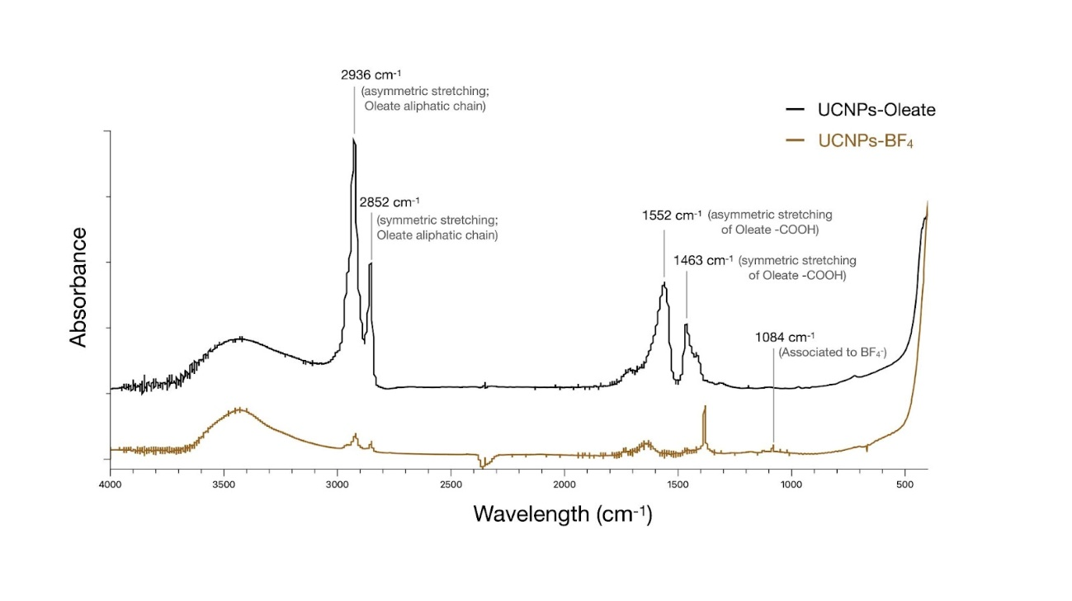
Figure S1 FTIR spectra of UCNPs before and after NOBF₄ treatment. The spectrum of as-synthesized, oleate-capped UCNPs displays characteristic C–H stretching bands in the 2850–2950 cm⁻¹ range, associated with surface-bound oleic acid ligands. After treatment with NOBF₄, these bands are significantly reduced, indicating efficient removal of oleate species. A new, weak band appears near 1084 cm⁻¹, consistent with the presence of weakly bound BF₄⁻ anions on the nanoparticle surface. [1] This spectral evolution aligns with previous reports showing that NOBF₄ treatment typically removes 80–85% of surface oleate ligands, enabling subsequent silica coating or functionalization [2]

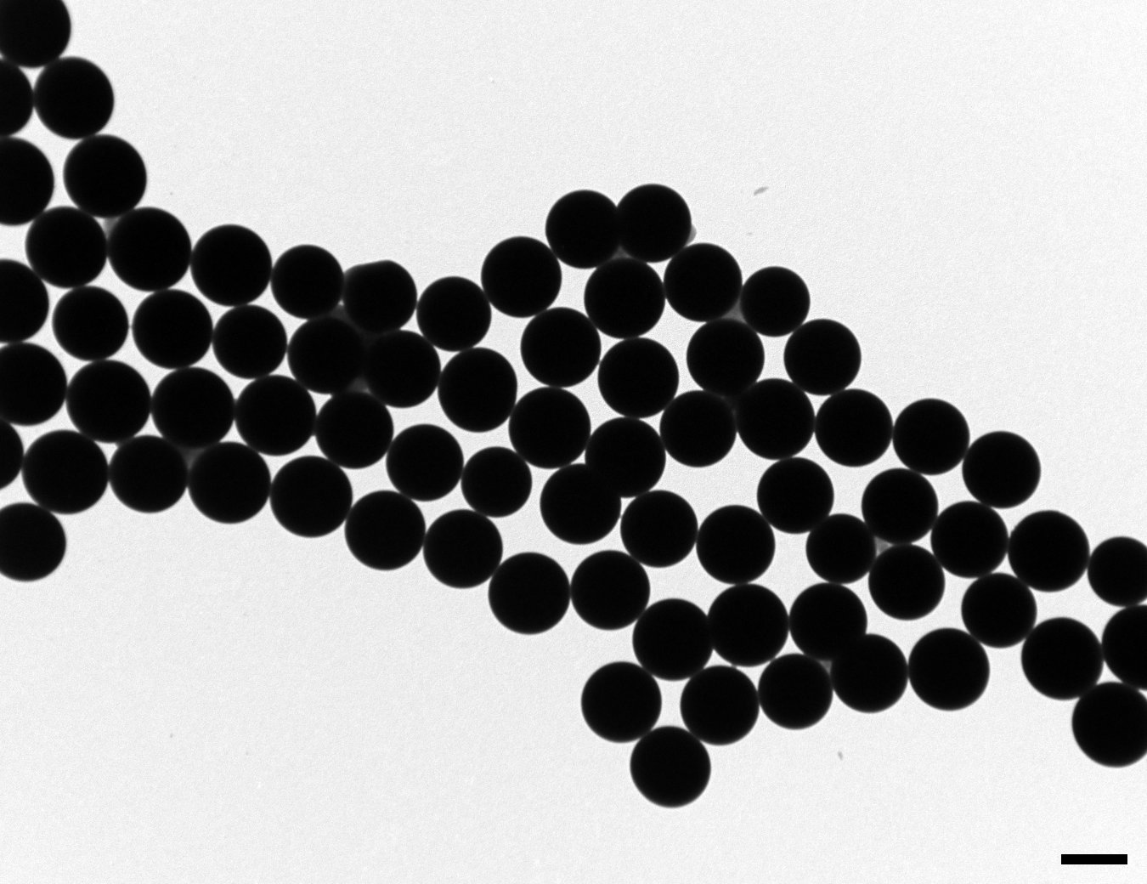
Figure S2 TEM picture of the core-shell particles made of 𝛽-NaYF₄:Yb³⁺_{0.2}Er³⁺_{0.02} UCNPs and SiO₂ shell, scale bar is 1 µm. The final size of the particle reaches 1.1 µm, showing the adaptability of the proposed method to synthesize SiO₂ shells ranging from 10 nm up to 530 nm. The core UCNPs is not visible due the thickness of the SiO₂ shell

UCNPs Stability Study in PBS
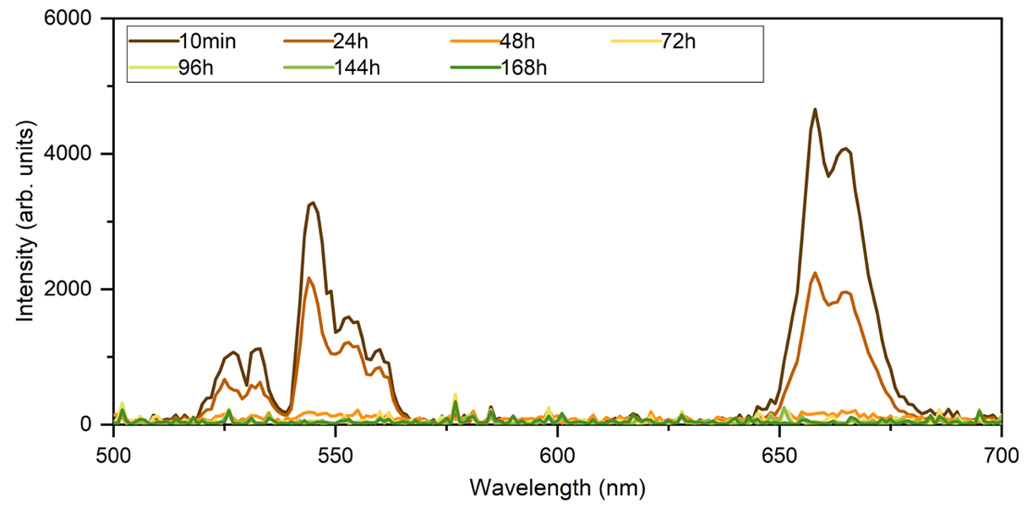

Figure S3 Emission spectra of UCNPs@SiO₂ with 10 nm silica shell up to 168 hours immersed in PBS at a UCNPs core concentration of 50 µg/mL

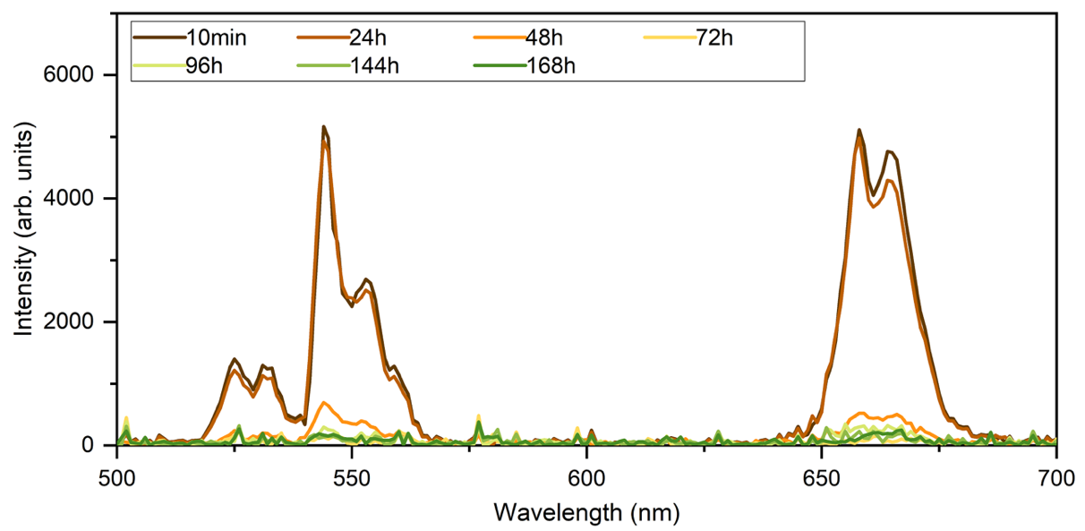
Figure S4 Emission spectra of UCNPs@SiO₂ with 45 nm silica shell up to 168 hours immersed in PBS at a UCNPs core concentration of 50 µg/mL

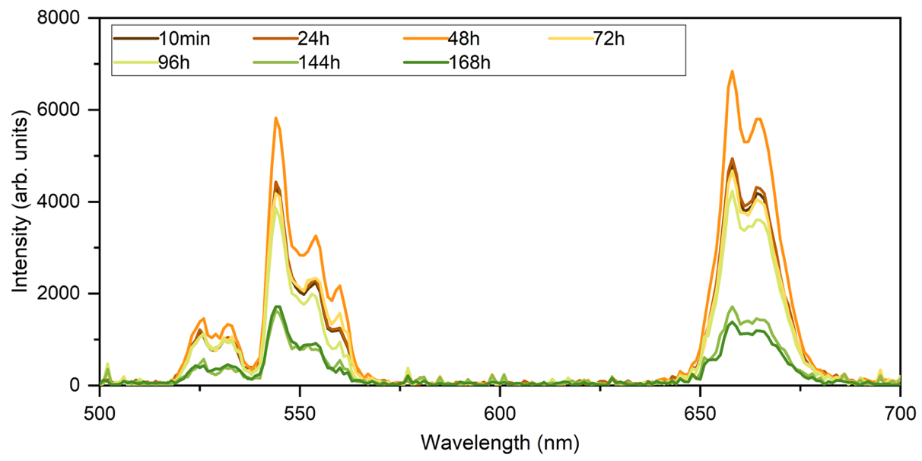
Figure S5 Emission spectra of UCNPs@SiO₂ with 120 nm silica shell up to 168 hours immersed in PBS at a UCNPs core concentration of 50 µg/mL

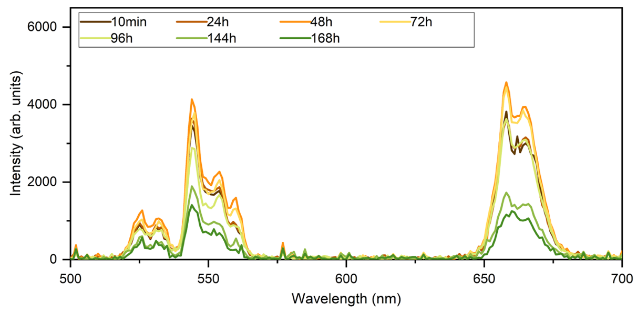
Figure S6 Emission spectra of UCNPs@SiO₂ with 200 nm silica shell up to 168 hours immersed in PBS at a UCNPs core concentration of 50 µg/mL

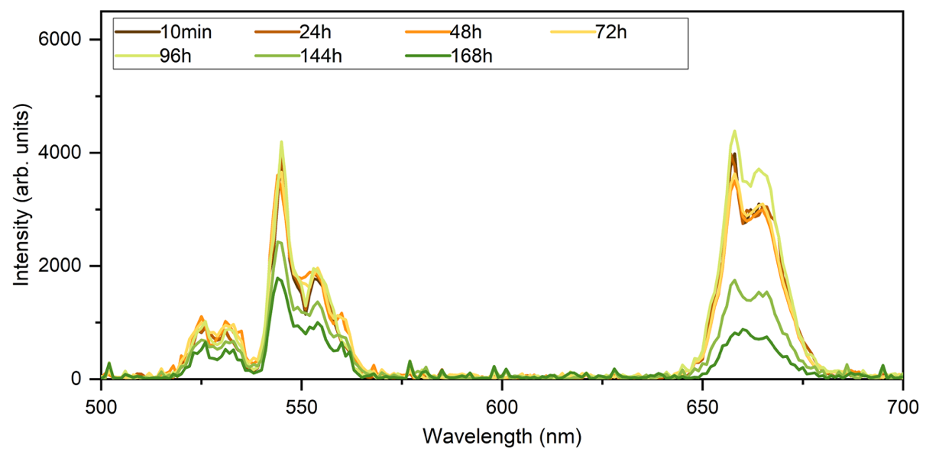
Figure S7 Emission spectra of UCNPs@SiO₂ with 300 nm silica shell up to 168 hours immersed in PBS at a UCNPs core concentration of 50 µg/mL
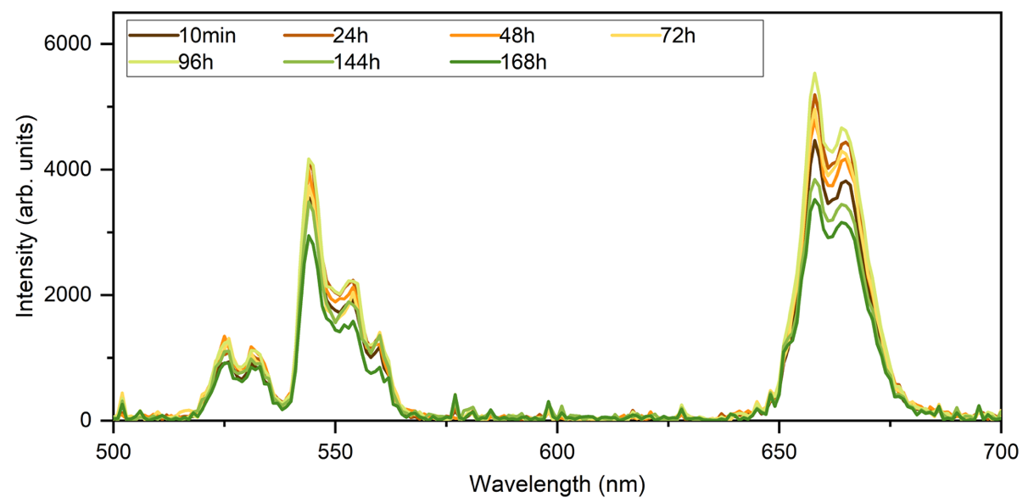
Figure S8 Emission spectra of UCNPs@SiO₂ with 420 nm silica shell up to 168 hours immersed in PBS at a UCNPs core concentration of 50 µg/mL

References
[1] Wen Wang, Mingying Zhao, Lun Wang, Hongqi Chen (2019) Core-shell upconversion nanoparticles of type NaGdF₄:Yb,Er@NaGdF₄:Nd,Yb and sensitized with a NIR dye are a viable probe for luminescence determination of the fraction of water in organic solvents. Microchim Acta 186, 630. https://doi.org/10.1007/s00604-019-3744-7
[2] Angang Dong, Xingchen Ye, Jun Chen, Yijin Kang, Thomas Gordon, James M. Kikkawa, and Christopher B. Murray, (2011) A Generalized Ligand-Exchange Strategy Enabling Sequential Surface Functionalization of Colloidal Nanocrystals. Journal American Chemical Society 133 (4), 998–1006. https://doi.org/10.1021/ja108948z

