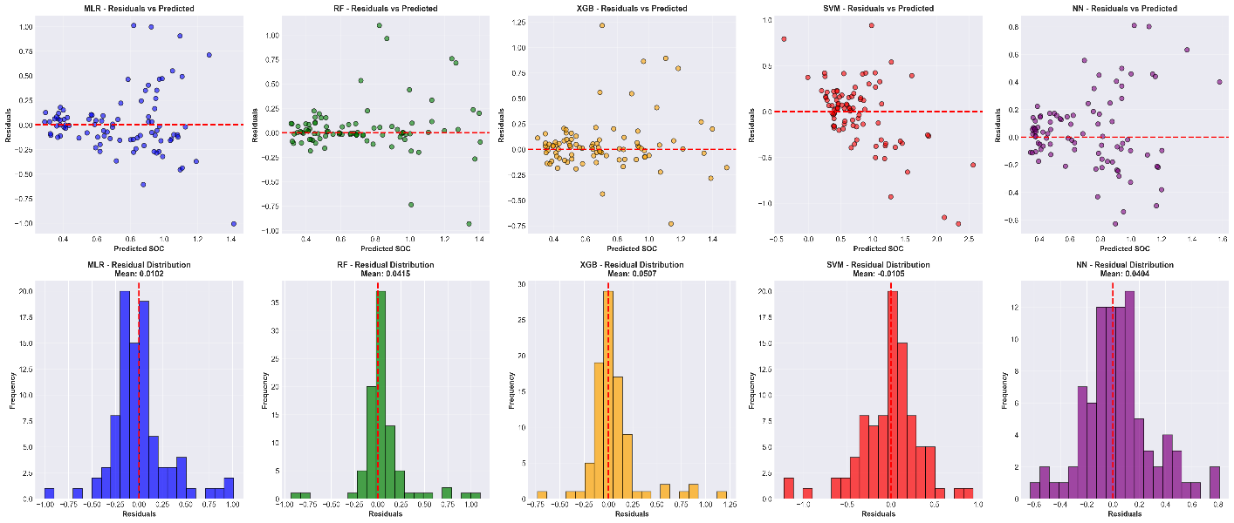
Fig. 6. - Residuals vs. predicted scatter plot of five machine learning algorithm.

